Working with Stakeholders to Support Workforce Planning

Contents
1. Introduction 3
What do we mean by stakeholders? 3
What is stakeholder analysis? 3
When should you do a stakeholder analysis? 3
How to do stakeholder analysis 3
2. Identify stakeholders 3
3. Prioritising stakeholders 4
4. Understanding Stakeholder perspectives 6
5. Building trust and relationships with your stakeholders 7
6. Working with your stakeholders 9

Introduction
Like all programmes or projects, successful delivery of a National or system-wide workforce plan is dependent on effective analysis and engagement of key stakeholders from across the whole system.

What do we mean by stakeholders?
A stakeholder is any individual, group or organisation that can affect or be affected by your plan.
Stakeholders can be classed as either;
- Primary or key stakeholders, those who can directly affect or are directly affected, by the outcomes of the workforce plan
- Secondary stakeholders, those who are indirectly affected by the outcomes of the workforce plan.

What is stakeholder analysis?
Stakeholder analysis enables you to identify everyone who needs to be involved in the workforce plan and assess how much time and resource to give to maintaining their involvement and commitment.

When should you do a stakeholder analysis?
Carrying out stakeholder analysis early in the development of your workforce plan will help you avoid conflict and delays caused by inadvertently failing to involve key people. We know from experience that actively engaging a wide variety of people such as clinicians, managers, administrative staff, patients and user groups is essential for your workforce plans success. Undertaking stakeholder analysis will support the effective planning of your engagement, ensuring that you engage with the right people, in the right way and at the right time.
As you progress the development your National or system wide plan you will need to revisit your stakeholder analysis as you understand more fully the scope of the plan to be developed.

How to do stakeholder analysis
There are 5 key stages to Stakeholder analysis
- Identifying stakeholders
- Prioritising stakeholders
- Understanding stakeholders’ perspectives
- Building trust with stakeholders
- Working with stakeholders

Identify Stakeholders
Start by generating a list of all the people and groups likely to be affected by, or who can affect the outcomes of the plan or project. You could bring a small group of key people together to generate this list or start the list yourself and share it with others so that they can add to it. There may be existing lists of stakeholders held by people within your organisation such as the Communications Team. At this stage, however, your stakeholder list is high level e.g. identifying groups rather than specific individuals.
When thinking about who the stakeholders are, you need to think both internally and externally. For example, stakeholders could include specific staff, subject matter experts, patients/service users, NHS Wales, Professional Bodies, Royal Colleges, Trade Unions, Welsh Government, Provider/Partnership Organisations, Governing Bodies, Health Inspectorate Wales, Local Health Boards and Local Authorities.

Prioritising Stakeholders
Once you have identified your stakeholders you will need to prioritise them to help you identify who and how you need to communicate and engage with them. The power/interest grid is a useful matrix used for categorising stakeholders. Stakeholders are plotted on the grid in relation to the power and interest they have in respect of the plan or project. The grid categorises stakeholders into the following four groups:
- High power/high interest
- High power/low interest
- Low power/high interest
- Low power/low interest

Why use a power interest grid?
Categorising stakeholders in this way allows you to develop strategies to identify the different approaches needed to work with and manage different stakeholders (see guide to Engagement for Workforce Planning). You may also use your categorisation to create a stakeholder communication plan. Stakeholders with high power and high interest will need to be engaged with regularly, whereas stakeholders with low power and low interest do not require regular and detailed communication (however, this does not mean that they should be ignored!).
Figure. 1 Example of a Power/ Interest stakeholder mapping grid
Who holds the most influence?
Who could support or hamper your plan?
Manage closely
Meet their needs

Power/Influence of stakeholder
Keep informed
Keep into account

Level of interest of stakeholder
Who holds the most interest?
Who will be most affected?

When plans or projects are large and complex with multiple stakeholders it can be beneficial to use a Nine Box Influence/Impact grid instead. This tool is very similar to the Power/Interest grid. Influence is the level of involvement the person has, and impact is the ability of the stakeholder to bring out a desired change. Where larger numbers of stakeholders and stakeholder groups are involved, it will provide you with more clarity about your stakeholders and how you will need to work with them.
Figure 2 Nine box Power/impact grid for stakeholder analysis
High Power
Moderate Power
Little or no Power
 | Little or no impact | Moderate impact | High impact

Two other tools may also be useful when prioritising your stakeholders and considering how to work with them; these include the Readiness for Change Matrix and the RASCI Matrix.
The Readiness for Change Matrix^{i} helps you understand who is for or against the plan or projects proposals and will help you decide on what influencing activities may be needed.
Figure 3 Readiness for Change Matrix
Stakeholder | Opposed/ obstruct | Neutral | In Favour
Local Health Boards |  | Movement needed
NHS Wales
Subject Matter Experts
Professional Body X
Primary Care Cluster Y |  | Movement needed
HEIW
Different stakeholders will have different agendas, drivers and values and may see the plan or project in very different ways, so it’s important to be aware of these from the outset.
You can also use the RASCI Matrix to help define each stakeholder’s involvement on a plan or project. RASCI is short for: Responsible, Accountable, Supportive, Consulted, Informed
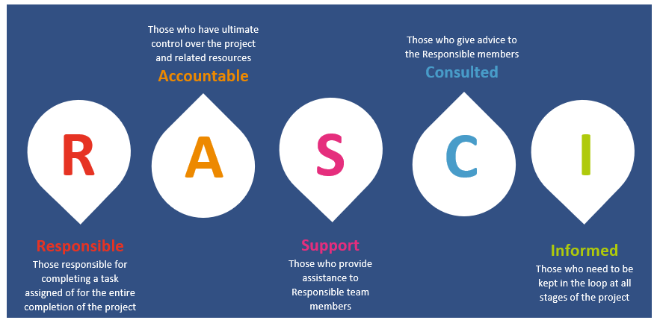

Understanding Stakeholder Perspectives
It is important to try and get an understanding about how stakeholders are likely to feel about the plan or project. Asking their opinions can be the first step in building a successful relationship with them.
Key questions that will help you understand your stakeholder’s perspective:
  - What financial or emotional interest do they have in the outcome of your work? Is it positive or negative?
  - What motivates them most?
  - What information do they want from you?
  - How do they want to receive information from you? What is the best way of communicating your message to them?
  - What is their current opinion of your work? Is it based on accurate information?
  - Who influences their opinions generally and who influences their opinion of you?
  - Do some of these influencers therefore become important stakeholders in their own right?
  - If they are unlikely to be positive, what might convince them to support your project?
  - If you don’t think you will be able to convince them, how will you manage their opposition?
  - Who else might be influenced by their opinions? Do these people become stakeholders in their own right?

Building Trust and Relationships with your Stakeholders

In order to work most effectively with your stakeholders, it is important to build trust and a good working relationship.

Trust and relationships
Trust requires two things - Competency and Caring. You can encourage people to trust you if you;
- Do what you say you will do and don’t make promises you can’t keep
- Always be consistent in thought and action
- Listen to stakeholders carefully and reflect back what you think you heard them say
- Understand what matters to each stakeholder and have empathy with their perspectives and views
- Admit when you make a mistake
- Let go of grievances
You can encourage good relationships with stakeholders if you;
- Engage in dialogue respectfully and actively listen to their views and ideas
- Show respect for stakeholders’ values and beliefs
- Be honest and tell the truth, however difficult

Rapport
When working with stakeholders its vital you communicate and work with them in ways that suit them, so building a healthy rapport with your stakeholder is important. Rapport is the process of building and sustaining a relationship of mutual trust and understanding. It’s the ability to relate to each other in a way that makes you both feel at ease.

“It’s not what you say, it’s the way you say it”
Louis Armstrong

Building on the understanding, trust and working relationships with your stakeholders enables you to frame communication and engagement activities and work in ways that best suit them. People tend to relate to the world around them in distinctly different ways. For example, analyst, amiable, expressive and driver. Understanding the different styles of your stakeholders will enable you to tailor these messages and deliver them in a way that maximises impact and engagement.

Figure 5 How to work with different styles of stakeholders
How to work better with Analyst  (Technical specialist) | How to work better with Amiables  (Relationship specialist) | How to work better with Drivers  (Command specialist) | How to work better with Expressive  (Social specialist)
- Tell how first  - List pros and cons  - Be accurate and logical provide evidence  - Provide deadlines  - Give them time, don’t rush or surprise | - Tell why and who first  - Ask instead of telling  - Draw up their options  - Explore personal life  - Define expectations  - Strive for harmony | - Tell what and when first  - Keep fast paced  - Don’t waste time  - Be business like  - Give some freedom  - Talk results  - Find short cuts | - Tell who first  - Be enthusiastic  - Allow for fun  - Support their creativity and intuition  - Talk about people and goals  - Handle the detail for them  - Value feelings and opinions  - Keep fast paced and be flexible

Working your way through the template below for each identified stakeholder, or group of stakeholders provides a structure for your thinking and actions to take forward in how you could more effectively communicate and engage with your stakeholders.

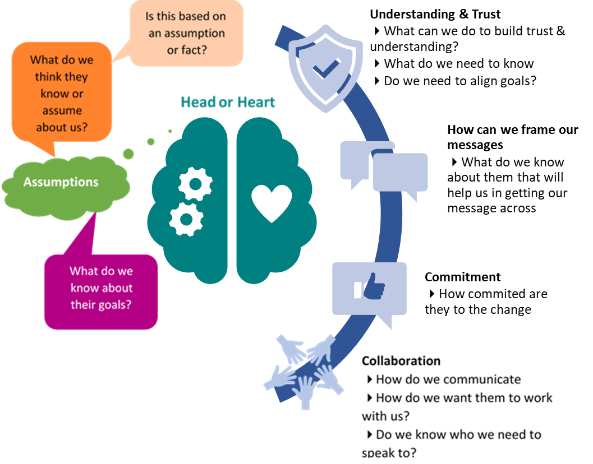
Figure 6 Building Trust and Understanding Template

Working with your Stakeholders
Stakeholder analysis without action is not helpful. Your analysis is a means of ensuring you are able to work effectively with the identified stakeholders in meaningful and productive ways.

Example
A Primary Care Cluster were considering how they could improve the effectiveness and efficiency of their administrative and clerical functions across the Cluster and what that would mean for the future workforce requirement (cluster workforce plan). The plan lead, together with some key staff from the cluster practices generated a list of stakeholders. They then considered their relative power and impact in relation to developing the plan and produced the following analysis.

High Power |  | GPs partners  Local Health Board
Moderate Power | NHS Wales  Practice managers  HEIW | Practices clinical staff  Community teams  Social services | Out of Hours Service
Little or no Power |  | 3rd sector organisations  Public health | Admin and clerical staff  IT suppliers  Patients and service users  Community pharmacy
 | Little or no impact | Moderate impact | High impact

Using the results of their analysis they revisited and changed the membership of the plan development group and developed a communication plan to keep all stakeholders informed and involved.

What next?
Following your stakeholder analysis you will need to develop a communication and engagement plan. The plan should outline which stakeholders need to be engaged at which point of the planning process, what type of engagement will be necessary and for what purpose. In relation to communication, what information should be shared, by which method, in what format and how frequently.

Please note - Materials within this resource have been adapted from the NHS Improvement Guide to Stakeholder Analysis. Online. Accessed May 2022.

NHS England and NHS Improvement. Stakeholder analysis. Accessed May 2022
IS improvement service. Power/Interest Grid. Accessed online May 2022
Interfacing. What is RASCI?RACI. A comprehensive guide on how and when to use them. Online Accessed May 2022
Dr R Edward Freeman (1984) Stakeholder management. A strategic approach
NHS Modernisation Agency. (2002) Managing the human dimensions of change: working with individuals. Accessed May 2022

