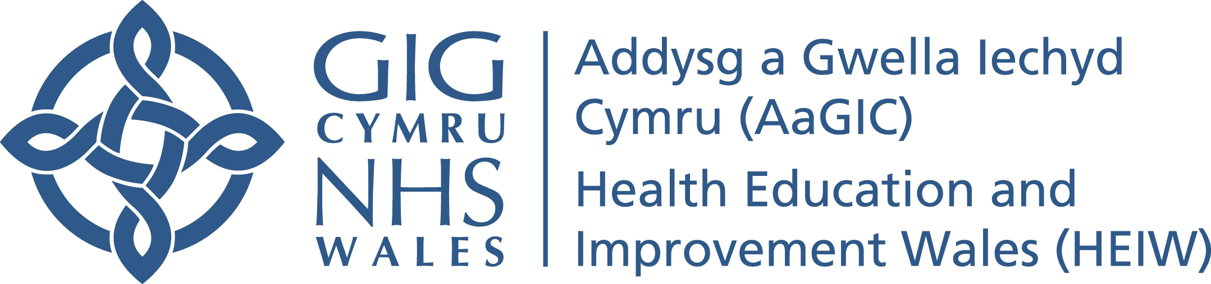


Guidance to support the Pathway Approach to Workforce Planning

Contents
The Pathway Approach to Developing a Workforce Plan 2
1. Introduction 2
2. Where does the Pathway Approach Fit in to Workforce Planning? 2
3. How to go about it 3
4. Stakeholder Engagement 5
6. Using this approach as part of your wider workforce plan 7
Appendix 1 - Example Pathway Template 8

The Pathway Approach to Developing a Workforce Plan

Introduction

This approach has been developed as a methodology that uses the patient/service user pathway to look at the skills and competences required to determine the workforce needed. It is designed to work within the NHS Wales Approach to Workforce Planning and will primarily support steps 3 and 4 in the Six Step® Framework.

NHS Wales Workforce Planning Approach

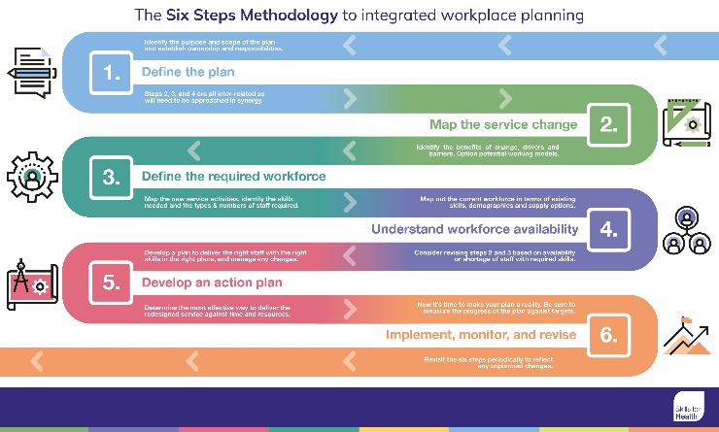
The approach to workforce planning in Wales is based on the Skills for Health Six Steps Framework®. The Skills for Health Six Step Framework is based on the following Principles that support effective workforce planning:-

Step 1: Defining the plan.
Step 2: Mapping service change.
Step 3: Defining the required workforce.
Step 4: Understanding workforce availability.
Step 5: Planning to deliver the required workforce.
Step 6: Implement, monitoring and refresh.

HEIW have developed a suite of tools and resources to support our approach to workforce planning

This approach does not develop a full workforce plan, it does enable you to identify the potential future workforce, including skills and competence, designed along a patient pathway. The information you gather using this approach can be used as a standalone piece of work but can also be used to inform the development of a full, long term, strategic workforce plan.

Where does the Pathway Approach Fit in to Workforce Planning?

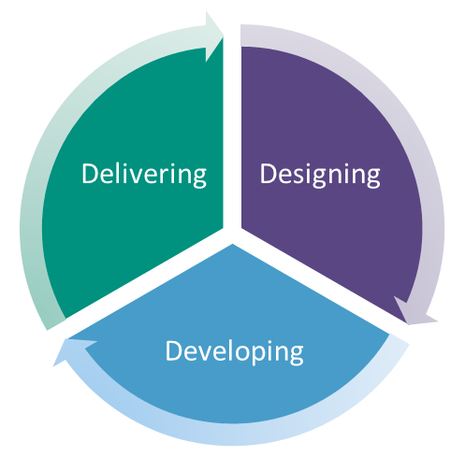
Workforce Planning is an iterative process that is integrated across workforce, finance and the service and involves three stages:-

Designing - Designing or re-designing a service and staffing it appropriately. This involves understanding the impact that service changes will have on the current and future workforce, and ensuring that these workforce implications are considered as part of the wider integrated planning process, so it’s achievable and sustainable and meets the needs of patients and service users. A pathway approach will both support and inform the design stage.

Developing - An understanding of what skills and competences will be needed to deliver planned services. You will need to consider where these skills and competences will come from and make provision and plans to develop these skills and competences if they are not already available within the current workforce. Pathway planning plays a key role in the development stage in identifying the competences and skills required.

Delivering - The management actions which are needed to ensure that clinicians are engaged; staff wellbeing is promoted; new ways of working are achieved; workforce development plans are delivered; and good practice is identified, shared and adopted. Pathway planning will inform the delivery stage.

The Pathway Workforce Planning Approach helps with Designing the future workforce; supports the identification of the skills and competence that needs to be Developed; can be used as part of a full workforce plan, enabling you to identify some of the actions that need to be undertaken to Deliver the future workforce.

How to go about it

The main purpose of the pathway approach to workforce planning is to identify the skills and competences required to deliver your service and meet the patient/service user needs, whilst identifying opportunities for improvement, re-design and transformation. In order to do this, you will need to start with your patient/service user pathway. This may be an existing pathway that you are looking to improve, or a new pathway that is being implemented, or it could be a re-designed pathway e.g. an optimum pathway.

Define your pathway

There are some things to consider when undertaking a patient pathway workforce planning approach and some things that you need to make sure are in place before you commence. These include:-

Key Information | Why it’s Important | Who needs to be involved
Defining your Clinical Model  This is the service you want your patient/service user to receive | Having an agreed clinical model will enable you to identify the skills and competences for the workforce you need to deliver that clinical model and meet the patient/service user need.  The clinical model relates to the type of service your patients/service users will receive e.g. access to ‘hot’ clinics or receiving treatment within a certain number of days.  This will need to be defined in more detail as you plan how the service will be delivered i.e. your operational service model - how will patients access the service and what they will need access to e.g. a scan. | Your stakeholders need to be involved in defining the clinical model, if it has not already been defined. This should include staff, patients/service users and key partners
Defining your Operational Service Model  This is how you plan to deliver the service | Once you have defined your clinical model you will need to consider how you will implement it in your organisation.  This is important, as how the service is provided will determine the patient/ service user pathway as well as helping you to identify the skills and competences required.  This is the first step in creating an overview of the workforce you require– a template is provided at appendix 1. A pathway will help you to identify the skills and competences required to deliver the service and meet patient/ service user needs. This will support workforce planning and to have the right people with the right skills, at the right time, in the right place along the pathway.  Through this activity you will be able to identify opportunities to re-shape the workforce, automate or re-design tasks. | Your stakeholders need to be involved in defining the operational model.  This should include staff, patients/service users and support services e.g. Digital and Facilities
Defining your planning assumptions | It will be important to consider what you know and what you don’t know.  Planning is often based on a number of assumptions which are usually what is considered to be true or certain. Sometimes assumptions are considered a ‘given’ without any proof, evidence or demonstration e.g. incidence of cancer is expected to increase by 2% year on year - but they can also be based on best evidence or something you know will definitely happen such as installation of a new machine.  Planning assumptions will help to define the type and/or numbers of workforce you may need | The project team will be the main people involved.  Subject Matter Experts can also be involved as the project develops e.g. Workforce or Population Data Analyst, Digital Team or Estates.
Identifying Good Practice | It is advisable to spend some time undertaking evidence-based research to identify examples of good practice, not only to identify what has worked well and how these may be adopted/adapted to your service, but also to identify any lessons learned. | A nominated project lead, small working group, or a commissioned researcher could do this.

Building your Workforce around the Patient Pathway

In identifying the workforce needed to deliver the improved, re-designed or new services, you will need to consider what skills/competence are needed, the type of workforce and numbers of staff required. To do this you will need you to have a good understanding of the pathway, how the patient/service user needs are met and what activities will be required, so involving those who know and understand the work is essential.

Your pathway should typically include (this is not an exhaustive list, you may want to add your own specific to your pathway):-

Activity | What part of the pathway it relates to e.g. outpatient appointment
What is the Task | What will happen at this point in the pathway e.g. routine blood taken
Is it a Specialist, Enhanced or Generic skill | Specialist - A task undertaken by a health care professional who formally qualified to undertake the work  Enhanced - Task undertaken by an Advanced Practitioner or person with extended skills  Generic - Task undertaken by an individual with generic skills; competence can be gained through work-based learning
What are the Regulated Requirements | Does the task require any specific regulatory requirements e.g. IR(ME)ER or MHRA
Who are the Current Workforce undertaking the task (In an existing pathway) | What type of workforce is currently or usually involved in undertaking the task.
Length of time required to deliver | How long does the task usually take, this could be the average based on 80% or the time to avoid skew from atypical times. This will be useful when working out your workforce numbers
What are the Opportunities for improvement or transformation | Could this task be delegated, automated, re-designed or done in another way?  e.g. delegated to another more appropriate role, be automated via digital solution, re-designed to patient self-monitoring or changed to be less frequent
What are the Challenges/Barriers | What are the challenges and/or barriers preventing workforce transformation, or hampering the service or result in poor patient experience
Are the challenges/ barriers national issues, local issues or outside the scope of the pathway | A National issue is something that affects other organisations impacting on pathways as well as the one you are developing e.g. a National Issue might be lack of access or limited access to specific training in Wales.  A Local issue might be lack of equipment or estate, funding or something outside the scope of the pathway that might be related to other services.

Stakeholder Engagement

The key to successfully developing your pathway workforce will be to involve stakeholders. You will need to involve stakeholders who can describe the functions, tasks, level of risk and competences required by the workforce to deliver the service.

This could include clinical, scientific and administrative staff as well as stakeholders from support functions in estates, digital, finance and workforce/OD and inclusion. Your stakeholders should include all staff involved along the pathway either delivering or supporting service delivery. You may also consider including service users.

Involvement of a wider range of stakeholders will support you in the consideration of a wider range of roles, skills and competences, for example, for an existing pathway, you will need to consider if any additional or different roles might be required and/or more of the types of roles you already have as well as levels of risk, patient safety, accessibility, equality and inclusion. If done correctly, developing the pathway to identify the workforce required should challenge the current workforce arrangements, by considering which type of staff should and could carry out different activities. This could mean consideration of roles working, perhaps across existing professional boundaries which may require some current roles to change. It should be a systematic process of asking questions, examining evidence and coming to a workforce configuration or shape that does all the things you need it to do. Workforce transformation opportunities should flow from examining the workforce requirement and may come about by changes in medicine, technology and digital.

Depending on the level of detail included in your pathway you may need to describe in detail the skills, knowledge and understanding needed to undertake a particular task which may be based on a formal or recognised level of competence e.g. National Occupational Standards, as well as identify how tasks can be automated or re-designed e.g. introduction of a chat bot to respond to queries or setting up a new activity in the pathway e.g. triage service or ongoing care advice.

Key Questions

As you complete your patient/service user pathway consider the following questions:-
- What are your current issues? - You will need to have a clear picture of what workforce is currently being used and what issues and challenges they are experiencing. Consider that the largest component of a future workforce will likely be your current workforce, what changes will be needed to deliver your patient service/user pathway. This should include consideration of Welsh Language, staff wellbeing, equality, diversity and inclusion requirement needs.
- Do you know what your current skill mix is? - Consider where there are opportunities for transformation. Could you improve productivity, outcomes and patient experience by incorporating new ways of working, changing skill mix and/or the introducing new and /or enhanced roles?
- Do you need to develop new roles or ways of working? - When considering the development of new roles or new ways of working it is helpful to review what types of innovative approaches are being developed elsewhere. What roles could you introduce? What will the effect of these roles be on other staff?
- What changes to process, systems or equipment are happening? - Are there any process/system developments that need to be taken into account? Are new technologies being introduced and what would be the impact(s) on workforce including efficiencies? What are the non-staffing considerations e.g. estates/equipment?
- Have you identified the roles required against the patient/ service user pathway? - What type and size workforce do you need? Is it multi-profession/multi-disciplinary? Is it prudent, safe, diverse and inclusive?
- What is your evidence? - Is there any evidence/research base or regulations that can support you in defining the workforce requirements?
- What training or development does your current workforce require? - NHS Wales Guidance on Delegation and Advance Practice Frameworks, HCSW Career Development and Framework and Role Re-Design can help here.
- Will this affect other services, teams or individuals? - Will there be an impact on other service areas and what will that impact be? Does your pathway need to extend beyond your service area?
- What is the size and composition of the workforce needed to deliver the service? - Do you have activity data (e.g. increasing demand, unmet need, population health information, accessibility and equity) to support this?

Using this approach as part of your wider workforce plan
Once your pathway workforce planning is completed you can use the information to help develop your workforce plan. Your final workforce plan will identify the actions you need to implement your pathway, workforce required, timescales to implement and differentiate between local, organisational and cross boundary actions where they exist and where you might need to work in collaboration with other services or organisations.
HEIW has a range of useful tools and resources to help you develop a workforce plan and can be accessed here:-
Workforce planning and information - HEIW (nhs.wales)
List the activities along the pathway | Tasks carried out within the activity | Is the task generic /enhanced /specialist | Regulatory requirements for the task | Workforce Involved in the task  (Job Role) | How Long does the Activity Take | Barriers & Challenges | National or Local Issue | Opportunities  Could this task be delegated, automated, re-designed or done in another way?
e.g.  Patient Follow-Up | e.g. post treatment | enhanced | none | Consultant | 15 minutes per patient | Variation in practice between consultants. Not all consultants undertake follow-up, some patients are discharged  Lack of suitable training | Local issue  National (Training needs to be available) | Opportunity to standardise practice. 6 week follow-up is helpful, also alternative is follow up with nurse led clinic.  Define standard procedure for follow-up  Opportunity for advanced practice or extended scope roles with specific training within protocol, could be Band 6 role.  Could patient led follow-up work?

Appendix 1 - Example Pathway Template

Skill Mix refers to the type of roles within your workforce e.g. doctors, nurses, AHP, HCS, healthcare support workers.
Productivity – achieving increased service activity for a given level of workforce input
A new role could be a completely new role to the NHS, or a role new to you e.g. an existing role within the NHS but not currently part of your workforce.

