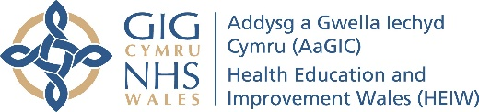
Step-by-step guide to the Digital Capabilities Self-evaluation:
Step 1: Sign up for an account on Y Ty Dysgu, the NHS Wales Learning Platform - https://ytydysgu.heiw.wales/
- This includes personal and professional details as it does not yet link to ESR, but you only do this once.
- You then need to wait up to 24hours for your access to be granted for the first time, then you can login.
Step 2: Select “Digital Capability Framework” and then “Enrol on this Course”.
Within this course, there are 3 sections:
- The Welcome takes you through the Framework, the Self-evaluation and Results (see images below).
- The Self-evaluation takes approximately 20-30minutes to complete. Once complete and you have clicked “Submit evaluation”, you will have access to the Results:
  - An overview of your answers and a ‘spider’ visualisation
  - A downloadable report for your PADR or CPD record
  - Suggested online resources to support any areas of need
- Then go back to the course, click that you have completed the self-evaluation, and move onto the final part: two pages on Additional Resources. You can then submit that the course is 100% complete.
Step 3: You have finished. You can go back to the downloadable report or the online resources at any time.
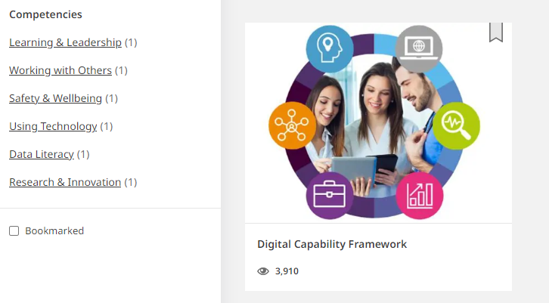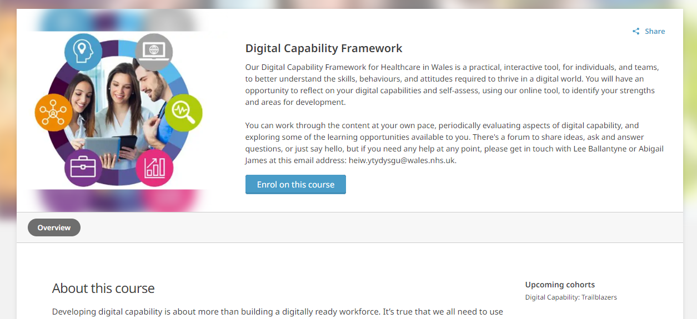
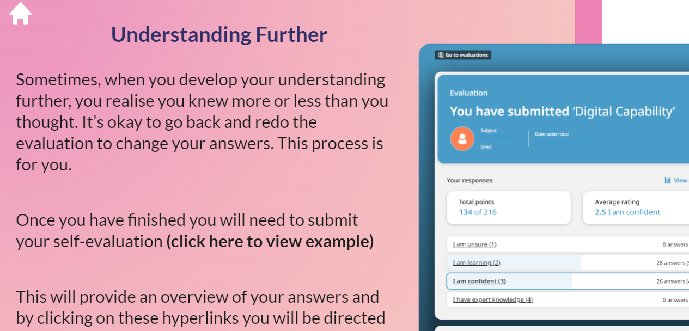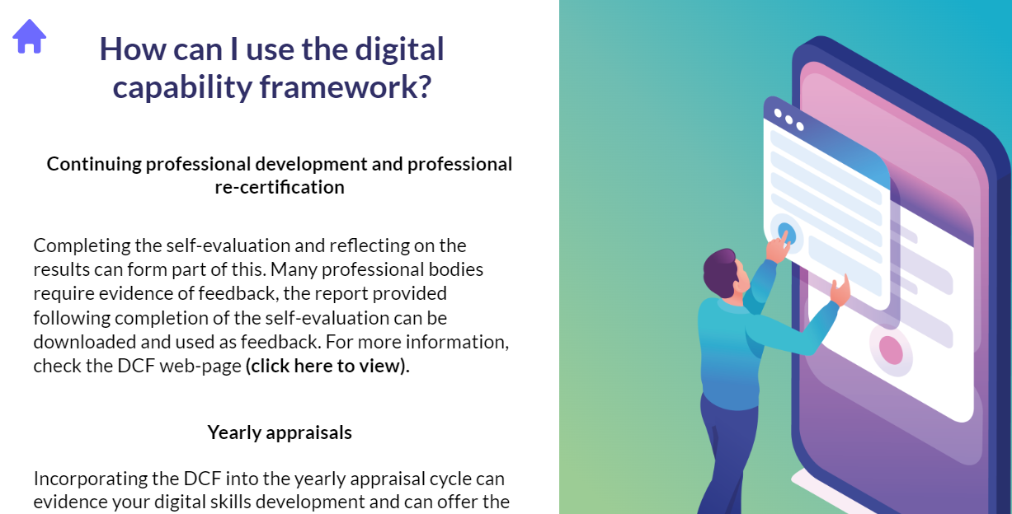
Why complete the Digital Capabilities Self-evaluation?
- Your own learning – You may wish to improve your digital capability, such as better managing your email workload, or understanding and presenting data, or finding new evidence to answer queries.
- Your PADR – You can share the report with your manager for any development needs.
- Your CPD and professional registration – Registration bodies now include requirement to meet digital capability standards, including HCPC and Academy for Healthcare Science. The report and learning resources can be used for your CPD and equivalence portfolios.
- Your service – By better understanding digital capabilities levels, services can support you to use these skills effectively or to support development where needed.
- Your organisation – Similarly, all health boards and trusts in Wales are keen to understand digital capability expertise and put appropriate training in place.
- Your profession – The anonymous results are tallied together by profession as part of HEIW and DHCW’s work to understand the skills across all professions in Wales. We will review the Healthcare Science anonymous results nationally and will share new resources out to all services.

