

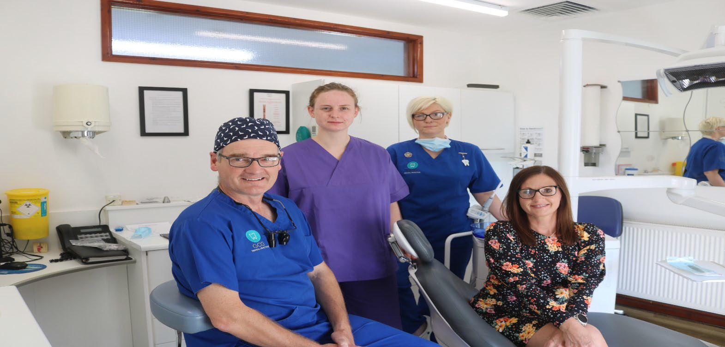
Dental Professional
Personal Development Plan (PDP) Portfolio 2022
GWAUN CAE GURWEN DENTAL PRACTICE

NAME

FIELD OF PRACTICE GDC NO
PDP CREATED ON PDP REVIEWED ON
GDC CPD FIVE YEAR CYCLE

Contents

- Background to the GDC Enhanced CPD scheme and PDPs

- The requirement to have a PDP

- The Development Outcomes

- The requirement to align CPD activity with specific Development Outcomes

- Field of practice and your PDP

- The requirement for professionals to plan CPD activity
according to their individual “field(s) of practice”

- CPD Hours

- Reflection

- PDP and CPD Activity Log

- Quality Improvement Educators

- Further information and help

Background GDC Enhanced
CPD scheme (ECPD) and Personal Development Plans (PDPs)

The General Dental Council (GDC)’s Enhanced CPD scheme commenced for dentists in January 2018 and DCPs in August 2018.

The main requirements to the scheme are:
- The requirement for all dental professionals to have a Personal Development Plan.
- A number of verifiable hours and the requirement to spread the hours more evenly across the five-year cycle.
- The requirement to make an annual declaration of CPD hours completed, even if zero hours have been completed for that year.
- The requirement to align CPD activity with specific GDC Development Outcomes
- The requirement for professionals to plan CPD activity according to their individual “field(s) of practice”
Since 2018 it has been a requirement for all dental professionals to keep a PDP. This portfolio provides some background and a framework for the PDP, which we hope will be helpful for you to utilise in order to plan, review and keep a record of all your continuing professional development (CPD) in the future.

More information can be found on the GDC website at: -

General Dental Council (United Kingdom). CPD for dental professionals. https://www.gdc-uk.org/ education-cpd/cpd/enhanced-cpd-scheme-2018

Health Education and Improvement Wales. Dental Professional Personal Development Plan. https:// heiw.nhs.wales/files/dental-personal- development- planning/pdp-portfolio-digital/

The requirement for all
dental professionals to have a Personal Development Plan

You do not have to create your PDP on your own. You could work with a colleague, your employer or mentor, or a tutor to help you with planning and recording your activity.

For the GDC, your PDP must include:
- The CPD you plan to undertake during your cycle, which must include CPD that is relevant to your current or intended field(s) of practice.
- The CPD activity that you plan to do that will address your identified learning needs, and the Development Outcomes that will link to each activity.
- The timeframes in which you expect to complete your CPD over your cycle.

A PDP is designed for you to carefully consider your role as a dental professional, and which CPD will give you maximum benefit for maintaining and developing your practice in your current and future areas of work.

We encourage you to regularly review your plan as it relates to your role and field of practice. It is a record of your continuing professional development for use throughout your career. Many methods are available for development and training. You will find as you progress those different methods will suit different circumstances and situations. Key to this is finding the method of staying up to date that most benefits your patients, you and the rest of the team that you work with.
Making sure your knowledge and competence is up to date is at the centre of being a dental professional.

Remember that any PDP and its content is for your personal use. The PDP will assure the GDC that your CPD activity supports your practice as a dental professional. The actual educational contents of the PDP will not be evaluated by the GDC. The GDC will, however, ask every dental professional to make an annual statement declaring that you hold and maintain a PDP. The GDC can randomly select professionals to check their records at any time during the CPD cycle.

The Development Outcomes of the ECPD for the PDP

This is a central aspect in the way in which you will plan your future CPD.

The Standards for the Dental Team sets out the ethical principles of dental practice. In the enhanced CPD scheme, the standards are brought to the forefront of CPD planning and activity through the four Development Outcomes. These development outcomes encourage
professionals to link their learning activity more closely to the standards and support them to embed the principles further in their working life.
The CPD rules state that professionals must link each of their planned and completed activities to at least one development outcome.
When you attend a course or educational event the provider should inform you of the intended learning outcomes and link the indicative development outcome(s) to each CPD activity they offer.
Below are the development outcomes and some examples of what kinds of CPD might be linked to each (NB – These examples are advisory only and not exhaustive). It is possible for some CPD activities to link to multiple outcomes.

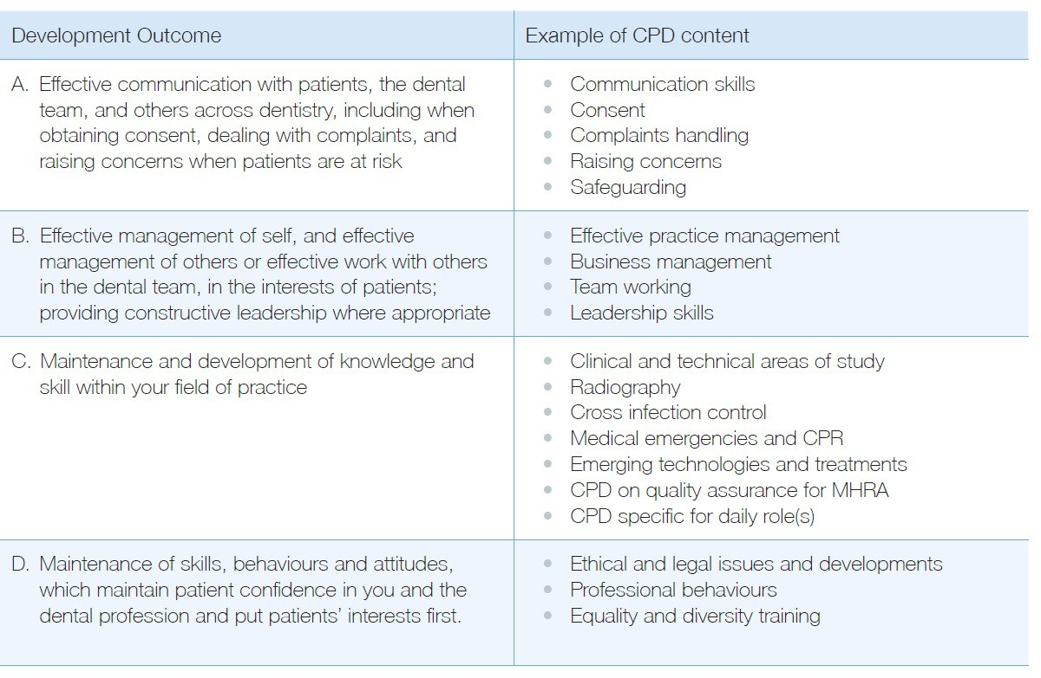

The requirement to align CPD activity
with specific Development Outcomes

Everyone’s learning style is individual however you should try and use a variety of methods and make the most of opportunities to interact with your fellow professionals.

Remember to map each of your planned learning activities to one of four Development Outcomes. You can map them to more than one outcome, however the links must be clear. You can include a variety of activities to support your continuing development.

The activities might include:
- Courses and lectures
- Training days or workshops
- Hands-on courses
- Conferences
- E-learning activities
- Audits

Field of practice and your PDP

These are based on the area practiced by a dental professional (also known as field of practice).

Below is a template that the GDC have provided to
enable all dental professionals to think clearly about their individual learning and developmental needs.
Examples of these can be found here.

My field of practice – notes to assist
The template consists of two aspects:
- The first is concerned with your field of practice – it encourages you to think about what your role is as a dental registrant; what type of practice or other workplace environment that you occupy; whether you have any additional roles as a dental professional; and most importantly to think about your patient population and consider their needs.
- The second aspect builds on this and helps you plan your CPD activities in a meaningful, practical way which will reflect and represent YOUR field of practice whilst making sure they relate to the four learning outcomes detailed on page 4.

My registrant category(s) and cycle period | My work setting(s) | Any additional roles, qualifications, or professional interests: | My patient population
List each category you are registered under, your cycle period and total hours needed | What is your place(s) of work and its environment? Different settings may require you to undertake certain roles and skills | Do you have additional roles, qualifications, specialties, or areas of focus/interest? Do any of these need continual learning or maintenance? | What are the oral health and management needs of patients in your care? Does this change across your work settings?

My personal development plan – notes to assist - a final PDP is available for your use on page 11.

What do I need to learn  or maintain for this cycle? | How does this relate to my field of practice? | Which development outcome does it link to?
What skills or knowledge have you identified that need developing or maintaining? Are there any gaps that need  addressing? | Why have you identified this, how does it relate to your daily job, patients, or tasks? | A, B,C or D (see development outcomes table above)
What benefit will this have to my work? | How will I meet this learning or maintenance need? | When will I complete the activity?
How will CPD activity in this area help you to maintain or improve your daily work and/or care for patients? | What activities could you do to help meet your learning and maintenance needs? | What are your target dates for review and completion?

The requirement for professionals to plan CPD activity according to
their individual field(s) of practice

Think carefully about what role you have, what is required of you to perform the duties associated with the role, where you may have a ‘special interest’ in something that requires you to keep up to date with current recommendations and finally, WHAT is needed to provide optimum dental care for your patient population.

These are highly recommended to do as part of the minimum verifiable CPD requirement:
- Medical Emergencies: at least 10 hours in every CPD cycle – recommend that you do at least two hours of CPD in this every year.
- Infection, Prevention and Control: recommend that you do at least five hours in every CPD cycle; and
- Radiography and radiation protection: recommend that you do at least five hours in every CPD cycle. This applies only to those who undertake radiography. If you are a dental technician, you can do CPD in materials and equipment instead of radiography and radiation protection: at least
five hours in every CPD cycle.

The GDC no longer has ‘core’ topics. As stated previously, the emphasis is on YOU, YOUR requirements, and YOUR field of practice.
Remember to stay focused on obtaining the knowledge skills and competencies you feel are required, to deliver optimum patient care in a safe manner.
To help and support you in your CPD choices, the GDC has identified some CPD topics that will relate to many dental professionals in their field
of practice.

The GDC makes these recommendations because they believe regularly keeping up to date in these topics contributes to patient safety.
The GDC also recommends that you keep up to date by doing CPD in the following areas:
- Legal and ethical issues.
- Complaint’s handling.
- Oral Cancer: Early detection.
- Safeguarding children and young people; and
- Safeguarding vulnerable adults.

CPD Hours

You are required to make an annual declaration of CPD hours completed, even if zero hours have been completed for that year.

An increase in the number of verifiable hours and the requirement to spread the hours more evenly across the five- year cycle.
The GDC will ask you to make a CPD statement every year as part of your routine annual registration renewal. Even if you have not carried out any CPD you MUST make this statement. In this statement you will need to confirm the number of hours that you
have undertaken, that you have kept a record of your CPD and that the CPD is relevant to your field of practice.
You cannot submit zero hours for two consecutive years.

Current hours for the Enhanced CPD scheme:
Registrant title | Minimum hours of verifiable CPD per five-year cycle
Dentists | 100
Dental therapists | 75
Dental hygienists | 75
Orthodontic therapists | 75
Clinical dental technicians | 75
Dental nurses | 50
Dental technicians | 50

Reflection

Reflection allows us as dental professionals to think about the outcome of a CPD activity.
Often it is not WHAT we learn, but HOW we reflect on the knowledge and skills that is the most useful aspect of activity.

The GDC are not prescriptive with how dental professionals record their reflection, however you must make sure that you record somewhere in your CPD/PDP that reflection has taken place.
You may wish to reflect after every activity, or at intervals during the year. As stated earlier you may find it helpful to reflect with your employer, or a peer or mentor.

Sample of Reflection
Maximising your educational experiences
Now you are carrying out continuous professional development on a regular basis you will want to make the most of your learning opportunities.
Before you decide to attend a course, or an educational event you need to question the relevance to you of the subject being covered.
To help keep you focused you should ask yourself if attending the course will change the way you think or carry out your role in the practice.
The purpose of education in the dental profession is to bring about changes and improvements in the way we care for our patients and work as part of the team.
Taking time to think about aspects of our role that may make us feel uneasy can be turned into educational needs.
After attending an event you will want to consider the experience to assess the value of what you have learnt. This is sometimes called reflection.
What is reflection?
Reflection is a type of thinking. It is associated with deep thought aimed at better understanding what we do and why we do it.
Experience can be the basis for learning and development. However just because we have been through an experience does not mean we have learnt all there is to know about it - or even that we have learnt anything at all.
In your individual role you can use the guide below to make sure that you apply any new knowledge you have gained - whether on a course or from an experience in your own practice - and apply it to make changes to the way you work.
What happened – what was I doing, what were others doing?
Here identify the experience and describe the detail.
So what – what more do I need to know and understand/could have done differently?
Here analyse and interpret.
Now what – what more do I need to do to make things better, what will be the consequences of my actions?
Here explore the alternatives and plan the action.

9.
YOUR PDP
ǀ 11
Personal Development Plan (PDP) Portfolio 2022

PDP CREATED AT START OF
CYCLE: DATE OF REVIEW:

Learning or maintenance need | How does this relate to my field of practice? | Which development outcome does it link to? | What benefit will this have to my work? | How will I meet this learning or maintenance need? | When will I complete the activity?

Learning or maintenance need | How does this relate to my field of practice? | Which GDC development outcome(s) does it link to? (A, B,C,D) | What benefit will this have to my work? | How will I meet this learning or maintenance need and by when? | How have I met this learning or development need?
YOUR PDP continued
12 ǀ
Personal Development Plan (PDP) Portfolio 2022

CPD ACTIVITY LOG
ǀ 13
Personal Development Plan (PDP) Portfolio 2022

LOG OF CPD ASSOCIATED WITH PDP

CPD | Date of Activity | Number of Hours of Activity | Evidence of Completion | Mapped Against GDC Learning  Outcome | Reflection on Activity

CPD | Date of Activity | Number of Hours of Activity | Evidence of Completion | Mapped Against GDC Learning Outcome | Reflection on Activity
CPD ACTIVITY LOG continued
14 ǀ
Personal Development Plan (PDP) Portfolio 2022

10. Quality Improvement Educators

Sue Stokes

The HEIW Dental Postgraduate Department employs a group of highly skilled, experienced, and local QI Educators to provide assistance and advice to Dental Practice Teams. This support includes giving guidance on ECPD and PDPs and facilitating practice sessions that look at utilising the various Quality Improvement tools that the department has to offer. Please see overleaf for details of how to book an appointment with your local QI Educator.
Cwm Taf UHB/ Aneurin Bevan UHB Sue.stokes2@wales.nhs.uk

Jane Norgate Cardiff & Vale UHB
Jane.norgate2@wales.nhs.uk

Ewart Johnstone Swansea Vale UHB
Ewart.johnstone2@wales.nhs.uk

Anne Walker
Hywel Dda/ Betsi Cadwaladr UHB Anne.walker2@wales.nhs.uk

Tracey Taylor
Betsi Cadwaladr UHB Tracey.taylor2@wales.nhs.uk

John Parkinson Powys THB
John.parkinson@wales.nhs.uk

Katherine Mills
Betsi Cadwaladr UHB Katherine.mills2@wales.nhs.uk

General Enquiries HEIW.DentalQI@wales.nhs.uk

Personal Development Plan (PDP) Portfolio 2022 ǀ

- Further Information and help

If your practice or workplace environment would like to have a facilitated session with a QI Tutor, please contact us.

Where do we access further information on help with this PDP or any other aspect of practice development?
The sessions will normally take about an hour, which will count as verifiable CPD.
Please see below for details of who to contact regarding arranging a tutor visit or for further information on any other of HEIW’s QI tools.

- Quality Improvement Projects  - National Audits  - Ionising Radiation checklist  - Wrong tooth extraction  - checklist  - All other QI queries | - Arranging an MMD visit  - Arranging a PDP visit  - Arranging a SOSET visit
For more information on any of the above please contact HEIW.DentalQI@wales.nhs.uk

Useful links
The Dental Postgraduate Department:
https://heiw.nhs.wales/

16 ǀ Personal Development Plan (PDP) Portfolio 2022

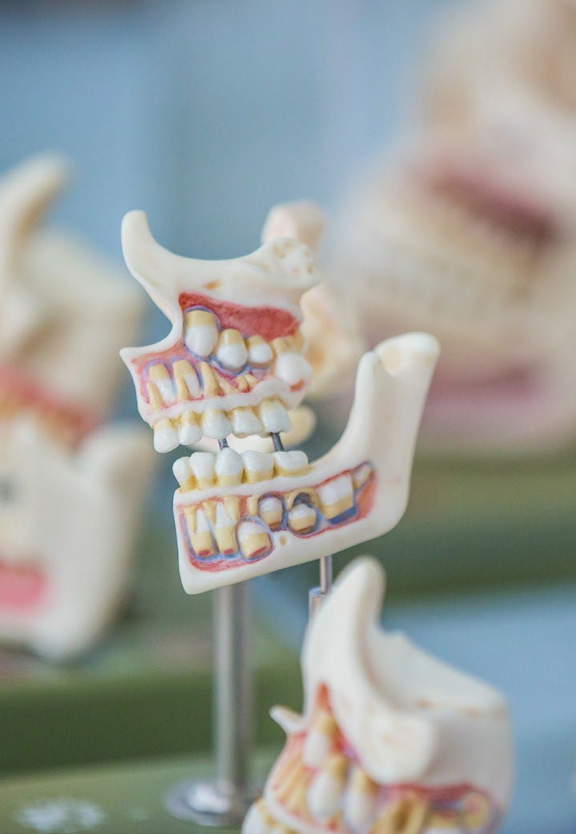

Personal Development Plan (PDP) Portfolio 2022

