February 2022

Dear Colleague,

RE: An Audit of Antimicrobial Prescribing for Dentists working in Primary Care in Wales

Professional bodies agree that all prescribers need to improve antimicrobial prescribing. It is essential that the use of such drugs is evidence–based, and that each prescription must be for the most appropriate drug, at the right dose and for the correct duration.

The Dental Section of HEIW (formerly Wales Deanery), Dental Public Health Team and Improvement Cymru developed the original antimicrobial prescribing audit for dentists in Wales. HEIW has recently reviewed and updated it.

The aims of this audit remain to:
- Support the most effective clinical use of antimicrobials
- Reduce the number of unnecessary and inappropriate prescriptions.

Funding is available for each General Dental Practitioner who holds an NHS Contract and Performer Number and one DCP to assist. You can only claim for this audit once every three years but are welcome to carry it out more regularly as a best practice exercise.

Dental Foundation Dentists, Community Dentists, Private Dentists with no NHS contract and Dental Care Professionals are encouraged to take part in the audit. All participants who are registered with the GDC are eligible to receive 3 hours verifiable CPD. The audit maps to GDC Development Outcome C. The named DCP who registers to collate data is entitled to 1 additional hour of verifiable CPD which maps to Development Outcome B, plus one hour of funding.

We hope you find the audit a constructive way to learn and to ensure your antimicrobial prescribing is as effective as possible.

Yours sincerely,
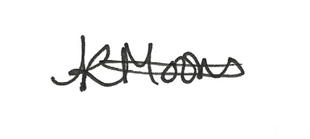

Kirstie Moons
Dental Postgraduate Education in Wales
An audit of Antimicrobial Prescribing for Dentists working in General Practice

This audit has been developed to support effective antimicrobial prescribing by dentists in Wales.

It is widely accepted that Dentists are responsible for almost 10% of all antimicrobial prescribing in Wales. With professional bodies agreeing that all prescribers need to improve antimicrobial prescribing, it is essential that the use of such drugs is evidence–based and that each prescription must be for the most appropriate drug, at the right dose for the correct duration.

It is now accepted that the inappropriate and unnecessary use of antimicrobials in the past is responsible for the present emergence of drug resistant strains of micro-organisms, such as MRSA, both within individuals and within populations. More recently and importantly, it has been demonstrated that improved prescribing habits by individual practitioners can lead to a reduction of antimicrobial resistance within the population.

More information on this can be found at https://bda.org/news-centre/blog/Pages/UK-unveils-plan-to-tackle-antimicrobial-resistance-but-where-do-dentists-fit-in.aspx

The aims of this audit are –
To support the most effective clinical use of antimicrobials, and
To reduce the number of unnecessary and inappropriate prescriptions.

Completing this audit also contributes to the delivery of Prosperity for All. Prosperity for All is the Welsh Government’s national strategy to build a Wales that is healthy and active, prosperous and secure, ambitious and learning, and united and connected.
http://gov.wales/about/programme-for-government/?lang=en

Step 1 - Register your audit using form AMP 1 which is included in this information pack

It is recommended that all dentists in the practice partake in the audit and start/finish at the same time.

To undertake this audit, you need to register by sending your AMP 1 form to HEIW.dentalQI@wales.nhs.uk Each participant must complete the audit fully to qualify for verifiable CPD (3 hours for dentist, 1 hour for DCP) and associated funding for dentists with an NHS performer number, and their DCP.

At registration you will be allocated a unique identifier number so that you can receive prescribing data feedback.
Step 2

Dentists are able to prescribe a wide range of antimicrobials within the NHS, as listed in the BNF. However a Clinical Guide - specially developed for Dentists - is available to support safer and more effective prescribing. Please see the Scottish Dental Clinical Effectiveness Programme (2016) Drug Prescribing For Dentistry: Dental Clinical Guidance. 3rd Ed http://www.sdcep.org.uk/published-guidance/drug-prescribing and associated information.

Dentists in Wales can access and use this Clinical Guidance.

Step 3
Data collection
Data is collected in hard copy on form AMP 2a and your DCP assistant collates this data from each participant into a single template form AMP 2b.
Complete a hard copy AMP 2a form for every patient for whom you prescribe antimicrobial medication(s).
You may prescribe for the patient’s presenting condition, or for an incidental finding.
Each patient counts as one form, regardless of how many medications have been prescribed at that visit.

This audit requires each dentist participant to complete 20 forms or collect data for a period of 3 months from registering the audit – whichever is first.

A printable form AMP 2a is attached. Print a maximum of 20 forms per participant.

These can be used at any practice a participant works in. Each participant should be able to identify their own forms. The group’s nominated DCP will collate data from all forms anonymously but each participant should have their own forms returned before they come to reflect on their prescribing.

Forms have space for a unique patient identifier. Participants can use any suitable identifier that allows them to check back against the patient’s notes, including the patient’s name: these forms remain with participants and are not shared with anyone except the nominated DCP for data collection.

The nominated DCP collates participants data and submits the completed template form AMP2b to the group , and to HEIW for feedback. An example of completed template form is attached to aid collation of the data.

Individual dentist prescribing data will remain strictly confidential and the findings kept by the group and HEIW only as collated anonymised figures. The data on the AMP 2b form does not include any individual patient data or identifier nor any dentist identifier from AMP 2a.

- This audit does not distinguish between tablets, capsules, oral solutions, oral suspensions etc. You will not be asked for this information
- This audit mostly uses generic names – it does not include all brand names. If you have prescribed a brand name please record under the generic name.
- This audit does not ask for the patient’s age, just whether they are over or under 13. It includes the full range of medication doses and can be used for patients of all ages – including children.
- This audit does not include mouthwashes (such as chlorhexidene) which may be prescribed alone or in addition to other medication.

Step 4: As a group, discuss the collated data form AMP2b

These case scenarios are completed individually AMP3a and returned to HEIW.

The final collated data on form AMP 2b and completed scenarios AMP3a are sent to HEIW, where they will be reviewed by a Dental Educator and the group will receive feedback on prescribing activity. Educator feedback will use a standard template (AMP3b) and will be provided* only once both AMP2b and AMP3a have been received from the group.

*HEIWs target turn-around time for this feedback from the Educator is usually 4 weeks

Step 5: Consider the feedback form AMP3b as a group and individually

DCPs and the practice team can contribute to safe and effective use of antimicrobials:
- Discuss the audit at team meetings, particularly the importance of only using antimicrobials when required, to reduce the likelihood of antibiotic resistance
- Ensure DCPs are aware of any alerts or safety notices about drug interactions, e.g. warfarin and miconazole
- Discuss with DCPs and reception staff the importance of allowing sufficient appointment time for new patients with urgent and emergency problems so that a proper medical and drug history can be taken.
- Encourage DCPs to reinforce the dentists’ advice on the following:
  - The importance of taking medication as directed, including how many days to take it for (see SDCEP guidance)
  - What patients should do in the event of suspected hypersensitivity (allergic) reaction
- Ensure DCPs are able to record any patient hypersensitivities as appropriate
  - Consider a DCP led audit to ensure that all patient records include history of hypersensitivities to medication / antimicrobials – and that allergies are clearly “flagged”.

Step 6
On receipt of AMP3b feedback you must reflect on your prescribing activity – individually and collaboratively with group members. Your hard copy data will support this stage.

Some points to consider –
Is your prescribing in line with the Clinical Guides?
Were your diagnoses clear, and were antimicrobials really necessary?
Were other appropriate interventions carried out?
If antimicrobials were necessary, was the correct drug prescribed at the right dose and duration?
Do you need to make changes to your antimicrobial prescribing?

Your reflection on your prescribing activity and completing the audit should be included on your audit certificate in the reflection section.

It is recommended that the forms are submitted no later than 6 months from the audit completion date. Payment will be processed when all dentists and the DCP in the group have submitted their forms AMP3a and AMP4 claim form..

Re-audit

Re-audit your prescribing 6 to 9 months after completion of first audit cycle to ensure you have embedded the identified changes into your prescribing practice.

Need Help?

If you require help with any aspects of this audit, contact HEIW.dentalQI@wales.nhs.uk who will direct you to an appropriate QI Dental Educator if necessary.

Drug Prescribing for Dentistry – Dental Clinical Guidance

SDCEP (Scottish Dental Clinical Effectiveness Programme) have compiled a useful guide to drug prescribing for dentistry. Please visit http://www.sdcep.org.uk/published-guidance/drug-prescribing/ to download a copy of this guidance and other useful documents including June 2021 update and prescribing cautions/contraindications information. THE BNF/BNFC app is also a useful source of information https://www.bnf.org/products/bnfbnfcapp

SDCEP Bacterial Infections Management flowchart

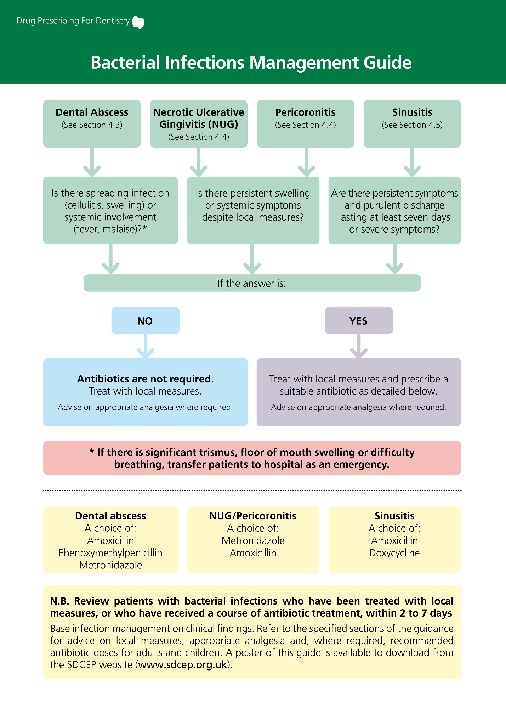
Add amp1 application form here, including new area for DCP to be named.

OR attach the form separately.

