
Mental Health Workforce Technical Document
January 2022

Contents
1. Data Specifications 3
1.1. Data used in Health Analysis 3
1.2. Data used in Social Care Analysis 3
1.3. Definitions 4
2. Summary of the Mental Health Workforce 6
2.1. Mental Health Workforce 6
2.2. Medical Mental Health Workforce 6
2.3. Nursing Mental Health Workforce 7
2.4. HCSWs in Mental Health 8
2.5. Average Workforce Retirement Age 8
2.6. Ethnicity Profile of the Workforce 9
3. Medical Mental Health Workforce 10
3.1. Percentage Change of the Medical and Dental Workforce 10
3.2. Participation Rates and Age Band 11
3.3. Medical Mental Health Age Band Profile 11
3.4. Medical Starters and Leavers 12
3.5. Medical Mental Health Age Retirement 14
3.6. Medical Mental Health Consultant Workforce by Specialty 14
3.7. Medical Mental Health Modelling by Specialty 15
3.8. Psychiatry Medical Modelling 16
3.9. General Psychiatry Modelling 16
3.10. Old Age Psychiatry Modelling 17
3.11. Child and Adolescent Psychiatry 17
Graph 16 Forecasted Change in FTE for Child and Adolescent 18
3.12. Psychiatry Medical Modelling Including Physician Associates 18
3.13. Medical Mental Health SAS Workforce by Specialty 18
3.14. Medical Mental Health Training Grade Workforce by Specialty 19
4. Nursing Mental Health Worforce 21
4.1. Percentage Change of Nursing and Midwifery Workforce 21
4.2. Participation Rate and Age Band 22
4.3. Nursing Mental Health Age Band Profile 22
4.4. Nursing Starters and Leavers 23
4.5. Nursing Mental Health Workforce Retirement 24
4.6. Nursing Mental Health Workforce by Hospital and Community Setting 25
4.7. Nursing Mental Health Workforce Pay Bands 26
4.8. Nursing Mental Health Modelling 27
5. HCSWs in Mental Health Workforce 28
5.1. Percentage Change of HCSW in Nursing and Midwifery Workforce 28
5.2. Participation Rate and Age Band 28
5.3. HCSW in Mental Health Age Band Profile 29
5.4. HCSWs in Mental Health, Starters and Leavers 31
5.5. HCSW Age Retirement 31
5.6. HCSWs in the Mental Health Workforce by Pay Bands 32
6. NHS Wales Psychology Workforce 33
6.1. Percentage Change of the Psychology Workforce 33
6.2. Age Band Profile Psychology Workforce 34
7. Social Care Mental Health Workforce 36
7.1. Introduction 36
7.2. Mental Health Social Care Workforce 36
7.3. Social Workers Workforce 37
7.4. Social Care Support Worker Workforce 38
7.5. Employment Status & Vacancy Rates for Social Care Support Workers working in Local Authority Social Work teams. 40
7.6. Social Care key messages 40

Mental Health Workforce

Data Specifications
This report contains information from various sources and describes what the profile of the Health and Social care Mental Health workforce looks like, where possible

Data used in Health Analysis
Based on the information available in the Data Warehouse (DW) we are able to identify the following groups of staff working within Mental Health. Data for this analysis has been extracted based on national occupational codes used to identify the workforce. The data included in these reports covers the period March 2015 – March 2021, except where stated otherwise. For the purpose of analysis, data for September each year (2015 – 2020) has also been included.

Medical Workforce
Medical Mental Health covers all MH specialties (listed below) and all grades including Consultant, SAS and Training Grades.
- General Psychiatry
- Old Age Psychiatry
- Child and Adolescent Psychiatry
- Forensic Psychiatry
- Medical Psychotherapy

Registered Nursing (Nursing)
- Community based
- Hospital based

Support to Nursing Mental Health
For individuals who provide support to nursing the national job roles of Health Care Support Worker & Health Care Assistant has been used.

Applied Psychology and Psychological Therapies – This staff group has been identified within ESR. These workers work across the spectrum of services and is not specific to those staff that work in mental health services. is unable to identify those working in a Mental Health setting specifically. However, the data is applicable to the mental health workforce and whilst there may be small variations within this cohort of staff compared to the general workforce, they will be minimal.

Allied Health Professionals - For this group of staff we were unable to identify from ESR those staff working specifically within Mental Health Services or those staff who worked a proportion of their time within this service. We have however received information from some of the professional bodies regarding their workforce which is detailed below.

Primary Care Workforce – For this group of staff we were unable to identify from ESR and the Wales National Workforce and Reporting System those staff working specifically within Mental Health Services or those staff who worked a proportion of their time within this service.

Data used in Social Care Analysis
The data used to describe the Social Care workforce was drawn from three sources.
      - A request sent to Local Authorities in December 2020 requesting specific data that included numbers of staff, types of staff and the specific teams that they were working to which 73% of Local Authorities responded to.

      - Social Care workforce registration data collected by Social Care Wales. The registration data that has been used to inform this report is based on social care workers who work across the spectrum of services that Local Authorities provide and is not specific to those staff that work in mental health services. However, the data is applicable to the mental health workforce and whilst there may be small variations within this cohort of staff compared to the general social care workforce, they will be minimal.

      - The Social Care Wales Workforce Development Programme capture, collected between April & August 2021 which represents all services that Local Authorities provide. The data is relevant to all of the Social Work workforce rather than mental health specific but can be applied to the mental health Social Work workforce with minimal variation. This data set also includes Social Care Support Workers working in Social Work teams.

Definitions
Participation Rate: The participation rate is a measure of impact of part-time working on the availability of the organisation’s workforce. The higher the participation rate the more hours on average, an individual will work each week.

SAS Doctors: have been split into 3 grades, Associate Specialist, Specialty Doctor, Staff Grade.

Training Grades: Training Grades include Doctors who are in training with the Deanery and Doctors who are not in training but who hold a training grade position.

Starters
When an individual is appointed to a post in NHS Wales on either a permanent or fixed term contract between two period of time, and they were not employed at the start of the period within any NHS Wales organisation on a permanent or fixed term contract, they are classed as a starter.

For example:
An employee identified as having a permanent or fixed term contract in March 2019 but not in March 2018 will be classed as a new starter between the period April 2018 and March 2019. (Apr18-Mar19)

If an individual is employed on a Bank contract by one of the NHS Wales organisations and they take up a permanent or fixed term contract within any NHS Wales organisation, including the one they are already employed at, they would also be classed as a starter.
Please note – Individuals who start on a permanent or fixed term contract with one NHS organisation after leaving a permanent or fixed term contract with another NHS Wales organisation without having a break in service will not be classed as a starter – this is defined as Organisational ‘Churn’. Churn is included separately in the report.

Leavers
When an individual leaves a permanent or fixed term contract between two periods of time and they do not appear as an employee with a permanent or fixed term contract at the end of the period, either within the same organisation or within a different NHS Wales organisation, they are classed as a leaver.

For example:

An employee identified as having a permanent or fixed term contract in March 2018 but not in March 2019 will be classed as a leaver between the period April 2018 and March 2019. (Apr18-Mar19)

If an individual leaves a permanent or fixed term contract during the month and they retain or take up a Bank Contract, they will be classed as a leaver.

Please Note – individuals who leave a permanent or fixed term contract with one NHS Wales organisation and take up a permanent or fixed term contract with another NHS Wales organisation without having a break in service will not be classed as a leaver – this is defined as Organisational ‘Churn’. Churn is included separately in this report.

Retirees
The analysis of retirements is based on staff with their reason for leaving recorded within ESR as one of the following:
- Flexi Retirement
- Retirement - Ill Health
- Retirement Age
- Voluntary Early Retirement - no Actuarial Reduction
- Voluntary Early Retirement - with Actuarial Reduction

Summary of the Mental Health Workforce

Mental Health Workforce
The following graph shows the percentage change in the full time equivalent (FTE) from March 2015 to March 2021 for the total Mental Health workforce i.e. Medical, Nursing and HCSWs. The percentage change for each period is calculated against the FTE figure for March 2015.

Graph 1 Percentage Change in FTE from March 15 to March 21 – Mental Health Workforce
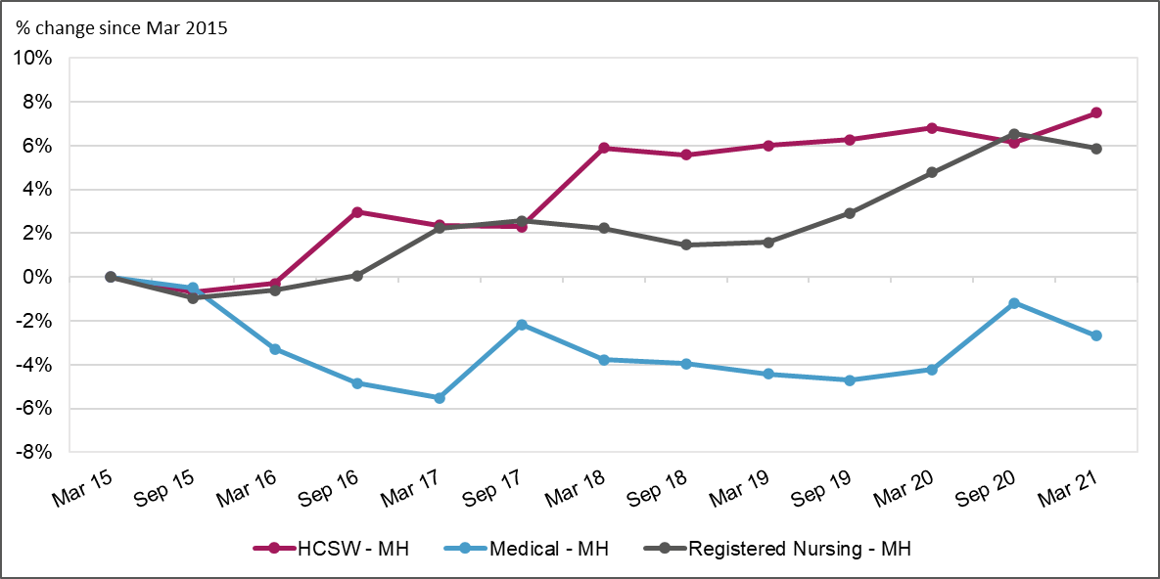
Data Source: ESR DW

Nurses and HCSW staff have seen an overall growth in their workforce between the periods March 2015 and March 2021 of 179FTE and 135FTE respectively. The Medical Mental Health workforce has seen an overall reduction of 12FTE between March 2015 and March 2021 which equates to a 2.7% reduction. (See Appendix 1.1 & 1.2)

Medical Mental Health Workforce
The graph below shows the total contracted FTE and percentage change from period to period of the Medical Mental Health workforce as described in section 1.

Graph 2 Contracted FTE March 15 – March 21 – Medical - MH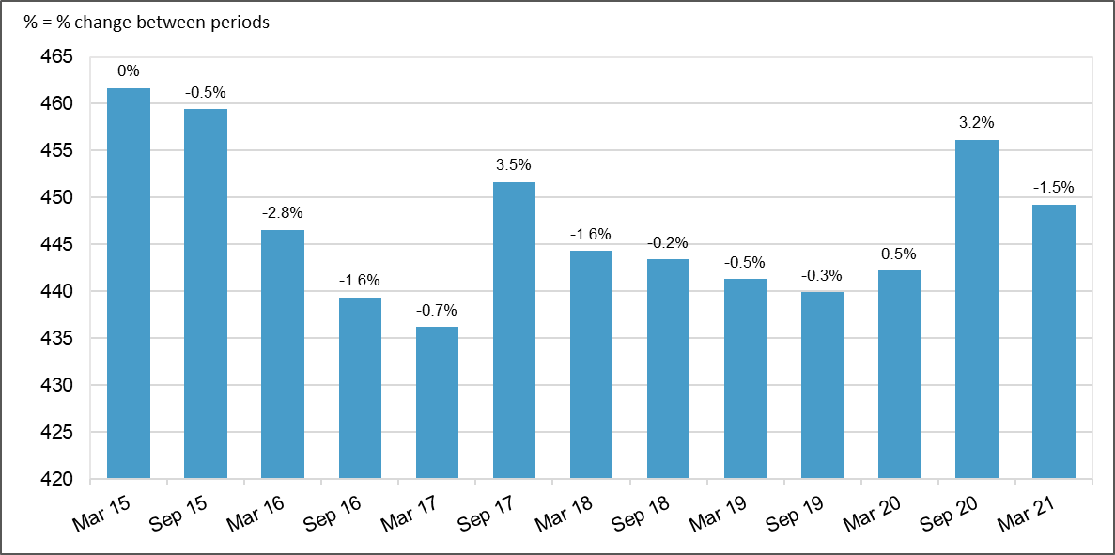
Data Source: ESR DW

Between March 2015 and March 2017 the workforce reduced by 25FTE which equates to a 6% reduction. The workforce increased in September 2017 by 3.5% and then declined again between March 2018 and September 2019. Following this decrease the workforce started to grow again from March 2020 and by September 2020 had increased by 3.7% which equates to 16FTE.

Nursing Mental Health Workforce
The graph below shows the total contracted FTE and the percentage change from period to period for the Nursing workforce as described in section 1.

Graph 3 Contracted FTE March 15 – March 21 – Registered Nursing - MH
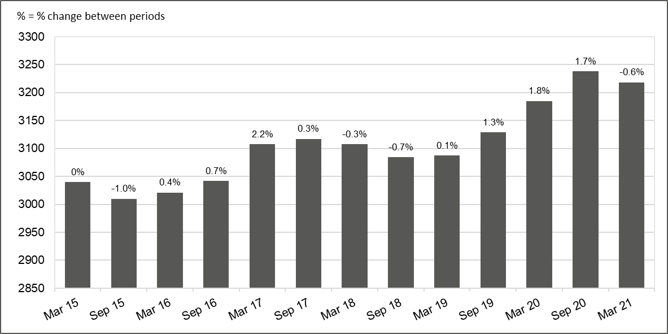
Data Source: ESR DW

Between March 2015 and March 2021, the Nursing Mental Health workforce has increased by 179 FTE. The graph shows that while there have been periods of growth and reduction the overall trend is one of growth.

HCSWs in Mental Health
The graph below shows the total contracted FTE and the percentage change from period to period of the HCSWs in the Mental Health workforce as described in section 1.

Graph 4 Contracted FTE March 15 – March 21 – HCSW - MH
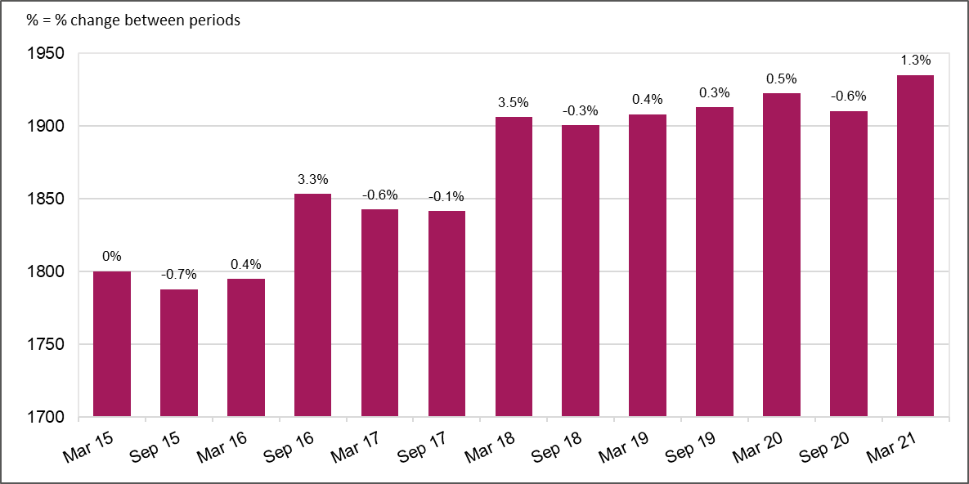
Data Source: ESR DW

Between March 2015 and March 2021, the HCSWs in the Mental Health workforce has increased by 135FTE. The graph shows that there was a significant increase in the workforce between September 2017 and March 2018 of 65FTE and from March 2018 onward the workforce has remained consistent.

Average Workforce Retirement Age
Staff Group | 2015-2016 | 2020-2021
Medical - NHS Wales | 61 | 61
Medical - MH | 60 | 57
Nursing and Midwifery- NHS Wales | 58 | 58
Nursing - MH | 57 | 57
HCSW - NHS Wales | 60 | 62
HCSW - MH | 60 | 61

On average the retirement age of the Mental Health workforce is generally slightly lower when compared against the NHS Workforce. The Medical Mental Health workforce which includes the Consultant and SAS grades retire earlier when compared to NHS Wales. For the reference period 2020-2021 the Medical Mental Health workforce retire four years earlier at age 57.

The Nursing Mental Health workforce have a slightly lower average retirement age compared to the Nursing and Midwifery workforce for NHS Wales which is 57 and 58 respectively, this has not changed between the two reference periods. The HCSW workforce have a higher average retirement age, although the retirement age for HCSWs in Mental Health is slightly lower than the retirement age compared to the HCSW workforce working across NHS Wales for the period 2020-2021.

Mental health officer (MHO) status is a benefit that was awarded to 1995 section of NHS Pension members working full or part-time in a hospital for patients suffering from mental disorders. Having MHO status allows you to retire at 55 years old without your pension being penalised. To qualify for and retain MHO status, it is necessary to spend substantially the whole of your time in the direct treatment or care of patients suffering from mental disorders.
From 1st April 1995 entry into this scheme has been closed to new members. The last retirees with MHO status being able to retire at 55 will be at 31/03/2029. If someone qualifying for MHO status started on 31/3/1995 and was 21 years old at the time, this would mean they would be 47 years old now.
In the Medical psychiatry workforce, early retirements can be attributed to Mental Health Officer (MHO) status and disincentives provided by pensions tax meaning that people leave early and/or reduce sessions earlier in their careers to avoid tax in the future. However, retirements due to MHO status should cease around 2025, which is the year the youngest qualifying doctor would reach 55.

Ethnicity Profile of the Workforce
The table below shows the ethnic profile of the Mental Health workforce for the 31st March 2021. Staff of Asian/black/mixed and other ethnic groups make up 39% of the General Psychiatry workforce and 44% and 34% respectively of the Old Age and Child and Adolescent Psychiatry workforce. In comparison for the Nursing and HCSW workforce the proportion of staff within the same ethnic groups equates to 5% for each staff group. However, it needs to be noted that there is a proportion of staff for each staff group who have not stated their ethnicity within the Electronic Staff Record.

 | General Psychiatry | Old Age Psychiatry | Child and Adolescent Psychiatry | Nursing Mental Health | Mental Health HCSW
White | 42% | 32% | 42% | 90% | 88%
Asian / Asian British | 28% | 34% | 20% | 1% | 2%
Unknown / Not Stated | 20% | 25% | 23% | 6% | 7%
Other Ethnic Groups | 6% | 4% | 6% | 1% | 1%
Black / African / Caribbean / Black British | 3% | 4% | 6% | 2% | 1%
Mixed / Multiple ethnic groups | 2% | 2% | 2% | 1% | 1%
NHS Wales | 100% | 100% | 100% | 100% | 100%

Vacancy Data
The tables below show vacancy data for the Mental Health workforce, as at 30th September 2021 which has been supplied directly by Organisations.

Vacancy Data Allied Health Professionals, HCSW and Nursing.

 | Total Vacancies (FTE)
AHPs working in Mental Health | 65.6
Physiotherapy | 5.6
Art/Drama/Music Therapists | 3.2
Occupational Therapists | 46.3
Other (Please state) | 9.1
SaLT | 1.5
HCSW working in Mental Health | 120.7
All Areas | 120.7
Registered Nurses working in Mental Health | 331.8
Community | 162.0
Hospital | 169.8
All Areas | 518.2

The information supplied so far shows that there is a total of 518.17 FTE vacancies across mental health services for Allied Health Professionals, HCSW and the Nursing workforce.

Vacancy Data Medical Workforce

 | Total Vacancies (FTE)
Child and Adolescent Psychiatry | 7.2
Consultant | 5.4
Other non-training grades | 1.8
General Psychiatry | 37.5
Consultant | 27.5
Other non-training grades | 10.0
Old Age Psychiatry | 21.0
Consultant | 10.0
Other non-training grades | 11.0
Grand Total | 65.7

For the Medical workforce, within Mental Health services there are a total of 65.7 FTE vacancies for the same period, the largest number of vacancies is within General Psychiatry.

Please Note. These figures will be updated once all submissions are received.

Agency Data
The tables below show agency data for the Mental Health workforce for the 12 month period up to 30th September 2021, which has been supplied directly by Organisations.

Agency Spend Allied Health Professional, HCSW and Nursing Workforce

 | Total Agency Spend (£)
AHPs working in Mental Health | £ 570,906
Physiotherapy | £ 130,265
Art/Drama/Music Therapists | £ -
Occupational Therapists | £ 310,492
Other (Please state) | £ -
SaLT | £ 130,148
HCSW working in Mental Health | £ 2,416,242
All Areas | £ 2,416,242
Registered Nurses working in Mental Health | £ 1,274,212
Community | £ 160,791
Hospital | £ 1,113,421
All Areas | £ 4,261,360

The total agency spend within Mental Health services stands at £4,261,360 for the 12 month period up to 30th September 2021. The biggest agency spend is within the HCSW workforce. Although the data is incomplete.

Agency Spend Medical Workforce

 | Total Agency Spend (£)
Child and Adolescent Psychiatry | £ 1,570,741
Consultant | £ 1,201,889
Other non-training grades | £ 368,851
General Psychiatry | £ 2,838,595
Consultant | £ 1,675,737
Other non-training grades | £ 1,162,858
Old Age Psychiatry | £ 1,349,732
Consultant | £ 849,681
Other non-training grades | £ 500,051
Grand Total | £ 5,759,067

For the Medical workforce, within Mental Health services the total spend on the agency workforce is £5,759,067 the biggest spend within General Psychiatry.

Please Note. These figures will be updated once all submissions are received.

Medical Mental Health Workforce
This section exclusively looks at the Medical Mental Health Workforce which consists of the following medical specialties:
- General Psychiatry
- Old Age Psychiatry
- Child and Adolescent Psychiatry
- Forensic Psychiatry
- Medical Psychotherapy

Percentage Change of the Medical and Dental Workforce
The following graph shows the percentage change for the Medical Mental Health workforce in comparison to the overall Medical and Dental workforce for NHS Wales between March 2015 to March 2021. This graph includes the workforce for all the specialities listed above.

Graph 5 Percentage Change in FTE March 15 to March 21 – Medical Workforce
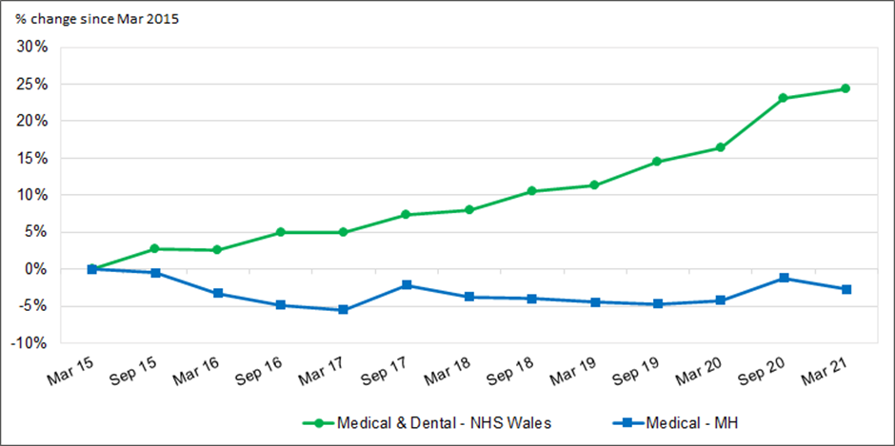

Data Source: ESR DW

The Medical Mental Health workforce has reduced by 2.7% whilst the total Medical and Dental workforce for NHS Wales has increased by 24.3% between the two periods. Indicating that the Mental Health workforce is out of step compared to other specialities. Participation Rates and Age Band

The graph below shows the participation rate by age band and gender for the Medical Mental Health workforce for March 2021.

Graph 6 Participation Rate by Age Band and Gender – Medical MH Workforce – March 21

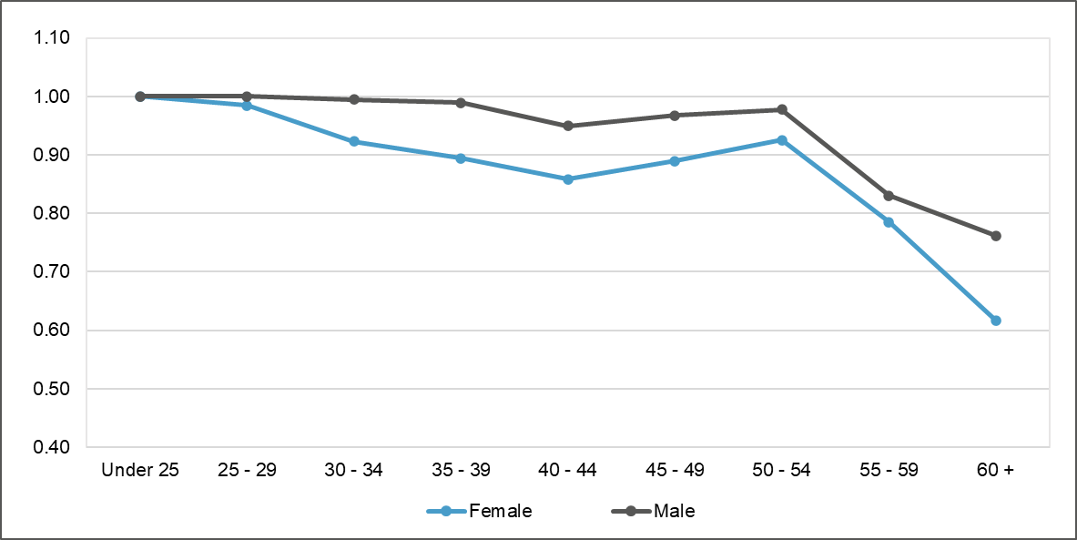
Data Source: ESR DW

The graph shows that the participation rate for females after the age of 25-29 starts to decline and is lower than the male workforce. Both the male and female workforce show a significant reduction in the participation rate after the age of 54. Details of Participation Rate by Age Band and Gender – Appendix 2.8

Medical Mental Health Age Band Profile
The graph below shows a comparison of the age profile of the Medical Mental Health workforce between March 2015 and March 2021.

Graph 7 Age Profile of the Medical MH Workforce – March 15 & March 21
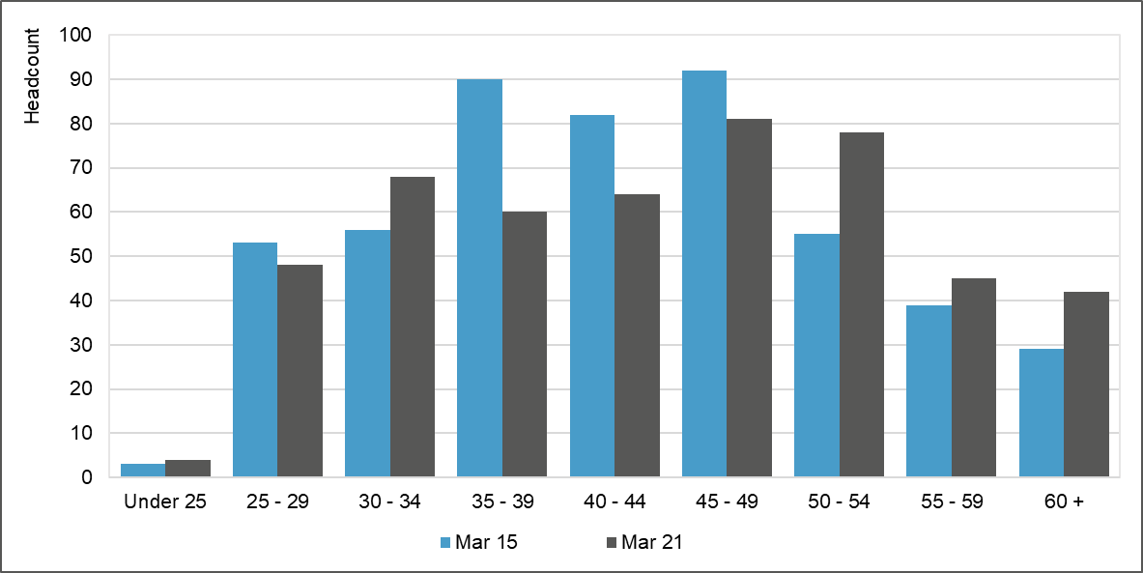
Data Source: ESR DW
The proportion of Consultants in the 45-age band and above has increased since March 2015. The proportion in this age group stood at 43% compared to 50% in March 2021.

Medical Starters and Leavers
The graph below shows the total starters and leavers by headcount (HC) for the Medical Mental Health workforce between March 2015 and March 2020.

Graph 8 Total Starters & Leavers Per Year – Medical - MH
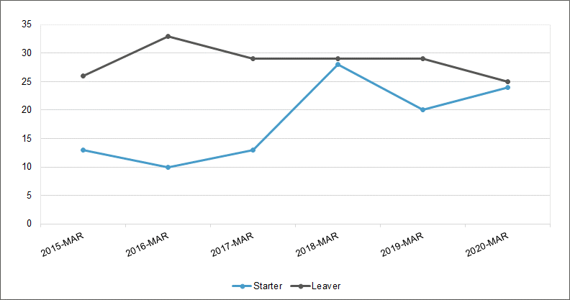
Data Source: ESR DW

Total Starters & Leavers Per Year - Medical – Mental Health
 | 2015-  MAR | 2016-MAR | 2017-MAR | 2018-MAR | 2019-MAR | 2020-MAR
Starter | 13 | 10 | 13 | 28 | 20 | 24
Leaver | 26 | 33 | 29 | 29 | 29 | 25
Difference between Starters and Leavers | -13 | -23 | -16 | -1 | -9 | -1

For each year over the last six years there has been fewer staff starting in the Medical Mental Health workforce compared to staff leaving, this has led to a reduction of 63 (HC) staff. March 2016 had the biggest reduction with 23 fewer staff starting compared to those leaving the workforce

Medical Mental Health Age Retirement
The following graph shows the percentage age retirement as a total of all retirees over a six-year period (2015 to 2021). The graph compares the retirement profile of the Medical Mental Health workforce against the Medical and Dental workforce for NHS Wales.

Graph 9 Percentage of Retirement by Age – Medical MH Compared to Medical & Dental – NHS Wales
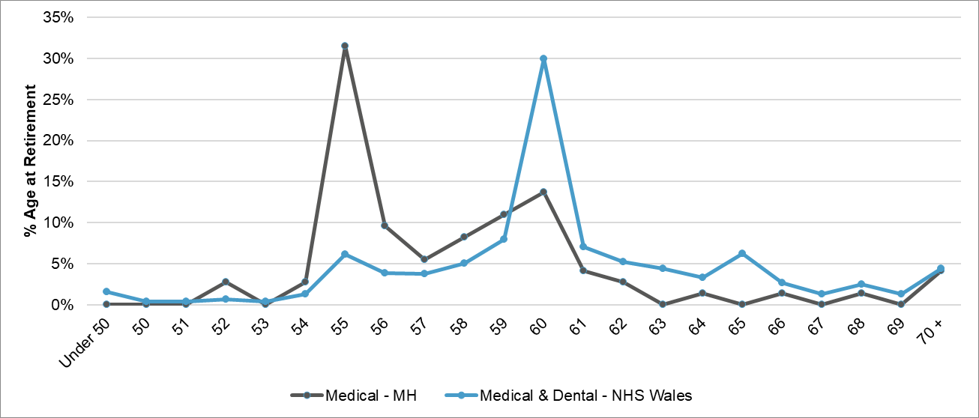
Data Source: ESR DW

There is a clear difference in the retirement age when we compare the Medical Mental Health workforce against the Medical and Dental workforce across NHS Wales. For the Medical Mental Health workforce 32% retire at the age of 55 compared to 6% for the Medical and Dental workforce across NHS Wales, where just over 30% of this workforce retired at age 60.

Medical Mental Health Consultant Workforce by Specialty
For the following analysis we have excluded the specialties of Forensic Psychiatry and Medical Psychotherapy due to the small numbers and potentially identifiable information. For Forensic Psychiatry we currently have a total of 14FTE Medical staff in post which includes all grades, of which 8FTE are Consultants. For Medical Psychotherapy there are currently no Medical staff in post. (as of March 2021).

The graph below shows the percentage change in FTE for the Medical Mental Health Consultant workforce from March 2015 to March 2021 by Specialty (see Appendix 2.1 & 2.2 for detailed figures).

Graph 10 Percentage Change in FTE March 15 to March 21 Medical Workforce by Specialty - Consultant

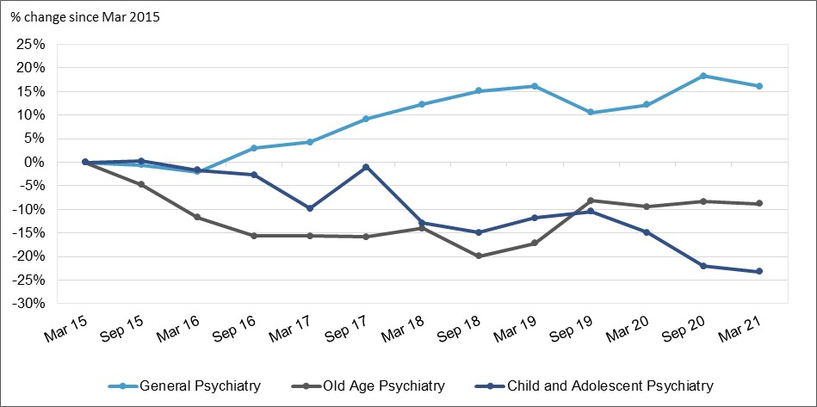
Data Source: ESR DW

Medical Mental Health Modelling by Specialty
The graph below shows the percentage change by FTE for the mental health medical workforce between 2020 and 2026; by specialty, as a total workforce. Between 2020 and 2026 there is a percentage reduction in the workforce for each specialty.

The modelling is based on the average number of CCT learners who remain in the workforce following training in a Consultant or SAS capacity. Leavers from the workforce is calculated on the average percentage of leavers by age band. (See appendix 2.3 for the modelling assumptions).

Graph 11 Workforce FTE % Change from 2020
Data Source: HEIW Forecasting

Psychiatry Medical Modelling
The graph below shows the forecasted FTE change in the Psychiatry medical workforce in totality between 2020 and 2026, which shows a decrease in the overall workforce from 276.63 FTE (2020) to 256.79 FTE (2026).

Graph 12 Forecasted Change in FTE for All Psychiatry
Data Source: HEIW Forecasting

General Psychiatry Modelling
The graph below shows the forecasted FTE change in the General Psychiatry medical workforce between 2020 and 2026, which shows a decrease in the overall workforce from 176.61 FTE (2020) to 170.95 FTE (2026).

Graph 13 Forecasted Change in FTE for General Psychiatry

Data Source: HEIW Forecasting

Old Age Psychiatry Modelling
The graph below shows the forecasted FTE change in the Old Age Psychiatry medical workforce between 2020 and 2026, which shows a decrease in the overall workforce from 55.71 FTE (2020) to 49.18 FTE (2026).

Graph 14 Forecasted Change in FTE for Old Age Psychiatry
Data Source: HEIW Forecasting

Child and Adolescent Psychiatry
The graph below shows the forecasted FTE change in the Child and Adolescent medical workforce between 2020 and 2026, which shows a decrease in the overall workforce from 46.05 FTE (2020) to 43.26 FTE (2026).

Graph 15 Forecasted Change in FTE for Child and Adolescent
Data Source: HEIW Forecasting

Please Note: Further modelling to follow.

Medical Mental Health SAS Workforce by Specialty
The graph below show the percentage change in FTE for the Medical Mental Health SAS workforce from March 2015 to March 2021 by speciality.

Graph 16 Percentage Change in FTE March 15 to March 21 – Medical Workforce by Speciality - SAS
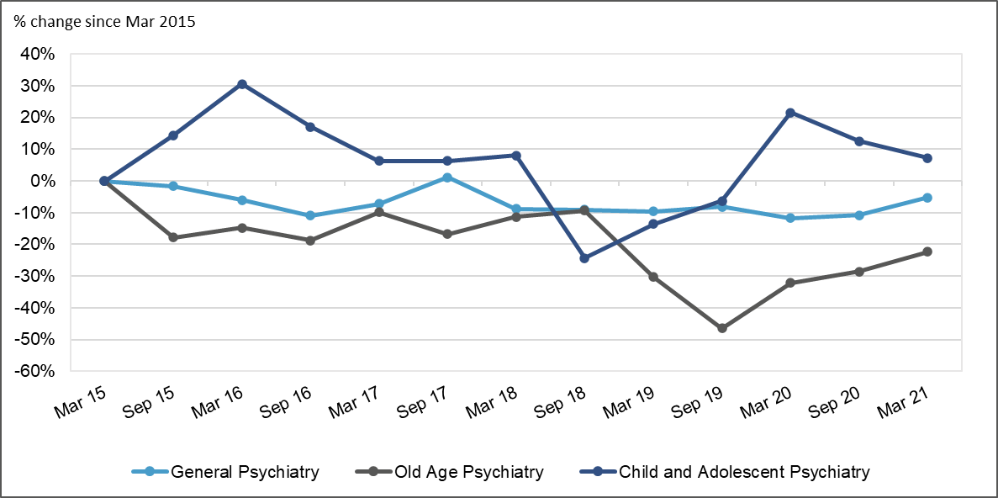
Data Source: ESR DW

The total SAS workforce for Mental Health has fallen overall between March 2015 and March 2021 by 7FTE. (See Appendix 2.4 & 2.5 for more detail).

Medical Mental Health Training Grade Workforce by Specialty
The graph shows the percentage change in FTE for the Medical Mental Health Training Grade workforce from March 2015 to March 2021 by speciality.

Graph 17 Percentage change in FTE March 15 to March 21 – Medical Workforce by Speciality – Training Grade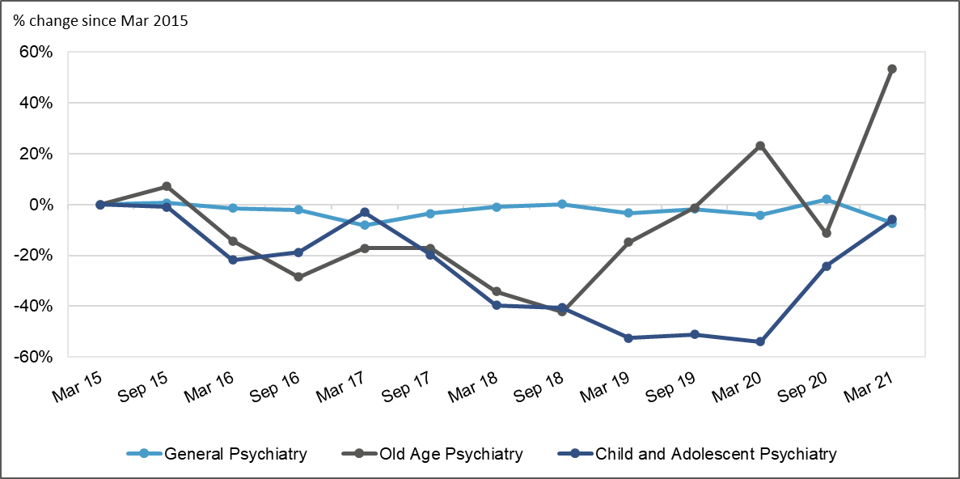
Data Source: ESR DW

The General Psychiatry training workforce has remained relatively stable between 120FTE and 135FTE. The Child and Adolescent training workforce has mainly seen a decrease in their total numbers up until March 2020 where numbers have increased from 4.7FTE to 9.5FTE in March 2021, 0.6FTE below where they were in March 2015. The Old Age Psychiatry Training Grade workforce between March 2015 and September 2018 numbers fluctuated but overall saw a 42% decrease which equates to 6FTE. Since September 2018 the workforce has seen an increase from 8FTE to 22FTE. (See Appendix 2.6 & 2.7 for detailed FTE figures).

Nursing Mental Health Worforce

Percentage Change of Nursing and Midwifery Workforce
The following graph shows the percentage change in the Nursing Mental Health workforce, which excludes Midwifery, in comparison to the Nursing and Midwifery workforce for NHS Wales, between March 2015 and March 2021.

Graph 18 Percentage Change in FTE March 15 to March 21 – Registered Nursing Workforce
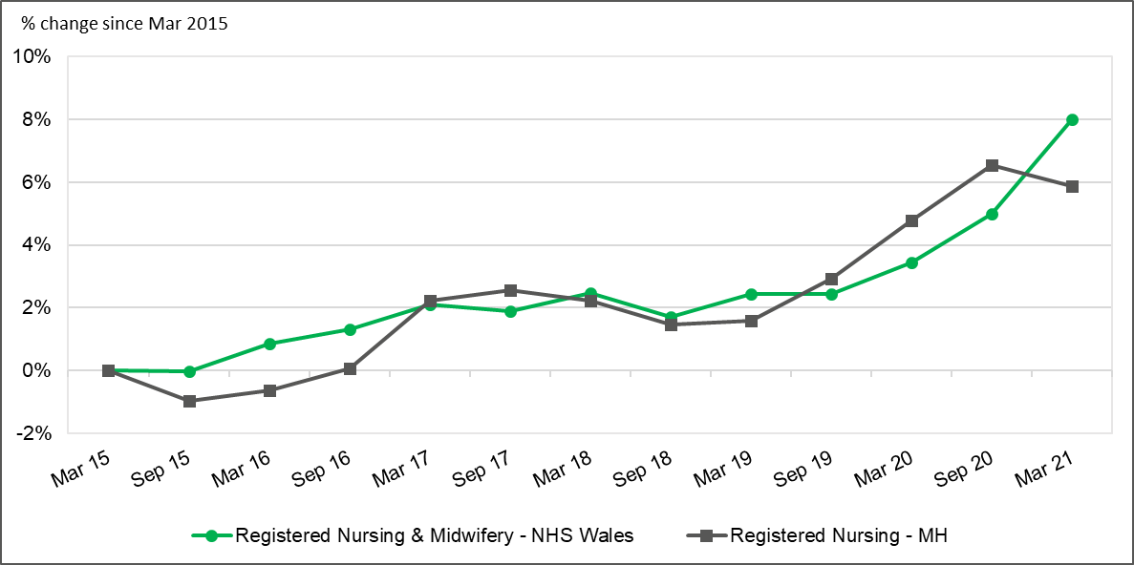
Data Source: ESR DW

The Nursing Mental Health workforce appears to have grown in line with the total Nursing and Midwifery workforce for NHS Wales from March 2017, showing a larger percentage increase between September 2019 and September 2020. Between September 2020 and March 2021 the growth of the Nursing Mental Health workforce has declined slightly to 5.9% whereas the percentage growth for the NHS Wales Nursing and Midwifery workforce has increased by 8%. Overall, the FTE and headcount of the Nursing Mental Health workforce has increased over the period by 179FTE. (225 Headcount).

Participation Rate and Age Band
The graph below shows the participation rate by age band and gender for the Nursing Mental Health workforce.

Graph 19 Participation Rate by Age Band and Gender – Registered Nursing – MH Workforce – March 21
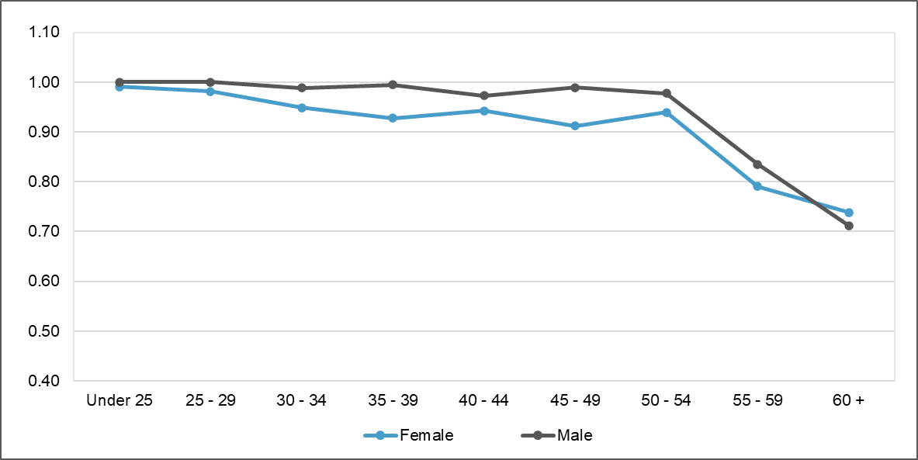
Data Source: ESR DW

The graph shows that the participation rate for females after the age band 25 to 29 starts to decline and is lower than the male workforce until the age band 60+. Both the male and female workforce show a significant reduction in the participation rate after the age of 54. (See Appendix 3.2 for more detail)

Nursing Mental Health Age Band Profile
The graph below shows a comparison of the age profile of the Nursing Mental Health workforce between March 2015 and March 2021.

Graph 20 Age Profile of the Registered Nursing – MH Workforce – March 15 & March 21
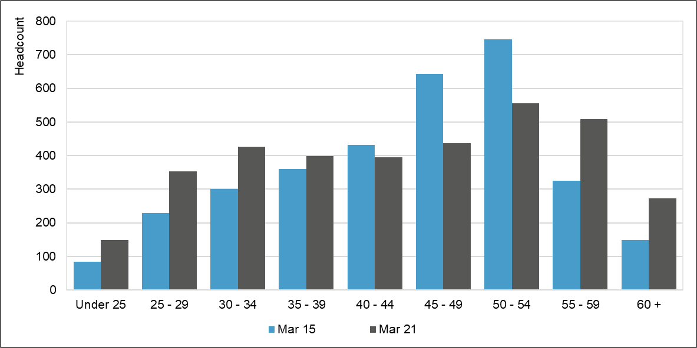
Data Source: ESR DW

In March 2015, the workforce aged 55 and over accounted for 14% of the workforce which increased to 22% in 2021. The number of Nurses under the age of 35 in March 2015 was 19% which has increased to 27% in March 2021.

Nursing Starters and Leavers
The graph below shows the total starters and leavers by headcount (HC) for the Nursing Mental Health workforce between March 2015 and March 2020.

Graph 21 Total Starters & Leavers Per Year – Registered Nursing - MH
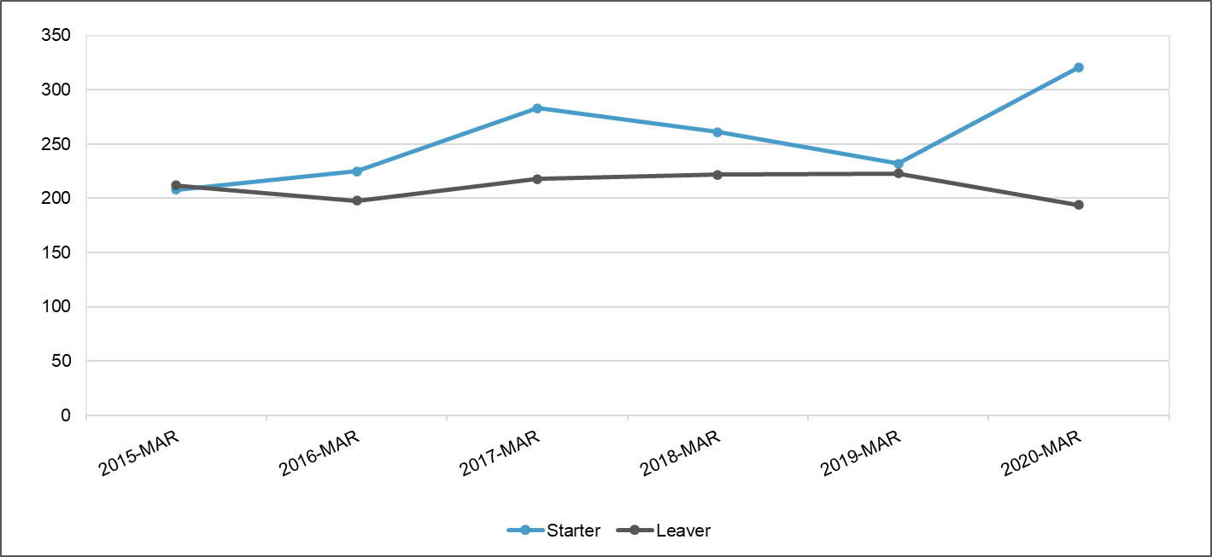
Data Source: ESR DW

Total Starters & Leavers Per Year - Registered Nursing – Mental Health
 | 2015-MAR | 2016-MAR | 2017-MAR | 2018-MAR | 2019-MAR | 2020-MAR
Starter | 208 | 223 | 282 | 261 | 232 | 321
Leaver | 211 | 197 | 217 | 222 | 223 | 193
Difference between Starters and Leavers | -3 | 26 | 65 | 39 | 9 | 128

The Nursing workforce has seen an overall increase of 264 (HC) over the last six years. With the exception of March 2015, each year the number of starters has been higher than the number of leavers, the largest increase can be seen in March 21 when there were 128 more starters than leavers.

Nursing Mental Health Workforce Retirement
The following graph shows the percentage age retirement as a total of all retirees over a six-year period (2015 to 2021). The graph compares the retirement profile of the Nursing Mental Health workforce against the Nursing and Midwifery workforce for NHS Wales.

Graph 22 Percentage of Retirement by Age – Registered Nursing – MH Compared to Registered Nursing & Midwifery – NHS Wales
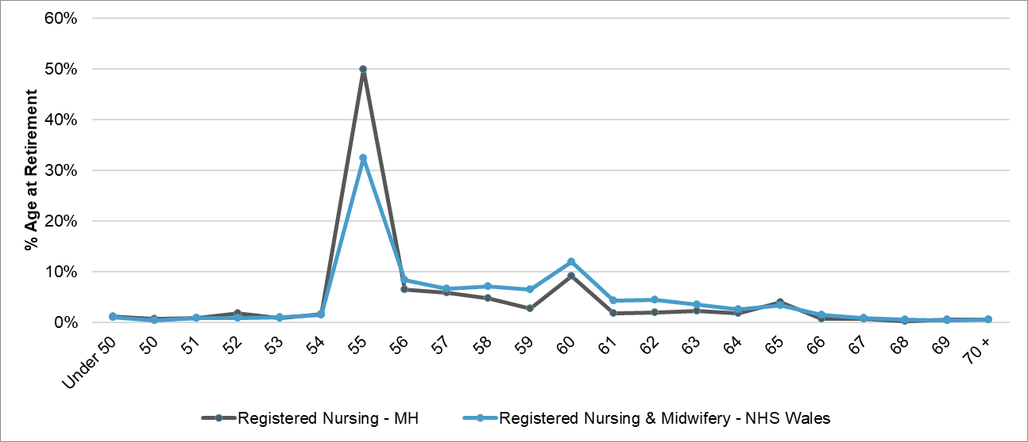
Data Source: ESR DW

There is a correlation in the retirement age for the Nursing Mental Health workforce and the Nursing and Midwifery workforce for NHS Wales, with the highest percentage across all age bands retiring at age 55, although the percentage retiring at this age for the Nursing Mental Health workforce is 50% compared to 32% for Nursing and Midwifery across NHS Wales.

Nursing Mental Health Workforce by Hospital and Community Setting
The following graph shows the workforce change for the Nursing Mental Health workforce between Hospital and Community setting by contracted FTE.

Graph 23 FTE March 15 to March 21 for Registered Nursing – MH Split by Setting
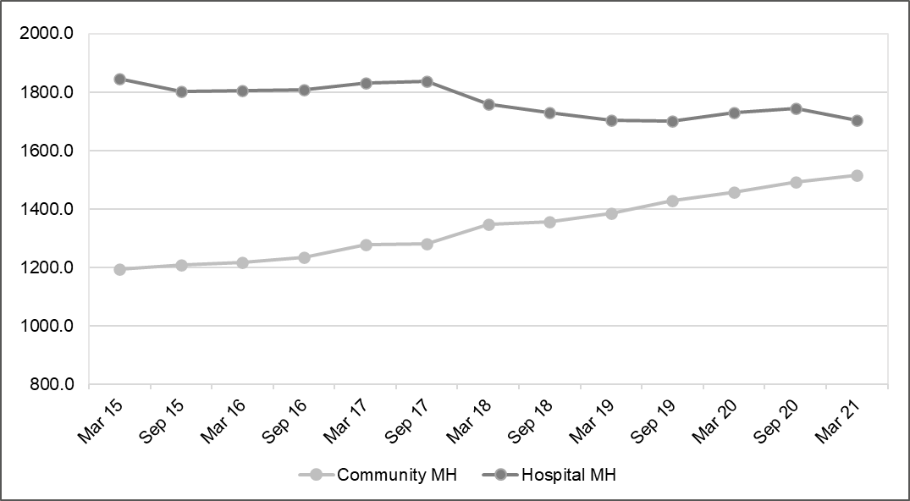
Data Source: ESR DW

The graph shows that since 2015 the Nurses working in the Community settting have seen an increase in nearly every period. This has resulted in the Community workforce increasing by 27% over the past six years. Overall, the FTE has increased over the period to 322FTE. (See Appendix 3.4 & 3.5 for more detail).

In parallel Nurses working in the hospital setting have seen a gradual decline in FTE resulting in an overall loss of 7.8% of the workforce. Overall, the FTE has decreased over the period by -143 FTE.

Nursing Mental Health Workforce Pay Bands
The following graph shows the change in FTE by pay band for the Nursing Mental Health workforce between March 2015 and March 2021. This graph excludes non-agenda for change bands due to the small numbers.

Graph 24 Percentage Change in FTE by Pay Bands March 15 to March 21 – Registered Nursing – MH Workforce – Mental Health
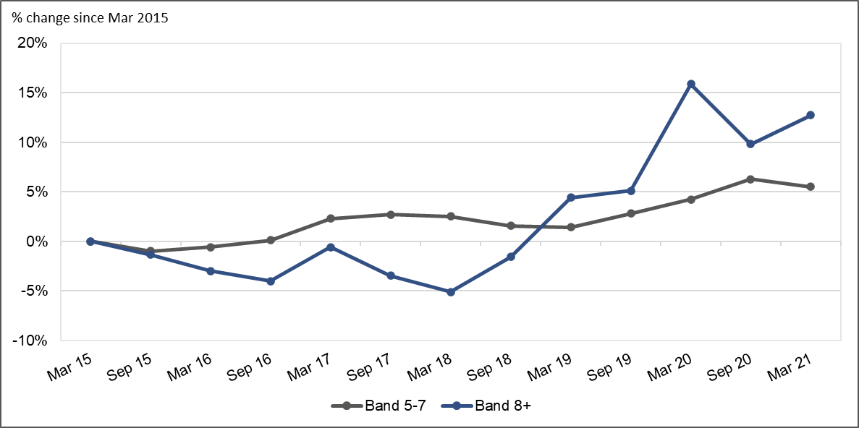
Data Source: ESR DW

The graph shows that the nursing workforce between bands 5-7 increased by 160FTE a 5.5% change between March 2015 and March 2021. For the Band 8+ workforce the increase was 16FTE, 12.7% for the same period. (See Appendix 3.6 for more detailed FTE figures).

Nursing Mental Health Modelling
The graph below shows the forecasted change in the FTE for the Nursing Mental Health workforce. The modelling is based on new graduates entering the workforce in addition to nurses other than those newly qualified joining the workforce. This figure is calculated using the average starters for the last three years. The modelling also considers leavers from the workforce based on the average leavers for the last three years.

The model shows that between 2020 and 2026, the workforce will grow by 603FTE. (See Appendix 3.7 for the modelling assumptions).

Graph 25 Forecasted Change in FTE for Mental Health Nursing
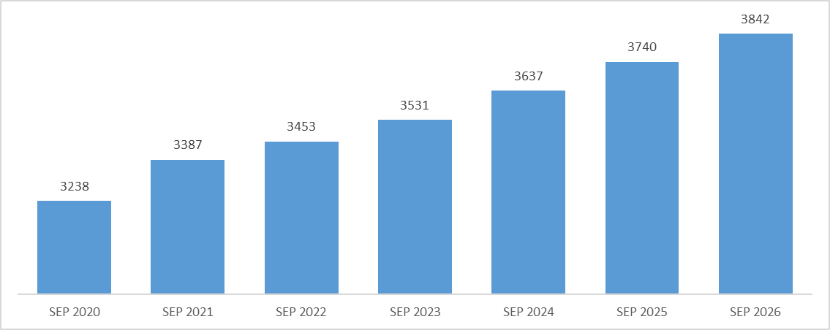
Data Source: HEIW Forecasting
Please Note: Further modelling to follow.

HCSWs Mental Health Workforce

Percentage Change of HCSW in Nursing and Midwifery Workforce
The following graph shows the percentage change in FTE comparing HCSWs in the Mental Health workforce and HCSWs in the Nursing & Midwifery workforce across NHS Wales between March 2015 and March 2021.

Graph 26 Percentage Change in FTE March 15 to March 21 – HCSW in Nursing & Midwifery Workforce

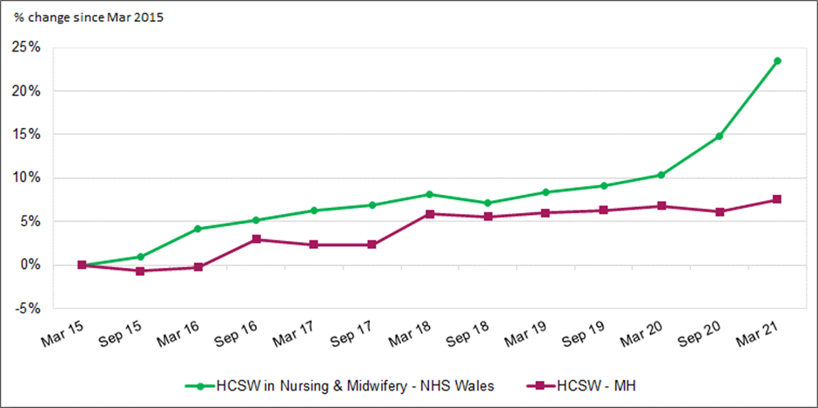

Data Source: ESR DW

Despite the increase seen in the FTE for HCSWs in the Mental Health workforce, this growth does not reflect the growth seen across NHS Wales which is 7.5% and 23.5% respectively.

Participation Rate and Age Band
The graph below shows the participation rate by age band and gender for the HCSW in the Mental Health workforce.

Graph 27 Participation Rate by Age Band and Gender – HCSW – MH Workforce – March 21
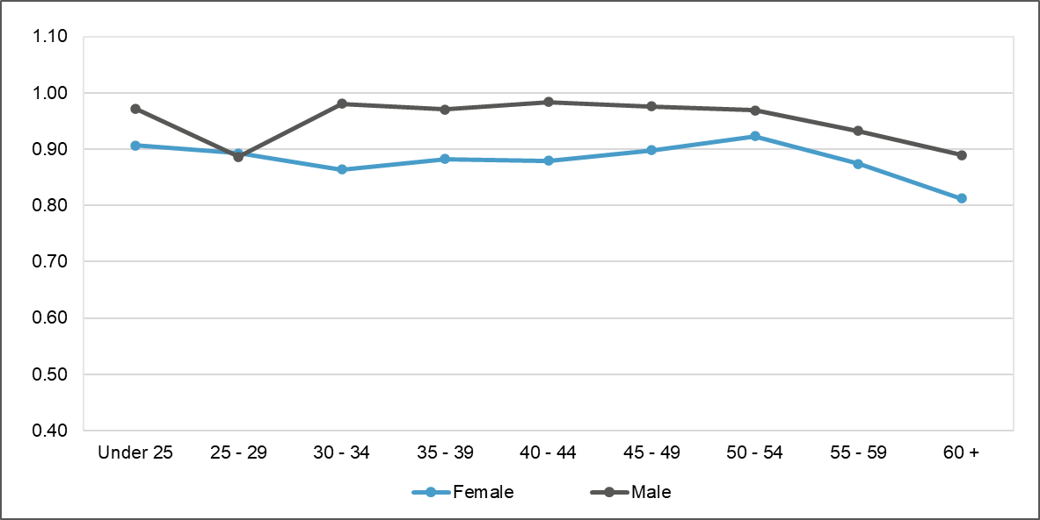
Data Source: ESR DW

Participation rates for the female workforce start to decline for the 25-29 age band and remains fairly stable increasing slightly at aged 50-54, where upon it drops again reaching the lowest rate at the 60+ age band. The participation rate for the male workforce follows a similar pattern dropping at the age band 25-29, before increasing between the age band 30-34 where it remains stable until the 55-59 age band reducing further until 60+. (See Appendix 4.1)

HCSW in Mental Health Age Band Profile
The graph below shows a comparison of the age profile of the HCSWs in the Mental Health workforce between March 2015 and March 2021.

Graph 28 Age Profile of the HCSW – MH Workforce – March 15 & March 21
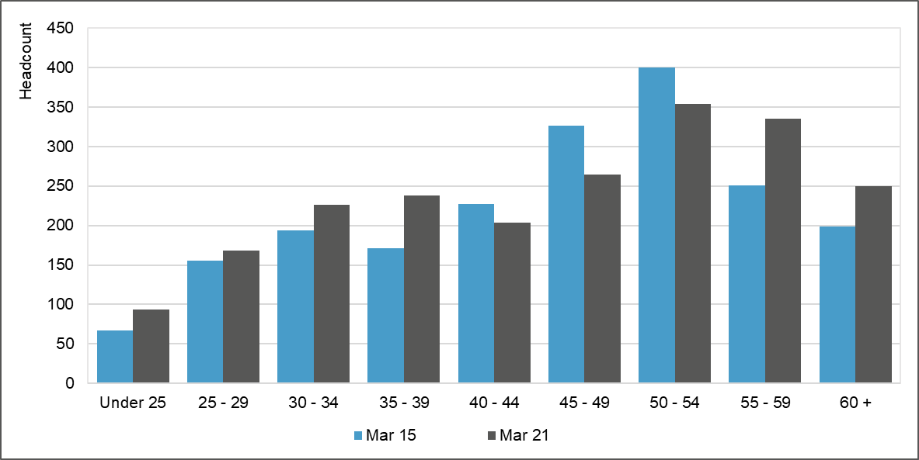
Data Source: ESR DW

In March 2015, the workforce aged 55 and over accounted for 23% of the workforce which increased to 27% in 2021. The number of support staff under the age of 35 in March 2015 was 21% which has increased to 23% in March 2021.

HCSWs in Mental Health, Starters and Leavers
The graph below shows the total starters and leavers by headcount (HC) for the HCSW in the Mental Health workforce between March 2015 and March 2020.

Graph 29 Total Starters & Leavers Per Year – HCSW - MH
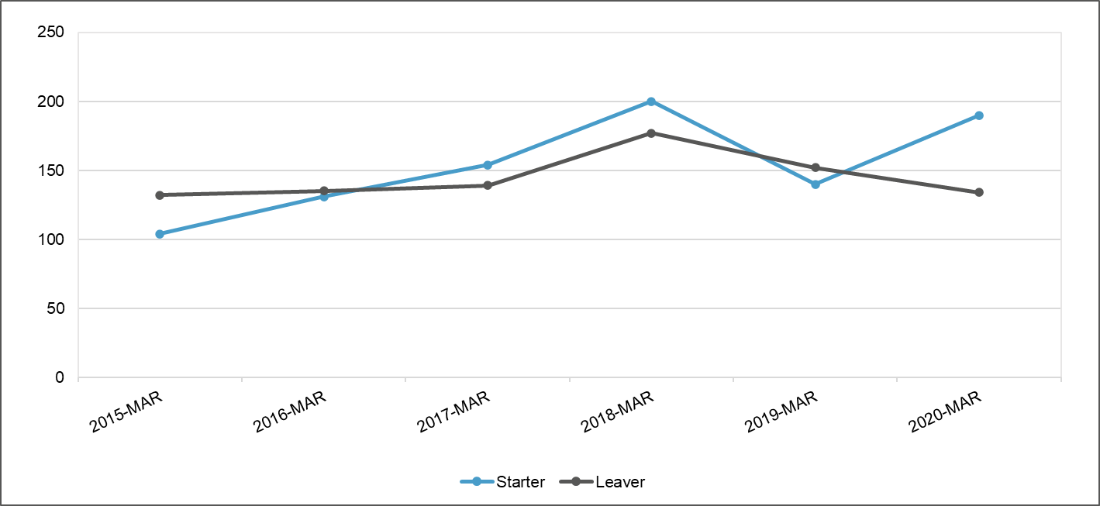
Data Source: ESR DW

Total Starters & Leavers Per Year – HCSW – Mental Health
 | 2015-MAR | 2016-MAR | 2017-MAR | 2018-MAR | 2019-MAR | 2020-MAR
Starter | 104 | 131 | 154 | 200 | 140 | 190
Leaver | 132 | 135 | 139 | 177 | 152 | 134
Difference between Starters and Leavers | -28 | -4 | 15 | 23 | -12 | 56

Over the reference period there has been an additional 50 new staff joining the HCSW workforce compared to those leaving.

HCSW Age Retirement
The following graph shows the percentage age retirement as a total of all retirees over a six-year period (2015 to 2021). The graph compares the retirement profile of the HCSWs in the Mental Health workforce against the HCSWs in the Nursing and Midwifery workforce for NHS Wales.

Graph 30 Percentage of Retirement by Age – HCSW – NHS Wales Compared to HCSW – MH
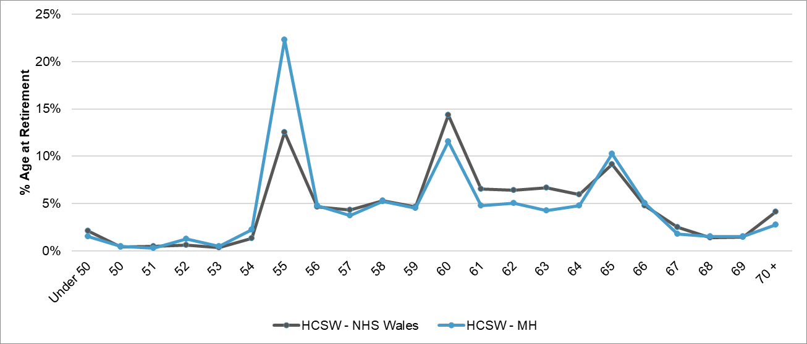
Data Source: ESR DW

For the HCSWs in the Mental Health workforce, the highest proportion of the workforce retire at age 55, which amounts to 22% of the workforce. This percentage is much lower (13%) when compared to HCSWs across NHS Wales. NHS Wales HCSWs are more likely to retire at age 60.

NHS Wales Psychology Workforce

Percentage Change of the Psychology Workforce
The data used for the analysis of the Psychology workforce represents the workforce in its entirety for NHS Wales. Utilising data from the ESR Data Warehouse, we are unable to identify the workforce who work exclusively within Mental Health Services.

The following graph shows the percentage change between the periods in the Psychology workforce for NHS Wales, between March 2015 and March 2021.

Graph 31 Contracted FTE From March 15 – March 21 – Psychology Workforce
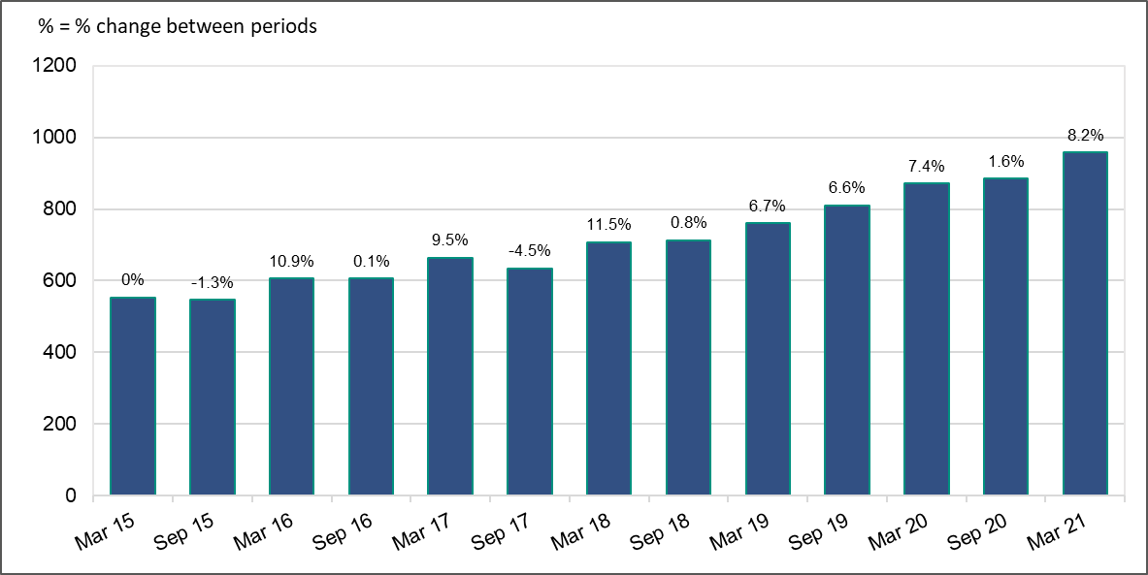
Data Source: ESR DW

Between March 2015 and March 2021, the Psychology workforce increased by 404FTE, which equates to a 73% increase. (See Appendix 5.1)

The following graph shows the percentage change in FTE for the Psychology workforce between 2015 and March 2021.

Graph 32 Percentage Change in FTE from March 15 to March 21 – Psychology Workforce
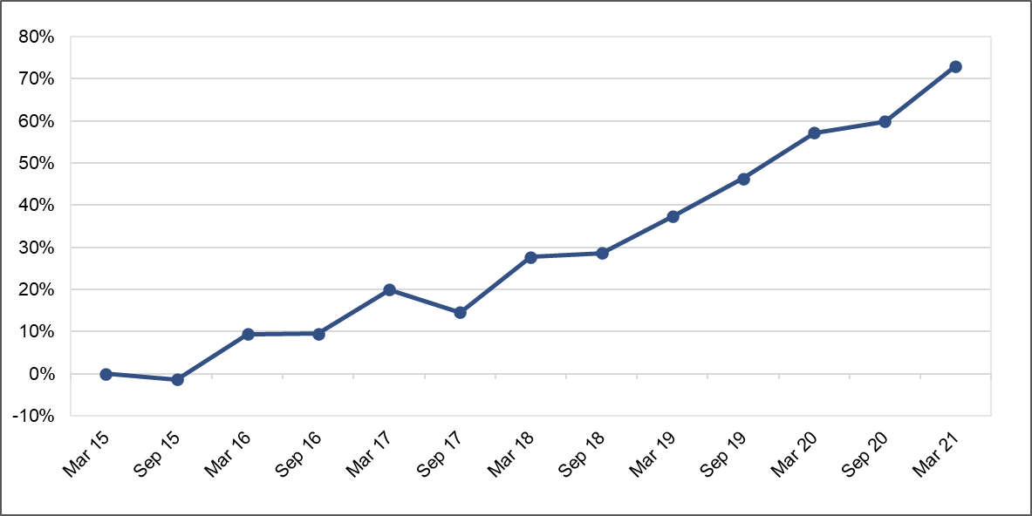
Data Source: ESR DW

Apart from the period of September 2017 where the workforce saw a decline of 1%, every other period up to March 2021 shows a growth in the Psychology workforce compared to March 2015.

Age Band Profile Psychology Workforce
Graph 33 Age Profile of the Psychology Workforce – March 15 & March 21
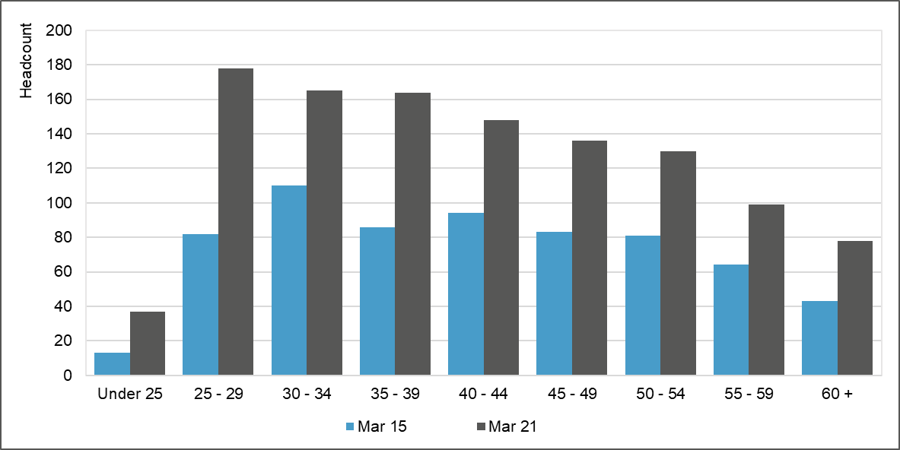
Data Source: ESR DW

As a percentage of the total workforce there is a small increase in those staff in the age bands 34 and below between 2015 and 2021, 31% and 33.5% respectively. There is also a very small decrease in the number of staff aged 50 and above, 29% for 2015 and 27% for 2021.

Allied Health Professional Mental Health Workforce
The ESR system does not identify those staff working specifically within Mental Health Services or those staff who worked a proportion of their time within this service. The information contained in the sections below has been provided by the professional bodies. We were not able to extract data from all the submissions.

Pharmacy Mental Health Workforce
Too few pharmacy professional roles in mental health exist. Wales has >2500 pharmacists (600 prescribers) and 1600 pharmacy technicians yet only 63 are specialist in mental health with only 17 prescribers. Children and Young Persons Mental Health has only 1.4 FTE pharmacist across Wales.

Speech and Language Therapy Mental Health Workforce

 | <=20 Years | 21-25 | 26-30 | 31-35 | 36-40 | 41-45 | 46-50 | 51-55 | 56-60 | 61-65 | >65 | Total
Speech and Language Therapist Specialist |  |  | 1 | 2 | 1 | 2 | 1 |  |  |  |  | 7
Allied Health Professionals |  | 22 | 43 | 62 | 78 | 70 | 64 | 61 | 41 | 7 | 1 | 449

There is concern that the data may present a misleading view of the current Speech and Language Therapy provision within mental health services in NHS Wales. This data may include posts in learning disability teams where speech and language therapy has historically but not currently been represented. The data may also include dementia services, neurodevelopmental services and youth offending teams. It may also include speech and language therapists providing limited in-reach to patients accessing mental health services who are not specifically employed to provide consistent and adequate services.

Occupational Therapy Mental Health Workforce
Current Workforce Makeup by age and title (data from ESR Wales)
 | <=20 Years | 21-25 | 26-  30 |  | 31-35 | 36-40 | 41-  45 |  | 46-50 | 51-55 | 56-  60 |  | 61-65 | >65 | Total
Occupational Therapist |  | 20 | 36 |  | 42 | 49 | 46 |  | 41 | 37 | 28 |  | 3 | 1 | 303
Occupational Therapy Specialist Practitioner | 0 | 0 | 0 | 1 |  | 3 | 3 | 0 |  | 2 | 1 | 0 |  | 0 | 10
Occupational Therapist Manager | 0 | 0 | 0 | 1 |  | 3 | 1 | 5 |  | 6 | 5 | 0 |  | 0 | 21

The figures in this table may be an under-estimate of the number of Occupational Therapists working in the field of mental health and learning disability in the Local Health Boards, as it only captures those who are identified in ESR as Occupational Therapists working in mental health services. These tables do not appear to include the Occupational Therapists who are working with children and young people who have mental health issues or learning disabilities

Physiotherapy Mental Health Workforce
Workforce data suggests significant inequalities in access to mental health physiotherapy practitioners in different geographical areas across Wales. Staffing levels vary greatly with Betsi Cadwallader UHB and Hywel Dda UHB having 1 WTE physiotherapist or less, providing services for an entire Health Board area and in the Aneurin Bevan and Powys regions there is no Mental Health physiotherapy workforce.

There are no funded Physiotherapy posts in Children and Young Peoples Mental Health services within Wales (CAMHS).

Podiatry Mental Health Workforce
The number of podiatrists who work in the NHS and are funded out of the mental health budget directly is still marginal, however, there are some encouraging examples from around the UK of where this arrangement works.

Social Care Mental Health Workforce

Introduction
This section of the report considers evidence and data collected from the social care workforce. In common with the HEIW data analysis, the aim is to summarise the high-level trends relating to the mental health workforce.

Mental Health Social Care Workforce
The data collected from Local Authorities in December 2020 has been summarised in the table below, it represents the mental health social care workforce.

Role | Number | Team
Approved Mental Health Professional | 355 | Various
Best Interests Assessor | 199 | Various
Manager | 61 | Mental Health Specific
Social Worker | 391 | Mental Health Specific
Social Care Support Worker | 292 | Mental Health Specific
Manager | 128 | Generic team with Mental Health Provision
Social Worker | 298 | Generic team with Mental Health Provision
Social Care Support Worker | 351 | Generic team with Mental Health Provision
Total | 2073

Social Workers Workforce
The following key facts were identified following analysis of the Social Work Registration data set from April 2021

Social workers have had to register with Social Care Wales since 2005
6,470 social workers are registered, an increase from 6,293 in 2020
4,172 told us they have a social work caseload.

What are the five year trends?
The ratio of female to male social workers remains 4:1
The number of social workers on the Register has increased by 7% since 2016
The percentage employed in the private sector increased from 4.5% in 2016 to 7.5%
The percentage who hold a Master’s or Bachelor’s degree in Social Work increased from 36% in 2016 to 52% this year.

How many joined and left the Register?
In the last 12 months 454 social workers joined the Register and 277 left
47% of those leaving did not maintain their registration
19% of those leaving had retired
13% continued to work in social care outside Wales

What qualifications do social workers hold?
All social workers on the Register are qualified
52% hold a Bachelor’s or Master’s degree in Social Work
34% hold a Diploma in Social Work
10% hold an older accepted social work qualification
3% qualified outside the United Kingdom.

Where are social workers employed?
73% work in local authority social services
7.5% work in the private sector
4% work in the third sector
4% are self-employed
36% of social workers have been in their current role for three years or less
13% have been in their current role for 10 years or more.

What is the profile of social workers?
There are 5,341 women and 1,129 men
The average age of social workers is 46
88% of social workers are white, white British, white Welsh or white Irish
40% of social workers speak some Welsh or are fluent
3% of social workers have a disability

The following key facts were identified following analysis of the Social Care Wales Workforce Development Programme data set collected between April & August 2021.

Employment Status of Social Workers registered with Social Care Wales
Permanent – 90%
Temporary – 5%
Bank/Agency – 2%
Zero hours/Casual – 2%

Local Authority Vacancy Rates for Social Workers, Senior Practitioners, Consultant Social Workers, Deputy Team Managers and Team Managers
Local Authorities submitted data which shows that the vacancy rate was 9.2% overall. The highest vacancy rate was for Social Workers who have been qualified for 1 to 3 years at 25.1%. For newly qualified Social Workers the vacancy rate as 10.7%. In addition, the vacancies held figure (defined as those posts that are vacant that LA’s do not intend to fill at the time of submission) was around 3%

Social Care Support Worker Workforce
As Social Care Wales does not yet hold registration data on other types of social care worker (e.g., residential, community support workers), the data held for the domiciliary social care workforce has been analysed and whilst there may be small variations within this cohort of staff compared to the overall social care workforce, they will be minimal. There is little historical data available for the domiciliary care workforce as the register was opened in April 2018 and registration became mandatory from April 2020.

To support the sector during COVID we have not removed anyone for failing to renew their registration. Therefore there may be a higher number registered than remain working in the sector at present.

22,131 domiciliary care workers were on the Register on 1 April 2021
2,968 workers had joined and 474 had left since 1 June 2021.

What qualifications do domiciliary social care workers hold?
59% of workers hold a practice qualification.
28% are registered having completed the induction route and they will be required to complete a qualification within three years.
13% are registered based on a declaration from their manager confirming their experience and competence (known as confirmed competence).

Where are domiciliary social care workers employed?
95% of workers are known to be in current employment.
51% of these work in the private sector
27% work in the third sector and 20% for a local authority.
36% started in their role in the last three years.
22% had been in their role for more than ten years.

What is the profile of domiciliary social care workers?
The average age of workers is 44 years old and there are broadly similar numbers in each age group.
83.5 % of workers are female and 16.5% are male.
97% of workers are white British, Welsh or Irish
9% speak fluent Welsh. 64% speak no Welsh at all.

Age of domiciliary social care workers registered with Social Care Wales
The average age of Domiciliary Care Workers is 44

Gender of domiciliary care workers registered with Social Care Wales
The ratio of female to male Domiciliary Care Workers is 5:1.

Percentage of domiciliary care workers registered with Social Care Wales who speak some Welsh or are fluent.
36% of Domiciliary Care Workers speak some Welsh or are fluent.

Ethnicity of domiciliary social care workers registered with Social Care Wales
96.5% of Domiciliary Care Workers are white, white British, white Welsh or white Irish.

Employment Status & Vacancy Rates for Social Care Support Workers working in Local Authority Social Work teams.
The following key facts were identified following analysis of the Social Care Wales Workforce Development Programme data set collected between April & August 2021.

Employment Status of Mental Health Social Care Support Workers
Permanent –73%
Temporary – 18%
Bank/Agency – 0.1%
Zero hours/Casual – 3%

Social Care key messages
The data collection exercise combined with qualitative evidence received from the sector via networks including the All Wales AMHP Leads Network also identifies some key messages.

Best Interests Assessors
The role of the Best Interest Assessor (BIA) is being deleted when the Liberty Protection Safeguards (LPS) are implemented and a new role of Approved Mental Capacity Professional (AMCP) is being created. As part of the implementation of LPS, LHBs and LAs provided data on numbers of BIAs. 100% of LHBs and LAs reported that they did not have enough BIAs to meet current demand. The AMCP role will be markedly different to the role of the BIA and it is envisaged that registered professionals such as Social Workers and nurses will undertake many of the assessments that are currently carried out by BIAs with only the most complex cases being considered by an AMCP. However, there is no way to know whether this assumption will become reality so any assessment of the numbers of cases that AMCPs will be required to assess is conjecture.

A separate LPS Workforce Plan is being developed that will support the sector to implement LPS. The BIA and AMCP roles are not specific to Local Authorities as many NHS staff currently act as BIAs.

Approved Mental Health Professionals
It is clear that there is currently a shortage of warranted Approved Mental Health Professionals (AMHP) in Wales. The recently established All Wales AMHP Leads Network reports that in some Local Authority areas, it is extremely difficult to attract permanent applicants to AMHP roles leading to a consequential increase in agency costs in order to fulfil statutory duties. In certain areas, even recruitment via agencies is proving problematic.

Since the Mental Health Act was amended in 2007, mental health or learning disability Nurses, Occupational Therapists and Clinical Psychologists have been permitted to train as AMHPs, however, take up has been low and very few non Social Work qualified staff act as AMHPs. Development of the Strategy offers an opportunity to address the shortage in the AMHP workforce both from a Local Authority and NHS perspective.

The introduction on the LPS could also have an impact on the AMHP workforce as many existing AMHPs also act as BIAs and some may be expected to act as AMCPs under the new regime. Whether AMHPs act as AMCPs in addition to their AMHP role (which is usually in addition to a substantive post) or cease to act as AMHPs in order to fulfil the AMCP role, there will be implications for this sector of the workforce.

