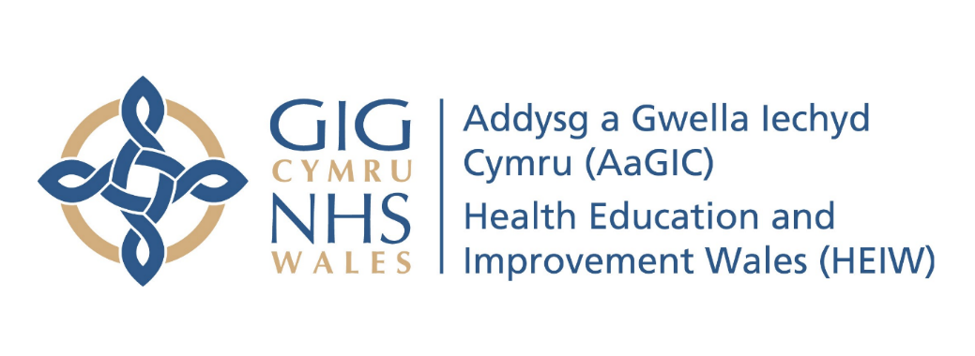
Appendix 1 - Risk Assessment Procedure

Executive Sponsor & Function:
Director of Workforce and Organisational Design
Document Author:
Ben Baker, Facilities & Compliance Manager
Approved by:
HEIW Executive Team July 2024
Review Date:
July 2027
Version: v3

1. Purpose and Scope

1.1 This standard establishes procedures for the development, implementation and review of risk assessments for health and safety

1.2 A Risk Assessment should:
- Identify significant hazards liable to arise because of work activity.
- (Significant hazards are those that pose a serious risk to individuals if not properly controlled).
- Identify and prioritise measures needed to control risk and comply with relevant legislation.
- Be appropriate to the work.
- Remain valid for a reasonable period of time.

The procedure applies to all:
- work areas under HEIW control
- activities undertaken by the employees of HEIW

2. Aims and Objectives

The aim of this procedure is:

- To protect employees (and others) by ensuring that all tasks are suitably and sufficiently assessed.
- To implement suitable control measures to eliminate or reduce exposure to hazards when undertaking these tasks.

3. Implementation

3.1 A Risk Assessment inventory (Appendix A) of work areas and activities undertaken by employees will be stored on the intranet to ensure that all hazards are identified, and risk assessments are completed, and the controls associated with the findings are suitably implemented.

3.2 A standard risk assessment form (Appendix B) will be used to capture risk information. Staff members facilitating an activity should complete a risk assessment for that activity and store in the inventory.
The Corporate risk assessment (Appendix C) has captured generic risks for working in the building Ty Dysgu. This can be used to help facilitators to consider the types of risks for use in writing their own risk assessment . It is the responsibility of the staff facilitator to ensure that activities in external locations have risk assessments in place. Facilitators must also complete an assessment for any new activity in an external location and record any risks that may cause significant harm.

3.3 HEIW will follow the HSE guidance for completing this form:

Create an inventory
Inspect premises and compile an inventory (appendix A) of all the tasks undertaken which have the potential to cause significant harm. To compile information ask staff about the hazards associated with the work that they do plus, it can also be helpful to review accident and illness records (how people have been injured in the past can help you understand any problem areas or task).

Identify the hazards
For each of the activities identified within the inventory identify and record the hazards associated with that activity on the risk assessment form (Appendix B). Consider anything which might harm or injure people and affect their safety e.g. trip hazards, electricity, plus you must also take into account potential longer term risks to employees health: e.g. causes of physical or mental stress; poorly designed workstations; and manual handling of objects.

Decide who could be affected.
As well as employees you should also consider risks to visitors, contractors and new employees as they may not be aware of safety procedures and consider anyone who might be particularly vulnerable (e.g. the disabled, young people and new or expectant mothers).

This should be recorded in the second column along with information on how the hazards identified could cause harm.

Evaluate the level of risk
Consider how likely it is that the things you have identified may cause problems, how many people it could affect, and how serious the potential for injury is. Are there any local legal requirements and do you comply?

Decide whether the risk presented is suitably controlled or more needs to be done to protect those affected by the hazards.

Eliminate or control the risk
When introducing control or improvement measures, always aim first to remove the risk (eliminate). If this is not possible or practical, then reduce the risk to as low as you can reasonably go. Safe systems of work and personal protective equipment can be used to do this but should be considered a last resort in the risk management process and generally to supplement more robust controls that have been introduced to safeguard staff and others.

Record and Review
Finally, record the outcome of your risk assessments and any corrective actions you have taken as a result. This should include both existing control measures in place or additional control measures required. Where control measures relate to other policies, procedures and/or assessments these should be referenced on the existing control measures section.

The person(s) undertaking the assessment should record their details on the form for reference purposes.
3.4 Completed assessments should be saved in the inventory. The responsibility to ensure that this happens will be with the staff facilitator in charge of activity.

3.5 Assessments need to be reviewed annually to check they remain relevant and will need to be re-assessed immediately should there be changes to the work, location, work methods or employees. This will ensure that new risks are identified.

3.6 The date of the assessment and the projected review date should be recorded on the risk assessment and the risk assessment inventory updated to reflect requirements.

4. Guidance on writing risk assessments for health and safety

4.1 All employees who are expected to complete health and safety risk assessments can be provided guidance and training to enable them to undertake assessments in their area of responsibility. Please contact the Facilities Management team if you would like further guidance..

4.2 All completed risk assessments and associated actions should be adequately communicated to individuals engaging in that activity and a record of this should be kept in case of incident.

4.3 Employees will be informed of their legal duty to make full and proper use of any control measures identified as part of the assessment process along with instruction and training in how to recognise issues in control measures and on the procedures for reporting such issues and risks.

5. Monitoring

5.1 All completed risk assessments should be reviewed at least on an annual basis or as new risks are identified. and

5.2 The effectiveness of this procedure will be reviewed annually through the health and safety committee with amendments made accordingly.

5.3 All control measures arising from risk assessments should be monitored on a regular basis to to ensure they are effective. Facilitators have overall responsibility for ensuring risks are assessed and that control measures work. This will reduce the likelihood of accidents and incidents occurring..

Appendix A – Risk Assessment Inventory

Reference | Activity | Date Produced | Date Last Reviewed | Date of Next Review | Responsible Person

Appendix B – Standard Risk Assessment Form

Date of Assessment: Completed By: Signature: Date of Review:

Hazard and potential for harm | People / Groups affected | What are the current controls in place to reduce risk? | What additional controls are needed to remove or reduce risk further? | Action and Responsibility

Appendix C – Risk Assessment Form – Corporate
HEIW - Site Assessment of Risks

Date of Assessment: 05/04/2024 Completed By: Ben Baker Signature:Date of Review: 05/04/2025

Site Description and Assessment Overview
Ty Dysgu is the head office of HEIW. The organisation employs approximately 630 people across all its operations, Approximately 450 people are employed at Ty Dysgu working to a hybrid working pattern while the remainder are remote working throughout Wales.

The site is a modern 3 storey building with all facilities provided, suitable access and egress, car parking, modern work space and environment with both adequate natural and artificial lighting. The business has a full external security system with cameras feeding into a manned reception area. All staff are required to sign in via an electronic fob at the front and rear entrance. Visitors sign in at reception and are given identity badges.

The site has frequent visitors which are in the main staff from NHS Wales, learners, individuals attending for interview and clients including contractors.

The risk assessment has highlighted that the key concerns are fire safety management and the health and safety of staff away from the building whether driving for work or attending duties on the premises of clients. The safety of visitors is paramount within the business and systems in place are effective but need regular reviewing to ensure the organisations health and safety measures are effective.

Hazard and potential for harm | People / Groups affected | What are the current controls in place to reduce risk. | What additional controls are needed to remove or reduce risk further | Action and Responsibility
1. Fire  Loss of life injury to person(s)  Business loss,  Business interruption  Insurance cost. | Employees, visitors, learners, contractors. | - Individual site fire risk assessment for Ty Dysgu.  - Statutory tests for all fixed and portable electrical equipment and systems with all results documented.  - Weekly fire alarm test  - Emergency Lighting monthly and six monthly tests.  - Drills and evacuations twice yearly.  - Personal emergency evacuation procedures.  - Written policy / procedure  - Fire Warden Training.  - Carry out fire warden monthly inspection checks with all results documented.  - Restricted car parking by the use of yellow lines to ensure that emergency vehicles are able to attend the site in the event of an emergency. | - Review and update site fire risk assessments on an Annual basis.  - Plan, monitor and review drills and evacuations through safety committee. | Facilities & Compliance Manager
2. Work Environment,  Water & Heating  Including mains water  Hot water systems  Heating & Ventilation  Boilers | Employees, visitors,  learners, contractors. | - Maintenance and testing checks in place for Water Hygiene and Legionella testing with all results documented.  - Statutory inspection and checks carried out for Boilers, HVAC, F-Gas, Gas Safety, Electrical (Fixed) and Water.  - HIEW member of staff trained as PAT Tester and PAT testing equipment purchased. | - Full Survey of Water Systems within Ty Dysgu Carried out by competent contractors (RMC) | Facilities & Compliance Manager
3. Electrical.  Fixed and Portable equipment.  Loss of life, burns, fire, electrocution | Employees, visitors, learners, contractors. | - Statutory testing of fixed electrical installations and equipment with all results documented.  - PAT Testing regime with all results documented.  - Individual responsibility to report faults through visual inspection.  - Individual awareness of potential risk and harm. | - Reinforce personal disciplines via health and safety committee.  - The implementation of a full Annual PAT Testing regime with all results documented at a central location. | Facilities & Compliance Manager
4. Slips Trips and Falls Injury to persons from trailing cables, boxes, bags, uneven surfaces and wet floors. | Employees, visitors, learners, contractors. | - Responsibilities outlined at induction.  - Well lit areas, internal and external.  - Service Desk reporting of issues, including faulty floor surfaces etc. with issues acted upon and repairs carried out in a timely manner.  - Good housekeeping disciplines  - Reduction / removal of identified hazards particularly cables and boxes  - Office cleaning with cleaning company reporting any hazards.  - House keeping checks / inspections.  - Effective signs and warnings of any hazards. | - Reinforce disciplines through safety committee.  - Review and communicate housekeeping checks and outcomes. | Facilities & Compliance Manager
5. First Aid provision  Loss of life, sustained injuries made worse, claims and business interruption. | Employees, visitors, learners, contractors. | - Provision of adequate First Aid facilities including First Aid boxes on each floor.  - Trained First Aiders.  - Provision of a Defibrillator at reception with staff trained in its use.  - Adequate signs and notice supporting first aid awareness.  - First Aid trained staff shown on notice board at reception with contact details. | - Annual review of numbers of trained people, level of training and coverage throughout the business | Facilities & Compliance Manager
6. Display Screen Equipment  Ergonomic injuries, eye strain, headaches stress and infection | Employees, visitors | - DSE Assessments carried out on all new starters.  - Induction training to make users aware of hazards involved.  - Workstation self- assessment checks.  - Housekeeping checklists  - Individual responsibility for workstations.  - Work planning to reduce risks, ie frequent breaks etc. | - Reinforce individual disciplines through safety committee and managers.  - Liaise with HR to identify issues related to absence / ill health.  - Hygiene regimes for keyboards and desk top equipment.  - Make DSE Training as a mandatory discipline in ESR.  - Make DSE training available to temporary staff.
3. Handling and Lifting  Injury to person from incorrect lifting, damage to equipment and materials. | Employees | - Potential for harm identified and covered on induction.  - Equipment provided to avoid / reduce handling tasks.  ESR Mandatory training in Manual handling

