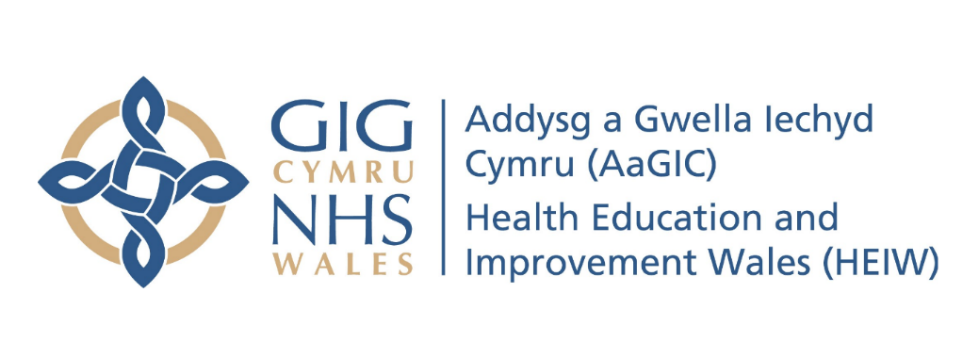
Appendix 12 – Health & Safety Incident/Accident Reporting & Investigation Procedure

1. Purpose and Scope

1.1 This document establishes standards and procedures for the reporting and investigation of incidents including hazardous situations, accidents that do not result in harm, accidents that result in harm and/or fire.

1.2 The procedure applies to all work areas and all activities carried out by the employees of HEIW and all those affected by those areas and activities.

1.3 HEIW require that all employees are aware of the procedure to follow in the event of any incident.

2. Aims and Objectives

2.1 The aim of this procedure is:

- To protect employees (and others) by ensuring that all incidents are reported and investigated.
- To ensure the integrity of existing control measures and to recommend additional control measures when these have not been deemed to be sufficient.

3. Implementation

3.1 All incidents to staff and others (including hazardous situation, accidents that do not result in harm, accidents that result in harm and/or fire), however minor, MUST be reported at the earliest opportunity.

3.2 For all incidents that result in personal injury, an entry must also be made in the approved accident book which is kept with the Facilities and Compliance Manager. This will usually be completed by the approved first aider who will remove the report from the accident book and pass to the Facilities & Compliance Manager for secure storage and to assist in the compilation of statistics and analysis of accidents.

3.3 It will be the responsibility of the Facilities & Compliance Manager to ensure that RIDDOR reportable incidents are reported within the relevant time frames. (Appendix 1).

3.4 Following an incident, regardless of whether an injury has been sustained or not, an ‘Incident Report Form’ must be completed on Datix using the link http://7a3b7svmdatixlv.cymru.nhs.uk/datix/live/index.php?module=INC&form_id=21 fully giving details of the incident along with the actions taking to prevent similar incidents occurring in the future.

3.5 The initial report should be made by the person reporting the incident and this should be forwarded to the relevant line manager for further investigation and action. A copy of this form must be sent to the Facilities & Compliance Manager as soon as possible but no later than the next working day following the incident.

3.6 Distribution of the Incident is form is as follows:

- Copy for the ‘injured’ person or the person reporting the incident;
- Copy for the injured person's manager or the manager of the person reporting the incident;
- Copy to the Facilities & Compliance Manager who will review all incidents which are reported and communicate relevant information through email, bulletin or verbally to all affected areas of the organisation.

3.7 All control measures introduced as a result of incident investigations should be closely monitored to check on their effectiveness and if necessary, relevant policy, procedure and/or risk assessment updated to reflect the changes made.

3.8 The Facilities & Compliance Manager will make a decision on whether a more detailed and in-depth investigation is required in the case of incidents which have a potential for either civil or criminal action. He will be responsible for ensuring that this is completed and retained along with all other information relating to the incident.

4. Training

4.1 All employees who are expected to report incidents in the workplace will be trained in this procedure so they will be able to complete the Incident Reporting Form and take appropriate action in the event of an incident occurring.

4.2 All employees will be informed of their duty to cooperate with the employer in the event of an incident by providing information, help and support so that the root causes of the incident are determined and corrective action implemented.

5. Monitoring

5.1 All completed Incident Report Forms will be reviewed by the Facilities & Compliance Manager with any issues identified fed back to the nominated manager for the location where the incident took place. This will include an analysis of the information reported, the actions taken to prevent similar incidents and the content of the Incident Report Form.

5.2 All incidents reported within HEIW will be collated and analysed to identify any patterns or trends that may have developed and require further action. This will be done by:

- Monthly and annual review of accidents and ill health by the Facilities & Compliance Manager;
- Monthly and annual review by the board; and
- Review of accidents and ill health at each health and safety committee meeting.

Appendix 1

1. RIDDOR - Reporting requirements

  - Under the Reporting of Injuries, Diseases and Dangerous Occurrences Regulations 2013 (RIDDOR) the following incidents need to be reported to the enforcing authority:

- The death of any person;
- Specified injury to workers;
- Over-seven-day incapacitation of a worker;
- Non-fatal accidents to non-workers e.g. members of the public;
- Occupational diseases;
- Carcinogens, mutagens and biological agents;
- Dangerous occurrences; and
- Gas incident.

2. RIDDOR Definitions

2.1 The death of any person

All deaths to employees and non-employees, with the exception of suicides, must be reported if they arise from a work-related accident, including an act of physical violence to a worker.

2.2 Specified injuries to employees

The list of ‘specified injuries’ in RIDDOR 2013 replaces the previous list of ‘major injuries’ in RIDDOR 1995. Specified injuries are (regulation 4):

- Fractures, other than to fingers, thumbs and toes;
- Amputations;
- Any injury likely to lead to permanent loss of sight or reduction in sight;
- Any crush injury to the head or torso causing damage to the brain or internal organs;
- Serious burns (including scalding) which:
- covers more than 10% of the body; or
- causes significant damage to the eyes, respiratory system or other vital organs;
- Any loss of consciousness caused by head injury or asphyxia;
- Any other injury arising from working in an enclosed space which:
- leads to hypothermia or heat-induced illness; or
- requires resuscitation or admittance to hospital for more than 24 hours.

2.3 Over seven-day incapacitation of an employee / worker

Accidents must be reported where they result in an employee or self-employed person being away from work, or unable to perform their normal work duties, for more than seven consecutive days as the result of their injury. This seven day period does not include the day of the accident, but does include weekends and rest days. The report must be made within 15 days of the accident.

An over-three-day incapacitation must be recorded, but not reported where they result in a worker being incapacitated for more than three consecutive days.

The record will be kept in the accident book under the Social Security (Claims and Payments) Regulations 1979.

2.4 Non-fatal accidents to non-employees e.g. members of the public

Accidents to members of the public or others who are not at work must be reported if they result in an injury and the person is taken directly from the scene of the accident to hospital for treatment to that injury. Examinations and diagnostic tests do not constitute ‘treatment’ in such circumstances. There is no need to report incidents where people are taken to hospital purely as a precaution when no injury is apparent.

2.5 Occupational Diseases

HEIW must report diagnosis of certain occupational diseases, where these are likely to have been caused or made worse by their work. These diseases are always associated with an occupation.

- Carpal Tunnel Syndrome: where the person’s work involves regular use of percussive or vibrating tools
- Cramp of the hand or forearm: where the person’s work involves prolonged periods of repetitive movement of the fingers, hand or arm
- Occupational dermatitis: where the person’s work involves significant or regular exposure to a known skin sensitiser or irritant
- Occupational asthma: where the person’s work involves significant or regular exposure to a known respiratory sensitiser
- Tendonitis or tenosynovitis: in the hand or forearm, where the person’s work is physically demanding and involves frequent, repetitive movements.

Work related occupational cancers and diseases associated with work related biological agents are also included in the RIDDOR requirements (see guidance links below).

2.6 Dangerous occurrences

Dangerous occurrences are certain, specified near-miss events. Not all such events require reporting. There are 27 categories of dangerous occurrences that are relevant to most workplaces (see guidance links below) e.g.:
- the collapse, overturning or failure of load-bearing parts of lifts and lifting equipment;
- plant or equipment coming into contact with overhead power lines;
- the accidental release of any substance which could cause injury to any person.

2.7 Gas incidents

Distributors, fillers, importers & suppliers of flammable gas must report incidents where someone has died, lost consciousness, or been taken to hospital for treatment to an injury arising in connection with that gas. Registered gas engineers (under the Gas Safe Register,) must provide details of any gas appliances or fittings that they consider to be dangerous, to such an extent that people could die, lose consciousness or require hospital treatment. The danger could be due to the design, construction, installation, modification or servicing of that appliance or fitting, which could cause:

- An accidental leakage of gas;
- Incomplete combustion of gas or;
- Inadequate removal of products of the combustion of gas.

3. Action to report Injuries, diseases and dangerous occurrences

3.1 There are two categories of RIDDOR reporting to the Health and Safety Executive (HSE):

- Immediate notification for high risk incidents followed by a written report in 10 days;
- Written report for less serious incidents within 15 days.

 | Immediate notification | Written report | Form | Timescale
Death | ✔ | ✔ | F2508 | 10 days
Specified injury | ✔ | ✔ | F2508 | 10 days
Dangerous occurrence | ✔ | ✔ | F2508 | 10 days
Gas incident | ✔ | ✔ | F2508 | 10 days
Over 7 day injury | ✖ | 15 days | F2508 | 15 days
Disease linked to work | ✖ | ‘forthwith’ | F2508A | 10 days

3.2 Immediate notification

The internet - http://www.hse.gov.uk/riddor/report.htm

By telephone for fatal and specified injuries only:

- Incident Contact Centre: 0345 300 9923 (opening hours Monday to Friday 8.30 am to 5 pm).

3.3 Written report

The internet - http://www.hse.gov.uk/riddor/report.htm

To fill in the RIDDOR Report it will be necessary to determine the circumstances of the event.

A record of RIDDOR reports will be kept for at least 3 years by:

- Keeping a copy of the form in a confidential folder entitled ‘Accident forms’ in HEIW
- Recording the incident electronically in the specific incident folder on Sharepoint.

Details of the accident will also be kept in the confidential folder entitled ‘Accident forms’ in reception at HEIW.

