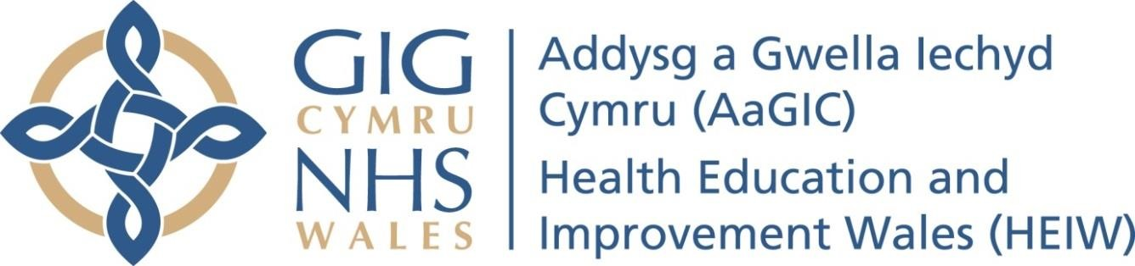

Appendix 14 –

SMOKE FREE ENVIRONMENT PROCEDURE

Executive Sponsor & Function:
Director of Workforce and Organisational Development
Document Author:
Ben Baker, Facilities and Compliance Manager
Approved by:
HEIW Executive Team
Approval Date:
June 2024
Review date
July 2027
Version: v3

1

Table of Contents
Contents Page
- Introduction 1
- Policy aims 1
- Scope 1
- Relevant Legislation 1
- Definitions 2
Second-hand smoking 2
Enclosed premises 2
Substantially enclosed premises 2
- Roles and Responsibilities 2
Staff 2
Managerial responsibilities 2
- Application of this policy 3
No smoking signs 3
Ty Dysgu site 3
Application of the policy to vehicles 3
Electronic cigarettes 3
Authorised breaks 4
- Support for staff who want to give up smoking 4

Introduction

  - This policy outlines the approach that HEIW intends to take to ensure that premises under HEIW control, including grounds and building, remain smoke free in order to protect staff and visitors from the harmful effects of smoking.

  - Smoking remains the single most common avoidable cause of ill health in Wales. Reducing the number of smokers is one of the most effective ways of reducing inequities in health expectation, which is a priority for HEIW.

  - HEIW is keen to provide support to staff who wish to give up smoking by encouraging any member of staff to contact the Stop Smoking Wales Service and participate in the smoking cessation programme. Further details can be found in section 9.

Policy aims

  - The main objectives of this policy are to:

    - Ensure that all HEIW controlled premises and grounds remain smoke free
    - Lead by example in helping to make no smoking the normal practice
    - Highlight the dangers of smoking/inhalation of second hand smoke
    - Provide support to staff who wish to give up smoking to participate in a smoking cessation programme.

Scope

  - This smoke free environment policy and any arrangements made under it applies to:

- all persons employed or engaged by Health Education and Improvement Wales (HEIW) including part time workers, temporary and agency workers and those holding honorary contracts.

- visitors, contractors and volunteers.

Other NHS Health Boards and Trusts will have their own health and safety policies that will apply to HEIW staff working in NHS premises elsewhere across Wales.

  - As part of the Smoke-Free Premises etc. (Wales) Regulations 2007, smoking is prohibited in all enclosed and substantially enclosed premises and assets. The use of e-cigarettes are also prohibited at HEIW controlled premises.

Relevant legislation

  - As part of the smoke-free legislation, smoking is prohibited in all enclosed and substantially enclosed premises. Failure to comply with the law will be a criminal offence, as set out in the Health Act 2006. Penalties and fines are being set in regulations and include:

    - Individuals may be liable to a fixed penalty fine for smoking in smoke-free premises;
    - The manager or person in control of any smoke-free premises could be fined a fixed penalty for failing to display appropriate ‘No Smoking’ signs;
    - The organisation accountable for premises could be fined for failing to prevent others from smoking in those premises.

Definitions

  - Second-hand smoking

3

Second-hand smoking is the involuntary inhalation of smoke from tobacco products. It occurs when tobacco smoke permeates any environment, causing inhalation of the waste smoke by all people in that area.

  - Enclosed premises

According to the smoke free legislation, enclosed premises are those that have a ceiling or roof and, except for doors, windows or passageways, are wholly enclosed.

  - Substantially enclosed premises

Premises are considered 'substantially enclosed' if they have a ceiling or roof, but have an opening in the walls, which is less than half the total area of the walls. The area of the opening does not include doors, windows or any other fittings that can be opened or shut.

Roles and responsibilities

  - Staff

    - All staff have a role in the successful implementation of this policy and where confident, are encouraged to politely remind other staff, visitors, service users and contractors who visit HEIW sites, of the Smoke-Free Environment policy.

    - Any member of staff who politely informs someone smoking on HEIW grounds about the Smoke-Free Environment policy will receive the full support of the Executive Team.

  - Managerial responsibilities

    - Executive Team, Senior Leadership Team and Line Managers

The Executive Team, the Senior Leadership Team and Line Managers are responsible for ensuring that the Smoke-Free Environment policy is adhered to at all levels within the organisation and acting as policy "Champions".

    - Director of Workforce and Organisational Development

The Director of Workforce and Organisational Development has overall responsibility for the implementation and review of this policy.

Application of this policy

The following actions illustrate HEIW’s approach to implementing and monitoring compliance with this policy. Staff found to be smoking on HEIW premises may be dealt with under the Disciplinary Policy.

  - No smoking signs

HEIW is required by law to display appropriate ‘no smoking’ signs, in prominent positions at or near each entrance to premises, so that people entering the premises can see it. If there is more than one entrance used by staff, service users, contractors or visitors, more than one sign will need to be displayed.

The Facilities and Compliance Manager will ensure that the site displays appropriate no smoking signage.

4

  - HEIW Controlled premises

Smoking and the use of electronic cigarettes is prohibited on HEIW controlled premises, which includes site, grounds and building. These restrictions include all areas up to the boundaries and include where applicable the car park and vehicles parked on HEIW property, outdoor seating areas and walkways. Any person wishing to smoke must first leave the grounds. Staff should also inform service users, visitors and contractors of this policy.

  - Application of the policy to vehicles

The Wales Regulations also cover vehicles used by more than one employee in work duties. This policy applies to:

- Vehicles leased through arrangements with HEIW when being used for HEIW business
- Privately owned vehicles when carrying one or more passengers travelling on business (i.e. claiming travel expenses from HEIW)
- Privately owned vehicles when parked on the HEIW site.

  - Electronic cigarettes

The use of Electronic cigarettes, e-cigs or vapes will be treated in the same way as any smoking cigarettes, cigars etc.

Staff must not charge e-cigarettes on HEIW controlled premises or whilst using HEIW power sources i.e. laptops.

  - Authorised breaks

HEIW does not recognise smoking breaks, although staff are entitled to scheduled breaks in line with local policy and contracts of employment. Where staff choose to smoke during their authorised breaks, this must be off HEIW controlled premises, at their own risk. Any person wishing to smoke must first leave the grounds.

Support for staff who want to give up smoking

Stop Smoking Wales offers free, friendly support for smokers who are ready to stop.

Before stopping smoking, a trained smoking cessation advisor will help you to understand why you smoke and when. He or she will also help you to plan and prepare for your quit date. You will also receive information about the different kinds of treatment available, such as Nicotine Replacement Therapy and prescription only medicines.

Weekly sessions are held across Wales in local venues during (weekday) mornings, afternoons and evenings. Consideration for releasing staff during work time to attend support sessions should be given by the individual’s line manager, but will depend on the needs of the service.

Stop Smoking Wales – Freephone 0800 085 2219 or access the website www.stopsmokingwales.com

Staff can also contact the local pharmacy for help and advice and some pharmacies provide similar support.

5

