
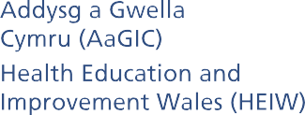

Final (Version 7)
Approved by HEIW Board, January 2021

INTEGRATED PERFORMANCE FRAMEWORK

Contents
1.0 Introduction 3
2.0 Purpose 3
3.0 Values and Behaviours 4
4.0 Approach 5
5.0 Embedding Performance Management 6
6.0 Taking Action 7
7.0 Accountability 7
8.0 The Performance Dashboard and Reporting 8
9.0 Performance Improvement Cycle 9

Appendix 1 Roles and Responsibilities 11

1.0 Introduction

Health Education Improvement Wales is the system leader for workforce for NHS Wales. In line with our vision of ‘Transforming the Workforce for a Healthier Wales’ we aim to ensure that training, education, workforce and leadership development are commissioned and delivered to a high quality. We will achieve our vision through delivery of our Strategic Aims which are shown below.

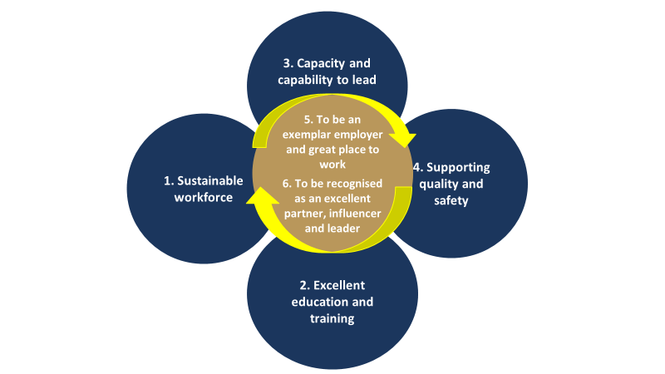

We are committed to developing a compassionate and collective culture that is underpinned by effective performance management and a focus on improvement. We consider that effective performance management is the responsibility of everyone in the organisation.

Our approach to measuring performance reflects our status as a unique organisation in NHS Wales. We have developed an approach to performance management that suits the functions of our organisation, drawing on practice in similar organisations across the UK. In the majority of our business areas we need to measure and monitor different indicators to the rest of NHS Wales and at a strategic level the reporting cycle for this is also very different, with a greater focus on academic cycles and annual timescales than the daily, weekly and monthly beat of other NHS organisations.

2.0 Purpose

The purpose of the Performance Framework is to describe the organisation’s system for making continuous improvements to achieve our Strategic Aims and Objectives and to deliver our ‘Business As Usual’ (BAU) activities effectively. It also enables the Board to scrutinise and provide assurance on the performance of the organisation. HEIW is publicly accountable for our performance and through the open Board reporting any other person or organisation with an interest in our responsibilities can understand how we are performing. The Performance Framework is part of our wider governance framework which ensures our business activities are undertaken in line with public sector accountability, due diligence and probity.

The development and communication of the Framework is a useful engagement tool to embed ownership of performance at every level of the organisation from teams, departments and Directorates through to the Executive Team and the Board. Along with our quality assurance and quality improvement activities, performance management forms part of the ‘I’ in HEIW and is at the heart of all that we do to enable continuous improvement in delivering quality, efficient and patient-focused education, training, workforce and leadership development. However, the management of individual performance is not addressed in this Framework but will be aligned to the organisation’s objectives and promoted through the application of HEIW’s Values Based Performance Appraisal and Development Policy.

Performance Management requires a system to be in place that improves performance through the consistent and regular review of the information that is important to the organisation as shown in the diagram.

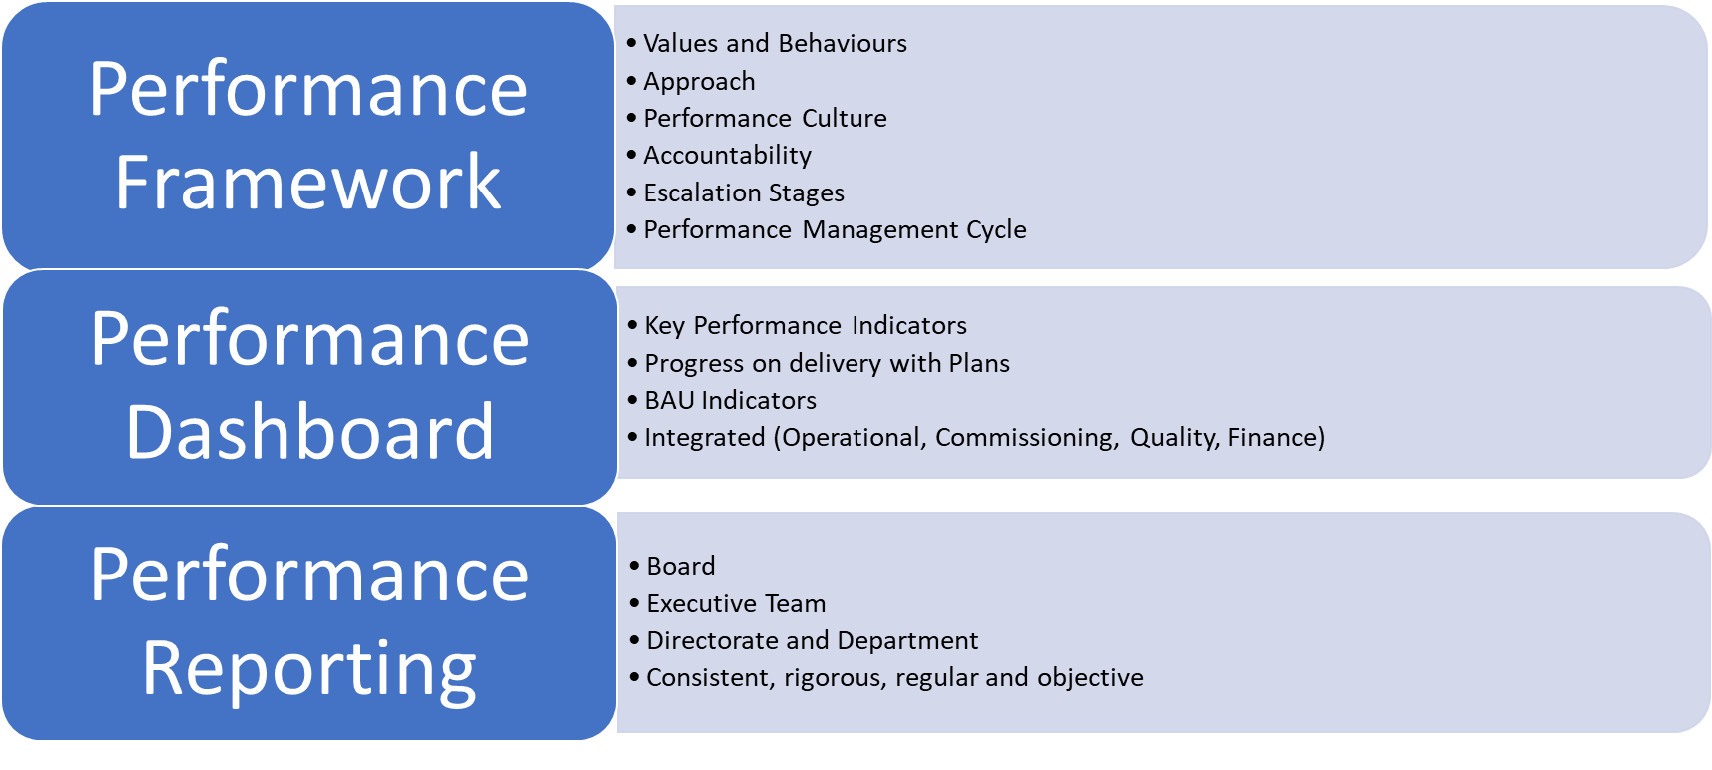
The Performance Framework sets out the system and how it will be operated, including:

- Value and Behaviours
- Approach
- Culture
- Accountability
- Escalation Stages
- Performance Management Cycle.

The Performance Dashboard includes the relevant data items that have been deemed by the Executive Team to be Key Performance Indicators (KPIs) which measure the progress with delivery of the organisation’s IMTP (or Annual Plan) and its Business As Usual activities.

Performance Reporting uses the Dashboard to provide a commentary on the KPIs, highlights issues by exception, tracks trends, measures against targets or benchmarks and identify mitigating actions.

The Performance Dashboard and Performance Reporting will be further developed as described in Section 8.0.

3.0 Values and Behaviours

HEIW is leading the work to create a shared culture across NHS Wales of compassionate and collective leadership at all levels. We also have clear organisational values which were co-produced by our staff and are underpinned by a set of behaviours that we expect each other to follow. Our aspiration is that taken together these will drive the way in which we do things in HEIW and how we interact with others.

The focus of performance management in HEIW is continuous improvement in line with our other work on quality assurance and quality improvement and the aim is to acknowledge good performance and to support improvement where needed. Performance management will be undertaken with a spirit of enquiry and is not punitive or blaming. We will operate this Framework and undertake all our performance management activities in line with our Organisational Values and the Compassionate Behaviours as set out below.

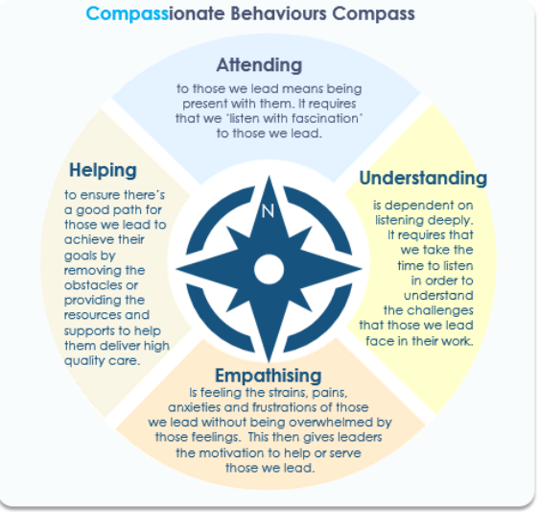

4.0 Approach

HEIW’s Compassionate Performance Approach is as follows.

- Improvement First - performance management is part of the ‘I’ in HEIW, aligned to our work on quality improvement and quality assurance.
- Proportionate - our performance improvement approach will be proportionate to the size and scope of HEIW as a strategic organisation within NHS Wales.
- Empowerment - by embedding performance management throughout the organisation performance is actively managed as locally as possible with assurance at Board, Executive Team and Directorate level.
- Knowledge Drives Action - All staff have a responsibility to share information and to escalate or to take action where performance issues become known.
- Transparency - Key Performance Indicators will be developed with teams and will be clear, consistent and systematically reported.
- Accountability - Roles and responsibilities are clear, good performance is acknowledged and the Escalation Stages are understood and fairly applied.
- Effectiveness - The operation of the Framework will ensure the organisation understands its progress in delivering the Strategic Aims and Objectives, laid out in its IMTP (or Annual Plan) and understands its BAU activities, particularly where teams are performing well, or if things are going wrong.

5.0 Embedding Performance Management

HEIW is a unique organisation in NHS Wales and has an improvement focus at its heart. To embed performance management in the way we work, Directorates and teams will be encouraged and supported to enquire about their own performance and individual and department objectives will be aligned to the organisational objectives as described in the Values Based Performance Appraisal and Development Review Policy https://heiw.nhs.wales/files/values-based-performance-appraisal-and-development-policy-v2

On an organisational basis performance will be monitored at the following levels:

Board assurance is high-level based on more detailed scrutiny in the Board Committees (particularly the Audit and Assurance Committee and the Education, Commissioning and Quality Committee). The Executive team will receive more frequent operational reports and Directorate-level scrutiny will take place twice a year through the Service Reviews. For more detail on roles and responsibilities see Appendix 1.

At present internal assurance and reporting is only at Board and Executive team and this will be expanded over the next eighteen months to encourage and support local management. Through the implementation of this Framework we will develop processes and systems which support the organisation to actively manage its performance as locally as possible, with assurance at Board, Executive Team and Directorate level.

Matrix working is promoted through the development and delivery of the Annual Plan, with Executive Leads and Senior Responsible Owners (SRO) agreed on a cross-organisational basis for each Objective agreed in the Plan, and these nominated leads are responsible for reporting on the delivery of the Objectives against the agreed milestones.

The system of Service Reviews at departmental level which take place bi-annually (mid and end of year) will continue as an integral part of the performance framework.

In addition to the internal reviews and reporting, Welsh Government review progress on the delivery of our IMTP on a 6-monthly basis through the Joint Executive Team (JET) and in the Quality and Delivery (Q&D) meeting cycle.

With regard to the quality of education and training, HEIW is accountable to the General Medical Council (GMC) and General Dental Council as the regulator for the quality of postgraduate medical and dental education and training in Wales. This responsibility is discharged through the commissioning of postgraduate medical and dental training, the application of HEIW’s Quality Management Framework and the accreditation of trainers for the GMC.

The organisation also meets the regulatory requirements of the Nursing and Midwifery Council, General Pharmaceutical Council, General Optical Council and the Health and Care Professions Council. In addition, structured, regular monitoring of the quality of education provision is taken through the education commissioning process.

Performance indicators regarding the discharge of these functions are included in the Dashboard and reporting or are under development for inclusion.

The Performance Management Cycle which includes the frequency of reports and reviews is included in Section 9.0

6.0 Taking Action

Performance management is not an end in itself and the principle of ‘Knowledge Drives Action’ means that success is determined by the action taken based on what the performance information is showing in a timely manner.

As well as the formal measurement, reporting and assurance cycle, all staff have a duty to share data and information and to escalate performance issues through the Directorate structures at any stage of the performance management cycle. This is particularly important whilst the Performance Dashboard and Reporting is still in its development stage. Once known, for continuous improvement to occur, the performance issue will be acted upon in order to remedy poor performance, share good practice and allocate resources effectively.

7.0 Accountability

The roles and responsibilities for the management and improvement of performance are set out in Appendix 1.

In a compassionate organisation it is important that good performance is recognised and celebrated, and any learning is spread throughout the organisation, for example through the regular Staff Forum, staff and stakeholder conferences, Board Showcase events and Annual Report. The Service Reviews are also an opportunity for departments to share success with the Executive Team and for this to be recognised in the CEO letter following the Review.

It is equally important in a compassionate organisation that additional support is provided for any performance challenges and issues. In these instances, the CEO will make a decision, in consultation with the Executive Team, as to whether informal improvement mechanisms are sufficient or whether the issue need to be escalated. The Chair will be informed of the decision to escalate any issue by the CEO and the Board will be informed at the next meeting or at the relevant Committee meeting.

Following the compassionate leadership principles, issues or areas of work will be put into escalation rather than individuals or teams. However, if it is identified that management action is required in an area of work in escalation, this will be addressed through the appropriate line management arrangements with advice from the People team.

Escalation means different levels of additional support as follows:

Escalation Stages | Rationale | Support
Enhanced Support | Significant difficulty in delivering strategic objective or BAU Indicator | - Consideration of Root Cause Analysis or process mapping to identify system issues.  - Additional support and input from Executive Team  - Weekly/regular monitoring meeting  - Action plan in place to address issue  - Progress Reports to Executive Team and by exception to the Board.
Targeted Support | Continued difficulty in delivering a strategic objective or BAU Indicator or further deterioration in original issue in Enhanced Support | - Above arrangements continue plus additional targeted resources are put in place to address issue.  - Review of OD requirements

8.0 The Performance Dashboard and Reporting

To support performance improvement HEIW will continue to develop the Board-level Performance Dashboard to include the most relevant set of KPIs.

A KPI is the measure of performance of an activity that is critical to the success of the business and must be both meaningful and measurable. The most effective indicators follow the SMART (Specific, Measurable, Achievable, Relevant and Timely) criteria. Well-defined KPIs engage staff, drive continuous improvement and encourage desired behaviours within the organisation, and these will continue to be developed with teams and approved for inclusion in the Dashboard by the Executive Team.

Each KPI will have an Executive and Management Owner that is responsible for ensuring the data included is verified as accurate and consistent and can provide a commentary on variation and trends. Every stage of the performance management process relies on evidence and data to allow us to make decisions on what is needed, what has been achieved, and how it compares. It is therefore vital that information is high quality, reliable and timely; meaningful; and presented with insight and commentary. In addition, the Dashboard will be developed further to include targets, trends and benchmarking information.

Due to the unique nature of HEIW’s activities most of the NHS Wales Delivery Framework measures do not apply to the organisation. Where national guidance does apply the KPI will be included according to this guidance to allow for benchmarking. However, many of our relevant KPIs are produced annually or quarterly and therefore, in line with the other UK Statutory Health Education Bodies, the reporting rhythm to the Board and the production of the Board-level Dashboard will move to quarterly from the beginning of 2020.

At present the Dashboard measures performance against the four quadrants below:

- Delivery of projects and programmes to improve and transform the workforce
- Education and Training activity
- Quality of Education and Training
- Corporate metrics for HEIW.
Over the next year the Dashboard will be developed to reflect the delivery of the organisation’s Strategic Aims and reviewed annually in alignment with the IMTP development process to ensure that changes in local, contractual and regulatory requirements are reflected.

To support the empowerment of performance improvement through the organisation other local Dashboards and reports will be developed to support the Performance Framework. This will include a more frequent ‘operational’ report to the Executive Team as well as biannual Directorate reports.

9.0 Performance Improvement Cycle

Our performance improvement approach is based on a cycle of continuous review and improvement and linked closely to the strategic IMTP planning cycle. The system is designed to ensure a proportionate, regular and effective approach to planning, monitoring performance, reviewing progress, agreeing actions, improvement and learning in a strategic organisation.

As a strategic organisation and to align with the monitoring of the Annual Plan/IMTP quarterly milestones the Board reporting will move to a quarterly cycle as follows:

Q1 Report September Board
Q2 Report (mid-year) November Board
Q3 Report March Board
Q3 Report (end of year) May Board.

This will also align with the biannual JET meetings and internal Service Reviews.

In order to ensure there is appropriate scrutiny and assurance of operational indicators a monthly Executive Team report will also be developed.

Continuous improvement depends on all staff at every level. Every team needs to be fully engaged in the performance management process. This has the added benefit of demonstrating the work that they do is important and valued. This circular approach applies equally to finance, corporate and workforce divisions who provide advice and support to other divisions. Our progress in delivery or our plans and BAU activities will inform our planning for the following year.

Appendix 1 Roles and Responsibilities

Effective performance management requires defined roles and responsibilities and clear ownership of Key Performance Indicators as follows.

The Board
The Board sets the strategic direction for HEIW and approves the Annual Plan/IMTP for submission to the Welsh Government in line with the NHS Wales Planning Framework. At a strategic level the Board scrutinises and assures the performance of the organisation which includes the delivery of the Annual Plan/IMTP and delivery of our ‘Business As Usual’ activities. The Board will approve the suite of Key Performance Indicators which is included in the Dashboard, as these are developed.

Board Committees
HEIW has three Committees. The Committees report to and provide assurance to the Board in respect of their areas of responsibility which are outlined below:

- The Audit and Assurance Committee keeps under review the design and adequacy of HEIW’s governance and assurance arrangements and its system of internal control.

- The Education, Commissioning and Quality Committee enables the Board to undertake greater scrutiny in respect of commissioning, monitoring and quality assessing of education and training.

- The Remuneration and Terms and Conditions Committee considers and recommends salaries, pay awards and terms and conditions of employment for the Executive Team and other key senior staff.

Executive Team
The Executive Team comprises HEIW’s Directors and the Board Secretary. The Executive Team has collective responsibility for operational decision-making and delivery of the Annual Plan/IMTP and the organisation’s Business As Usual activities. The leadership and line management of all staff flows from the Executive Team.

The Executive Team will consider the strategic performance reporting before formal scrutiny by the Board and will also regularly scrutinise the operational performance of the organisation. If the performance of an issue or area of work is escalated, the Executive Team is responsible for overseeing the escalation arrangements and advising on whether enhanced escalation or de-escalation is appropriate. The Team will ensure that the operation of this Framework is undertaken in line with the organisation’s Values and the compassionate leadership principles.

The Team will agree changes to the Dashboard for recommendation to the Board for approval, including the suite of Key Performance Indicators that will be reported.

Senior Leadership Team
The Senior Leadership Team (SLT), through monthly formal meetings, provides a forum for Directors and Senior Team Leaders to discuss matters of strategic or operational significance prior to onward transmission or cascade. The SLT as a forum does not have a formal role in the Performance Management process.

The Chief Executive Officer
The CEO is the Accountable Officer and has overall statutory responsibility for the governance and performance of the organisation. The CEO will decide, using relevant information and discussion with the Executive Team, whether the performance of an issue or area of work requires escalation under this Framework, and when enhanced escalation or de-escalation is appropriate.

The CEO has delegated responsibility for the detailed operation of this Framework to the Director of Planning, Performance Corporate Services.

The Director of Planning, Performance and Corporate Services (PPCS)
The Director of PPCS leads the development and implementation of the Performance Framework and has delegated responsibility for preparing, implementing and updating this Framework. The Director of PPCS will ensure that systems are in place for the measurement of national and local measures and KPIs which are reported via the Dashboard(s) and that the Integrated Performance Reports are produced for scrutiny and assurance by the Executive Team and the Board. The Director will ensure that these include transparent reporting of areas of good progress as well as areas of performance that require attention and/or escalation. The Director of PPCS will also seek to ensure that governance arrangements and sustainable resources are in place to support effective performance improvement and management.

The Director of PPCS leads the PPCS team who run the system described in the Performance Framework and provides a range of support functions working closely with staff and management across HEIW. The team implements the Framework by:
- ensuring the performance cycle is maintained and reporting requirements are met.
- working with services, in partnership with the Workforce Analytics team, to develop the KPIs, Dashboard and Reports and maintain the Data Glossary.
- working with KPI Management and Executive Owners, in partnership with the Workforce Analytics team, to ensure data quality and consistency.
- working with services, in partnership with others, to undertake targeted work to improve performance as required.

The Director of Workforce and Organisational Development (WOD)
The WOD leads the Workforce Analytics team who will support the Performance Framework by:
- maintaining and developing the Performance Dashboard and ensuring it is updated in line with the performance reporting cycle.
- working with the performance team to develop the KPIs, Dashboard and Reports and maintain the Data Glossary.
- working with KPI Management and Executive Owners, in partnership with the performance team, to ensure data quality and consistency.
- working with services, in partnership with others, to undertake targeted work to improve performance as required.

Individual Directors
Individual Directors are the Executive Leads for the delivery of Annual Plan/IMTP Objectives and are responsible for ensuring that they are delivered and progress is reported in line with the performance reporting cycle.

They are also the Executive Owners for designated KPIs as included in the Data Glossary and are responsible for ensuring that the KPI data is validated and consistent and any issues are transparently reported.

The Executive Owner is responsible for:

- Ensuring the functions of the Responsible Owner are carried out;
- Advising the Executive Team or Board of any issues with the reporting or with the performance measured by the KPI; and,
- Taking action on a local basis to resolve reporting difficulties or advising the Executive Team on escalation if required.

Individual Senior Team Leaders / Responsible Owners
Individual members of the SLT, and other team leaders are SROs for the delivery of Annual Plan/IMTP Objectives and are responsible for delivery and that progress is reported in line with the performance reporting cycle.

Individual members of the SLT, and other team leaders, may also be Responsible Owners for designated KPIs as included in the Data Glossary and will ensure that the KPI data is validated and consistent and any issues are transparently reported.

The Responsible Owner for the KPI is responsible for:
- Ensuring the data is validated and correct and reported on time in line with the reporting schedule;
- Ensuring the data is reported consistently from one period to another;
- If there are any changes to the definition or data used, making sure this is transparently reported to the Workforce Analytics and performance teams; and,
- Helping to investigate and explain any variation in the performance between periods.

All Staff
Every employee contributes towards performance improvement and management by being encouraged and supported to identify improvement opportunities and to take the required action. It is important that staff own the data and information on their activity and understand how that contributes to the corporate performance of the organisation. All staff have a responsibility to ensure that good progress is celebrated and any performance issue or off-track progress is transparently reported in the spirit of compassionate and collective leadership laid out in this document.

Individual objectives will be aligned to the organisation’s objectives as described in the Values Based Performance Appraisal and Development Review Policy.

