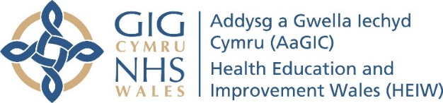

2019-20 Commissioning Process Lay Representative Feedback Form

What Commissioning meeting did you attend (please state which Health Board/Trust):

Date of meeting:

In Advance of the Commissioning Meeting

Was the communication prior to the Commissioning meeting appropriate and did it provide you with all of the information you required?
Yes ☐ No ☐

Comments:

Is there any additional information that it would have been helpful for you to have received in advance of the meeting?
Comments:

How well do you feel that you understood the purpose of the meeting and your role at it prior to attending?
Full understanding ☐ Partial understanding ☐ Little understanding ☐ No understanding ☐

Comments:

Commissioning Meeting

Was the meeting conducted in an open and transparent manner?
Yes ☐ No ☐

Comments:

Were all attendees treated with dignity and respect?
Yes ☐ No ☐

Comments:

Were all attendees encouraged to participate?
Yes ☐ No ☐

Comments:

Were you given the opportunity to participate and raise concerns if necessary?
Yes ☐ No ☐

Comments:

Did the Commissioning meeting encourage a two way conversation between HEIW and LEP representatives?
Yes ☐ No ☐

Comments:

Was there appropriate representation from HEIW to enable effective discussion?
Yes ☐ No ☐

Comments:

Was there appropriate representation from the LEP to enable effective discussion?
Yes ☐ No ☐

Comments:

Was the Commissioning process effective in assessing compliance with the GMC’s standards for medical education and training?
Yes ☐ No ☐

Comments:

Did the Commissioning meeting provide a focus for identifying and considering challenges and opportunities for the year ahead?
Yes ☐ No ☐

Comments:

Any other feedback

Do you have any further comments on the Commissioning process (e.g. issues you wish to raise, suggestions for improvement, etc?
Comments:

Thank you for taking the time to complete this form. Please return completed forms via email to heiw.qa@wales.nhs.uk or by post to Quality Unit, HEIW, Ty Dysgu, Nantgarw, Cardiff, CF15 7QQ.

