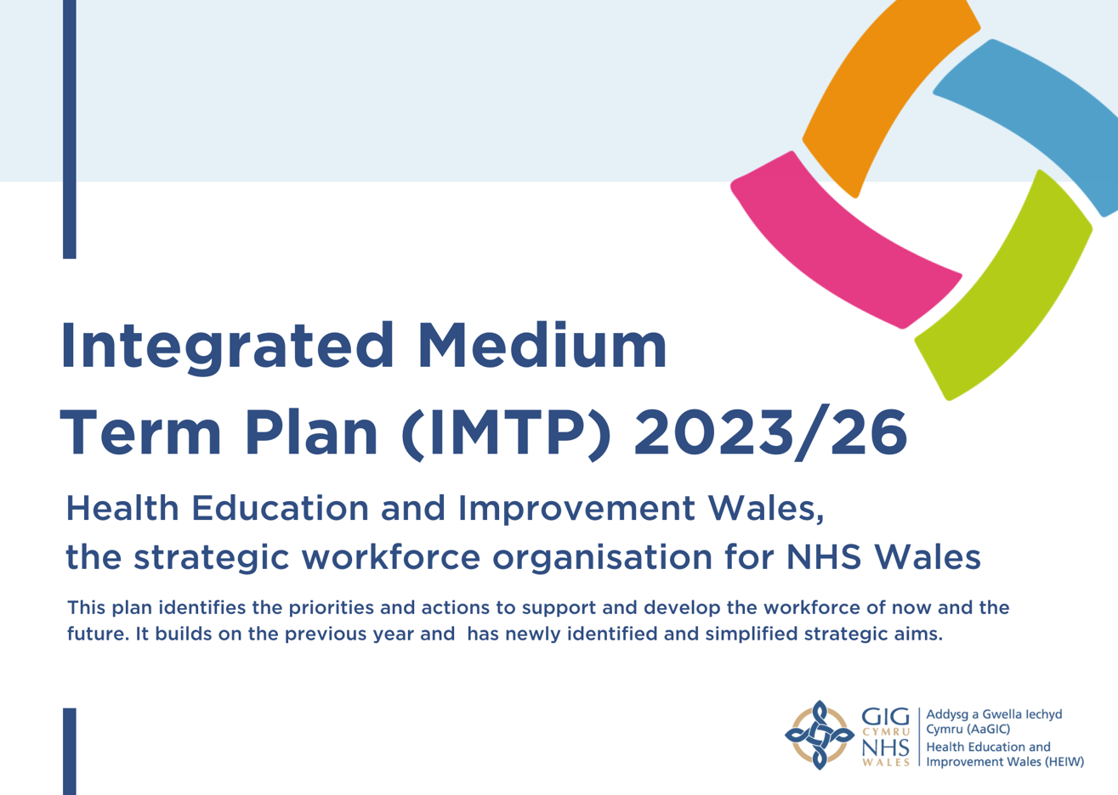
Contents
Plan on a Page 2
Foreword 3
Chapter 1: Who we are and what we do for the Workforce in Wales 5
Chapter 2: Strategic Context and Stakeholder Engagement 9
Chapter 3: Our Strategic Aims, Objectives, and Deliverables 15
Our strategic aims, objectives and the deliverables and outcomes for 2023-24 20
Building our Future Workforce - Developing and implementing plans that align the future demand for workforce with supply 20
Developing our Current Workforce - transforming today’s workforce to contribute to new models of care which improve quality and safety 26
Shaping Culture and Leadership in NHS Wales – embedding compassionate leadership principles to develop cultures that support inclusion, wellbeing, and quality 31
Chapter 4: Enabling Plans – Our Seven Foundations for Success 34
Chapter 5: Financial Plan 38
Chapter 6: Accountability and Measuring our progress 42
Chapter 7 – Deliverable Plans 43
APPENDIX 1 44

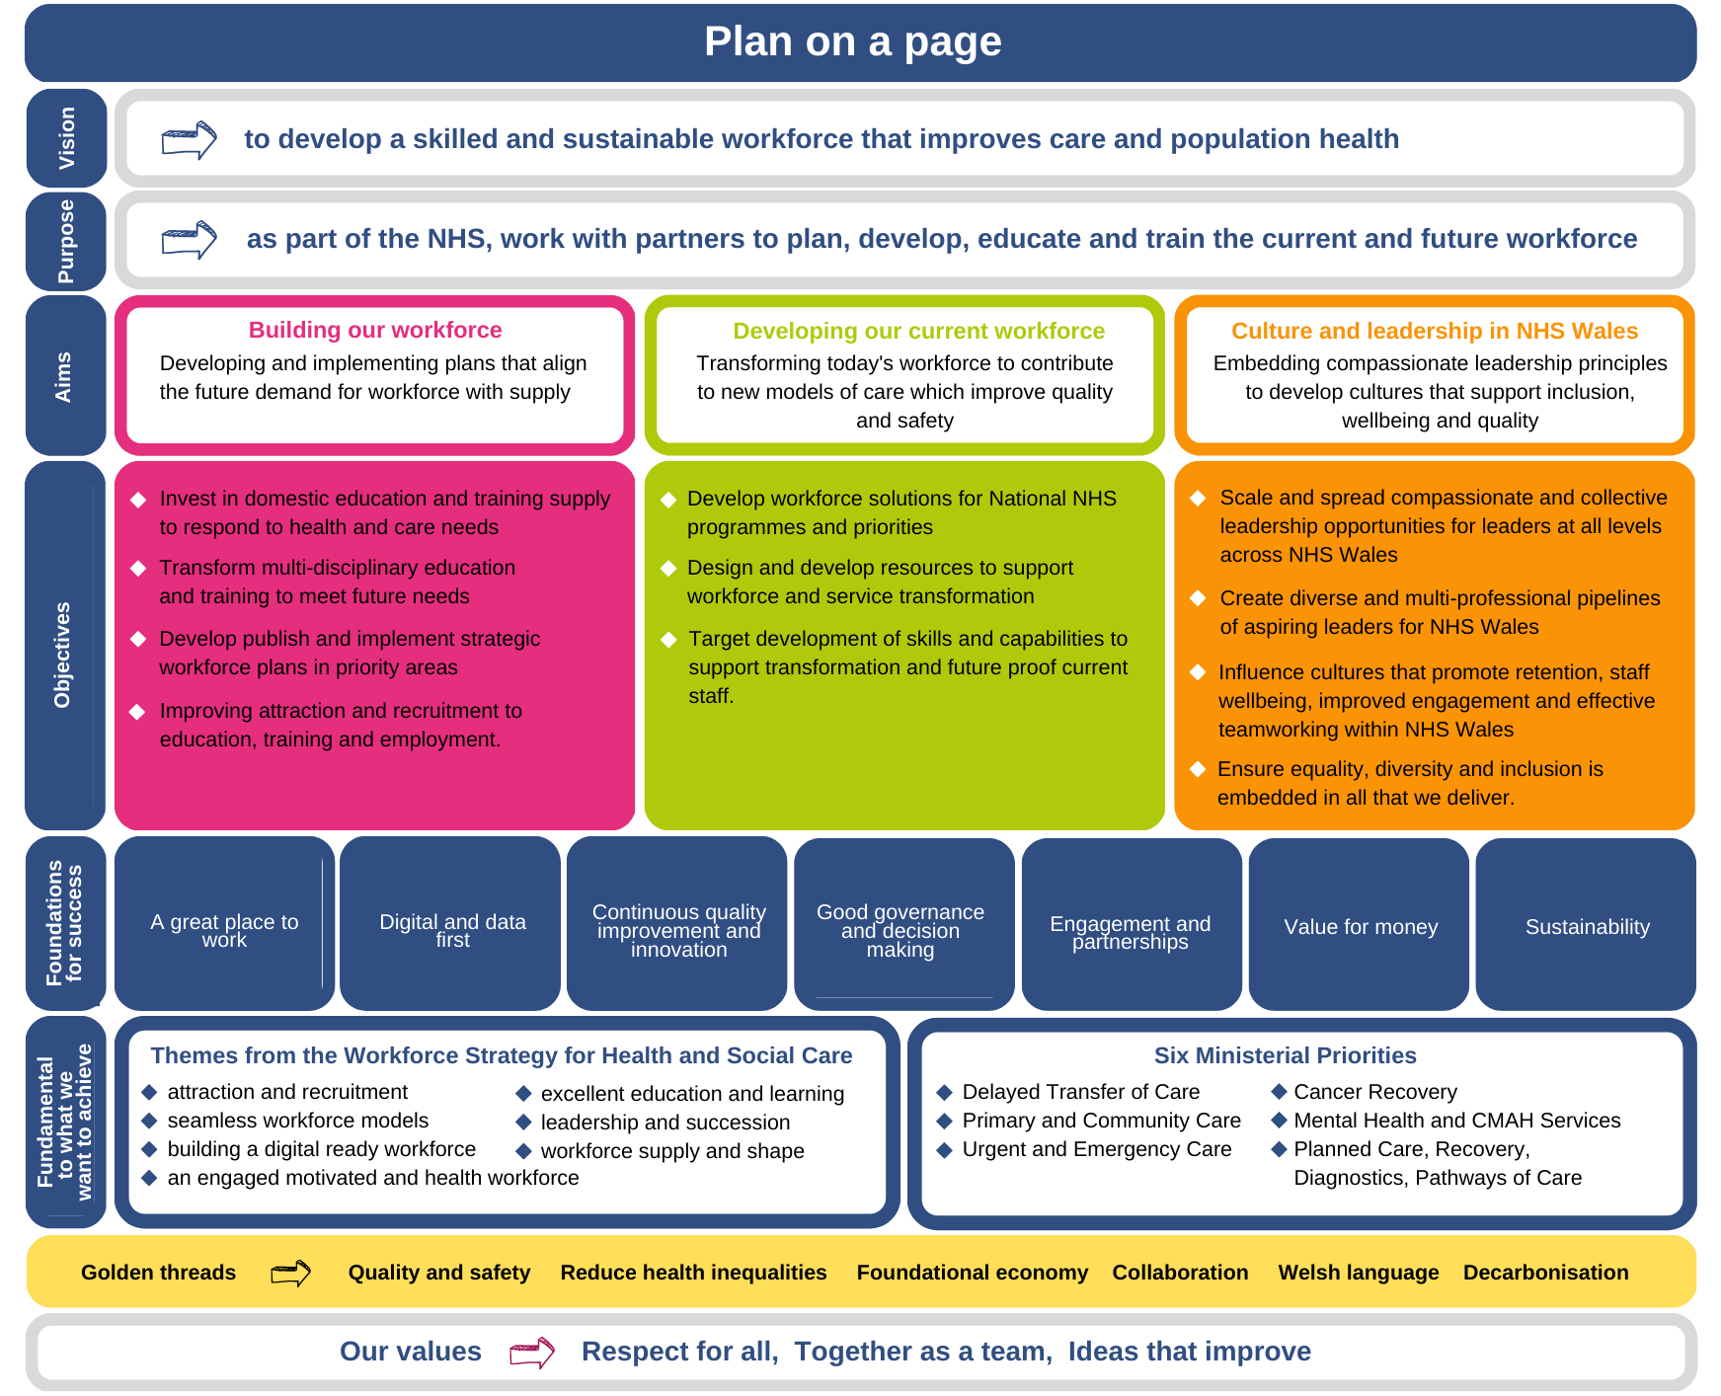
Plan on a Page

Foreword
Health Education and Improvement Wales (HEIW) is the national strategic workforce organisation for NHS Wales. We are committed to supporting a world leading health and care system in Wales through the delivery of our strategic aims and objectives for 2023-26, which will drive the development of a highly qualified, empowered, and sustainable workforce for both now and the future.

We have created a coherent, financially balanced strategic plan to attract, retain and develop the NHS workforce, in the context of the Workforce Strategy for Health and Social Care in Wales. Our plan sets out our vision, purpose and functions and describes the way in which we will contribute to the Ministerial Priorities and the National Workforce Implementation Plan.

Workforce is the key strategic issue at the heart of the service and one of the key quality challenges affecting health and care in Wales, and it is essential that we continue to work together to optimise investment in our future pipeline and increase the support and development available to our current workforce. We believe that through the development and expansion of education and training opportunities in Wales we play a key role in the foundational economy.

Our plan has been formulated at a time of instability, including the impact of war, a cost-of-living crisis, a winter of industrial action and a system experiencing the knock-on impact of a crisis in adult social care.

We also recognise the difficult financial context creating urgent funding pressures and we have reprioritised activity to focus on workforce interventions that offer the highest value within our financial allocation to ensure our plan is affordable and deliverable but sets out our ambition clearly for all our stakeholders and partners to see.

Data and workforce intelligence are central to delivering HEIW led national strategic workforce plans and NHS organisations’ strategic workforce plans. This year will see the creation of a workforce insights and observatory function that will act as a centre of excellence for workforce intelligence using high quality standardised data sets, analytical methods, and sophisticated modelling techniques to support workforce planning, development, and productivity. The outcome will help us to better match demand and supply of workforce across the system.

We are delighted that our Education and Training Investment Plan for 2023-24 https://heiw.nhs.wales/files/heiw-etp-2023-24/ was approved by Welsh Government in January 2023, and this is a core part of our IMTP. We will continue to expand the education and training pipeline across all professions in Wales, recognising the concerted and collective effort that will be required to increase interest and take up in health professional roles. This also needs to recognise our increasing reliance on international graduates and recruits, and the desire amongst our students and trainees for more flexible training and working.

Retention of the NHS workforce at this time is critical and we will continue to work in partnership with our stakeholders to address this, implementing strategic retention programmes such as continuing professional development, wellbeing, and compassionate leadership. This is both for the system and us as an organisation. We want staff to recognise the benefits of collective and compassionate leadership and identify HEIW as a great place to work.

We continue to implement our Strategic Equality Plan and a programme of work to enable delivery of the Anti-Racist Wales Action Plan.

We will also continue to implement and embed the Welsh Language Scheme in HEIW and work with partners to deliver the required actions in More Than Just Words to increase the Welsh language skills of the workforce, including exploration of the role of HEIW in respect of the Welsh translation profession.

We are supporting staff in tackling climate change and have plans this year to focus on climate smart leadership across the system. This year we will develop research and evaluation skills to support innovation and to share this widely across the system.

This IMTP is a step change in terms of ambition and pace for our plans and addresses the requirements necessary to see transformational change across the system addressing workforce issues.



Dr Christopher Jones, CBE, Chairman
Ms Alex Howells
Chief Executive

Chapter 1: Who we are and what we do for the Workforce in Wales
This chapter sets out who we are and what we do for the workforce in Wales. It outlines our vision, purpose, and our key functions. It also describes our added value and impact.
HEIW is the strategic workforce body for NHS Wales. We have a unique contribution to make in addressing strategic and specialist workforce issues, making Wales a great place to train and work for our health and care staff and maximising the contribution of all professions and occupations through our statutory functions.

Our Vision and purpose
Our vision is “to develop a skilled and sustainable workforce that improves care and population health”. Over 100,000 people work in the NHS in Wales and are pivotal to building a sustainable health and care system that meets the needs of the population.

Our purpose is, “as part of the NHS, to work with partners to plan, develop, educate and train the current and future workforce”.

Our key functions are as follows:

Education and Training, Planning Commissioning and Delivery
We plan, commission, deliver and quality manage undergraduate and postgraduate education and training for a wide range of health professions. We are the Welsh Government’s development partner for the suite of healthcare apprenticeship frameworks. We spend the largest proportion of our budget on commissioning education and training for NHS Wales to ensure future supply.

Leadership Development
HEIW is responsible for setting the strategy, principles, and frameworks for leadership development across Wales, based on compassionate and collective leadership. Together with the commissioning and delivery of leadership development activity for key groups, we lead on succession planning and talent management for aspiring Directors and Chief Executives.

Workforce Strategy, Planning, and Intelligence
As well as providing strategic leadership for the development of workforce planning capacity across the NHS we play a lead role in the development of strategic workforce plans and the provision of analytical insight and intelligence to support the development of the current and future shape of the workforce.

Workforce Development and Transformation
We support workforce transformation and improvement to respond to significant service challenges, including skills development, role design, continuous professional development, and career pathway development.

Professional support for workforce and organisational development
We support the development of the workforce and organisational development profession within Wales.

Quality
The quality of our education and training, both direct and commissioned, is continuously improving and teams across the organisation work to implement and embed quality standards of national frameworks and strategies in HEIW work and throughout the wider system through our collaborative activity.

Careers and Widening Access
We promote health careers and the widening access agenda to ensure that opportunities to work in the health and care system are available to all. We work to include people in our communities that have valuable skills and experience that are currently under-represented in our workforce.

Retention
We are working with our system partners to embed health and wellbeing in working practices to drive retention.
Our added value and impact
Our added value to the system is our ability to develop national strategic solutions to address workforce demand and supply. A range of innovative and high impact activity has taken place in the last year bringing great benefits for the system.

Our most notable achievements stem from the actions in our Workforce Strategy for Health and Social Care (2020). Organisations are now using the strategy to shape their workforce plans and we continue to use it to frame our profession specific workforce plans including the published Mental Health workforce plan and the forthcoming workforce plans for Nursing, Perinatal, Pharmacy and Dentistry. We have also made significant progress since the launch of the strategy on the development of health and wellbeing frameworks based on common principles and approaches across health and social care workforce. We will continue to monitor their progress through national surveys and performance management mechanisms.

Roles are being promoted through the National Health and Social Careers services reaching out to all parts of the community and workforce. We are working together with Social Care Wales to build our existing brands of WeCare and TrainWorkLive to attract and recruit staff to our sectors and delivering targeted campaigns for significant shortage group such as domiciliary care, pharmacy, and nursing. The Careersville platform is also being widely used to promote health and social care careers.

We developed and rolled out new roles including Care Home Education Facilitators (CHEF) which has started to expand the training on offer to workers in care homes. In addition, we implemented the new Clinical Associate in Applied Psychology (CAAP) roles into mental health multi-disciplinary teams. Health Boards in Wales have started recruiting CAAP posts and we will procure a suitable CAAP course for delivery in Wales. This exciting initiative will increase the career pathways available for clinical psychology and psychological therapy. This will contribute to the creation of a sustainable mental health workforce.
We also supported a new workforce model for Anaesthesia in Wales with the exciting introduction of a new Anaesthesia Associate role, which aims to provide an invaluable service to patients and support to doctors in ICUs and HDUs. We commissioned the training programme with Swansea and Cardiff with a view to recruiting new Anaesthesia Associate trainees from 2023. This initiative will support the delivery of safe and high-quality Anaesthesia services across Wales.

In 2020, we were particularly proud to publish the strategic Mental Health Workforce Plan for Health and Social Care that we developed which is the first of its kind in Wales. Developed in partnership with Social Care Wales, the plan supports Welsh Government’s Together for Mental Health and places sharp focus on some early priorities including CAMHS, Clinical Psychology and Perinatal Services. This plan will help develop a workforce that can respond to the demand on mental health services in the future and give people the best care possible.

In 2022, we published Informing the Future Workforce for Critical Care Services, a plan that identifies the solutions to resolve longstanding workforce challenges within critical care services. It places workforce expansion and education at the centre of future critical care service development and a focus on the development of new workforce roles within critical care units.

Working collaboratively with partners, we implemented a multi-professional Primary and Community Education and Training Framework. This will develop and expand the multi-professional workforce that underpins the primary care model. This will deliver high quality training and development for all professional groups based on clear and consistent standards. It will also contribute to the sustainable development of the primary and community workforce to enhance recruitment and retention.

In 2022, we were delighted to launch the General Practice Nurses (GPN) Foundation Programme which provides a standardised pathway for nurses who want to develop a career as a GPN. This will increase a supply of nurses trained locally, helping to improve retention within primary care settings, inspiring future GPNs to support patient care for future generations.

We completed the first All Wales Simulation Strategy following extensive consultation with stakeholders, and this will be implemented in 2023. This will provide the foundation for developing quality assured training to a high standard in a safe learning environment with an emphasis on interprofessional opportunities to promote collaborative working in the clinical setting.

In partnership with the Schools of Pharmacy at Cardiff and Swansea universities, we supported students training to become pharmacists to be given extra time in supervised placements in the community, General Practices, and hospitals during their four-year programme. The increase in the number and quality of clinical placements will ensure that pharmacists with enhanced clinical skills are produced and make the training programmes more attractive to potential students.

We are rolling out GatewayC, an online cancer education tool for General Practitioners and their staff to support education and processes around earlier detection of cancer. It is hoped that this resource will improve cancer outcomes by facilitating earlier diagnosis and improve patient experience.

We undertook a significant piece of work to ensure that our education and commissioning work meets the needs of the health and Care system, collaborating with university providers, City and Guilds and other awarding bodies to support the delivery of new qualifications, ensuring there are improved opportunities to learn through the medium of Welsh and maximising opportunities for work-based learning and apprenticeships. We have consistently grown workforce numbers across professions including speciality medical and foundation places, physiotherapy, paramedics, podiatry, and nursing with an increase of 857 pre-registration nursing places across the last three years. We developed the education and training plan for NHS Wales and recommended an increase in health professional education and training budget to include extra training places for a wide range of NHS professionals in Wales, which was approved by Welsh Government. Building on growth from previous years, the additional education and training places mean increased numbers of a range of qualified healthcare professionals will be available to deliver quality care to our population and work in Wales in a range of roles and locations.

Significant progress has been made with embedding leadership and compassionate leadership principles through the compassionate behaviour compass and a growing number of resources have been made available through the Gwella leadership portal as well as developing professional leadership networks and communities of practice. We have also produced and rolled out a national staff and wellbeing framework for NHS Wales and a national retention guide is being led through the nursing workforce programme.

Our new Digital and Data strategy for HEIW sets out our approach to digital and data business intelligence over the next five years. We are increasing digital capability throughout the workforce, enabling them to work and learn using appropriate technology and digitally enabled ways of delivering health and care services. We were delighted that in December 2022, our new learning management system, Y Ty Dysgu was launched. This will provide us with a standardised approach to managing courses and delivering online learning activities. It will also maximise opportunities for multi-professional learning and provide the platform for the delivery of our Digital Capabilities work.

We have also been building capacity and capability in strategic workforce planning and development across health and social care underpinned by our six-step model. We have developed resources, tools, and intelligence to support the Health Boards and Trusts to undertake strategic workforce planning to help others understand the drivers creating the demand and the solutions for supplying the workforce.

We have been monitoring the key and emerging risks and issues that have impacted on the delivery of our IMTP. Recruitment to health and care training has been especially challenging this year, particularly in the nursing professions, caused by an increase in the number of commissioned places and the simultaneous fall in number of applications, most notably in adult nursing and learning disability nursing, resulting in the inability of HEIs to recruit to the targets set. This has been identified as a risk for the new IMTP and significant mitigation has been put in place to reduce the impact in the coming year.

We depend heavily on our ability to engage and collaborate with NHS partners to implement change within the system and recognise that because of the immense pressure on the system currently, there is a risk that this will become more difficult to achieve. We have therefore streamlined our engagement approaches and prioritised activities in key areas.

Procurement has also been raised as an issue that has impacted on the progress of some of our activities and work has been undertaken to understand the issues and we have revised our methodology to resolve this issue.


Chapter 2: Strategic Context and Stakeholder Engagement
This chapter describes the strategic context in which we operate. We have ensured that our strategic framework supports the strategic direction of NHS Wales and the wider contextual environment. We have also summarised the findings of our engagement with our wide range of stakeholders.
Our culture, values, and behaviours
As a workforce-focussed organisation our culture and the way we do business are very important to us, and together with our staff we have developed our organisational Values:
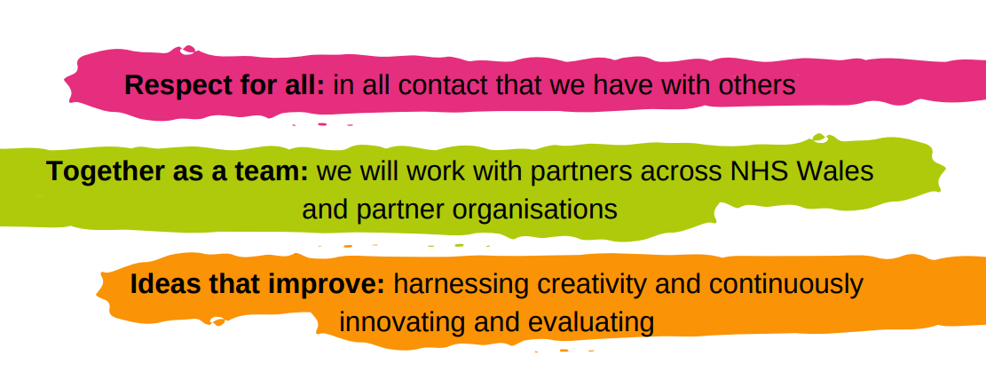This provides the internal operating context for delivering our planned activity.

National drivers and system context
As a strategic organisation it is essential that our plans are developed in the context of future trends and needs, and the wider environment for health and care. We undertook a PESTLE analysis and following this identified our key considerations for this year include:

- National policy and legislation detailed in Appendix 1
- National Workforce Implementation Plan
- Duty of Quality
- Duty of Candour
- Cancer Improvement Plan for NHS Wales 2023-2026
- Workforce intelligence and insights
In reviewing the above to inform and shape our plan the importance of the following themes has been reinforced:
- Professional standards, remits, behaviours, and codes of conduct
- New roles and ways of working to address current deficits/support registered workforce
- Importance of retention
- Flexible working
- Changes to education and training to meet changing needs
- Valuing our staff and promoting wellbeing
- Need for longer term system wide workforce planning
- Support for international graduates
- The importance of Equality Diversity and Inclusion
- Digital literacy and inclusion
- Compassionate and collective leadership

We have aligned our plans to NHS Wales policies which set the context for health and care in 2022-23 such as the Wellbeing of Future Generations Act (2015), the National Clinical Framework (2021) and the Workforce Strategy for Health and Social Care (2020). The main implications for us include building more effective working relationships with Welsh Government and key stakeholders; promoting and demonstrating the value and benefit from the investment in the workforce; developing our plan with realistic expectations about new investment; continuing to improve our capacity to predict and model future demand; exploring all opportunities to support students and trainees; embedding sustainability in all our functions; focusing on developing the primary, community and integrated care workforce; and developing innovative ways of widening sources of supply.

The National Workforce Implementation Plan (NWIP) (2023) describes 78 urgent actions to tackle the most important workforce challenges/issues currently being experienced in the NHS in Wales now. It also recognises the Workforce Strategy for Health & Social Care and a large part of HEIW activity is explicitly or implicitly linked to the implementation plan for the phase 2 actions. We will also sit on the Strategic Workforce Implementation Board alongside key partners and look forward to collaborating on the development of the implementation plan for the Social Care workforce. The actions we are responsible for delivering are reflected across this plan.

A key influence on our plans and development in 2023/24 will be the implementation of the duties of quality and candour. As an organisation which does not directly provide care, we need to consider how these duties become embedded in our functions. We will build upon the work we have undertaken to develop our current quality framework for education and training and work with the new quality statements in the development of clinical services.

We will also comply with the duty of candour, to ensure that we are open and honest when things go wrong.

There are sustainability issues across the health and care workforce due to recruitment, retention and the current age profile of key professional groups who are critical to the effective delivery of services. Expectations of the Workforce are changing with an increase in staff wanting flexible working patterns and part-time opportunities (LTFT) resulting in a decreasing pipeline. Changes in education and training standards and the reform of independent contracts is opening opportunities for new workforce and service models. In addition to the workforce challenges, economic and social global/national issues such as cost of living, recovery from covid-19 and Brexit are impacting upon the sustainability of the future workforce across all sectors of health and care. Technological advances could significantly reshape care in the medium to long-term (AI, Genomics) and will impact upon how staff deliver care utilising these innovations and in turn on their education and training requirements.

Key Risks

As part of the Risk and Board Assurance Strategy, the Board will review the Corporate Risk Register at each Board meeting and the Board Assurance Framework bi-annually. The identification of key risks during the planning process has provided a clear view of what may affect our ability to deliver our ambitious plans.
We identified three key external risks to delivery of our IMTP:

- If further challenges occur in this already difficult and constantly evolving strategic environment, we could be slow in our response and our focus diverted away from delivery of this plan, resulting in the failure to deliver the agreed strategic aims and objectives within this plan. This would have a detrimental impact our organisation’s reputation. Our mitigating action includes improving access to robust workforce intelligence and regular horizon scanning by our senior leaders and creating an agile response to key and emerging risks and issues that might impact negatively on the delivery of our plan.
- If HEIs are unable to achieve the commissioned level of university student places on the health professional nursing and allied health programmes to grow the workforce required in response to identified need, this could impact the ability to fully achieve the required number of students and will result in an underspend position in year. Our mitigating actions involve undertaking a significant piece of additional work this year in partnership with HEIs to maximise the numbers on commissioned programmes.
- If we are unable to engage with our partners due to service pressures, then we might not be able to undertake collaborative work or consultations in a sufficiently meaningful way, to achieve the desired improvement. Our mitigating action involves Senior Responsible Officers making use of efficient governance structures to support effective engagement, focusing on existing pathways and aligning across strategic programmes of work wherever possible.

We also identified three key internal risks to delivery of our IMTP:

- If we are unable to provide excellent digital systems or provide quality data for data modelling, then this could have an adverse impact on NHS workforce planning, and we would fail to meet the expectations of those requiring data and digital support and negatively impact the delivery of our IMTP commitments. We have considered our mitigating actions, and these are articulated within the HEIW Digital and Data Strategy (2023-2028).

- If we are unable to manage the procurement of services, over and above the existing volume of activity, at the right time, then it might impact on the lead time needed to procure the services highlighted in our plan. The mitigating action involves HEIW finance leads working with senior leaders in the organisation and procurement staff to identify and plan for these significant requirements in the coming year. Training and resources are also being developed to ensure there is capability to deliver at the required pace to create efficiencies in capacity.
- If we are unable to fund additional resources to provide the capacity and capability within our existing workforce in year, or specialist skills to deliver these plans, then this may impact negatively on the successful delivery of our IMTP commitments and our ability to support the NHS. Our mitigating action has required our Executive Team and Senior Responsible Officers to review the additional resource identified and to prioritise those that need to be covered within current resources, require in year flexibility, or will need to seek additional funding from Welsh Government.
POLITICAL | ECONOMIC | SOCIAL
- Lack of stability at UK level.  - Policy decisions affecting economy and NHS budget.  - Current and unresolved threat of industrial action.  - Changing relationship and interface with Welsh Government – NHS Executive.  - Focus on workforce planning and deficits e.g., in Senedd and from professional bodies.  - Commission for Tertiary Education.  - New National Workforce Implementation Plan. | - High inflation and high energy, fuel, and food costs is likely to continue into 2023.  - Changes to NHS Pensions scheme implemented in October 2022.  - Pay in healthcare not as attractive as in other areas.  - Significant financial challenges for NHS in next few years in terms of revenue and capital. | - Growing and ageing population with more complex health needs (peak death period).  - Current shortages of staff across the workforce (nurses and GPs in particular).  - Impact of the pandemic on mental health and emotional well-being.  - Cost of living crisis and impact on current and future workforce including student numbers.  - Poverty due to social deprivation.
Constructively challenging current approaches to find appropriate short-, medium-, and long-term solutions | Ensuring value for money through the planning and quality of our educational provision to get it right first time | Demonstrating our social and economic duty to widen access and provide greater flexibility in education and employment
TECHNOLOGICAL | LEGAL | ENVIRONMENTAL
- Technological changes have been made at pace due to Covid.  - Medical advances in technology such as Genomics have the potential to change the shape of patient care.  - Improved learning platform systems for education.  - Digital solutions to enhance workforce planning. | - Health and Social Care (Quality & Engagement) (Wales) Act (2020).  - More than Just Words, strengthen Welsh language.  - The draft Mental Health Bill (2022) proposes reforms that will cut across Health and Social Care.  - Changes to the Education Standards Regulations and Laws. | - Welsh Government ambition for the public sector in Wales to be net zero by 2030.  - Extreme weather conditions and impact on people.  - Increased energy costs because of the cost-of-living crisis affected by the war in Ukraine.
Demonstrating delivery of interactive education and improvements in the digital literacy of the workforce | Outlining workforce transformation across the whole pipeline that helps improve team-based working | Highlights how we will Influence the reduction of carbon emissions through leadership and climate smart education
PESTLE Analysis

Developing, reporting, and delivering our IMTP

Our Integrated Planning Approach
Our integrated approach to planning involves triangulation between Workforce, Finance, and activity planning with the completion of the Minimum Data Set (MDS) technical templates and financial returns.

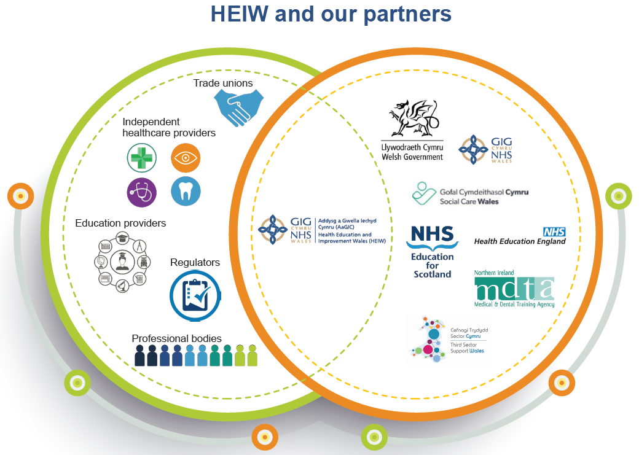
Stakeholder and staff engagement
As an All-Wales organisation the importance of communicating and engaging with our partners and stakeholders cannot be over emphasised.

The purpose of our engagement with stakeholders and staff was to seek out their views and priorities to ensure that our plans aligned to deliver the change the system requires.

Through the Stakeholder Reference Group (SRG) we have also engaged with over 40 different organisations in two dedicated sessions on our draft IMTP. We shared the draft plan with our stakeholders and feedback was submitted to us.

We met with virtually all NHS Wales Health Boards, Trusts and other NHS Wales organisations in November who provided feedback on the proposed content of our IMTPs. They also presented us with a sense of the real workforce challenges and issues they currently face.
Several organisations talked about the uncertainty around the financial position and the difficulty for them to be able to plan with any degree of certainty. Several Health Boards talked about the fragility of their services in terms of both filling posts because of a diminishing pool of labour compounded by rurality issues and the scale of the workforce gaps compared to last year spread across every profession. Some voiced concerns about the ageing profile of staff in the Health Boards and the impact this will have in the next few years. They also described feeling so pressurised that they had insufficient capacity to engage meaningfully with partners. Some were struggling to fill Health Care Support Worker roles, and some were unable to take on extra trainee pharmacists because they had insufficient placements and supervisory capacity, e.g., WAST are unable to train enough Advanced Paramedic Practitioners due to lack of placements. Other organisations such as DHCW were experiencing problems recruiting IT specialists because they were unable to compete with private sector market rates.

Our Board also fed back to us that there was a need to clearly demonstrate HEIW’s added value to the health and care system in Wales and to demonstrate the impact we had made over the last year. They were also keen for us to describe our role in developing supply strategies to build the future workforce.

IMTP Reporting
We will report on defined Key Performance Indicators that will enable our stakeholders to follow and monitor our progress. Demonstrating what we know is important in the strategic building and development of a sustainable workforce who are supporting prevention and improved outcomes. We want to show our quality improvements across the year and demonstrate the impact we are having on the system.

Our planning process and performance management arrangements focus on ensuring finance, planning and workforce are clearly connected and that stakeholders can see our work through different lenses.

Delivering the IMTP
Alongside our extensive range of core business activities, it is essential that we are skilled at working in partnership with and engaging with stakeholders. We have multiple mechanisms in place to facilitate this such as working with the Regional Partnership Boards on the development of regional plans that contribute towards pathway development, reducing waiting lists and improving patient experience.

We also embrace innovation and improvement and are committed to using best practice in digital ways of working. Over the next three years we will promote digital training as well as improving our data quality and digital provision of education and training.

Business Continuity
We have a Board approved Business Continuity Plan which was reviewed in Summer of 2022. It describes our contingency and business continuity planning for threats, incidents, and seasonable demands.



Chapter 3: Our Strategic Aims, Objectives, and Deliverables
This chapter describes our strategic aims and outlines our strategic objectives, deliverables for 2023-24 and the outcomes. Detailed deliverables, milestones and actions are included in templates.
Our plans are targeted to support strategic planning to meet future demand and create sustainable services in NHS Wales and respond to workforce challenges as a result of the pandemic and demand pressures. We are committed to aiding in recovery activity.

Our plan also addresses the six Ministerial Priorities which include:

- Delayed Transfers of Care
- Primary and Community Care
- Urgent and Emergency Care
- Planned Care, Recovery, Diagnostics, Pathways of Care
- Cancer Recovery
- Mental Health and CAMH Services

Whilst these workforce challenges are being addressed through the long term plan A Healthier Wales (2018), and the Workforce Strategy for Health and Social Care (2020), the recently published National Workforce Implementation Plan (February 2023) also sets out short term actions to accelerate this ten-year vision. We have responded to this by reviewing our plans to ensure these are clearly connected and that stakeholders can see where we are contributing. Our plan provides an overarching framework of activity at a national level, that supports local partners and partnerships to continue to plan and deliver the NHS Wales workforce needed to provide excellent services that promote better population and public health outcomes.

Our Strategic Aims and Objectives
Our three strategic aims and strategic objectives form the key pillars of our strategic framework for this IMTP (2023-26). Our strategic aims and objectives have been streamlined to ensure they clarify our role, our unique contribution and added value in the wider NHS system. They will enable us to focus our resources and capacity on key priorities and facilitate improved performance management processes through clear KPIs. Our three strategic aims describe the long-term goals we want to achieve for NHS Wales.
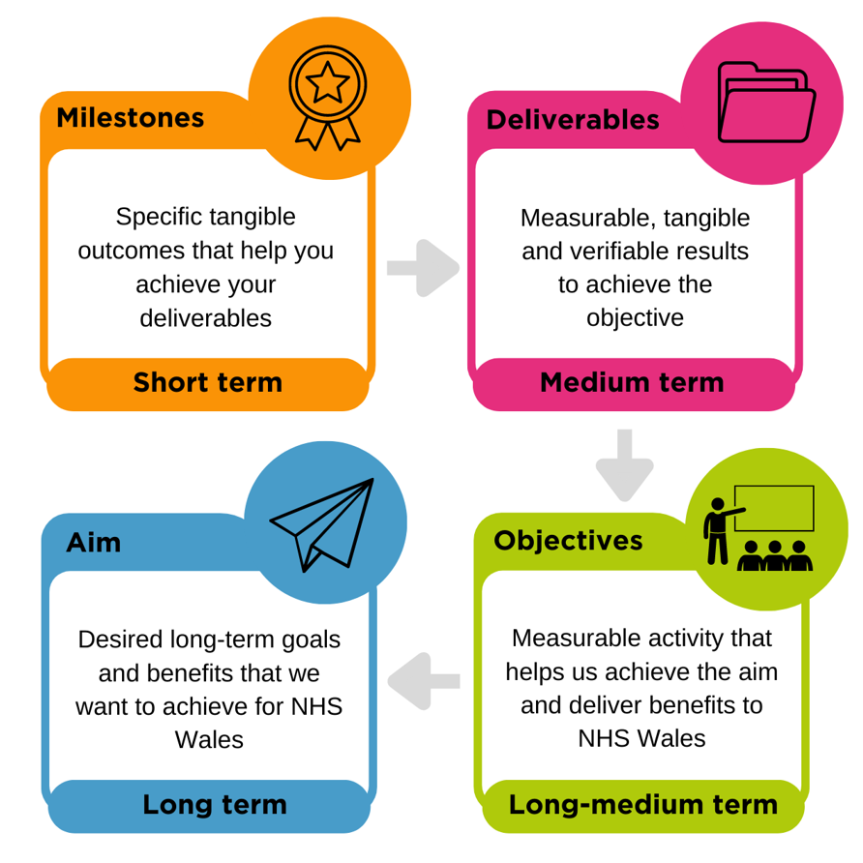

Building our Future Workforce is about developing and implementing plans that align future workforce demand with supply. This includes making investments in training the new workforce, delivering multi-disciplinary education, and training and strategic workforce plans and improving attraction and recruitment to education, training, and employment.
Developing our Current Workforce places sharp focus on transforming our workforce to contribute to new models of care which improve quality and safety.

Shaping culture and leadership means embedding compassionate leadership principles to develop cultures that support inclusion, wellbeing, and quality.

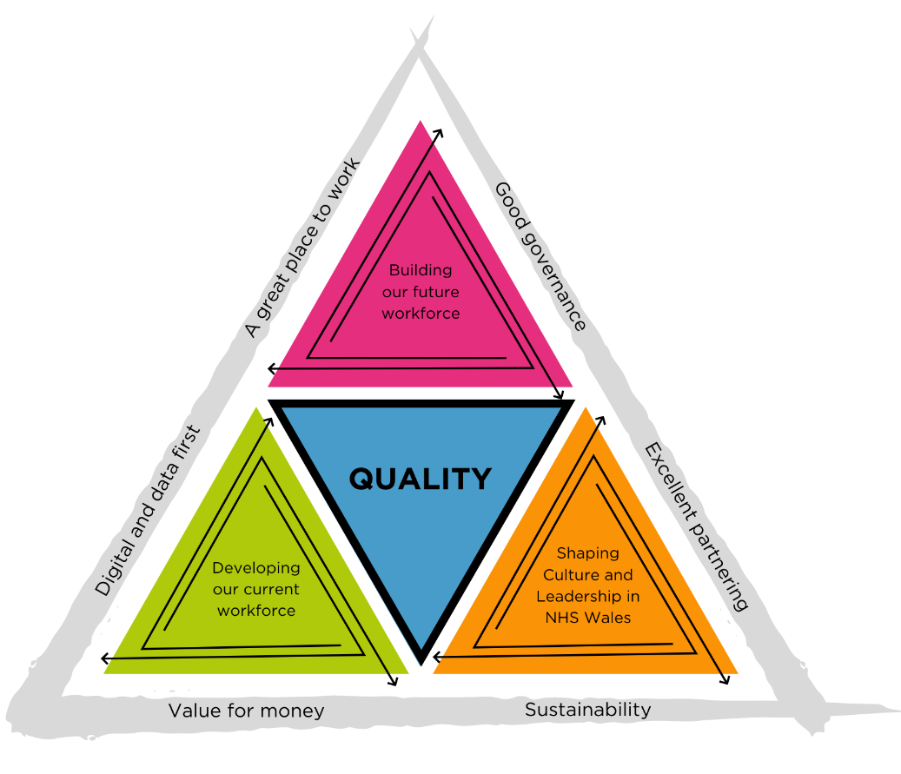
These strategic aims are inextricably interlinked and are interdependent and delivered by our committed staff and supported by our enabling teams, who put quality at the heart of everything they do.
Our medium-term activities over the next three years are described in our eleven strategic objectives, which are to:

- Invest in domestic education & training supply to respond to health and care needs.
- Transform multi-disciplinary education & training to meet future needs.
- Develop, publish, and implement strategic workforce plans in priority areas.
- Improving attraction & recruitment to education, training & employment.
- Develop workforce solutions for National NHS Programmes & Priorities.
- Design and develop resources to support workforce and service transformation.
- Target development of skills & capabilities to support transformation & future proof current staff.
- Scale and spread compassionate & collective leadership opportunities for leaders at all levels across NHS Wales.
- Create diverse & multi-professional pipelines of aspiring leaders for NHS Wales.
- Influence cultures that promote retention, staff wellbeing, improved engagement and effective teamworking within NHS Wales.
- Ensure equality, diversity & inclusion is embedded in all that we deliver.

Our Workforce Strategy for Health and Social Care sets the context for our plans and our plans contribute to and support the delivery of the 6 Ministerial priorities. Underpinning our strategic objectives are deliverables that are required to achieve our objectives. All our deliverables are supported by a focus on quality, safety, and prevention as a part of their planned activity and describe the milestones and actions under each deliverable that will be completed over the course of the forthcoming year.

Building our Future Workforce

The care that people need will continue to change rapidly over the next decade, as will people’s expectations of work. We need to ensure that we develop the future supply of workforce in the right numbers and with the right skills. As the national workforce system body, we have a key role to play in building a sustainable NHS workforce for the future.

We will invest in domestic education and training supply to respond to health and care needs

This is an essential cornerstone of our future supply and is progressed through our Education and Training investment Plan which responds to assessed workforce requirements for Health and Care. Increasing the quality and capacity of education and training is another key part of this and we will work collaboratively with partners to implement an improvement programme for clinical placements and training and education environments.

Our Pharmacy team will continue to progress the implementation of the transformation of education and training for the multi-disciplinary pharmacy team, due for completion by August 2026, in line with the regulator’s Initial Education and Training Standards.

We will also continue to implement the strategic review phase 2 priorities including the redesign and re-procurement of health professional post registration education programmes.

Furthermore, we will progress priority areas for the first phase of the Work Based Learning element of Y Ty Dysgu and ensure continuous improvement through quality and performance management of the Nursing, Allied Health Professionals (AHPs) and Health Care Scientists (HCS) pre-registration education contracts.

In addition, we will transform multi-disciplinary education and training to meet future needs

We will develop a multi-disciplinary education strategy setting the future vision and principles to guide our work in transforming education. We will complete the roll out of the multi professional HEIW Quality Framework for education and training to ensure continuous improvement.

We will also establish the education and careers infrastructure to ensure Medical Associate Practitioners (MAPs) are embedded in Multi-Disciplinary Team workforce models. We will also implement a multi-professional clinical skills training academy model for NHS Wales, starting with endoscopy. We will increase multi-professional education and training programmes in Primary and Community care, supported by the continued development of the Academy Model and sustainable all Wales education and training programme. With partners we will implement the multi-professional strategy that we have developed for Simulation-Based Education and Training. Our Digital team will also fully implement and evaluate the ‘Y Ty Dysgu’ learning management system (LMS) to improve the quality of and access to workforce learning resources.

We will develop, publish, and implement strategic workforce plans in priority areas

We will develop three new separate strategic workforce plans in key priority areas including Primary Care, Maternity and Neonatal and Genomics. We will implement the first year of the implementation of the Strategic Workforce Plan for Mental Health in partnership with Social Care Wales and the Mental Health Network Board. We will also publish and commence implementation of the strategic workforce plans developed in our last IMTP for Nursing, Dental and Pharmacy.

We will also launch the implementation plan for the phase 2 actions of the Workforce Strategy and establish shared governance arrangements between HEIW and Social Care Wales (SCW).

The establishment of a workforce observatory function will support horizon scanning, scenario planning, modelling, and strategic workforce planning in NHS Wales. We will also develop and improve the data intelligence function to inform strategic workforce planning, modelling, and performance reporting in HEIW and working with partners, improve the governance, quality, and standards of workforce data across NHS Wales.

To improve attraction and recruitment to education, training, and employment:

We will implement an agreed programme of careers and outreach activity, including the further development of Careersville to broaden its reach to all-ages. In addition, we will implement the refreshed TrainWorkLive attraction and marketing campaign, for national and local priorities, and encompassing employment and education. We will work with partners to implement the reservist workforce model for NHS Wales, following an initial pilot. We will also deliver a work experience and internship framework for NHS Wales, drawing on the model established in HEIW and deliver a grant scheme and compendium of best practice aimed at promoting innovative approaches to widening access.

Developing our Current Workforce

We need to continue to invest in our current workforce to enable them to make the best possible contribution they can, to have long and rewarding careers and to adapt to new models of care and new technology.

We will do this by developing workforce solutions for National NHS Programmes and Priorities

We continue to support the key Ministerial priorities though our role within each of the national programmes, in advising, innovating, and leading on all Wales workforce solutions including the Strategic Programme for Primary and Community Care, Planned Care, Diagnostics, Cancer and Urgent and Emergency Care. We will build on the work we have undertaken in relation to increasing community capacity in the onward development of the Further Faster policy intent.

We will also design and develop resources to support workforce and service transformation.

We will implement the assurance framework for multi-professional Advanced Practice and Consultant Practice and the priority actions from the Critical Care Workforce Review for HEIW. We will also lead the implementation of the Allied Health Profession (AHP) Framework to transform AHP practice and workforce across Health and Social Care in Wales. We will effectively manage the Healthcare Science Programme to implement the future vision for the Healthcare Science workforce as described in the national framework. We will also create the career progression framework for the support workforce and deploy a package of curated resources to facilitate their development.

In addition, we will target development of skills and capabilities to support transformation and future proof current staff

This will involve ‘levelling up’ access to education and training for Staff Grade, Associate Specialist and Specialty (SAS) doctors and locally employed (LE) doctors who represent 30% of the medical workforce in Wales. We will also support the Wales Eye Care plan by delivering a framework to train and support Optometrists and Dispensing Opticians to provide optimum community care to all persons in Wales. We will implement a multi-professional CPD strategy and drive improvements in current CPD activity. Furthermore, we will establish infrastructure to support ongoing delivery of climate smart education for the health workforce. In addition, we will implement the national digital capability framework for the healthcare workforce (for those who are not digital professionals) enabling them to develop the skills, behaviours, and attributes required to thrive in a digital world. Finally, we will support the implementation of the standards for competency assurance of Non-Medical Prescribers in Wales.

Shaping Culture and Leadership in NHS Wales

Embedding compassionate cultures and leadership in NHS Wales is essential to improving the safety and quality of our services for the people who use them, and for improving wellbeing and staff morale. It is therefore essential that we embed compassionate leadership principles to develop cultures that support inclusion, wellbeing, and quality. This will involve the:

Scale and spread compassionate and collective leadership opportunities for leaders at all levels across NHS Wales

We will implement a cohesive communication, engagement, and promotional plan to increase awareness, uptake, and use of the Gwella resources and national leadership programmes available. We will also market, recruit and deliver the HEIW, multi-disciplinary Advanced Clinical Leadership Programme and Clinical Leadership Fellowship Programme. In addition, we will co-produce and deliver a quality assured national Compassionate Leadership development programme for leaders at all levels across health and care in Wales.

This will also require us to:

Create diverse and multi-professional pipelines of aspiring leaders for NHS Wales

We will market and recruit Executive Director and Chief Executive Talent Pools, and NHS Wales General Management Graduates, delivering a leadership development framework in support of senior leader succession planning. We will also enhance Gwella with talent management software that effectively enables the management, visibility, and development of talent for all professions. Furthermore, we will deliver the national programme to develop the Workforce and OD Profession, in partnership with NHS organisations and Healthcare People Management Association (HPMA) Cymru.
This strategic aim will also require us to influence cultures that promote retention, staff wellbeing, improved engagement and effective teamworking within NHS Wales

We will also develop national resources to support the induction and onboarding of new Directors and Chief Executives into NHS Wales. In addition, we will upskill our NHS Wales strategic OD partners in effectively using culture, leadership and diagnostic tools and resources. We will review and update with partners the NHS Core Principles setting out expectations for both employers and employees to drive positive employee experience and improved quality. Lastly, we will work with partners to transform traditional HR policies/approaches to reflect compassionate people practices and processes that ensure the wellbeing of those involved is at the heart of what we do.

In our work, we will ensure equality, diversity, inclusion is embedded in all that we deliver

We will achieve this by actively maintaining and implementing HEIW’s Strategic Equality Plan (SEP) incorporating Welsh Government Equality, Diversity and Inclusion Action Plans ensuring an intersectional approach. We will advance equality in training and education for students, trainees and learners who undertake training commissioned and provided by HEIW. We will also deliver the required actions in More Than Just Words to increase the Welsh language skills of the workforce, including exploration of the role of HEIW in respect of the Welsh translation profession.

Our strategic aims, objectives and the deliverables and outcomes for 2023-24
Further detail can be seen by clicking the deliverables highlighted in blue below.

Building our Future Workforce - Developing and implementing plans that align the future demand for workforce with supply
Strategic Objective 1: Invest in domestic education and training supply to respond to health and care needs
No: | Exec Lead: | SRO: | Deliverables: | Impact:
1.1.1 | Director of Nursing/Medical Director | Assistant Director of Planning & Performance (SROM) | Develop a comprehensive Education and Training investment Plan to respond to assessed workforce requirements for Health and Care. | - Secure investment in the continued development of the education and training pipeline in Wales.  - Increase numbers of students and trainees.  - Expanded new commissioned education opportunities.  - Provide a wide ranging and skilled supply of healthcare professionals for the future.
1.1.2 | Director of Nursing | Programme Manager Education (SROM) | Implement an improvement programme for clinical placements and training & education environments. | - Improve the quality of and increased the number of healthcare placements across Wales.  - Demonstrate multi-professional governance, alignment, and efficiency.
1.1.3 | Medical Director | Pharmacy Dean | Continue to implement required transformation of education and training for the multi-disciplinary pharmacy team in line with the regulator’s Initial Education and Training Standards by August 2026. | - Produce pharmacists with enhanced clinical skills and independent prescribing skills.  - Make training programmes more attractive to potential students.  - Increase the number of highly trained Pharmacy Technicians.
1.1.4 | Director of Nursing | Deputy Director of Education Commissioning | Implement strategic review phase 2 priorities including the redesign and re-procurement of health professional post registration education programmes. | - Develop new contracts driving improvement and change in terms of Welsh language, interprofessional education, recruitment, and student wellbeing.  - Increase numbers of students applying for health professional post registration education programmes.  - Improve retention and creation of a sustainable workforce.
1.1.5 | Director of Nursing | Education Development Manager | Identify the priority areas for the first phase of the Work Based Learning element of Y Ty Dysgu | - Provide access to resources and better flexibility in terms of training via Y Ty Dysgu.  - Create flexible, high-quality education to meet the needs of the workforce.
1.1.6 | Director of Nursing | Head of Undergraduate/ Pre-registration Health Professional Education and Quality | Ensure effective implementation of the pre-registration contracts to deliver the agreed benefits with a focus on continuous improvement through quality and performance management | - Improve student experience through quality performance management of the contracts.  - Deliver safe and high-quality services giving people the best possible care.  - Drive improvements and change in terms of Welsh language, interprofessional education, recruitment, and student wellbeing.
Strategic Objective 2: Transform multi-disciplinary education and training to meet future needs
No: | Exec Lead: | SRO: | Deliverables: | Impact:
1.2.1 | Medical Director | New SRO to be appointed | Develop a multidisciplinary education strategy setting the future vision and principles to guide our work to transform education. | - Contribute to the creation of a sustainable health and care workforce that can respond to the demand on services.  - Contribute to the delivery of safe and high-quality services across Wales, giving people the best possible care.
1.2.2 | Director of Nursing/Medical Director | Medical Dean | Complete roll out of multi professional HEIW Quality Framework for education and training to ensure continuous improvement | - Support the delivery of high-quality education and training and access to high quality facilities and educational support so that future healthcare workforce achieve their potential in service provision to the NHS in Wales.  - Ensure good quality patient care is closely associated with patient safety.
1.2.3 | Medical Director | Director of Medic Professional Support & Development | Establish the education and careers infrastructure to ensure Medical Associate Practitioners (MAPs) are embedded in Multi-Disciplinary Team workforce models. | - Support the resolution of longstanding workforce challenges.  - Create an engaged and motivated MAPs workforce.  - Develop the PA and AA workforce ready for professional registration.
1.2.4 | Director of Nursing | Assistant Director Training Academies | Implement a multi professional clinical skills training academy model for NHS Wales, starting with endoscopy. | - Deliver a central hub and a set of branches to support rapid accelerated learning within the profession.
1.2.5 | Medical Director | Clinical Lead for Multidisciplinary Primary and Community | Increase multi-professional education and training programmes in Primary and Community supported by the continued development of the Academy Model | - Develop new infrastructure that will contribute to the sustainability of primary care and the delivery of the Primary Care Model for Wales.
1.2.6 | Medical Director | Director of Educational Improvement & Governance | Implement the multi-professional strategy for Simulation-Based Education and Training. | - Improve the quality and standardisation of and equitable access to interprofessional Simulation Based Education and Training across healthcare in Wales.
1.2.7 | Director of Digital & Data | Head of Digital Strategy and Planning | Fully implement and evaluate the ‘Y Ty Dysgu’ learning management system (LMS) to improve the quality of and access to workforce learning. | - Improve access to flexible, high quality, bilingual CPD to maximise digital learning opportunities for the workforce.
Strategic Objective 3: Develop, publish, and implement strategic workforce plans in priority areas.
No: | Exec Lead: | SRO: | Deliverables: | Impact:
1.3.1 (a) | Chief Executive Officer | Programme Director for National Programmes | Develop a strategic workforce plan for Primary Care | - Identify workforce solutions, in line with the Workforce Strategy, that enhance recruitment and retention and contribute to a sustainable primary care model.  - Develop and expand the multi-professional workforce that underpins the primary care model.  - Develop high quality training and development producing a highly skilled workforce.
1.3.1 (b) | Director of Nursing | Interim Deputy Director of Workforce Transformation | Develop a multi-disciplinary perinatal strategic workforce plan | - Reduce the number of leavers and improve morale in the perinatal workforce.  - Develop a more digitally competent workforce.  - Reduce staff sickness, agency and bank spend.  - Increase the number of applications across all elements of perinatal workforce.  - Develop a clear understanding across the perinatal team of workforce models to facilitate delivery of high quality multi-disciplinary care.
1.3.1 (c) | Chief Executive Officer | Programme Director for National Programmes | Develop a strategic workforce plan for Genomics | - Assess the specialist workforce requirements over the medium term to better align commissioning of education and training in key specialist areas.  - Develop appropriate educational resources to align with individual requirements spanning the whole workforce including specialist areas.  - Develop an appropriate infrastructure that embeds education and training at a national and local level.
1.3.2 (a) | Director of Nursing | Workforce Modernisation Manager | Publish and commence implementation of the strategic workforce plans being developed in Nursing. | - Identify workforce solutions to support a sustainable nursing workforce.  - Develop a plan that can respond to the demand on services in the future and give people the best care possible.
1.3.2 (b) | Medical Director | Dental Dean | Publish and commence implementation of the strategic workforce plans being developed in Dental. | - Develop a Dental Workforce Plan that provides the context for and the development of a multi-skilled workforce in line with A Healthier Wales.  - Support the understanding of patient demand for dental services across local, regional, and national landscape.  - Evidence further decisions on training and education commissioning requirements from initial pre-registration to advanced practitioner.
1.3.2 (c) | Medical Director | Pharmacy Dean | Publish and commence implementation of the strategic workforce plans being developed in Pharmacy. | - Implement a clear plan for local, regional, and national action to support the delivery of the integrated Pharmacy workforce.  - Monitor and assess progress against the proposed actions.
1.3.3 | Director of Workforce & OD | Deputy Director of Workforce & OD | Complete year 1 implementation of the strategic workforce plan for Mental Health in partnership with Social Care Wales and the Mental Health Network Board | - Contribute to the development of an engaged, motivated, and healthy mental health workforce across health and social care, with the capacity, capability, and competencies to meet the needs of the people of Wales.
1.3.4 | Director of Workforce & OD | Deputy Director of Workforce & OD | Continue to prioritise the implementation stages of the Workforce Strategy and communicate plans with partners and stakeholders | - Contribute to the development of an engaged, motivated, and healthy workforce across health and social care, with the capacity, capability, and competence to meet the needs of the people of Wales.
1.3.5 | Director of Workforce & OD | Assistant Director of Strategic Workforce Planning | Establish a workforce observatory function to support horizon scanning, scenario planning, modelling, and strategic workforce planning in NHS Wales | - Identify the workforce intelligence to enable HEIW and NHS Wales senior decision makers to make sense of workforce issues.  - Improve access to robust underpinning workforce intelligence, including horizon scanning and research to improve strategic workforce planning across the system.
1.3.6 | Director of Digital & Data | Assistant Director of Data and Analytics | Develop and improve the data intelligence function to inform strategic workforce planning, modelling, and performance reporting in HEIW and working with partners, improve the governance, quality, and standards of workforce data across NHS Wales. | - Produce useful data on the number of students graduating in future years and the number joining NHS Wales to develop better understanding of workforce trends and provide better support our learners to undertake informed workforce planning and education commissioning.  - Develop an agreed methodology for demand and supply modelling to enable NHS Wales understand the impact of demand on future workforce.  - Enhance supply and demand modelling, workforce planning and education commissioning decisions.
Strategic Objective 4: Improving attraction and recruitment to education, training, and employment
No: | Exec Lead: | SRO: | Deliverables: | Impact:
1.4.1 | Director of Workforce & OD | Deputy Director of Workforce & OD | Implement an agreed programme of careers and outreach activity, including further development of Careersville to broaden its reach to all-ages. | - Provide high quality careers information in health at all career stages to increase and retain both current and future workforce.
1.4.2 | Director of Workforce & OD | Deputy Director of Workforce & OD | Implement the refreshed TrainWorkLive attraction and marketing campaign, for national and local priorities, and encompassing employment and education | - Increase the workforce in training and working in Wales, with an emphasis on increasing socio-economic inclusion and diversity.  - Increase recruitment to NHS Wales workforce.  - Highlight benefits of training, working, and living in NHS Wales to support workforce retention.
1.4.3 | Director of Workforce & OD | Deputy Director of Workforce & OD | Implement the reservist workforce model for NHS Wales in partnership with NHS organisations | - Develop well-trained, competent, and flexible reservists to support the workforce challenges, at times of significant pressure.  - Offer a mechanism to retain talent within the NHS.  - Provide an alternative working model for local people to support their local health community in a way that works for them too.
1.4.4 | Director of Workforce & OD | Deputy Director of Workforce & OD | Deliver a grant scheme and compendium of best practice aimed at promoting innovative approaches to widening access | - Provide a consistent, efficient, and transparent approach for programme support to widen access to careers in NHS Wales.

Developing our Current Workforce - transforming today’s workforce to contribute to new models of care which improve quality and safety
Strategic Objective 5: Develop workforce solutions for National NHS Programmes and Priorities
No: | Exec Lead: | SRO: | Deliverables: | Impact:
2.1.1 | Chief Executive Officer | Programme Director for National Programmes | Continue to support the multi-professional workforce priorities of the Strategic Programme for Primary and Community Care. | - Delivery of consistent leadership and support across Wales.  - Support for new and existing clinical lead roles to ensure cluster representatives at Pan Cluster Planning Group are appropriately supported in their new role.  - Contribute to the development of a future cadre of leaders within NHS Wales who could potentially take on broader roles in the future.  - Contribute to the sustainability of General Medical Services through investment in the Integrated GP Fellowship Programme.
2.1.2 (a) | Chief Executive Officer | Programme Director for National Programmes | Implement a coordinated set of workforce actions to support recovery for planned care, and recovery including diagnostics | - Increase the multi professional workforce and skills deployed within diagnostics services to ensure sustainable service delivery, supporting top of license working and freeing capacity to enable better throughout.
2.1.2 (b) | Medical Director | Programme Director for National Programmes | Implement a coordinated set of workforce actions to support recovery for national cancer programme | - Strengthen the workforce in areas where pressures are resulting in backlogs in treating patients.  - Strengthen education provision for primary care to improve the quality and timeliness of cancer referrals resulting in earlier diagnosis.
2.1.3 | Director of Digital | Programme Director for National Programmes | Implement an agreed set of workforce actions to support delivery of the six goals for Urgent and Emergency care with a focus on SDEC | - Gain an understanding of the current demand drivers and key factors shaping the demand for urgent and emergency care.  - Identify workforce solutions (in line with the Workforce Strategy) providing a clear approach to recruitment and retention of the right workforce to manage the right patient demand.  - Develop appropriate training and educational resources to enable the multi-professional workforce across the urgent and emergency care pathway to develop, while maintaining their wellbeing.
Strategic Objective 6: Design and develop resources to support workforce and service transformation
No: | Exec Lead: | SRO: | Deliverables: | Impact:
2.2.1 | Director of Nursing | Workforce Modernisation Manager | Lead the implementation of the assurance framework for multi-professional Advanced Practice (AP) and Consultant Practice and Implement the priority actions from the Critical Care Workforce Review for HEIW | - Develop other options in relation to roles within critical care, supporting staff via improved/standardised education and the professional nurse advocate.  - Improve governance arrangements around Advanced Practice and Consultant Practice.  - Improve the reliability of workforce data to support an efficient and sustainable service.  - Support career path development to aid retention of skills.  - Develop a strong professional voice across the system.
2.2.2 | Director of Nursing | Associate Director AHP Transformation | To lead the implementation of the AHP Framework to transform AHP Practice and workforce across Health and Social Care in Wales. | - Improve knowledge of and access to Allied Health Professional Careers.  - Improve retention strategies across professions.  - Improve understanding of digital competencies across the professions.
2.2.3 | Director of Nursing | Head of Healthcare Science Transformation | Effectively manage the Healthcare Science Programme to implement the future vision for the Healthcare Science workforce described in the national framework. | - Develop clear intelligence on the current workforce.  - Strengthen accessible healthcare science careers.  - Improve recruitment and retention through a quality approach and promotion of accreditation.  - Enable research and innovation across all healthcare science services to improve evidenced based diagnostics for patient care throughout the NHS.  - Develop a strong collaborative, collective professional voice throughout the system.
2.2.4 | Director of Nursing | Education Development Manager | Create the career progression framework for the support workforce and deploy a package of curated resources to facilitate their development. | - Develop a digital interactive career framework to facilitate increased engagement for an expanded support worker group.
Strategic Objective 7: Target development of skills and capabilities to support transformation and future proof current staff
No: | Exec Lead: | SRO: | Deliverables: | Impact:
2.3.1 | Medical Director | Director of Medic Professional Support & Development | Continue to ‘level up’ access to education and training for SAS (Staff Grade, Associate Specialist and Specialty Doctors) and locally employed (LE) doctors who represent 30% of the medical workforce in Wales. | - Reduce differential attainment among International Medical Graduate doctors regardless of grade.
2.3.2 | Medical Director | Head of Optometry Transformation | Support the Wales Eye Care plan by delivering a framework to train and support Optometrists and Dispensing Opticians to provide optimum community care to all persons in Wales | - Provide optometrists and optometry practice staff in Wales with access to QI training and support to improve skills.  - Provide access to online education resource for all practicing optometrists and dispensing opticians to improve skills.  - Provide new optometry practice placements for higher qualifications to ensure that placements are closer to home and in a familiar environment.  - Improve the patient care pathway and enable eye care in community optometry practices to improve services for patients.
2.3.3 | Director of Nursing | Interim Deputy Director of Workforce Transformation | Implement a multi-professional CPD strategy and drive improvements in current CPD activity | - Drive improvements in CPD provision to increase activity, develop and expand the multi-professional workforce and contribute to building a sustainable workforce.
2.3.4 | Director of Finance | Assistant Director of Planning & Performance | Establish infrastructure to support ongoing delivery of climate smart education for the health workforce | - Develop a consistent approach to embedding climate smart thinking across the education and training pathways.  - Develop a climate smart leadership package delivering actionable learning in tackling climate change.
2.3.5 | Director of Digital & Data | Head of Digital Strategy and Planning | Implement the national digital capability framework for the healthcare workforce (for those who are not digital professionals) enabling them to develop the skills, behaviours, and attributes required to thrive in a digital world | - Improve Healthcare professionals understanding of digital capability and provide resources to support appropriate education and training.  - Improve understanding of national digital capacity and capability to make suitable recommendations to HBs and partner organisations to improve digital participation and positive outcomes such as improved health and wellbeing.  - Improve staff digital capability to realise the benefits of digital transformation programmes e.g., improve efficiency, increase productivity, cost saving, improve patient care, and increase capacity.  - Improve uptake of digital technologies to reduce impact on environment, widen access through online provision, and improve quality.
2.3.6 | Medical Director | Pharmacy Dean | Support the implementation of the standards for competency assurance of Non-Medical Prescribers in Wales | - Monitor and encourage the adoption of the standards by all Health Boards to increase the number of competent non-medical prescribers in Wales.

Shaping Culture and Leadership in NHS Wales – embedding compassionate leadership principles to develop cultures that support inclusion, wellbeing, and quality
Strategic Objective 8: Scale and spread compassionate and collective leadership opportunities for leaders at all levels across NHS Wales
No: | Exec Lead: | SRO: | Deliverables: | Impact:
3.1.1 | Director of Workforce & OD | Assistant Director of Leadership & Succession | Implement a cohesive communication, engagement, and promotional plan to increase awareness of the Gwella@HEIW resources and national leadership programmes available | - Reinforce HEIW’s leading role in influencing and supporting a positive change in NHS Wales workplace culture and creating an inclusive and compassionate climate.  - Increased usage of HEIW culture, leadership and succession resources including the Gwella@HEIW leadership portal.  - Create measurable improvements in workplace culture.
3.1.2 | Director of Workforce & OD | Senior Manager Clinical Leadership Development | Market, recruit and deliver the HEIW multi-disciplinary Advanced Clinical Leadership Programme and Clinical Leadership Fellowship Programme | - Create compassionate leadership behaviours demonstrated by senior clinicians across NHS Wales.  - Establish collective and inclusive clinical teams with a focus on patient safety and quality.  - Develop a robust pipeline of clinical leaders.
3.1.3 | Director of Workforce & OD | Assistant Director of Leadership & Succession | Co-produce and deliver a quality assured national Compassionate Leadership development programme for leaders at all levels across health and care in Wales | - Provide a quality assured compassionate leadership programme and suite of digital resources to support individuals and organisations across health and care in Wales.  - Embed compassionate leadership principles into existing leadership and management programmes.  - Award educational credits to compassionate leadership models to embed within professional and non-professional training.
Strategic Objective 9: Create diverse and multi-professional pipelines of aspiring leaders for NHS Wales
No: | Exec Lead: | SRO: | Deliverables: | Impact:
3.2.1 | Director of Workforce & OD | Succession Planning and Talent Management Lead | Market and recruit Executive Director and Chief Executive Talent Pools, and NHS Wales General Management Graduates, delivering a leadership development framework in support of senior leader succession planning | - Develop a sustainable and diverse pipeline of aspiring senior and executive leaders across NHS Wales.  - Enhance and target leadership development offerings for senior and executive leaders to improve workplace cultures.
3.2.2 | Director of Workforce & OD | Leadership & Digital Senior Programme Manager | Enhance Gwella@HEIW with talent management software that effectively enables the management, visibility, and development of talent for all professions | - Report on talent and skills of the professions within the NHS workforce in Wales to inform and positively target talent processes.
3.2.3 | Director of Workforce & OD | Developing the Workforce & OD Profession – Programme Lead | Deliver the national programme to develop the Workforce & OD Profession, in partnership with NHS organisations and HPMA Cymru | - Increase employee engagement levels, retention levels, ability to recruit with impact, number of internal promotions, strength of our succession plan, breadth of our talent pool, employer of choice brand in Wales.  - Enhance level of consultation and service to deliver market leading and future fit solution-based services moving to a ‘strategic partner’ model.
Strategic Objective 10: Influence cultures that promote retention, staff wellbeing, improved engagement and effective teamworking within NHS Wales
No: | Exec Lead: | SRO: | Deliverables: | Impact:
3.3.1 | Director of Workforce & OD | Assistant Director of Leadership & Succession | Develop national resources to support the induction and onboarding of new Directors and Chief Executives into NHS Wales | - Develop the NHS Wales health and political context for new CEOs and Executive Directors to enable them to be effective in their role soon after their commencement.
3.3.2 | Director of Workforce & OD | Head of OD & Inclusion | Review and update with partners the NHS Core Principles setting out expectations for both employers and employees to drive positive employee experience and improved quality | - Define the core principles that outline the behaviours and actions that staff can expect from NHS leaders and colleagues to improve the experience for everyone working in the NHS.
3.3.3 | Director of Workforce & OD | Head of OD & Inclusion | Work with partners to transform traditional HR approaches to reflect compassionate people practices and processes and ensure that the core needs of staff are met and are an integral part of organisational planning | - Reduce the number of employee investigations in NHS Wales.  - Improve understanding of issues to and ways to improve retention.  - Improve organisational performance.
Strategic Objective 11: Ensure equality, diversity, inclusion is embedded in all that we deliver
No: | Exec Lead: | SRO: | Deliverables: | Impact:
3.4.1 | Director of Workforce & OD | Head of OD & Inclusion | Actively maintain and implement HEIW’s Strategic Equality Plan (SEP) incorporating Welsh Government Equality, Diversity and Inclusion Action Plans ensuring an intersectional approach | - Design SMART objectives to meet our organisational needs to increase diversity across our programmes so they are reflective of our communities within Wales.
3.4.2 | Medical Director | Dental Dean | Advance equality in training and education for students, trainees and learners who undertake training commissioned and provided by HEIW | - Develop processes to address the variation in attainment for different professional groups.  - Advance equality in training and education.
3.4.3 | Board Secretary | Welsh Language Support Manager | Deliver the required actions in More Than Just Words to increase the Welsh language skills of the workforce, including exploration of the role of HEIW in respect of the Welsh translation profession | - Support the current and future workforce to actively promote bilingualism.

Chapter 4: Our Seven Enabling Plans –Foundations for Success
This Chapter sets out how our enabling plans are designed to support the successful delivery of this IMTP.
Our seven enabling plans and the foundations for the successful delivery of this IMTP and include:
- A Great Place to Work
- Digital and Data First
- Continuous Quality Improvement and Innovation
- Good Governance and Decision Making
- Engagement and Partnerships
- Value for Money
- Sustainability
These plans demonstrate how our people will be supported with the capacity and capability that they need; the digital and data enabling support they require to operate effectively and efficiently; the support they will require to make continuous quality improvements and develop innovation; the advice and support they will need to develop good governance practices to aid effective decision making; the support they will need to undertake effective engagement and build strong partnerships; and finally, the support needed to guide them in delivering value for money and ensuring that activities are undertaken sustainably.

A Great Place to Work
A great place where our people are proud and excited to work, where teams and individuals are respected, trusted, and valued for their contribution and where every member of staff has the opportunity to learn, develop and achieve.
In developing the great place to work enabling plan we have considered the ABC core needs that need to be met to ensure wellbeing and motivation at work Autonomy, Belonging and Contribution.
- We will have an agile culture that nurtures learning, collaboration and innovation and offers visible, compassionate, and inclusive leadership.
- Through our staff networks, we will regularly ask, listen and act so that the voice of our staff has influence and adds value and direction to our work.
- We will inclusively recruit and retain talent, welcome new staff and improve our diversity.
- We will provide a work environment that enables our people to thrive as healthy, engaged, and motivated individuals.
- We will regularly recognise and reward staff for their contribution to HEIW.
- We will publish and commence implementation of our People & Organisational Development Strategy.

Measuring progress - Key Performance Indicator(s):
Annual NHS Staff Survey Engagement Index will provide our one KPI to measure our performance. This index incorporates 7 questions and three overall themes from the survey. They are, intrinsic psychological engagement (includes responses around looking forward to going to work, going the extra mile), ability to contribute towards improvements and staff advocacy (proud and would recommend HEIW as a place to work).

Digital and Data First
Empowering improvement and insight through digital and data transformation
The HEIW digital and data strategy sets out a vision for the next five years to "transform the workforce for a healthier Wales" using digital technologies and data intelligence. The strategy includes five missions, each focusing on a specific area of priority, which will be delivered through implementation plans and integrated through the IMTP process and strategic workforce plans.

The Digital and Data Directorate will transform service delivery of its statutory and operational functions via the development of excellent, high-quality digital and data solutions to inform and improve insight and decision making.
Growing a digital culture focused on collaboration, empowerment, and the customer will be key to successful digital transformation, the M365 and single platform programmes will drive this approach. At the national level, the focus will be on preparing the wider NHS workforce for a digitally transformed environment and engaging and shaping the workforce through effective and efficient education and training and improved data intelligence. Underpinning all our work, the cyber security, and Information Governance (IG) plans will focus on minimising risk across the organisation. The plan will be balanced across people, process and technology and will focus on driving continuous improvement, reducing unhealthy security and IG friction, improving engagement, and enhancing HEIW’s security and IG position. Established governance arrangements are in place to realise benefits and deliver value through a sustained cycle of investment and transformation.
Digital Transformation:
- Identify key business processes that can be improved and transformed with digital systems.
- Implement the appropriate governance and assurance model for HEIW.
- Identify and research the digital transformation opportunities which will have the biggest impact on the NHS Wales workforce.
Single Platform:
A single online location that brings together existing applications, resources, and digitised processes to improve management of the postgraduate training journey for trainees and supporting users via a single NHS login and real time data intelligence.

- Submission of a costed, benefits focused business case, outlining the rationale for the recommended approach (in-house build vs outsourced solution).
- Develop a high-level architecture and data approach, ensuring alignment to the data strategy.
- Create roadmaps for the decommissioning of existing standalone systems.
In addition to our strategic objectives and departmental delivery plans, potential enabling support from the digital and data team has been identified across digital and data support of the strategic deliverables. These range from detailed technical data analysis and modelling to delivery of new and innovative digital systems, solutions and learning support requirements.
Measuring progress - Key Performance Indicator(s):
- Increased number of active Digital Champions within HEIW
- Funding for the single platform secured via a robust business case submission
- Improved access to data driven intelligence

Continuous Quality Improvement and Innovation
Demonstrating continuous improvement in our work (putting the ‘I’ in HEIW)
Our enabling plan is intended to support a wide range of requests outlined within the deliverables, many of which are high priority and high profile. Several of the deliverables are research focused, aiming to address gaps in UK knowledge base connected with education of the healthcare workforce. A range of support is therefore required including advice and guidance on the development of research and evaluation proposals for existing or new programmes and ethics approval where publication is required. As such, a framework to underpin evaluation of multiple existing and future programmes will be developed.
Additional capacity and specialist research skills are needed to provide existing staff with the skills to undertake high quality research, evaluation, innovation, and improvement in HEIW in addition to access to externally commissioned pieces of research.
- Embedding research and evaluation as methods to inform quality planning and quality assurance across HEIW.
- Delivering quality improvement training and support to the HEIW workforce and the learners that we are responsible for.
- Promoting innovation in HEIW and supporting innovation across NHS Wales.
- Publishing HEIW scholarly activity created via research, evaluation, improvement, and innovation.
Measuring progress - Key Performance Indicator(s):
- Number of submissions for ethics consideration.
- Number of individuals trained internally and externally (in Bronze IQT/Foundation, Fundamentals of Improvement, Improvement in Practice).
- Number of Improvement in Practice projects completed.
- Number of HEIW publications.

Good Governance
Improve and strengthen understanding to achieve our aim of a high trust and low bureaucracy organisation
Our Governance team will ensure that our risk management policy is adhered to, and the risk management system is maintained so that staff are empowered to identify, assess, and manage risks to HEIW, giving clear visibility of what might prevent us from delivering this IMTP.

We also have an important part to play in improving the use of the Welsh language which is a golden thread running throughout our plan.

- We will ensure that we maintain good corporate governance arrangements and that the Board Assurance process is reviewed and approved by the Board on an annual basis.
- We will ensure that our Internal Audit programme is focused and managed in a timely manner.
- We will develop and execute an information governance plan which strengthens our IG posture and approach to handling information.
- We will develop and execute a cyber security plan and objectives which set out the dimensions of cyber security and resilience to improve HEIW’s security posture and resilience to attack.
- We will maintain adequate Crisis Management and Business Continuity arrangements via the agreed policy and review arrangements at regular intervals
- We will continue to embed HEIW’s Welsh Language Plan and seek to support the strengthening of Welsh.
Measuring progress - Key Performance Indicator(s):
- Positive reports from Internal Audit and Audit Wales in respect of areas relating to HEIW’s corporate governance, information governance and cyber security arrangements.
- Staff demonstrating high awareness and engagement rates with our Welsh language plan through high demand for translation and Welsh language lessons and implementing the plan across our services.

Excellent Partnering
Being an excellent partner
As an All-Wales organisation, excellent partnerships through effective communications and engagement is critical.
- We will refresh and relaunch our communications and engagement strategy.
- We will continue to build engagement and relationships with unengaged groups.
- We will put in place a stakeholder management system to ensure ongoing effective engagement and communications.
- We will continue to develop effective strategic relationships with education partners.

Measuring progress - Key Performance Indicator(s):
- 5% increase in website hits per year

Value for Money
Maximising use of our financial allocation
As a Strategic Health Authority, it is imperative that we utilise our financial resources as effectively as possible in adding value to NHS Wales through delivery of our strategic aims and corresponding deliverables in educating and training the future NHS Wales health professional workforce. Our enabling plan will support us to achieve this through robust financial planning and monitoring of performance, ensuring budget holders and the Executive Team receive the appropriate information and support to make effective decisions. Where we commission and contract for services to support delivery, we will drive forward approaches to ensure procurement activities are timely, reflect service need and achieve best value whilst where possible making a difference to the Welsh supply chain as part of our commitment to the principles of the Foundational Economy.
We are acutely aware of the financial constraints prevalent in society. Therefore, we need to develop evidence with partners of the value and difference our investments have made on the healthcare system in terms of the future workforce, patient care and Welsh society. This Value-Based approach will facilitate and inform future decision-making on resource utilisation or the need for new funding aligned to ministerial education and training priorities. Furthermore, where possible we will utilise our role and functions to influence strategic direction to support changes in education and training to take account of future needs and be reflective of current pressures faced by the health professional workforce.
- We will develop and monitor a robust financial plan to effectively utilise resource allocations to deliver our agreed Strategic aims and corresponding objectives.
- With NWSPP, we will implement agreed actions to review and monitor procurement activity to meet public sector procurement regulations and agreed operational timescales whilst achieving best value for money.
- We will develop mechanisms to evidence and highlight the value of investment in Education and Training for the benefit of NHS Wales and build a value approach into performance reporting and influence future investment priorities.
- With Welsh Government we will influence the development of future policies and arrangements in relation to SIFT and bursaries.
Measuring progress - Key Performance Indicator(s):
- A break-even financial position is achieved in line with our statutory responsibilities
- 80% of procurement activity requiring competitive process (>£25k) to meet agreed timescales

Sustainability
Being climate smart in everything we do for the wellbeing of future generations
The climate emergency is facing us all. Welsh Government were the first nation to declare a climate emergency and are ambitious in their decarbonisation goals. Sustainability is a golden thread within this plan and will be integral to building a future-proofed NHS in Wales. The mission and deliverable are simple but focused. We will continue to deliver our Sustainability Action Plan in contribution to the Welsh Government vision of net zero emissions in the public sector by 2030. We will also support our staff on how best to be climate smart in their own actions whilst maintaining a commitment to ensuring organisational delivery. We will also work with staff to create resources that enable taking climate smart decisions in delivering HEIW activity. This can be complex, but we will strive to simplify our support to tackle the climate emergency and be climate smart in everything we do.
- We will deliver our sustainability action plan which will contribute to the Welsh Government vision of net zero public sector by 2030.
Measuring progress - Key Performance Indicator(s):
- Co2 emissions from HEIW estate and travel
- Waste sent to landfill/recycling rate
- Delivery of Sustainability Action Plan

Chapter 5: Financial Plan
This Chapter sets out the financial plan for HEIW and how we will demonstrate value and sustainability.

Our Approach
The HEIW Financial Plan is designed to enable the programmes and activities agreed by the Board to be taken forward. The identified funding requirement is for the full range of functions and programmes agreed with Welsh Government and will be appropriately managed to achieve financial balance in each year of the financial plan. Supporting the delivery of best value in the use of public money is an important requirement and HEIW will demonstrate the value and sustainability of its programmes and activities over the life of the IMTP through:

Leadership:
- Board assurance of a resource plan that sets out HEIW’s intention to comply with the statutory requirement for a balanced IMTP whilst delivering a plan to build a sustainable workforce for the future.
- Clear and effective leadership by the Executive Team.
- Timely planning, monitoring, support, and action by the Finance Team.
- Integrated working with all Executives, Senior Leaders, Budget Holders, and Departments.
- Visible and timely intervention and interaction by all Executives, Senior Leaders, and Budget Holders.
- Interrogation and collaboration of strategies, plans and approaches with our UK sister organisations.

Using a Value-Based Approach to Commissioning and Development activities:
- Utilising a Value-Based approach to articulate the system benefits of investing resources in Education and Training.
- Embedding a robust and prudent approach to business case development.
Strong Discipline:
- Disciplined financial management of all expenditure commitments.
- Continuous and detailed monitoring and management of the financial position.
- Timely corrective response to any variation from plan.
- Adherence to standards and governance requirements.

Ensuring excellent Assurance and Governance:
- Effective budget holder engagement to deliver the Plan and training in support of the management of budgets.
- Provision of high quality, accurate and timely financial advice for budget holders, the Executive team and HEIW Board.
- Expert support and technical advice to budget holders to enable the development of robust plans and business cases.
- Continuous evaluation of systems to identify areas of innovation or improvement and timely actions in response to audit recommendations.

Engagement with Budget Holders:
- The Finance team will provide regular timely and high-quality reports and support for budget holders.
- Promotion of financial behaviours that encourage, incentivise, and add value.

Using available tools to demonstrate efficient use of resources where appropriate:
- Relevant and timely Performance Reporting aligned to the organisation’s Performance Framework.
- Use of relevant NHS Benchmarking.
- Application of Efficiency Framework where possible.

The Financial Plan within this IMTP presents the resource requirements and deployment over an extended five-year planning time frame to ensure that the timescales of the current agreed programmes and those envisaged are presented over their full annual cost commitment. It is important that the scale of the stepped commitment, arising from the phasing impact of programmes is understood, particularly as the cost increases between one year and the next can be substantial when the additional student/trainee numbers commissioned progress through all the years of their education and training.

The process of developing the financial plan to date has involved a detailed review with individual budget holders of their 2022-23 budgets and Welsh Government agreed commitments, which were set following agreement of the 2022-25 IMTP. The emerging in-year financial position and year-end outturn forecast as at month nine was also considered in establishing the new-year starting base. Due to the inherent complexity involved in pay modelling, the exercise has been carried out centrally within the Finance Team, with budget holders able to subsequently review their proposed budgeted establishment for accuracy.

All business cases and increases in commissioning budgets that have the approval of Welsh Government or are part of the NHS Wales Education Commissioning and Training Plan for 2023-24 have been included. Budget holders were also asked to consider within the planning template a consolidation of the investment made to date and the enabling corporate requirements and new investments required to fully deliver the deliverables set out within the IMTP. The resource requirements of any future business cases have not been included within the Plan and will be subject to further discussion and agreement with Welsh Government during the 2023-24 year and will only be taken forward if and when they are agreed.

The key Pay and Inflation assumptions within the financial plan are as follows:

- For NHS staff inflationary uplifts on pay scales to date for 2022-23 have been applied for future years.
- Inflationary uplifts for Cardiff University and DDRB pay scales have been applied based on 2022-23 rates.
- Pay uplifts have yet to be agreed for 2023-24 and have not been included at this stage.
- The agreed 1.5% inflationary uplift on non-pay budgets has been applied.

The five-year summary of the financial plan is set out overleaf:

2023-24 – 2027-28 IMTP Financial Plan


Development and investments
Through the process of developing the IMTP, with a focus on consolidation of available resources, developments, and potential investments to deliver the Plan were identified through the ‘Deliverable Planning Template’ approach. Some of these have been incorporated into the updated financial plan where they have already been subject to discussion and agreement. However, any further resource requirements identified will be costed and when they are agreed will be subject to further discussion and agreement with Welsh Government in-year.

Financial risks and opportunities
The financial plan has been developed with the best available information and within the existing policy environment. 2022-23 was a particularly challenging year in terms of fully utilising the funding available through commissioned programmes, fill rates for some courses were down across the UK and it is our understanding that the cost-of-living issues exacerbated attrition from programmes and eroded the attraction of the bursary package. However, a renewed focus on these issues and a range of actions agreed with commissioned providers will mitigate this risk in 2023-24.

Capital
HEIW has a recurrent discretionary Capital Allocation of c.£88k for 2023-24. Although this modest allocation will not initially inhibit the developments set out in the plan, a process will be established that involves budget holders and other partners to determine the capital needs of HEIW in support of its objectives and strategy over the next five years.

Chapter 6: Accountability and Measuring our progress
HEIW was formally launched as a statutory body on 1 October 2018 and our statutory Board comprises a Chair, Chief Executive, six Independent Members and four Executive Directors. Details on the Executive Directors and the Board can be found on our website at https://heiw.nhs.wales/about-us/heiw-board-executive/ The Board sets the strategic direction for HEIW by developing and approving the Integrated Medium-Term Plan (IMTP). Our approach to the development of this IMTP has been to engage with the Board at all stages as the strategic framework was refreshed and priorities and actions have been developed.

The Board scrutinises and assures the performance of the organisation and progress with delivery of the IMTP through quarterly integrated performance reports. Our Performance Framework sets out how we scrutinise, assure, and improve performance in all our activities, based on the Performance Dashboard and reporting cycle. We are reviewing our performance arrangements to respond to the NHS Wales Outcomes Framework. In our detailed planning we have identified the outcomes of all our Strategic Deliverables and in 2023 we will be doing more work on developing our Key Performance Indicators for measuring and monitoring progress.

The Board also ensures arrangements are in place to monitor and manage the key risks of the organisation following the Risk Management Policy and the HEIW’s Board Assurance Framework.

Chapter 7 – Deliverable Plans

[DN3: Include deliverable plans here if links fail to work]

APPENDIX 1

The PESTLE Analysis
We continue to face significant political challenges such workforce shortages, the cost-of-living crisis, NHS Finances and the funding and organisation of social care, the increasing demand for healthcare following the pandemic and the impact on staff wellbeing and absence, all of which is having an enormous impact on NHS systems and services. The establishment of the NHS Executive has the potential to change aspects of HEIW’s accountability, governance and service planning within the Health and Social Care system and it will be important to clarify these at the earliest possible opportunity. We continue to strengthen our relationship and interface with Welsh Government at Health Minister, DGH and CDO level. From our recent horizon scanning exercise, there is an increasing focus on workforce planning from professional bodies.

The most urgent NHS issues that require immediate attention currently relate to the planning, deployment, and design of the workforce. We will therefore support the 6 Ministerial priorities and will constructively challenge current approaches with our partners in the NHS to find appropriate short, medium, and long-term solutions.

The economic trend of high inflation and high energy, fuel, and food costs will continue into 2023. The UK Government has given assurance that there will be no spending cuts across public services and the financial settlement for the NHS is unlikely to change but there will be higher costs in terms of energy, fuel, and food. Changes to member contribution structure for the NHS Pensions scheme implemented in October 2022 will mean that some NHS staff will pay higher contribution rates which may impact staff retention. More attractive pay rates can be achieved in the private sector or through agency working and low pay in the NHS is a disincentive to attracting and retaining staff. The Education and Training Commissioning Plan should be described as the Training and Education Investment Plan rather than simply the Education and Training Plan.

We must be more efficient with our financial settlement ensuring value for money through the planning and quality of our educational provision to get it right first time.

Increasing social pressures from a growing and ageing population with more complex health needs in addition to clearing the elective care backlog created as a result of the pandemic and delivering the best tailored care for patients in their local area. Current shortages of staff across the workforce (nurses and GPs in particular) and ensuring that there are sufficient people to fill vacancies in both health and social care and staff leaving the professions due to high workload and poor staff morale. There is a moral obligation to prioritise the well-being and health of the workforce as a result of the significant impact of the pandemic on physical and mental health and emotional well-being. The cost-of-living crisis has the potential to reduce the number of students training in a health care discipline if costs, particularly in relation to fuel and accommodation, become prohibitively high. Trends such as heavy workload, balancing a career and personal responsibilities and promoting flexible approaches to work i.e., portfolio working.
This demonstrates our social and economic duty to widen access and provide greater flexibility in higher education and employment for under-represented groups.

Technological changes have been made at pace within the NHS in recent years as a result of the pandemic and digital services have made organisations more connected. There is potential for further integration of digital tools and systems in every day working life and tools for remote working thereby increasing digital accessibility to create a digitally ready workforce able to adapt to new ways of working to improve the quality and efficiency of patient care. Medical advances in technology such as Genomics have the potential to change the shape of patient care. Advances in technologies such as simulation and Virtual Reality could also advance the provision of interactive careers information and facilitate the delivery of interactive education and improvements in the digital literacy of the workforce. Improved learning platform systems for education have the potential to improve the delivery of education and training. Digital solutions to improve the capture and analysis of data to improve the availability and use of intelligence (i.e., what if scenarios and case studies) to enhance workforce planning of the future workforce.

This demonstrates the delivery of interactive education and improvements in the digital and data literacy of the workforce.

Welsh Government laws and regulations enable us to drive our agenda. Engagement on implications of legal perspectives contribute to our understanding and enhances our implementation. The More than Just Words strategic framework to strengthen Welsh language provision in health and social care. The proposed reforms to the Mental Health Act 1983 will cut across Health and Social Care. The Equality Act (2010) and the Anti-Racist Wales Action Plan continue to help us embed equality and anti-racism in our planning. Changes made to the Education Standards Regulations and Laws will help us improve the quality of education and training. Workforce transformation across the whole pipeline will help improve team-based working. The Data Protection Regulations (2018) guide us on how we collect, monitor, protect and share our data with other organisations.

The environmental Climate Change Act (2008) requires us to reduce our carbon emissions, a key contributor to climate change (50% reduction by 2025 and 80% by 2050) and Welsh Government has set more ambitious targets for the public sector in Wales, net zero by 2030. The pandemic saw fewer people travelling for work and saw a noticeable increase in awareness of climate issues. However, there is an increase in the number of people returning to the office due to multiple factors including business need and the cost-of-living crisis which will have an impact on the organisations carbon emissions.

This highlights how we will influence the reduction of carbon emissions through leadership and climate smart education.

