Duty and Decision (6) – Proximity and Risk
Previous blogs in this series have suggested that risk is helpfully conceptualised as risk of impact on wellbeing - operationalised as a set of underlying needs that contribute to psychological and physical wellbeing. This blog begins by looking at the role of proximity in the foreseeability of harm
The image below illustrates several aspects of the relationship between proximity and risk.
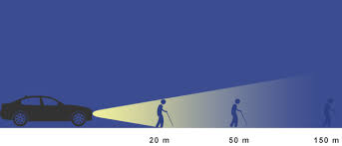
First, the closer a person is to a risk, the more visible it is likely to be to them.
Second, if we make the somewhat dramatic assumption that the gentleman is walking towards a cliff edge, the nearer the car is to him the more likely it is that the driver will be able to intervene. This observation is equally true as a general principle in relation to risk of impact on wellbeing. Research suggests that interventions tend to be more effective and sustainable when they are provided by the people who are closest to the identified person.
The above image also helps to highlight the difference between imminence and severity. The risk to the man at 20m is more imminent than the risk to the men at 50 and 150m. Put simply, if the car continues to move at the same speed it will hit him first. However, if the car is accelerating the severity (impact) will be greatest on the man at 150m. This distinction is important because our risk judgements tend to focus on the the likelihood of the event (ie. imminence) rather than on impact. Judging the latter requires an understanding of personal meanings underpinning a person’s wellbeing – i.e. the ‘so what’ of the harmful event.
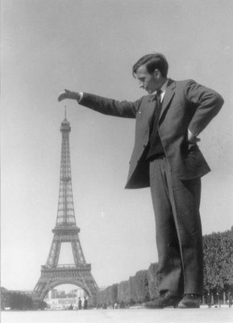
Proximity can be misleading, however. Just because someone is close to a risk does not mean that they are able to provide the most helpful portrayal of it. The gentleman in the picture on the right could be seen as close to but misreprenting the risks to life and limb and wellbeing of jumping off the Eiffel Tower. In this instance, the misrepresentation is deliberate. In reality there are a range of other factors that contribute to differences in perceptions of risk. These include, emotional involvement and contagion, and prior experience, and knowledge. For instance, knowing that the Eiffel Tower is 324 meters tall helps us to identify the illusion and appreciate that despite appearances it would be unwise to jump off the tower in the picture.
In understanding risks it is important to look for and understand discrepancies between different people’s perception of the same risk. This includes discrepancies between our own and other people’s judgements. This information helps to build a full and accurate picture of the relative risk. It also helps in understanding the current capability of proximal people to accurately judge, communicate, manage, and ameliorate risk. These capabilities are an important aspect of the strengths and resources available to a person. Understanding the limits of these resources can in turn help to formulate what might be needed to improve them.
The next blog continues to explore the issue of proximity. It focuses on the importance of clarifying who is concerned and the route through which this concern is communicated to us.

