Duty and Decision (1) – Ethical and Legal Foundations
This series of 10 blogs is aimed at people who have completed module 1 or modules 1&2 of the Care Aims Intended Outcomes Framework. The aim is to provide a complementary view of the ways in which the framework can guide defensible decisions about duty. The series is neither designed to provide a complete overview of Care Aims or to replace attendance at a Care Aims workshop.
Writing the blog has highlighted to the author the breadth and interconnectivity of the Care Aims framework. It is hoped that future blogs will pick up on areas of the framework that are briefly introduced or passed over in this series.

The Collins Dictionary defines duty as “a task or action that a person is bound to perform for moral or legal reasons”¹. This definition reminds us of the need to consider both the law and ethics in decisions about duty.
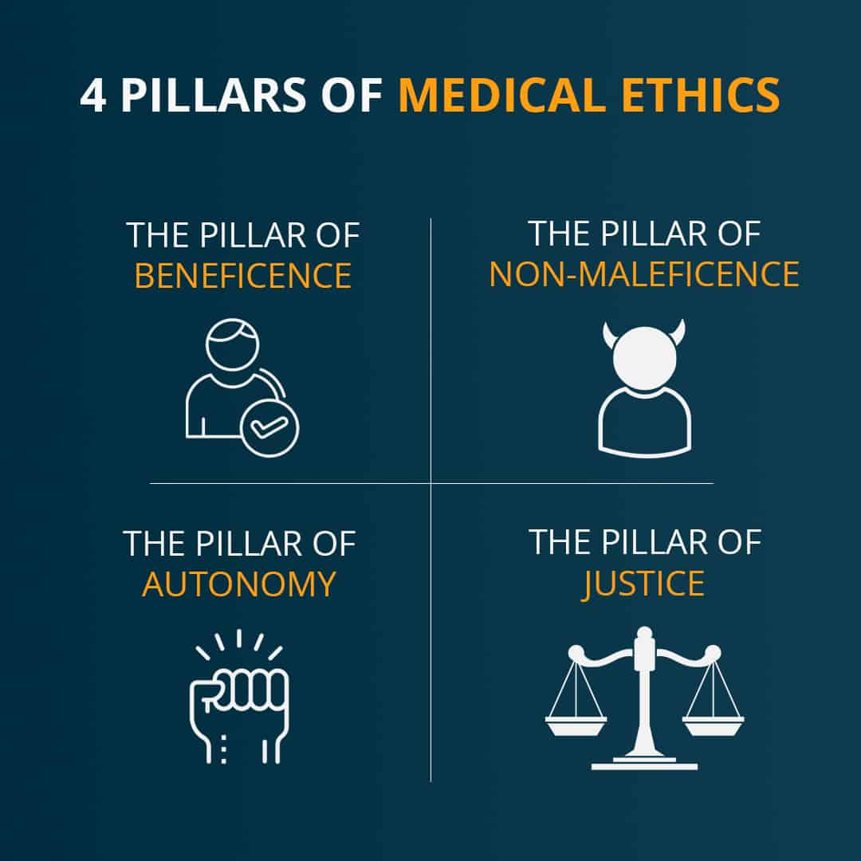
Duty of Care is typically defined as “doing what is reasonable”. But what is reasonable? The Royal College of Nursing notes that “Generally, the law imposes a duty of care on a health care practitioner in situations where it is ‘reasonably foreseeable’ that the practitioner might cause harm to patients through their actions or omissions.” ² This locates the concept of risk of harm at the centre of decisions about duty.
Turning to ethics, four key ethical principles are typically highlighted as guiding biomedical decisions about duty. These principles are respect for autonomy; beneficence; non-maleficence; and justice. In simpler terms these relate to actively supporting informed choice; doing good; not doing harm; being equitable and fair.
Shared Decision Making (SDM) is a contemporary framework supporting collaborative decisions in situations where the practitioner is presenting a range of options to the person they are working with. In this respect SDM focuses on the first of the ethical principles outlined above – respecting autonomy through actively promoting informed consent.
The Care Aims Intended Outcomes Framework supports practitioners to use a defensible set of principles to reason and record their decisions about duty using all four of the ethical principles outlined above. For instance, it promotes just use of resources by encouraging practitioners to consider the impact on the wider community of choosing one course of action over another. It also guides practitioners to focus on risk, benefits, and harm to wellbeing in all aspects of their decision making. Finally, the framework goes beyond respect for autonomy (informed consent) to emphasise the facilitation of autonomy through a focus on self-management and independence.
The next blog in this series looks more closely at autonomy as an ethical principle guiding decision making. It focusses on the difference between respecting and creating autonomy.
¹ https://www.collinsdictionary.com/dictionary/english/duty
² https://www.rcn.org.uk/get-help/rcn-advice/duty-of-care
³ Beuchamp and Childress (2001). Principles of Biomedical Ethics, OUP, 5th Edition.
⁴ https://www.bmj.com/content/309/6948/184
⁵ https://www.england.nhs.uk/shared-decision-making/why-is-shared-decision-making- important/shared-decision-making-to-meet-the-ethical-imperative/

