






-Fsi

Integrated Medium-Term Plan
2022/25 V1.0

Document History

Document Location
This document is only valid on the day it was printed.

Revision History
Date of this revision: 21 March 2022
Date of next revision:
Revision Date | Previous Revision Date | Summary of Changes | Changes Marked
20/01/22 | - | First Issue | Yes
24/02/22 | 20/01/22 | Second Issue | -
04/03/22 | 24/02/22 | Third Issue | -
07/03/22 | 04/03/22 | Fourth Issue | -
21/03/22 | 07/03/22 | Fifth Issue | -

Approvals
This document requires the following approvals.
Signed approval forms are filed in the Management section of the IMTP planning files
Name | Signature | Title | Date of Issue | Version
HEIW Board |  |  | 31/03/22 | Final V1.0

Distribution
This document has been distributed to:
Name/Group | Title | Date of Issue | Version
Executive Team | - | 21/01/2022 | V0.1
Board | - | 21/01/2022 | V0.1
Senior Leadership Team | - | 21/01/2022 | V0.1
Stakeholder Reference Group | - | 25/01/2022 | V0.1
Policy Leads | - | 25/01/2022 | V0.1
Executive Team | - | 24/02/2022 | V0.2
Board | - | 24/02/2022 | V0.2
Executive Team | - | 28/02/2022 | V0.3
Welsh Government | - | 07/03/2022 | V0.4
Board | - | 21/03/2022 | V1.0

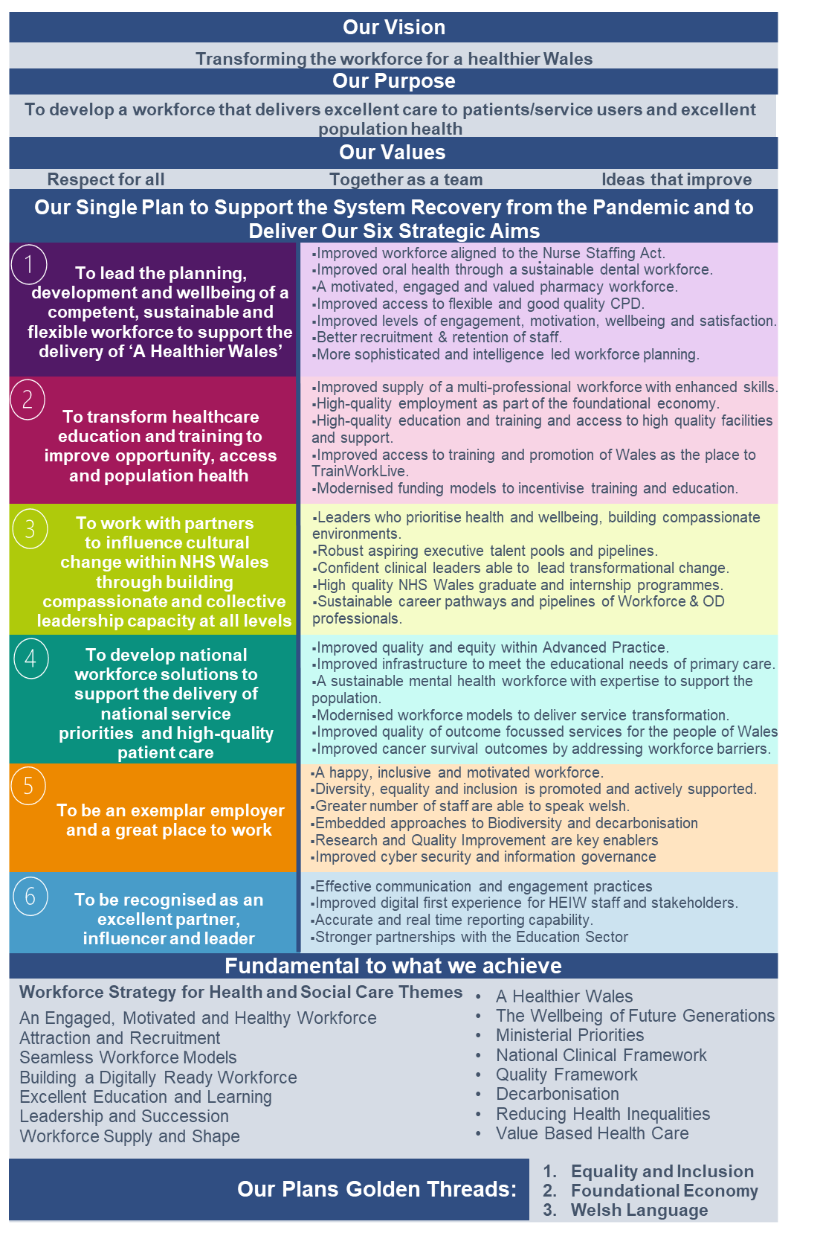
Plan on a Page

Contents

Plan on a Page 3
Foreword from the Chair and Chief Executive 5
Executive Summary 6
Chapter 1 – Organisational profile and progress
1.1 Vision and Purpose 8
1.2 Functions 8
1.3 Culture, values and behaviours 9
1.4 Organisational structures for planning and delivery 10
1.5 Capacity and Capability to deliver 10
Chapter 2 – Progress in 2021/22
2.1 Response to the COVID-19 pandemic and new ways of working 11
2.2 The Workforce Strategy for Health and Social Care 12
2.3 Key Achievements and progress with delivery in 2021/22 12
Chapter 3 – Strategic Framework, Engagement and Planning approach
3.1 Strategic Framework 14
3.2 Stakeholder and Staff Engagement in the development of the IMTP 14
3.3 Planning approach 15
Chapter 4 - Strategic Aims and Objectives 16
Chapter 5 – Education and Training Commissioning and Delivery
5.1 Overview 39
5.2 HP Education Commissioning for 2022/23 (Nursing, Midwifery, AHPs, HCS,
PAs, support workforce and postgraduate education) 40
5.3 Postgraduate Nursing Education 41
5.4 Postgraduate Medical Education 42
5.5 Dental Education 42
5.6 Pharmacy Education 42
5.7 Addressing Equality and Diversity in Education and Training 43
Chapter 6 – The HEIW Workforce
6.1 Developing our People and organisation 45
6.2 Shape of our workforce 45
6.3 Future Priorities 46
6.4 Attraction, recruitment and selection 47
6.5 Equality, Diversity and Inclusion 47
Chapter 7 – Financial Plan
7.1 Our approach 49
7.2 Developments and Investments 51
7.3 Financial Risks and Opportunities 51
7.4 Capital 52
Chapter 8 – Digital
8.1 Digital and Information Systems 53

Hyperlinks to Appendices 55

Foreword from the Chair and Chief Executive
This Plan, our first IMTP, comes at a pivotal moment for the NHS and Care Services in Wales.
It is rightly an ambitious Plan and is relevant as much to the here and now as it is to the future of our health and care services. The Plan reflects very much what we have heard from key partner organisations – Health Boards, NHS Trusts, regulators, government, educational bodies, students, trainees, Social Care Wales and others.
This IMTP sets the direction of travel and builds the momentum to deliver the workforce fit to meet the needs and aspirations of NHS services now and into the future. The investments outlined are core to ensuring we have the right number of people who are capable, confident and supported to make this happen.
Having developed and launched our Workforce Strategy in October 2020, this Plan reflects the learning and reflections from the pandemic experience. We are now able to articulate and lay out our delivery ambition through the actions and the clear deliverables that underpin this IMTP. The shift from pandemic to endemic, with all the service and financial challenges the health and care system is facing, places the workforce centre stage in the delivery of those services. Leadership, education, training and wellbeing, are the core ingredients to delivering a Healthier Wales. The ‘Golden Threads’ of foundational economy, Welsh Language and equality, diversity and inclusion run throughout the Plan.
The rebound in demand, following the seismic impact of the past two years is considerable, and expectations are high. The Plan supports those key actions that are more urgent and relevant to the present workforce issues. But our ambition is more than that. We do not ignore the longer-term aims because we are continuing to respond to the challenges of the here and now, and this is essential as we build a sustainable workforce
We value and will develop the present workforce, as well as the workforce of the future. The redesign of services, and service transformation will require a workforce that can sustainably deliver in an environment that is rapidly changing. There is an essential need to develop better workforce planning and to build the culture of compassionate leadership at scale. Building the data, capability and capacity to plan ahead and cultivate the capabilities of our workforce are at the heart of the Plan. Ensuring our present and future workforce are best prepared to meet the digital opportunities both now and the future is a critical element of the Plan.
We commend the work done in generating this Plan, but most importantly commit the whole organisation in working with our health and care partners to supporting all those staff whose calling is to deliver excellent care for the people of Wales.

 | 
Ms Alex Howells | Dr Christopher Jones, CBE
Chief Executive | Chairman

Executive Summary
HEIW is the system workforce body for NHS Wales and our vision is ‘Transforming the Workforce for a Healthier Wales’. This Plan sets out our vision, purpose, and functions in the context of the Workforce Strategy for Health and Social Care (WFS), the Ministerial Priorities and the Wellbeing Goals through delivery of our six Strategic Aims. We have a strong part to play in the foundational economy, improving equality, diversity and inclusion and use of the Welsh language and these are ‘golden threads’ throughout our Plan. We have learnt a lot from the changes we made to respond to the pandemic, and we know that the NHS Wales system is facing an enormous recovery challenge. Our Plan demonstrates our support to meet this challenge at pace as well as to deliver our strategic agenda over the next three years.
Our Plan is founded on the considerable planning that has been done since the organisation came into being in 2018, including the extensive engagement around the Workforce Strategy. It has been developed through engagement with NHS and Welsh Government colleagues, our wider stakeholders and our staff. We have also taken into account our good progress with delivery of our Annual Plan 2021/22, the learning from the pandemic, the system priorities for reset and recovery and responded to the major risks on our risk register.
Whilst delivery of the Workforce Strategy is all health and care organisations’ responsibility, our IMTP Strategic Aims and Objectives describe our delivery of the seven themes of the Workforce Strategy to achieve the goal of a sustainable, engaged, competent and confident health and care workforce.
We will improve the sustainability and wellbeing of the workforce in key service areas through the development and delivery of workforce solutions for nursing, pharmacy and dental as well as implementing the mental health workforce plan which is being developed in 2021/22. This is the first time this whole-service approach has been taken in Wales. We will also improve NHS Wales’ strategic workforce planning, through building capacity and capability, underpinning workforce data and intelligence and analytics. We will also support the existing workforce to cope with change and to work in new service models through our Continuous Professional Development, education and wellbeing Strategic Objectives.
These Objectives are particularly important as, during our engagement phase, all NHS organisations reported ongoing extensive strategic service change, as well as the effects of the pandemic and the challenges of recovery. Our Compassionate Leadership programme plans are important in this context; over the next three years we will continue to build capacity and capability at all levels to lead in a highly complex and challenging environment. As part of the learning from the pandemic all NHS organisations also reported a greater focus on organisational development, culture, leadership, workforce wellbeing and resilience and our Leadership and Succession programme provides the national framework that they are using in their local work.
Our strategic plans are underpinned by our significant investment in education and training and the IMTP describes the ongoing increasing investment in this area, which is predicted to continue over the next three years. Through the Strategic Review of Health Professional Education Commissioning, we will complete much of our work to modernise the workforce and maximise our impact as part of the foundational economy. The modernisation of education and training to support quality care in new service models will also progress in medicine, pharmacy and optometry. The Plan also describes the delivery of the next three years of the major strategic professional change programmes for Healthcare Sciences and Allied Health Professionals and the Nurse Staffing Levels (Wales) Act work programme to improve standards and quality of care.
Work is being undertaken to align our IMTP and Education and Training planning as part of developing an all-Wales longer term strategic workforce planning approach, as well as our important horizon-scanning and research roles. We are uniquely placed to develop frameworks for new roles informed by workforce planning and funded through educational commissioning. Our plans reflect the principles underpinning our commissioning and provision of healthcare education and training and through these functions, over the next three years, we will improve quality, equality, diversity and inclusion, Welsh language and digital literacy. In addition, we will have improved recruitment and retention through actively promoting careers, education and training in Wales, as well as incentivising training in Wales through revising the funding models.
Our IMTP is our single plan to support the system recovery from the pandemic and to deliver our Strategic Aims. We are highly engaged with the national recovery priorities, from our underpinning work on workforce supply and wellbeing, simulation-based training, new roles, digital literacy and advanced practice through to our direct leadership of the workforce, education or training elements of the national recovery programmes. We will significantly improve the educational infrastructure in primary care to support the primary care model for Wales and we will contribute to improving cancer survival outcomes through our work on cancer workforce redesign, education and training across a range of services (endoscopy, diagnostics and the single cancer pathway). During the period of this Plan, we will deliver education to promote an agile and skilled critical care workforce and the workforce, training and development priorities of the national Urgent and Emergency Care and Planned Care Programmes.
As the national workforce system body, we aim to model compassionate and collective leadership and in our aim is to have a happy, inclusive and motivated workforce. Our plan recognises the importance of the Welsh Language in terms of our own organisation, but also through our functions which impact on the wider workforce. We will also embed our approach to decarbonisation and research and innovation. As a strategic NHS organisation with an exciting and engaging IMTP to deliver as well as extensive Business as Usual activities, it is essential that we are skilled at working in partnership as well as using best practice in digital ways of working. Over the next three years we will promote digital training as well as improving our data quality and we will also focus on our partnerships with the education sector.
We look forward to delivering our ambitious set of Strategic Objectives with our staff and underpinned by our finance and digital plans. We will monitor delivery of the Plan through our agreed Performance Framework and remain agile to support the system recovery from the pandemic.

Chapter 1 – Organisational profile and progress in 2021/22
This Chapter sets out our vision and purpose. It outlines our functions demonstrating how we support NHS Wales. Our values are described with the behaviour framework that underpins them. Finally, we outline how we will ensure we are able to deliver the plan through governance structures, capability, and capacity.
1.1 HEIW Vision and Purpose
We are the strategic workforce body for NHS Wales and our vision is “Transforming the Workforce for A Healthier Wales,” Over 100,000 people work in the NHS in Wales and all of us are pivotal to building a sustainable health and care system that meets the needs of the population.

Our purpose is to develop a workforce that delivers excellent care to patients and service users and excellent population health. As a Special Health Authority, we have a unique contribution to make to NHS Wales by:
- Addressing strategic and specialist workforce issues.
- Making Wales a great place to train and work for our health and care staff.
- Maximising the contribution of all professions and occupations through our statutory functions.

  - Functions
Leadership Development
Workforce - strategy planning
Intelligence
Workforce development and transformation
Education & Training – planning commissioning delivery
Careers & widening access

- Leadership Development: we are responsible for setting the strategy, principles and frameworks for leadership development across Wales, based on compassionate and collective leadership, together with the commissioning and delivery of leadership development activity for key groups. We lead on succession planning and talent management for aspiring Directors and Chief Executive.
- Workforce Strategy, Planning and Intelligence: as well as providing strategic leadership for the development of workforce planning capacity across the NHS we have a lead role in the development of strategic workforce plans, and the provision of analytical insight and intelligence to support the development of the current and future shape of the workforce.
- Workforce Development and Transformation: we support workforce transformation and improvement to respond to significant service challenges, including skills development, role design, prudent approaches, Continuing Professional Development (CPD) and career pathway development.
- Education & Training, Planning Commissioning and Delivery: we plan, commission, deliver, and quality manage undergraduate and post graduate education and training for a wide range of health professions, and lead on apprenticeship frameworks in Wales.
- Careers and Widening Access: we promote health careers and the widening access agenda to ensure that opportunities to work in the health and care system are available to all. Working to include people in our communities that have valuable skills and experience that are currently under-represented in our workforce.

We employ circa 250 members of staff, as well as approximately 150 members of our sessional staff working in the NHS across Wales who deliver education, training, supervision and appraisal with us on a daily basis. We also have significant reach across the 12,000 healthcare students and trainees and our multiple stakeholders and partners.
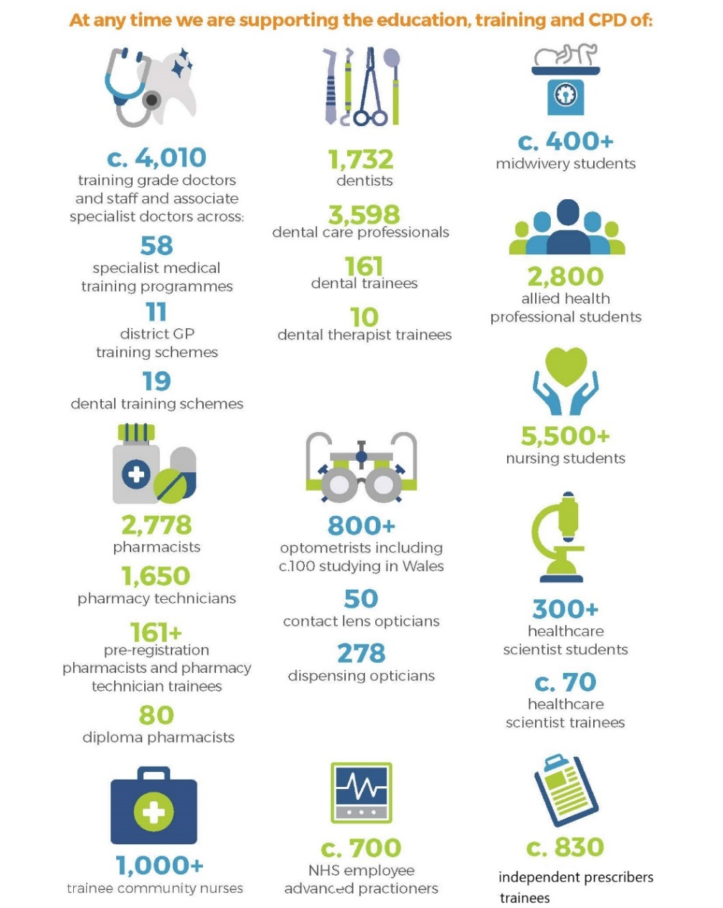
1.3 Our Culture, Values and Behaviours
As a workforce-focussed organisation our culture and the way we do business are very important to us, and together with our staff we have developed our organisational Values:
Respect for all: in every contact we have with others
Together as a Team: we will work with colleagues across NHS Wales and with partner organisations
Ideas that Improve: harnessing creativity, and continuously innovating and evaluating
Our Values and Behaviour Framework is on our website at https://heiw.nhs.wales/about-us/values-and-behaviours/ We stride to be a role model for the national work we are leading on compassionate and collective leadership, equality and inclusion, bilingualism and culture.

1.4 Organisational Governance Structures for Planning and Delivery
HEIW was formally launched as a statutory body on 1 October 2018. We have a statutory Board consisting of a Chair, Chief Executive, six Independent Members and four Executive Directors. A summary of Executive Director portfolios and a “who’s who” of the Board can be found on our website at https://heiw.nhs.wales/about-us/heiw-board-executive/ The Board sets the strategic direction for HEIW by developing and approving the Integrated Medium-Term Plan (IMTP). Our approach to the development of this IMTP has been to engage with the Board at all stages as the strategic framework was refreshed and priorities and actions have been developed.

The Board scrutinises and assures the performance of the organisation and progress with delivery of the IMTP through quarterly integrated performance reports. Our Performance Framework sets out how we scrutinise, assure and improve performance in all our activities, based on the Performance Dashboard and reporting cycle. We will continue to review our performance arrangements throughout 2022/23 to respond to the NHS Wales Outcomes Framework as phases two and three are published. In our detailed planning we have identified the outputs and outcomes of all our Strategic Objectives and in 2022 we will be doing more work on developing our own Outcomes Framework.

The Board also ensures arrangements are in place to monitor and manage the key risks of the organisation. The updated Risk Management Policy was approved at November Board together with HEIW’s Board Assurance Framework. The organisation’s Structured Assessment 2021 from Audit Wales was received in two separate phases. Phase 2 of the Structured Assessment found that HEIW’s arrangements to manage risk are strong and has continued to improve its risk management arrangements and maintained oversight of strategic and operational risks. Phase one is available here and Phase two is available here.

1.5 Capacity and Capability to Deliver
In common with other NHS organisations, we have had to deploy additional capacity to respond to new pressures and to manage operational delivery over the last few years, particularly in relation to our core activity of education and training. Remote working has presented some challenges to us as a young organisation, particularly for our new starters and our projects that have required stakeholder engagement. We are therefore looking forward to refocusing our efforts this year on leading the accelerated implementation of the Workforce Strategy with our colleagues in Social Care Wales, as this is the key to a sustainable approach. We have been developing our change methodologies, skills and expertise to support this.

The planned streamlining of national programmes and mechanisms will also have a beneficial impact on our capacity as an organisation by reducing duplication. We will remain strategically agile and will respond to emerging issues in-year, including developing further plans as required around maternity services and integrated care.

Robust planning, performance and programme management arrangements are in place to enable HEIW to achieve our Strategic Aims. Further details can be found in Appendix A which describes all the enabling functions.

Chapter 2 – Progress in 2021/22
This Chapter reflects on the progress we have made in delivering our Annual Plan from last year. We highlight the role we have provided in response to the COVID-19 pandemic encouraging new ways of working. Finally, we outline the achievements we have made against each of our six strategic aims. Further information on our performance is included in our latest Integrated Performance Report.
2.1 Response to the COVID-19 Pandemic and New Ways of Working
As an active partner in the COVID-19 response, our priority in 2021/22 was to support the wider NHS and care system, but also to support our trainees and students to continue their education, accelerate our work to support wellbeing and maintain our own business continuity.
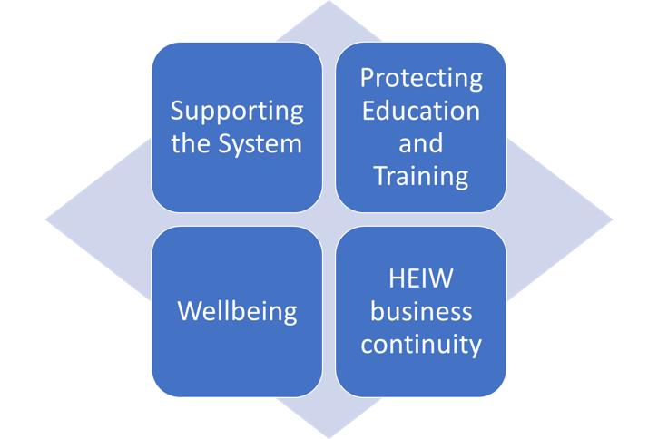
We supported the System Response and Recovery plan, refreshing our previous work to support the prudent in practice principle including staffing ratios, skill mix and delegation guidelines. Examples of this can be seen in our work on infection, prevention and control and non-registrant protocols on vaccinations. We continued the care home support package including education facilitators and developed a compendium of integrated workforce tools and case studies. During the Omicron wave we also encouraged our staff to volunteer to support the response, including the vaccination programme.

From the outset of the first wave, we rapidly moved to virtual CPD, recruitment, training, progression and quality management. Our leadership and influencing of the protection of Education and Training has been recognised at the UK wide level. Whilst there is evidence of ongoing disruption to some medical, dental and pharmacy trainees, this is less than in 2020/21, and there are no COVID-19 risks reported so far this academic year with Nursing and other Health Professional education.

We accelerated our Wellbeing response and Leadership programme through the pandemic. We implemented a health and wellbeing framework to support physical and mental wellbeing and accelerated our work to embed compassionate and collective leadership. We invested in our Professional Support Unit to ensure support for the wellbeing of students and individual trainees including investment in psychological therapies.

We have a Board-approved Business Continuity Plan in line with our approach to HEIW Business Continuity and arrangements were put in place and reviewed after the first phase of the pandemic. We undertook a lessons-learned exercise in the Summer of 2021 in preparation for the difficult winter ahead. During the Omicron wave we temporarily reactivated our Crisis Management Team and we are pleased that overall we have had very few COVID-19 absences amongst our own staff.

2.2 The Workforce Strategy for Health and Social Care
In October 2020, the ten-year national Workforce Strategy for Health and Social Care https://heiw.nhs.wales/files/workforce-strategy/ was endorsed and published by Welsh Government. The strategy enables the delivery of A Healthier Wales and is part of the NHS Wales planning system alongside the National Clinical Framework and the Quality Framework. It forms the basis for our partnership work with Social Care Wales and others to make a difference to the health and social care workforce, including seamless workforce models in integrated care. We will respond to the recommendations of the Expert Group looking at a National Care Service when these are available and remain agile to support any practical steps that fall within our remit.
2.3 Key Achievements and Progress with Delivery in 2021/22
This year has required us to respond to the urgent demands of the pandemic whilst maintaining our focus on strategic programmes of work that will deliver longer term outcomes. The most recent Performance Report which outlines our performance against delivery of our Annual Plan 2021/22 and Business as Usual can be found here this also outlines any areas that have not progressed as we would like this year and the actions we are taking to resolve this.
Chapter 4 outlines how we are continuing to progress the areas of action still required for the strategic objectives that are continuing for 2022 onwards.
The table below summarises our progress towards delivery of our six Strategic Aims:
Strategic Aim 1: To lead the planning, development and wellbeing of a competent, sustainable and flexible workforce to support the delivery of ‘A Healthier Wales’ | Strategic Aim 2: To transform healthcare education and training to improve opportunity, access and population health
Achievements | Achievements
- Continued to drive forward the key actions in the WFS  - Developed and secured funding to support recommendations for 22/23 education and training plan  - Formally launched Careersville in October with a highly successful event aimed at schools. The take-up by Welsh schools was very positive, leading to an unusually high ‘hit rate’ for the Welsh-language version of the platform.  - Launched our workforce planning matrix via the Workforce Planning Network and we progressed the interactive on-line version.  - Scoped the development of a workforce plan for Nursing.  - Development of the Continuing Professional Development Strategy progressed through robust engagement.  - Created a minimum dataset for workforce profiling and modelling. This has been produced to support the Mental Health Strategic Workforce Plan and will be used to support the Nursing Strategic Workforce Plan. | - Finalised plans to transform health professional undergraduate education with a multi million pound procurement exercise.  - Successfully migrated the Wales Optometry Postgraduate Education Centre (WOPEC) staff into HEIW from Cardiff University.  - Welcomed our first Welsh Allied Health Professional Leadership Fellows.  - Framework in place for All Wales Simulation Strategy following extensive development, literature review and stakeholder consultation.  - Strategic Outline Case for the 5-year Initial Education and Training Standards for Pharmacy (IETP) Implementation Programme signed off by the Board in July and subsequently presented to Welsh Government.  - Established a project to develop the quality and capacity of clinical placements across Wales, including the first Education facilitators in care homes  - Completed a review of digital capabilities frameworks reviewing across multiple sectors and worldwide examples to inform a self-assessment tool.

Strategic Aim 3: To work with partners to influence cultural change within NHS Wales through building compassionate and collective leadership capacity at all levels | Strategic Aim 4: To develop national workforce solutions to support the delivery of national service priorities and high-quality patient care
Achievements | Achievements
- Successfully launched the Compassionate Leadership Principles.  - Launched the Aspiring Directors programme with Kings Fund.  - Developed proposals for a multi professional leadership development programme.  - Compassionate leadership book with Professor Michael West was launched in July 2021.  - Launched Masters level Compassionate Leadership in Practice module in partnership with Glyndwr University concluded (attracting 20 credits at Masters’ Level) with interest across the UK.  - Twenty-one General Management Graduates onboarded and on first placements.  - HEIW internship programme established as a future pipeline for graduates in non-clinical roles.  - Leadership and Succession Team - winners of UK Learning Technologies ‘Team of the Year’ Award.  - Established the National Talent Board to play a key role in developing our directors and chief executives of the future. | - Leading the workforce, education and training requirements of the Imaging, Pathology and Urgent and Emergency Care national programmes.  - Progressed the education and training elements of the National Endoscopy Programme including development of the Endoscopy Assistant Practitioner role and the new Clinical Endoscopy Training Programme.  - Agreed a multi professional primary care education and training framework and commenced implementation.  - Established workforce transformation posts in critical care to develop future workforce solutions and commissioned a new critical care qualification with Health Education England on critical care education.  - Consulted on the Strategic Mental Health Workforce Plan following extensive engagement and research.  - Delivered our agreed commitments to the allied health professional and healthcare scientists frameworks, supported by robust governance and stakeholder input.
Strategic Aim 5: To be an exemplar employer and a great place to work | Strategic Aim 6: To be recognised as an excellent partner, influencer and leader
Achievements | Achievements
- Approved our Decarbonisation and Biodiversity Strategy, a plan to protect the planet and developed an action plan for its delivery.  - Awarded the Level 2 Disability Confident Employer status and renewed our Stonewall Diversity Champion membership.  - Exceeded the 85% target statutory and mandatory training compliance for the first time since the creation of the organisation.  - Translated 2.5 million words into Welsh and expect to exceed 5.3 million words in 2021/22.  - Equality Diversity and Inclusion masterclasses provided.  - Significant work programme undertaken to improve the cyber security posture of the organisation.  - Undertaken large scale complex migration programme to cloud technology to host all of HEIW web applications, providing a future proof platform to run optimum digital services for HEIW and is a critical enabler to the delivery of the digital strategy. The approach meets the requirements of the technical standards required by Welsh Government of being cloud native and adopting a cloud first strategy resulting in considerable technical operational and security improvements. | - First WomenSpire Award sponsored by HEIW won by Dr Bnar Talabani for work promoting COVID-19 vaccinations to diverse communities.  - Significant contribution made to the development of the Welsh Government’s Race Equality Action Plan.  - Stakeholder Reference Group established to provide a formal mechanism for engagement.  - Attendance at Board Development Sessions for most NHS organisations to discuss strategic priorities.  - Completed a review of engagement with education partners to inform plan in 22/23.
Chapter 3 – Strategic Framework, Engagement and Planning Approach
This Chapter sets our strategic framework that informs this plan. We have ensured that our strategic framework supports the strategic direction of NHS Wales and the wider contextual environment. We have summarised the findings of our engagement with our wide range of stakeholders. Finally, we have confirmed our planning approach recognising we will continue to be agile and support the system throughout the year.
3.1 Our Strategic Framework
The Board has refreshed our Strategic Framework for the next three years through reflection on our vision, purpose, and the strategic context. The Board agreed that our 6 Strategic Aims remained fit for purpose and they form the Strategic Framework of our Plan as shown in the diagram below.
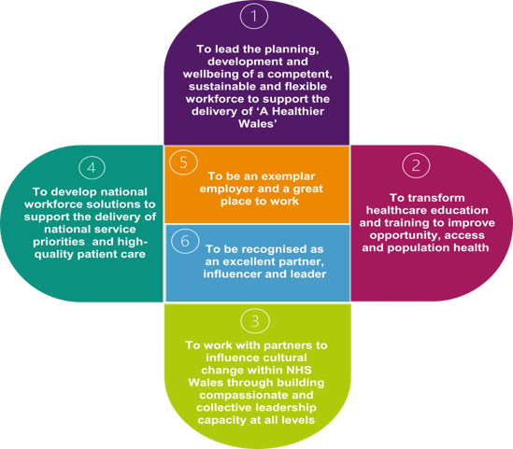
We have mapped our Strategic Aims to the ministerial priorities and wellbeing goals and the alignment of our Plan to the National Clinical Framework the Quality Framework is included in Appendix B. We have a strong part to play in the foundational economy, improving equality diversity and inclusion and use of the Welsh language and these are ‘golden threads’ throughout our Plan and shown in the Quick Reference Guide in Appendix G.

As a strategic organisation it is important that we build on our progress in 2021/22 by planning within the wider contextual environment. The impact of the COVID-19 pandemic has radically changed the strategic context in which we work and live on a global, national and local basis. Along with other contextual changes this has offered opportunities, as well as challenges, which we respond to in this Plan. We have reviewed and refreshed our PESTLE analysis to inform the review of our Strategic Objectives this analysis is included in Appendix C.

3.2 Stakeholder and Staff Engagement in the Development of the IMTP
This year we are pleased that we have been able to have conversations with all NHS organisations on our emerging IMTP 2022-25. Through the establishment of our Stakeholder Reference Group we have also engaged with over 40 different organisations on our draft IMTP, as well as a dedicated session to discuss our plans with Welsh Government Policy Leads.

The purpose of the engagement was to engage with all key stakeholders and partners on their views and priorities to ensure that our plans are aligned to deliver the change the system needs. The themes captured from the engagement conversations with NHS organisations align very closely with those identified through the extensive engagement on the Workforce Strategy for Health and Social Care. A summary of the engagement themes is included in Appendix D.

We have also discussed the development of our plans regularly with Welsh Government planning colleagues to update on progress, built relationships and shared information about key risks and incorporated the feedback into our Plan as part of this process. We have consulted with our staff on the development of the Plan through ongoing engagement at our monthly Senior Leadership Team meetings and our Local Partnership Forum. We have also discussed our Plan with all of our staff through our wider engagement mechanisms.

3.3 Planning Approach
As a strategic body it is essential that we focus on longer term planning as well as short term solutions to support current pressures and COVID reset. This has been challenging over the last two years but in this plan we aim to balance the short and more medium term, sustainable actions. These will support implementation of the Workforce Strategy which forms such an important part of our strategic context, as well as providing flexibility to respond to emerging priorities from the recovery programme.

Our plan reflects the multi-dimensional nature of our work – including profession-specific objectives, multi-professional objectives and objectives that relate to national programmes. We value our strategic agility and we will respond as required to emerging issues in-year, including reviewing our plans following the recent Ockenden report on maternity services, and the development of integrated care. Our planning process and our performance management arrangements focus on ensuring that these are clearly connected, and that stakeholders can see our work through these different lenses.

A large component of our plan is already agreed in the form of the education and training commissioning plan. This is produced on an annual basis, linked to academic cycles. This is a critical foundation for the IMTP and requires us to understand our financial profiles on at least a 5 year timescale given the duration of the programmes we commission.

We have mechanisms in place to flexibly respond to the development of regional plans, and our Plan includes our contribution to decarbonisation and climate change which is further outlined in our Biodiversity and Climate Change Strategy which can be found here.

As part of our planning the organisation was encouraged to consider which of the previous Strategic Objectives should now be embedded into ‘Business as Usual’ activities or closed. A summary of the closed strategic objectives and new strategic objectives are included in Appendix E.

We have also responded to essential new priority areas and addressed the major risks on our Corporate Risk Register. We have developed an ambitious and exciting set of Strategic Objectives to support the system recovery and to deliver our Strategic Aims and these are described in Chapter 4.

Chapter 4 – Strategic Aims and Objectives
Appendix F
This chapter describes our Strategic Aims and outlines our Strategic Objectives, deliverables for 2022/23 and Year 3 outcomes. Detailed deliverables and milestones and the high-level deliverables for Year 2 and Year 3 of the IMTP are included in Appendix F.
Strategic Aim 1: To lead the planning, development and wellbeing of a competent, sustainable and flexible workforce to support the delivery of ‘A Healthier Wales’
Strategic Objectives | Deliverables for 2022/23 | Outcomes
1.1: Establish a programme of work with sound governance arrangements, to ensure the implementation of our Workforce Strategy for Health and Social Care remains on track for full delivery by 2030.  Exec Lead: Deputy CEO/ Director of Workforce & OD  SRO: Deputy Director of Workforce & OD | - Sound governance arrangements are in place to oversee development and delivery of the medium term (Phase 2) implementation plans through an Oversight Group.  - Stakeholders and partners have the opportunity to contribute to the development of the medium term three year implementation plan (commencing 2023/24) through a multi-agency conference.  - A comprehensive stakeholder communication plan is in place.  - An WFS website is created to inform all stakeholders, and will include sharing examples of good practice, news items and progress updates. | - Improved evidence of delivery against the seven themes of the Workforce Strategy for Health and Social Care.
1.2: Lead and develop a sustainable national workforce plan for nursing to achieve a better match between demand and supply in Wales.  Exec Lead: Director of Nurse & Health Professional Education  SRO: Head of Nursing and Midwifery Transformation | - Engagement and consultation events to develop workforce plan, following publication of current workforce mapping.  - Engagement events to scope potential new workforce models and priorities.  - Working with partners complete workforce analysis, research and engagement to inform demand and supply planning assumptions  - Develop key actions to improve recruitment, retention, education and training in line with planning assumptions  - Complete strategic review of post registration education.  - Develop future workforce models including multi professional working, skill mix and new roles such as nurse associate  - Outline the Role of the Nurse 2030 vision for Wales | - Reduced vacancies supporting improved quality of care and better use of resources  - Workforce aligned to the Nurse Staffing levels (Wales) Act..
1.3: Scope solutions for the dental workforce in Wales to ensure the workforce is identified, trained, supported and available to deliver dental services for the future to meet the oral health needs of the Welsh population.  Exec Lead: Medical Director  SRO: Postgraduate Dental Dean | - Programme Manager for Dental Workforce Plan recruited if business case supported.  - Scope and present options for dental nurse training provision and funding.  - Work with key partners and stakeholders to develop Dentist with Enhanced Skills (DES) frameworks for specific areas.  - Engage dentistry in Advanced Cluster Development work as part of SPPC.  - Dental Specialty Training included in Education and Training Plan.  - Develop Leadership offer to the dental workforce. | - Address dental workforce challenges and identify opportunities to deliver the optimum workforce to meet the oral health care needs of patients in Wales.
1.4: Support the modernisation of the pharmacy workforce, through finding workforce solutions and planning for the future workforce.  Exec Lead: Medical Director  SRO: Pharmacy Dean | - Establish a programme of work in partnership with key stakeholders to address the workforce issues.  - Establish with key partners the future roles for the pharmacy workforce.  - Describe an employment model that meets the aspirations of the workforce.  - Describe a workforce that maximises skill mix and utilises workforce enhanced skills.  - Establish the 23/24 priorities and actions which enable the implementation of a transformed workforce.  - Establish a robust dataset which underpins the workforce solutions.  - Commence the implementation of the agreed short-term solutions. | - A motivated, engaged and valued pharmacy workforce, with the capacity, competence and confidence to deliver the new IETPs and meet the medicines needs of the people of Wales.
1.5: Lead the development of a multi-professional CPD strategy and drive improvements in current CPD activity to ensure that the existing NHS Wales workforce has the skills and capabilities required for the future.  Exec Lead: Director of Nurse & Health Professional Education  SRO: Deputy Director of Workforce Transformation | - Engagement with key stakeholders on the principles of the CPD Strategy  - Development of the CPD strategy informed by engagement  - Consultation on the CPD Strategy  - Consideration of the comments received and refinement of the CPD strategy  - Publication of the CPD Strategy. | - Staff across the professions have access to high quality life long learning activities to support personal and service development and improvements in patient care.
1.6: Fully implement and evaluate the ‘Y Ty Dysgu’ Education Delivery System (EDS).  Exec Lead: Director of Digital Development  SRO: Head of Digital Strategy and Planning | - Implementation of Y Ty Dysgu across HEIW.  - Complete migration activity from third party systems in scope.  - Decommission the Overt, Maxinity and other third party systems.  - Agree an approach for future hosting of education and training for the Health Boards.  - Develop an evaluation process of the use and effectiveness of the EDS and identify any barriers to use.  - Development of the EDS further to suit the needs of HEIW. | - Improved access to flexible, good quality CPD delivered via the single EDS.  - Improved information about provision and utilisation.
1.7: Lead, develop and embed a range of actions to support workforce and workplace wellbeing and colleague experience.  Exec Lead: Deputy CEO/ Director of Workforce & OD  SRO: Deputy Director of Workforce & OD | - Enhance our approaches to supporting the wellbeing of our Future Workforce by providing age-appropriate career information and guidance to create meaningful work experience to better prepare our prospective students, learners and workers.  - Support our students by setting and monitoring standards for wellbeing support through our education contracting and commissioning.  - Support our trainees/PG students by reviewing our approach to wellbeing of trainees and PG students including our offer of the Professional Support Unit and how we hold joint responsibility with employers.  - Supporting our NHS Family by providing system leadership and the curation and navigation of approaches and resources to improve retention by creating conditions for staff to thrive. | - Colleague (including students and trainees) wellbeing underpins all that we do, evidenced by continually improving scores/feedback in staff and student surveys.
1.8: Improve recruitment and access to careers in the health and care sector in partnership with Social Care Wales (SCW).  Exec Lead: Deputy CEO/ Director of Workforce & OD  SRO: Deputy Director of Workforce & OD | - Develop Careersville as the primary resource for NHS Wales careers marketing, promotion and event management, taking opportunity to align with Train Work Live and We Care marketing campaigns when appropriate.  - Engage with stakeholders to inform the development of our Careers and Widening Access Strategy.  - Review and revise the governance arrangements for management and delivery of the Widening Access grant scheme.  - Review current schemes and develop targeted schemes for shortage areas focussing particularly on actions to address the diversity of the workforce.  - Develop an action plan for medicine careers support advice following on from the Medical and Dental Careers Strategy. | - Increased recruitment of people in our communities that have valuable skills and experience currently underrepresented in our workforce, and reinforcing NHS Wales’ reputation as an excellent place to train, work and live, right from the start.
1.9: With partners in NWSSP and DHCW, develop our workforce intelligence function to inform strategic workforce planning and modelling for Wales.  Exec Lead: Deputy CEO/ Director of Workforce & OD  SRO: Head of Data & Analytics | - Develop phase 1 Project Initiation Document (PID).  - Establish partnership working arrangements to progress this work.  - Define our data requirements to enable us to discharge our statutory responsibilities.  - Create the governance mechanisms required.  - Ensure close alignment to HEIW data strategy and the recommendations from the data maturity review.  - Develop the vision for the Centre of Excellence to inform the outline business case in 2023-24. | - Improved understanding of our workforce by developing analytical methods and sophisticated modelling techniques.
1.10: Improve the quality of strategic workforce planning across NHS Wales, by curating and harnessing renowned external expertise, developing education and training for NHS organisations and providing strategic workforce planning expertise and advice to support NHS organisations.  Exec Lead: Deputy CEO/ Director of Workforce & OD  SRO: Head of Workforce Planning | - Develop the project plan and governance arrangements to oversee development and delivery of our strategic workforce planning observatory.  - Create partnerships with key organisations, think tanks and acknowledged experts to curate resource and expert opinion, analyse workforce trends, population and social needs to inform workforce forecasting, modelling and scenario planning.  - Commission work with appropriate partner to provide a research-based overview of the workforce context for Wales.  - Create a digital presence to enable publication and sense making of recent research and development.  - Develop a three year plan for improving Workforce Planning capability across NHS Wales commencing with improving capability in HEIW.  - Scope the development of academic/accredited Workforce Planning training. | - A recognised and acknowledged body providing sophisticated, evidence-based and intelligence led strategic workforce planning, enabling us to change our workforce to meet our population need.

Strategic Aim 2: To transform healthcare education and training to improve opportunity, access and population health.
Strategic Objectives | Deliverables for 2022/23 | Outcomes
2.1: Improve and develop roles (including ‘Generalist’ and ‘Extensivist’ roles) and programmes, informed by and aligned to the recommendations of ‘The Future Doctor Programme’ (2020).  Exec Lead: Medical Director  SRO: Director of Educational Improvement & Governance | - Implement the outcomes of the engagement event held in January that identified opportunities for development of a multi-professional workforce to meet future population need.  - Develop a programme of work encompassing projects aimed at enhancing postgraduate medical training and ‘future-proofing’ medical roles in the context of multi-professional training and working.  - Promote and support learning through both flexible and traditional models of education  - Facilitate enhanced generalist skills in medical training programmes.  - Agree our education, learning and development principles and test for implementation  - Work with education providers to embed shared understanding of healthcare roles across professions and multi-professional approaches to training | - Commissioning of the right education programmes to ensure the right professionals are in the right roles to deliver the care needed by the people of Wales.
2.2: Lead the implementation of new contracts for Phase 1 of the Strategic Review of the commissioning of health professional education.  Exec Lead: Director of Nurse & Health Professional Education  SRO: Deputy Director of Education Commissioning & Quality | - Each contract to begin one year prior to student enrolment (September 2021) enabling for a mobilisation year.  - All contract clarifications requested by HEIs provided by September 2022.  - 2022 courses approved by the regulator (NMC / HCPC).  - First cohort of students to go through new courses.  - Performance Monitoring Framework (Aligned to HEIW Quality Framework) developed and implemented.  - Performance reports for new contracts developed. | - Graduates working in Wales from 2025 onwards with enhanced Welsh language. Digital, improvement, leadership and team working skills
2.3: Lead Phase 2 of the Strategic Review of the commissioning of health professional education.  Exec Lead: Director of Nurse & Health Professional Education  SRO: Deputy Head of Education, Commissioning & Quality | - Award of contracts for procurements outlined below:  o HCSW (Nursing) level 4 education.  o Medical genomics level 7 standalone modules.  o CAAPs.  o Work based learning framework.  o Clinical photography work-based learning.  - Medical ultrasound – work based learning Qualification developed.  - Medical ultrasound – postgraduate diploma notice to trigger procurement and evaluation of bids.  - PTP part time; pathology, audiology and clinical engineering notice to trigger procurement and evaluation of bids.  - Authorisation of Blood transfusion programme notice to trigger procurement and evaluation of bids.  - Scoping of post-registration nurse education. | - Graduates working in Wales from 2023 onwards with enhanced Welsh language. Digital, improvement, leadership and team working skills
2.4: Support the modernisation of the pharmacy workforce, plan for and implement the Initial Education and Training Standards for Pharmacists (IETP).  Exec Lead: Medical Director  SRO: Pharmacy Dean | - Post-Registration Foundation Pharmacists 2022/23 intake -in partnership with HEIs start delivery of the new transition pathway for IETP to include IP outcomes.  - Complete negotiations with HEIs regarding the proposed funding of clinical placements within MPharm to support the transition of learning outcomes.  - Submit business case to Welsh Government for the new investment in pharmacy undergraduate clinical placements  - Develop the infrastructure to support increased pharmacy clinical placements.  - Iterative development, continuous improvement and quality management of Foundation Training Programme and move to fully multi-sector delivery.  - Ensure all pharmacists in Wales identified (or self-identified) as requiring an IP qualification have access to IP training. | - Wherever pharmaceutical care is provided, patients will be assured that the pharmacy team will be able to help patients to achieve the best from their medications and maximise their quality of life.
2.5: Support the modernisation of the pharmacy workforce, plan for and implement the Initial Education and Training Standards for Pharmacy Technicians (IETP).  Exec Lead: Medical Director  SRO: Pharmacy Dean | - Implement the new IETP Pharmacy Technicians Training Programme.  - Recruit 3 cohorts of Pre-Registration Pharmacy Technicians into the new training programme.  - Agree strategic plan and commence the implementation for Pharmacy Technicians post-registration. | - Wherever pharmaceutical care is provided, patients will be assured that the pharmacy team will be able to help patients to achieve the best from their medications and maximise their quality of life.
2.6: Lead and promote a reduction in differential attainment in education and training in line with the Strategic Equality Plan.  Exec Lead: Medical Director  SRO: Postgraduate Dental Dean | - Develop, monitor and review a programme of activity to identify and address the DA gap in different health education and training areas e.g. medical, dental, pharmacy, nursing, AHP etc.  - Engage with key stakeholders in service, education and under-represented groups to identify barriers, raise awareness, develop discussions, inform progress and encourage collaboration.  - Review existing policies/interventions, links to wellbeing and mental health and make decisions on action to be taken to address any deficiencies/gaps in this area.  - Develop a toolkit of interventions for use in identifying and addressing the DA gap and improving outcomes.  - Establish and receive updates from task and finish groups as required to focus on specific actions within the implementation plan. | - A workforce in healthcare that does not experience adverse effects in education and training that may impact upon wellbeing, performance, progression and attainment and consequently patient care.
2.7: Maximise opportunities for work-based learning (WBL) and apprenticeships in health to promote the ‘Made in Wales’ ethos.  Exec Lead: Director of Nurse & Health Professional Education  SRO: Deputy Director of Education Commissioning & Quality | - Support all learners in clinical environments through the development and implementation of a WBL approach to support learning in practice for all students and trainees.  - Embed the required quality control systems and processes for WBL across NHS Wales to include all aspects of the WBL Governance Framework.  - Establish a process for the review of all Wales WBL resources to ensure that they are up to date.  - Develop the Y Ty Dysgu learning platform to host WBL resources and other relevant information.  - Undertake reviews of current work-based learning qualifications in line with their agreed review dates.  - Deliver assessor and Internal Quality Assurance (IQA) training.  - Take responsibility for the registration of all learners undertaking post registration WBL qualifications to support Phase 2 of the Strategic Review.  - Work with the Education Workforce Council to ensure any NHS Wales staff who need to register are supported to do so.  - Development of work-based learning qualifications identified as part of Phase 2 of the Strategic Review and that align with actions within the workforce strategy. | - Improved opportunities to support staff with their aspirations for high-quality employment as part of the foundational economy.
2.8: Develop and implement a multi-professional education and training quality framework.  Exec Lead: Medical Director  SRO: Postgraduate Dean | - Continue engagement with key stakeholders to refine a multi-professional Quality Framework  - Establish evaluation mechanisms to ensure robust feedback  - Launch the multi-professional Quality Framework through robust engagement  - Implement a multi-professional Quality Framework to underpin a system for ensuring high-quality education and training for the NHS Wales workforce.  - Establish a single section for quality planning, management and improvement for the Medical Deanery  - Establish matrix working arrangements with Nursing Directorate | - Delivery of high-quality education and training and access to high quality facilities and educational support so that the future healthcare workforce can achieve their potential
2.9: Implement improvements to ensure equitable access to education and training for SAS (Staff Grade, Associate Specialist and Specialty Doctors) and locally employed (LE) doctors.  Exec Lead: Medical Director  SRO: Director of Medic Professional Support and Development | - Review the current HEIW structures supporting SAS and locally employed doctors.  - Assess the impact of interventions already delivered.  - Review the role and responsibilities of the SAS tutor following the development of the new SAS advocate role.  - Develop a plan to deliver good quality and cost effective continuing professional development to SAS doctors.  - Review the current budget for SAS doctors to ensure cost effectiveness and value.  - Develop appropriate support and development opportunities for SAS and LE doctors who are international medical graduates.  - Align work done in this area across NHS Wales to share expertise/resource and reduce replication. | - Increased SAS workforce with improved job satisfaction and morale.
2.10: Lead the development and implementation of a multi-professional strategy for Simulation-Based Education and Training.  Exec Lead: Medical Director  SRO: Director of Educational Improvement & Governance | - Implementation of key priorities within the All-Wales Simulation-Based Education and Training Strategy for the Health and Care Workforce Plan, and particularly –  - Support and promote interprofessional simulation-based education and training (IPSBET).  - Standardise the faculty approach for simulation-based education in Wales though faculty development.  - Develop lines of accountability to facilitate strategy implementation, particularly regarding quality assurance, IPSBET and accessibility.  - Work across HEIW to support the delivery of key resources, support structures and mechanisms needed for simulation.  - Enhanced and quality assured use of resources on appropriate virtual platforms.  - Disseminate and promote simulation developments in Wales. | - Improving access to training, contributing to the promotion of Wales as the place to TrainWorkLive.
2.11: Lead the development and implementation of a digital capability framework for the healthcare workforce in partnership with Digital Health and Care Wales (for staff who are not digital specialists).  Exec Lead: Director of Digital Development  SRO: Head of Digital Strategy and Planning | - Continue to implement iteratively, reviewing effectiveness and impact as the roll out progresses.  - Developed and implemented Phase 2 plan of the programme.  - Reviewed domains, subdomains, descriptive and capability statements with Nursing, and the Mental Health Workforce.  - Identified and mapped additional L&D resources.  - Developed an updated Digital Capability Framework (v1.0).  - Developed an online self-evaluation tool on the LMS.  - Completed a successful alpha test of the tool and framework with Nursing, and the Mental Health Workforce.  - Developed a plan for Phase 3, incorporating outputs from Phase 2. | - Improved understanding of digital capabilities, the opportunity to develop and evidence digital skills and the ability to continually develop digital skills as technologies evolve.
2.12: Develop and implement modernised funding models to incentivise training and education in NHS Wales.  Exec Lead: Director of Finance  SRO: Deputy Director of Strategic Finance and Corporate Services | - Development of a roadmap with NWSSP to consider and implement application and allocation of individualised trainee study leave budgets.  - Scope and Develop proposals for funding postgraduate education centre contributions.  - Development of method to revise funding for training grade posts in NHS Wales.  - Provide advice on changes to WG policy on bursary and SIFT developments. | - Transparent and proportionate multi-professional approach to funding allocations facilitating and supporting education and training.
2.13: Support the development of placement availability and quality to underpin delivery of education and training across healthcare programmes.  Exec Lead: Director of Nurse & Health Professional Education  SRO: Programme Manager Education | - Confirm HEIW placement governance and expand network of external placement stakeholders.  - Undertake baseline scoping of effective and efficient use of placement capacity across nursing, allied health profession and healthcare science programmes, and determine additional HEI/Health Board support required to maximise placement provision.  - Set up stakeholder workstreams to develop new placement availability across priority target areas identified within primary, secondary, and tertiary health and care services, agree pilot sites, and manage further roll out of increased capacity.  - Scope Practice Education Facilitator (PEF) equity across professional groups to maximise existing placement capacity.  - Develop quality benchmarks for placement excellence and align with the HEIW Quality Framework.  - Produce a placement metrics dashboard for use in HEI quality and performance monitoring.  - Implement Regional Care Home Education Facilitator (CHEF) roles.  - Establish the added value of introducing HEIW placement software and specific programme functionality. | - Placement learning experiences that prepare future registrants to provide service excellence and be part of a sustainable and committed workforce.
2.14: Develop, review and implementation of an approach to secure the longer-term provision of services provided by the Welsh Institute for Minimal Access Therapy (WIMAT).  Exec Lead: Interim Director of Finance and Corporate Services  SRO: Deputy Director of Strategic Finance and Corporate Services | - Complete detailed analysis of existing service provision, capacity and resources.  - Agree and develop procedures to support current approach to operational practice.  - Establish agreed details of future training requirements and commissioning approach.  - Complete options analysis to determine recommendation for longer term training requirements. | - Enhanced skills and competencies of the Welsh NHS workforce across a range of medical and surgical specialties.

Strategic Aim 3: To work with partners to influence cultural change within NHS Wales through building compassionate and collective leadership capacity at all levels
Strategic Objectives | Deliverables for 2022/23 | Outcomes
3.1: Lead, embed and evaluate the value chain and impact of the Health and Care Leadership Strategy across NHS Wales.  Exec Lead: Deputy CEO / Director of Workforce & OD  SRO: Assistant Director of Leadership & Succession | - Establish a network faculty of leadership associates who can support Executive and clinical development offerings.  - Provide health and social care learning events to share best practice and create communities of compassionate and collective leaders.  - HEIW established as credible system leader in the field of compassionate leadership.  - Evaluate the impact and value chain Gwella, leadership strategy and framework for action for NHS Wales.  - Continue to enhance Gwella to reflect NHS Wales requirements through a series of pipeline developments.  - Production of leadership resources for health and social care in line with KPIs and continued publication and signposting toa wide range of leadership offerings. | - Enhanced leadership capacity and capability at all levels with leaders who build positive, safe and compassionate environments where teams flourish.
3.2: Lead the development of sustainable pipelines of senior leaders and executive talent in line with the NHS Wales Succession Planning Strategy.  Exec Lead: Deputy CEO / Director of Workforce & OD  SRO: Succession Planning and Talent Management Lead | - Provision of a range of national executive development leadership programmes, offerings, and interventions.  - Development of best practice TM processes and toolkits to support robust local application.  - Continued support and management of the Talent Management Board and Talent and Succession Operational Group.  - Develop and deliver an NHS Wales Executive Leadership Development Framework offer for Tier 3.  - Evaluate the Aspiring Executive Leadership offerings and specifically assess the impact of the systems leadership module, complimenting and strengthening the programme as required.  - Resources and assessor capacity available for future development centre delivery. | - Robust aspiring executive talent pools and pipelines established with up to 3 NHS applicants shortlisted for all NHS Wales Executive positions by 2024 (3 minimum by 2027).
3.3: Lead the adaptation, development and implementation of leadership programmes and resources for clinical leaders from a range of professional backgrounds.  Exec Lead: Deputy CEO / Director of Workforce & OD  SRO: Assistant Director of Leadership & Succession | - Review, enhance and provide clinical leadership development programmes, alumni and networks.  - Explore application of educational credit to clinical leadership programmes.  - Review support required to develop and grow leadership capacity within Primary Care.  - Onboarding, delivery and project management of Welsh Clinical Leadership Training Fellows (WCLTF) Programme.  - Support recruitment for the annual Florence Nightingale Scholarship.  - Continued support and establishment of clinical leadership networks.  - Delivery of Medical Directors Programme.  - Following evaluation, exploration of Medical Director programme model for application to another professional Director Peer Group. | - Confident clinical leaders able to effectively lead transformational change through a model of compassionate and collective leadership.
3.4: Robustly evaluate the re-established NHS Wales Graduate Programme and develop a financially viable operating model that ensures a continuous pipeline of future leadership talent.  Exec Lead: Deputy CEO / Director of Workforce & OD  SRO: Assistant Director of Leadership & Succession | - Evaluation of the graduate programme operating model and graduate experience.  - Continued support and delivery of the 2021-23 National Graduate Programme and HEIW internship programmes.  - Securing NHS Wales commitment and a repeat funding stream for continued delivery of the Graduate Programme.  - Market and recruit to 2023-2025 NHS Wales Graduate Programme.  - Secure NHS Wales Graduate Programme Assessment Centre provision.  - Establish a 2022 HEIW Internship Gwella page, marketing, and engagement plan to attract diverse talent into HEIW.  - Recruitment and provision of a HEIW summer and annual internship programme. | - High quality NHS Wales graduate and internship programmes that attract a wide range of diverse individuals creating a rich pipeline of aspiring leaders.
3.5: Lead the Development of the W&OD Profession creating sustainable career pathways and pipelines of Workforce & OD professionals across NHS Wales.  Exec Lead: Deputy CEO / Director of Workforce & OD  SRO: TBC | - Mapping of all the Workforce & OD professions across NHS Wales organisations.  - Mapping of all the W&OD professional competence frameworks.  - Development of a vision for the W&OD profession.  - Development of a W&OD career pathway.  - Development of a range of W&OD development opportunities and offerings including a mentoring and coaching exchange and secondment bureau.  - Development of Workforce and OD networks aimed at upskilling the profession and sharing best practice.  - Development of a Workforce and OD heat map highlighting roles at risk and enabling positive action.  - Development of a range of W&OD Success Profiles utilising the Gwella talent management software. | - Mature talent pools and visibility of W&OD talent who able to be shortlisted for NHS Wales W&OD positions.

Strategic Aim 4: To develop national workforce solutions to support the delivery of national service priorities and high-quality patient care. Additional objectives may be added to this Aim in-year as required to support the workforce needs of the emerging regional and recovery plans.
Strategic Objectives | Deliverables for 2022/23 | Outcomes
4.1: Support the development and implementation of multi-professional workforce models for primary and community care, in line with the Strategic Programme for Primary Care.  Exec Lead: HEIW Chief Executive  SRO: HEIW Programme Director – Primary Care | - Establish the primary care infrastructure.  - Agree local primary care academy infrastructure.  - Establish HEIW team.  - Agree a prioritised phased plan for development and/or roll out of education programmes across Wales.  - Undertake a baseline scoping of education and training programmes available to the wider community workforce.  - Review and assess funding models/approaches.  - Develop a communications and engagement plan. | - A funded, sustainable all Wales coordinated infrastructure designed to meet the educational needs of the primary and community care workforce.
4.2: Develop a mental health workforce model and plan in collaboration with Welsh Government and Social Care Wales to support the implementation of Together for Mental Health (including CAMHS).  Exec Lead: HEIW Chief Executive  SRO: Head of Nursing and Midwifery Transformation | - Complete consultation and finalise costed actions for next 3 years  - Agree funding requirements with WG  - Finalise and publish plan  - Agree implementation plan for 22/23 and governance mechanisms  - Embed actions in existing work programmes where relevant including education and training commissioning planning process, leadership development, and strategic review phase 2.  - Implement first cohort of CAAPs  - Continue implementation of new education and training for CAMHS and perinatal  - Develop a training package for MHA work part 1. | - A sustainable mental health workforce that has the expertise to support the population with their mental health and wellbeing needs recognising the impact of COVID-19.
4.3: Support the development of the workforce needed to deliver the Planned Care Recovery Programme  Exec Lead: HEIW Chief Executive  SRO: HEIW Chief Executive | - Map and quantify contributions of existing work programmes to planned care recovery (endoscopy, critical care, imaging, eye care, HCS, AHP, cancer, remote clinical assessment and digital skills etc).  - Review opportunities for short term solutions / accelerated progress in these areas.  - Promote existing work programmes and showcase good practice/innovation.  - Develop clear expectations and requirements for education and training capacity in planned care recovery programme.  - Review education and training support for planned care recovery (new role of Anaesthetic Associates, and theatre and recovery workforce models in particular).  - Research good practice and emerging innovation in workforce across Wales and UK (including NHS Scotland Academy).  - Develop proposals to address any gaps in the workforce plans and programmes to support the planned care recovery programme. | - Development of size and shape of workforce to support planned care recovery
4.4: Support the recovery of Endoscopy services through increasing workforce capacity and capability through education and training.  Exec Lead: Director of Nurse & Health Professional Education  SRO: Head of Nursing and Midwifery Transformation | - Deliver clinical endoscopist educational pathways to meet all National Endoscopy Plan (NEP) staffing requirements and support the development of new roles.  - Evaluate the impact of the national workforce plan and related endoscopy training programme on patient experience and outcomes.  - Support the NEP to deliver workforce planning and the implementation of recruitment strategies. Continue to support NEP education approaches including incorporating new technology and enhancing the usage of resources on an appropriate web platform.  - Review implementation of regional and local workforce as part of national endoscopy training plans in line with the NEP action plan 2019-2023 and recovery plan.  - Review and agree funding to support and maintain the National Endoscopy Training Programme. | - A sustainable training programme for the endoscopy workforce to meet the service demands.
4.5:Modernise workforce models to deliver service transformation arising from the NHS Wales Collaborative strategic programmes  Cancer  Exec Lead: Medical Director  SRO: Deputy Director of Workforce & OD | - Scope the impact of ongoing work in endoscopy, imaging, pathology, and Pet and within the wider HEIW remit that will improve the implementation of the Upper GI and Colorectal National Optimal pathways.  - Identify further work on specialist issues and gaps.  - Agree priority workforce, education and training solutions.  - Develop a methodology that can be used by the Wales Cancer Network to roll out to other tumour sites. | - Improving cancer survival outcomes by addressing workforce barriers to implementing the National Optimal Pathways for cancer.
4.6: Modernise workforce models to deliver service transformation arising from the NHS Wales Collaborative strategic programmes  Diagnostics  Exec Lead: Medical Director  SRO: Head of Healthcare Science Transformation | - Support the implementation and completion of the Imaging Strategic Workforce Plan.  - Development and delivery of education in response to the Imaging Strategic Workforce Plan.  - Commission a part-time Practitioner Training Programme in Biomedical Science.  - Develop an all-Wales resource for the Level 3 Healthcare Science qualification.  - Review the future NHS Wales multi-professional Diagnostics workforce to develop a shared national vision of a flexible and modern workforce. | - A modernised NHS Wales Diagnostics workforce to support the recovery priorities.
4.7: Modernise workforce models to deliver service transformation arising from the NHS Wales Collaborative strategic programmes  Critical Care  Exec Lead: Medical Director  SRO: Deputy Director of Workforce Transformation | - Standardised education qualification for critical care nurses delivered by Welsh HEI’s, comparable to the new HEE critical care module.  - Review of the practice educator role within critical care. Standardisation on the required qualifications to undertake the practice educator role within critical care.  - Working with the leadership team signpost to compassionate leadership resources supporting the embedding of compassionate leadership throughout critical care.  - Developed and published workforce solutions plan to address current workforce challenges.  - Facilitation of good practice workshops / webinars and development on online resources. | - An agile sustainable and skilled critical care workforce which will have a positive impact on patient care and outcome due to increased education opportunities and career paths.
4.8: Support the delivery of the Six Goals for Urgent and Emergency Care through workforce modernisation, education and training.  Exec Lead: Director of Digital Transformation  SRO: Deputy Director of Workforce Transformation | - Lead workforce, education and training development and transformation in the priority areas as identified with the WTD Enabling Group of National UEC Programme Board.  - Develop UEC workforce models in-line with prudent health principles for areas identified as a priority.  - Initial priorities include:  - Remote Clinical Decision Making (RCDM) training Phase 2.  - Educational Framework for Mental Health 111.  - Advanced Paramedic Practitioner workforce model.  - Urgent Care Practitioner (UCP) education. | - Modern, multi-professional urgent and emergency care workforce models, that use their skills in line with the prudent in practice principles, to deliver the Six Policy Goals.
4.9: Support the implementation of national policy and professional frameworks and legislation related to the health professional workforce.  Eyecare  Exec Lead: Director of Nurse & Health Professional Education  SRO: Head of Optometry Transformation | - Prepare and implement new education and training to support the new contract using Y Ty Dysgu.  - Commission at least a further 10 courses for higher qualifications in glaucoma, 20 medical retina and 10 for Independent Prescribing.  - Deliver mentoring and support for all newly qualified optometrists using a Wales Professional Review for Optometry IT system (linking with RSU).  - Scope the applicability of quality improvement Bronze level Improvement Cymru module for optometrists in Wales.  - Deliver a toolkit which includes educational resources to support cluster working for optometrists who will be representatives at cluster planning groups. | - Increased number of eye care services available in primary care optometry practice, supported by education, training and mentoring from HEIW.
4.10: Support the implementation of national policy and professional frameworks and legislation related to the health professional workforce.  Allied Health Professionals  Exec Lead: Director of Nurse & Health Professional Education  SRO: Head of Allied Health Professionals Transformation | - Develop principles of best practice to expand AHP roles / responsibilities to have greater influence on patient flow / delivery of care closer to home including consistency and equity for AHP input into discharge facilitation and admission avoidance models across Wales.  - Coordinate / develop equitable AHP leadership / succession planning offer and prepare plan for:  - pre-registration  - early / mid-career  - aspiring executives.  - Develop a Research and Innovation (R&I) strategy for AHPs – including audit, evaluation, quality improvement.  - Develop and implement project plans for priority projects around clinical portfolios:  - Person-centred rehabilitation  - Public health & prevention | - Improved integrated roles for AHPs across whole system delivering quality outcome focussed services for the people of Wales.
4.11: Support the implementation of national policy and professional frameworks and legislation related to the health professional workforce.  All Wales Nurse Staffing Programme  Exec Lead: Director of Nurse & Health Professional Education  SRO: Head of All Wales Nurse Staffing Programme | - Continue to deliver the key priorities as directed by Executive Nurse Directors and Welsh Government.  - Support the implementation of the interim nurse staffing principles for Health Visiting and Mental Health inpatient services.  - Conduct testing of the draft Welsh Levels of Care for Mental Health to refine the tool and develop the evidence base.  - Conduct testing of the draft Welsh Levels of Care for Health Visiting to refine the tool and develop the evidence base.  - Implement use of the draft Welsh Levels of Care for District Nursing to further develop the evidence base.  - Contribute to work commissioned by Welsh Government to evaluate the impact of the Nurse Staffing Levels (Wales) Act.  - Explore how the data collected through the programme can be used to inform strategic workforce planning.  - Confirm HEIW responsibilities in data collection and analysis to support the delivery of the programme.  - Confirm handover arrangements and responsibilities for HEIW to health boards when the 2nd duty of the Act is extended. | - NHS Wales is able to plan and deploy the right number and skill mix of nursing staff required to meet the needs of patients, improving quality and patient safety.
4.12: Support the implementation of national policy and professional frameworks and legislation related to the health professional workforce.  Healthcare Sciences (HCS)  Exec Lead: Director of Nurse & Health Professional Education  SRO: Head of Healthcare Science Transformation | - Effectively manage the Healthcare Science programme across all objectives described in the 5 pillars of the Framework action plan:  - Deliver the elements of the Healthcare Science Framework relevant to HEIW strategic aims. In Year 1:  1a) Utilise the service-led approach to workforce planning to create a stable and balanced workforce and to establish procedures for more coordinated planning by services.  1b) Strengthen the Modernising Scientific Careers education and training career framework from associate to consultant, with in year focus on transition to practitioner and to consultant.  2) Work in partnership with Welsh Government and NHS R&D Directors to promote understanding of and capability for prudent and value-based research, development and innovation in healthcare science.  3) Through prudent and value-based approaches, co-produce workforce solutions with NHS Wales for recovery aligned to healthcare science.  4) Promote the use of ‘one voice’ to communicate and collaborate with the healthcare science profession, promoting coherence and identity and sharing success.  5) Understand the current registration/accreditation levels in the healthcare science profession and barriers to gaining registration/accreditation. | - Improved access to the Modernising Scientific Careers education and training career framework from associate to consultant level.
4.13: Plan and implement improvements to develop and embed further the roles of physician and anaesthesia associates in Wales, including ensuring educational and careers infrastructure is developed to support future regulation.  Exec Lead: Medical Director  SRO: Director of Medic Professional Support and Development | - Explore the development of a postgraduate school structure for PA/AAs to provide leadership and raise the profile of the roles across NHS Wales.  - Using best practice and UK frameworks develop educational governance/infrastructure guidance for employer supporting PA and AA (PA internship, early years AA role).  - Support employers to further implement the role of AAs across NHS Wales.  - Develop the role of HB PA/AA tutors/ambassadors to develop the roles further across NHS Wales.  - Develop and support opportunities for continuing professional development for PAs/AAs.  - Align work done in this area across NHS Wales to share expertise/resource and reduce replication. | - Increased, highly engaged and motivated associate workforce across NHS Wales.
4.14: Develop assurance framework for multi-professional Advanced Practice (AP)and Consultant Practice including:  Exec Lead: Director of Nurse & Health Professional Education  SRO: Workforce Modernisation Manager | - Development of a database of AP and Consultants.  - Work with the Welsh Advisory Group for Advanced Practice to develop AP and Consultant practitioners’  - Establish AP and Consultant networks.  - Revise and update AP and Consultant Framework and Guidance for employers. | - Improved confidence in ability to assure the quality and safety of AP & Consultant practice for employers and the people of Wales.
4.15: Support development of the four social prescribing deliverables of Connected Communities Strategy and to lead on deliverable number 2 - National skills and competency framework for social prescribers in Wales.  Exec Lead: Deputy CEO/ Director of Workforce & OD  SRO: Programme Manager Primary Care | - Develop a business case to Welsh Government to secure funding.  - Establish an expert group of that will steer framework development and procurement standards  - Develop the procurement standards and evaluation.  - Run the procurement process and award the contract.  - Develop competency statements that will inform the framework  - Undertake extensive engagement to ensure the framework will reflect the needs of NHS Wales  - Develop and publish the all-Wales Education and Training Framework for Social Prescribing  - Framework rollout in alignment with National Framework for Social Prescribing (WG) | - Standards for social prescribing education and training determined and assisted in measuring if education and training satisfy these standards.

Strategic Aim 5: To be an exemplar employer and a great place to work
Strategic Objectives | Deliverables for 2022/23 | Outcomes
5.1: Initiate measures to further improve staff & customer experience including implementation of the People and Organisational Development (OD) Strategy  Exec Lead: Deputy CEO/ Director of Workforce & OD  SRO: Senior Workforce Business Partner | - Implementation of the key themes from the People and OD strategy.  - Provision of a learning and development offering that includes a range of training supported by e-learning packages, support for individual learning and development, the PADR process including 360º, regular staff conferences and an awards ceremony.  - Reviewed the recruitment and selection process and policy to improve understanding, implement best practice and ensure recruitment of a highly skilled and diverse workforce reflecting the community we serve.  - Undertaken internal workforce planning for HEIW staff and developed inclusive internal succession planning and talent management procedures.  - Undertaken regular review of staff experience using a range of tools and undertaken follow up action as required.  - Reviewed existing W&OD policies and introduced new policies in accordance with the policy matrix.  - Improved the health and wellbeing of HEIW staff and acted as an exemplar within NHS Wales.  - Support the development of the HR profession in HEIW in conjunction with the CIPD and HPMA. | - A happy, inclusive and motivated workforce that reflects the community we serve.
5.2: Deliver the external element of the Race Equality Action Plan (REAP) and implementation of HEIW Strategic Equality Plan (SEP)  Exec Lead: Deputy CEO/ Director of Workforce & OD  SRO: Head of OD & Inclusion | - Continue to deliver accreditation pledges and calendar of EDI events.  - Develop a HEIW programme of work that enables delivery of the Race Equality Action Plan.  - Develop processes to increase the diversity within the aspiring executive leadership talent pool.  - Develop /Review Directorate strategic equality action plans reporting in alignment with HEIW quarterly strategic objective reporting processes.  - Commence year 2 directorate strategic equality action planning. | - Diversity, equality and inclusion is promoted and actively supported throughput our business and our workplace.
5.3: Implement and embed the Welsh Language Scheme within HEIW  Exec Lead: Board Secretary  SRO: Welsh Language Support Manager | - Continue to implement and embed the Welsh Language Scheme.  - Continue to motivate and inspire staff to learn Welsh.  - Continue to deliver Welsh language training and how to use Welsh language in the workplace training.  - Establish and develop a confidence raising course for Welsh Language Skills for HEIW staff.  - Continue to improve the Welsh language translation service including the implementation of the Welsh language scheme.  - Grow the number of staff able to undertake basic Welsh translation and explore options to deliver bespoke courses for fluent speakers to give them the confidence to translate their own work.  - Reconsider priorities for Welsh language translation and introduce the Welsh Language Guide to all staff. | - Greater number of staff are able to speak Welsh and undertake Welsh translation.
5.4: Implement organisational changes to meet expectations regarding biodiversity and climate change  Exec Lead: Director of Finance, Planning, Performance & Corporate Services  SRO: Assistant Director of Planning and Performance | - Establish formal governance arrangements to deliver our Biodiversity and Decarbonisation Strategy and our responsibilities under the NHS Wales Decarbonisation Strategic Delivery Plan.  - Develop an action plan with clear organisational ownership and mechanisms of delivery against our four areas of action:  - Engaging and supporting our staff.  - Sustainable procurement.  - Developing our office, Ty Dysgu, and supporting our local communities.  - Environmental sustainability.  - Produce a 3-yearly biodiversity report to Welsh Government (following report in Dec 2019) in relation to requirements of Environment Act 2016.  - Commission with partners/stakeholders the appropriate resources to be embedded into respective education and training curricula.  - Embed an understanding of how healthcare contributes to the climate crisis and what the trainee and student workforce can do to help.  - Promote sustainable healthcare and embed an understanding of how healthcare contributes to the climate crisis through our leadership and CPD programmes. | - The concept of ‘Sustainable Healthcare’ is recognised and  HEIW has embedded approaches to Biodiversity and decarbonisation into standard working practice.
5.5: Embed multi-disciplinary Quality Improvement (QI) capacity and capability within HEIW.  Exec Lead: Medical Director  SRO: Director of Educational Improvement & Governance | - A functional collaborative supporting and coordinating quality improvement and innovation activity across all sections of HEIW, including delivery of the QIST programme and securing advanced QI skills.  - Scope the delivery of ‘internal QI consultancy’ to support improvement within HEIW.  - Scope available expertise in implementation science and behavioural science to promote upscaling and spread.  - Showcase Improvement and Innovation collaborations in Wales and internationally.  - Scope how we support medical/dental undergraduates with QI skills. | - Improvement skills evidenced through the completed projects in the areas of patient safety, wellbeing and sustainability.
5.6: Develop the capacity and capability for evaluation, innovation and research.  Exec Lead: Medical Director  SRO: Director of Educational Improvement & Governance | - Functional ERIIC supporting and coordinating Evaluation, Research, Quality Improvement and Innovation activity across all sections of HEIW.  - Functional infrastructure for research governance across HEIW.  - Showcase HEIW Evaluation, Research, Innovation and Quality Improvement activity in Wales and internationally.  - Scoped available expertise in implementation science and behavioural science to promote upscaling and spread. | - HEIW is a research-engaged and research-active institution with a reputation for evidence-based practice and scholarship.
5.7: Reduce HEIW’s organisational risks relating to cyber security and information governance.  Exec Lead: Director of Digital Development  SRO: Information Governance Manager, Head of Cyber Security | - Managing cyber security and information governance risk.  - Improving the management of information assets, networks and systems.  - Minimising the impact of cyber security and information incidents.  - Improving recovery strategies and plans to ensure that HEIW can recover faster from cyber security and information incidents in a more timely and safe manner. | - Improved cyber security awareness and culture.

Strategic Aim 6: To be recognised as an excellent partner, influencer and leader
Strategic Objectives | Deliverables for 2022/23 | Outcomes
6.1: Initiate measures to further improve customer experience and organisational profile including refresh and relaunch the HEIW Communications and Engagement Strategy.  Exec Lead: Deputy CEO/ Director of Workforce & OD  SRO: Head of Communications & Engagement | - Refresh and relaunch the HEIW Communications and Engagement Strategy.  - In line with Strategic Equality Plan build effective relationships with seldom heard from groups and communities to ensure their inclusion / feedback to HEIW programmes.  - Increase engagement and feedback opportunities with new appropriate evidence based digital engagement tools to reach different audiences and communities.  - Maintain effective key relationships with previous, current and potential customers and stakeholders using a relationship management approach.  - Plan and facilitate regular Stakeholder Reference Group meetings ensuring ongoing engagement and feedback on key HEIW projects and plans. With the Digital Team continue to plan the delivery of additional functions to the new HEIW website (known as HEIW+) enabling effective communication with our stakeholders.  - Progress report against HEIW Communications and Engagement Strategy to ensure we are engaging and communicating effectively with our partners and stakeholders. | - Embedded communications and engagement ensures we learn what is needed and we are able to tailor our work to successfully provide support and solutions enabling the delivery of safe high-quality care.
6.2: Scope and agree our future single digital platform.  Exec Lead: Director of Digital Development  SRO: Head of Digital Services | - Evaluate intelligence from NES, HEE, NIMDTA system demos.  - Engage and evaluate feedback from internal engagement activity.  - Create first stage of functional map for single platform.  - Engage with external stakeholders.  - Define data and governance approach.  - Develop a costed, benefits focused business case, resource plan and high-level architecture.  - Create a roadmap and end of life strategy for each individual digitally managed system.  - Ensure alignment to data strategy and recommendations from the data maturity review. | - Ability to track individual’s training and education progress via accurate, real time reporting capability.
6.3:Lead the development of a Digital and Data Strategy for HEIW  Exec Lead Director of Digital Development SRO: Head of Digital Services / Head of Digital Strategy and Planning | - Evaluate intelligence gathering and current data process.  - Engage/evaluate feedback from internal engagement activity in relation to the strategy.  - Research industry best practices approaches.  - Engage with National Developments and external partners of:  - ERS re-procurement  - National Data Resource  - Use of Cloud first  - NES / HEE / Northern Ireland.  - Identify digital strategy leads for the elements of the strategy.  - Research digital innovation in education and learning.  - Align to the goals of the simulation strategy.  - Receive feedback from the user engagement conducted in the development of the digital single platform.  - Align with revised NHS Wales Digital strategy and NDR data strategy.  - Completed strategy and roadmaps and architecture plans.  - Develop resources plan and implementation plans. | - An improved digital first experience for HEIW staff and stakeholders. HEIW being a data driven organisation, gaining insight and direction from business data.
6.4: Partnership with Education Sector  Exec Lead: HEIW Chief Executive  SRO: Head of Communications & Engagement | - Establish annual meetings of HEIW CEO and HEIW DN&HPE with Colegau Cymru executive.  - Establish annual meetings of HEIW Chairman/CEO and University Vice Chancellors (and other relevant Directors as required).  - Evolve annual education commissioning meetings with HBs/Trusts into multi-professional education and training meetings.  - Plan for introduction of a multi-professional annual heath and care education and training conference.  - Further develop strategic relationships with all key professional statutory and regulatory bodies (PSRBs) supported by memorandums of understanding and regular meetings. Review terms of reference of Education Partnership Board to ensure it is fit for purpose.  - Ensure regular Executive attendance at Council of Deans. | - Healthcare education and training in Wales will produce a ready and able high-quality multi-professional workforce to meet the health and care needs of the people of Wales.  - Healthcare education and training in Wales will support the upskilling of the existing workforce to meet changes and advances in health and care.
6.5: Establish and temporarily host the Office of the Chief Digital Officer (OCDO) on behalf of Welsh Government  Executive Lead: Deputy CEO/Director of Workforce & OD  SRO: Head of People & OD | - Immediate re-start and commencement of recruitment to senior roles for the OCDO to go live in Q1.  - Effective governance through joint WG/HEIW Project Board meetings.  - Timely recruitment to meet agreed go live date. | - The successful establishment of the OCDO in line with agreed timescales.

Chapter 5 – Education and Training Commissioning and Delivery
This Chapter sets out how we continue redesign of education and training for NHS Wales and sustained growth in education and training places, which is planned to continue in the medium term. It highlights our commitment to encouraging and supporting equality, diversity and inclusion within the healthcare workforce.
5.1 Overview
In the context of system strategic workforce planning and addressing the service and workforce challenges in NHS Wales, education and training is an enabler of delivery of our Strategic Aims and Objectives. We invest over 90% of our annual budget in these activities and this has been increasing year on year. There has been, and continues to be, significant redesign of education and training for NHS Wales and sustained growth in education and training places, which is planned to continue in the medium term. This growth is also a major contributor to the foundational economy in Wales, both through direct funding into the education and training sector and by promoting access to high-quality employment.

One of the statutory functions of HEIW is to set the strategic direction for healthcare education and training in NHS Wales. We lead the planning and commissioning of Health Professional education, and Postgraduate Medical and Dental education and training as well as a range of education and training for Pharmacy. In line with the Workforce Strategy, our overall approach is to:
- promote accessibility to NHS Wales careers across the whole of Wales
- improve the economic opportunities for our population
- promote bilingualism
- improve equality, diversity and inclusion
- improve digital capability
- ensure a sustainable supply of staff to provide high-quality healthcare in Wales

Due to the nature of the academic planning cycle the Education and Training Plan for 2022-23 has already been approved by Welsh Government and therefore forms an important part of the IMTP 2022-25. In developing the Education and Training Plan 2022-23 HEIW used:
- the principles of the Strategic Review of Health Professional Education
- workforce needs and challenges identified through NHS organisations’ plans
- wider workforce intelligence
- review of medical specialties on a priority basis and the Future Doctor report
- our emerging strategic work in pharmacy and dentistry
- capacity within the system to support training/student/trainees particularly in relation to clinical placements
- the needs of a number of workforce priority areas and national work programmes
- impact of COVID
- reflections on graduate recruitment in 2020 and 2021

In the planning round for the IMTPs (2022-25), information on the number of students likely to be graduating as a result of our commissioning activity over the three years from 2022 onwards was also circulated for the first time with the IMTP Education Commissioning Templates to inform the workforce plans included in Health Board and Trusts’ IMTPs and to align with our work on bursary and streamlining.

During 2022/23 we will be aligning our strategic planning and education and training planning to develop the ‘HEIW way’ of undertaking these activities as a single cycle. We believe we can add greater value through a feedback loop which supports our own national strategic workforce plans and NHS organisations’ strategic workforce plans by providing better data and modelling on workforce supply and future workforce gaps, changing and developing new roles and tracking the workforce supply.

The establishment of our Stakeholder Reference Group is instrumental in shaping our planning practices recognising the importance of stakeholder engagement. Throughout the development of the next Education and Training plan we will increase the quality and robustness of the plan through scrutiny of the commissioning recommendations by stakeholders.

5.2 Health Professional Education Commissioning for 2022/23 (Nursing, Midwifery, AHPs, Optometry, HCS, PAs, support workforce and postgraduate education)

The 2021/22 plan for Health Professional Education delivers the following:
- Increasing nursing commissions for adult, mental health and learning disability branches
- Maintaining current commissioning numbers for paediatric nursing
- Maintaining current commissioning numbers for midwifery
- Maintaining current commissioning numbers for AHPs/HCS with the exception of a few smaller professions where increases are required
- Maintaining current commissioning numbers for Physicians Associates
- Maintaining current levels of investment for Support Worker, Advanced Practice and Postgraduate Education

The nursing workforce remains the largest element of our education commissioning at 45.7% this will remain for the foreseeable future and is reflected in the strategic workforce plans of the organisation also. Increased commissions over the past three years have led to record numbers of adult, Mental Health and Learning Disability nurses being trained. There has been a commitment from Health Boards and Trusts, to work with HEIW and the universities to develop more placement capacity and innovative solutions for the additional student nurses and their employment upon graduation in 2025.

There have been significant increases in Healthcare Support Worker funding over recent years with the budget increasing from £500k in 2016 to £2.5m in 2022/23.

The third cohort of Physicians Associates graduated in 2021. The numbers in training have steadily increased and as part of the bursary tie-in arrangements, Physician Associates graduating in 2021 have been recruited as part of the streamlining processes. HEIW is working collaboratively with Bangor University and Swansea University, the Health Boards and Primary Care leads to develop more placements for Physician Associates. Maintaining commissions at 54 is challenging in the current climate and therefore, until further innovative placement capacity is developed commissioning levels will be maintained.

In the development of the Education and Training Plan 2022/23 we will be exploring opportunities to enhance workforce models in Wales further through training Anaesthetic Associates, Clinical Associates in Applied Psychology and Endoscopy Assistants as well as other new roles.

Continuation of commissioning will continue to ensure there is at least one optometrist in every cluster in Wales with higher qualifications and independent prescribing registration by 2023 to support a reduction in demand for ophthalmology. Optometrists, dispensing opticians and contact lens opticians will be supported through a programme of high quality education and skills improvement aligned to continued professional development, reflective practice and mentoring.

HEIW is now the Welsh Government’s Development Partner for the Healthcare Apprenticeship Frameworks, a role previously held by Skills for Health. HEIW is committed to ensuring that Wales has a suite of Apprenticeship Frameworks that met the needs of the HCSW workforce. The development of this workforce also provides those with the aspiration to continue their career and progress on to formal training programmes to become registered healthcare professionals, thus delivering the ‘Made in Wales’ ethos and also enabling individuals to ‘earn while they learn’.

In 2022/23 we will be continuing our work to align the whole education and training pipeline to deliver a sustainable workforce for NHS Wales including the need to expand the availability of placements across multiple sectors. We will also be using our learning from the pandemic including our communication mechanisms, blended learning and simulation and exploring the promotion of decarbonisation and sustainable healthcare through education and training.

As commissioners of Education and Training we have formal arrangements in place to review and monitor the activity we commission from HEIs in Wales and Local Education Providers (NHS Health Boards and Trusts). One of our Strategic Objectives for 2022/23 is to review our interface with education providers to ensure that commissioning takes place in a more strategic and long-term context going forward.

As outlined in Chapter 4, the pattern of Undergraduate Health Professional Education continues to undergo significant change this year as a result of Strategic Review Phase 1 which will deliver the following benefits:
- New contracts resulting in over 30,000 graduates from 2025.
- £1bn investment into Education and Training over the next 10 years which will support the Welsh economy and NHS Wales role in the foundation economy.
- Greater opportunities across all areas of Wales – including a focus on the most rural areas.
- Incentives for students from the most deprived areas.
- Embedding key skills and values into future workforce before registration.
- Compassionate Leadership.
- Digital literacy.
- Greater understanding of their own professional identity and what they bring to the MDT.
- A greater appreciation and understanding of value and influence of other professions.
- A greater understanding of Welsh Culture and basic Welsh conversation.

5.3 Postgraduate Nursing Education
In line with the NMC review of post-registration standards that build on ambitions for community and public health nursing in the UK, this will be a priority area in HEIW’s phase two of the strategic review of health professional education. We will be engaging with stakeholders to prepare for the implementation of the new standards, recognising the need to create quality learning and service environments to accommodate new ways of working and upskill our current workforce to meet new standards.

As part of our commitment to lead and develop a sustainable national workforce plan for nursing to achieve a better match between demand and supply in Wales we have included a strategic review of post-registration education. We recognise the importance of post-registration education in the delivery of care closer to home and supporting the aims of a Healthier Wales.

The development of AP and Consultant Nurses will be supported through the assurance framework for multi-professional AP and Consultant Practice.

5.4 Postgraduate Medical Education
The medical workforce planning recommendations have been developed in consideration of the wider workforce requirements as it is increasingly important to understand how new roles and ways of working might support delivery of service in areas traditionally considered the remit of the doctor. This has informed the recommendations for increases in posts in the vast majority of specialty areas. Overall, Specialty training has increased by 5% (91 new posts added to baseline of 2,012 posts) and Foundation training has increased by 8% (60 new posts added to baseline of 732 posts). The few areas that did not increase are:
- Unscheduled care – emergency medicine.
- Clinical Neurophysiology – awaiting results of the neurophysiology workforce review.
- General Adult Psychiatry - review further for 2023 in the light of the HEIW Review on Mental Health workforce findings.

The number of GP trainees was maintained at 160 with flexibility up to 200 posts, however for various reasons that has resulted in financial and training quality risks. The GP training risks are included on our Corporate Risk Register including the mitigating actions and these will be taken into account in developing on Education and Training Plan for 2023/24. Other changes include a new INR post in Clinical Radiology and a review of Histopathology and Paediatric and Perinatal Pathology with recommendations to Chief Executives in 2022.

Looking forward, the trend in increasing training numbers is likely to continue with the Deanery continuing to take a strategic view and responding to the Future Doctor report as outlined in Chapter 4.

5.5 Dental Education
HEIW took over the Dental Foundation Training (DFT) programme funding from Welsh Government in August 2020. A total of 74 places are funded annually for DFT. This includes the trainee salary, trainers grant and service costs to dental practices.

For 2022/23 and onwards it was agreed that the full allocation of funding for 74 places was allocated to HEIW to distribute to DFT and GDSCT to maintain the dental workforce in Wales. Due to the increased focus on the prevention agenda, there were recommendations to increase education commissioning for Dental Hygienists and Dental Hygienists and Therapists.

5.6 Pharmacy Education
A notable change for 2022/23 is that NHS Wales, as single lead employer, is unique in moving to offer only multi-sector trainee pharmacist programmes based on the General Pharmaceutical Council (GPhC) 2021 interim learning outcomes and standard curriculum which starts to move further towards the new Initial Education and Training Standards of Pharmacists (IETP) reforms. The single programme will drive transformational changes to developing a more sustainable pharmacist workforce.

The requirement to upskill the existing pharmacy workforce to the same level of skills, has shaped the request from the service to increase investment in the pharmacy team. In recognition of this HEIW has:
- Included 50 new post registration foundation posts to upskill individuals primarily for primary care and community pharmacy.
- Continued 40 Clinical Pharmacy diploma posts for the hospital sector for 2022.
- Increased investment in foundation pharmacy technician training bursaries for level 4 Agored units from 20 to 30 and increased to 20 BTEC level 4 clinical skills.
- Increased the number of Independent Prescribing courses for pharmacists to 200.
- Increased funds for advanced and extended practice for pharmacists.
- Included DIP/MSc Pharmaceutical Technical services and Quality Assurance to support the Transforming Access to Medicines (TRaMS) programme.

The key priorities for the pharmacy workforce in 2022/23 are:
Priority | Purpose
Provide access to programme for health care support staff to gain the necessary entry criteria for level 3. | Provides a ‘widening access’ route to pharmacy technician training, and a prudent workforce, releasing pharmacy technicians from historic roles (including dispensing).
Implement a national post-registration foundation pharmacist programme that follows the multi-sector trainee pharmacist programme (pending business case approval). | Equitable support for novice pharmacists in all areas of practice to an RPS credential, assuring employers of ‘level of competence’ and expediting the registrant journey to prescriber and advanced practice.
Increase annual numbers of independent prescribing courses for community pharmacists to 100 with supporting bursaries. | All patient facing pharmacists in Wales are independent prescribers.
Continue to increase competency in advanced practice amongst the existing pharmacist and pharmacy technician workforce and for those transitioning to GP practice. | Deliver service transformation in medicines management close to people’s homes.
Introduce Wales first ‘Pharmaceutical Sciences’ Science Training Programmes. | Support growth and diversification in the technical services and manufacturing workforce to deliver the Welsh Government Transforming Access to Medicines (TrAMs) project for three new medicines manufacturing hubs in Wales
By ensuring all training of our future pharmacy professionals is of high quality and across all the main sectors of practice, in particular within primary and community care, HEIW can ensure a seamless approach to the care of patients and deliver on the goals of A Healthier Wales. A professional reference guide can be found in Appendix G.

5.7 Addressing Equality, Diversity and Inclusion in Education and Training
HEIW is committed to encouraging and supporting equality, diversity and inclusion within the healthcare workforce and also promoting the ‘widening access’ agenda to ensure that those we train are representative of the communities they serve. The diversity of UK graduates in regards to ethnicity and other protected characteristics continues to increase which is welcomed and supported.

HEIWs new health professional contracts commencing in 2022 will embed measures to promote the recruitment and support of students from BAME backgrounds. The new contracts will require Universities to provide specialist advice and support for students regarding diversity, inclusion and practicing a religion; and allow the gathering of data and engagement with students with protected characteristics to identify negative variations in experience, perceptions, or attainment.

Recently, ethnicity and progression in postgraduate medical training has received a lot of attention in the UK with a focus on understanding and addressing the differential attainment gap identified between International Medical Graduates (IMG), UK BAME graduates and graduates from UK white backgrounds with the former two groups more likely to experience issues impacting their progression. HEIW will increase the understanding of such differences and introduce initiatives to address these, e.g. ensuring that our trainers are appropriately trained and skilled in understanding cultural diversity and unconscious bias to better support these individuals.

Furthermore, the 2019 RCN Employment Relations survey found that nursing staff from an ethnic minority background were far less likely to employed at higher Agenda for Change bands. We are committed to ensure that diversity and inclusion expands across the whole health and social care workforce at every stage of an individual’s career. We recognise our role to inform workforce policy and plans ensuring inclusivity and that we are developing a workforce that reflects the communities we serve.

HEIW is also fully committed to understanding the barriers and challenges faced by trainees with other protected characteristics and the impact this has had on their training experience. Wherever necessary, the organisation will introduce measures to address issues to protect diversity, equality and fairness which are all fundamental requirements for a positive training experience in Wales.

Chapter 6 – The HEIW Workforce
This Chapter sets out how we are developing our people and organisation. It outlines the current shape of our workforce and our future priorities that support the development and implementation of our People and OD strategy. Finally, we confirm the actions we are taking to ensure equality, diversity and inclusion for our workforce.
6.1 Developing our people and organisation
Our people are our most precious asset and our aim is to be an exemplar employer and great place to work. Our workforce challenges are different to other organisations in NHS Wales both in respect of the skills our staff need, legacy contractual terms and also the large number of sessional workers. For almost half our staff we are the second employer, with their main employment being in a Health Board or Trust and many of these staff work less than 3 sessions a week for us. In that context we balance what we need organisationally in areas such as statutory and mandatory training and appraisal with what we can reasonably ask of this group of our staff.

We know that around 80% of our future workforce are with us today. Therefore, it is vital they feel valued and that their wellbeing is supported. We have led work to curate and develop a national range of wellbeing resources and in addition, we have facilitated bespoke HEIW wellbeing resources. These have been widely promoted within the organisation.

We are working towards ensuring that our organisational Values and Behaviours Framework underpins everything we do including recruitment and selection processes, Performance Appraisal and Development Reviews and our health and wellbeing programmes. During 2022/23 we will continue rolling out compassionate and collective approaches and these will be embedded alongside our Values.

Effective communications and engagement are integral to everything that the organisation does. The COVID-19 pandemic meant that our staff switched to a remote-working model and we adapted the way communications and engagement were undertaken across the organisation, with good feedback from our staff. We will retain many of these new ways of working as we recover from the pandemic.

Whilst remote working has been successful in ensuring we continued to deliver our business priorities it has had an impact on ‘Team HEIW’; our culture and our connectivity to each other. Our view is that an agile approach, underpinned by clear principles will help us to maximise the benefits of virtual working with the benefits of continuing to build our HEIW team culture and connectedness. This will be implemented through our Agile Working Policy from March 2022 onwards, as the progress of the pandemic allows.

Our relationship with our Trade Union partners continues to be extremely positive. We have a well-established Local Partnership Forum which meets bi-monthly and a HEIW steward has been appointed to undertake trade union duties. Our Trade Union partners continue to support HEIW in its work programme by supporting the development and implementation of policy and participating in internal consultations as requested.

6.2 Shape of our Workforce
When HEIW was established in October 2018, we brought together staff from three former organisations. At this point 92% of HEIW staff were on Cardiff University Terms and Conditions under Transfer of Undertakings (Protection of Employment) Regulations (TUPE) arrangements. Currently, circa 20% of non-medical and dental staff remain on Cardiff University contractual terms, a substantial reduction since October 2018. All newly appointed staff are employed on NHS Terms and Conditions, and staff who wish to transfer from existing University contracts are supported to do so. Our long-term plan remains the harmonisation of terms and conditions across the organisation, and we are working in partnership with our Trade Union colleagues to progress this.

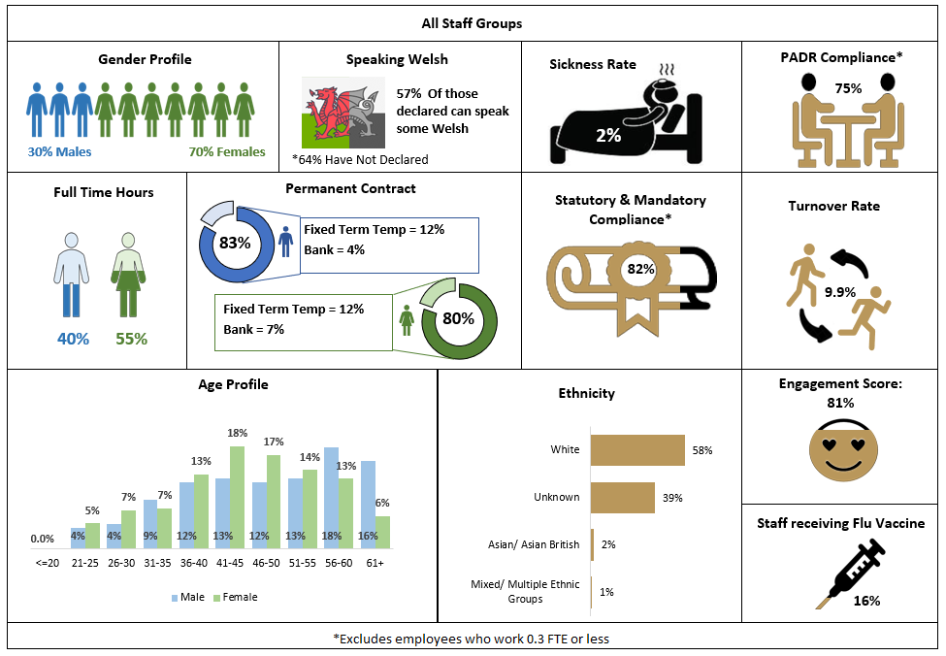
Over the past year, we have continued to recruit to our vacancies, we have taken on new or additional functions and our workforce headcount has increased by 63, from 453 in March 2021 to 516 in November 2021.
- Of the HEIW workforce 70% are female, this is an increase of 2% compared to last year.
- HEIW’s sickness absence rate is 2%, well below the Welsh Government target rate.
- The compliance rate for Statutory and Mandatory training for core staff (excluding those sessional staff who work 0.3 FTE or less) is 85% and is a positive increase on March 21(79%).
- 76% of Personal Appraisal Development Reviews (PADR) for core staff have been entered into ESR, which is a positive increase on March 21 (63%).
- In November 2021, 50% (256 headcount) of the total workforce worked less than full time compared to 53% (239 headcount) in March 2021.

6.3 Future Priorities
Our work to develop our first People and OD Strategy was initially paused due to the onset of the pandemic but was subsequently resurrected, with a further round of engagement undertaken. Finalising and implementing our local strategy will be a priority for 2022/23.

We have continued to review the shape of our Executive and Senior Leadership Team to ensure we have stable and capable leadership in place, and we will maintain some agility in this as we continue to mature and develop as an organisation.

Other workforce priorities include the creation of a detailed Workforce Plan and planning process that encompasses known developments and growth and horizon scanning. This will include the development of an internal succession planning/talent management programme to prepare staff for their next career move.

Our focus on ensuring our staff feel engaged and that we are listening to their views has been strengthened during the last year. We have utilised innovative tools and approaches to measure staff satisfaction and wellbeing. This included four homeworking and wellbeing surveys, two health needs assessments and our second national staff survey which received an engagement score of 81%, up 3.4% from 2018.

Facilitated conversations are taking place across the organisation in line with the implementation of NHS Wales’s new ‘Healthy Working Relationships’ programme and to ensure that staff survey feedback is acted upon locally. The new Respect and Resolution Policy for NHS Wales has been rolled out and the NHS and Social Care Workforce Wellbeing Conversation Guide has been launched. Training to support the Respect and Resolution Policy will be delivered during 2022. This represents a significant cultural shift away from traditional grievance and disciplinary policies, much like the transformational approach introduced through the implementation of Managing Attendance at Work in 2019. It will require a new mindset for our managers and staff and will need to be supported through training and awareness events.

6.4 Attraction, recruitment and selection
We aim to be an inclusive employer and want to ensure we recruit the best people, with the right values and behaviours. To support this, we want our recruitment experience to be excellent for all prospective employees from their first contact with HEIW.

We will continue to utilise a variety of attraction methods to advertise our vacancies and embed values-based recruitment across all areas. We continue to roll out recruitment and selection training to managers which includes training on unconscious bias. Local implementation of the NHS Wales National Succession Planning Strategy for 2017-2027 will be advanced by offering training to help staff prepare for applying for vacancies. During 2022 we will undertake an end-to-end review of recruitment and selection to ensure that it continues to meet our aim to recruit the best people with the right values and behaviours.

6.5 Equality, Diversity and Inclusion
We have continued to embed the progress made since April 2019 starting with the publication of our first Diversity, Equality and Inclusion policy early in 2020. We are broadly representative of the overall NHS workforce in terms of the gender profile of the organisation, with nearly 70% of workforce being female, and this includes our senior leaders as represented by the HEIW Board. In respect of our ethnicity profile we have more work to do in representing the ethnicity of the population. Currently those from ethnic minorities make up 2.4% of our workforce which is less than overall NHS Wales profile of 6.6% and 3.2% of the overall population of Wales. Our age profile is more in keeping with NHS Wales workforce overall with the majority of workforce being between 36 and 60. Across younger age brackets we have work to do as our data indicates the younger workforce to be half of the NHS Wales average.

Our network of Inclusion Champions has increased and we are committed to continuing with this approach through 2021/22. The Champions undertook a wide range of activities throughout the past year starting in January 2020 with Diversity and Inclusion Week, Holocaust Memorial; International Women in Science; LGBT month; St David’s Day; International Women’s Day; celebrated EID; PRIDE; Black History Project; Tran Health Week; International Men’s Day; White Ribbon Day; and Purple Light Up for Disability Month in December.

HEIW is aware of its responsibility as a public body to apply our responsibilities under the socio-economic duty when making strategic decisions. As the system leader for the NHS workforce in Wales we understand we have a significant role in considering how our work helps to reduce inequalities associated with socio-economic disadvantage across Wales.

HEIW has been fully engaged with the development of Welsh Government’s draft Race Equality Action Plan (REAP). The HEIW Medical Director is a member of the First Minister’s REAP Steering Committee which has led on this work. We will have a significant role in the delivery of the plan as can be seen from the themes below which form the basis of the actions proposed.
Health and Social Services have identified goals under five broad themes:
Health  - Leadership and accountability  - Workforce  - Data and intelligence  - Access to health services  - Tackling health inequalities | Social Services  - Access to and provision of social care services  - Workforce  - Leadership  - Accountability  - Data and analysis
As part of the development process for the Strategic Equality Plan (SEP), internal engagement was undertaken utilising focus group methodologies. This allowed us to retest our equality objectives against the backdrop of the pandemic. Work on individual directorate action plans which hook directly onto high level actions within our SEP was completed, and these formed the basis of progressing this work as well as monitoring and reporting during 2021/22.

We continue to engage with external partners to provide an impartial review of our policies and practices to ensure alignment with national standards in respect of equality, diversity and inclusion. Policy development has continued and last year saw us sign off and implement policies in relation to Domestic Abuse and Mental Wellbeing in the Workplace. Since 2019 we have opted to sign up to:

- Stonewall Diversity Champion – tackling barriers and inequalities faced by lesbian, gay, bisexual and transgender staff.
- Disability Confident –HEIW gained level 2 status Disability Confident Employer September 2021.
- Dying to Work TUC – additional employment protection for terminally ill workers.
- Anti-Violence Collaboration – sets out the responsibilities of the partners when dealing with violent or aggressive incidents relating to NHS staff.
- Communication Access Symbol – We were the first organisation in Wales to make a commitment to adopting Communication Access Symbol – giving a voice to people living with a communication disability.

We will continue to progress the implementation of our SEP and local action plans whilst also leading on the national review and revision of NHS mandatory training ‘Treat me Fairly’; to develop a Transitioning at Work Policy; and develop Equality and Diversity training packages. Other work being progressed next year will include the establishment of an EDI national Talent Group to develop a national infrastructure that provides a transparent and equitable process to identifying aspiring leaders of the future. This work will be supported by the recruitment of an EDI Fellow and an EDI internship within HEIW.

Chapter 7 – Financial Plan
This Chapter sets out the financial plan for the organisation and how we ensure we will demonstrate value and sustainability. It’s important to note that due to our education commissioning responsibilities we develop a five-year financial plan.
7.1 Our Approach
The HEIW Financial Plan is designed to enable the programmes and activities established by the Board, in response to our vision of Transforming the Workforce for A Healthier Wales, to be taken forward. The identified funding requirement is for the range of functions and programmes agreed with Welsh Government and will be appropriately managed to achieve financial balance in each and every year of the financial plan. Supporting the delivery of Value Based Healthcare and delivering value in the use of public money is an important requirement and HEIW will demonstrate the value and sustainability of its programmes and activities over the life of the IMTP through:

Leadership | - Clear and effective leadership by the Executive Team.  - Timely planning, monitoring, support and action by the Finance Team.  - Integrated working with all Executives, Senior Leaders, Budget Holders and Departments.  - Visible and timely intervention and interaction by all Executives, Senior Leaders and Budget Holders.  - Interrogation and collaboration of strategies plans and approaches with our UK sister organisations
Using a Value-Based Approach to Commissioning and Development activities | - Developing a value-based approach to articulate the system benefits of investing resources in Education and Training.  - Developing a robust approach to business case development.
Strong Discipline | - Disciplined financial management of all expenditure commitments.  - Continuous and detailed monitoring and management of the financial position.  - Timely corrective response to any variation from plan.  - Adherence to standards and governance requirements.
Ensuring excellent Assurance and Governance | - Effective budget holder engagement to deliver the Plan and management of budgets.  - Provision of high quality, accurate and timely financial advice for budget holders, the Executive team and HEIW Board.  - Expert support and technical advice to budget holders to enable the development of robust plans and business cases.  - Continuous evaluation of systems to identify areas for improvement and timely actions in response to audit recommendations.
Engagement with Budget Holders | - The Finance team will provide regular timely and informative reports and support for budget holders.  - Promotion of financial behaviours that encourage, incentivise and add value.
Using available tools to demonstrate efficient use of resources where appropriate | - Relevant and timely Performance Reporting aligned to the organisation’s Performance Framework.  - Use of relevant NHS Benchmarking.  - Application of Efficiency Framework where possible.
HEIW agreed an Annual Plan with Welsh Government for 2021/22. The Financial Plan within this IMTP presents the resource requirements and deployment over an extended five year planning time frame, in order to ensure that the timescales of the current agreed programmes and those envisaged are presented over their full annual cost commitment. It is important that the scale of the stepped commitment, arising from the phasing impact of programmes is understood, particularly as the cost increases between one year and the next can be substantial when the additional student/trainee numbers commissioned progress through all the years of their education and training.

The process of developing the financial plan to date has involved a detailed review with individual budget holders of their 2021/22 budgets and Welsh Government agreed commitments, which were set following agreement of the 2021/22 Annual Plan. The emerging in-year financial position and year-end outturn forecast as at month nine was also considered in establishing the new-year starting base. Due to the inherent complexity involved in pay modelling, the exercise has been carried out centrally within the Finance Team, with budget holders able to subsequently review their proposed budgeted establishment for accuracy.

All business cases and increases in commissioning budgets that have the approval of Welsh Government or are part of the NHS Wales Education Commissioning and Training Plan for 2022/23 have been included. Budget holders were also asked to consider within the planning template a consolidation of the investment made to date and the enabling corporate requirements to fully deliver the Strategic Objectives set out within the Annual Plan. The resource requirements of any future business cases have not been included within the Plan and will be subject to further discussion and agreement with Welsh Government during the 2022/23 year and will be taken forward if and when they are agreed.

The key Pay and Inflation assumptions within the financial plan are as follows:

- For NHS staff inflationary uplifts on pay scales to date for 2021-22 have been applied for future years.
- Inflationary uplifts for Cardiff University and DDRB pay scales have been applied based on 2021-22 rates.
- Any pay uplifts agreed in 2022-23 have not been included at this stage.
- The agreed % inflationary uplift on non-pay budgets has been applied.

The five-year summary of the financial plan is set out overleaf:
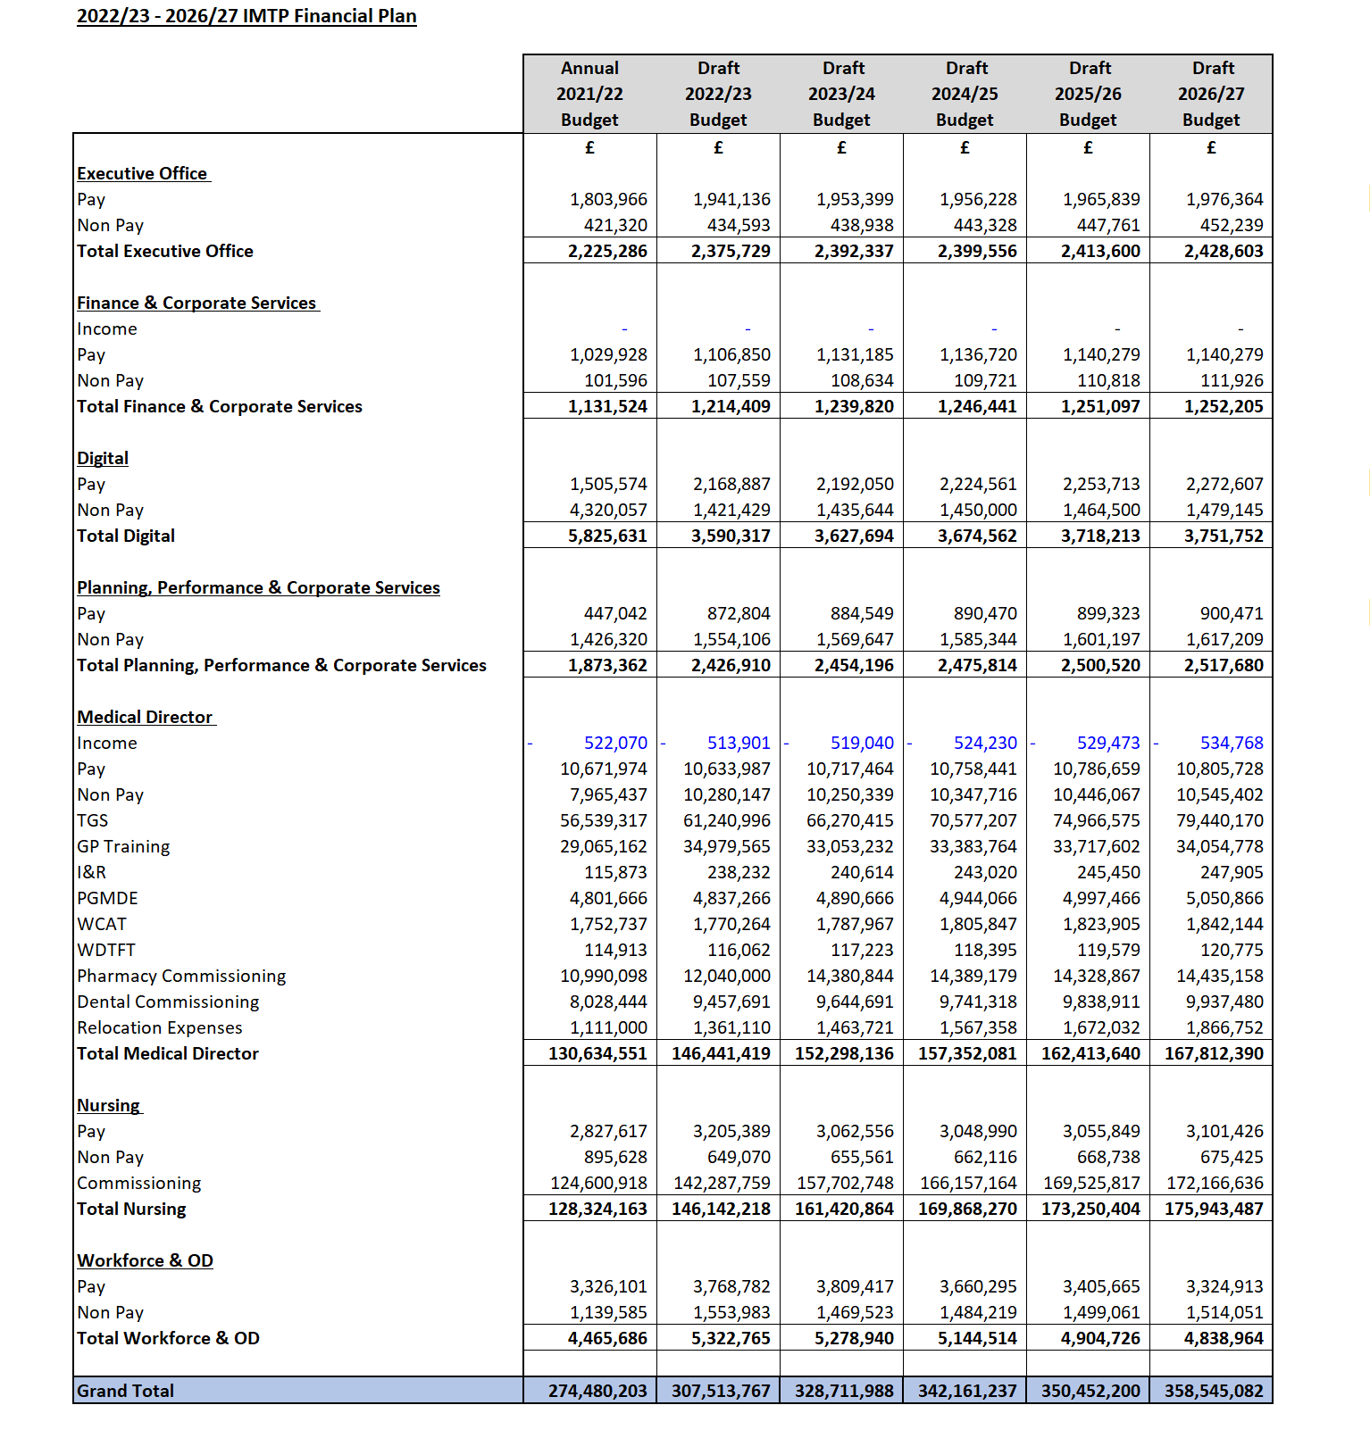
7.2 Developments and Investments
Through the process of developing the IMTP, with a focus on consolidation of available resources, developments and potential investments to deliver the Plan were identified through the ‘Plans on a Page’ approach. Some of these have been incorporated into the updated financial plan where they have already been subject to discussion. However, any further resource requirements identified will be costed and when they are agreed will be subject to further discussion and agreement with Welsh Government in-year.

7.3 Financial Risks and Opportunities
The financial plan has been developed with the best available information and within the existing policy environment. There remains some uncertainty on the scale, length and impact of the COVID-19 pandemic on the educational and training commitments in the early years of the financial plan. Consequently, the basis of the planning assumptions has been conservative.

7.4 Capital
HEIW has a recurrent discretionary Capital Allocation of c.£76k. Although this modest allocation will not initially inhibit the developments set out in the plan, a process will be established that involves budget holders and other partners to determine the capital needs of HEIW in support of its objectives and strategy over the next five years.

Chapter 8 – Digital
Appendix A
This Chapter sets out how our plan will be enabled through digital and information systems. We have included a summary of the work of our other enabling functions in Appendix A.
Digital health is transforming the access, delivery and availability of healthcare in the UK. It has the potential to revolutionise the healthcare sector. The refresh of the Welsh Government NHS Digital Strategy in 2022/23 will describe how digitisation and technologies such as telemedicine, smartphone apps, wearables and artificial intelligence (AI) are likely to be widely integrated in healthcare delivery in Wales. These technologies should not just be seen as increasing costs but rather as a new means of addressing the challenges of the 21st century.

In HEIW, the Director of Digital Development provides professional leadership and direction to advise how these new and emerging technologies can support and enable the Workforce Strategy for Health and Social Care. The key themes of this IMTP include:

Defining the digital and data strategy (objective 6.3) is a key area of work for 2022/23. This will enable digital transformation and improve data availability and quality to inform data-driven decision making. Digital has the potential to disrupt current health systems and transform the way work is organised and the workforce that is needed to run it. HEIW’s digital and data strategy will consider how technologies such as AI, genomics, robotics and big data will disrupt and enhance the workforce supply and demand, and what impact this has on the delivery of education and training. The strategy will also consider how HEIW delivers its services using the most effective technology and how those systems deliver a data driven way of working that delivers actionable insight and foresight.

During 2022/23 the Digital team will undertake the scoping, design and development of an integrated digital platform (objective 6.2) which will result in a single portal to access many of the existing HEIW applications. It will provide access and manage the education and training journey of students, trainees and trainers in NHS Wales and the appraisal and revalidation function for doctors. This single platform approach will be hosted in the cloud, offering safer and faster infrastructure. This transformation will mean the move from a siloed digital architecture of historical systems to an integrated person-centred experience.

The team will take a leading role to ensure that HEIW makes use of current, emerging and future technologies to their fullest potential to develop and implement a digital learning platform (objective 1.6). Y Ty Dysgu will enhance HEIW’s reputation as a provider of high-level education and training to the NHS workforce in Wales. It will provide a standardised approach (quality and financial) for HEIW’s current provision of course management and delivery of online learning activities and KPI reporting and will act as a vehicle for the operational delivery of HEIW’s CPD strategy and digital capabilities work. Building on the accelerated transition to digital education and training in the early phases of the pandemic, Y Ty Dysgu will support the delivery of more than 25 of the Strategic Objectives in this year’s IMTP.

The Topol review concluded that ‘Within 20 years, 90% of all jobs in the NHS will require some element of digital skills. Staff will need to be able to navigate a data-rich healthcare environment. All staff will need digital and genomics literacy’. In recognition of this we will improve Digital skills and literacy (objective 2.11). The pandemic has demonstrated the system’s capacity for rapid digital transformation, but this is not without challenges. This programme of work focusses on developing the digital capabilities of all staff employed in NHS Wales and will therefore lead to increased digital participation and improving outcomes more broadly. The approach works across professions, and delivers useable resources, and tools. It builds consensus around skills and capabilities, whilst allowing for contextualisation within different professions.

Cyber security risk remains a key corporate risk for HEIW and therefore reducing the cyber and information governance risk (objective 5.8) is a key priority for us. HEIW’s cyber security and information governance programme provides the basis for developing a risk-balanced approach to appropriately manage cyber and information security and resilience. The Programme aims to embed a security governance regime which will aid, control and inform HEIW’s approach to cyber security risk management. The recent roll-out of the cyber assessment framework for Health by the newly formed Cyber Resilience Unit (as a result of the NIS Regulations) provides a unified platform and approach for the completion of cyber-assessments across NHS Wales, identification and management of cyber-related risks and will present opportunities for improvement. The information Governance toolkit will provide a tool for assessment and improvement.

APPENDICES

Appendix A Description of our enabling functions
Appendix B Alignment of the strategic aims with ministerial priorities, wellbeing of future Generations Act and Workforce Strategy for Health and Social Care
Appendix C The PESTLE Analysis
Appendix D Summary of engagement undertaken
Appendix E Summary of closed Strategic Objectives
Appendix F Detailed deliverables and milestones
Appendix G Professional Reference Guide
Appendix H Quick Reference Guide
Appendix I HEIW Contribution to Planned Care Recovery
Appendix J HEIW Contribution to Primary Care Strategic Programmes



