Guidance to Trainees - Updating Self-Service Details on Intrepid
The following guidance describes how to validate and update your personal and contact details within your Intrepid database record. Please review your details on a regular basis.
Step 1: Log into your Intrepid account: INTREPID (hicom.co.uk)
Step 2: Once logged in, go to the ‘My Record’ tab in the left-hand column. This will take you to the Person summary page which contains your personal and contact details.
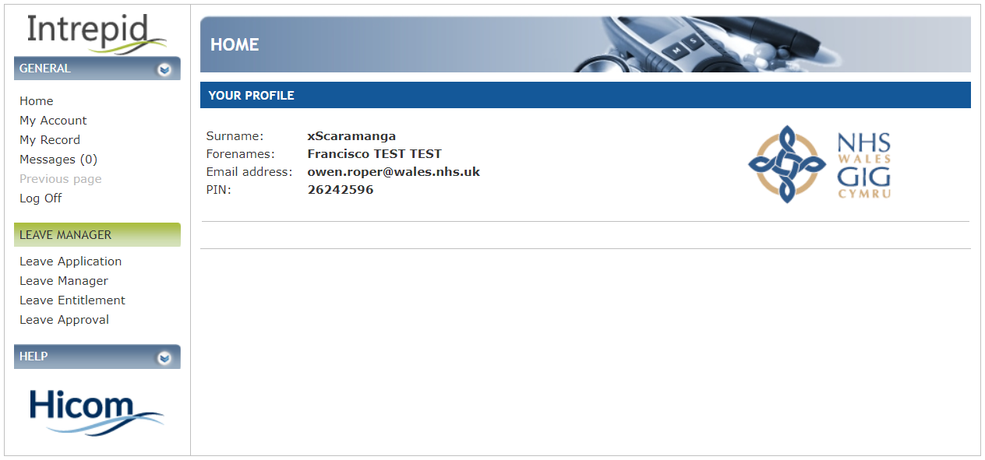

Step 3: Here you can validate and update your personal details. Please ensure your correct name, telephone number, email address(es) and contact address are recorded. Remember to click ‘Save’ when you are finished.
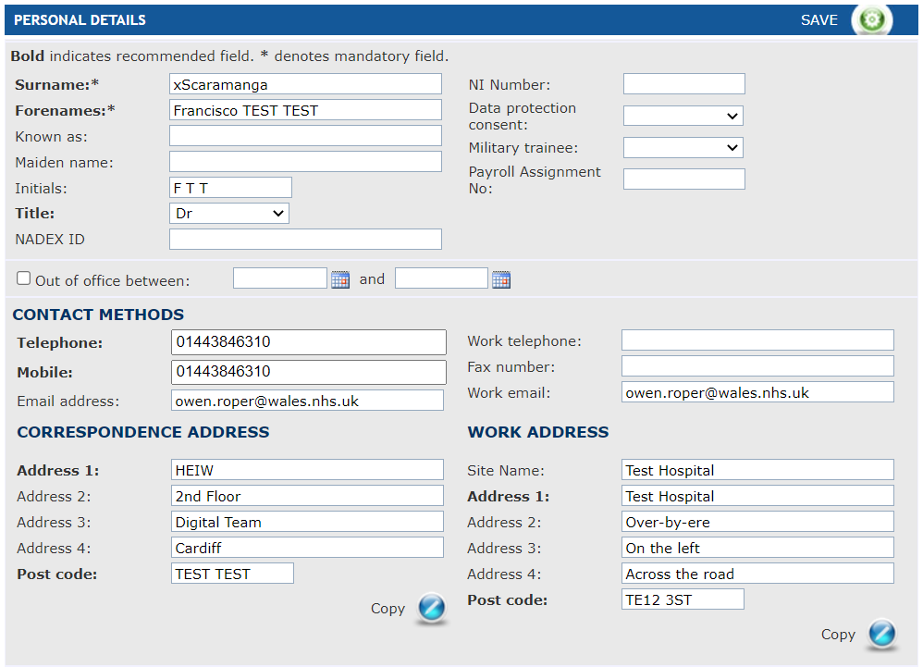

Step 4: Further down this same page, you are able to validate and update your equality & diversity and next of kin information. Please note that date of birth is a required value for Single Lead Employer purposes. To view and update the details, click the banners to expand each section. Remember to click ‘Save’ when you are finished.


