
Education and
Training Plan (ETP)
2025-26
Appendices

Contents
Appendix A Workforce Analysis 3
Appendix B Using intelligence to inform the Education and Training Plan 18
Appendix C Education and Training Recommendations Further Information 19
1. Overview of Health Professional Education and Training Places in Wales 19
2. Nursing 21
3. Midwifery 24
4. Healthcare Professionals 25
5. Healthcare Science 29
6. Medical 32
7. Medical Associate Profession 41
8. Dental 41
9. Pharmacy 43
10. Optometry 43
11. Primary and Community Care 44
12. Community Nursing 45
13. Post-Registration Education 47
14. Work Based Learning 55
15. Education and Training Infrastructure 57
Appendix D Education and Training Commissioning Trends 59
Appendix E Summary of Engagement Undertaken 63
Appendix F Financial Scenario Planning 68
Appendix G Case Studies 71

Appendix A Workforce Analysis
NHS Wales need to address the backlog of people waiting for planned care and the increased waiting lists across several specialties. It is recognised that workforce availability both in terms of numbers and skills will be a challenge over the forthcoming years, training and developing the skills and competence of our existing workforce alongside training the next generation of NHS Wales workers will be key.

In the development of the education and training recommendations consideration is given to the workforce context for NHS Wales. This section considers factors that influence these recommendations including consideration of the current and future workforce, factors include:
- the current workforce shape and size, and the workforce trends for preceding 10 years
- information provided within organisations’ Integrated Medium Term Plans and Workforce Planning Questions
- future workforce/student/trainee supply from a population perspective
- longer term trends that could impact the future workforce.

- Current Workforce and Trends
Further information on the shape and size of the NHS Wales workforce can be found in NHS Wales Workforce Trends (2023).

The number of people employed by NHS Wales workforce is currently 94,663 full time equivalent (FTE). The number has increased annually, increasing by 19.6% since 2018. The single biggest increase in the workforce was seen between 2020 and 2021. Staffing numbers continue to increase across all staff groups. Nursing and

Midwifery has seen a 10% increase, and the Medical and Dental workforce has increased by 25% between 2018 and 2023 (figure 1).

Figure 1: Staff Group by FTE and Percentage change, March 2018 to March 2023
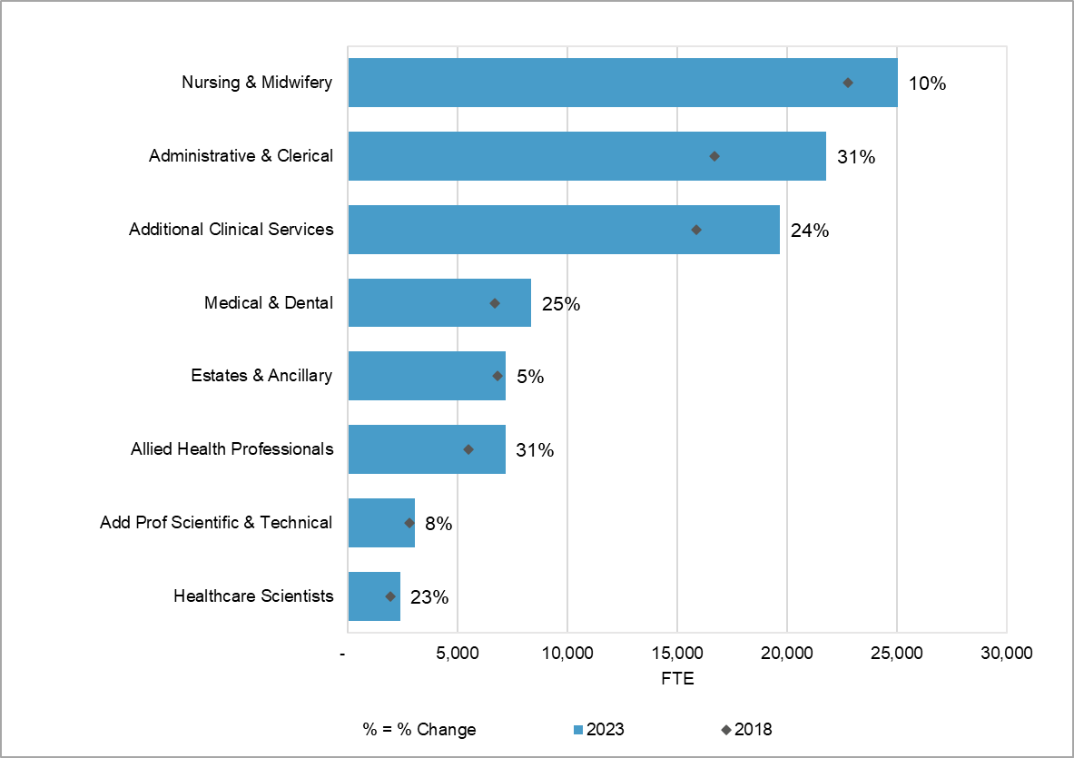

The age profile of the workforce is changing. Since March 2018, there has been an increase in the percentage of staff in age bands 21-40, and a reduction in the percentage of staff aged between 41-55. The percentage of those aged 56-60 has remained static and a slight increase in the 61-65 age group (see figure 2).

Figure 2: Age profile of Workforce March 2018 – March 2023
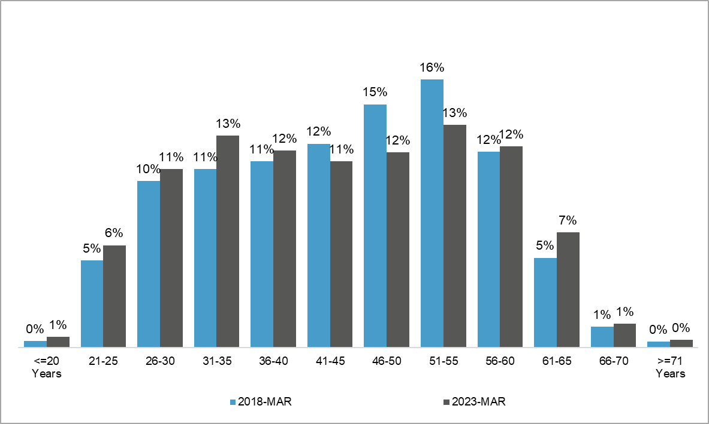

The NHS Wales workforce is predominantly female, accounting for 76% of the total workforce across all staff groups. Nursing and Midwifery has the largest percentage of females, where females account for 91% of the workforce (see figure 3).

Figure 3: Gender profile of staff group – March 2023
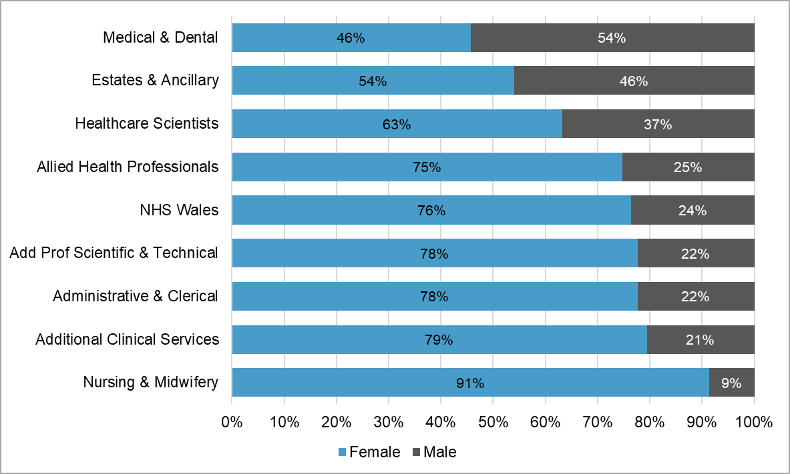

The participation rate is a percentage of part time working. Rates for the female workforce are generally lower than for the male workforce; from age band 51-55 the participation rate for both genders steadily decreases. The lowest participation rate for both the male and female workforce is in the 71 years and above age band (see figure 4).

Figure 4: Participation rates by age and gender – March 2023
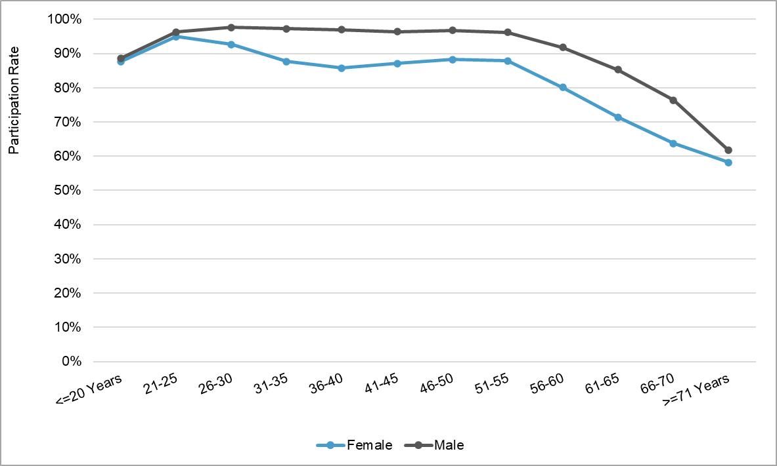

The cost of the total NHS Wales workforce (including agency and locum) for 2022-23 was £5.6 billion compared to £3.8 billion in 2018-19. This represents an increase of nearly 50%.

Since April 2018-19, there has been an overall growth in agency and locum spend of 126%. This increased from £144 million to just over £325 million over this time period. Nursing and Midwifery accounts for the biggest locum and agency spend and has seen a significant increase from £65 million in 2018-19 to £156 million in 2022-23 (see figure 5).

Figure 5 Monthly Agency and Locum Spend, 2018-19 – 2022-23*
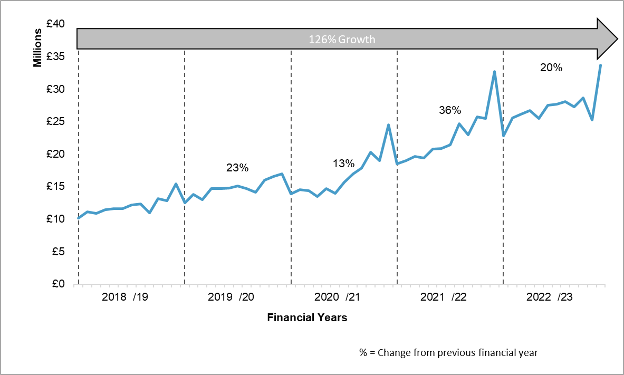
*Data Source: NHS Wales Financial Monitoring Returns

The twelve-month average sickness rate has risen year on year between 2018 and 2023 reaching a peak of 6.7% for 2021-22. Since 2020-21 the shape of sickness has changed, from the seasonal peak in winter months to more unpredictable shape throughout the year.

Workforce Analysis (for ETP 2025 – 26)
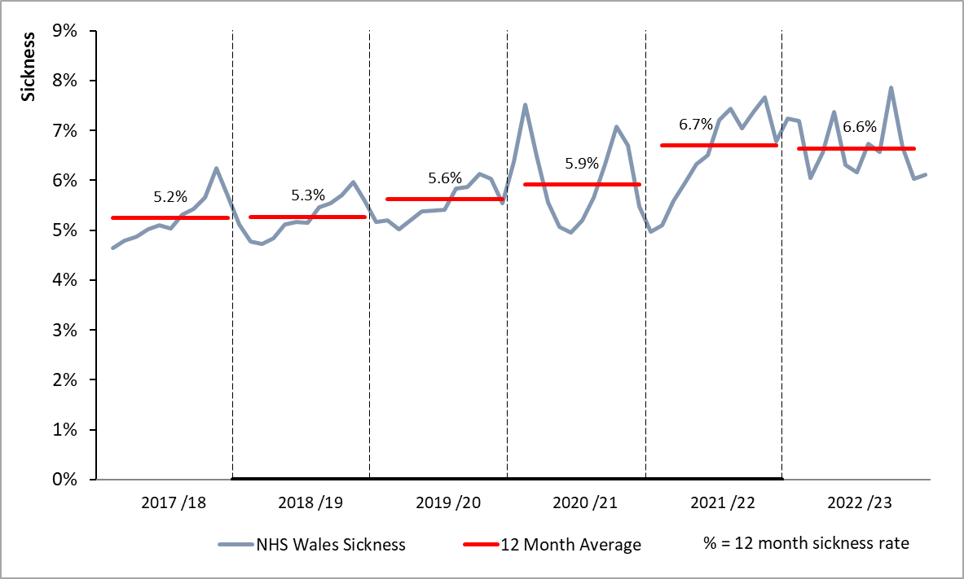

- Current Workforce Context – Analysis of IMTPs and Workforce Planning Questions
HEIW requests organisations respond to 9 high-level workforce planning questions in support of their education commissioning requests and provide additional focussed workforce information regarding retirement, recruitment, part time working, workforce transformation, development of the multidisciplinary team and small speciality areas.

As part of the IMTP engagement process, meetings were arranged with each organisation to discuss emerging workforce gaps, issues or planned changes over the period of the IMTP and beyond.

This information has been analysed alongside information provided within the IMTPs and common trends, concerns and a number of workforce challenges have been identified:
- Increasing demand and a rise in acuity of patients. Although vacancies in some areas have reduced, overall demand is increasing.
- High level of retirements anticipated over the next 5 years in roles where there are high levels of vacancies, including nursing, pharmacy, biomedical science, ODPs and smaller specialisms such as podiatry, neurophysiology, respiratory physiology, and cardiac physiology.
- Development of new roles within existing multi-disciplinary teams e.g., CAAPS and Psychological Well-Being Practitioner roles in Mental Health services.
- Development of advanced and consultant practice including ANPs, ENPs and Consultant Practitioner roles across nursing, pharmacy, and therapies professions as part of effective multidisciplinary team working.
- Increasing skills sets of the existing support worker workforce including the development of the skills of Healthcare Support Workers and Assistant Practitioners across acute, primary care and district nursing.
- Providing routes for Assistant Practitioners to develop into roles such as Nursing, Biomedical Scientists and Pharmacy Technicians.
- Development of Assistant Practitioners in therapy specialisms as well as generic therapies roles to support front door services.
- Smaller speciality areas reporting workforce challenges including psychology, radiology, cardiac physiology and theatres staff.
- A focus on staff retention and understanding why people leave.
- Patient demand and workload increase with organisations reporting widespread pressure on diagnostics, cancer and mental health services as backlogs are tackled.
- A focus on regional working in areas including diagnostics, orthopaedics and ophthalmology.
- Intentions to reduce agency/locum spend and focus on permanent recruitment and job planning.

There is consensus across the IMTPs of the need to develop better long-term workforce planning, enabled by access to better quality and reliable data and improved management skills to identify, plan and prepare the future workforce. There is a recognition of the need to transform and re-design the existing workforce, to shift workforce capacity focused around the areas of greatest need and service value.

Recruitment across organisations continues to be challenging, with significant national shortages and longstanding gaps in specialist professional roles which are impacting on the delivery of key programmes of work including diagnostics, cancer, urgent and emergency care and mental health. Whilst many of the organisations are developing attraction plans for targeted services, building international pipelines and considering innovative recruitment methods, all are recognising the need to retain and develop the existing workforce (including recognising the contribution of the support worker workforce), the need to reduce turnover and emphasis on “growing your own” via apprenticeship routes and widening access. There is recognition of the importance of retention of staff and the ongoing work in this area to develop retention plans.

Quality and patient safety is a focus across organisations with the Duty of Quality requiring an improvement in quality and purpose for patients. All organisations state their ambition to work differently, transforming traditional roles, promoting development, advanced practice and top of license working. The development of new roles features across the IMTPs, including Physician Associates, Clinical Associate in Applied Psychology (CAAPs), Assistant Practitioners plus extended roles, including Pharmacy Technicians and developing support worker roles.

In terms of key pressures and specialisms requiring the most urgent attention, the IMTPs make repeated references to the same clinical areas:
- Improving diagnostic capabilities to meet referral demands through the development of Regional Diagnostic Centres.
- Primary and Community Care sustainability is one of the critical areas for recovery and improvement.
- Improving single cancer pathway and reducing waiting times.
- Improving clinical outcomes in circulatory diseases including stroke and heart disease.
- Reviewing and streamlining of mental health services to ensure services can match increasing levels of demand, with a community focus.
- A move from acute to a community-based care model.
- Extensive delays for orthopaedic referrals & treatment – focus on addressing backlog and unmet demand.
- Focus on increasing use of technology (including AI) to reshape professions and the shape of the workforce while recognising the digital skills gaps.

Through the Education & Training Plan and HEIW’s own IMTP, we will support organisations to address these pressures.

- Student Recruitment
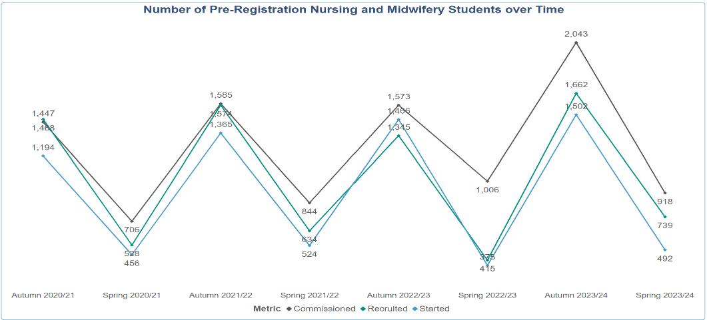

The data for pre-registration nursing and midwifery students' recruitment phases from 2020/21 to 2023/24 shows a clear upward trend in the number of commissioned slots, indicating a growing appetite to provide more healthcare professionals for NHS Wales. Although recruitment generally increased, there was a noticeable dip in 2022/23, suggesting potential challenges during that period. Despite this, the number of students starting the program also shows a general increase, reflecting successful overall recruitment efforts.
The high conversion rates from commissioned to recruited to started students highlight the effectiveness of recruitment strategies, despite some yearly variations. The overall positive trend in all categories suggests a robust interest in increasing nursing and midwifery provision.

- Population and Future Workforce Supply
Building on analysis of the 2021 Census, the latest population data highlights the following trends:
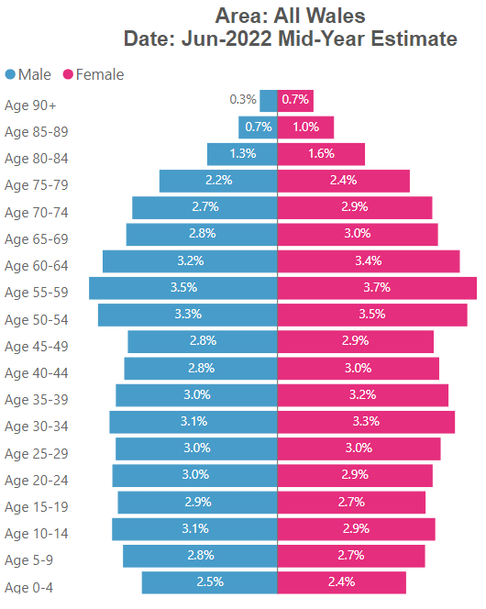
- The population of Wales is 3,131,640 as of mid-2022, with a growth of 67,882 or 2.2% since mid-2011 (compared to 7.5% in England).
- The population in Wales is ageing, with those aged 65+ increasing by 19.0%. There is a decrease in those aged 16-24 down by 12.2%, and those aged under 16 down by 1.2% since 2011.
- The median age of the population has increased from 41.5 in 2011 to 42.9 in 2022 (compared to 40.5 in England).
- Based on the population aged up to 18 at the 2021 census, the number of 18-year-olds in subsequent years shows an increase of 7.1% (+2,465) by 2029, followed by a sharp fall of 18.1% (-6,250) by 2050. However, the latest ONS projections, which include migration, suggest that the number of 18-year-olds will rise by 13.3% by 2029, fall by 9.1% by 2041, and then rise slightly, leading to an overall fall of 4.8% by 2050, where the changes are relative to the 2021 census.
- Since 1991, the population of Wales has grown by 9.0% (+258,780), with significant decreases in the under 30 population (including -13.5% in age 0-9 and -10.1% in age 20-29) and significant increases in the age 50+ population (including +41.5% in age 50-59, +40.2% in age 70-79, +49.8% in age 80-89 and +138.7% in age 90+).
- The dependency ratio (which compares the economically dependent population, ages 0-14 and 65+, to the economically productive population of ages 15-64) has increased from 54.9% in 2011 to 61.1% in 2022 (compared to 56.1% in England).
- The population of Wales is 49.0% male and 51.0% female, with the gap widening by 0.2 percentage points since 2011 - females tend to live longer than males and the age profile (see chart) shows a clear population bulge in the older ages.

The latest official population projections up to 2050 (based on the 2021 population estimates), show an increase in the population of 347,983 or 11.2% by 2050. This is much higher than previously projected, driven largely by immigration. This includes a fall of 7.8% in the under 16 population and a rise of 30.8% in the population aged 65 and over. The projected trends by age band are illustrated below.
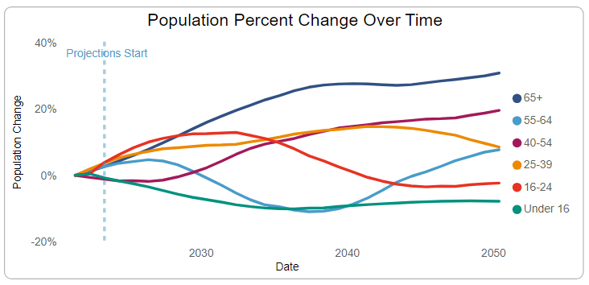
There is a significant increase in the population aged 65+ until 2038 when the population bulge from the baby-boom years begins to decline, as this generation passes away. On the other hand, the under 16 population continues to fall until 2035-2036 before picking up slightly.

These changes drive the trends in the dependency ratio and median age as illustrated below.
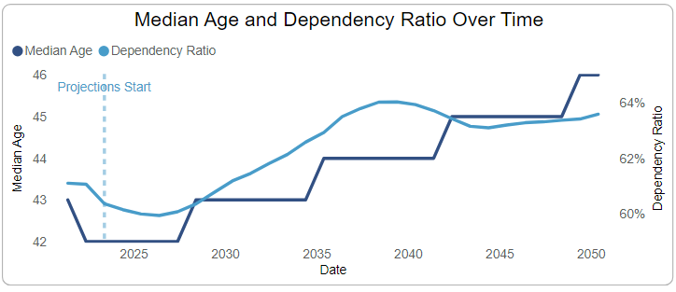

Hence, the dependency ratio is projected to rise to 64.0 by 2044 before falling slightly, and the median age is expected to continue its upward trend, rising to 46 by 2049.

This could lead to an increase in demand for healthcare as the population ages combined with a decline in the younger generation which may impact supply of workforce to meet the demand.

- Labour Market Intelligence
The labour market has suffered significant disruption in recent years, due to the pandemic and the ending of freedom of movement for EU (and British) citizens. There have been noticeable increases in economic inactivity, especially due to long-term sickness, as well as increased competition for workers to fill job vacancies.

Whilst the Covid-19 pandemic had a significant impact on the labour market, many (but not all) of the trends have since returned to pre-pandemic levels, and current trends are more likely to be caused by inflationary pressures and the cost-of-living crisis.

As of December 2023, there were 50,506 unemployed people in Wales and 499,705 economically inactive. While the unemployment rate of 3.6% remains low by historical standards, the rate of economic inactivity is relatively high at 25.3% for males and 27.1% for females, which is 26.2% overall.

The changes in unemployment and economic inactivity since 2010 and change trends since the start of the pandemic across Wales and the UK are illustrated below.

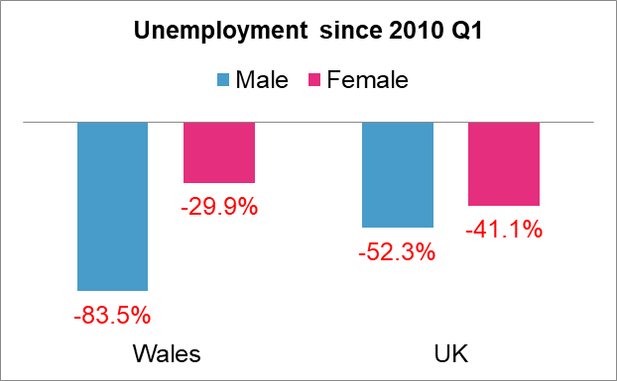

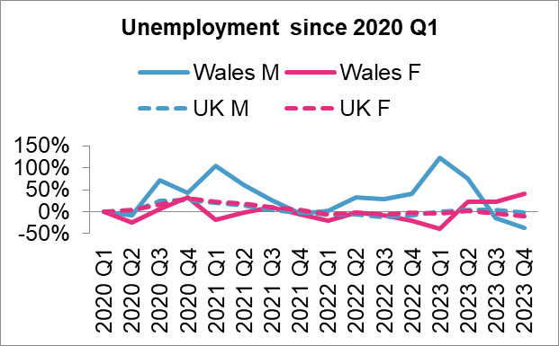

These show that, over the long term, unemployment is down for males and females across Wales and the UK. Since the pandemic, the graph on the right shows that unemployment returned to pre-pandemic levels around the end of 2021, and while the UK levels have since remained fairly stable, the levels in Wales have been more volatile.

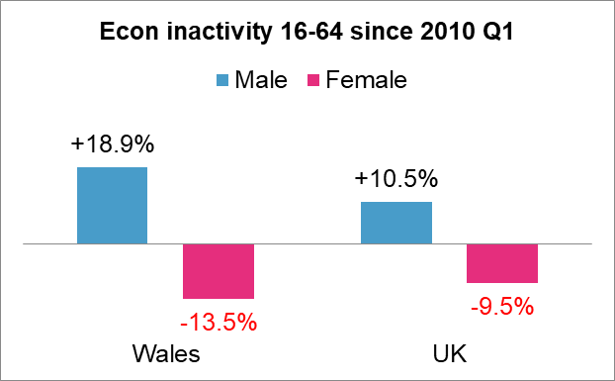

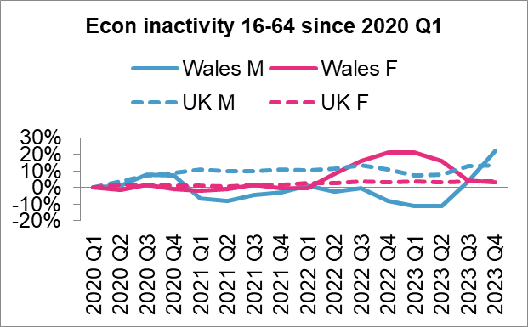

Over the long term, economic inactivity has increased for males and fallen for females, although the rates for females remain higher than the rates for males. Since the pandemic, the levels in Wales returned to pre-pandemic levels by the start of 2022 and the levels for males and females then went in opposite directions. Across the UK, economic inactivity for males has not recovered since the pandemic and continues to rise, and the same is true to a lesser extent for females. The changes vary by age band.

Across the local authorities in Wales, the distribution of economic inactivity (excluding students) is illustrated below, where pink is above the national average and blue is below.

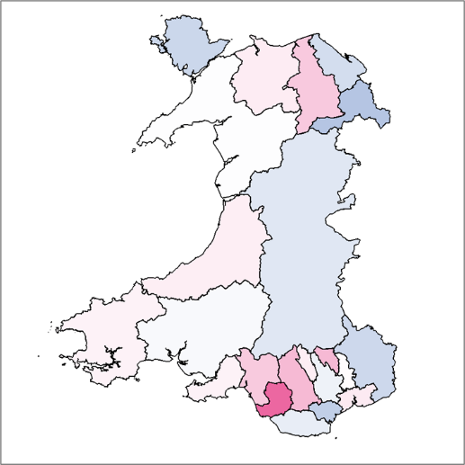

The highest rate is in Bridgend (29.2%) and the lowest is in Wrexham (14.7%). Of all the people who are economically inactive across the UK, 20.1% want a job. When combined with unemployment, there are over 3.1 million people across the UK who want a job, which could equate to over 150,000 in Wales.

The current reasons for economic inactivity across the UK are shown below, along with the changes since the start of the pandemic.
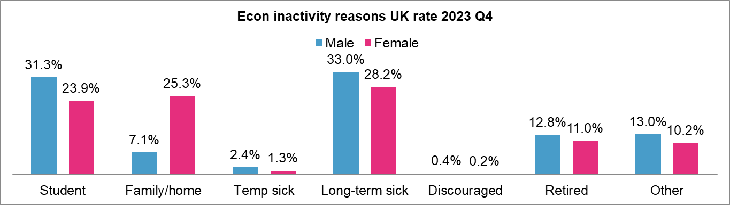

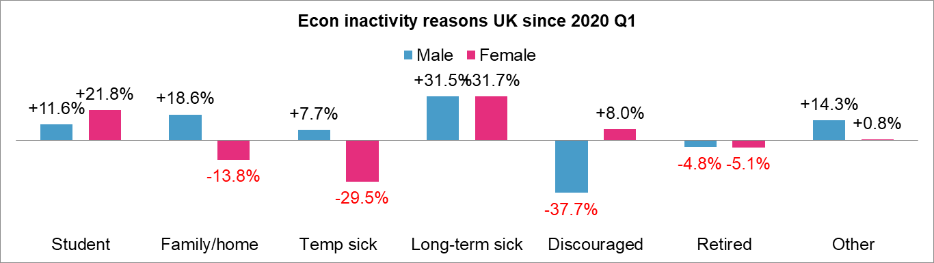

The significant reasons include long-term sickness, students, and females looking after the family or home. Since the pandemic, the biggest growth in economic inactivity is due to long-term sickness, students, and more males looking after the family/home, although the proportion of females looking after the family/home remains much higher than for males.

Across all sectors, there are over a million job vacancies across the UK, including 168,000 in human health and social work activities. The trends in job vacancies in selected sectors since 2010 are shown below.

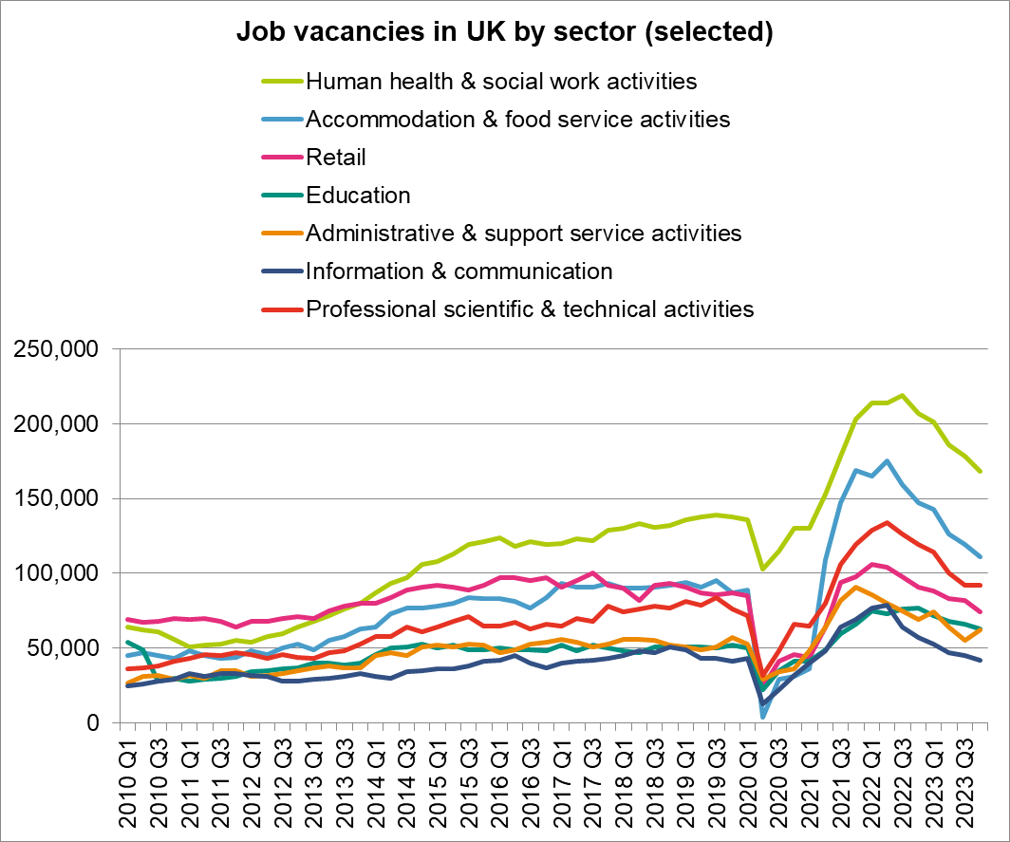

The impact of the pandemic on is clearly visible, when vacancies plummeted but rose sharply afterwards. Vacancies in many sectors peaked in 2022 before falling back.

The latest vacancy data for NHS Wales, as of December 2023, shows 5,561 full-time equivalent vacancies, with an overall vacancy rate of 5.7%. The highest vacancy rates were in medical and dental (excluding trainees) at 9.9% (501 vacancies), and nursing, midwifery and health visiting (registered) at 7.4% (2,059 vacancies). There were also 1,544 vacancies in administration, estates, health care assistants and other support staff.

- Pensions Changes and Special Class Status
Special Class Status is a reserved right that permits eligible members of the 1995 NHS Pension Scheme to retire from age 55 with an unreduced pension. The right is available for nurses, physiotherapists, midwives, health visitors and mental health officers who joined the scheme before 6 March 1995 and have not subsequently had a break in membership of over five years. It is a conditional right, which in the case of nurses requires the individual to be employed continuously in a nursing role for the five years immediately preceding the date of retirement.

The right was withdrawn for new members of the 1995 Scheme from 6 March 1995. Staff with pension savings in the 1995 NHS Pension Scheme who did not acquire or satisfy the conditions for Special Class Status have a normal scheme retirement age of 60. Subsequent reforms saw new NHS Pension Schemes introduced in 2008 and 2015 with a later retirement age of 65 and state pension age respectively for all staff in those schemes.

Upon introduction of the 2015 NHS Pension Scheme, transitional arrangements permitted staff closest to retirement to continue accruing pension in the closed 1995 Scheme. A small number of 1995 Scheme members with Special Class Status were too young to benefit from this protection and therefore transferred to the 2015 Scheme for future service. Such members can claim their 1995 Scheme pension accrued prior to transfer, on a Special Class basis from age 55 should they satisfy the conditions. The pension built up under the 2015 has a retirement age equal to the member’s state pension age.

Also, of note are the changes to the NHS Pension scheme and the State Pension age which will have an impact on retirement patterns. There are still staff within the workforce with Special Class Status who are eligible to retire at 55 and who, following the McCloud Judgement will have an additional 7 years in any 95 Pension Scheme contributions they hold; the last retirees with this Special Class Status who will be able to retire at 55 will be in March 2029.

There have been further changes to the Pensions scheme that may have an impact on retirement patterns over the forthcoming years. The McCloud Judgement means that all member who had pension savings within the 1995 scheme will have an additional 7 years. In effect this means that their entry into the 2015 CARE scheme will be with effect from 1st April 2022. All members will have the option to decide, at point of retirement, which is the most beneficial to them i.e. taking the additional 7 years in the 1995 scheme or maintaining the 2015 scheme benefits from 1st April 2015.

On 1st October 2023 a new partial retirement option became available for members of the 1995 section of the NHS Pension Scheme. This allows members to partially retire and claim up to 100% of their 1995 Section benefits while continuing to work and to accrue further pension in the 2015 Scheme. This change may have an impact on the numbers of people applying for Retire and Return. For people retiring after 6th April 2023, the lifetime allowance charge on paid pensions benefits has been removed which is likely to have a positive impact on retirement patterns for high earning staff.

There will be a change to normal pensions age over time with more people having joined the 2015 scheme, with State Pension Age as their retirement date. State Pension age is increasing from 66 to 67 and with further government reviews. Therefore, some of the workforce currently aged over 50 may elect to retire earlier whilst others will need to work longer, and the working behaviours of this older workforce will need to be monitored.

- Retire and Return
Looking ahead, it seems that there is a seasonal pattern with spikes in returns around March each year, which could persist if the underlying causes, such as the end-of-year financial cycles and post-holiday season recoveries, continue. As the direct impact of the pandemic wanes, we might expect a stabilisation in the number of returns. However, similar spikes could occur if new COVID-19 variants or other health crises emerge.

The dynamics of the healthcare workforce suggest that the demand for experienced professionals will likely sustain a steady inflow of retirees returning to work, particularly during high-demand periods like flu seasons or unforeseen health emergencies. Additionally, any changes in retirement policies or incentives for returning to work will play a crucial role in shaping these trends. Monitoring these policy changes will be essential for making accurate future predictions.

- Horizon Scan
In the development of the HEIW Education and Training plan, a horizon scan is undertaken of workforce research, to identify emerging external changes and trends that could impact the NHS Wales workforce.

- Intergenerational Workforce and Changing Behaviours
There is an emerging body of research into intergenerational working and changing work expectations across the generations. These changes and trends will be monitored over the forthcoming years to assess how these might be impacting the NHS Wales workforce. Key themes in relation to the desire for flexible working and retirement are highlighted below.

The trend for flexible working continues post-Covid, with increasing numbers of people looking for work which offers increasing flexibility (often known as ultra flexibility) in terms of the hours worked and the location of work. There are increasing numbers of Millennial and Gen Z generations entering the workforce and research indicates that these generations have different expectations of work, with one common characteristic being their appetite for better work-life balance and the opportunity to work remotely for at least part of the working week. Organisations are having to carefully balance office, remote and hybrid working to prevent a loss of key talent, as without remote and hybrid work, many people including parents, carers and those with disabilities would be unable to access employment.

Research undertaken by the CIPD highlights that shifting workforce behaviours show a mismatch between the hours that people want to work, compared with the hours that they have to work, often resulting in an early exit from the labour market and contributing to the increasing rate of economic inactivity. With low unemployment and high rates of economic inactivity, CIPD calls for employers to fully embrace flexible working to prevent a further loss of skilled workers.

The desire for ultra flexibility regarding work is also impacting upon the number of young people considering a career within healthcare. With a declining birth rate and fewer numbers entering the workforce, research undertaken by Universities UK tells us that although many young people are interested in a career in healthcare, many are being put off by the seeming lack of flexibility, perceived high workload and low pay. Although interest in healthcare careers varies across the UK, the lowest proportion of young people considering healthcare careers is in Wales (66% compared to the highest proportion in Scotland – 79%).

The NHS Wales workforce is predominantly female and is ageing. Research tells us that although women live longer than men, they are experiencing more years in poor health – according to a global gender health gap analysis published in the Lancet. The health differences between women and men continue to grow with age, with women particularly susceptible to musculoskeletal problems, headache disorders and mental health problems. These conditions contribute to illness and disability throughout life as opposed to leading to premature death, posing a challenge to employers who are managing an older workforce, with employees often experiencing many years of ill-health before they are able to retire. Consequently, employers are urged to create roles which support women within the workplace to remain engaged, empowered and productive, and therefore capable of managing the full spectrum of health issues affecting women throughout their lives.

Research indicates that there are changing expectations regarding retirement due to on-going cost of living pressures, increases in normal retirement ages and the overall ageing of the population. These changes are driving people to work longer. Research emphasises the need for employers to consider recruiting, retaining and retraining people in their 50s, as fundamental to reducing levels of economic inactivity amongst those aged 50+

- Growth of Skills, AI and the Digital Agenda
The pace of change within technology is relentless, with expectation that in the near future, every job will have a digital component. It is anticipated that Science, Technology, Engineering and Maths (STEM) will see a significant increase in demand as the majority of new roles expected to be created by 2030 will be directly aligned to these specialist subject areas. The opportunities afforded by AI across the wider healthcare system could include tasks that range from the simple to the complex - everything from answering phone calls, population health trending and analytics, therapeutic drug and device design, reading radiology images, making clinical diagnoses and treatment plans, and even talking with patients. Deloitte’s recent paper, AI and the Future of Work describes how AI is likely to drive changes in healthcare, with women most likely to be affected. This is particularly significant for NHS Wales as a female-dominated employer.

The latest report by the World Economic Forum, “The Future of Jobs” for 2023 suggests that technology adoption will remain a key driver of business transformation in the next five years, but that organisations will have to identify and address the existing skills gaps to enable this transformation to take place. Whilst the Harvard Business Review suggests that workers should develop a much broader skills set to suit the future of work. The Health Foundation argue that productivity is not about how hard people work, but the system that helps people to work effectively, i.e. having all the things which enable people to do their job well to be aligned and be in place.

The consensus reached in the research is that three things are key when considering NHS productivity:
- Having the right number of people with the right skills, organised in the right way and working together as an effective team (i.e. through a workforce plan).
- Capital investment: having the right equipment in the right place to do the job well.
- Getting the digital revolution to work well in healthcare.

- Workforce Supply and Demand Modelling
The HEIW Digital and Data Strategy outlines HEIW’s approach to digital transformation and data management for the next five years, aiming to enhance healthcare education and workforce development in Wales. It emphasises the importance of leveraging technology and data analytics to improve decision-making, operational efficiency, and the delivery of educational resources.

The Data and Analytics team at HEIW is responsible for providing data-driven insights and solutions to support strategic workforce planning and development of the Health and Social Care sector in Wales. In the HEIW Digital and Data Strategy, Mission 4 states “HEIW will develop its capability and capacity to carry out predictive and prescriptive analytics”. The Data and Analytics team have developed high level supply and demand models that enables complex systems to be better understood, and their behaviour over time to be projected using computer simulation.

The model estimates the current and future workforce needs and supply gaps. The model uses a range of data sources, such as population projections, workforce statistics, service activity, and workforce intelligence, to project the demand and supply of the workforce over a 12-year horizon. The model also allows for scenario analysis and sensitivity testing to explore the impact of different assumptions and interventions on the workforce outcomes. The modelling team elicit assumptions via qualitative and quantitative techniques to create baseline supply and demand lines. Through stakeholder engagement the team modify those assumptions to produce scenarios. The output of this analysis is intended to support strategic workforce planning decisions.

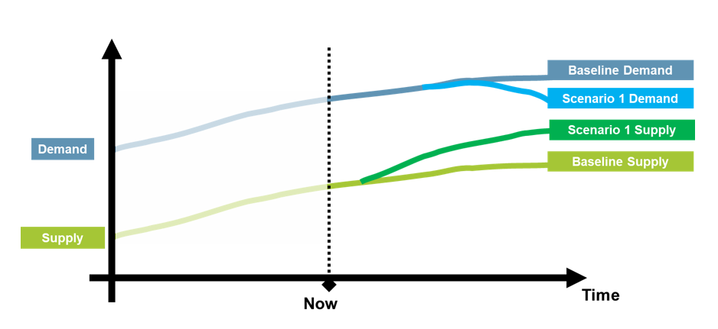
Conceptual chart: Showing a typical Supply and Demand visualisation

HEIW recognises the importance of workforce data as a key strategic asset for the development of complex workforce supply and demand models. HEIW plan to work in partnership with other organisations to improve the availability, quality and usage of workforce data across NHS Wales.

To advance our goals, the Data and Analytics team are working on various projects and initiatives that aim to improve these elements:
- Data Quality and Governance
This work stream focuses on developing and implementing data quality standards, policies, and procedures for the data sources and systems used by HEIW and its partners. The team also provides data quality assurance and validation services. This work stream is key as workforce projections are only as good and the data they are based on.
- Data Integration and Infrastructure
This work stream aims to enhance the data integration and infrastructure capabilities of HEIW and its partners, by developing and maintaining data pipelines, data warehouses, data lakes, and data platforms. By creating robust infrastructures ensures that the data used for workforce modelling is accurate, comprehensive, and timely.
- Data Analysis, Reporting and Modelling
This work stream involves conducting data analysis and reporting activities to support the workforce planning and development functions of HEIW and its partners. The team provides data analytics and visualisation tools, as well as data reporting and dashboarding services. This enables the communication and interpretation of the results and insights from workforce modelling. This in turn helps the decision-makers and planners to understand the current and future workforce scenarios and challenges, and to formulate evidence-based strategies and interventions.
- Data Collaboration and Innovation
This work stream aims to foster data collaboration and innovation across HEIW and its partners, by engaging with external organisations such as the NHS Wales Executive, Health Foundation, Decision Analysis Services, and NHS England, who have expertise and experience in data analytics and modelling. The team seeks to learn from best practices, share knowledge and insights, and explore new opportunities and solutions for improving workforce planning and development.

Whilst the Supply and Demand modelling within HEIW is still in the early stages, it is already helping senior leaders within HEIW and WG to discuss a range of possible scenarios and outcomes based on different assumptions and interventions. By visualising and quantifying interventions, decision makers are able to assess the magnitude of the impact. For example, altering education commissioning figures, as shown in the below chart.

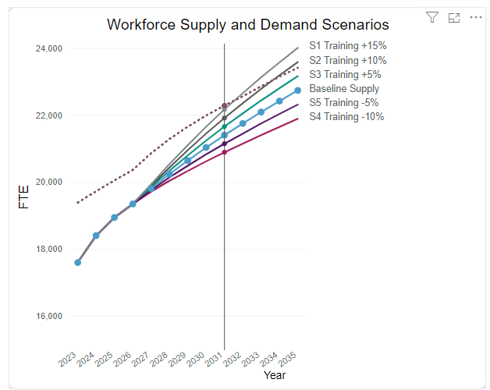Example chart: Showing the impact of changing education commissioning figures.

The development of the modelling has highlighted some limitations that will need to be addressed in the next iteration of the model to enable more robust decision making.
- The model relies on the availability and quality of data sources, which may vary across different organisations, settings, and professions. Data gaps and inconsistencies may affect the accuracy and reliability of the model outputs and projections. During 2024/25 the team will collaborate with organisations to understand data limitations and find additional data source to help improve modelling assumptions.
- The model uses a short time horizon to draw current patterns because of the effect of COVID and the impact on staffing over this period. The team will need to understand from organisations if the assumptions used are reflective of past trends and future potentials.
- A crucial activity is to engage with stakeholders to seek their expert advice, so the team can create reliable baseline assumptions and scenarios. The process has been challenging because many staff are unfamiliar with scenario-based supply and demand modelling. The team will need to develop methods and strategies that enable robust assumption gathering and ways to quantify modelling metrics.

Appendix B Using intelligence to inform the Education and Training Plan
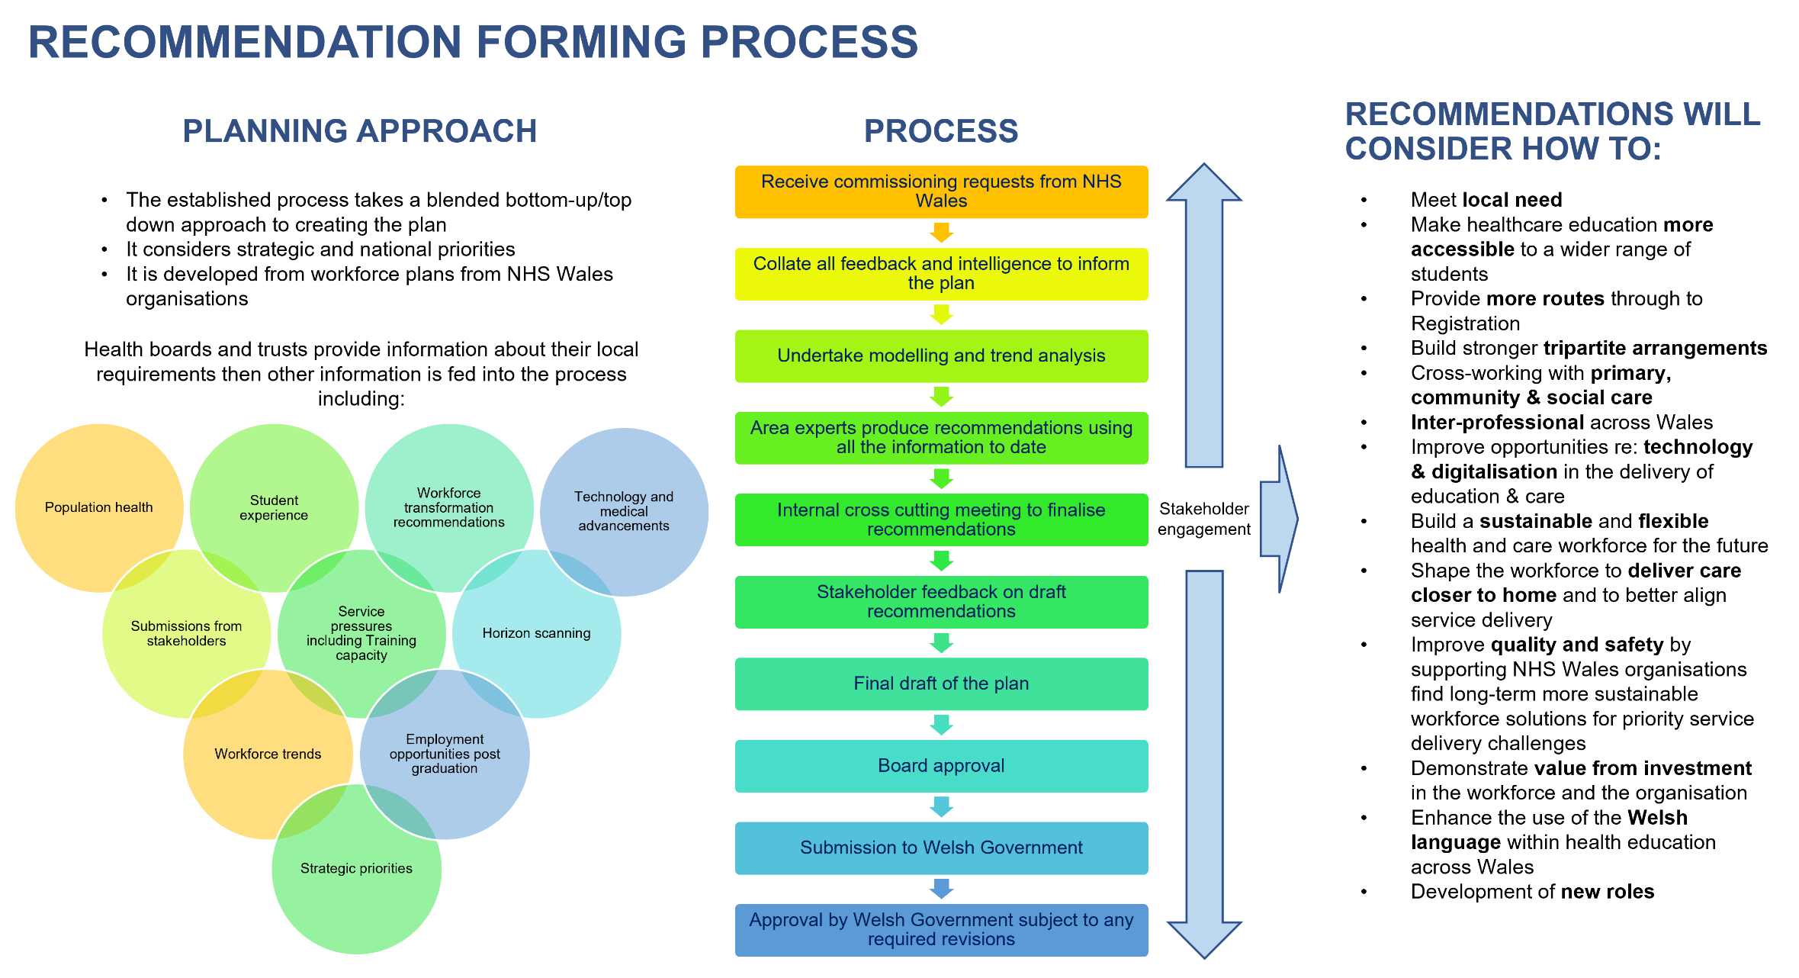

Appendix C Education and Training Recommendations Further Information
This appendix provides further information relating to the recommendations made in Chapter 3.

Educational Commissioning is structured into contracts aligned to Health Board organisation footprints to build stronger tripartite arrangements between HEIW, Education Providers and placement providers. In 2022 the geographical reach of pre-registration education in Wales changed and new contracts were secured.

The education contracts require Universities to incorporate contextual admission requirements to students from backgrounds in the lowest 10% of the Welsh Index of Multiple Deprivation (WIMD). Universities are provided with additional financial support for each of these students admitted to provide additional student support. The universities are required to market these opportunities to schools and colleges within the lowest WIMD footprints.

A number of the key themes of the pre-registration education contracts are aligned to meet the Healthier Wales plan and also map to recently published National Workforce Implementation Plan. All pre-registration training is now interprofessional. Additionally, HEIs will be required to provide interprofessional simulated learning in teams and 4 weeks of interprofessional placements will be incorporated into all programmes.

All students will have compassionate leadership principles taught at the beginning of their programmes and be given the opportunity to reflect and build their leadership skills as they progress, and all HEIs will provide a leadership academy providing mentorship to students from healthcare leaders.

- Overview of Health Professional Education and Training Places in Wales
The graph below shows that, since the establishment of HEIW in 2018, nurse commissioning numbers have grown significantly from below 2,000 per annum to 2,701 in the 2023-24 academic year. In order that these increases can be accommodated HEIW has also invested in developing the placement infrastructure across Wales to ensure that the students have access to safe and quality learning environments. This has involved investing in more Practice Educator roles and developing additional capacity in Primary, Community and Social Care.

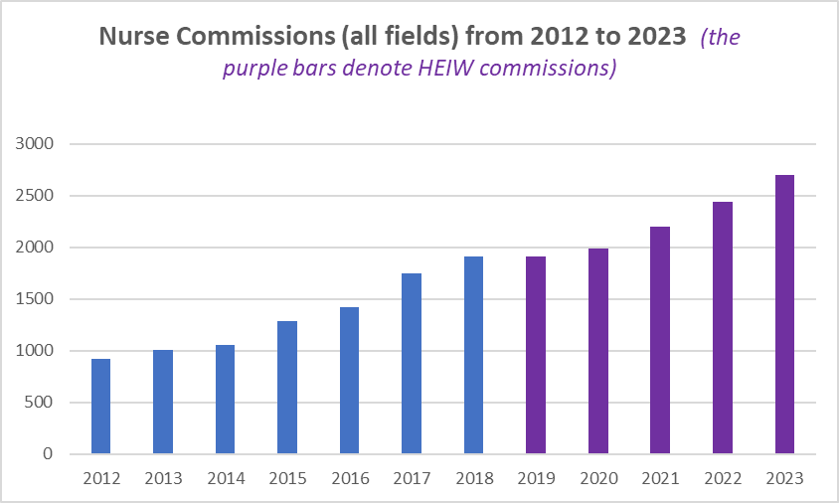

The investment in training infrastructure has enabled the increase in commissions but the number of applications for nursing places has dropped significantly reducing the fill rates on courses. Across the UK applications to nursing courses have dropped by in excess of 22% over the last two years. In response HEIW has led on a series of initiatives to supplement the traditional University recruitment processes. A total of 2,307 student nurses across all four fields of nursing have been recruited in the 23/24 academic year. This is 509 above 2022-23 levels and the highest number of student nurses ever recruited in Wales. The HEIW led initiatives accounted for 768 filled places which represents 33% of all filled places. Such initiatives have included:
- Enhanced bridging modules between Further and Higher Education
- The introduction of the International Student Nurse Scheme
- New opportunities for Healthcare Support Workers to progress
- Introduction of a new part-time distance learning course

However, whilst recruitment to adult and child field places were high, both Mental Health and Learning Disability commissioned places remained difficult to fill. HEIW are leading on several innovative solutions to ensure that recruitment to these fields of nursing continue to increase.

Midwifery, Healthcare Science and Allied Health Programmes Commissioning
All commissioned places for midwifery were filled and all Allied Health Professional and Healthcare Science courses achieved fill rates in excess of 95% with the exception of Diagnostic Radiography, Occupational Therapy, Dietetics, Podiatry and. Courses with less than 90% fill rates have been escalated with the relevant University and quality improvement plans have been developed, approved and are subject to monthly monitoring.

The following infographic is the final 2023-24 recruitment position for these professions following the Spring 2024 intakes.
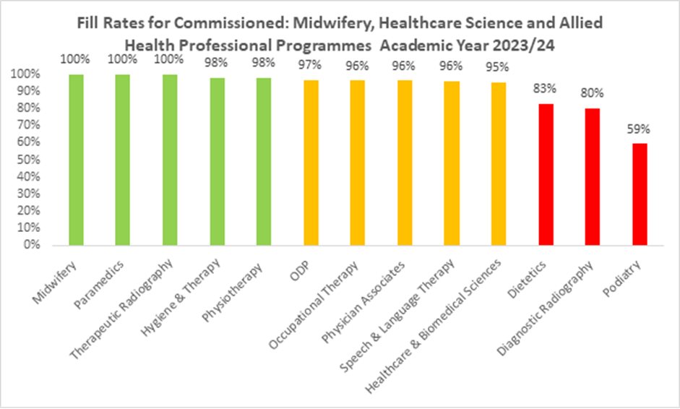

Quality of Education and Training
HEIW is responsible for ensuring there are high quality learning environments for all healthcare learners in Wales, providing high quality education and training for our future and current NHS Wales workforce, in line with regulatory standards and requirements. This remains one of HEIW’s core functions and top priorities.

HEIW has adopted a Quality Framework integrating Quality Planning, Quality Management, Quality Assurance and Quality Improvement as a system for underpinning high quality multi-professional education and training across professional groups. The organisation also has a statutory duty to secure continuous improvements in the quality of education and training. Excellent communication with all our partners, stakeholders, students and trainees continues to be essential in this work.

HEIs and the Performance Quality Framework
Universities are a key partner of the NHS as they provide routes into education and training for all health professionals at undergraduate and postgraduate level. The quality aspects of the contract management process with universities assures HEIW, Welsh Government and NHS organisations that the health professional education commissioned and delivered in Wales adheres to the appropriate academic and vocational standards. This process also supports initiatives to widen access, promote the use of the Welsh Language and to provide a local route to education, amongst other themes.

As part of this contract assurance process, HEIW undertakes an individual quality review with each of its education partners. This review is only possible due to the open, collaborative approach undertaken by all parties. The aim of each individual review is to guide the continuous improvement of education programmes and, as such, improvement plans set out in the individual quality report for each University are incorporated into their own improvement processes. This is all encapsulated within our Quality Performance Framework.

The Performance Quality Framework also sets out the principles and practices deployed to manage concerns via a staged escalation process facilitating a risk-based approach to managing concerns. Within the escalation process is the mechanism to performance manage concerns relating to the key performance indicators and associated requirements of the contracts with HEIs. The aim of the escalation process is to seek assurance that sustainable quality improvements are implemented in a timely, effective and efficient way.

HEIW draws on several data and mechanisms for assurance that Education Providers meet their responsibilities for provision of placement quality. These measures link with all elements of a quality cycle (planning, management, improvement, and assurance).

- Nursing
The Welsh Government A Healthier Wales: our plan for health and social care suggests that:
- A strong public health approach is key. People need to take responsibility for their own health and wellbeing when choosing lifestyle factors (smoking, maintaining healthy weight, excessive drinking).
- Over the next decade, there will be a shift of services from hospitals to communities, and from communities to homes. People will be supported to remain active and independent, in their own homes, for as long as possible.
- Primary and community care will offer a wider range of professionally led services and support.

Scientific Evidence Advice NHS in 10 years +. An examination of the projected impact of Long-Term Conditions and Risk Factors in Wales, reports:
- Wales has an ageing population. By 2038 almost one in five people in Wales projected to be aged 70 or over.
- An ageing population will mean a higher proportion of the population living with long term conditions (LTC), including frailty, dementia, cancer, CHD, CVD, diabetes, hypertension and poor mental health. For many these will be co-morbid with other conditions; complex multimorbidity (4+ conditions) is expected to increase (almost double) by 2035.
- Considering all-ages rates, atrial fibrillation; dementia; heart failure; chronic obstructive pulmonary disease (COPD); osteoporosis; chronic heart 4 Science Evidence Advice (SEA) – NHS in 10+ years disease (CHD); inflammatory bowel disease; peripheral vascular disease (PVD); asthma; hypertension; anxiety disorders; and diabetes are projected to increase more quickly than demographic growth. (Likely)
- New technology and treatments will likely reduce time in hospital for care, but there will still be significant increases in future needs for full-time equivalent NHS staff to provide existing levels of care. (Likely)
- Prevalence of stroke has increased over time, and it is expected Welsh adults who have had a stroke will increase by 33% from 2015 to 2035.
- Prevalence of diabetes is expected to rise, partly driven by an ageing population; specific modelling for Wales suggests that if prevalence of diabetes remained at current levels, 260,000 people would be living with diabetes by 2035-36, a 22% increase.
- By 2035, the majority (two-thirds) of patients with complex multimorbidity will include mental ill-health.

Royal College of Nursing. Nursing in Numbers, reports:
- The age profile of nurses working in GP settings is concerning. Fewer than one in twenty (4.3%) of female nurses are 29 or younger; 41.5% are aged between 30 and 49; while over half (54.2%) are aged 50 or over. The age profile of GPNs is concerning nurses approaching or older than 55 may be considering leaving the workforce as they near retirement age. Owing to their numbers, this could have a devastating impact on the delivery of primary care.
- In 2022/23, health boards spent a total of £161.2m on agency nursing. This is a 21% increase since 2021/2022, during which health boards spent £133.4m – itself a 41% increase on the year before.

Learning Disability Strategic Action Plan 2022 to 2026, reports:
- In 2022 there were approximately 54,000 adults living in Wales with a learning disability.
- Many people with a learning disability experience poor health and die at a young age.
- Priority - Health, including reducing health inequalities and avoidable deaths.
- Improve how mainstream NHS services identify and respond to the needs of people with a learning disability and ensure reasonable adjustments are made that reduce diagnostic over-shadowing and ultimately reduce preventable adverse events and avoidable deaths.
- Reduced admissions through increased community-based crisis prevention/early intervention support.

IMTP requests for nursing pre-registration commissioned places have increased again for 2025-26 on the back of significant increases in recent years (note that the increase in nursing IMTP requests is only slightly higher than last year). However, only 60% of the IMTP request was commissioned in 2024-25 due to constraints outlined below.

There is clear justification for the need to increase this workforce (set out on strategic drivers above). Nurse workforce modelling shows an increase in the pipeline of future registrants due to increased commissioning in recent years particularly for adult nursing. However, this only goes towards filling the 9.3% vacancy rate which is the highest vacancy rate of all professional groups.

High levels of retirements are anticipated across nursing, HCSW, health visitors. There are nurses who still fall within the ‘special class status’ allowing them to retire at 55. Staff retention is an issue across all four nursing fields (but especially adult and mental health). Participation rates drop as nurses progress through their careers with more and more working part time in the latter years of employment.
It is identified that there are a number of constraints to meeting the numbers:
- Current contracts: The total number of places set out in the contracts is a limiting factor on the number of nurse training places commissioned. (See spreadsheet for a full breakdown of commissioning ranges set out in the contracts). However, there is a clause in the contract allowing HEIW to commission up to 20% above the commissioned numbers and even go above this if the commissioned number is mutually agreed by both parties (HEIW and HEI). The financial envelope has already been set for the 10 years of the contract which cannot be exceeded. Traditionally not all students have required HEIW funding as a certain % opt out of the bursary and self-fund through a student loan, however it is anticipated that the Welsh Government changes to the bursary policy allowing students to access the full student maintenance loan as part of the scheme will likely see an increase in rates of students opting into bursary funding.
- Placement capacity: 2,300 hours of practice are required for these professions as specified in the NMC standards. HEIs can utilise up 600 hours of simulation in meeting the placement requirements if agreed with the NMC (however no HEI has taken up this opportunity to date). Currently there are 5682 nursing students enrolled on programmes in Wales at this point in time. This poses a significant placement burden on the service during a challenging time. New placement capacity solutions are being progressed through the Head of Placements and Improvement programme of work including development of placements in social care, the expansion of the Practice Education Facilitator role, placement accessibility recommendations and Inter-professional placement development. Financial constraints are having an impact on the progression of placement innovation as the funding of Care Home Education Facilitator (CHEF) roles has now come to an end despite evidence of impact on development of placements in social care. Currently numbers set out in the placement plan are met in nursing however as the number of placements increase risks of a reduction of quality of placements increases. Poor quality placements lead to slowed student progression and increases in programme attrition.
- Applications to programmes: Student nurse recruitment is a UK wide issue and is thought to result from poor NHS media coverage in relation to the pandemic, widespread industrial action and the impact of the cost of living. Recruitment in Wales has been affected by the money available for living expenses through NHS bursary. This is set to improve for Welsh domiciled students in Sept 2024 as they will be able to access the full maintenance student loan for the first time on top of the bursary package.

In 2023 and 2024 applications per nurse training place reduced in a context of increased commissioning numbers. Not all places were filled in 2022-23 and 2023-24 with Spring cohorts being affected in particular. A programme of work to increase applications to nursing programmes been progressed. As a result of this work more Health Care Support Workers (HCSW) and part time places were supported and HEIW supported pilots for bridging modules in USW and Wrexham University for students who had missed out on a place due to insufficient academic credit. The introduction of a project to introduce a funding for international student places led to 447 international students being recruited to nursing programmes in Wales. All international students will be supported into posts on graduation as part of the tie in arrangements to stay in Wales for a minimum of 2 years.

2024 will also see the commencement of a new pre-registration nursing part time distance learning contract with the Open University. This programme is flexible and provides a part time route for all four fields of nursing for the first time. This contract provides a diversification of the routes on offer providing greater access to nurse training for all.

  - Mental Health Nursing
Student recruitment for mental health nursing has been identified as a risk to meeting the mental health workforce plan ambitions. Only adult nursing can be considered for international student nurse recruitment as the other nursing fields do not exist in many other countries therefore this route cannot be used to bolster student recruitment numbers. Part time routes will be maximised for this field.

  - Learning Disability nursing
Programmes for learning disability nursing have long experienced poor recruitment. IMTP requests for this field have fallen this year however the number recruited historically for quite a number of years has not been close to meeting the identified demand.

A programme of work around this has been established to better market the profession across Wales. Placements in LD have been utilised by students from all fields allowing them the opportunity to swap fields during their training. Additionally, it has been identified that many graduates from psychology or health and social care degrees may want to progress to LD nursing. Therefore, a change control notice to existing contracts has been progressed to develop a PG Dip route of training alongside the BSc routes.

96% of student graduates were recruited into posts in Wales through the student streamlining process in 2023.

- Midwifery
Maternity and Birth Statistics 2022, reports:
- Since the 1960s ‘baby boom’ there has been a fairly stable ebb and flow of births in Wales, over the next 13 years the number of births is predicted to first fall and then slowly grow again.
- The number of live births in Wales has decreased by 15.4% compared to ten years ago; this is equivalent to just over 5,000 fewer births per year (Stats Wales 2023). In 2022, 28,296 live births took place in Wales (ONS 2023).
- More pregnancies are becoming complex due to rising levels of obesity, women with more complex medical conditions becoming pregnant, increasing maternal age and more widespread use of assisted reproductive techniques.
- Wales has increasing levels of obesity, 60% of women in Wales in 2022 were overweight or obese at initial assessment (Royal College of Midwives 2023), 31% of women had a BMI of 30 or greater at initial assessment (Stats Wales 2023). An increase in childhood obesity is likely to lead to increases in obesity amongst women giving birth. This will lead to an increased likelihood of pregnancy complications compared to women giving birth in previous generations.
- Three out of ten pregnant women in Wales are reporting a mental health condition at initial assessment. This proportion has increased every year since data was first collected in 2016, with younger pregnant women more likely to report a mental health condition than older pregnant women.

The Welsh Government Midwifery Workforce Report (2023) Birth Rate Plus Report 2023, commissioned by Welsh Government shows the workforce required in Wales to meet current demand is an additional 4.2 WTE midwives.

The report also states that over the last 5 years there has been an increase in commissioned places for midwifery programmes in Wales of 42%. Over the last 10 years midwifery (full-time equivalent) numbers have increased in Wales by 10%.

IMTP commissioning requests have increased to 223 places for 2025 recruitment.

Applications to pre-registration midwifery places slightly dropped in 2024 however recruitment is still buoyant with commissioned places continuing to be filled.

There is a requirement to grow this workforce due to strategic drivers highlighted above. Politically the need to ensure sufficient midwifery staff to support perinatal mothers is a priority.

Constraints include:
- the contractual ranges with each university
- meeting the placement requirements in the Southeast of Wales has been an issue in 2024 commissioning. Placement capacity for 2024 is still under negotiation and may result in a reduction of commissioning numbers for this cohort.

99% of midwifery student graduates were recruited into posts in Wales through the student streamlining process in 2023.

- Healthcare Professionals
  - Allied Health Professions Pre-Registration
A Healthier Wales (2018) sets out the need to transform the workforce in order to deliver future services differently and have an increased focus on prevention and public health. There is a need to deliver services in Health and Social Care closer to people’s homes preventing them from accessing secondary acute services. Allied Health Professions (AHPs) workforce transformation is in a context of an aging population, the legacy of Covid and people presenting to the NHS with more complex needs and widening inequalities in health.

The Allied Health Professions are 13 individual professions allied by their belief in the importance of enabling people to live the lives they want to live. Individually and collectively AHPs work to empower people of all ages, from birth through to the end of life, to manage their own wellbeing and prevent or reduce the impact of psychological and physical ill health and disability.

Allied Health Professions deliver strong, practical, solution-focused and life-affirming outcomes through a unique range of biological, psychological and social interventions that are particularly valuable in responding effectively to the complex, multi-dimensional needs of the population. These can:
- prevent unnecessary hospital admissions
- reduce length of stay
- facilitate safe sustainable discharge
- enable people to reduce reliance on long term care services
- allow people to remain as independent as possible for as long as possible
- (AHP Framework for Wales).

In addition, having an increasing public health focus can address inequalities and both universal and targeted interventions to improve population health and wellbeing.

There are a number of strategic drivers in place to consider when proposing the commissioning number recommendations for these professions:
- AHP Framework for Wales: Looking forward together
- All Wales Rehabilitation framework and AHP public health strategic framework.
- Recurrent WG AHP of £5 million funding to increase the Allied Health Professional services and delivery of community-based care. Available from April 2023, this recurrent funding will increase the number of community based AHPs and support workers. This will help prevent hospital admissions and allow more people to be discharged from hospital with the right support and rehabilitation in place to recover at home.
- Primary and Community Care Allied Health Professions workforce guidance.
- Mental Health workforce plan.
- Healthy Weight: Healthy Wales
- Perinatal Workforce Plan.

Agency costs have increased significantly in recent years for this workforce when taking into account inflation, and there is a need to provide routes through to advanced practice and consultant posts in order to support transformation of the workforce.

Each profession is considered individually in relation to workforce need, IMTP requests, and constraints to current education delivery. There are constraints for many professions in relation to placement capacity.

The Placements Innovation programme is progressing with proposals to introduce 1 multi professional Practice Education Facilitator (PEF) per Health Board organisation to support with increasing placement capacity.

    - Physiotherapy
This profession is key to enabling people to stay fit and well in the community and supporting the reablement agenda. Physiotherapy can keep people out of secondary NHS services or speed up recovery and discharge of those who have been acutely unwell and can also have an impact on health and wellbeing of the population through an increased public health focus.

Graduate recruitment was buoyant for this profession with 94% of students recruited to posts in Wales in 2023. Long term vacancies have been identified for physiotherapy roles.

Physiotherapy is a relatively young workforce, and participation rates are similar to other AHPs dropping to ~85% during their 30s as a predominantly female workforce. There are no red flags in terms of large numbers of imminent retirements.

Placement capacity issues have been escalated for this profession with recommendations being managed through the placement innovation IMTP for 2024-25.

IMTP requests have fallen from last year’s return, with 173 requested for 2025-26 compared to 198 requested in 2024-25. In 2023-24 and 2024-25 180 places were commissioned.

The maximum number of HEI pre-registration contracts is 200 for Wales, and applications remain buoyant for these programmes and commissioning numbers were met for 2024-25.

    - Occupational Therapy (OT)
This profession is key to enabling people to stay living independently in the community, supporting the reablement agenda in keeping people out of secondary services. OT is identified as an important profession to realise the ambition set out in the set out in the mental health workforce plan.

Applications remain buoyant for this profession, however commissioning numbers were not fully met in 2024-25. Issues have been raised in relation to placement capacity and a report with recommendations is being supported through the placement’s innovation IMTP.

Graduate recruitment was buoyant for this profession with 94% of students recruited to posts in Wales in 2023.

There is a greater number of the OT NHS workforce in the over 55 age bracket than other AHPs indicating a risk in terms of retirements in the next 5 years.

In 2024-25, 197 places were commissioned which was above the IMTP requests in recognition of the mental health workforce plan recommendations. However, only 189 places were filled.

For 2025-26 there is a further increase to 213 to reflect both the commitments in the Strategic Mental Health Workforce Plan and an increasing need in local government social care settings.

    - Dietetics
This profession has significant bearing on the prevention agenda, having a specific population health focus to enable people to attain good nutritional status, crucial in early years and child development. Dietetic intervention can prevent diet related Non-Communicable Disease such as Obesity, Cardiovascular Disease, Diabetes, and support people to self-manage their condition.

Dietitians support programmes of work to prevent falls related to malnutrition and hydration in later years; and maintain their nutritional status during illness.

This NHS workforce is predicted to grow over the next 5 years with the increased numbers already in the training pipeline. An excess of graduate posts were made available last year with good recruitment, with 95% of graduates taken up posts in Wales. The profession reports significant vacancies that they have been unable to fill.

Placement capacity is difficult for this growing profession however there has been a commitment from the profession to support the training of the increase in commissioned numbers.

Dietetics is a relatively young workforce, and participation rates are similar to other AHPs dropping to ~85% during the over 30s age bracket as a predominantly female workforce. There are no red flags in terms of large numbers of imminent retirements.

The IMTP requests have increased from 75 in 2024-25 to 96 in 2025-26. Commissioned numbers for 2024-25 were 74 compared to 82 in 2023-24. HEIs have struggled to recruit to the higher numbers due to fall in applications, with 68 recruited to 75 places in 2023-24.

Applications increased in Wrexham University the North of Wales for 2024-25 and Cardiff Metropolitan University has reduced the entry tariff to bring them in line with institutions across the UK.

Commissioning numbers have been split to maximise recruitment for Wales, however there is a need to build placements in Powys Teaching Health Board and Hywel Dda University Health Board to accommodate students training in North Wales accessing placements.

    - Speech and Language Therapy
The Speech and Language Therapy (SLT) profession provides treatment and support to people throughout their lifespan with communication or swallowing difficulties, is key to enabling children to reach their child development potential and supporting people to manage conditions associated with dysphagia during rehabilitation and in the community.
Welsh Government is set to consider ‘Flying Start’ and ‘Early Years Integration’ transformation workforce requirements in coming years therefore there is an identified potential future increase in workforce required in local authority settings that may not be picked up in the IMTPs.

The Speech and Language Therapy workforce are a relatively young workforce compared to other professions, however the workforce under 25 is lower.

In 2023 poor graduate recruitment was noted, posts were advertised late in the cycle meaning graduates had been released from their bursary contractual requirement by the time posts were released. The number of posts this year are currently being monitored monthly and shared with the profession.

The IMTPs requests have jumped to 58, an increase on 47 last year, although IMTP figures are likely to not include future local authority workforce from all Health Boards. In the 2024 -25 plan 55 places were commissioned following an increase recommended by Welsh Government to ensure sufficient places recruited through a Welsh Language route.

A range of 48-57 commissions are set out in the education contracts, and the Royal Society of Speech and Language Therapist recommend increasing commissions due to expanding services citing that there are fewer SLTs per head of population in Wales than any other part of the UK, as reflected in membership data.

    - Podiatry
The podiatry profession is key to supporting people to improve mobility and maintain independence. Podiatry services enable people to remain mobile and infection free preventing them from requiring admission to hospital. Therefore, they have an important role to play in transforming services to strengthen community care.

Unlike other AHPs the NHS podiatry workforce has decreased in size in recent years. It is also an aging workforce with imminent retirements set to deplete the workforce over the next 5 years. More new posts were advertised in the NHS last year than available graduates. Additionally, students may well work in private practice which supports the NHS by managing minor cases and preventing the need for people to access NHS services. From engagement with students, it is clear that their preference is to work in the NHS on graduation.

Students build their clinical skills throughout their training in the HEI’s NHS clinic located on site, they can also access clinical placements within the Health Boards. Students and practice educators have raised with HEIW that the students do not spend enough time in NHS placements to gain the skills required. HEIW has raised this issue with the HEI to address placement structure. Cardiff Metropolitan university has incorporated a diabetic foot ulcer clinic into the new Allied Health Hub specifically requested by Health Boards to give students more exposure to this condition prior to placement and graduation.

In the 2024-25 Education and Training plan 27 podiatry student places were commissioned which was 30% more than the IMTP numbers requested. The commissioning numbers set out in the HEI pre-registration contract are 26-31 places. Cardiff Metropolitan University struggled to recruit to the programme in 2023 and only 17 places were filled.

    - Paramedics
Paramedics are registered healthcare professionals who have a unique role that crosses healthcare, public health, social care and public safety, they work autonomously providing care in a range of situations.

Most well-known for working within Ambulance Services, paramedics provide immediate and emergency care in response to 999 calls made by the public. Paramedics now also work in other areas of healthcare, for example GP practices, hospital emergency departments and police custody suites (College of Paramedics).

37% of the workforce are over the age of 50 presenting a risk to the workforce in terms of retirements in the next 10 years. In 2024-25 more students were recruited in the North of Wales as more vacant posts were identified in the Betsi Cadwaladr University Health Board footprint than other parts of Wales.

- Healthcare Science
A Healthier Wales (2018) sets out the need to transform the workforce in order to deliver future services differently. There is a need to deliver services in Health and Social Care closer to people’s homes preventing them from accessing acute secondary services.

There is also a need to develop the diagnostics workforce to progress people through care pathways in a timely manner to improve outcomes. This workforce transformation is in a context of an aging population, the legacy of Covid and people presenting to the NHS with more complex needs.

Strategic drivers for healthcare science include:
- Healthcare Science Framework (2018)
- Statements of Intent – Pathology, Imaging, etc
- Primary and Community Care
- Genomics Delivery Plan for Wales (2022)
- Imaging Workforce Strategic Plan (2023 tbc)
- Diagnostics Strategy (2023 tbc)
- Cancer Pathways

There are a number of developments taken into account when developing recommendations for the Health Care Science workforce, these include:
- Scientific/Technological advancements such as:
  - Genomics
  - Artificial intelligence
  - Advanced therapeutic medicines
- Realisation of value and essential role of diagnostics following the pandemic.
- Regionalisation and restructure, including:
  - Regional laboratories
  - Diagnostic hubs/regional treatment centres
  - Community delivery
  - Primary care
  - Digital and online platforms/telehealth
  - Point of care testing.
- Career development capacity considerations including:
  - Job planning
  - Postgraduate and Consultant training uptake.

Each profession is considered individually in relation to workforce need, IMTP requests, and constraints to current education delivery. There are constraints for many professions in relation to placement capacity.

The Placements Innovation programme is progressing with proposals to introduce 1 multi professional Practice Education Facilitator (PEF) per Health Board to support with increasing placement capacity.

Some recommendations are below or above actual contractual ranges and negotiations on these ranges will be undertaken with HEIs as it is anticipated that overall their commissioned numbers should fall within acceptable ranges when collated for each HEI.

  - BSc Cardiac Physiology PTP
This profession carries out crucial diagnostic, monitoring and analytical procedures for patients with known or suspected heart disease and assist in interventions.

A large percentage of this workforce is over the age of 50 (23%) and the potential number of retirements over the next 5 years presents a risk to ongoing service delivery. This is in a context of the Wales Collaborative highlighting the importance of this profession for streamlining cardiac services identifying an increase in the future demand the workforce. Long term vacancies have also been noted for this profession.

Placement capacity is a significant constraint. One of the main service providers is currently not taking students on placement despite a programme manager being appointed by HEIW specifically to support placement development in this organisation.

HEIW commissioned 23 places in the 2024-25 plan. However, due to placement constraints commissions were reduced to 20 halfway through the recruitment cycle. Applications are buoyant and HEI commissioned places are generally filled. The range on the HEI pre-registration contract is 23-26.

  - BSc Audiology PTP (Full and Part Time) and Higher Education Certificate (HE Cert) Audiological practice
Audiologists identify and assess hearing and balance function and their associated disorders, they recommend and provide appropriate therapeutic rehabilitation and management.
The shape of the workforce is fairly flat with 50% of the workforce over the age of 40. No red flags are evident in terms of imminent retirement risk. The long waiting lists for these services indicate an increased need. Services that are being set up by private providers is impacting graduate recruitment into the NHS.

Applications to the programme in Wales are buoyant with commissioning numbers met. The HE Cert gives those in support roles the opportunity to progress to an associate practitioner.

There is a new contract in place for part time BSc PTP Audiology, which is designed as a progression route for employees to complete levels 5 and 6 of pre-registration education and graduate to become a PTP Audiologist.

The new part time PTP route was introduced for commencement in September 2024. To date the profession and HEI has managed recruitment of employed learners successfully. Placement issues are currently well managed by the profession or the HEI. There are some issues with leavers choosing private sector dispensing in Wales over the NHS.

The profession has confirmed that it would support increased HE Cert numbers to contract levels.

  - Nuclear Medicine and Radiotherapy Physics
Nuclear medicine is a technique that uses radioactive tracers (radiopharmaceuticals) to assess bodily functions and diagnose and treat disease. Radiotherapy is the treatment of cancer with high energy radiation such as x-rays.

Healthcare science staff working in this field are responsible for the precision and accuracy of treatments by using advanced computer calculations to develop individual patient treatment plans.
The Positron Emission Tomography (PET) Workforce Plan sets out the need to increase this workforce over the coming years to ensure sufficient technical expertise available to realise ambitions.

  - Respiratory physiology and sleep science
Respiratory physiology and sleep science involves the diagnosis and treatment of lung disease and sleep disorders. The demand for this workforce has expanded since the pandemic.

IMTP requests for commissioned places have risen in recent years and 13 places were commissioned in 2024-25. However, there are placement capacity constraints, and commissioning numbers for 2024 were reduced partway through the recruitment cycle to 10 places to ensure all students recruited could be supported with a quality placement.

  - Diagnostic Radiography and HE Cert Diagnostic Radiography
Diagnostic Radiographers are key members of the Multi-Disciplinary Team (MDT) who operate a wide range of imaging equipment including Computed Tomography (CT), Magnetic Resonance Imaging (MRI), Diagnostic Ultrasound and X-ray equipment. This profession is key to realising the NHS Wales ambitions in relation to diagnostics and reduction of waiting lists.

20% of the current NHS Wales workforce are over the age of 50 and therefore retirements cause a potential risk over the next 5 years.

HEIW commissioned 125 places in 2024-25 and 120 places were filled. 10 Radiography Associate Practitioner (RAP) places were not filled, and the cohort didn’t run, however this programme is now due to run in 2024-25 as employees have been identified.

BSc applications to the programmes in Wales are buoyant. There is a range of 139-167 places (including the HE Cert Diagnostic Radiography) set out in the pre-registration HEI contracts. However, placement capacity is a significant constraint for this profession. Placement supervision is required to be on a 1:1 student to practice educator basis due to patient safety risk. Placement capacity issues have been scoped for this profession with recommendations being managed through the Placement Innovation IMTP for 2025-26.

  - Life sciences PTP
This profession has a key role in investigating the causes of illness and how it progresses, identifying the best type of treatment for patients, and monitoring its effectiveness.

Workforce data does not indicate risks in terms of age and imminent retirement and participation rates are higher than other professions. High agency spend and vacancy rate has been noted for this profession. In 2024-25 all commissioned places were filled however applications per place dropped.

The profession has a strong ethos of work-based learning (WBL) and therefore a tender for a part time route to PTP as a progression route from the Level 4 apprenticeship was completed and learners are due to start in September 2024. Additionally standalone modules have also been commissioned, providing equivalence training for employees with an existing Biomedical Sciences degree.

Full time PTP placement capacity has been a significant issue for the profession as work-based learning supervision is a priority. HEI contracts for pre-registration education include commissioning range of 28-35 places.

  - Radiotherapy and Oncology
This profession uses radiotherapy to create individual treatment plans for cancer patients. Graduates are key to the cancer patient pathway and will be employed in one of three centres in Wales.

This profession has a flat workforce curve with no risks identified in relation to imminent retirements. Recruitment to the programme is buoyant with commissioned places filled. Pre-registration HEI contracts set out a range of 23-30 places, with only 20 places commissioned in 2024-25.

  - Operating department practitioners (ODP)
ODPs provide support during each phase of a patient’s perioperative care (anaesthetic, surgery and recovery). In recent years the demand for their services has grown to support theatre services targets in reducing waiting lists.

New roles are also now available in A&E, ITU and Endoscopy, in addition to long-standing roles in Resus training, with further career pathways opening such as Anaesthetic Associate roles.

IMTP requests have significantly increased in recent years, with 86 requests for 2025-26. As part of the strategic review HEIW now has 3 providers of this education spread across Wales rather than one provider in the Southeast.
Commissioning numbers increased to 69 places in 2024-25, with contract ranges for a total of 51-62 places.

Recruitment to commissioned places has been an issue in the past, however 60 of 62 places were filled in 2023-24. New programme managers are marketing this profession with local communities which is increasing applications.

ODP graduates progress through the nurse student streamlining process which works well with an excess of posts and successful recruitment of all graduates into posts in Wales. There is evidence of unfilled vacancies for this profession.

- Medical
The strategic drivers for the medical workforce recommendations are:
- A Healthier Wales
- NHS Executive & National Programmes including Planned care, Urgent and Emergency Care
- Strategic plans:
  - Strategic Mental Health Workforce Plan
  - Diagnostics Workforce Plan
  - Strategic Workforce Plan for Primary Care
- GIRFT reports
- Increases in trainees applying to train on a less than full time basis.

  - Secondary Care Specialty Training
Our recommendations are to increase posts across a wide range of specialties/training programmes in Secondary Care/Specialty Training. We have worked with colleagues and stakeholders across the system in Wales and considered data and intelligence from a range of sources to review the specialty training provision within the contexts of patient need, training capacity and future planning.

The workforce shortages and consultant gaps we have in a number of priority areas is a limiting factor in the ability of the NHS in Wales to deliver key services and address the backlog in planned care following disruptions to services arising from the COVID pandemic. These recommendations aim to bridge this gap and increase the output of consultants over the next 5-10 years enabling NHS Wales to futureproof services and maintain current consultant levels against projected consultant retirements during this period. In the immediate term, the increased capacity afforded through these recommendations will support NHS Wales to provide regional treatment, healthcare closer to home and timely access to treatment and diagnostic procedures.

The increase in posts created through these recommendations will be distributed across NHS Wales according to education and training capacity. For 2025/26 the approach to workforce planning for the medical workforce has focused on several key themes to build sustainable capacity:
- Urgent and Emergency Care
- Cancer care
- Planned care
- Diagnostic specialties
- Mental Health.

The medical workforce planning process and its recommendations are not undertaken in isolation from the process for other healthcare professions as it is increasingly important to understand how new roles and ways of working might support delivery of service in areas traditionally considered the remit of the doctor.

The growth in training on a Less Than Full time (LTFT) basis continues to have implications for workforce planning and programme management. Focussing specifically on Secondary Care Specialty Training, at the end of July 2023 436 trainees were training LTFT. This represented 24.6% of the trainee population and was an increase of 76 trainees compared to the same timepoint in 2022 and in July 2021 this figure was 270. The graph below highlights the growth in LTFT across the ten Specialty Training Schools. We have continued to see a rise in trainees choosing to work LTFT either to maintain a better work life balance or to develop portfolio careers as a response to reported increasing levels of self-reported burnout (65.7% reporting high or moderate levels of burnout in Wales – GMC NTS data 2023). Wales will be participating in the UK pilot of LTFT posts as part of the national recruitment offering from August 2025 which will aim to minimise %WTE shortfalls across our training programmes:

  - Secondary Care Training
Table 1 below summarises the recommended increases across a range of programmes for inclusion within the 2025-26 Education and Training Plan to be recruited for the August 2025 intake cohort of doctors.

Table 1 – Secondary Care Training Recommendations
Priority areas | Specialty | 2025/26 recommendations for increase
Emergency Care | Emergency Medicine | 2
Cancer Care | Medical Oncology | 3
Planned and urgent care | Cardiology | 3
Planned and urgent care | Dermatology | 3
Planned and urgent care | Diabetes & Endocrinology | 1
Planned and urgent care | Haematology | 2
Planned and urgent care | Otolaryngology | 2
Planned and urgent care | Plastic Surgery | 3
Planned and urgent care | Trauma & Orthopaedics | 3
Planned and urgent care | Urology | 3
Planned and urgent care | Vascular Surgery | 2
Diagnostics & Small specialties | Medical Microbiology/Infectious Diseases | 3
Diagnostics & Small specialties | Paediatric & Perinatal Pathology | 2
Diagnostics & Small specialties | Histopathology | 2
Diagnostics & Small specialties | Clinical Neurophysiology | 1
Diagnostics & Small specialties | Clinical Immunology | 1
Diagnostics & Small specialties | Rehabilitation Medicine | 1
Diagnostics & Small specialties | Paediatric Haematology | 1
Mental Health | Old Age Psychiatry | 6
Mental Health | General Adult Psychiatry | 6
Mental Health | Child & Adolescent Mental Health | 6

  - Emergency Care
    - Emergency Medicine (EM)
HEIW has been increasing EM training posts each year for several years through the Education and Training Planning process (ETP) with recommendations included for both Higher Emergency Medicine and the Acute Care Common Stem (ACCS) core programme.

Trainees appointed to the ACCS programme can apply for run-through status enabling progression straight into Higher EM training without having to go through a competitive recruitment process. As the increased numbers of ACCS trainees progress through the pipeline and to ensure alignment between Core and Higher training we continue to increase the number of Higher programmes enabling us to deliver run-through training to all trainees wishing to undertake this along with opportunities to recruit at the ST4 level to import trainees from elsewhere who wish to enter the EM Higher Programme in Wales.

  - Cancer Care
    - Clinical and Medical Oncology
Cancer services remain a priority for Welsh Government as highlighted in the Cancer delivery Plan for Wales (2016 – 2020) with incidences of new cases rising by approximately 1.5% a year and set to rise by at least 2% a year for the next 15 years.

Recommendations have been made for Medical Oncology to increase by 3 posts implementing year 4 of the proposal to expand by 3 posts per year for 5 years. Increases have not been recommended within the 2025-26 plan for Clinical Oncology, this is due to ongoing recruitment challenges within the specialty, predicted CCT output and rising numbers of trainees training on a less than full time basis. Once these aspects stabilise HEIW will explore further expansions in this specialty.

  - Planned Care
    - Cardiology
Wales continues to have high levels of complex cardiac disease compared with UK averages. Waiting times for routine cardiology appointments have increased significantly post-pandemic alongside an increasing demand for complex cardiac devices and cardiology departments are seeing increased demand as a direct consequence of these long waiting lists. 32% of the current consultant workforce are aged 55 or over and therefore likely to retire or reduce clinical sessions in the next 5-10 years. Following the recent changes to the higher medical curricula unlike most medical specialities the length of the Cardiology training programme remains unaltered (5 years) and as a result the rate of production of CCT holders is therefore unchanged. Current projected output in Cardiology will not meet this future demand.

    - Dermatology
There is a national shortage of dermatologists. Even before the Covid-19 pandemic waiting lists were lengthy. Dermatology is amongst six other specialty areas where ambitious targets were set by Welsh Government to address waiting list delays. Wales currently falls considerably short of the Royal College of Physician’s recommendation of consultant dermatologists per head of population with longstanding vacancies in key areas and services supported by intermittent locum consultants and a pooling of waiting lists for urgent cancer referrals.

    - Diabetes & Endocrinology
The demand for Diabetes and Endocrinology services is increasing with higher rates observed in Wales both in the community and hospitalised populations. The epidemiology of Type 1 diabetes has changed with rises in paediatric and adult diagnoses.

Consultant recruitment into Diabetes and Endocrinology remains high, however 34% of the consultant workforce are over 55 and therefore likely to retire of reduce clinical sessions in the next 5-10 years and even with a reduction in training time arising from a change in the curricula training output will not meet this deficit.

    - Geriatric Medicine
With an ageing population it is likely that the demand for Geriatric Medicine services will continue to increase. The development of front door frailty services within the MEAU/A&Es across Wales continues with clear signalling that this is a major area for expansion. A quarter of the current consultant workforce is aged over 55 and therefore likely to retire or reduce sessions in the next 5-10 years. Current training output will not meet this projected deficit especially given the numbers training less than full time with significant numbers planning to maintain this as a consultant.

HEIW has previously recommended the need for significant expansion in the training programme to meet the projected deficit. These recommendations followed on from a period of rising fill rates in the programme. Unfortunately fill rates over the past two years have dropped considerably and whilst there is a significant need to expand the number of posts in this area the current programme carries a substantial number of vacancies. Any expansion for 2025 will exacerbate this and result in significant gaps in geographical areas. HEIW will continue to work with the specialty and monitor the programme closely to determine next steps.

    - Haematology
There is a shortage of trained Haematology consultants across Wales with various Health Boards reporting constant vacancies. Across the current establishment of consultants in this area in Wales approximately 25% of posts are either currently vacant or house locums, alongside this 30% of the current workforce are aged over 55 and therefore likely to retire within the next 5-10 years.

Trainees coming through the programme in Wales generally stay in Wales but focus in South-East Wales. There have been no new substantive consultant appointments in Swansea Bay UHB, Hywel Dda UHB or Betsi Cadwaladr UHB from haematology trainees in past 7 years.

Haematology is a small training programme and current projected output of the Programme will not meet the projected deficit in consultant numbers as a result a Programme of expansion over several years is proposed which would enable new roles to be created across various sites including the Welsh Blood Service.

    - Occupational Medicine
The Occupational Medicine programme closed in February 2017 following issues with insufficient trainer infrastructure to enable Wales to deliver training. At various intervals since then the training supervisor and capacity issues have been revisited to determine whether the programme could be restarted but a lack of substantive consultants in the specialty has prevented this.

The current number of Occupational Medicine trainees across the UK is insufficient to meet the future demands for Occupational Medicine consultants. The lack of training capacity both in the NHS and private sector limits the opportunities for growth and development. HEIW has been approached by the National School of occupational Medicine to explore whether we would support private sector placements with a view to creating two new posts if agreed and funded by the private sector. HEIW will continue to explore this possibility whilst liaising with Welsh Government to consider future approaches to meeting requirements of NHS Wales.

    - Ophthalmology
Workload in Ophthalmology continues to increase given the ageing patient demographic and demand of patient numbers. Wales is below the recommended number of consultants per 100,000 population with an ageing workforce particularly in certain geographical areas.
There is a well-rehearsed argument to increase training numbers in this specialty however there are ongoing training capacity issues and a consultant shortage. Due to this the focus for 2025 will be to maximise the current HEIW funded training positions available across Wales before exploring expansion opportunities. Alongside this some minor changes to The Royal College curriculum changes are planned for 2024 which suggest that trainees will be able to complete training at an expedited rate. It is therefore proposed that current numbers of training posts on the programme are retained at this point in time with a review scheduled for next year and once more is known about the impact of the proposed regionalisation of services.

    - Otolaryngology (ENT)
ENT across the UK has seen significant advances in technology and a requirement for a consultant-led service. Wales now provides a comprehensive secondary and tertiary service at all levels. ENT is amongst those specialties with the greatest number of people waiting on outpatient appointments.

Wales has unfilled consultant posts in North and West Wales. Over a quarter of the current consultant population are due to retire in the next 5-10 years. A vital component for the sustainability of the service is local training since time has proved that those that apply to train in Wales also want to stay and work in Wales. The current projected output of the Programme will not meet the projected deficit in consultant numbers.

    - Plastic Surgery
The British Association of Plastic and Reconstructive Surgery (BAPRAS) annual workforce report for the UK recommended that there should be 1 consultant plastic surgeon per 80,000 population. Based upon this Wales should have 38 WTE consultant plastic surgeons; a deficit of 15 based upon current numbers.
20% of the current consultant workforce are aged 55 or over and therefore likely to retire or reduce clinical sessions in the next 5-10 years.

Demand for services continues to increase and there are long waiting lists with new patient referrals waiting up to 52 weeks and for those receiving treatment up to 252 weeks. Recruitment and retention into the specialty is excellent however the current projected output will not keep pace with the predicted retirement and expansion.

    - Trauma & Orthopaedics
Post-pandemic there are now significantly more people listed for outpatient appointments, diagnostic and treatment services than before. Waiting lists are at their highest levels ever recorded with over 60% of people on the waiting list waiting for their first outpatient appointment. Trauma and orthopaedics have one the longest waiting lists alongside an increased demand for orthopaedic trauma specialties seen through the establishment of the Trauma Network in Wales. With 31% of the consultant workforce being over 55 it is projected that the current number of trainees will not replace planned retirements and service the recovery/Planned Care agenda.

Due to ongoing challenges with training opportunities and educational capacity post pandemic we have slightly reduced our recommendation for this specialty for 2025 however, we will continue to monitor future needs to ensure opportunities are maximised to meet the future demands arising from consultant retirements.

    - Urology
Demand in Urology is being driven by increased demand especially with cancer work. Prostate cancer is now the commonest UK cancer and 50% of urology workload is cancer related. The changing demographic with an ageing population means that demand is increasing by roughly 10% per year.
There are significant shortages in unfilled consultant posts across UK in Urology. A third of the current consultant urology surgeons in Wales are over the age of 55 and therefore likely to retire in the next 5-10 years. Current projected output of the Programme will not meet the projected deficit in consultant numbers.

    - Vascular Surgery
The Vascular Society workforce plan for the UK proposes that for a population of Wales the current number of training positions is insufficient. Coupled with this there are a number of unfilled consultant posts across Wales and almost half of the current consultant vascular surgeons in Wales are over the age of 55 and therefore likely to retire in the next 5-10 years.

The training programme delivers high quality training and there is sufficient training capacity to support an expansion which is essential to ensuring the sustainability of future services in this area.

  - Diagnostic specialties & Health promotion/prevention
    - Medical Microbiology & Infectious Diseases
Demand for Medical Microbiology and Infectious Diseases continues to increase, a need further highlighted by the pandemic. There is a recognised national shortage of trained medical microbiology/infectious diseases staff, and these shortages are also present for nursing and scientific staff in this specialty area.

Across the current establishment of consultants in this area in Wales approximately 30% of posts are currently vacant and projected retirements over the next 5 years will exacerbate this further. This expansion concludes a 5-year plan to expand the programme by 3 posts per year.

  - Pathology specialities
    - Histopathology
As reported in previous ETPs workload in Histopathology increases year on year and complexity of reporting has dramatically increased in recent years especially around cancer reporting and the developing requirements and technology for genetic and molecular testing.

The evolving field of genomics will significantly increase histopathology workforce requirements. Whilst there is a recognised need for an increase in the number of histopathology training posts in Wales to support the current and future workforce there have been identified issues around training capacity and the impact of pay differentials preventing significant expansion. Whilst these issues remain it is important to continue to make small incremental changes, where possible.

    - Paediatrics and Perinatal Pathology
The Paediatrics and Perinatal Pathology programme has been frozen for a couple of years following issues with insufficient trainer infrastructure to enable Wales to deliver training. It is anticipated that this issue will be resolved to enable a resurrection of the programme from August 2025. However, UK concerns regarding applicant and the introduction of a financial incentive in England may limit success in this area.

  - Small Specialties
    - Clinical Neurophysiology, Clinical Immunology, Rehabilitation Medicine and Paediatric Haematology
Programmes such as Clinical Neurophysiology, Clinical Immunology, Rehabilitation Medicine and Paediatric Haematology comprise of small numbers of posts usually 1 or 2. Recruitment into these training programmes can be challenging due to the lack of exposure to the specialty during medical school, Foundation or early years training. Recruitment into consultant roles in these specialties is also challenging and interest from candidates outside of Wales is typically low. These programmes are therefore usually heavily dependent on the Wales training programmes to supply and maintain a permanent workforce to sustain future services.

All of these areas have an ageing consultant workforce, long term consultant vacancies, increased demands in service and significant waiting list times. With consultant retirements projected there is a finite window available to invest now in the future of these specialties to ensure sustainability.

Due to the small nature of these specialties some of the wider workforce discussions are led on an UK basis rather than Wales-wide as is the case for Paediatric Haematology; a new programme to Wales from 2025 but an essential area for development and support.

  - Mental Health
Mental Health has been a priority area and with increased levels of depression and anxiety compared to pre-pandemic estimates and longer waiting times for services. Over the past three Education and Training plans we have invested in a total of 24 new posts in the three-year Core Psychiatry Programme, this will ensure an increased number of trainees eligible to enter Higher Psychiatry training in future years.
The supply and demand analysis for Higher Psychiatry training and associated services highlights a need to increase training post numbers to address current shortfalls in consultant numbers, projected consultant Higher Psychiatry training is delivered across a range of specialties including Child and Adolescent, Old Age and General Adult Psychiatry all of which report significant workforce challenges now and in the future. Recruitment into Higher Psychiatry Specialty training remains an issue.

The Core Psychiatry Training programme has now seen 100% fill rates for a number of years, and we continue to monitor the impact of this on recruitment to higher psychiatry training. With increased output from the Core Programme is it hoped that fill rates for Higher Programmes will start to increase going forward. However, trainee feedback and destination data currently suggest that trainees due to complete Core training in the next year or two are hesitant to progress straight into Higher programmes for the following reasons:
- an excess of locum vacancies are considered an opportunity to earn more money and work less
- a lack of experience and confidence to enter higher training
- burnout or concerns about a future in the specialty
- a Break from portfolio and training commitments.

HEIW will be working with the programmes and trainees to explore this in further detail and identify ways of attracting, retaining and supporting doctors to deliver sustainable services.

  - General Practice and Public Health Medicine
The General Medical Council has recently approved plans for the development of a dual Accreditation programme for training in Public Health Medicine and General Practice. This new 7-year programme will integrate both GP and Public Health training into once pathway. A pilot cohort was recruited into the programme in August 2024 with Wales planning to participate in August 2025 utilising existing GP and Public Health posts as required.

  - Foundation Training
In 2019 a Business Case was shared with Welsh Government outlining a need to expand training posts at Foundation level to address training pipeline challenges with expanded Medical School output and increases across Specialty Training Programmes as detailed in this and previous Education and Workforce plans. The paper recommended a phased expansion programme commencing in August 2020 with increases to Foundation Year 1 and Year 2 posts required over a 5-year period as detailed in the table below:

Foundation Year 1 and Year 2 posts required over a 5-year
 | Number of F1 posts | Number of F2 posts
August 2020 | 351 (+12) | 339
August 2021 | 381 (+30) | 351 (+12)
August 2022 | 411 (+30) | 381 (+30)
August 2023 | 450 (+39) | 411 (+30)
August 2024 | 450 | 450 (+39)

This expansion programme is now complete and has ensured alignment of medical school output in Wales to the first stage of the postgraduate training pipeline (Foundation Training).

On completing Foundation Training Wales has sufficient Year one Core/Specialty/GP training positions available with approximately 270 Core/Specialty posts and 200 GP posts available each year to match the output of 450 Foundation Year 2 doctors from the Foundation Programme.

There are no immediate plans to expand F1 numbers further however future expansions will be required to match output of the increased numbers of trainees who have entered Swansea Medical School and the future output of the North Wales Medical School.
  - General Practice
Our recommendation for recruitment to General Practice (GP) Training Schemes for 2025-26 is set at 200-220 trainees. This figure will meet the need to supply sufficient new GPs to the workforce in Wales to both replace exiting GPs and make a small reduction to the large deficit of GPs currently working in Wales.

In 2019 Welsh Government agreed that GP Training numbers should increase to better reflect population numbers in each Health Board area. At the same time as an expansion of training places, the 1+2 model was also introduced (two years in general practice and one year in hospital). The target now is to recruit 160 GP trainees per year with an agreement that we can recruit up to 200 trainees if there are sufficient numbers of eligible candidates. Since that agreement, the number of GP trainees has steadily increased. There is sufficient capacity within the system to recruit to 200-220 trainees and sufficient applicant numbers.

In addition to recommending recruiting 200-220 for 2025-2026 it is also recommended that we recruit additional trainees for the 2024-2025 training year for a February 2025 start. An additional 40 trainees can be accommodated within the programme. This would give a more even throughput of trainees and serve the workforce needs better (less hospital rota gaps, more doctors serving in GP, care closer to home). At the present time the GP workforce is reducing and at too low a level to deliver even current care demands adequately. Wales has capacity to train these numbers, and this will represent a reasonable increase to start to address the large deficit of GPs currently working. It also aligns with the recommendations in the Strategic Workforce Plan for Primary Care. This number will need to incrementally increase over the coming years to align with the changes in the other nations.

Trends:
Year | 2016-2017 | 2017-2018 | 2018-2019 | 2019-2020 | 2020-2021 | 2021-2022 | 2022-2023 | 2023-2024 | 2024-2025
Number accepting offer | 130 | 144 | 134 | 187 | 200 | 184 | 175 | 199 | Capped at 160

  - The cost of training
Alongside the cost of trainee salaries additional infrastructure and services are required to appropriately support trainees within their programmes. Aligned to the Duty of Quality HEIW will be reviewing the current arrangements and allocation of funding to support training to ensure equity and transparency going forward. Details of this review will be shared within future Education and Training plan recommendations. This review will consider funding models and action plans for:
- Less Than Full Time Training: currently HEIW provides a maximum uplift of 0.2WTE salary funding for certain slot share arrangements where, for example, two trainees working at 60% share a full-time post. With increasing levels of LTFT and varying configurations of %WTE this can leave Health Boards with varying gaps across their rotas for example if a 60% and 80% trainee were based in a hospital a slot sharing arrangement would not currently be possible resulting in 0.6 WTE vacancy. For workforce priority areas we will be looking at the funding requirements to increase this LTFT uplift funding to enable more trainees to be appointed to programmes. In the above case an additional 0.2WTE uplift on top of the current arrangement would enable a 1.4WTE slot share to be facilitated and a gap released to appoint another trainee to the programme.
- Supporting International Medical Graduates: approximately one third of all appointments across medical training posts in the past few years have been overseas doctors. Across the programmes a number of initiatives have been introduced to support IMGs which include:
  - Extended shadowing models and targeted induction programmes to enable overseas doctors to fully adapt to their new surroundings, colleagues and to develop their confidence.
  - Initiatives to address differential attainment in conjunction with the GMC and Royal Colleges to explore the challenges faced by doctors including IMGs and develop targeted interventions.
We are keen to build on these existing programmes to ensure that IMGs in Wales receive high quality support and training. We will also be looking at funding models for IMG VISAs given the current model of first placement location pays the VISA charges is inequitable across Wales.
- Period of Grace and Extension Placements: vacancies within training programmes across Secondary Care vary year on year, this is due to several factors including trainee extensions and the period of grace (POG). Extensions and POG placements are often of 6 months or less in duration and required but trainees occupying these posts often block the appointment of new trainees within the programme; this results in vacancies across the programme part way through the training year. With specific funding earmarked for extensions and POG placements HEIW will be able to maintain a steady stream of trainees within the programmes and minimise the in-year vacancies which have a long-term impact on the number of trainees completing training.

- Medical Associate Profession
  - Physician associates
Physician associates support the medical workforce in the diagnosis and management of patients allowing people to receive the support they need more quickly.

This is a relatively new profession which has developed over the last 10 years. HEIW has supported the development of new posts for this profession to allow it to grow. Historically there has been good recruitment to posts across Wales through the student streamlining processes for this profession. However, in 2024 insufficient posts have been identified for graduates which is currently being escalated to Health Boards. There has been good recruitment to the HEI commissioned places but the recent social media and political controversy around this profession has caused problems with student experiences in placement settings.

The minimum contractual requirement held with HEIs is for 52 places.

- Dental
  - Workforce plan
HEIW has recently developed a dental workforce plan which has a series of actions that will improve the dental workforce position for the future. The plan is focussed on the General Dental Service workforce however many of the recommendations will have an effect on dental services across other sectors.

The plan will be implemented over a five-year period, delivered in partnership with the Strategic Workforce Plan for Primary Care, and will aid the future planning of dental services and improve some of the existing workforce challenges while continuing to train the workforce for the future.
  - Contract reform
Welsh Government has acknowledged that the most recent dental contract requires reform as it does not encourage needs-led care, prevention or make the best use of the skills of the dental team. Negotiations between Welsh Government and professional bodies on changes to the existing dental contract are ongoing with plans to implement a new contract in the longer term.

Contractual changes combined with wider economic pressures mean that the delivery of NHS services is vulnerable in a mixed economy of provision, where there are alternative options for practitioners to choose to focus on private practice.

  - System reform
There are reforms taking place in dentistry across primary, secondary and community dental services, in parallel with work taking place on NHS dental contract reform. Underpinning much of the reform is the need to attract, recruit, retain and remodel the workforce to support the changes. Alongside the reforms, there are reported workforce shortages in all dental roles that are impacting upon the delivery of patient care and the health and wellbeing of the existing workforce.

  - Skill mix increase
Evidence and case studies suggest that optimising and using effective skill-mix leads to a more cohesive team and better role satisfaction. Patients report satisfaction with treatment and care provided by other team members.

The February 2023 Senedd enquiry accepted the recommendations for the need for wider skill mix within the dental workforce, and to consider the appropriate skill mix to ensure that people receive the care from the most appropriate dental professional.
Benefits of the use of skill mix include:
- Access to services -
  - Skill mix allows for a range of services to be provided by the most appropriate personnel. Dental Nurses can provide prevention advice, dental hygienists are able to provide routine preventive care and dental therapists can also undertake restorations and paediatric extractions, releasing dentists to undertake more complex work.
- Managing workflow
  - Optimising the skills of the workforce improves access and provides care in a timely manner.
- Best use of resources
  - The introduction of legislative changes enabling dental therapists and dental hygienists to supply and administer specific medications without the need for a prescription from a dentist improves accessibility and reduces barriers for patients to this part of the workforce.

Evidence suggests that recruitment and retention of the dental workforce is challenging. Reponses from the NHS General Dental Services Quality Assurance System 2022 analysis indicates that almost a third of NHS practices had dentist vacancies, while the roles of Dental Therapists, Dental Hygienist and Dental Nurses all reported vacancies of 10% or greater.

Wales has one dental school in Cardiff University and work is ongoing to improve recruitment and retention of Welsh domiciled students into training in dentistry and subsequently the Welsh workforce. This is across the system through recruitment drives, open days and Careers events. The Train, Work, Live campaign is in its second year and has significant engagement and interest as Wales also recruits national and international dental graduates into training posts and the workforce.

- Pharmacy
There are six key strategic influences on pharmacy commissioning priorities continue from last year, namely:
- Pharmacy: Delivering a Healthier Wales (PDaHW); the professions response to A Healthier Wales, endorsed by Welsh Government
- Implementation of the new GPhC Initial Education and Training Standards (IETS) for pharmacists and pharmacy technicians
- Community pharmacy contractual reforms: A New Prescription: The future of community pharmacy in Wales
- Transforming Access to Medicines (TrAMs), delivering medicines manufacturing hubs in Wales
- HEIW Strategic Pharmacy Workforce Plan
- HEIW Strategic Primary Care Workforce Plan.

An independent report Prescribing Progress: Transforming Clinical Hospital Pharmacy in Weles for Enhanced Patient Care (2023) was commissioned by the Welsh Government, and the Welsh Governments Response on Independent Review of Clinical Pharmacy Services in Wales (2023), provides short to medium term direction on secondary care priorities for Pharmacy.

A UK-wide consultation signals further change to improve safe access to medicines for the public via the pharmacy workforce. A Department of Health and Social Care consultation to amend Human Medicines Regulations, reported 84% agreement with proposals to enable pharmacy technicians to supply and administer medicines under Patient Group Directions, a change which would enable significant clinical development of roles. The GPhC are reviewing their role in assuring safe practice for post-registration professionals with the scheduled date for a consultation likely to be confirmed later in 2024.

Safe access to medicines is a key part of providing care across all Ministerial Priorities (Cancer, Planned Care, Urgent and Emergency Care, Mental Health, Primary Care and Critical Care). The challenge is to support the multi-sector pharmacy workforce across a high number of priorities simultaneously. More modular development options, and supportive infrastructure for ‘communities of practice’ are being introduced with a view to credentialing becoming embedded (e.g. Independent Prescribers, Advanced and Consultant Pharmacists and in future, Pharmacy Technicians). Supporting developments within professional career development frameworks, in line with strategic priorities meets, the HEIW Duty of Quality and delivers high quality and more consistent health care.

The implementation of our change model which concludes in 2026 must be completed, this is underpinned by a Business Case for funded pharmacy undergraduate placements (FPUPs) and delivers on the pharmacy regulators new Initial Education and Training Standards (IETS).

Other HEIW investment must support the workforce to increase safe access to medicines for the public.

- Optometry
The 2023 Optometry contract reforms enable optometrists to provide extended eye care services to prevent onward referrals (GP and ophthalmology) and manage more eye conditions in the community, with pathways for Glaucoma, Age-related macular degeneration (ARMD/AMD), Hydroxychloroquine, Independent Prescribing. New Optometry regulations stipulate Health Boards must plan for service pathways.

Over the next 9 years to 2033 the incidence and prevalence of eye condition/disease are expected to increase by:
- Cataracts incidences increase by 11%, prevalence increase by 12.5%
- Glaucoma incidences increase by 11.7%, prevalence increase by 13%
- Retina Diseases incidence increase by 13%, prevalence increases by 12.6%.

Betsi Cadwaladr UHB; Hywel Dda UHB and Aneurin Bevan UHB are consistently in the top 3 priorities for our population for the potential of burden of eye disease due to ARMD/AMD, glaucoma and ocular hypertension (OHT). Whilst the data should be used with caution, this outlines that these health boards should prioritised for ARMD/AMD and glaucoma qualifications. The elderly population statistics for these health boards also show that this is where funding should be prioritised.

For independent prescribing, analysis of acute eye problems is far more challenging to predict the population needs and so, in the absence of robust data, allocations should be considered equally for health board areas. Low Vision is prioritised according to service need in collaboration with the Low Vision Service.

Increasing opportunities for optometrists to deliver enhanced services as recommended in the Welsh Government paper, ‘The future approach of Optometry Services’ in 2022 and underpinned by the Optometry Contract Reforms 2023-24. The Clinical Implementation Network and National Clinical Strategy for Ophthalmology also state that ‘Regional delivery of secondary care services supported by the extensive primary/community care network’.

Changes to regulations (Education, training review GOC 2021) demonstrate changes to education and training both in pre-registration and post-registration to facilitate new ways of working clinically. Further changes will facilitate newly qualified optometrists to have additional skills and qualifications, requiring the existing workforce to be upskilled.

Ophthalmology has the longest waiting list of any outpatient speciality, therefore, shifting services out of secondary care into primary care for those low-risk patients is a priority e.g. Glaucoma and medical retina services, and Independent Prescribers will help keep onward referrals down.

Optometry contract reforms allow increased remuneration for delivering managing and monitoring service in optometry practices. This aligns to a Healthier Wales ensuring patients are seen closer to home and kept away from hospitals. With electronic patient records optometrists and ophthalmologists can work closer together to manage patients.

- Primary and Community Care
Since Setting the Direction (2010) there has been a consistent policy direction to move towards a more proactive and preventative healthcare model based closer to home.

To deliver the Primary Care Model for Wales and A Healthier Wales (2018), the Strategic Programme for Primary Care have been working with HEIW and launched the Strategic Workforce Plan for Primary Care in May 2024.
Other key drivers include the Community Nursing Specification, Further Faster (2021) and NHS Pension arrangements & McCloud judgement, and strategic workforce plans for pharmacy, dentistry, nursing and mental health, all of which have important actions relevant to primary and community care.

The Multi-Professional Primary and Community Care Education & Training unit, together with the academy network in all seven health boards are working together to deliver key components of these plans with particular focus on expanding capacity to train through educator development and specific programmes.

The Duty of Quality underpins all our work as healthcare workers should be trained to provide safe, timely, effective, efficient, equitable and person-centred care. These same principles apply to the education and training offered. HEIW are an important enabler to the Health and Care Quality Standards providing a well-trained workforce, a compassionate culture, information for workforce planning and training programmes, learning, improving, and researching our offer through strong leadership and a whole systems approach working with key stakeholders.

Primary and Community Care Academy Infrastructure

Following development of the Operating Model for the Academy Network and signed delivery agreements in early 2023, all HB academies have now appointed a core team (2.5FTE) in each health board. Working with the HEIW central unit as a network, rapid progress is being made in integrating with existing education and training teams across professional groups. Engaging with the workforce across primary care contractor and community services to understand their education and training needs and facilitate a multi-professional offer that supports innovative service development, prudent healthcare, the Duty of Quality, and wellbeing of our staff. Good practice is highlighted, national programmes co-produced and delivered with local flexibility to meet national priorities and local needs.

Ongoing investment in the Primary and Community Care Academy Network will be a key enabler to delivering innovation and transformation through the Strategic Workforce Plan for Primary Care and the Strategic Programme for Primary Care.

General Practice Nursing (GPN)
Workforce data shows an ageing General Practice Nursing (GPN) workforce. There is a need to attract nurses to a GPN career through student placements and new to practice programmes which have been developed and now need to be scaled up to meet workforce need. GP retention remains a significant issue and programmes which support GP wellbeing, job satisfaction and increasing their contribution to an integrated health care system is a priority.

- Community Nursing
Strategic drivers for Community Nursing are:
- Welsh Government (WG) A Healthier Wales: long term plan for health and social care (WG, 2021), the
- WG plan for community nursing care in Wales move towards a 24/7 system and the Science Evidence Advice (SEA) NHS in 10+ years:
- An examination of the projected impact of Long-Term Conditions and Risk Factors in Wales (WG, 2023).
- Welsh Governments phased expansion of the Early Years Provision (commenced in September 2022)
- NMC new standards (2022) for SCPHN and SPQ programmes
- Chief Nursing Officer priorities for 2022-2024 include providing education and development to provide career opportunities and trajectories.
Specialist Practice Qualification (SPQ) and Specialist Community Public Health Nurses (SCPHN)
Our recommendation is to increase the level of funding for community nursing for 2025-26 to aid the facilitation and implementation of the Welsh Government (WG) A Healthier Wales: long term plan for health and social care (WG, 2021), the WG plan for community nursing care in Wales move towards a 24/7 system and the Science Evidence Advice (SEA) NHS in 10+ years: An examination of the projected impact of Long-Term Conditions and Risk Factors in Wales (WG, 2023). It is acknowledged that the realisation of these plans requires additional capacity in general practice and community care nursing services.

Community Nursing funding is allocated to Health Boards based on identified need. Community Nurses are registered nurses who provide highly skilled, invaluable care to people in their own homes, care homes, or close to where they live, in clinics and/or GP practices. They also provide outreach services to those who may not have a secure home. Community nursing covers all four fields of nursing practice.

Community nurses Specialist Practice Qualification (SPQ) programmes lead to an annotation on the NMC register providing a recordable qualification i.e. District Nurse, Practice Nurse, Community Mental Health Nurse, Community Learning Disability Nurse, Community Children Nurse.

Specialist Community Public Health Nurses (SCPHN) are registered nurses or midwives who have undertaken an NMC approved Specialist Community. SCPHN nurses provide highly skilled, expert care for individuals within the communities. Health Visitors provide a professional public health service based on best evidence of what works for individuals, families, groups and communities; enhancing health and reducing health inequalities through a proactive, universal service for all children 0-5 years and for vulnerable populations targeted according to need.

School nurses are specialist community public health nurses (SCPHN) who work with school-aged children and young people and their families to improve health and wellbeing outcomes and reduce inequalities and vulnerabilities.

There are two health visiting services within health boards, generic services funded by the health board and Flying Start services funded by Welsh Government, through the local authority with an element of funding from health boards. The Welsh Government has announced the phased expansion of the Early Years Provision. The first phase of the expansion (commenced in September 2022) included all local authorities across Wales undertaking a targeted expansion of Flying Start in more deprived areas that are not currently part of the Flying Start Programme. The expansion includes all four elements of Flying start, including an enhanced health visiting support service.

The NMC published new standards for SCPHN and SPQ programmes in 2022. In response to this we undertook an ambitious procurement exercise to ensure that SPQ and SCPHN education within Wales meets the needs of the local populations and delivers to the requirements of ‘A Healthier Wales’. To meet this, need new contracts will be in place to deliver the new education, commencing in September 2025, which will be of a higher standard, reflecting the specialist knowledge, skills and attributes required by nurses working in community settings in roles which involve more autonomous decision making with nurses managing greater clinical complexity and risk. The new educational programmes aim to facilitate inter-professional working, promote Welsh language, aid career progression, enhance retention and be cost effective in delivery.

2025 will see the introduction of the following Community Nursing Education Programmes:
- Community Learning Disability Nursing SPQ
- Community Mental Health Nursing SPQ
- Occupational Health SCPHN.

These programmes will support in transforming the workforce to ensure the right people are in the right place with the right skills to be able to ensure a Healthier Wales and provide a structured career development path for registered nurses who wish to pursue career development within these specialist fields.

The impact of the new community nursing contracts on the seven goals of the Well-being of Future Generations (Wales) Act (2015) are:
A Prosperous Wales | - Development of a skilled, multi-disciplinary workforce  - Working closely with partners and key stakeholders and planning ahead to ensure the Health and Care workforce meets the needs of the NHS and people of Wales, now and in the future.  - Monitoring of social and environmental clauses in contracts, for example community benefits on an annual basis.
A Resilient Wales | - Supporting social resilience through delivering high quality patient care.  - Reduction in unnecessary travel across Wales through education delivery via distance learning.
A Healthier Wales | - Strengthening of support, training, development and services available to the NHS Wales.  - Transforming the workforce vision, ambition and approaches to deliver an inclusive, sustainable, flexible and responsive workforce in Health and Social Care in Wales.
A More equal Wales | - Improve equality of health outcomes for people across Wales.
A Wales of Cohesive communities | - Enable communities to be connected through digitalization and technology. Planning ahead to predict and embrace changes, and to build a sustainable Health and Social care system.
A Wales of Vibrant culture and thriving Welsh language | - Developing high level partnerships with education providers to build a robust, collaborative approach to Welsh language.  - Ensure staff are provided with relevant signposting to Welsh language resources.
A Globally Responsible Wales | - Procure services in a way that makes a positive contribution to global wellbeing by positively contributing to community benefit initiatives.  - Provide opportunities for education to be provided throughout Wales.  - Ensure through the contract that successful education providers have fair and ethical supply chains.  - Provide flexibility on the number of students that can be commissioned on an annual basis.

- Post-Registration Education
  - Nursing, Midwifery, Healthcare Professionals and Healthcare Science
The strategic drivers for post registration education are:
- Welsh Government (WG) A Healthier Wales: long term plan for health and social care (WG, 2021).
- WG plan for community nursing care in Wales move towards a 24/7 system and the Science Evidence Advice (SEA) NHS in 10+ years: An examination of the projected impact of Long-Term Conditions and Risk Factors in Wales (WG, 2023).
- The Professional Framework for Enhanced, Advanced and Consultant Clinical Practice in Wales (HEIW, 2023).
- The Ockenden report (2022).
- Strategic national programme for urgent and emergency care.
- Welsh Government’s Genomics for Precision Medicine Strategy (WG, 2017).
- UK Government’s strategy Genome UK: The Future of Healthcare.
- Welsh Government’s Task and Finish group on Critical Care (2019).
- Guidelines for the Provision of Intensive Care Services (GPICS), Faculty of Intensive Care Medicine (FICM) and the Intensive Care Society (ICS) 2019.
- UK National Competency Framework for Registered Nurses in Adult Critical Care.
- Strategic national programme for planned care, cancer and diagnostics services.

  - Enhanced and Advanced Practice Education
Education to support registered practitioners to achieve enhanced, and advanced practice is critical to ensure we are developing a prudent in practice workforce maximising the opportunities of all professions to work to the top of their licence. Equally post registration education is key in supporting the vision set out in A Healthier Wales, transforming care services for the Welsh population, providing care closer to home and echoes the core values that underpin the NHS in Wales, and is fundamental to the development of specialist practice and beyond.

The Professional Framework for Enhanced, Advanced and Consultant Clinical Practice in Wales (HEIW, 2023) published in 2023, recognises that practitioners develop to reach an enhanced or advanced level of practice.

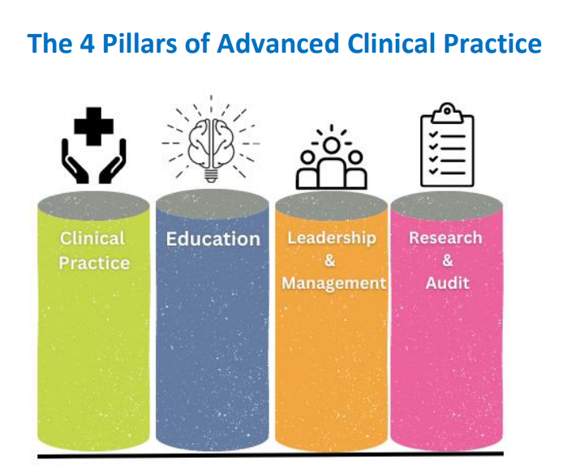
This is supported by education and governance whilst they are in a clinical role. The evidence to support this level of practice is achieved by demonstrating that they have developed in the 4 pillars of advanced practice.

Education and training provide registered practitioners with the skills and knowledge to provide excellent patient care, but more than that, supporting their education and training shows they are valued and that we are prepared to invest in their future. Retention across all professions is an issue, the lack of development opportunities is one of the main reasons cited for leaving, supporting the development of individuals will go some way to retaining our professional staff.

Impact and Quality
The impact of post registration education has been demonstrated recently during the “Future of Post Graduate Education” event, held on Friday 3rd May, where four registrants, who were previous post graduate learners spoke eloquently about the benefit that education has had on them as individuals and the patients they provide care for.

The Nursing and Midwifery Council (NMC) has also put forward recommendations on how it would like to regulate advanced practice nursing, as part of a major review. Currently there is variation in how professionals enter and undertake advanced practice roles across the UK. If the NMC develop standards of proficiency for advanced level practice this will bring UK wide consistency for this level of practice.

The current tender in development for new contracts for Advanced and enhanced practice will ensure that any regulatory changes are included in the education contracts and meet the requirements of The Professional Framework for Enhanced, Advanced and Consultant Clinical Practice in Wales.

  - Independent prescribing
Independent prescribing (IP) education represents an important area of expansion bringing direct benefit to the people of Wales. Funding for this programme has remained static for a number of years, with fee increases eroding the available number of places available.

Nurses undertaking the new NMC programmes will enter the workforce in 2023 and carry the NMC’s expectation that they will be able to:

“Apply knowledge of pharmacology to the care of people, demonstrating the ability to progress to a prescribing qualification following registration.”

These prescribing ready nurses may impact on the knowledge base of current registrants and an increase in those wanting to access independent prescribing.
The ability for Nurses and AHP’s to be able to supports:
- increased patient choice in accessing medicines,
- improved access to advice and services,
- appropriate use of skilled healthcare workforce,
- contribution to the introduction of more flexible team working across the NHS,
- increased capacity to meet demand of new ways of working and
- improvement in patient care without compromising patient safety.

HEIW is currently tendering for a framework contract to deliver new prescribing education programmes for academic year 2025-26. The framework will contain four lots:
Lot 1 - IP – Pharmacists | Blended Learning
Lot 2 – IP/SP/V300 – multi profession | Blended Learning
Lot 3 - Community Nurse Prescribers V150 | Distance Learning
Lot 4 - Community Nurse Prescribers V150 | Distance Learning
The introduction of distance learning provision is as a direct result of our engagement with service recognising that service pressures sometimes prevented multi-professional learners from attending face to face sessions.

Impact and Quality
Commissioning postgraduate education for the NHS Wales workforce enables healthcare professionals to access efficient, equitable and timely education in order to provide safe, effective and person-centred care.

The new education framework contract incorporates the well-being goals including a healthier Wales, a more equal Wales and thriving Welsh language. In addition, the new education frameworks include sustainable development principles including avoiding duplication of learning and embedding inter-professional education.

The procurement of this education provides the opportunity to embed key themes from the pre-registration contracts including compassionate leadership, quality improvement, Welsh language, digitalisation and technology and inter-professional education. In addition, it enables the inclusion of key requirements regarding the duty of quality, duty of candour and social value.

The contract will be performance managed through the quality performance framework in place, which seeks assurance on recruitment of learners, education standards and provision, learner experience, learner outcome including attrition.

  - Independent Authorisation of Blood Transfusion (IABT)
HEIW is currently tendering for a new education programme for academic year 2025-26 will enable healthcare professionals to complete a 40 credits distance learning programme at either level 6 or 7. The programme has been developed to align with the Welsh Government (2023) IABT policy which requires practitioners to pass of Higher Education Institution accredited education. The existing programme is 60 credits with delivery via blended learning. This accredited programme is unique in the UK. To date this education has been funded via the prescribing budget however as identified in last year’s ETP the new contract will require separate funding:
- There is a risk to blood authorisation services if HEIW stops funding IABT education.
- New contract anticipated Sept 2025 for 12-18 students.
- Anticipated costs based on a ceiling price of £2551.00 per student below.

Impact and Quality
The new education contract incorporates the well-being goals including a healthier Wales, a more equal Wales and thriving Welsh language. In addition, they include sustainable development principles including avoiding duplication of learning and embedding inter-professional education and demonstrate compliance with the Duty of Quality.

  - Genomic Medicine Modules
In collaboration with the Genomics education partnership education and training group HEIW has reviewed provision of this education during 2021 and 2022 and following a successful procurement exercise contracts are now in place for seven 20 credit Genomics modules. Module content is aligned with the NHSE Genomic Medicine MSc framework, and all commissioned modules will cover the relevant ethical, legal and social issues. This education will support national upskilling of existing health professionals to deliver Welsh Government’s Genomics for Precision Medicine Strategy (WG, 2017). Welsh Government’s 3-year Genomics Delivery Plan, also includes a strong commitment to:

“Develop and invest in our healthcare workforce by training and supporting them to acquire the relevant knowledge and skills so that they can deliver the benefits of genomics to their patients through improved clinical pathways and standards of care”.

and in 2020, Wales signed as a partner the UK Government’s strategy Genome UK: The Future of Healthcare. This ten-year strategy sets out the ambition for the UK to have a world-leading genomic healthcare system for the benefit of patients.

The programme now enables a wider range of professionals, across Wales to access genomics education.

  - Post Graduate Certificate Critical Care
Critical care nurses provide highly skilled, expert care for the most severely ill or injured patients, for example patients with multi-organ failure requiring advanced respiratory support. Critical care nurses undertake postgraduate study and ongoing training to deliver this highly skilled care.

Critical care nurse education supports national upskilling of existing health professionals to meet the recommendations of Welsh Government’s Task and Finish group on Critical Care (2019). They recommended critical care education and opportunities are explored to improve retention of current staff. Education for nurses working in critical care settings should meet the Guidelines for the Provision of Intensive Care Services (GPICS), Faculty of Intensive Care Medicine (FICM) and the Intensive Care Society (ICS) 2019:

“A minimum of 50% of registered nursing staff must be in possession of a post-registration academic programme in Critical Care Nursing”

“Post-registration adult intensive care nursing courses should be awarded a minimum of 60 credits at level 6. To meet the requisite standard, courses must adopt the core curriculum described in the National Standards for Critical Care Nurse Education (2016)”

The covid pandemic significantly increased the demand for critical care nursing resulting in higher rates of experienced nurses leaving together with a significant influx of new nurses. Critical care nursing vacancy rates were approximately 9% pre-covid but have subsequently increased, placing further strain on front line patient care (Critical Care National Network Nurse Leads Forum (CC3N) (2020).

Following on from a successful tendering process HEIW now has contracts in place across three universities to deliver a 60 credit Postgraduate Certificate in Critical Care which is mapped to the UK National Competency Framework for Registered Nurses in Adult Critical Care: Steps 2 and 3. The intended learners are Registered Nurses and Allied Health Professionals working in adult critical care settings in NHS Wales who can evidence they have already achieved Step 1.

The first cohort commenced September 2023. The contract will be performance managed through the quality performance framework in place, which seeks assurance on recruitment of learners, education standards and provision, learner experience, learner outcome including attrition.

  - Medical ultrasound
Clinical healthcare professionals can undertake specialist post-registration training to be able to undertake ultrasound scans. Ultrasound imaging enables healthcare professionals to see internal body structure and function in real time to make diagnoses, screen for conditions and undertake interventions. Ultrasound images are typically taken in obstetrics/gynaecology, vascular, cardiac, Musculo-skeletal and early pregnancy units by radiologists, sonographers and other appropriately trained healthcare professionals.

Ultrasound services are experiencing major growth in demand as a result of more effective clinical pathways, increasing numbers of older people, increasing cancer incidence, improved technology and new techniques. Ultrasound waiting lists across Wales are reported to be 50% higher than pre covid levels (Imaging Essential Services Group, 2021). A UK ultrasound workforce survey found increasing use of agency or locum sonographers to fill service gaps with recruitment difficulties attributed to resources for training/workplace supervision staff.

Imaging (including ultrasound) is recognised as a key component in the delivery of prudent health services to the population of Wales and a key enabler of national health delivery plans including cancer and stroke. Welsh Government specifically recognise that obstetric and doppler ultrasound services are heavily pressured and are vital to reduce stillbirth rates.

There is both a national shortage of sonographers and an increasing demand for ultrasound services to deliver diagnostics national programmes.

HEIW currently funds both 120 credit postgraduate diplomas and 60 credit postgraduate certificates HEIW pays fees and 65% salary backfill to cover 1 day study and 2 days ultrasound practice in host workplace.

HEIW is currently tendering for a new Medical Ultrasound education contract for academic year 2025-26, education will be Consortium for the Accreditation of Sonographic Education (CASE) accredited and there will be for the first-time involvement in the programme from the National Imaging Academy Wales (NIAW). Education will provide access to full scope for sonographers and focused scope e.g. Midwives undertake ultrasound imaging in obstetrics as part of GAP/GROW foetal monitoring initiatives. Education will also align with the Professional Framework for Enhanced, Advanced and Consultant Practice (HEIW, 2023).

Impact and Quality
The new education contract incorporates the well-being goals including a healthier Wales, a more equal Wales and thriving Welsh language. In addition, the contracts include sustainable development principles including avoiding duplication of learning and embedding inter-professional education and demonstrate compliance with the Duty of Quality. The contract will be performance managed through the quality performance framework in place, which seeks assurance on recruitment of learners, education standards and provision, learner experience, learner outcome including attrition.

The anticipated contract numbers are set out below with the initial costings for education fees only. Salary will require costing separately.
Education Programme | Range of Commissioning Numbers  per year
Education Programme | Minimum | Maximum
Postgraduate Certificate in Ultrasound | 3 | 6
Postgraduate Diploma in Ultrasound | 12 | 25

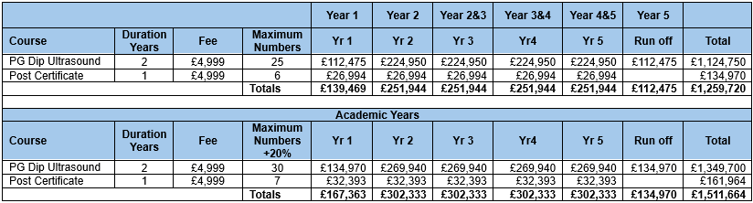

  - Reporting Radiographic Practice
Consultant radiologists as well as radiographers remain on the occupational shortage list, therefore there is a need to develop more reporting Radiographers and expand other areas of Advanced Practice in Radiography to better utilise and develop skills and support shortages across the profession.

  - Doctorate in Clinical Psychology
The Doctorate in Clinical Psychology is an employed model of training which on completion allows individuals to register as a Clinical psychologist on the Health and Care Professions Council (HCPC) register. HEIW currently has contacts in place with Cardiff and the Vale, Cardiff University and Bangor University for the delivery of this programme.

This education will support the multi-disciplinary workforce to enhance the delivery and development of psychological therapy and psychologically informed services, to meet the needs of the people of Wales. Demand is increasing across the service due to increased demand for mental health services, this has been exacerbated by the pandemic. The mental health workforce plan identifies a need to grow the workforce which delivers talking therapies and sufficient clinical psychology workforce is needed to ensure we have adequate numbers to support and supervise the introduction of new roles and extended team. Workforce data also shows that there is an ageing workforce with the risk of a third retiring within the next 5 years.

  - MSc Clinical Associate in Applied Psychology (CAAP)
CAAPs are psychology graduates who complete a 1-year level 7 MSc programme to become an applied psychologist, working under the supervision of a clinical psychologist. This is a new role in Wales and fills an identified skills gap between Assistant Psychologists (band 4 and 5) and Health and Care Professions Council (HCPC) Registered Clinical Psychologist (band 8a+). These roles are open to psychology graduates who undergo one year of training at master’s level to become part of the applied psychology workforce at pre-registration level.

In 2021 CAAPs was introduced as an emerging role, to help increase access to psychological therapies, and this role is an exciting opportunity to expand the psychological workforce. This is an employed model of training which is predominantly work based. There is a supply chain as there are a copious amount of these graduates exiting from HEI’s annually. CAAP’s are an advanced practice role which deliver psychological assessments and interventions, under the supervision of a registered practitioner psychologist. The first cohort evaluated very well, and HEIW will continue to support the embedding of this new role into practice. HEIW currently has contracts with both Cardiff and Bangor university to deliver this programme.

  - Cognitive Behaviour Therapy (CBT) Level 1 (PG Certificate) and Level 2 (PG Diploma)
CBT is a strong evidence-based psychotherapy (as per Matrics Cymru) which is a stand-alone treatment for a range of mental health and even physical disorders, ranging from; depression, anxiety disorders such as PTSD and OCD to eating disorders, psychosis related presentations and chronic pain/health conditions.

CBT BABCP level 1 education is already an embedded element in the Doctorate in Clinical Psychology. CBT can also be undertaken as standalone education to enable individuals to work as BABCP accredited CBT practitioners. The commissioning of CBT will help NHS Wales staff to develop and refine their CBT skills, empower staff to use CBT in a range of clinical situations and focus on the development of a respectful and pro-active relationship with patients. HEIW currently has contracts with both Cardiff and Bangor university to deliver this programme.

  - Clinical Photography Level 7 WBL Diploma
Clinical photographers work as part of the Medical Illustration profession and the wider healthcare team to deliver direct patient care. They record patients’ medical conditions daily through photography and videography. Clinical photographers provide photographic and video services to a range of clinical specialities, including but not exclusive to, ophthalmology, dermatology, wound healing, burns and plastics, paediatrics (including child protection cases), trauma and orthopaedics, dental, ENT, obstetrics and gynaecology.

Images taken can be used for diagnosis, for example as part of a tele-dermatology scheme, to monitor a patient’s medical condition in response to treatment, for teaching, research, publication and medico-legal purposes. Clinical photographers also use specialised equipment to produce ophthalmic, dermoscopic and 3D images.

To practice as a registered Clinical Photographer, individuals must successfully complete a minimum of 60 credits at level 7, to be eligible to join the Academy for Healthcare Science (AHCS) Medical Illustrators Register. This also enables individuals to become a Professional Member with the professional body for clinical photographers, the Institute of Medical Illustrators (IMI).

Clinical photography posts in Wales increased by 72% between 2011 to 2021. The reasons for the expansion of clinical photography in Wales has been influenced by the involvement of photography in diagnostic services, such as ophthalmology, virtual clinics, and tele-dermatology. Covid also increased the demand in clinical photography services through advances in telemedicine, enabling healthcare services to become more easily accessible.
The all Wales teledermatology service enables patient imaging to occur locally and be reviewed by dermatologists in specialist centres elsewhere in Wales and the telelids service offers a similar provision for ophthalmology. The clinical photography department in Aneurin Bevan University Health Board have adopted a clinical photography Ear, Nose and Throat (ENT) triage service with the purpose of reducing waiting lists.

These telemedicine schemes reduce waiting lists, travel time for both doctors and patients, as well as making healthcare services more accessible to patients in rural areas. Tele-dermatology has led to the recent growth of the clinical photography department in Betsi Cadwaladr UHB (March 2024) with future growth in service and staff recruitment on the horizon. The recruitment of clinical photography trainees will support the growth and delivery of these innovative services.

The Level 7 Diploma in Clinical Photography incorporates the will incorporate HEIWs priorities for the NHS workforce (below) and A Healthier Wales strategy in providing a clinical photography workforce with the “capacity, competence and confidence to meet the needs of the people of Wales”.
- Improve responsiveness to service need.
- All Wales education provision.
- Building resilience.
- Improving use of technology and digitalisation in delivery of education and care.
- Welsh language provision.
- Developing flexible routes to registration.
- Improved quality and accessibility of education and training.

This new programme is in its first year of running and, ongoing evaluation has identified improvements for the next cohort. Staff delivering the programme continue to develop assessment resources. Betsi Cadwaladr University Health Board are a new site for this training programme, and will require support with developing its assessment structures, and supporting its first trainee.

- Work Based Learning
HEIW has an annual budget from Welsh Government, as part of the education and training budget, to support the development of Health Care Support Workers (HCSWs) and integrated sector specific work-based accredited learning (work-based learning (WBL)) between Level 2 and Level 7, which encompasses a diverse range of both clinical and non-clinical roles with internal staffing infrastructure to support learning, development delivery and assessment.

The dedicated flexible funding is an established and a well-used investment that enables routes to registration/regulation via an alternative or equivalence with services increasing in awareness and use of these routes to support ‘grow your own’ (GYO )approaches. This has been anecdotally highlighted as supporting retention and succession planning.

The funding allocation for education provision for WBL is aligned to the development of education provision and national priorities with learning provision developments completed to ensure the range of pathways to enable staff progression. This results in wide curriculum availability and learning programmes aligned at local level. The focus on reducing inequalities impacts the type and content of qualifications offered, both the Integrated Medium-Term Plans (IMTPs) and separately collated information from the health boards and trusts articulate the range of requirements for funding to develop HCSW staff. Prolonged austerity has increased pressure to ‘earn as you learn’ which in turn has increased the potential need for WBL, widening available qualification requirements and increasing developmental needs.

HCSW with Wales make up 41% (2023 figure). working within nursing, Allied Health Professionals (AHPs), Healthcare Science, Facilities, Estates, administration and Primary Care. This cohort receives £2.5million of education-based funding, which equates to approximately 1% of the overall education and training budget. Workforce profiling suggests that 80% (2023 figure) of tomorrow’s NHS workforce is in post today. Supporting HCSW to develop and progress is fundamental to delivering service and maintaining staffing levels. Without continually building capacity and capability in the HCSW workforce there is the risk of being perpetually out of step with continually training and developing a workforce to address yesterdays and not tomorrow’s healthcare needs.

Table 1 provides a summary of the career framework data, that shows there is still much work to do to ensure opportunity for all staff is available to achieve qualifications at the band of employment. Figures for January 2023 – December 2023 are currently being collated.

Table 1: All Wales Data Nursing and Therapies 2015 to 2022
 | % Band 2’ s meeting Framework requirement | % point change from 2015 | % Band 3’ s meeting Framework requirement | % point change from 2015 | % Band 4’ s meeting Framework requirement | % point change from 2015
2022 | 43% | +8 | 58% | +32 | 42% | +17
2021 | 44% | +9 | 42% | +16 | 42% | +17
2020 | 51% | +16 | 47% | +21 | 42% | +17
2019 | 61% | +26 | 62% | +36 | 39% | +14
2018 | 45% | +10 | 41% | +15 | 34% | +9
2017 | 38% | +3 | 47% | +19 | 28% | +3
2016 | 31% | -4 | 39% | +13 | 20% | -5
2015 | 35% |  | 26% |  | 25%

HEIW provides funding to enable Health Boards and Trusts to employ relevant education-based staff and purchase required packages in line with submitted bids, where alternative provision is unavailable or inaccessible. The local needs vary dependent upon training availability, service delivery and staffing structures. Health boards and Trusts currently articulate a requirement for funding to develop HCSWs in the following areas:
- Primary Care
- Emergency Care
- Complex Care
- Theatres
- Therapies (dietetics, podiatry, speech and language, OT)
- Health and Social Care
- Facilities
- Estates
- A range of healthcare science sub-sectors
- Administration

HEIW also supports new models of all-Wales delivery through faculty development and enables the Health Boards and Trusts in delivering in house GYO pathways. As the range of accredited education is vast, the Health Boards and Trusts are responsible for sourcing their local/regional education availability.

HEIW aims to fund learning opportunity in areas where Apprenticeship Frameworks do not exist, or the learning provision is not available through other funding mechanisms that Further Education Institutions are able to access.

Health Boards and Trusts work in partnership with education providers to source learning once the developments have been completed on an all-Wales basis. The request for education numbers is based upon availability of education provision both accredited and non-accredited. As qualification range, availability and organisational understanding of the funding availability across all areas of work force increases, so does the expectation for funding to supporting learners career pathways.

As HEIW creates mechanisms to visualise Learning Pathways, learners and their career choice are informed more clearly, supporting recruitment and retention into service areas. Since the introduction of the Apprenticeship Levy in 2016, organisations have sought to increase the number of HCSWs undertaking apprenticeships, referenced within several of the IMTPs. However, this trend seems to be reducing within IMTP data returns since 2023. It is hoped that organisations will continue to maximise the use of apprenticeship funding, which would increase the breadth of support that could be given to organisations from the HCSW budget. HEIW has a dedicated fixed term member of staff to support developments and implementation of this work area until March 2025, and are currently working with the sector to develop models for more sustainable approaches to collaborative delivery and assessment models.

Funding returns, specifically requested in January 2023 for April 2023 funding use and January 2024 for April 2024 funding use has increased over and above the £2.5 million typically available through ETP allocation, with education requirements showing a large increase against previous years:
- 2024 – 2025 £4.6m
- 2023 - 2024 £3m
- 2022 - 2023 £2.5m

During 2023- 2024 HEIW were able to utilise L4 HE Certificate Year 1 funding to positively affect the real impact of availability of additional funds, increasing spend to £3.5m. For 2024 – 2025 there was a greater negative impact in funding potential, which is significant in terms of meeting demand and reduced funding across education, resources and staffing categories.

Apprenticeships numbers are typically collected to ascertain the volume of alternative education routes that are utilised. We have been working with the sector to enable expansion of apprenticeship frameworks, with the intention for a greater range of organisations to invest in apprentices and maximise their levy contribution. However, with the 24.7% cut in this funding across Wales we anticipate potential reduction in availability of health-based apprenticeships via the ten main contract holders and their sub-contracting affiliated education providers. This will increase the demand and pressure for in-house GYO approaches and models of delivery.

Work continues to visualise progression routes for a range of sector areas. This will enable learners to more easily plan progress between settings/roles to continue their education journey. The workforce pipeline, which starts with HCSWs, needs to be underpinned by robust education and training programmes to ensure that individuals are competent to undertake their current role whilst also allowing for career progression.

Over the next few years HEIW are committed to ensure WBL qualifications are developed at Credit and Qualification Framework (CQFW) education Levels 2 through to Level 7 to support the development of the registered and non-registered workforce. Work is also being undertaken to identify education and training gaps in the progression routes and develop appropriate solutions, such as, the development of Level 4 WBL qualifications and procurement of part-time routes to health professional registration. However, these can only be developed if funding is available to support learning delivery and assessment mechanisms.

In order to maintain currency and appropriateness of development and available education offers, HEIW will ensure continuing external relationships, and education provision influence. This is best highlighted through the Regional Skills Partnerships, Welsh Government and the Commission for Training Education and Research (CTER) relationships. This will be extremely important in constructing the future vision and centralised vision for all modes of education available in this area. Even with the introduction of the Registered Nurse Associate role there remains the need for specific specialist support worker learning and development for service delivery efficiency.

HEIW continue to engage with multiple Strategic National Programmes, identifying gaps and requirements for training between Level 2 – Level 7, with progression framework visualisation to support retention and recruitment. HEIW are collaboratively working with the NHS Wales Executive to develop competencies and support delivery of the specialist support worker workforce at level 4 in cancer care. The Suspected Cancer Pathway Workforce Recommendations identified HEIW to work with Wales Cancer Network, Health Boards and Trusts to promote national funding streams for healthcare support worker and post graduate education across cancer services, (linked to NHS Wales education commissioning process and relevant advanced practice and competency frameworks).

- Education and Training Infrastructure
  - Placement
Quality placements are key to converting investment in education and training into workforce that stay and work in the health and care system in Wales.

Our programme of placement work supports an increasing volume of students and trainees to meet the proficiency requirements of their professional programme, register on time, and contribute to a sustainable workforce in Wales. The 2024-25 HEIW Annual Placement Plan has been published across education and placement provider networks. The plan provides Universities with student allocation numbers to operationalise within particular Health Boards and wider placement providers.

    - Practice Education Facilitators (PEF)
A full-time-equivalent PEF for each Health Board PEF Team will support evidence-based increased workload related to international nursing student acculturation into practice-based learning; new interprofessional placement learning initiatives as part of HEIW national drives; support for students in practice who are not meeting required levels of proficiency (data shows significant increases in the last three years); work to facilitate nursing students’ achievement of NMC required ‘Future nurse’ skills and procedures.

PEF involvement in supporting the introduction of Registered Nurse Associates in Wales has also been identified as significant given the need for preparation of staff within Health Boards on parameters of RNA practice, development of robust practice supervision and assessment, and the development of an all-Wales Practice Assessment Document.

    - Multi-professional Practice Education (PEF)
A Multi-professional PEF hosted in each health board will support practice-based learning and educational governance for student placements across Allied Health Professions.

    - Diagnostic Radiography Practice Education Facilitator (PEF)
Diagnostic Radiography PEF roles will support practice-based learning and educational governance for student placements in Diagnostic Radiography & Imagining services across Wales.

    - Regional Primary Care Practice Education Facilitator (PEF) and Mental Health PEF Roles
Regional Primary Care PEF roles will support the continuing work on practice-based learning and educational governance for student placements in General Practice and Mental Health settings respectively across Wales.

Appendix D Education and Training Commissioning Trends
Staff Group | 2025 | 2024 | 2023 | 2022 | 2021 | 2020 | 2019 | 2018
Pre-Registration Nursing | 2531 | 2400 | 2701 | 2202 | 2202 | 1,987 | 1,911 | 1,911
Midwifery | 224 | 224 | 190 | 185 | 185 | 161 | 134 | 134
District Nurses | 85 | 65 | 80 | 80 | 80 | 80 | 80 | 80
DN (Modules) | 95 | 149 | 123 | 123 | 123 | 123 | 123 | 123
Health Visitors | 126 | 82 | 92 | 92 | 92 | 92 | 92 | 90
Health Visitors (Modules) | 20 | 22 | 30 | 30 | 30 | 30 | 30 | 30
Community psychiatric nurse (CPN) | 10 | 0 | 30 | 30 | 30 | 30 | 30 | 30
Community psychiatric nurse (CPN) (Modules) | 12 | 20 | 60 | 60 | 60 | 60 | 60 | 60
Community learning disability nurse (CLDNs) | 14
Community learning disability nurse (CLDNs) (Modules) | 12 | 0 | 10 | 10 | 10 | 0 | 10 | 10
School nurse | 43 | 30 | 30 | 30 | 30 | 19 | 19 | 19
School nurse (modules) |  |  |  |  |  | 3 | 3 | 3
Practice nurses (PN) | 20 | 10 | 30 | 30 | 30 | 20 | 20 | 20
Practice nurses (PN) (Modules) | 60 | 30 | 50 | 50 | 50 | 29 | 29 | 29
Community Children’s Nursing (CCN) (p/t) | 12 | 10 | 0 | 0 | 4 | 0 | 0 | 0
Paediatric nurses |  |  |  |  |  | 7
Community Children’s Nursing (CCN) (Modules) | 11 | 25 | 24 | 24 | 24 | 10 | 24 | 24
Occupational Therapists | 184 | 197 | 197 | 179 | 179 | 163 | 133 | 133
Physiotherapists | 180 | 180 | 180 | 174 | 174 | 164 | 147 | 147
Speech & Language Therapy | 58 | 55 | 49 | 49 | 49 | 49 | 44 | 44
Dietetics | 75 | 55 | 60 | 40 | 40 | 40 | 30 | 30
Post grad. Dietetics | 20 | 20 | 22 | 20 | 20 | 20 | 12 | 12
Podiatry | 27 | 27 | 27 | 27 | 27 | 24 | 24 | 24
Orthoptics |  |  |  |  |  | 5 | 5 | 5
Clinical Photography (new for 24-25 | 9 | 11 | 9 | 0 | 0 | 0 | 0 | 0
Medical Photography |  |  |  |  | 7 | 5 | 5 | 5
Operating Department Practitioners | 74 | 69 | 62 | 49 | 49 | 49 | 49 | 49
Surgical Care Pracs | 0 | 0 | 0 | 0 | 0 | 0 | 0 | 0
Physicians Associate | 42 | 52 | 57 | 54 | 61 | 60 | 42 | 32
Clinical Psychologists | 40 | 44 | 40 | 36 | 32 | 29 | 27 | 27
Post-reg Pharmacist Foundation | 80 | 70 | 80 | 50
Pharmacy Technicians | 100 | 80 | 100 | 80
Trainee Pharmacists (previously Pharmacists - Pre Reg) | 116 | 113 | 122 | 132 | 160 | 40 | 50 | 41
Pharmacists Dip & Techs |  |  |  |  | 77 | 99 | 85 | 75
Dental Hygienists | 30 | 30 | 30 | 33 | 18 | 18 | 18 | 18
Dental Therapists | 45 | 24 | 15 | 13 | 13 | 13 | 13 | 13
Ambulance Paramedics | 109 | 127 | 120 | 116 | 105 | 115 | 85 | 76
Diagnostic Radiographers | 131 | 125 | 140 | 140 | 166 | 140 | 112 | 112
Therapeutic Radiographers (Rad & Onc) | 20 | 18 | 20 | 26 | 26 | 22 | 20 | 20
Asst Practitioners Radiography | 15 | 10 | 10 | 12 | 12 | 12 | 12 | 12
PTP
BMS - Blood/Infection/Cellular/Genetics | 36 | 28 | 26 | 25 | 25 | 24 | 21 | 21
HE Cert in Audiological Practice | 11 | 8 | 10 | 15 | 13 | 15
Clinical Physiologists - Cardiac Physiology/Audiology/Respiratory and Sleep Science | 51 | 49 | 48 | 44 | 44 | 39 | 45 | 47
Neurophysiology | 5 | 4 | 4 | 3 | 3 | 4 | 3 | 3
Medical Radiation Techs - Nuclear Medicine & Radiotherapy Physics | 6 | 6 | 6 | 3 | 6 | 3 | 3 | 3
Clinical Engineering in Rehab | 10 | 2 | 6 | 4 | 4 | 2 | 3 | 3
Medical Engineering | 10 | 2 | 0 | 4 | 4 | 0 | 0 | 0
STP - 53
Audiology | 6 | 7 | 5 | 5 | 5 | 6 | 6 | 3
Neurophysiology | 2 | 3 | 2 | 2 | 2 | 0 | 2 | 2
Respiratory and sleep science | 5 | 7 | 6 | 2 | 2 | 1 | 3
Reconstructive Science | 1 | 1 | 1 | 1 | 0 | 0 | 1
Cardiac Science | 8 | 7 | 9 | 7 | 7 | 3 | 1 | 3
Haematology and Transfusion Science |  |  | 1 | 0 | 0 | 1
Biochemistry | 4 | 1 | 1 | 1 | 0 | 4 | 2 | 0
Cytogeneticists | 5 | 0 | 0 | 0 | 0 | 0 | 0 | 0
Medical Physics/Radiotherapy Physics/INIR/IIR | 4 | 9 | 11 | 8 | 11 | 7 | 3 | 3
Genomics | 1 | 3 | 1 | 2 | 1 | 1 | 1 | 1
Cancer Genomics | 1 | 2 | 1 | 1 | 1 | 1 | 1 | 1
Genomic Counselling | 0 | 0 | 1 | 0 | 1 | 2
Bioinformatics | 1 | 3 | 5 | 2 | 1 | 1 | 1 | 2
Tissue Typing/Immunology/Histocompatibility |  |  |  | 1 | 0 | 0 | 0 | 0
Clinical Engineering/DRMG/rehab | 4 | 4 | 5 | 4 | 3 | 2 | 1 | 2
Cellular Science/Embryology/Andrology | 3 | 0 | 2 | 0 | 1 | 1 | 2 | 0
Clinical Microbiology | 1 | 4 | 0 | 0 | 0 | 2 | 0 | 3
Clinical Pharmaceutical Science | 3 | 1 | 2 | 3
Vascular Science | 1 | 1
Histopathology | 3 | 2
HSST - 11
Life Sciences - Genetics/Genomics | 0 | 0 |  |  | 0 | 0 | 0 | 0
Microbiology/infection | 2 | 5 | 1 | 1 | 2 | 1 | 0 | 1
Life Sciences - Molecular Pathology of acquired disease |  |  |  |  | 0 | 0 | 0 | 1
Life Sciences - Clinical Biochemistry |  |  | 1 | 1
Physical Sciences and Biomedical Engineering - Medical Physics (Radiotherapy/radiation protection) | 2 | 5 | 1 | 1 | 2 | 1 | 1 | 1
Physical Sciences and Biomedical Engineering - Clinical Biomedical Engineering | 0 | 1 |  |  | 0 | 0 | 1 | 0
Bioinformatics |  |  |  | 1 | 2 | 0 | 1
Respiratory and sleep | 0 | 5
Physiological Science (Audiology/Vascular/Cardiac) | 3 | 0 | 1 | 5 | 0 | 1 | 0 | 0
Histocompatibility & Immunology | 1 | 0 | 1 |  | 0 | 3 | 1 | 0
Clinical Biochemistry
Neurophysiology | 1 | 2
Virology | 1 | 0
Vascular science and imaging | 0 | 1
Transfusion Science/Haematology | 1 | 1 | 1 | 1 | 0 | 0 | 0 | 1

Appendix E Summary of Engagement Undertaken
The development of the Education and Training Plan (ETP) is supported by the integration of robust stakeholder engagement. We have extensively engaged with HEIW staff, the NHS and our wider stakeholders, including Welsh Government, in the development of this plan

Presentations on the ETP were made to members of HEIW’s Stakeholder Reference Group (SRG), HEIW Education Commissioning Quality Committee (ECQC), HEIW Board, NHS Director Peer Group Meetings, Council of Deans and Welsh Government Policy leads.

A summary of activity is provided below:
Date of Presentation | Forum
07/06/2024 | Directors of Planning (DOP’s)
12/06/2024 | Council of Deans for Health Wales
17/06/2024 | Workforce Planning Network (WFPN)
21/06/2024 | Directors of Finance (DOFs)
27/06/2024 | HEIW Board Briefing
27/06/2024 | HEIW Stakeholder Reference Group (SRG), Welsh Government Policy Leads, Directors of Therapies, Directors of Workforce and Directors of Nursing
28/06/2024 | Chief Pharmacist Group (CPG)
05/07/2024 | Medical Directors AWMDs
09/07/2024 | NHS Chief Executives (CEMT)
09/07/2024 | HEIW Deputy Deans Group (DDG)
11/07/2024 | HEIW Education, Commissioning and Quality Committee (ECQC)
12/07/2024 | Directors of Therapies and Health Science (DOTH’s)
17/07/2024 | HEIW Executive Team
17/07/2024 | Full Welsh Partnership Forum
19/07/2024 | Directors of Workforce (WODs)
23/07/2024 | NHS Wales Leadership Board
26/07/2024 | Executive Directors of Nursing (EDONs)

There has been an increase in the audience in communicating and engaging of the Education and Training Plan for 2025-26, this has meant a wider range of feedback that is welcomed by HEIW. Throughout the process there has been positive feedback from the peer groups and NHS leadership on the level and detail of engagement and that more opportunities to maximise system working should be pursued including a focus on retention and the continued development of data and intelligence to improve workforce planning. Key themes from the engagement included concerns that commissioning recommendations are more than some IMTP submissions, which is some cases are at the minimum contract levels so commissioning below would cause contract breaches, and there is continued capacity issues for training and education in specific areas.
18 different organisations fed back on the draft plan and scenario approaches:
- British Medical Association, Wales | - Royal College of Podiatry
- Coleg Cymraeg | - Royal College of Speech and Language Therapists
- Council of Deans | - Royal Pharmaceutical Society
- Department of Health and Social Services (WG) | - Royal College of Occupational Therapists
- Institute of Biomedical Science | - Social Care Wales
- Institute of Physics and Engineering in Medicine | - Welsh Blood Service
- Llais | - HEIW
- NHS Wales Shared Service Partnership | - Cardiff and Vale
- Optometry Cymru | - Royal College of Anaesthetists
- Royal College of Midwifery | - Royal College of Nursing Wales
  - Chair of the Applied Psychologists in Health & Social Care National Specialty Advisory Group

We have captured this feedback to action within the plan as appropriate, to support our ongoing engagement with our partners and to support the development of future plans. Individual feedback will be provided to each stakeholder who submitted a written response.

Feedback Themes
We have received positive feedback on the levels of engagement on the plan. Key themes that arose for the feedback included, the improved engagement on the plan, the emphasis on the quality of placements, protecting the investment in healthcare education and training is crucial, more data, trends and system capacity needs to be included, and additional emphasis on strategies for retention and reducing attrition could be included within the plan.

The table below provides a summary of the feedback received and the action taken in response:

Strengths | Areas to Improve/Future Considerations | Actions Taken
- Engagement sessions were informative and gave an opportunity to provide feedback.  - The continued emphasis on provision of quality placements is welcomed.  - Support for contents of the plan and helpful in setting out the priorities for the year.  - The increase in Work based learning is welcome.  - Encouraging to see the future workforce coming through which will continue to address the concerns highlighted in the RCM Wales (2023) State of Maternity services.  - Recognition of the current financial challenges for Welsh Government.  - Protecting investment in healthcare education and training is crucial.  - Recommendations are clearly itemised for each discipline.  - The continued expansion of specialty training places is welcomed.  - The ambition to increase the target range for GP training places is welcome.  - The significant increase in full time courses and the introduction of part time courses for health visiting is welcome and the investment in this area should continue to help prevent ill health from the early years of life.  - Satisfaction that a whole system approach has been thoroughly considered within the plan and will help build sustainable health and social care services.  - Through implementation of the recommendations in the ETP this will improve access in the future for the people of Wales.  - The delivery of clinical placements during the undergraduate programme is not only exciting to see, but absolutely vital to develop the clinical skills of undergraduates to ensure they are prepared for clinical practice. | - Access & funding for higher qualifications for the existing Optometry workforce needs to be improved.  - Backfill of HCSW need to be considered when they become nurses.  - Consideration of Welsh Language Skills within Health Boards to develop a bilingual workforce.  - Encourage HEIW to work with the CNO to support the refocus on career structure of nursing.  - Concerns on the declining trend in adult and learning disability nursing, midwifery and some AHP programmes.  - Concerns on the number of posts for Physicians Associates via streamlining compared to the number of students in the system. Expanding placements within community social care settings is a vital agenda to increase placement capacity.  - A more detailed insight into system capacity within the plan to provide a clearer picture would be welcome.  - The use of past data and trends to forecast future needs may be useful. It would be beneficial to explicitly state the sources of these data and the statistical methods used for forecasting to enhance the credibility of the predictions.  - Additional emphasis on strategies for retention and reducing attrition could be included within the plan.  - More detailed breakdowns of the financial allocations and justifications for each sector could enhance transparency and accountability.  - Engagement between submission and approval of the ETP with stakeholders is needed.  - Future Education and Training Plans must address the imbalance of surgical training numbers and the anaesthetic training numbers. | - There are a number of requirements for education providers to deliver on this includes the more specific Welsh Language requirements.  - HEIW recognise the current financial challenges and understand the necessity of making difficult budgetary decisions.  - HEIW is committed to delivering the recommendations in the Registered Nursing Associate report and are part of the RNA Implementation Board Chaired by the Welsh Government.  - HEIW recognise the shortage of numbers applying for AHP programmes and the historical difficulties filling these programmes and are working in partnership across the health and education sectors to implement innovative solutions to address these.  - HEIW recognises the national (UK) issues with Physician Associates (PA’s). HEIW is committed to supporting students in the system and is working with Health Board colleagues to ensure that there are adequate and appropriate employment opportunities for PAs after graduation. HEIW are currently developing placements opportunities for PAs and are considering options internally.  - HEIW recognise the need to include more data within the plan and will progress this for inclusion in the next annual plan.  - HEIW will be sharing the final plan that is submitted to Welsh Government with stakeholders and peer groups.

Members of the Stakeholder Reference Group
- (BAOT) Occupational Therapy | - Directors of Therapies and Healthcare Science
- Academy for Healthcare Science (AHCS) | - Diverse Cymru
- Academy of Royal Medical Colleges | - DWOD
- Association for Respiratory Technology and Physiology (ARTP) | - Executive Directors of Primary, Community and Mental Health Peer Group
- Association of Clinical and Reproductive Scientists (ARCS) | - Health Board Chief Pharmacist
- BDA (British Dietetic Association) | - HEFCW
- Board of Community Health Councils | - Independent Board Members (HEIW)
- British Association for Music Therapy | - Institute of Biomedical Science (IBMS)
- British Association of Art Therapists | - Institute of Physics and Engineering in Medicine (IPEM)
- British Association of Drama Therapists | - Medical Deanery Lay Representatives
- British Association of Prosthetists and Orthotists (BAPO) | - Medical Directors
- British Dental Association | - Medical Schools
- British Medical Association (BMA) | - Pharmacy Schools Council
- British Psychological Society (BPS) | - Pharmacy Trainee
- British Society for Histocompatibility and Immunogenetics (BSHI) | - RCOP (Royal College of Podiatry)
- Chair - HEIW | - RCN (Royal College of Nursing)
- Chief Medical Officer | - RCOT (Royal College of Occupational Therapists)
- Chief Nursing Officer | - RCPCH (Royal College of Paediatrics and Child Health)
- Chief Operational Officer | - RCSLT (Royal College of Speech and Language Therapists)
- Chief Scientific Adviser for Health | - Royal College of General Practitioners
- Chief Therapies (Allied Health Professions) Adviser | - Royal College of Physicians
- Coleg Cymraeg Cenedlaethol | - Royal College of Surgeons Edinburgh
- College of Optometrists | - Royal Pharmaceutical Society
- College of Paramedics | - Social Care Wales
- Colleges Wales - Colegau Cymru (Merthyr) | - Society of Radiographers
- CSP (Chartered Society of Physiotherapy) | - The Association for Clinical Biochemistry and Laboratory Medicine (ACB)
- Dental Trainee | - The Council of Deans
- Deputy CEO/ Director of Workforce & OD | - Trust Chief Pharmacist
- Directors of Finance | - Wales Health Student Forum (WHSF)
- Directors of Nursing | - Welsh Council for Voluntary Action
- Directors of Planning | - Welsh Health Partnership Forum (WHPF)

Appendix F Financial Scenario Planning
Chapter 6 within the Education and Training Plan 2025-26 sets out the investment associated with the commissioning and training recommendation, which have been developed following the standard process of developing the plan.

In developing the financial plan for 2025-26 two other scenarios were modelled, a do minimum option based on the minimum contractual commissioned levels, and a maintain numbers option based on commissioning at the same numbers as agreed following the 2024-25 plan.

Scenario 1: Do Minimum
The total requirement of a Do Minimum option is £7.169m of additional funding. The table below outlines the costings of this approach:

Although the funding requirement for commissioned activity is broadly in balance there is an underlying funding requirement for a range of other commissioned activity that HEIW has undertaken in response to Ministerial priorities or actions in the National Workforce Implementation Plan, published in January 2023.

This activity has historically been funded through non-recurrent underspend against commissioning budgets. However, the flat funding settlement in 2023-24 and financial modelling based on a do minimum option would eliminate this opportunity and mean that continuing the activity would expose HEIW to an unmanageable level of financial risk. The actions are set out by theme to enable choices to be made on what can be funded or stopped.

Table 1-3 below include details of such activity and associating costings:

A number of the activities included in table 1 are in response to actions for HEIW in the National Workforce Implementation Plan

The activities in table 2 & 3 are in support of National Programmes and Ministerial priorities.

As HEIW has matured a need for additional senior capacity in specific areas has been identified to enable the Organisation to achieve and deliver on aims and objectives. Examples include digital and data and education strategy, quality, equality diversity and inclusion and other corporate enabling functions.

Impact of reducing commissioned numbers
The impact of reducing the commissioned numbers to a minimum for nurses can be quantified as a short-term reduction in investment of £3.45m by comparison to the recurrent HEIW allocation, or the avoidance of £11.3m of additional investment in Education and training. However, the additional agency costs associated with 733 fewer nurses (recommended 2,531 less minimum contract level 1,798) entering the workforce would equate to c£58.6m with c£27.8m attributable to agency premium.

Scenario 2: Maintain Commissioning Numbers

Maintaining Commissioning numbers would require an additional investment of £15.753m. This assumes that all of the activity as set out above will continue. If choices are made to stop any of this activity, then the requirement would reduce.

Appendix G Case Studies
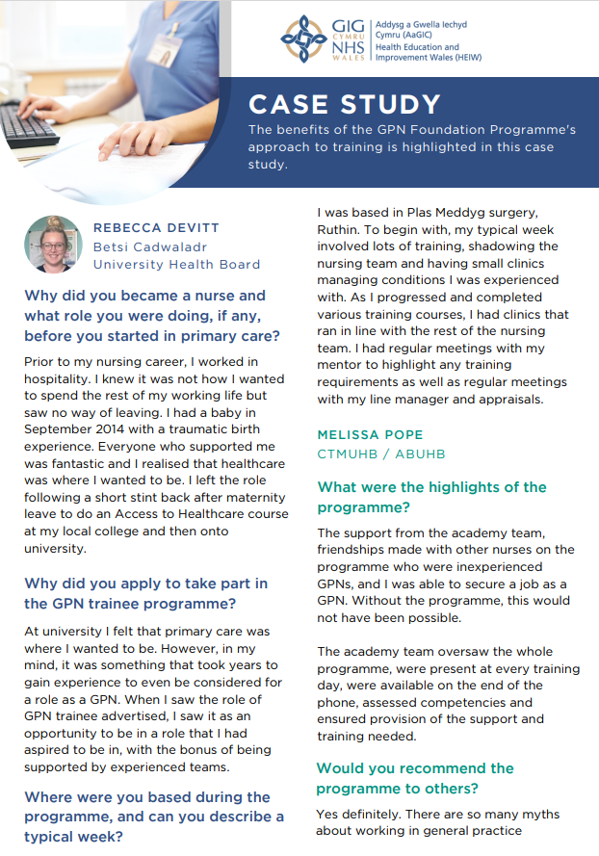

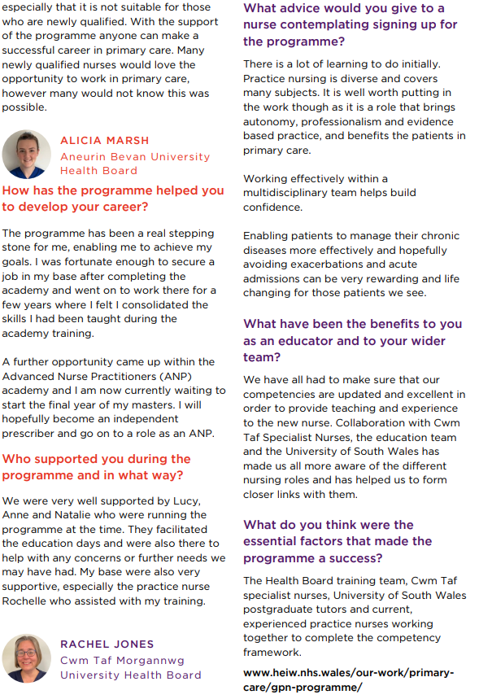

Straight-A* student to join fight against cancer after being inspired by family | Evening Standard
A teenager who lost two grandparents to cancer is on the path to helping others with the disease after her straight A* grades have seen her accepted to study nuclear medicine.
Leah Morgan, 18, achieved top A-level grades in mathematics, biology, chemistry and physics and will now take up her place at Swansea University where she will learn to work with radiation therapy.
Leah, from Bedwas, is one of a handful of learners in Wales to be awarded an NHS Bursary. This will see her tuition fees paid by NHS Wales and the Welsh Government. On completion of her degree, she is guaranteed a job in nuclear medicine.
She decided against applying for a place at Oxford due to her commitment to helping other people with cancer.
“I’d developed a love of science through school, and for the last few years I’ve wanted to work in a field that deals with cancer,” Leah said.
“My two grandparents had cancer which opened my eyes to it, before they unfortunately died.
“There’s only two places in the UK that do my course, so it’s a really niche subject. I thought about Oxford, but it wouldn’t be for the specific course I wanted to do. Nuclear medicine is really tailored to me.”
On the course she will learn to work with radiation therapy to treat cancer patients, as well as those suffering from neurological conditions.
The teenager said it was her motivation to work in the field and battle cancer that helped her bounce back from a pre-Christmas low point when coronavirus lockdowns and loneliness began affecting her grades.
“I had Covid 10 days before Christmas, so I had to isolate at a time when we were still allowed to socialise with friends before lockdown came in,” she said.
“After it did, I felt lonely, and I found my grades dropped a bit around January.
“But then my motivation kicked back in when I received my conditional offer from Swansea which showed me I could make it. I saw what grades I needed to improve and studied double hard.”

HR Magazine - Return-to-office mandates are failing worldwide, study finds
Could mismatch in desired and actual hours worked prompt early labour market exit? | CIPD
How can we improve access to healthcare careers? (universitiesuk.ac.uk)
Women live more years in ill-health than men, finds gender health gap study | Women's health | The Guardian
New report calls on UK Minister for Employment to make flexible working for the over 50s a priority | CIPD
The World of Work to 2030, Russell Beck (published by Bloomsbury, 2024)
Future of Artificial Intelligence in Health Care | Deloitte US
WEF_Future_of_Jobs_2023.pdf (weforum.org)
9 Trends That Will Shape Work in 2024 and Beyond (hbr.org)
The unsustainable is not sustained - The Health Foundation
Welsh Cancer Intelligence & Surveillance Unit (2015) Cancer in Wales: 2001-2013.
GOV.UK: Proposal to enable pharmacy technicians to supply and admister medicines using patient group directions: consultation response
Well-being of Future Generations (Wales) Act 2015 – The Future Generations Commissioner for Wales
Written Statement: Ministerial Priorities for the NHS in Wales (7 February 2023) | GOV.WALES

