
Hiu

Education and
Training Plan (ETP)
2025-26

Health Education and Improvement Wales,
the strategic workforce organisation for NHS Wales

This plan sets out our commissioning and training recommendations for the education of the health professional workforce. It is the companion plan to HEIW’s Integrated Medium Term Plan (IMTP) 2024-27.
Document History
Document Location
This document is only valid on the day it was printed.
Revision History |  |  |  |  | Distribution  This document has been distributed to:
Revision Date | Previous Revision Date | Summary of Changes | Changes Marked |  | Name/Group | Date of Issue | Version
14 June 24 | - | First Issue | No |  | Deputies and Deans Group | 04/07/2024 | First
4 July 24 |  | Second Issue | Yes |  | HEIW Stakeholder Reference Group | 21/06/2024 | Second
11 July 24 |  | Third Issue | No |  | Executive Team | 13/6/2024 | Second
19 July 24 |  | Fourth Issue | No |  | ECQC | 11/07/2024 | Third
6 Feb 25 |  | Fifth Issue | No |  | Executive Team | 17/07/2024 | Third
 |  |  |  |  | Executive Team | 24/07/2024 | Fourth
 |  |  |  |  | HEIW Board | 01/08/2024 | Fourth

Approvals
This document requires the following approvals.
Signed approval forms are filed in the Management section of the ETP planning files
Name | Signature | Title | Date of Issue | Version
Donna MacArthur |  | Chair ECQC | 04/11/2024 | 2
Dr Chris Jones |  | Chair HEIW Board | 01/08/2024 | 4

Contents
Plan on a Page 4
Executive Summary 5
Recommendations Summary Table 6
Chapter 1. Purpose and Overview 9
1.1. Purpose 9
1.2. The importance of Education and Training 9
1.3. Education and Training Commissioning Overview 10
1.4. NHS Wales Workforce Context 11
Chapter 2. Strategic Context, Engagement and Planning Approach 14
2.1. Strategic Framework 14
2.2. Stakeholder Engagement 14
2.3. Planning Approach 14
2.4. Planning Assumptions 15
2.5. Risks 15
Chapter 3. Education and Training Recommendations 17
3.1. Nursing 17
3.2. Midwifery 18
3.3. Healthcare Professionals 19
3.4. Healthcare Science 20
3.5. Medical Workforce 23
3.6. Dental 24
3.7. Pharmacy 25
3.8. Optometry 27
3.9. Primary and Community Care 29
3.9.1. Primary and Community Care Academy 29
3.9.2. General Practice Nursing 30
3.9.3. Community Nursing 31
3.10. Post-registration Health Professional Education 33
3.11. Work-based Learning 35
3.12. Education and Training Infrastructure 36
3.12.1. Wales Asylum Seeking and Refugee Doctors and Dentists (WARD) Scheme 36
3.12.2. Placements 36
3.13. Mental Health 37
Chapter 4. Supporting Multi-professional National Programmes 38
4.1. Primary and Community Care 40
4.2. Mental Health 41
4.3. Urgent and Emergency Care 42
4.4. Cancer 43
4.5. Planned Care and Recovery including Diagnostics 44
4.6. Genomics 45
Chapter 5. Implementation through our IMTP 2024-27 46
5.1. Activities Relating to Strategic Aim One - Building Our Future Workforce 47
5.2. Activities Relating to Strategic Aim Two – Developing Our Current Workforce 49
5.3. Activities Relating to Strategic Aim Three – Culture & Leadership in NHS Wales 51
Chapter 6. Financial Plan 52
6.1. Our Approach 52
6.2. Developments and Investments 52
6.3. Financial Risks and Opportunities 52
6.4. Finance Plan 52
APPENDICES 54

Plan on a Page
Education and Training Plan 2025-26 Plan on a Page
Purpose | Invest in quality education and training on behalf of NHS Wales to help build sustainable health and care services
Drivers | Strategic context and ministerial priorities, national programmes and strategic workforce plans, workforce issues, quality and safety, workforce and population profiles, increasing agency and locum spend, pandemic recovery, collaboration with partners to drive efficiency
Benefits | - A modernised workforce with extended and enhanced skills  - Quality learning and service environments to accommodate service transformation  - Access to care closer to home supporting prevention and population health |  |  |  |  |  | - Sustained growth benefitting the foundation economy  - Increased access to education across the geography of Wales  - A multi-professional workforce that use their skills in line with the prudent in practice principles
Commissioning Context 25/26 | Strategic Priorities |  |  |  |  |  | System capacity and context
Commissioning Context 25/26 | Prevention and Population Health/ National priorities |  | Innovation and Transformation |  | Sustainable Services |  |  | Placement capacity and quality | Aging workforce |  |  | National challenges in filling commissioned places for certain professions
Recommendations | - Increases across Adult, Mental health, child nursing  - Maintain Learning Disability Nursing  - Increases in community nursing  - Reduction of one in midwifery  - Maintain or make small increases across Healthcare Professional Education with a small reduction in Occupational Therapy and Doctorate level clinical Psychology  - Increase Paramedicine |  |  | - Increase in Post Registration Education  - Small decrease in Post Registration Consultant training in Healthcare sciences  - Overall increase in Healthcare sciences  - Increase Operating Department Practitioners |  |  |  | - Increase Dental Core training, maintain specialty and foundation  - Increase range for GP Training  - Maintain foundation training posts  - Increase specialty training posts  - Decrease in Physicians Associates  - Continue PG Optometry course provision  - Increases for Pharmacy |  |  | - Increases for Independent Prescribing  - Support for primary care  - Increase annual budget for Work based learning  - Increase annual funding for post-reg education
Enabled by | - Attraction, recruitment and widening access  - Retention and wellbeing of the workforce  - Addressing equality, diversity and inclusion including Welsh Language |  |  |  | - Career Frameworks and continuous professional development  - Clinical Placements and Supervision  - Enhanced, Advanced and Extended Practice |  |  |  | - Multi-professional education and training  - Simulation based learning  - HEIW’s Digital and Data strategy
Supported through | a quality management framework driving training standards (safeguarding) and continuous improvement through student and trainee feedback.
Delivered through our  IMTP 2024/27 |  | Building our  Workforce |  |  |  | Developing our Current Workforce |  |  |  | Culture and Leadership in  NHS Wales

Executive Summary
Health Education and Improvement Wales (HEIW) is the strategic workforce body for NHS Wales and is committed to the development of a highly qualified, empowered, and sustainable workforce for both now and the future.
This is the sixth HEIW Annual Education and Training Plan (ETP) for Wales developed to support the health and social care system in implementing ‘A Healthier Wales’. It dovetails with our Integrated Medium-Term Plan (IMTP) for 2024-27 and details our recommendations for training and commissioning numbers for 2025-26 within the context of system need and national priorities.
The plan aims to support NHS Wales with the wicked problems affecting health and care by taking a whole system approach that highlights the central and important role that education and training has in making effective progress to address these problems. It supports the implementation of the Workforce Strategy for Health and Social Care, the profession specific strategic workforce plans and the National Workforce Implementation Plan.
This plan represents the needs of the system, the increased demand across multiple services due to changing population needs and the move to the preventative primary and community care-based agenda.
The work within the 2024-27 IMTP supports wider system transformation including the national well-being and retention agenda, a fundamental principle in Our Workforce Strategy, helping to build compassionate cultures through effective leadership and the support for education and training.
The recommendations set out in chapter 3 build on the investment made to date recognising the national challenges in relation to filling commissioned places and specialty recruitment, the difficult financial context, retention of the workforce and the impact of an ongoing period of instability across the system. Our recommendations are set in the context of workforce as a key enabler of sustainable quality services with safety and improving patient outcomes at their core. It focuses on building sustainability across all professional groups and at every level, from early attraction, through supply into the pipeline, supporting the skills base of our existing workforce and improving retention.
Robust engagement with our stakeholders is central to the development of this plan and essential to ensure it reflects the needs of NHS Wales. Increasingly our engagement with NHS Leaders is demonstrating the collective commitment for a sustainable workforce that can deliver optimal outcomes for the population of Wales. As the strategic workforce body for NHS Wales, we recognise the fundamental foundations investment in education and training provide for our partner organisations and a prosperous Welsh Economy.
The plan is underpinned by quality and safety, there are a range of frameworks that ensure the voice of the student and trainee is consistently sought and considered to both continuously improve the quality of the education and training and maintain the safety of the education and training environment.
The recent Kings Fund publication on Productivity in The NHS and health care sector (June 2024) highlighted a number of factors behind the fall in productivity, which include higher staff sickness, higher rates of burnout, low morale and higher staff turnover rates of more experienced staff. The Plan demonstrates the importance of investing in education and training to provide an NHS workforce which can deliver improved performance and productivity.
The total funding requirement for Education Commissioning and Training for 2025-26 including the impact of various Welsh Government policy changes is calculated as £369.946m, increasing to £380.685m by 2027-28. This is a Value-Based investment which takes into account the strategic risks of NHS Wales capacity and infrastructure, achieving commissioning numbers and graduate employment to ensure the sustainability of the NHS Wales workforce.
The table overleaf gives a summary view of the recommendations with further detail in the main body of the plan. The numbers included are indicative subject to confirmation in Welsh Govt Remit / Funding Letter for 2025/26.

Recommendations Summary Table
The dashes in the table below represent either areas of work that were not commissioned in that year or commissioning number data is still being verified.
Nursing & Midwifery | 2023-2024 | 2024-2025 |  | Original  2025-2026 | Updated  2025-2026
Adult Nursing | 1892 | 1596 |  | 1714 | 1596
Child Field Nursing | 192 | 189 |  | 200 | 189
Mental Health Nursing | 530 | 461 |  | 530 | 461
Learning Disability Nursing | 87 | 87 |  | 87 | 87
Return to Practice | - | 50 |  | 50 | 50
Level 4 Education for HCSW's to access Year 2 of Nurse Training | - | 400 |  | 400 | 400
Midwifery | 190 | 224 |  | 224 | 224
Healthcare Professionals | 2023-2024 | 2024-2025 |  | Original  2025-2026 | Updated  2025-2026
Human Nutrition & Dietetics | 82 | 75 |  | 75 | 75
Occupational Therapy | 197 | 197 |  | 213 | 197
Doctorate in Clinical Psychology | 40 | 44 |  | 54 | 44
Clinical Associates in Applied Psychology (CAAPs) | - | 20 |  | 20 | 20
Paramedicine & EMT Conversion | 120 | 127 |  | 139 | 127
Physiotherapy | 180 | 180 |  | 180 | 180
Podiatry | 27 | 27 |  | 27 | 27
Speech & Language Therapy | 49 | 55 |  | 58 | 55
Healthcare Science | 2023-2024 | 2024-2025 |  | Original  2025-2026 | Updated  2025-2026
Clinical Scientist Training Programme | 53 | 55 |  | 53 | 53
Higher Specialist Training | 10 | 20 |  | 11 | 11
Equivalence Routes to Registration Funding | £0.140m | £0.400m |  | £0.4m | To be agreed*
PTP Cardiac Physiology | 23 | 23 |  | 18 | 18
PTP Audiology | 11 | 13 |  | 9 | 9
PTP Audiology (Part time) | - | 10 |  | 11 | 10
HE Certificate Audiological practice | 10 | 8 |  | 11 | 8
PTP Respiratory & sleep science | 14 | 13 |  | 11 | 11
PTP Neurophysiology | 4 | 4 |  | 7 | 7
PTP Nuclear Medicine | 6 | 3 |  | 3 | 3
PTP Pathology/Biomedical Science | 26 | 25 |  | 20 | 20
PTP Pathology/Biomedical Science (Part time) | - | 17 |  | 17 | 17
PTP Pathology/Biomedical Science (Modules) | - | 22 |  | 22 | 22
PTP Clinical Engineering | 6 | 4 |  | 6 | 4
PTP Clinical Engineering (Part time) | - | 10 |  | 8 | 8
Radiotherapy Physics | 2 | 3 |  | 3 | 3
PTP Diagnostic Radiography | 140 | 115 |  | 131 | 115
HE Certificate Radiography Assistant Practitioner | 10 | 10 |  | 10 | 10
PTP Radiotherapy and Oncology | 20 | 20 |  | 20 | 20
Operating Department Practice | 62 | 69 |  | 74 | 69
Medical Workforce | 2023-2024 | 2024-2025 |  | Original  2025-2026 | Updated  2025-2026
Foundation Training | 861 | 918 |  | 918 | 918
Secondary Care/Specialty Training | 90 | 21 |  | 42 | To be agreed*
General Practice | 160-200 | 160 |  | 200-220 | 160
Medical Associate Professions | 2023-2024 | 2024-2025 |  | Original  2025-2026 | Updated  2025-2026
Physician Associates | 54 | 52 |  | 42 | 42
Dental | 2023-2024 | 2024-2025 |  | Original  2025-2026 | Updated  2025-2026
Dental Foundation Training | 74 | 74 |  | 74 | 74
Dental Core Training Year 1 | - | 28 |  | 30 | 28
Dental Core Training Year 2 | - | 37 |  | 35 | 32
Dental Core Training Year 3 | - | 8 |  | 14 | 8
Dental Specialty Training | 38 | 38 |  | 38 | 38
Welsh Dental Therapist Foundation Training | 20 | 16 |  | 20 | 16
Diploma HE Dental Hygiene | 31 | 30 |  | 30 | 30
BSc Dental Hygiene and Therapy (3yr) | 18 | 24 |  | 30 | 24
BSc Dental Hygiene and Therapy (1yr) NEW 2025 | - | 15 |  | 15 | 15
Pharmacy | 2023-2024 | 2024-2025 |  | Original  2025-2026 | Updated  2025-2026
Pharmacy Support Staff ‘Access to Pharmacy’ | 100 Level  2 units | 100 Level  2 units |  | 50 Level  2 Units | 50 Level  2 Units
Pre-registration Pharmacy Technicians | 100 courses | 80 courses |  | 100 | 80 courses
Funded Pharmacy UG Placements | 7560 days | 11,155 days |  | 1111 students | To be agreed*
Trainee Pharmacists | 122 | 113 |  | 116 | 113
HEIW Post-registration Foundation Programme | 80 | 70 |  | 80 | 70
Independent Prescribing (Multi Professional) | 0 | 200 |  | 250 | 200
Novice Independent Prescribing Practice | - | 20 |  | 40 | 20
Enhanced, Advanced and Consultant Level Practice  Post Reg Pharmacy Technicians (Agored Level 4) | £0.460m  50 Units | £0.460m  50 Units |  | 852.5k | To be agreed*
Optometry |  |  | Original  2025-2026 |  | Updated  2025-2026
Independent Prescribing (Optometrists) |  |  | 22 |  | To be agreed*
Higher Certificate in Medical Retina (level 7) |  |  | 7 |  | To be agreed*
Professional Certificate Medical Retina (level 7) |  |  | 14 |  | To be agreed*
Higher Certificate in Glaucoma (level 7) |  |  | 7 |  | To be agreed*
Professional Certificate in Glaucoma (level 7) |  |  | 14 |  | To be agreed*
Diploma in Glaucoma |  |  | 7 |  | To be agreed*
Low Vision Certificate |  |  | 20 |  | To be agreed*
*Subject to confirmation in Welsh Govt Remit / Funding Letter

Primary and Community Care
Primary and Community Care | 2024-2025 | Original  2025-2026 | Updated  2025-2026
Primary Care Academies | £1.62m | £1.62m | To be agreed*
General Practice Nursing (GPN) Foundation Programme | 21 | 50 | 21
Adult Nursing Placement in General Practice (Pre-Registration) (New) |  | 300 | To be agreed*
Integrated Care GP Fellowship (New) |  | 14 | To be agreed*
Multi-Professional Primary and Community Care Education & Training |  | £0.100m | To be agreed*
Community Nursing |  | 2025-2026 | Updated  2025-2026
SCPHN School Nursing (Part-time) |  | 15 | To be agreed*
SCPHN School Nursing (Full-time) |  | 28 | To be agreed*
SCPHN Health Visiting (Modules) |  | 20 | To be agreed*
SCPHN Health Visiting (Full-time) |  | 95 | To be agreed*
SCPHN Health Visiting (Part-time) |  | 31 | To be agreed*
SCPHN Occupational Health (Part time) NEW 2025 |  | 6 | To be agreed*
SPQ General Practice Nursing Modules |  | 60 | To be agreed*
SPQ General Practice Nursing (Part-time) |  | 20 | To be agreed*
SPQ District Nursing Modules |  | 95 | To be agreed*
SPQ District Nursing (Part-time) |  | 85 | To be agreed*
SPQ Community Childrens Nursing Modules |  | 11 | To be agreed*
SPQ Community Childrens Nursing (Part-time) |  | 12 | To be agreed*
SPQ Community Learning Disability Nursing (CLDN) (Modules) |  | 12 | To be agreed*
SPQ Community Learning Disability Nursing (CLDN) (Part-time |  | 14 | To be agreed*
SPQ Community Mental Health Nursing (Part-time) |  | 10 | To be agreed*
SPQ Community Mental Health Nursing (modules) |  | 12 | To be agreed*
SPQ Backfill |  | £1.587m | To be agreed*
*Subject to confirmation in Welsh Govt Remit / Funding Letter

Annual Investment
Post-registration Health Professional Education | 2023-2024 | 2024-2025 |  | Original 2025-2026 |  | Updated 2025-2026
Enhanced/Advanced/ Consultant Practice Education | £2.0m | £2.1m |  | £2.1m |  | £2.1m
Independent Authorisation of Blood Transfusion (IABT) | £0.500m | £0.600m |  | £0.03m  (12 places) |  | £0.03m  (12 places)
Independent Prescribing (Nursing & AHP only) | - | - |  | £0.955m |  | To be agreed*
Community Nurse Prescribers (V150) | -
Genomic Medicine Modules | - | £0.090m |  | 100 places |  | To be agreed*
PG Certificate Critical Care | - | £0.250m |  | £0.286m |  | £0.250m
Post Graduate Certificate in Ultrasound (New) | - | - |  | 3 - 6 |  | To be agreed*
Post Graduate Diploma in Ultrasound (New) | - | - |  | 12 - 25 |  | To be agreed*
Reporting Radiography | 20 places | £0.050m |  | £0.050m |  | £0.050m
Level 7 Clinical Photography Diploma | - | 11 |  | 9 |  | 9
Work-based Learning | 2023-2024 | 2024-2025 |  | Original 2025-2026 |  | Updated 2025-2026
Work Based Learning | £2.5m | £2.5m |  | £4.6m |  | To be agreed*
Medical Education and Training Infrastructure |  |  | 2024-2025 |  | Original 2025-2026 | Updated 2025-2026
Wales Asylum Seeking and Refugee Doctors and Dentists |  |  | £0.100m |  | £0.100m | To be agreed*
Multi-professional placement support |  |  |  |  | Original 2025-2026 | Updated 2025-2026
Practice Education Facilitators (PEF) |  |  |  |  | 7 | To be agreed*
Multi-professional Practice Education (PEF) |  |  |  |  | 7 | To be agreed*
Diagnostic Radiography Practice Education Facilitator (PEF) |  |  |  |  | 3 | To be agreed*
Regional Primary Care Practice Education Facilitator (PEF) |  |  |  |  | 3 | To be agreed*
Regional Care Home Education Facilitator (CHEF) |  |  |  |  | 3 | To be agreed*
Mental Health | 2023-2024 | 2024-2025 |  | Original 2025-2026 |  | Updated 2025-2026
Mental Health | £3.370m | £2.745m |  | £2.745m |  | To be agreed*
*Subject to confirmation in Welsh Govt Remit / Funding Letter

- Purpose and Overview
This chapter sets out the purpose of the Education and Training Plan and its statutory function. It outlines the overview of the education and commissioning process and the current shape and context for the workforce in NHS Wales.
  - Purpose
The creation of the annual Education and Training Plan (ETP) is a statutory requirement for Health Education and Improvement Wales (HEIW), the purpose of which is to address workforce requirements on behalf of NHS Wales.
Engagement with NHS health boards, trusts and wider stakeholder groups including Social Care Wales is an integral part of creating and informing the plan. It is, however, ultimately HEIW’s responsibility to produce a plan that is deliverable within the context of the education and training capacity available.
HEIW’s unique contribution or “added value” is to:
- Address strategic workforce issues that require all Wales solutions, both demand and supply.
- Make Wales a great place for our health and care staff to be educated, trained and employed.
- Maximise the contribution of all professions and occupations.

The 2025-26 plan:
- Supports the strategic aims of HEIWs Integrated Medium Term Plan (IMTP) 2024-27, The Workforce Strategy for Health and Social Care and National Workforce Implementation Plan.
- Demonstrates our commitment to building a sustainable workforce at all levels.
- Sustains the growth in the training pipeline.
- Considers workforce need, challenges in the context of wider workforce intelligence, including information from NHS Wales IMTP submissions, analysis of the current workforce, horizon scanning, census data and the training pipeline.
- Recognises strategic priorities across the system including the ongoing recovery from the pandemic.
- Considers the training capacity both within Education Providers and the health and care system.
- Appreciates the need to create quality learning and service environments to accommodate new and agile ways of working, workforce upskilling, and service transformation.
- Recognises the geographical, cultural, digital, leadership and language needs of the workforce, and health and care providers.
HEIW continues to improve workforce intelligence and understanding of workforce dynamics to create the evidence base that underpins the ETP. HEIW has established the NHS Wales Workforce Observatory and Data and Analytics portal bringing together information from multiple sources to create more effective foresight of workforce supply and availability.
  - The importance of Education and Training
The Education and Training Commissioned by HEIW is on behalf of NHS Wales and recognises the crucial role effective skills play in delivery value for money, sustainable, quality services for citizens.
Continuous education and training ensure that healthcare professionals are up to date with the latest medical knowledge, techniques, and technologies, leading to improved patient outcomes. Training promotes the adoption of best practices and evidence-based medicine, reducing errors and increasing the effectiveness of treatments.
Education and training are also core to retention and morale, providing opportunities for professional development helps in retaining skilled staff by offering clear career progression paths and has a positive cost impact in terms of reduced staff turnover and sickness.
From a quality and patient experience perspective well-trained staff can perform their duties more efficiently, reducing wait times and improving patient flow.
HEIW are commissioning more education and training focused on primary and community than ever before, education on preventive healthcare practices can reduce the incidence of chronic diseases and other health issues, lowering long-term healthcare costs. Supporting this is multi-professional learning in multi-disciplinary teams to deliver better informed care for the rapidly increasing complex care needs and a changing population health profile.
With an increased focus on the education and training pipelines into NHS Wales employment, the benefit of investing in education and training will be realised through building a knowledgeable, skilled, and adaptable workforce capable of delivering high-quality, efficient, and sustainable healthcare, ensuring value for money and better health outcomes for the population.
Education to Employment: % of bursary students entering NHS Wales workforce (2023)
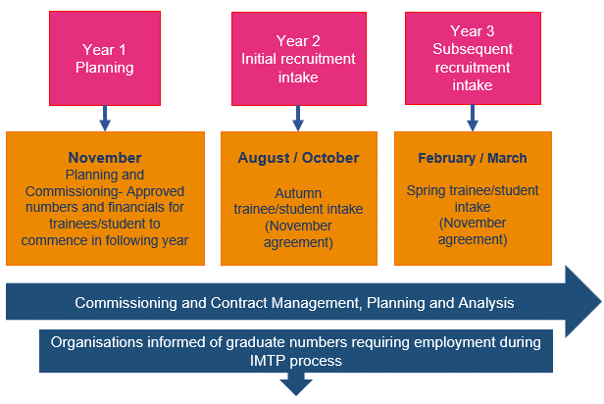
HCS – Health Care Scientists / AHP – Allied Health Professions

  - Education and Training Commissioning Overview
Commissioning of education and training places with Education Providers takes place on an annual basis. The education places that are in this plan will (with a longer lead in time for medical, pharmacy and dental trainees) be the registrant workforce of 2029. This timeline is essential given the timetables for national recruitment processes and UCAS rounds.
To inform the proposed recommendations, each NHS Wales Health Board and Trust provided their requirements in relation to the commissioning for Undergraduate Education, Post Graduate Education and Healthcare Support Workers. For medical, pharmacy and dental specialty training, a wide range of intelligence is gathered to determine the recommendations including consideration of workforce needs and challenges identified through organisations’ plans. The intelligence used to inform the education and training recommendations and requirements includes but is not limited to:
- Consideration of the current workforce challenges and trends
- Wider workforce intelligence and context from a range of sources
- The education and training infrastructure capacity within the system to support training/student/trainees
- The needs of several workforce priority areas and national work programmes
- Reflections on graduate recruitment
- Consideration of the need from new, extended, and additional skills and knowledge
- Review of education standards by professional regulatory bodies.
The recommendations within the ETP are sent for Ministerial approval in July each year. Once approved, Education Providers are informed to ensure that the appropriate number of places on their educational courses are made available. The image below outlines how the flow of training works.


  - NHS Wales Workforce Context
The supply of the future workforce is influenced by the wider workforce context. In the development of this plan, consideration was given to:
- The current workforce shape and size, and the workforce trends for preceding 10 years
- Information provided within organisations’ Integrated Medium Term Plans and Workforce Planning Questions
- Future workforce/student/trainee supply from a population perspective
- Longer term trends that could impact the future workforce.

Current Workforce and Trends
The workforce profile is changing. NHS Wales currently employs 94,663 full time equivalent staff, an increase of 19.6% since 2018. Over that time Nursing and Midwifery has increased by 10% and Medical and Dental by 25%. The age profile of our workforce is also changing, with increases in younger employees and decreases in those aged between 41 and 55. From 50+, the participation rate steadily decreases, and the twelve-month average sickness rate has risen year on year since 2018, reaching a peak of 6.7% for 2021-22. Since 2020-21 the pattern of sickness has changed, from the seasonal peak in winter months to a more unpredictable shape throughout the year.

The total cost of the total NHS Wales workforce (including agency and locum) for 2022-23 was £5.6 billion compared to £3.8 billion in 2018-19. This represents an increase of nearly 50%. Since April 2018, agency and locum spend has increased by 126%, from £144 million to just over £325 million. Nursing and Midwifery locum and agency spend and has seen a significant increase from £65 million in 2018-19 to £156 million in 2022-23.

Current Workforce Context
Organisations highlighted that recruitment continues to be challenging, with significant national shortages and longstanding gaps in specialist professional roles. Whilst many organisations are developing attraction plans, building international pipelines and considering innovative recruitment methods, all are recognising the need to retain and develop the existing workforce, reduce turnover and “growing your own” via apprenticeship routes and widening access.

In terms of key pressures and specialisms requiring the most urgent attention, the IMTPs make repeated references to:
- Improving diagnostic capabilities to meet referral demands through the development of Regional Diagnostic Centres.
- Primary and Community Care sustainability for recovery and improvement.
- Improving single cancer pathway and reducing waiting times.
- Improving clinical outcomes in circulatory diseases including stroke and heart disease.
- Reviewing and streamlining of mental health services to ensure services match increasing levels of demand, with a community focus.
- A move from acute to a community-based care model.
- Extensive delays for orthopaedic referrals & treatment.
- Increasing use of technology (including AI) to reshape professions and the shape of the workforce while recognising the digital skills gaps.

Student Recruitment
Nursing and Midwifery student recruitment has generally increased, despite a noticeable dip in 2022-23. The number of students starting these programmes is general increasing, reflecting successful student recruitment initiatives with increases in rates between commissioned, recruited and students who have started courses.

Population and Future Workforce Supply
Population data analysis highlights the following trends:
- The population of Wales is just over 3 million and grew by 2.2% since mid-2011 (compared to 7.5% in England).
- Since 1991, the population has grown by 9.0% with significant decreases in under 30 and significant increases in age 50+.
- The population in Wales is ageing, with a 19% increase in those aged 65+. The median age of the population has also increased to 42.9 in 2022 (compared to 40.5 in England).
- A decrease of 12% in those aged 16-24 and a 1.2% decrease in those aged under 16 since 2011.
- Analysis of the 18-year-old population trends indicates an increase of 18-year-olds by 2029 followed by a sharp fall by 2050.
- The dependency ratio (which compares the economically dependent population, ages 0-14 and 65+, to the economically productive population of ages 15-64) has increased from 54.9% in 2011 to 61.1% in 2022 (compared to 56.1% in England).

The latest official population projections up to 2050 (based on the 2021 population estimates), show an increase in the population of 11.2% by 2050, driven largely by immigration. This includes a fall of 7.8% in the under 16 population and a rise of 30.8% in the population aged 65+. This could lead to an increase in demand for healthcare as the population ages combined with a decline in the younger generation which may impact supply of workforce to meet the demand

Labour Market Intelligence
The labour market has suffered significant disruption in recent years, due to the pandemic and the ending of freedom of movement for EU (and British) citizens. As of December 2023, the unemployment rate in Wales was 3.6%. The rate is low, but the rate of economic inactivity is relatively high at 26% and has been increasing with noticeable increases due to long-term sickness.

There are more economically inactive women in Wales than men. There are over a million job vacancies across the UK, including 168,000 in human health and social work activities. The latest vacancy data for NHS Wales, as of December 2023, shows 5,561 full-time equivalent vacancies, with an overall vacancy rate of 5.7%.

Pensions Changes, Special Class Status and Retire and Return
Changes to the NHS Pension scheme and the State Pension age may impact retirement patterns. The last date at which remaining staff with Special Class Status, who are eligible to retire at 55, will be March 2029. Pensions changes include the McCloud Judgement which has meant an additional 7 membership categories in the 1995 scheme, a new partial retirement option for 1995 scheme members and removal of the lifetime allowance charge on paid pensions benefits which is likely to have a positive impact on retirement patterns for high earning staff.

These changes could impact retirement choices of workers and with planned changes to normal pensions age and further government reviews some of the workforce currently aged over 50 may elect to retire earlier whilst others will need to work longer. Retire and Return has increased, with seasonal pattern spikes in returns around March each year. Demand for experienced professionals will likely sustain a steady inflow of retirees returning to work.

Intergenerational Workforce and Changing Behaviours
There is an emerging body of research into intergenerational working and changing work expectations across the generations. Key themes relate to desire for flexible working and retirement with increasing numbers of people looking for work which offers flexibility in terms of the hours worked and the location of work. There are increasing numbers of Millennial and Gen Z generations entering the workforce and these generations have different expectations of work, with one common characteristic being their appetite for better work-life balance and the opportunity to work remotely for at least part of the working week.

CIPD research highlights shifting behaviours and a mismatch between the hours that people want to work, compared with the hours that they have to work, often resulting in an early exit from the labour market. This desire for flexibility is impacting the number of young people considering a career within healthcare. With a declining birth rate and fewer numbers entering the workforce, research tells us that although many young people are interested in a career in healthcare, many are being put off by the seeming lack of flexibility, perceived high workload and low pay.

Research tells us that although women live longer than men, they are experiencing more years in poor health. The health differences between women and men continue to grow with age, with women particularly susceptible to musculoskeletal problems, headache disorders and mental health problems.

Growth of Skills, AI and the Digital Agenda

The pace of change within technology is relentless, with expectation that soon, every job will have a digital component. It is anticipated that Science, Technology, Engineering and Maths (STEM) will see a significant increase in demand as the majority of new roles expected to be created by 2030 will be directly aligned to these specialist subject areas. The opportunities afforded by Artificial Intelligence (AI) across the wider healthcare system could include tasks that range from the simple to the complex - everything from answering phone calls, population health trending and analytics, therapeutic drug and device design, reading radiology images, making clinical diagnoses and treatment plans, and even talking with patients.

Deloitte’s recent paper, Generative AI and the Future of Work describes how AI is likely to drive changes in healthcare, with women most likely to be affected. This is particularly significant for NHS Wales as a female-dominated employer.

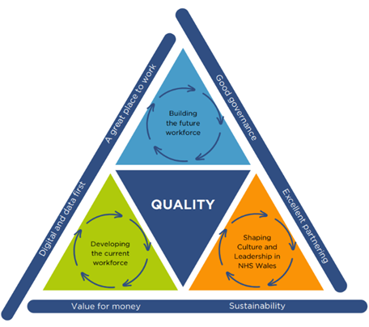
- Strategic Context, Engagement and Planning Approach
HEIW’s Three Strategic Aims
This chapter sets out the relationship between the ETP and our IMTP. We have summarised the findings of our engagement and planning approach with our wide range of stakeholders and outlined the risks to delivery.

  - Strategic Framework
Our IMTP 2024-27 sets out the strategic context in which HEIW operate and how we will support the wider system in achieving its strategic ambitions.
The ETP is a companion plan to our IMTP and key to delivering the commitments set out in The Workforce Strategy for Health and Social Care (WFS) through education, learning, leadership and workforce supply. The WFS enables the delivery of A Healthier Wales and is part of the NHS Wales planning and delivery system alongside the Well Being of Future Generations Act, National Clinical Framework and the Duty of Quality.
Our three identified strategic aims form the strategic and operating framework of the organisation.
The ETP is critical to ensure the transformation of healthcare education and training to improve opportunity, access, and population health, and is a fundamental element of shaping the future workforce supply for NHS Wales.

  - Stakeholder Engagement
Through the establishment of our Stakeholder Reference Group (SRG), we engage with over 40 different organisations on the draft ETP, and request written and verbal feedback. We present to each of the NHS Wales Executive Peer Groups and invite the Welsh Government Policy leads to join the dedicated SRG session. A summary of the engagement undertaken for the current year can be found in Appendix E.

  - Planning Approach
The ETP is produced on an annual basis and is linked to academic cycles. It provides a critical foundation for the IMTP and considers future financial profiles, given the duration of the programmes commissioned.
As in previous years a blended bottom-up/top-down planning approach has been taken to develop the ETP. The bottom-up planning includes workforce planning intelligence supplied by the Health Boards and Trusts, service developments, workforce trends, training capacity, quality of training and training pipelines. This is reviewed against workforce planning intelligence, supply and workforce modelling and population intelligence.
Validation of the findings is undertaken with stakeholders, which then inform the proposed education and training recommendations. Consideration is given to how the recommendations support the delivery of strategic programmes and national priorities. An overview of how intelligence is used to inform the ETP is provided in Appendix B. Our work to support and enable workforce training and education is outlined in Chapter 5. Below provides a summary of the formulation process.
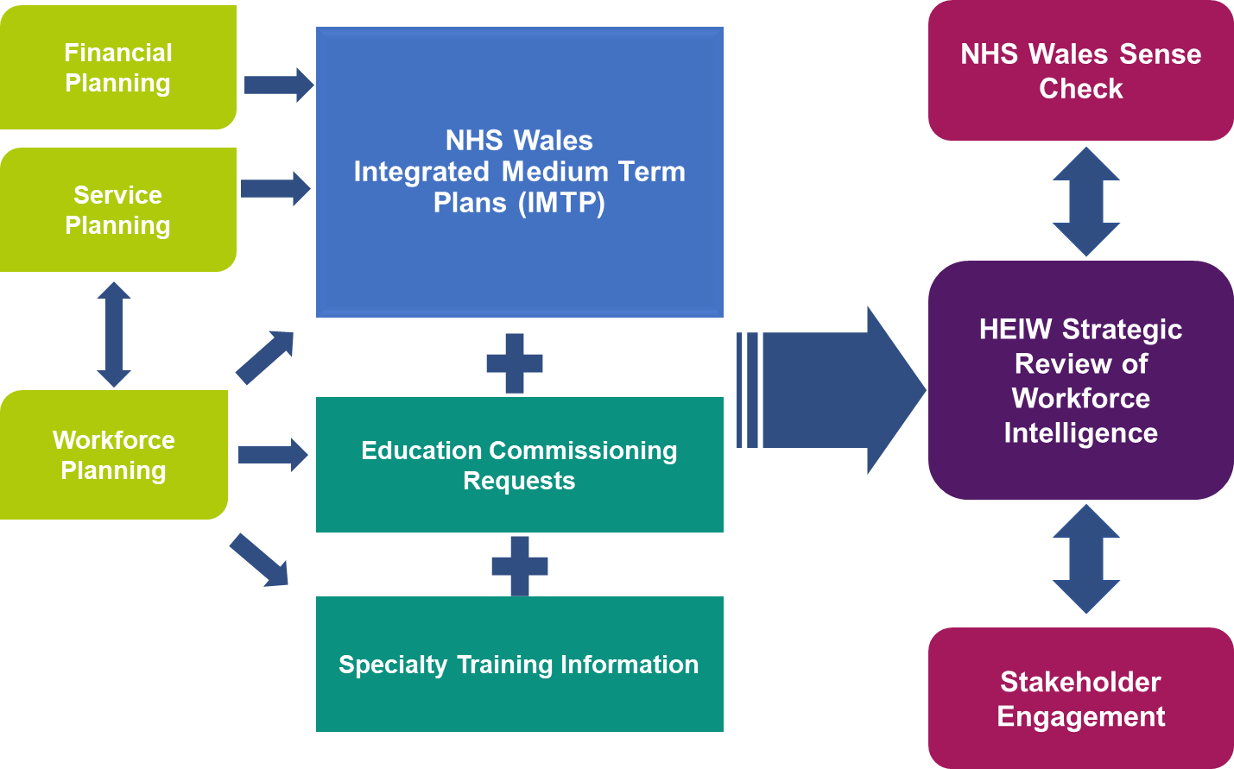
  - Planning Assumptions
There were three planning assumptions for 2025-26:
- Support transformation and strategic system need: Assessing service need and delivering workforce transformation that can alleviate service pressure and deliver new workforce models is critical to sustainable workforce supply and shape. This forms the basis of the recommendations and takes into account system capacity for education and training.
- Finance & Resources: The recommendations are developed based on system need and capacity but as part of the process HEIW work with Welsh Government on costing alternative scenarios to ensure these can be shared with stakeholders throughout the engagement process.
- Honour previous education and training plan commitments: Ensure existing students and trainees can continue through their education and training pathways as a minimum.
  - Risks
The 2025-26 plan builds on the ambitious commissioning of last years’ plan. Record numbers of students are in training in the NHS and wider health care sector in Wales.
We have identified five key external risks to delivery of our ETP:
- System Capacity and Infrastructure. The capacity of organisations to host training remains a key risk. Ensuring that there are no barriers to trainees and students receiving a safe and high-quality learning experience is vital. We are working with key partners within Education Providers and NHS Wales, as well as regulators, to build on the existing infrastructure. This involves building sustainable capacity through expansion of multi-disciplinary placement opportunities with multi-professional learning, particularly within Primary Care and Mental Health settings, development of the Practice Education Facilitator roles, simulation, and regional support roles.
- Challenging student and trainee recruitment environment. There are national challenges in filling commissioned programme places and achieving 100% recruitment to training programmes for some areas. This is a key external risk identified within our IMTP due to its potential impact on service delivery, the growth of the workforce required and under recruitment causing an underspend position. This is being mitigated through a programme of work to maximise the numbers on commissioned programmes, bespoke programmes such as Wales Enhanced Recruitment Offer.

- Graduate Employment. To ensure that Wales is championed as the place to train, work and live there must be employment opportunities for our students on graduation and Wales must be an attractive place to live and work. Mitigation focuses on collaboration with stakeholders to support graduate employment across Wales, particularly in the more rural and remote areas. The experience as a student or trainee is key in registrants making their employment decision.
- Commissioning demand not aligned to current contract arrangements. There are several areas where commissioning demand has not met the minimum contract requirements including the inbuilt 20% range. There have been specific issues this year that are being managed with NHS Wales stakeholders linked to employment for graduates. There is further risk regarding future employment opportunities for areas commissioned at minimum contract levels but more than NHS Wales organisations commissioning requests. Work is underway with stakeholders to maximise new workforce models and areas of work to ensure students and trainees funded through investment in education and training are recruited and retained in employment in Wales.
- Policy Changes. There are two policy changes that have been calculated within the recommendations, the increase in the cost of tuition fees and the change to the student bursary approach. There is a risk that should the additional cost not be provided as part of the funding envelope, commissioning and recruitment numbers will be impacted to achieve a break-even position. Ongoing communication with Welsh Government to ensure any potential impact is kept to a minimum.
- Education and Training Recommendations

This chapter sets out the commissioning and training recommendations for 2025-26. Further information relating to these recommendations can be found in Appendix C. Information relating to recruitment rates can also be found in our Integrated Performance Report within our public Board papers.

In addition to the context and factors set out in Chapters 1 and 2, these recommendations have been through a rigorous internal scrutiny process, and it is important to recognise that a range of factors have been considered when developing the recommendations.
The recommendations are focused on supporting achievable and sustained growth of the workforce. This means that there is a range of increases, static recruitment and in some cases a reduction where appropriate.
We feel that these recommendations are the optimum level for Wales for 2025-26.

  - Nursing
Requests for nursing pre-registration commissioned places have increased for 2025-26 on the back of significant increases in recent years. However, only 60% of the IMTP requests were commissioned in 2024-25 due to the following constraints:
- Current contracts
- Placement Capacity
- Applications to programme.
Nurse workforce modelling shows an increase in the pipeline of future registrants due to increased commissioning in recent years particularly for adult nursing. Staff retention is an issue across all four nursing fields, but especially in adult and mental health nursing. Participation rates drop as nurses progress through their careers with more and more working part time in the latter years of employment.
The 2025-26 recommendations for pre-registration nursing are:
Area | 2023-2024 | 2024-2025 | Original 2025-2026 | Updated 2025-2026 | Context
Adult Nursing | 1892 | 1596 | 1714 | 1596 | - An increase in adult nursing commissions was recommended. These are not to the level identified in IMTP submissions due to contract, placement and application constraints.
 |  |  |  |  | - There was a 23% increase in number of filled places in 2023-24 and therefore the ambition of maximising the number or pre-registration nurses in training was set out in the recommendation, building on the growth seen to date.
Child Field Nursing | 192 | 189 | 200 | 189 | - The original request was an increase of 11 places on 2024-25 commissions. This was against an 8.4% increase in IMTP requests to 396.
 |  |  |  |  | - Fill rate for child field in 2023-24 100%.
Mental Health Nursing | 530 | 461 | 530 | 461 | - 310 students were recruited in 2023-24, far short of the ambition. International recruitment is not possible for this field, therefore 530 is the maximum number that can be contracted. (utilising 20% above contractual range).
Learning Disability Nursing | 87 | 87 | 87 | 87 | - The fill rate for Learning Disability Nursing remains low.
 |  |  |  |  | - IMTP request have dropped for 2025-26 by 29%.
 |  |  |  |  | - The proposed recommendations were at the top end of the contractual range.
Return to Practice | N/A | 50 | 50 | 50 | - These reflect the set numbers within the contracts.
Level 4 Education for HCSW's to access Year 2 of Nurse Training | N/A | 400 | 400 | 400 | - Numbers to maintain growth of this education to ensure ongoing workforce pipeline during development of RNA route.

  - Midwifery
Commissioning requests have increased for 2025-26 recruitment. However, applications to pre-registration midwifery places slightly dropped in 2024, but recruitment is still buoyant with commissioned places continuing to be filled.
Growing the workforce in this area to ensure sufficient perinatal staff is a priority.
Constraints include:
- The contractual ranges with each university
- Meeting the placement requirements in the Southeast of Wales has been an issue in 2024 commissioning. Placement capacity for 2024 is still under negotiation and may result in a reduction of commissioning numbers for this cohort.
- 99% of midwifery student graduates were recruited into posts in Wales through the student streamlining process in 2023.

The 2025-26 recommendation for midwifery is:
Area | 2023-2024 | 2024-2025 | Original 2025-2026 | Updated 2025-2026 | Context
Midwifery | 190 | 224 | 224 | 224 | - Recommendation is at the IMTP request levels.  - Excellent student recruitment for Midwifery, placement capacity constraints may impact on recruitment  - Proposed number are 20% above the contracted range but within the threshold allowed per contract.

  - Healthcare Professionals
Each profession is considered individually in relation to the workforce need, IMTP requests and constraints to current education delivery. There are constraints for many healthcare professions in relation to placement capacity. The Placements Innovation programme is progressing with proposals to introduce 1 multi professional placement support in each Health Board organisation to support with driving up placement capacity.
The 2025-26 recommendations for healthcare professional education are:
Area | 2023-2024 | 2024-2025 | Original 2025-2026 | Updated 2025-2026 | Context
Human Nutrition & Dietetics | 82 | 75 | 75 | 75 | - There have been issues with recruitment for this profession and not all commissioned places were filled in 2023-24.  - Placement capacity has also been an issue.
Occupational Therapy | 197 | 197 | 213 | 197 | - There are good fill rates and graduate recruitment for this profession.  - Placement capacity issues have been noted.  - This is a reduction on the 2024 recommendation with a higher proportion as part time places.
Doctorate in Clinical Psychology | 40 | 44 | 54 | 44 | - Recommendations to align with the Strategic Mental Health Workforce Plan for Health and Social Care (SMHWFP).
Clinical Associates in Applied Psychology (CAAPs) | N/A | 20 | 20 | 20 | - Recommendations to align with the Strategic Mental Health Workforce Plan for Health and Social Care (SMHWFP).
Paramedicine & EMT Conversion | 120 | 127 | 139 | 127 | - There have been good fill rates for this profession with good graduate recruitment.  - Some issues have been noted with lack of posts in South Wales.  - Commissions were increased last year for North Wales, and these higher numbers will be maintained this year to recommend an overall increase.  - The split was recommended as 109 full time 30 Emergency Medicine Technician (EMT) conversion employed route.
Physiotherapy | 180 | 180 | 180 | 180 | - Good fill rates and improved graduate recruitment has been noted for this profession.  - Recommended numbers are higher than those requested via IMTP returns to avoid a boom and bust approach to commissioning ensuring a consistent pipeline for the profession.
Podiatry | 27 | 27 | 27 | 27 | - Risks of aging and shrinking workforce have been noted for this profession  Poor fill rates were recorded in 2023-24, however applications did increase for 2024-25.  - HEIW are engaging with the service and Education Providers to improved placement opportunities.
Speech & Language Therapy | 49 | 55 | 58 | 55 | - An increase in the recommendations was made for this profession to take into account the requirement for the Welsh language route.

  - Healthcare Science
Post Registration and Consultant Training
The 2025-26 recommendations for post registration and consultant training in healthcare science are:
Area | 2023-2024 | 2024-2025 | Original 2025-2026 | Updated 2025-2026 | Context
Clinical Scientist Training Programme | 53 | 55 | 53 | 53 | - Recommendations to support IMTP requests but takes into account system capacity.
Higher Specialist Training | 10 | 20 | 11 | 11 | - Recommendations to support IMTP requests but takes into account system capacity.
Equivalence Routes to Registration Funding | £140k | £400k | £400k | To be agreed* | - The profession continues to require significant investment in professional registration and regulatory examinations.
*Subject to confirmation in Welsh Govt Remit / Funding Letter

Pre-Registration
Each profession within pre-registration healthcare science is considered individually in relation to workforce need, IMTP requests and constraints to current education delivery. There are constraints for many professions in relation to placement capacity. The Placements Innovation programme is progressing with proposals to introduce 1 multi professional Practice Education Facilitator (PEF) per Health Board to support with increasing placement capacity and support. Some recommendations fall below or above contractual ranges. It is planned to negotiate numbers with HEIs as it is anticipated that overall, their commissioned numbers should fall within acceptable ranges when collated for each HEI.
The 2025-26 recommendations for pre-registration healthcare science are:
Area | 2023-2024 | 2024-2025 | Original 2025-2026 | Updated 2025-2026 | Context
PTP Cardiac Physiology | 23 | 23 | 18 | 18 | - Recommendations are below contractual range but within the 20% threshold and maintain the 2023-24 fill rates.  - There are placement constraints for this profession, including one key health board not supporting placements, but providing IMTP returns for workforce need.  - Profession starting to prefer grow your own routes as indicated on IMTP.
PTP Audiology | 11 | 13 | 9 | 9 | - Recommendations are as requested by Health Board IMTP requests.
PTP Audiology (Part time) | N/A | 10 | 11 | 10 | - Recommendations are as requested by Health Board IMTP requests.
HE Certificate Audiological practice | 10 | 8 | 11 | 8 | - Numbers are within the contractual range.  - Buoyant recruitment has been seen with placement and part time in service numbers managed by profession across Wales.
PTP Respiratory and sleep science | 14 | 13 | 11 | 11 | - Recommendations are as requested by Health Board IMTP requests.
PTP Neurophysiology | 4 | 4 | 7 | 4 | - Recommendations were due to developments with Joint Commissioning Committee (JCC) commissioning of services, and within contractual ranges.
PTP Nuclear Medicine | 6 | 3 | 3 | 3 | - Recommendations are as requested by Health Board IMTP requests and within contractual range.
PTP Pathology/Biomedical Science | 26 | 25 | 20 | 20 | - IMTP requests from health boards are below contractual range.  - 25 places were commissioned in 2024 but only 23 trainees were placed.  Recommendations support the IMTP decrease.
PTP Pathology/Biomedical Science (Part time) | N/A | 17 | 17 | 17 | - Recommendation is to maintain commissioned numbers from 2023-24, which are below contractual range but within the 20% threshold.  - 20 students are currently progressing through the level 4 apprenticeship.
PTP Pathology/Biomedical Science (Modules) | N/A | 22 | 22 | 22 | - Numbers reflect the contractual requirements.
PTP Clinical Engineering | 6 | 4 | 6 | 4 | - Original recommendations were commissioned to the number requested from Heath Board IMTP returns.
PTP Clinical Engineering (Part time) | N/A | 10 | 8 | 8 | - Access to this programme is currently being reviewed.  - Recommended numbers are below contractual range but within 20% threshold.  - Recommendation is in line with the national consortium intent to train 3.
PTP Diagnostic Radiography | 140 | 115 | 131 | 115 | - Original recommendations were within contractual ranges but reflective of the system capacity for employment.
HE Certificate Radiography Assistant Practitioner (RAP) | 10 | 10 | 10 | 10 | - Development is underway for this course and for Assistant Practitioner roles.  - Profession have confirmed that existing course will be supported to a maximum of 10.
PTP Radiotherapy and Oncology | 20 | 20 | 20 | 20 | - Recommendations commissioned to the number requested from Heath Board IMTP returns, and below contractual range but within the 20% threshold.
Operating Department Practice (ODP) | 62 | 69 | 74 | 69 | - Original recommendations were commissioned to 20% above the contractual ranges.  - There is a need to grow these roles across all areas of Wales.
PTP - Practitioner Training Programme

  - Medical Workforce
Our recommendations are to:
- Maintain foundation training positions.
- Increase range for General Practice Training.
- Increase posts across a wide range of specialties/training programmes in Secondary Care/Specialty Training.

In 2024-25 HEIW took a decision at risk to over recruit to the foundation programme in order to maximise the retention from recruitment to start dates. The recommendation represents the additional 18 places recruited in this year’s process needing a pipeline place and is correct at the time of submission.
The increase in posts created will be distributed across NHS Wales according to education and training capacity.
Less Than Full Time (LTFT) training rates continue to grow in Wales and across the UK. The flexibility agenda, to help prevent burnout and retain doctors across the NHS by providing trainees with a better work life balance and opportunities to train on a part time basis, is now a fundamental part of training. HEIW continues to work with partners and stakeholders to deliver the flexible training initiatives including LTFT training aimed at retaining the current workforce and reducing the impact of trainee burn-out and exhaustion. At the end of July 2023, 436 Specialty Trainees in secondary care placements were training LTFT, representing 25% of the trainee population. It is, therefore, of note that whilst we are seeking to increase specialty training by a further 42 training posts from August 2025, this may translate to more than 42 additional trainees entering the system.

Area | 2023-2024 | 2024-2025 | Original 2025-2026 | Updated 2025-2026 | Context
Foundation Training | 861 | 918 | 918 | 918 | - Recommendation is to maintain the current numbers within the Foundation Programme to ensure continued alignment to Medical School output and to ensure continued pipeline for the over recruitment undertaken in 2024-25.
Secondary Care/Specialty Training | 90 | 21 | 42 | 21 | - Original recommendations were to align with policies in key priority areas supporting NHS Wales to build sustainable capacity including:  - Urgent and Emergency Care  - Cancer Care which includes increases in medical oncology.  - Diagnostics and small specialties, which includes increases in pathology and infection training.  - Planned care recovery which includes a range of medical and surgical specialties  - Mental Health.
General Practice | 160-200 | 160 | 200-220 | 160 | - Original recommendations aligned to the need to supply sufficient new GPs to the workforce in Wales to replace existing GPs and make a small reduction to the large deficit of GPs currently working in Wales.

    - Medical Associate Professions (MAPs)
MAPs roles include Physician Associates (PAs), Anaesthesia Associates (AAs) and Surgical Care Practitioners (SCPs). Each role is at a very different point in terms of its implementation across NHS Wales. PAs work across a wide range of medical specialties in secondary care and in a number of practices in primary care, providing services to patients and supporting clinical staff.

Physician Associates
Physician associates support the medical workforce in the diagnosis and management of patients allowing people to receive the support they need more quickly.
This is a relatively new profession which has developed over the last 10 years. HEIW has supported in the development of new posts for this profession to allow it to grow. Historically there has been good recruitment to posts across Wales through the student streamlining processes for this profession however, in 2024 insufficient posts have been identified for graduates which is currently being escalated with Health Boards.
Area | 2023-2024 | 2024-2025 | Original 2025-2026 | Updated 2025-2026 | Context
Physician Associates | 54 | 52 | 42 | 42 | - The Health Board IMTP requests were down for this profession. This recommendation meets the minimum contract number.

  - Dental
There is significant system reform taking place in dentistry across all sectors of primary, secondary and community dental services, in parallel with work taking place in NHS dental contract reform.

There are also significant workforce shortages in all areas of Dentistry, the recently published Strategic Dental Workforce Plan for Wales acts as a companion plan to the Primary Care Workforce Plan and aims to ensure the workforce is recruited, trained, supported and available to deliver dental services for the future. This work is supported by attraction campaigns, local recruitment incentives through the Wales Enhanced Recruitment Offer (WERO) scheme to recruit to rural areas for a specified number of Dental Foundation Training places and continuing support for the Dental Nurse Training Programme.
The 2025-26 recommendations for dental are:
Area | 2023-2024 | 2024-2025 | Original 2025-2026 | Updated 2025-2026 | Context
Dental Foundation Training | 74 | 74 | 74 | 74 | - Maintain training places to 2024-25 level.  - The number of dental foundation training places is determined through the allocated funding from Welsh Government.
Dental Core Training Year 1 | N/A | 28 | 30 | 28 | - Maintain training places to 2024-25 level.
Dental Core Training Year 2 | N/A | 37 | 35 | 35 | - Maintain training places to 2024-25 level.
Dental Core Training Year 3 | N/A | 8 | 14 | 8 | - Maintain training places to 2024-25 level.
Dental Specialty Training | 38 | 38 | 38 | 38 | - Maintain training places to 2024-25 level
Welsh Dental Therapist Foundation Training | 20 | 16 | 20 | 16 | - Maintain training places to 2024-25 level
Diploma HE Dental Hygiene | 31 | 30 | 30 | 30 | - Maintain training places to 2024-25 level.
BSc Dental Hygiene and Therapy (3 year) | 18 | 24 | 30 | 24 | - Maintain training places to 2024-25 level.
BSc Dental Hygiene and Therapy (1 year) NEW 2025 | N/A | N/A | 15 | To be agreed* | - This is a conversion programme contracted to meet increase in workforce
*Subject to confirmation in Welsh Govt Remit / Funding Letter

  - Pharmacy
Our recommendations are to support the implementation of the Strategic Pharmacy Workforce Plan.
Pharmacy is midway through a series of transformation projects to deliver the new standards for the Initial Education and Training (IET) of Pharmacists. These recommendations are a key enabler to support transformation of the roles and contributions of pharmacists, pharmacy technicians and the wider pharmacy team.
Our analysis tells us these recommendations are the best way to support:
- A prudent (affordable) pharmacy skills mix.
- Resources for clinical practice, professional leadership, developing others and research.
- A workforce with multi-sector understanding.
- Pharmacy teams better positioned in multi-professional models to directly impact care.
- Public access to more consistent quality services, (STEEEP Duty of Quality).
- More pharmacy leadership on medicines use in primary and secondary care.
The 2025-26 Pharmacy recommendations are:

Area | 2023-2024 | 2024-2025 | Original 2025-2026 | Updated 2025-2026 | Context
Pharmacy Support Staff ‘Access to Pharmacy’ | 100 Level | 100 Level | 50 Level | 50 Level | - The pathway opened in 2023, taking staff with the potential for registration, but missing pre-requisite GCSES, through Key Skills so they can compete for admission to a programme leading to professional registration.
Pharmacy Support Staff ‘Access to Pharmacy’ | 2 units | 2 Units | 2 Units | 2 Units | - Commissions increased in 2024, and with the initial backlog of demand met, numbers can now be reduced to a maintenance level.
Pre-registration Pharmacy Technicians | 100 courses | 80 courses | 100 | 80 courses | - Our HEIW programme is delivered in partnership with University of East Anglia and employers.  - This commission meets demand and matches capacity for quality training placements.  - The balance of training opportunities are equally split between community and secondary care. Overall programme attrition is extremely low with 91% of starters remaining active learners.
Funded Pharmacy Undergraduate Placement (FPUPs) | 7560 days | 11,155 days | 1111 days | 1111 days | - Implementation of the planned increase was approved by Welsh Government Business Case to deliver competent pharmacist independent prescribers at the point of registration from 2026 onwards.  - Now includes students in year 2, 3 and 4 across two schools of pharmacy.
Trainee Pharmacists | 122 | 113 | 116 | 113 | - The level of multi-sector training site numbers offered by employers is 116 for 2025.  - Recommended numbers match training capacity.
HEIW Post-registration Foundation Programme | 80 | 70 | 80 | 70 | - Original recommendations supported a bridging programme to actively retain pharmacists registering before 2026 and including independent prescribing.
Independent Prescribing (Multi Professional) | 0 | 200 | 250 | 200 | - Original recommendations represented the peak of IP commissions based on expected fill rates and availability of supervisors.  - There are more commissions for primary and community contractors supporting the workforce to deliver contracted services closer to home.
Novice Independent Prescribing Practice | N/A | 20 | 40 | 20 | - New pharmacist independent prescribers have a limited scope of practice.  - This programme supports implementation of the HEIW Independent and Supplementary Prescriber standards for Competency Assurance of Non- Medical Prescribers, and better public access to medicines  - Numbers are matched to training capacity.
Enhanced, Advanced and Consultant Level Practice | £459,960.00 | £459,960.00 | 852.5k | To be agreed* | - This budget includes pharmacy technicians and pharmacists.  - A number of 2- and 3-year programmes are running their course from this budget.  - Access is maintained for transition to general practice programme, minor ailments and specialist manufacturing courses.  - Prioritisation of more modular developments will provide opportunities for more individuals and support progress with professional career development frameworks at Post-Registration Foundation, Advanced and Consultant levels.  - Requests for these developments, supporting NHS strategic priorities, will be balanced ‘in-year’ against all requests in this pharmacy budget line.
Post Reg Pharmacy Technicians  (Agored Level 4) | 50 units | 50 units |  | To be agreed* | - Historically requests remain low for this profession but may increase with professional role expansion (delivery of PGDs) and publication of a new post-registration career development framework, so access is maintained.
*Subject to confirmation in Welsh Govt Remit / Funding Letter

  - Optometry
Increasing opportunities for optometrists to deliver enhanced services as recommended in the Welsh Government paper, ‘The future approach of Optometry Services’ in 2022 and underpinned by the Optometry Contract Reforms 2023-24. Changes to regulation (Education, training review GOC 2021) demonstrates changes to education and training both in UG and PG to facilitate new ways of working clinically. Further changes will facilitate newly qualified optometrists to have additional skills and qualifications, therefore there is a need to upskill existing workforce.
Ophthalmology has the longest waiting list of any outpatient speciality, therefore, shifting services out of secondary care into primary care for those low-risk patients is a priority e.g. Glaucoma and medical retina services. Independent Prescribers will help keep onward referrals down.
Optometry contract reforms allow increased remuneration for delivering, managing and monitoring service in optometry practices. This aligns to a Healthier Wales ensuring patients are seen closer to home and kept away from hospitals. With electronic patient records optometrists and ophthalmologists can work closer together to manage patients.
The 2025-26 Optometry recommendations vary each year and are a mix of project/ infrastructure development and investment and course places to a total investment pot of £0.658m which means trending data is not comparable so is not included in the table below. As part of the investment pot, placements in optometry practices are also included so that there is a mixed model of placement opportunities for trainees undertaking higher qualifications.
The recommendations for 2025-26 are:
Area | Original 2025-2026 | Updated 2025-2026 | Context
Independent Prescribing (Optometrists) | 22 | 22 | - The Independent Prescribing pathway is now Wales wide, which enables patients to be moved from secondary to primary care.  - The aim is to recruit from all Health Boards in equal numbers for equity of patient services.
Higher certificate in Medical Retina (level 7) | 7 | 7 | - There is a stable number of specialised qualifications to ensure expertise across Wales.
Higher certificate in Medical Retina (level 7) | 7 | 7 | - Due to population demographics, BCUHB, HDUHB and ABUHB take preference for places.
Professional cert Medical Retina (level 7) | 14 | 14 | - The new Wales General Ophthalmic Service (WGOS) Medical retina pathway enables patients to be moved from secondary to primary care.  - Qualifications are commissioned across all Heath Boards and assigned to clusters with small numbers of optometrists with the qualification.  - Due to population demographics, BCUHB, HDUHB and ABUHB take preference for places
Higher Certificate in Glaucoma (level 7) | 7 | 7 | - There are a stable number of specialised qualifications to ensure expertise across Wales.
Higher Certificate in Glaucoma (level 7) | 7 | 7 | - Due to population demographics, BCUHB, HDUHB and ABUHB take preference for places.
Professional Certificate in Glaucoma (level 7) | 14 | 14 | - There are a stable number of specialised qualifications to ensure expertise across Wales.  - Due to population demographics, BCUHB, HDUHB and ABUHB take preference for places.
Diploma in Glaucoma | 7 | 7 | - There are a stable number of specialised qualifications to ensure expertise across Wales.  - Due to population demographics, BCUHB, HDUHB and ABUHB take preference for places.
Low Vision Certificate | 20 | 20 | - This service has been expanded to allow for an increase in numbers of practices that can offer Low Vision services.

  - Primary and Community Care
Delivery of the Primary Care Model for Wales requires transformation of clinical services providing care closer to home and a skilled workforce. Development of a multi-professional workforce with the right skills to deliver care at the right time in the right place prudently is complex. Empowering our workforce to deliver excellence in healthcare requires co-ordinated development of programmes that develop those new to primary care, embedding of new roles in primary care, professional development to maintain and develop new skills, work in multi-professional teams and train the future workforce. This is all underpinned by the Duty of Quality, Sustainability, Equality, Diversity and Inclusion, educator development, and the Welsh language. HEIW Central Unit are working closely with the Strategic Programme for Primary Care on a number of workstreams including actions in the Strategic Workforce Plan for Primary Care

    - Primary and Community Care Academy
During 2022-24 HEIW invested in a sustainable infrastructure a small, central HEIW Multi Professional Primary and Community Care Education & Training Unit and Health Board Primary and Community Care (PaCC) Academies; working alongside existing Deaneries to support Primary and Community Care and the development of the Primary Care Model for Wales (PCMW). Led by the HEIW central unit, this has formed the Primary and Community Care Academy Network who are working with HB colleagues to co-ordinate the education and training offer to ensure innovative practice is shared and skills to meet population health priorities are being developed. At full maturity, the network will be an important enabler to prudent workforce development, workforce planning, and communication and engagement with the primary and community care workforce.
Area | 2023-2024 | 2024-2025 | Original 2025-2026 | Updated 2025-2026 | Delivery
Primary and Community Care Academy | 1.62m | 1.62m | 1.62m | To be agreed* | Programme Delivery  - General Practice Nurse Foundation Programme  - Integrated Care GP Fellowship  Programme Development:  - Nursing Student placements in general practice  - Primary Care Multi-Professional Musculoskeletal Competency Framework  - Independent & Supplementary Prescriber Peer Support  - Urgent Care Practitioner Competency Framework  - Educator Development  - Practice Manager Development  Health Board Academy Development  - Integration with existing education and training teams  - Understanding the needs of the workforce and services  - Facilitating local delivery of education and training to meet local needs
*Subject to confirmation in Welsh Govt Remit / Funding Letter

    - General Practice Nursing
More than 50% of the General Practice Nursing (GPN) workforce is over 50. With an ageing population living with long term conditions and increased complexity of care needed, a well-trained GPN workforce able to provide evidence based high quality care in communities is essential.
Foundation training supports acquisition of enhanced skills by experienced nurses to work at the top of their license providing prudent care closer to home, optimising management of long-term conditions to support planned care recovery, multiprofessional working and career development including development of practice nurse supervisor and leadership roles across health boards.
Investment in attracting nurses to general practice is essential to nursing workforce retention, delivery of care closer to home, prudent healthcare and multi-professional working.
Development of GP portfolio roles help to retain GPs in Wales following qualification, supporting care closer to home where enhanced skills are used within general medical services, as well as supporting wider access to services. Portfolio roles support GPs to increase their contribution to the wider system.

Area | 2023-2024 | 2024-2025 | Original 2025-2026 | Updated 2025-2026 | Context
General Practice Nursing (GPN) Foundation Programme | - | 21 | 50 | 21 | - Strategic Workforce Plan for Primary Care (SWPPC) actions are to expand capacity and number of educators in primary care.  - This programme requires the nurse to be employed in general practice which supports attraction, recruitment and retention.  - There is a need to attract to general practice nursing from registration.  - Retention of workforce no longer wanting to work in secondary care through this transition programme.  - Workforce supply for enhanced and advanced scope of practice bringing care closer to home.
Adult Nursing Placement in General Practice (Pre-Registration) (New) | - | - | 300 | To be agreed* | - This reflects the expansion of capacity and opportunity for nursing students to gain experience of general practice nursing.  - SWPPC actions are to expand training capacity and number of educators in primary care.  - There is a need to attract nurses to careers in primary and community care.
Integrated Care GP Fellowship (New) | - | - | 14 | To be agreed* | - This is integrated holistic care that is provided by GPs closer to home.  - Allows GPs to work to the top of license.  - Also allows for the development of portfolio careers to support GP retention and WTE working.
Multi-Professional Primary and Community Care Education & Training | - | - | 100k | To be agreed* | - The central unit continue to innovate through workstreams including independent and supplementary prescriber support network, primary care multi-professional musculoskeletal capability framework, primary care advanced clinical practice competency framework digitisation, practice manager development programme, urgent care practitioner competency framework and educator development programme.  - Funding is required to pilot, evaluate and scale these projects where they are not at a stage to be included as single items in the ETP due gap between development of the ETP and delivery of the plan.  - This fund allows for flexible innovation at pace taken through the primary care governance structure
*Subject to confirmation in Welsh Govt Remit / Funding Letter

    - Community Nursing
The community nurse recommendations are to increase the level of funding for community nursing for 2025-26 to aid the facilitation and implementation of :
- Welsh Government (WG) A Healthier Wales: long term plan for health and social care (WG, 2021).
- Welsh Government plan for community nursing care in Wales move towards a 24/7 system
- Science Evidence Advice (SEA) NHS in 10+ years: An examination of the projected impact of Long-Term Conditions and Risk Factors in Wales (WG, 2023)
It is acknowledged that the realisation of these plans requires additional capacity in general practice and community care nursing services.
2025 will see the introduction of Community Nursing Education Programmes that are not currently commissioned including:
- Community Learning Disability Nursing Specialist Practice Qualification (SPQ),
- Community Mental Health Nursing SPQ
- Occupational Health Specialist Community Public Health Nurses (SCPHN).
These programmes will not only support the transforming of the workforce but will also ensure that there are the right people in the right place with the right skills to be able to ensure a Healthier Wales and provide a structured career development path for registered nurses who wish to pursue career development within these specialist fields.
SPQ Backfill
HEIW provides salary backfill for students who undertake a SCPHN programme but not for students who undertake a SPQ programme. To encourage applications into community nursing and to ensure parity with SCPHN students a pilot programme has been established to provide salary backfill covering all fields of the SPQ for a cohort of students that commenced in autumn 2025.
Area | Original 2025-2026 | Updated 2025-2026 | IMTP Requests | Context
SCPHN School Nursing (Part-time) | 15 | 15 | 15 | - These recommendations reflect an increase from 2024-25 due to political strategic drivers and demand from Health Boards IMTP submissions.  - The first phase of the Welsh Government (WG) Flying Start expansion, started in September 2022. This includes an enhanced health visitor (HV) support requiring an increased workforce of HV’s. Roll out is ongoing
SCPHN School Nursing (Full-time) | 28 | 28 | 32
SCPHN Health Visiting (Modules) | 20 | 20 | 5
SCPHN Health Visiting (Full-time) | 95 | 95
SCPHN Health Visiting (Part-time) | 31 | 31 | 15
SCPHN Occupational Health (Part time) NEW 2025 | 6 | 6 | N/A | - This is a new programme that was identified as a requirement via stakeholder engagement and political drivers.
SPQ General Practice Nursing (Modules) | 60 | 60 | 81 | - These recommendations reflect an increase from 2024-25 due to political strategic drivers and demand from Health Boards IMTP submissions.
SPQ General Practice Nursing (Part-time) | 20 | 20 | 42
SPQ District Nursing (Modules) | 95 | 95 | 86
SPQ District Nursing (Part-time) | 85 | 85 | 105
SPQ Community Childrens Nursing (Modules) | 11 | 11 | 11
SPQ Community Childrens Nursing (Part-time) | 12 | 12 | 9
SPQ Community Learning Disability Nursing (CLDN) (Modules) | 12 | 12 | 14 | - This is a new programme that was identified as a requirement via stakeholder engagement and political drivers.
SPQ Community Learning Disability Nursing (CLDN) (Part-time | 14 | 14 | N/A
SPQ Community Mental Health Nursing (Part-time) | 10 | 10 | N/A
SPQ Community Mental Health Nursing (modules) | 12 | 12 | 11
SPQ Backfill | 1.587m | 1.587m | To be agreed* | - This is in support of salary backfill for Sept 2025 – April 2026
SCPHN - Specialist Community Public Health Nurses
SPQ - Specialist Practice Qualification
*Subject to confirmation in Welsh Govt Remit / Funding Letter

  - Post-registration Health Professional Education
Our recommendation is to increase the annual funding for post-registration education to ensure that there continues to be sufficient resource to support the development of the workforce, the development of consultant practice and to support the delivery of the Enhanced, Advanced and Consultant Practice Framework.
Post-registration education is key to the development of specialist practice and in supporting the national priorities as part of the national programmes and delivering on the vision set out in A Healthier Wales in terms of transforming services for the Welsh population.
The post-registration health professional education recommendations for 2025-26 are:
Area | 2023-2024 | 2024-2025 | Original 2025-2026 | Updated 2025-2026 | Context
Enhanced/Advanced/ Consultant Practice Education | £2 0m | £2.1m | £2.1m | To be agreed* | - The recommendation to maintain funding supports workforce development linked to retention and working at the top of licencing for effective multi-disciplinary team working.
Independent Authorisation of Blood Transfusion (IABT) | £500k | £600k | £30k  (12 places) | To be agreed* | - There is a risk to blood authorisation services if HEIW stops funding IABT education.  - New contracts are anticipated from September 2025 for 12-18 students.
Independent Prescribing (Nursing & AHP only) | £500k | £600k | £955k | To be agreed* | - These recommendations reflect an increase from 2024-25 due to political strategic drivers and demand from Health Boards IMPT submissions.  - New contracts will be in place from September 2025.  - New contract fees will be more than current fee arrangement as it is well below current market benchmark.
Genomic Medicine Modules | - | £90k | 100 places | To be agreed* | - This education will support national upskilling of existing health professionals to deliver Welsh Government’s Genomics for Precision Medicine Strategy (WG, 2017). Welsh Government’s 3-year Genomics Delivery Plan.  - Strategic driver planned care, cancer and diagnostics services
PG Certificate Critical Care (New contract) | - | £250K | £286k | To be agreed* | - Strategic drivers include:  - Guidelines for the Provision of Intensive Care Services (GPICS), Faculty of Intensive Care Medicine (FICM) and the Intensive Care Society (ICS) 2019  - UK National Competency Framework for Registered Nurses in Adult Critical Care
Post Graduate Certificate in Ultrasound (New 2025) | N/A | N/A | Min 3 -Max 6 | To be agreed* | - New contracts will run from 2025.  - There is both a national shortage of sonographers and an increasing demand for ultrasound services to deliver diagnostics national programmes.
Post Graduate Diploma in Ultrasound (New 2025) | N/A | N/A | Min 12 -Max 25 | To be agreed* | - Initial recommendations to commission the maximum numbers for the PG certificate and commission 16 for PG Diploma.
Reporting Radiography | 20 places | £50k | £50K | To be agreed* | - Maintain numbers at the same level as for 2024-25.  - Consultant radiologists as well as radiographers remain on the occupational shortage list,  - Strategic drivers include, planned care, cancer and diagnostics services
Level 7 Clinical Photography Diploma | - | 11 | 9 | To be agreed* | - This new programme is in its first year of running and ongoing evaluation has identified improvements for the next cohort.  - Staff delivering the programme continue to develop assessment resources.  - Betsi Cadwaladr UHB are a new site for this training programme, and will require support with developing its assessment structures, and supporting its first trainee.
*Subject to confirmation in Welsh Govt Remit / Funding Letter

  - Work-based Learning
HEIW has an annual budget from Welsh Government, as part of the education and training budget, to support the development of Health Care Support Workers (HCSWs) and integrated sector specific work-based accredited learning (work-based learning (WBL)) between Level 2 and Level 7, which encompasses a diverse range of both clinical and non-clinical roles with internal staffing infrastructure to support learning, development delivery and assessment.
The funding allocation for WBL education provision is aligned to the development of education provision to ensure the range of pathways to enable staff progression. This results in wide curriculum availability and learning programmes aligned at local level. The focus on reducing inequalities impacts the type and content of qualifications offered, both the Integrated Medium-Term Plans (IMTPs) and separately collated information from the health boards and trusts articulate the range of requirements for funding to develop HCSW staff. Prolonged austerity has increased pressure to ‘earn as you learn’ which in turn has increased the potential need for WBL, widening available qualification requirements and increasing developmental needs.
There is an urgent need to develop and invest in clinical and non-clinical HCSWs working in primary, community and hospital services. Many of the current HCSW workforce have the knowledge, skills, values and behaviours to undertake higher-level programmes with minimal extra support. Anecdotal evidence would suggest that these individuals are more likely to stay with their local Health Board/Trust employer if invested in.
The scope of the funding required includes Work Based Learning (WBL) qualifications and learning programmes (not included in Apprenticeship Frameworks), standalone units for clinical induction and CPD for staff development; and infrastructure costs to support the delivery and assessment of WBL. Reduction in apprenticeship funding means that some qualifications may need to have all-Wales delivery models designed and implemented to facilitate learning programme availability if WG contract holder providers decide not to offer apprenticeship learning programmes. This is currently outside of HEIW scope and remit. To support availability HEIW are working on innovative approaches for pilot models to support GYO and framework pathways, but all these require increased investment in staffing and / or local education provision purchasing.

The recommendation for WBL 2025-26 is:
Area | 2023-2024 | 2024-2025 | Original 2025-2026 | Updated 2025-2026 | Context
Work Based Learning | £2.5m | £2.5m | £4.6m | To be agreed* | • The initial recommendation reflected an increase in investment for Education and the administration of training, to support a range of upskilling for a range of service delivery staff and invest in the wellbeing education for staff and service users in line with Welsh Government National Priorities.
*Subject to confirmation in Welsh Govt Remit / Funding Letter

  - Education and Training Infrastructure
    - Wales Asylum Seeking and Refugee Doctors and Dentists (WARD) Scheme
As a Nation of Sanctuary, Wales has a long history of welcoming asylum seekers and refugees. The WARD initiative has been running since 2002, with the aim of providing proactive support to asylum seeker and refugee doctors and dentists. This includes help with English language tuition and financial support for language tests, securing registration with a licence to practice with the GMC/GDC, and, if required, a short-term job placement in the NHS to help individuals to be job ready. Since its inception, the WARD scheme has supported 300 asylum seeker and refugee doctors and dentists to settle and find long term employment, the majority of which have settled in Wales.
Area | 2023-2024 | 2024-2025 | Original 2025-2026 | Updated 2025-2026 | Context
Wales Asylum Seeking and Refugee Doctors and Dentists (WARD) Scheme | NA | 100k | 100k | To be agreed* | - Maintained support for the WARD scheme to ensure opportunities for qualified professionals into Wales.
*Subject to confirmation in Welsh Govt Remit / Funding Letter

    - Placements
Quality placements are key to converting investment in education and training into workforce that stay and work in the health and care system in Wales.
Our programme of placement work supports an increasing volume of students and trainees to meet the proficiency requirements of their professional programme, register on time, and contribute to a sustainable workforce in Wales. The 2024-25 HEIW Annual Placement Plan has been published across education and placement provider networks. The plan provides Universities with student allocation numbers to operationalise within particular Health Boards and wider placement providers.
The 2025-26 recommendations build on our existing investment in multi-professional placement support in each health board with a wider remit that can support the move to multi-disciplinary teams through multi-professional learning.

Area | Original 2025-2026 | Updated 2025-2026 | Context
Practice Education Facilitators (PEF) | 7 | To be agreed* | - Numbers reflect 1 full-time-equivalent for each Health Board PEF Team to support evidence-based increased workload related to international nursing student acculturation into practice-based learning; new interprofessional placement learning initiatives as part of HEIW national drives.
Multi-professional Practice Education (PEF) | 7 | To be agreed* | - Numbers reflect a Multi-professional Practice Education Facilitators hosted in each health board to support practice-based learning and educational governance for student placements across Allied Health Professions.
Diagnostic Radiography Practice Education Facilitator (PEF) | 3 | To be agreed* | - These roles are to support practice-based learning and educational governance for student placements in Diagnostic Radiography & Imagining services across Wales.
Regional Primary Care Practice Education Facilitator (PEF) | 3 | To be agreed* | - These roles are to support the continuing work on practice-based learning and educational governance for student placements in General Practice settings across Wales.
Regional Care Home Education Facilitator (CHEF) | 3 | To be agreed* | - These roles are to reinstate work on practice-based learning and educational governance for student placements in care home settings across Wales.
*Subject to confirmation in Welsh Govt Remit / Funding Letter

  - Mental Health
The strategic mental health workforce plan (SMHWFP) (is a 10-year plan that gives a huge opportunity to strengthen a seamless mental health system bringing together multi-professional and multi-agency teams through person centred mental health services. The plan is set against the backdrop of an anticipated threefold increase in the demand for mental health services in the next four years. There is an average life expectancy reduction of 15 years for someone with severe mental health, the importance of well-being, prevention and tackling mental ill health is highlighted in Prosperity for All as having the greatest potential contribution to Wales’s long-term prosperity and well-being. The annual funding agreed by Welsh Government supports the phased implementation work of the Mental Health Programme.

The 2025-26 recommendation for mental health is:
Area | 2023-24 | 2024-2025 | Original 2025-2026 | Updated 2025-2026 | Context
Mental Health | £3.370m | £2.75 | £2.745m | To be agreed* | - The funding is part of a Welsh Government package approved via the Mental Health Workforce Plan.
*Subject to confirmation in Welsh Govt Remit / Funding Letter

- Supporting Multi-professional National Programmes
Our IMTP 2024-27 sets out the contribution we will make to supporting multi-professional programmes. This chapter describes the contribution of education and training to supporting the delivery of national programmes with the associated benefits for the workforce.

 | Primary & Community Care | Mental Health | Urgent & Emergency Care | Cancer | Planned Care | Diagnostics | Genomics
Deliverables  2024-25 | - Launch and begin implementation of the Strategic Workforce Plan for Primary Care in partnership with the Strategic Programme for Primary and Community Care | - Complete Year 2 implementation of the strategic workforce plan for Mental Health in partnership with Social Care Wales and the Mental Health Implementation Board | - Continue to support delivery of the National Six Goals Programme for Urgent and Emergency Care with a focus on Same Day Emergency Care (SDEC), preventing deconditioning, frailty and the ED Quality Statement. | - Implement a coordinated set of workforce actions to support recovery for the national cancer programme | - Implement a coordinated set of workforce actions to support recovery and workforce modernisation for planned care | - Implement a coordinated set of workforce actions to support recovery for diagnostics. | - Launch and begin implementation of the Strategic Workforce Plan for Genomics to provide a clear and comprehensive roadmap to address the workforce challenges as a result of genomic advances over the next few years.
Milestones 2024-25 | - Launched the first Accelerated Cluster Development Leadership Programme for Pan Cluster Planning Group (PCPG) representatives.  - Improved the Gwella Collaborative pages and developed further resource materials available via Gwella.  - Launched an All-Wales GP Integrated Care Fellowship programme (as part of the GMS sustainability actions and delivered by the multi-professional education unit).  - Launched the Primary Care Compendium. | - Year 1 Implementation commenced and progressing to plan.  - Time limited task and finish groups are in place to drive specific actions.  - Publish a half yearly review of year one implementation progress.  - Host a series of regional and national events to support implementation at local level. | - Pilot and evaluate the All-Wales Urgent Care Practitioner Competency Framework.  - Develop a Same Day Emergency Care (SDEC) workforce plan to ensure appropriate skill mix for an expanding service model.  - Improving culture and leadership across the UEC system  - Develop an ED workforce dashboard  - Improve awareness of hospital acquired deconditioning  - UEC demand and capacity modelling  - Improved understanding of the 'frail population' across the UEC system  - Quality assurance of training placements across the UEC system  - Ensuring doctors in training pipeline is appropriate  - Continue to support emerging priorities of the National Six Goals Programme. | - Review workforce size and shape across the provision of specialist cancer nursing in NHS Wales.  - Education provision gaps mapped to ACCEND learning outcomes and recommendations made with Wales Cancer Network (WCN) to ensure continued development of the workforce  - Develop a UK wide cancer career and development programme for nurses and AHPs working in cancer care.  - Review of the Gynaecological Cancer Workforce including current position, gaps and future training and education need to inform the ETP. | - An assessment of the current theatre workforce position across Wales identifying gaps, challenges, constraints, and opportunities.  - The development of a peri-operative workforce guide including a multi-professional career development framework  - An enhanced education offer for peri-operative staff (post-registration)  - An assessment of the potential for accelerated adoption of workforce models that support prudent use of skills including Medical Associate Professions (MAPs) roles.  - Development of a national Palliative and End of Life competency Framework for specialist and generalist staff across NHS Wales, social care and independent/ third sector organisations. | - In partnership with the National pathology programme, support the development of a virtual Pathology academy hosted by Y Ty Dysgu.  - Address the inconsistencies with Job roles/descriptions across diagnostics and identify potential innovative new roles.  - Assess the impact of regional working on future diagnostic workforce requirements.  - Develop a demand model that will support longer term projections for the development of the diagnostics workforce over a 5-year period. | - In partnership with Genomics Partnership Wales (GPW), finalise, seek approval, and launch the workforce plan  - Begin implementation of the plan by progressing year 1 actions and ensuring Year 2 actions are built into IMTP 25/26.  - Develop a benefits framework and undertake baselining for evaluation and benefits management.  - Continue to embed learning to improve 'genomic literacy' amongst the wider (non-specialist) workforce.
Outcomes  2026 | - A funded, sustainable all Wales coordinated infrastructure designed to meet the educational needs of the primary and community care workforce. | - A sustainable mental health workforce that has the expertise to support the population with their mental health and wellbeing needs following the pandemic. | - Modern, multi-professional urgent and emergency care workforce models, that use their skills in line with the prudent in practice principles. | - A sustainable workforce ensuring cancer patients across Wales have access to high quality, timely treatment from an appropriately skilled and robust workforce. | - A modernised and appropriately skilled NHS Wales planned care workforce to support the recovery priorities. | - A modernised NHS Wales Diagnostics workforce to support the recovery priorities. | - A robust specialist workforce and a wider workforce with sufficient ‘genomic literacy’ to ensure that genomics can be effectively mainstreamed into service delivery.

  - Primary and Community Care
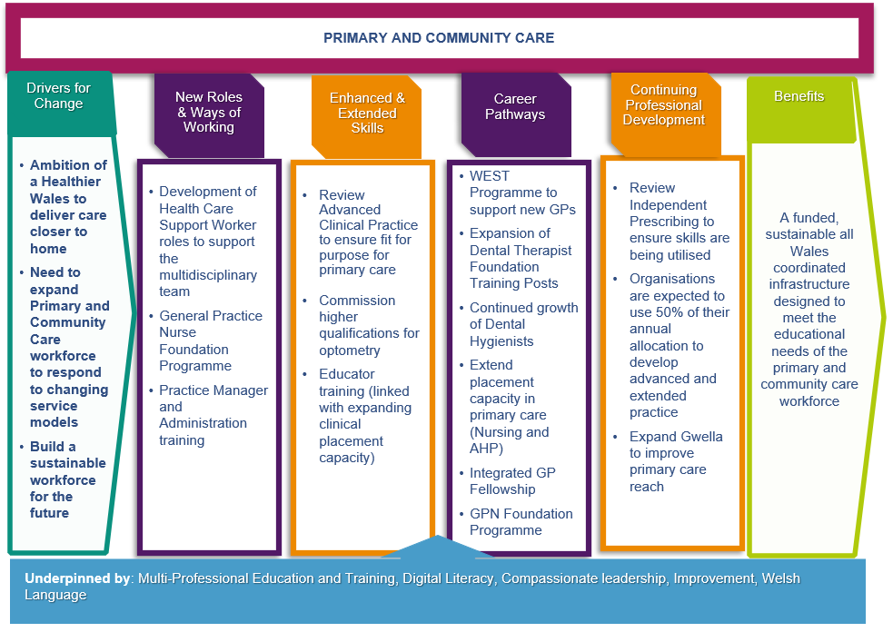

  - Mental Health
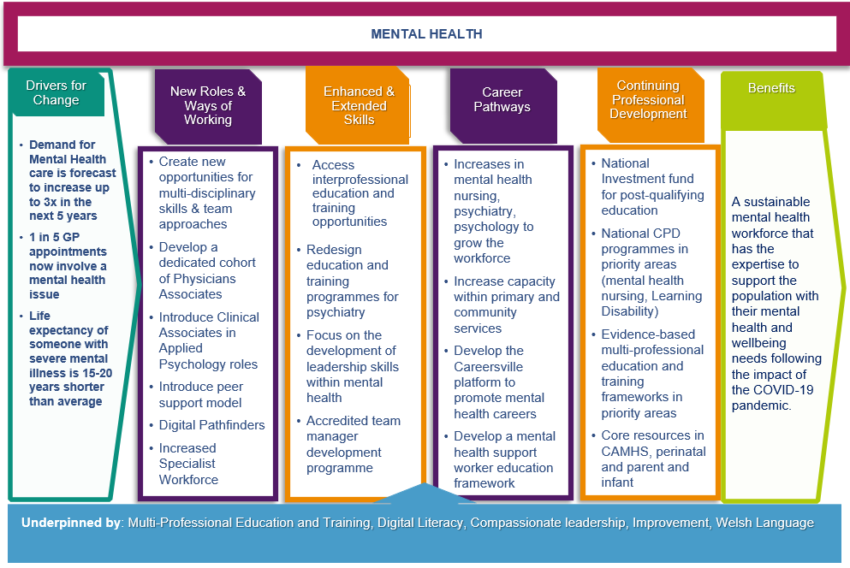
  - Urgent and Emergency Care
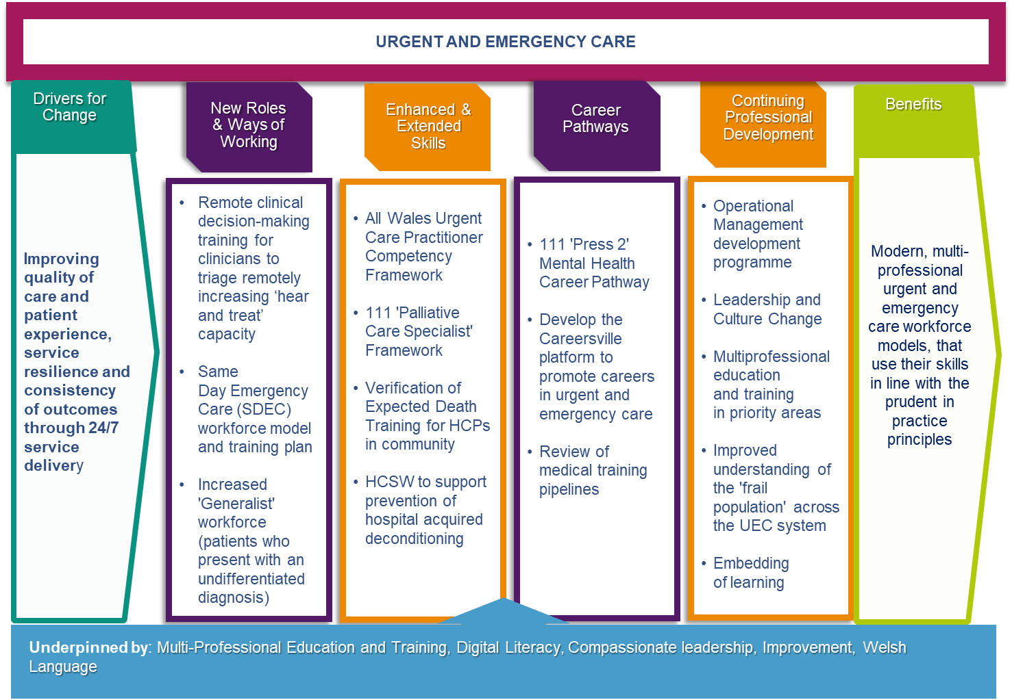

  - Cancer
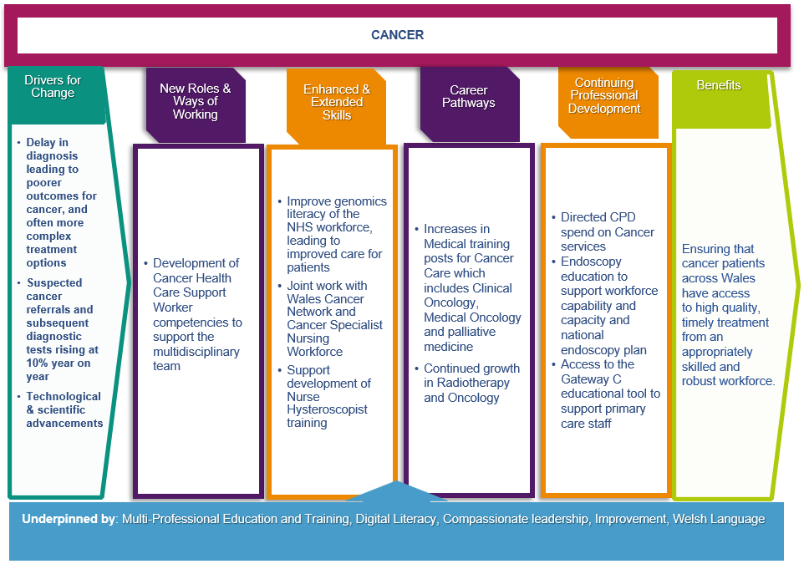
  - Planned Care and Recovery including Diagnostics
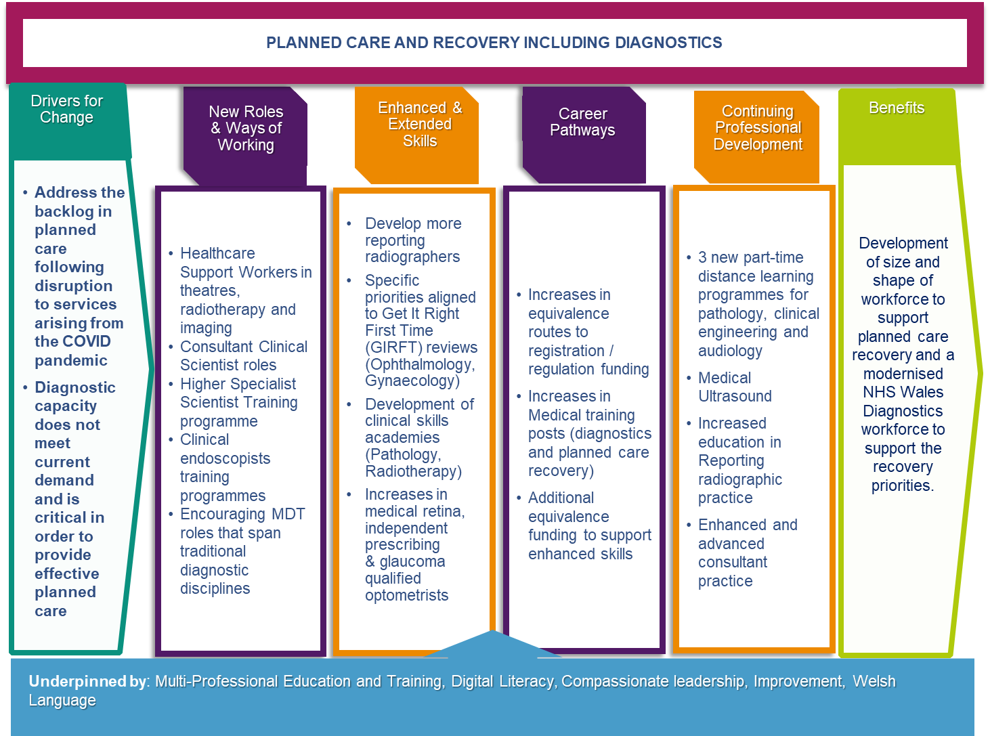
  - Genomics
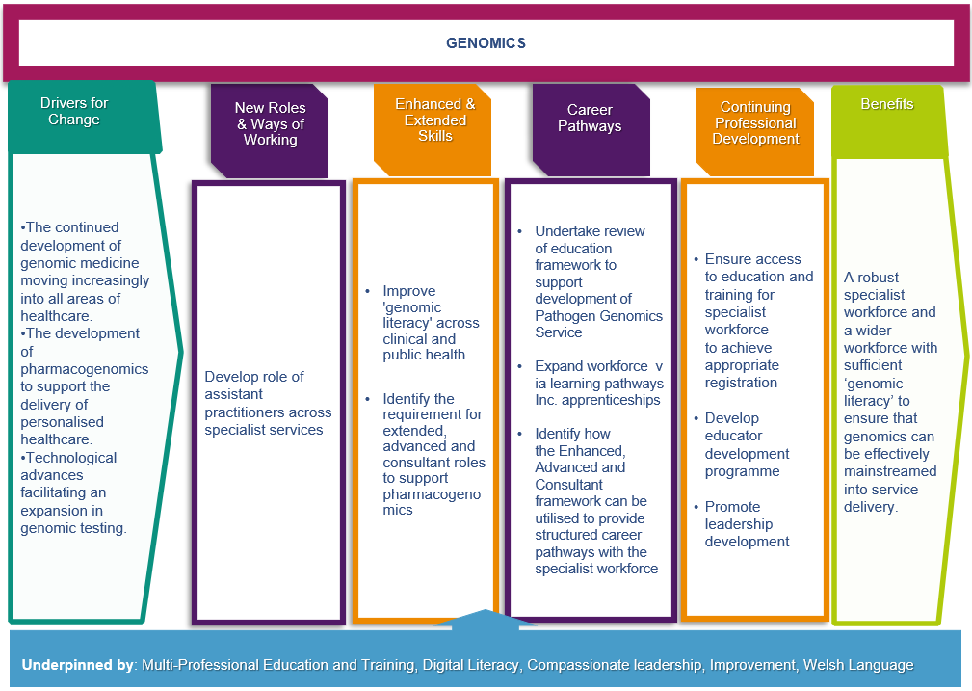
- Implementation through our IMTP 2024-27
This chapter outlines the commitments we have made and the actions we are taking within our Integrated Medium Term Plan (IMTP) to support education and training of the workforce now and for the future. It summarises the education enablers necessary to achieve optimal education and training, and recruitment into the workforce.

Education and training is supported and enabled through

Workforce intelligence
Retention of the workforce
Addressing Equality, Diversity & Inclusion
Welsh Language Provision
HEIW’s Digital & Data Strategy
Simulation & multi-professional education
Continuing Professional Development
Compassionate leadership cultures & wellbeing
Building Career Frameworks & Attraction
Clinical Placements & Supervision
Widening Access

  - Activities Relating to Strategic Aim One - Building Our Future Workforce
Building our Future Workforce
Developing and implementing plans that align the future demand for workforce and supply
  Drive transformation in multi-disciplinary education and training through investment and innovation to meet future health and care needs | Develop, publish, and implement strategic workforce plans in priority areas
To achieve this we will: | To achieve this we will:
- Implement a continuing improvement programme for clinical placements and training and education environments.  - Drive implementation of the delivery of a once for Wales approach for relevant health-based work-based learning and apprenticeship frameworks in support of career progression frameworks.  - Establish the education and careers infrastructure to ensure Medical Associate Practitioners (MAPs) are embedded in MDT workforce models.  - Implement a multi-professional endoscopy training academy for NHS Wales.  - Increase multi-professional education and training programmes in Primary and Community supported by the continued development of the Academy Model.  - Implement the multi-professional strategy for Simulation-Based Education and Training.  - Use Y Ty Dysgu Learning Management System to improve the quality of and access to multi-professional workforce learning.  - Develop a multi-disciplinary education strategy setting the future vision and principles to guide our work to transform education.  - Deliver a single data and application architecture for the administration of postgraduate trainees and NHS Wales professionals.  - Deliver a plan for the integration of advanced data analytics and artificial Intelligence into healthcare and education systems. | - Complete year 2 implementation of the strategic workforce plan for Mental Health in partnership with Social Care Wales.  - Develop and improve the data intelligence function to inform strategic workforce planning, modelling and reporting.  - Working in collaboration with partners across the system, to implement the Strategic Workforce Plan for Pharmacy.  - Implement a range of actions emerging from the dental workforce plan aligned with the Duty of Quality to further develop new and existing offers to the dental workforce.  - Commence implementation of the Primary Care Workforce Plan.  - Develop and implement the multi-disciplinary Strategic Perinatal Workforce Plan (SPWP).  - Develop, publish, and implement the strategic workforce plan for Genomics.  - Publish and commence implementation of the strategic Nursing workforce plan.
Impact | Impact
- Improved standards of education and training resulting in high quality patient care and improved student/trainee experience.  - Improved staff capability and competence resulting in increased productivity, improved workforce retention and sustainability for future generations based on need/demand.  - Improved education and development opportunities for PA, AA and SCP workforce enabling seamless models of care.  - Improved standards of education and training in endoscopy resulting in improved staff capability and competence, increased productivity leading to better quality individualised patient care and safety.  - Improved staff capability and competence, increased productivity and better quality patient care. Creating a more sustainable General Practice workforce for future generations based on need/demand.  - Improved quality of simulation-based education and training across healthcare in Wales leading to better patient care, increased productivity and equitable access to simulation-based resources across Wales.  - Improved quality of and access to multidisciplinary learning and education and better reporting and insight for use in evaluation.  - Improved standards of education and training resulting in high quality patient care and improvement in staff, student/trainee experience and impact on culture.  - Improved quality of data and improved user experience.  - Data-driven insights, streamlined administrative tasks, enhanced diagnostic capabilities, reduced workload, more efficient resource allocation, and potential cost savings, that contribute to better healthcare delivery and outcomes. | - Contribute to an engaged, motivated, and healthy mental health workforce across health and social care, with the capacity, capability, and competence to meet the needs of the people of Wales.  - Increased data quality enabling decisions based on accurate data stored in a secure and safe environment.  - Improved pharmacy workforce with enhanced research, digital and leadership skills to accelerate service transformations.  - Support the development of a multi-skilled workforce and improve access to oral health care for patients and relieve pressure on secondary care services.  - Give the primary care workforce enhanced clinical, education, research, and leadership skills to deliver the primary care model for Wales to meet the needs of their local communities and improve staff recruitment and wellbeing to increase retention across Primary Care.  - Improved standards of education and training to increase retention and wellbeing of perinatal workforce and resulting in high quality patient care.  - Improved standards of Genomics education and training to improve staff capability and competence in genomic testing to deliver high quality patient care and improve workforce retention (*within specialist services).  - Improved nurse retention building a more sustainable workforce and improved patient care.
Improve attraction and recruitment to education, training, and employment
To achieve this we will:
- Deliver high quality attraction and marketing campaigns, for national and local priorities, and encompassing employment and education.
- Deliver a National Graduate Management Programme to support the NHS Wales talent pipeline.
Impact
- Increase recruitment into vacancies, higher education, and undergraduate pre-registration training.


  - Activities Relating to Strategic Aim Two – Developing Our Current Workforce
Developing our Current Workforce
Transforming today’s workforce to contribute to new models of care which improve quality and safety

Develop workforce solutions for National NHS Programmes and Priorities | Design and develop resources to support workforce and service transformation
To achieve this we will | To achieve this we will
- Lead actions to support recovery of planned care.  - Lead actions to support cancer recovery.  - Lead actions to support recovery for the Diagnostics National Programme.  - Lead actions to support Six Goals for Urgent Emergency Care. | - Lead the implementation of the AHP Framework action plan to transform AHP Practice and workforce across Health and Social Care in Wales.  - Effectively manage the Healthcare Science Programme to implement the future vision for the Healthcare Science workforce described in the national framework.  - Lead the development of approaches to enhanced, advanced and consultant practice.
Impact | Impact
- Improved standards of education and training in planned care improving staff capability and capacity, resulting in increased productivity, high quality patient care, improved staff retention and patient experience.  - Improved standards of education and training in cancer improving staff capability and capacity, resulting in increased productivity, high quality patient care improved staff retention and patient experience.  - Improved standards of education and training in diagnostics improving staff capability and capacity, resulting in increased productivity, high quality patient care, improved staff retention and patient experience.  - Enhanced clinical, education and leadership skills in urgent and emergency care (UEC) to deliver timely urgent and emergency care, improved recruitment and retention and expansion of MDTs to improve sustainability and reliability of the UEC workforce and offer high quality patient care. | - Improved staff capability and competence resulting in increased productivity and improved retention leading to AHP workforce sustainability now and for future generations based on need/demand.  - Improved staff capability and competence resulting in increased productivity and improved retention leading to Health Care Science workforce sustainability now and for future generations based on need/demand.  - Improved staff capability and competence resulting in increased productivity, achieved legal and/or regulatory compliance, career progression and retention of the clinical workforce and improved patient experience.
Target development of skills and capabilities to support transformation and future proof current staff
To achieve this we will
- Continue to ‘level up’ access to education and training for SAS (Specialty and Specialist doctors) and locally employed (LE) doctors who represent approximately 30% of the medical workforce in Wales.
- Support the Wales Eye Care plan by delivering a framework to train and support Optometrists and Dispensing Opticians to provide optimum community care to all persons in Wales.
- Support the implementation of a multi-professional CPD strategy and drive improvements in current CPD activities.
- Deliver the actions outlined in the More Than Just Words Plan.
Impact
- Improved attraction and retention of SAS and LE doctor workforce in Wales and improved patient care.
- Delivery of enhanced services accelerating workforce change with more enhanced services available in primary care optometry practice providing faster access to expertise for patients. Improved capacity to provide clinical care, quality of the student/trainee experience and learner/student safety.
- Improved standards of education and training resulting in high quality patient care.
- Enable the provision of health and care delivery through the Welsh language, improving the quality of care for patients.

  - Activities Relating to Strategic Aim Three – Culture & Leadership in NHS Wales
Shaping Culture and Leadership in NHS Wales
Embedding compassionate leadership principles to develop cultures that support inclusion, wellbeing, and quality

Scale and spread compassionate and collective leadership opportunities for leaders at all levels across NHS Wales | Create diverse and multi-professional pipelines of aspiring leaders for NHS Wales
To achieve this we will | To achieve this we will
- Embed compassionate leadership across NHS Wales to support leadership and management development.  - Enhance leadership capability through the provision of national and local leadership development programmes and resources. | - Deliver multi-professional leadership development framework in support of senior leader succession planning.  - Deliver the NHS Wales People Profession Development Programme.
Impact | Impact
- Positively influence cultural change, improve skills resulting in high quality management abilities that improve staff experience. Embed compassionate leadership that drives staff wellbeing and improved retention.  - Enhance clinical leadership capacity across NHS Wales, create compassionate cultures and working environments across NHS Wales and create diverse pipelines of compassionate clinical leaders within NHS Wales. |   - National talent pipelines for our executive/board level roles along with National and comprehensive development plan for aspiring executive directors underpinned by Executive Director Success Profiles and National approach to mobilising talent at executive director level. Ensring the right skills, in the right place at the right time.  - Broader diversity and strength in our Workforce & OD knowledge, skills, and expertise; better attraction, onboarding and retention of future-fit skills, expertise, and experience and improved talent mobilisation of the Workforce & OD community across NHS Wales to address national workforce challenges.
Through insights and staff experience data, influence cultures that promote team working,
retention and wellbeing to improve organisational outcomes
To achieve this we will
- Deliver the All-Wales Retention Programme, shaping and embedding best practice retention strategies and projects.
- Work in collaboration with partners to embed person-centred practices and policies that reduce employee harm, increase wellbeing, and improve staff experience.
- Deliver an annual, evidence-based NHS Wales Staff Survey to measure staff experience to inform our strategies and provide data so that NHS Organisations can assess how systems, policies and procedures can positively contribute to workforce health and wellbeing. Deliver a single set of unified, core leadership and management standards and resources to support induction, onboarding and CPD of Executive Directors and Managers across NHS Wales.
Impact
- Increased staff retention, engaged workforce, and compassionate leadership and cultures.
- Improvement in staff experience, positively influenced cultural change and improved wellbeing of the workforce.
- Provide visibility of manager competences and gaps for assurance, targeting and prioritisation of resources/training to areas of largest skill gaps. Also established and standardised, national resources for onboarding Executive Directors with clear understanding across the system on role and responsibilities of an Executive Director and strengthen national board governance, leadership, and organisational effectiveness.

- Financial Plan
This chapter sets out the financial investment associated with the Education and Training Plan.
  - Our Approach
In determining the financial implications of this Education and Training Plan the identified funding requirements across multi-professional areas has been calculated utilising consistent costing criteria based on known salary scales and anticipated annual uplifts.
  - Developments and Investments
Aligned to the contents of this plan, HEIW is actively progressing a range of workforce programmes which will complement the requirements identified in the plan and where additional resource is to be invested. These include:
- Mental Health Workforce Plan
- Primary and Community Care Academies
- Strategic Workforce Plans.
- Actions assigned to HEIW in the National Workforce Implementation Plan (NWIP).
Furthermore, organisationally HEIW is reviewing and advising on a number of existing funding streams currently in place to facilitate education and training across NHS Wales such as study leave, training grade salaries and advising on the future approach to Service Increment for Teaching.

  - Financial Risks and Opportunities
The financial plan has been developed with the best available information and within the existing policy environment and investment approaches. The actual costs of investment will vary across the years of the plan as a result of the levels of recruitment and commencement of individuals into the wide variety of training programmes commissioned.

  - Finance Plan
The total funding requirement for the initial recommendation contained within the Education, Commissioning & Training Plan for 2025-26 was calculated as £360.475m increasing to £363.336m by 2027-28 excluding the impact of Welsh Government Policy Decisions.
The costs of the initial recommendation for 2025/26 were broken down into £157.632m for wider Health Professional Education, £17.029m for Pharmacy Training, £75.258m for Medical Training, £42.573m for GP Training, £10.020m for Dental Training. They also included costs associated with the Strategic Mental Health Workforce plan of £2.745m, Primary Care Plan of £1.143m, Optometry of £0.658m as well as other commissioning activity of £5.293m and general running costs of £46.504m.
  - Updated Financial Plan – Maintenance of Investment
Following Welsh Government request to prioritise commissioning to achieve a maintained investment position, the table below shows the breakdown of commissioning costs for each of these professions:
 | Allocation 2024/25 | Maintained Investment 2025/26
 | £m | £m
Health Professional Commissioning | 143.257 | 150.881
Pharmacy | 16.048 | 16.430
Medical Training | 74.656 | 74.500
GP Training | 39.393 | 40.772
Dental Training | 10.991 | 10.020
Primary Care Academies | 1.620 | 1.620
Total Existing Commissioning Activity | 285.965 | 294.223
Mental Health Workforce Plan | 2.745 | 2.745
Primary Care Plan | 0.850 | 0.850
Optometry | 0.658 | 0.658
Other Commissioned Activity | 0.000 | 4.000
Running Costs | 43.852 | 44.347
Welsh Government Policy Decisions | 0.000 | 5.100
Total Additional Activity | 48.105 | 57.700
Total | 334.070 | 351.923

Impact of Welsh Government Policy Decisions
The impact of two changes in Welsh Government policy will have a material impact on the overall cost of the plan. Funding totalling £5.100m has been agreed by Welsh Government toward the cost of these changes with any further impact to be considered and potentially supported in year.

- Removal of the cap on reduced student loans for Welsh domiciled students funded by the bursary
The impact of more Welsh domiciled students taking up the bursary offer, compared to previous years due to the change in Welsh Government policy allowing bursary students to access the full student maintenance Loan from September 2024.

Historically, there have always been students who choose to fund their training through the student loan route. This meant that there were no costs for these students payable to HEIs by HEIW. With the enhanced offer, it is likely that more students will take up the bursary, resulting in additional cost. We have estimated the additional cost of year 1 Welsh Domiciled students taking up the offer of bursary to be circa £6.743m.

- Increase in tuition fees
Welsh Government announced that HEI’s would be able to increase the tuition fees that they could charge from £9,000 to £9,535. HEIW currently contract with a number of HEI’s for a variety of courses with some of the contracts subject to price review in September 2025. The impact of increasing tuition fees paid to HEI’s from September 2025 would add an additional circa £2.504m to the costs outlined.

Value for Money / Return on Investment
The maintenance of investment levels in training health professionals can
be considered in the context of the cost of agency and locum staff to cover
vacant posts if numbers in the training pipeline aren’t at least maintained. Some examples include the cost of an agency Nurse at c.£80k per annum compared to a salary cost of £44k for a nurse with the cost of training repaid through agency cost savings in just over a year.

For Specialty Doctors, the cost of salaried staff vs agency can result in savings of £42k per annum for F1 trainees up to £70k for higher specialist trainees. The associated qualitative benefits of substantive staff over temporary staff and impact on patient care and outcomes has also been considered as part of this investment plan.

APPENDICES

Appendix A Workforce Analysis
Appendix B Using intelligence to inform the Education and Training Plan
Appendix C Education and Training Recommendations Further Information
Appendix D Education and Training Trends
Appendix E Summary of Engagement Undertaken
Appendix F Financial Scenario Planning
Appendix G Case Studies

https://wales.cityofsanctuary.org

