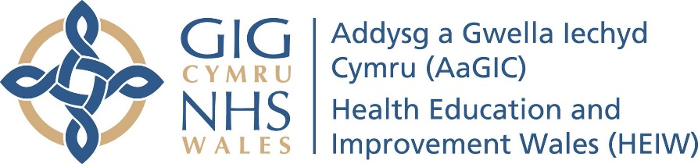
Person Specification Educational Supervisor
Essential | Desirable | Measure
Qualifications

Registered with the GDC, has current professional indemnity and is an NHS performer.  Has no current conditions with the GDC or Health Board  - The training practice complies with all expectations and requirements of Welsh Government and Health Board guidance (relating to the GDS contract they have decided to work under) in place at the time of application and during the training year.  - Activity levels of relevant contractual KPI’s are in the range of expectations of the relevant Health Board and National averages.  - A full range of NHS Mandatory services must be offered to all NHS patients.  - The practice NHS commitment is suitable to allow adequate supervision of Foundation Dentist and provides an environment which allows the ES to give context and understanding of the NHS contract, Quality Improvement initiatives and ways of working.  There should be a minimum practice contract value of £27,000. (Excluding DFT contract)  Stable professional relationship in practice  Present in the practice with FD for minimum 3 days a week [ overlapping hours  Willing to accept FD into practice on the contractual terms of DFT scheme and Single lead employer. | Has dental committee experience.  Involvement in management of practice. Practice owner  Present in practice with FD each day they are present in the practice  Postgraduate qualifications,  Works as a joint ES in the practice.  An alternative clinical supervisor is available on days that ES is not at the practice. | Practice visit, application form  Practice visit  application form, practice visit  Practice visit, application form  Application form
Knowledge and Experience

Minimum 4 years’ experience in GDS or salaried service, including own FT year, at time of FD starting in practice  Minimum 20 hours verifiable CPD in year of application [to comply with new GDC 100 hours in 5 years]  High clinical and ethical standards  Can demonstrate a stable commitment at the practice  Can produce a personal or professional development plan | Over 4 years’ experience in GDS or salaried service  More than 20 hours CPD on postgraduate courses  Previous experience as a dental clinical educator. Education qualification. Reflective practitioner.  Has worked at the practice for more than two years  Ability and desire to be an educator. Motivated to do FT for the interests of the FD.  Completion of a Dental/Medical education course which may be a PG Cert or HEIW Developing Dental Educators course. (All four modules need to be completed or signed up for).  Teaching experience  Knowledge of DFT curriculum/Portfolio  Can produce evidence of reflective writing and practice  Can produce evidence of involvement in appraisal | Application form  Certificates  Practice visit, application form certificates, reflections, interview  Interview  Interview/application form  Interview/ application form  Evidence with application form  Evidence with application form
Skills, abilities and values

Is able to integrate well into a team, and valued by the members of the team  High clinical and ethical standards.  Provides a full range of NHS treatment  Good communication skills.  Has skills required to support colleagues.  A dentist able to cope with change, who is flexible and can handle uncertainty  Can demonstrate time in working week to adequately support an FD  Mentoring Skills - Demonstrates strong mentoring capabilities, including the ability to build trusting and supportive relationships with mentees. Shows empathy and understanding, provides constructive and actionable feedback, and creates a positive learning environment. Encourages and motivates others, helping them to grow in confidence and reach their full potential. | A dentist who works as part of a team in a well-managed practice  Able and willing to be adaptive and accept change as legislative requirements, technologies, materials and methods change.  A dentist who can communicate effectively with patients and team members.  A dentist who is available and accessible to patients and staff  A dentist willing to re-organise their daily routine and that of the practice to take account of the presence of a Foundation Dentist  A dentist who can demonstrate a critical faculty for self-assessment.  A dentist who can demonstrate involvement in staff training and development.  A dentist who can demonstrate the ability to give and receive feedback.  A dentist who can demonstrate enthusiasm and commitment to teaching and learning | Interview and practice visit

Practice Specification of training practice
Essential | Desirable | Measure
Compliance  Complies with all HIW requirements, including WHTM01-05.  Practice documentation complete and up to date. | Meets WHTM01-05 gold standard. | Practice visit, application form (practice checklist).
FD surgery  Minimum 3 square metres, well equipped. | On same floor as trainers’ surgery. Very short distance from trainer’s surgery. Larger room | Practice visit, application form (practice checklist).
Equipment available for FD use  Everything expected of a good general dental practice.  Defibrillator, rotary/reciprocating endo handpiece, rubber dam, Hall crowns, clinical camera, surgical kit. Internet access freely accessible | Large range of good quality modern instruments, equipment and materials | Practice visit, application form (practice checklist).
Staff  GDC registered nurse available to work with Foundation Dentist | Staff are all long-term employees. | Practice visit, application form (practice checklist).
Educational resources  Educational resources are available for the FD to use. |  | Practice visit, application form (practice checklist).
Workload  Adequate number of patients available for the FD without being excessive.  Trainer’s workload allows for FD accessibility. Dedicated time for tutorials. | New patients available for the FD to treat. | Practice visit, application form (practice checklist).
Dental treatments offered.  Full range of NHS treatments provided, including full acrylic dentures, Co-Cr dentures, Crowns and Bridges, endodontics, MOS. Adults and children seen and treated on the NHS. | Practice offers other treatments (such as implants, orthodontics, sedation) | Practice visit, application form (practice checklist).
General  Practice is well decorated, clean and tidy, organised. | Individual dentists able to dictate their own length of appointments. | Practice visit, application form (practice checklist).
Please note that the Dental Educational Supervisor Application Process (DESAP) and the Educational Supervisor Person Specification (ES PS) set out the core expectations for training practices and Educational Supervisors, including the supervision standards they are required to uphold.

Inability to meet these requirements may result in non-selection.

