Environment (Wales) Act 2016 Part 1 - Section 6
The Biodiversity and Resilience of Ecosystems Duty
Report 2025
HEALTH EDUCATION AND IMPROVEMENT WALES (HEIW)
Introduction and Context
For the purpose of the Environment (Wales) Act 2016 Section 6 (S6) duty reporting, HEIW is a Group 1 organisation type. HEIW occupies a leased office building, and its functions are not directly connected to biodiversity and/or land management.

As such, its minimum S6 actions relate to buildings management, procurement, sustainability, awareness raising, training, and working in partnership with other organisations. The Nature Recovery Action Plan for Wales (NRAP) objectives reported against in this report are 1, 4 and 6.

HEIW’s head office is based in Ty Dysgu in Nantgarw and HEIW leases the building and car park/grounds from Rhondda Cynon Taf (RCT) Borough Council. The building is a three-storey open plan office building with plant located in the roof space. The site is 0.35 hectares, and the building is 27,986 square feet. The layout can be seen in the aerial shot in Appendix 1.

HEIW is a Special Health Authority (SHA) within NHS Wales, sitting alongside Health Boards, Trusts, NHS Wales Performance and Improvement and the other SHA, Digital Health and Care Wales (DHCW). Working with Welsh Government, NHS Wales organisations and partners in social care, its purpose is to develop a skilled and sustainable workforce that improves care and population health.
The organisation has a broad remit encompassing workforce intelligence, workforce strategy and planning, education commissioning and delivery, quality management, support for regulation, leadership development and succession planning, careers and widening access, workforce improvement and professional support for workforce and organisational development.
HEIW is a national health organisation in Wales. As such, HEIW recognises the importance of access to nature and green spaces for health and wellbeing, as was widely recognised during pandemic lockdowns and since, through increased recognition of the importance of nature and the practice of social prescribing.

HEIW also recognises that healthy workspaces and surroundings are important for staff wellbeing, for its own staff and for staff across NHS Wales in its remit of supporting the wellbeing of the NHS Wales workforce. At its head office (Ty Dysgu), HEIW has developed the small areas of green space it has in its grounds to enhance biodiversity and to provide a space in nature for staff to use when at the building.
HEIW is subject to the Well-being of Future Generations (WFG) Act 2015 from 2024/25 and HEIW has now submitted its first report to the Future Generations Commissioner’s Office. The organisation has, however, aligned itself to the WFG five ways of working since its formation. The environmental work of NHS Wales, and HEIW as part of that, contributes to the goals to create a Resilient Wales, a Healthier Wales and a Globally Responsible Wales and naturally relies heavily on applying the five ways of working, and notably prevention, collaboration and long-term working to ensure successful delivery.
HEIW is building sustainability into an integrated impact assessment tool for staff to gauge how sustainable its events, projects and work are, and the tool will be mapped to the WFG goals.
In 2021-22, the organisation published its first Biodiversity and Decarbonisation Strategy and Sustainability Action Plan (SAP), which incorporated action related to the S6 duty for biodiversity. In 2025-26, the strategy is under review and will be published as the new HEIW Climate Smart Strategy, 2026-2031, with the proposed tagline ‘Climate Smart in everything we do’ and an associated Climate Action Plan, again incorporating action related to the S6 duty for biodiversity.

HEIW has dedicated resources to its sustainability work programme, which incorporates biodiversity; these are a Sustainability Programme Lead, supported by a Project Support Manager, with some additional resources for administration and planning from the organisation’s Planning and Performance team.

The Sustainability Steering Group (SSG) oversees the delivery of HEIW’s sustainability strategy and action plan. The group reports to the Executive Team and is chaired by the Senior Responsible Officer (SRO) for Sustainability (Assistant Director of Planning and Performance). HEIW’s Green Group is made up of staff volunteers interested in supporting the delivery of the sustainability action plan and progressing green initiatives.

HEIW reports on an annual basis to the HEIW Board and through its annual report. A Sustainability key performance indicator (KPI) dashboard is currently in development which focuses on how the organisation is tackling its carbon footprint, including printing and waste management, how activities and events are driving behavioural change through awareness raising, and how biodiversity is being increased across the Nantgarw office estate.

Highlights, Key Outcomes and Issues
In 2022, HEIW reported that work was undertaken to improve the existing use of the green space at Ty Dysgu, to incorporate new planting and develop wildflower meadow spaces to enhance the environment for staff health and wellbeing purposes and to encourage additional wildlife. This was planned in line with the expectations of the S6 duty in the Environment (Wales) Act 2016, the National Biodiversity Strategy and Action Plan for Wales and HEIW’s own strategy and wellbeing goals. Advice was sought from the Wales Biodiversity Partnership for Ty Dysgu’s local area (RCT), and the local Biodiversity Coordinator undertook a site visit to advise on the plans submitted by the landscaping provider.

At the same time, a ‘place to reflect’ was created, with a memorial bench, for HEIW staff and visitors using the building, to enable HEIW to commemorate the extraordinary work of all our NHS Wales colleagues during the pandemic, as well as to provide a small area of calm and beauty for staff to use and enjoy for wellbeing purposes.

Since then, HEIW has supported ongoing maintenance of the grounds in Ty Dysgu for biodiversity and staff wellbeing purposes, with the support of the organisation’s volunteer Green Group Gardening Group and the Building Facilities team. This includes regular watering and bird feeding rotas and annual staff planting sessions, which tie in with wider plans to raise staff awareness of the importance of maintaining and enhancing biodiversity through an annual spring event.

The Green Group runs the annual Spring Event for staff every May, focusing on biodiversity, and organises a planting session to prepare the green space for the summer. The volunteers in the group benefit from the session themselves as an opportunity to work as a team in person to improve the environment for all staff that use Ty Dysgu, but it is an event that is open to all staff and tends to be attended by 4-5 additional staff each year, on top of the 10-15 volunteers who make up the Green Group.

The Sustainability Team and the Green Group have also continued to run monthly litter picks in Ty Dysgu and the surrounding areas, with at least two bags of rubbish being collected each month, benefitting the green areas at Ty Dysgu and the Charnwood Business Park in Nantgarw.

Monthly environmental bulletins are published on HEIW’s staff intranet and on the NHS Wales Climate Smart Community on Y Ty Dysgu, the NHS Wales learning platform. The bulletins include articles and items related to all aspects of HEIW’s sustainability programme, including biodiversity, as well as new sections this year promoting positive news stories and achievements from around the world (entitled ‘a brighter green’) and highlighting free learning and courses for staff. Staff views of the monthly bulletin on the intranet are usually 100 to 150 each month, and any additional engagement and comments are most likely to be connected to biodiversity articles, as these usually resonate more strongly with staff.

Since 2022, when HEIW made a successful bid to the Welsh Government Health and Social Care (H&SC) Climate Emergency National Programme Funding Scheme to run three years of training for NHS Wales staff on sustainable healthcare, the ‘Climate Smart Champions’ project has run for two further years, with the final year scheduled to run in 2026/27. The training procured is available to NHS Wales staff on a voluntary basis, with the aim of driving sustainability improvements and ensuring healthcare practitioners deliver safe, quality and sustainable healthcare in their settings through an understanding of the impact of climate change and how to mitigate and adapt appropriately to this. The importance of the environment in delivering this is not underestimated and environmental factors are incorporated into the training. To date, around 230 NHS Wales staff have been trained through the Centre for Sustainable Healthcare, with a further 30 places to be made available next year.

This project is part of a wider piece of work to embed climate smart education and training across healthcare leadership, practice, training and education across professional pathways (including circa 12,000 healthcare students and trainees). Appendix 2 shows HEIW’s plan for embedding sustainable healthcare education and training into professional pathways 2024-27 and also includes the delivery of the Climate Smart Education and Training Action Plan, alongside the Climate Smart Champions training and other actions relating to senior leaders and learners in Higher Education Institutes. Baselining for the Climate Smart Education and Training Action Plan was undertaken in 2022, and this informed the development of the plan for 2024-2026, which is now being implemented (see Appendix 3). There are 60 actions in the plan, across six action themes and 19 professional areas, of which 12 are completed or embedded in business as usual and 48 are in progress or scoping.

The NHS Wales Decarbonisation Strategic Delivery Plan was reviewed and refreshed in 2025. The 2025-2030 refresh incorporates a clearer focus on education of the workforce, of relevance to the work of HEIW, and on communications and engagement as a tool for raising awareness and influencing behaviour change on all aspects of environmental sustainability, including biodiversity. Responsibility for a number of actions in these areas falls to an all-Wales group currently tasked with education-related actions and known as the ‘Climate Smart Education Task and Finish Group’. This group is jointly led by two secondees to Welsh Government under the H&SC Climate Emergency National Programme, and the group includes a representative from HEIW in the form of the Sustainability Programme Lead. The terms of reference of this group are under review as a result of the new responsibilities.

Members of the existing group were fortunate to be able to attend a climate-focused session of the Dragon’s Heart Institute Spread and Scale Academy in 2025 (funded by the Climate Emergency National Programme) to focus on their education project. The project aims to address the problem that healthcare professionals are not sufficiently engaged in number in healthcare sustainability. The result is a lack of engagement in meaningful climate action when evidence shows that climate and nature crises are affecting health. A range of solutions incorporating biodiversity, decarbonisation and adaptation are under consideration to empower and support the NHS Wales workforce to take action to improve the sustainability of their practice.

The Spread and Scale Academy provided support for building and promoting the project, gaining networking opportunities with others undertaking a range of climate projects across NHS Wales and ongoing support following the session. The education project group will be able to present to NHS Wales senior leaders in February 2026, to raise awareness and to ask for support, an incredible opportunity in successfully delivering the project.

In 2025, one of the current cohort of the Welsh Clinical Leadership Fellows is focusing on the ‘Future Doctor’ project, and will be overseeing development of a new ‘domain’ on sustainability (in addition to the existing General Medical Council domains), which will dovetail into the work being undertaken by the (proposed) All-Wales Climate Smart Group to develop a curriculum and resources for the NHS Wales workforce. Early indications show that it will be straightforward to adopt/adapt this domain and associated curriculum to be suitable for different health professionals and multi-professional teams.

Action Report
NRAP Objective 1: Engage and support participation and understanding to embed biodiversity throughout decision making at all levels.
Actions that have been taken to:
- Embed biodiversity action across HEIW’s functions:

  - Recognition of biodiversity and the S6 duty in the development of HEIW’s 2026-2029 Integrated Medium Term Plan and the new sustainability strategy and climate action plan (development of all underway at the time of writing) – IMTP staff workshops; internal and external engagement for the sustainability strategy
  - Continued work to embed the climate agenda (decarbonisation, biodiversity, and adaptation) in healthcare leadership, practice, education and training, raising awareness and affecting change in sustainability across healthcare professions and settings throughout the system, from undergraduates to senior leaders
  - Review and fine-tuning of the Sustainability Impact Assessment (SIA) tool for use by staff across the organisation in considering projects and events
  - Significant work has been undertaken to consider internal and external benefits of the Sustainability programme and a KPI dashboard is in development to inform reporting

- Raise awareness across HEIW:
  - Regular promotion of sustainability e-learning modules available to all NHS Wales staff on the Electronic Staff Record (ESR) site
  - ‘Sustainability’ section on HEIW’s staff intranet, with access to information, ideas, updates, and regular engagement with staff about ongoing and new initiatives and links to biodiversity related items
  - Green Group noticeboard and table in the main staff kitchen in Ty Dysgu and access to watering cans and tools for garden maintenance for any staff who want to help at any time
  - Annual Spring Event for staff, focusing on biodiversity and the outdoor space at Ty Dysgu, typically including a staff planting session, a quiz, a sunflower growing competition, and biodiversity-related communications
  - A new video promoting the HEIW Gardening Group from one of the group’s members
  - Monthly environmental bulletins published on the staff intranet, with a significant number of biodiversity-related articles, which usually generate between 100 and 150 views per issue and the biodiversity-related items often sparking additional engagement
  - A communication to all staff setting out the achievements of the Green Group on its fifth anniversary (in 2025), highlighting the development and ongoing maintenance of the green space at Ty Dysgu
  - Monthly staff litter picking event to improve the Ty Dysgu grounds and the local area

Measures and/indicators monitored or collected:
  - A Sustainability KPI dashboard is currently in development, which will include views of the sustainability pages and of the resources available to staff (some directly related to biodiversity) and views of the monthly environmental bulletin
  - Between April 2024 and March 2026, a total of 60 staff from across NHS Wales have undertaken or are signed up to undertake the Climate Smart Champion training being delivered by the Centre for Sustainable Healthcare, and a further 30 places will be available in 2026-27. Circa 230 NHS Wales staff from across all NHS Wales organisations and a range of disciplines have undertaken the training – which encompasses biodiversity – since it was introduced in 2022
  - Awareness raising for biodiversity is undertaken via an annual staff Spring Event, maintenance of the green space at Ty Dysgu and monthly e-bulletins that include a strong focus on nature and biodiversity
NRAP Objective 4: Tackle key pressures on species and habitats
Actions to address key pressures:
- Ongoing careful management of the buddleia on site as an invasive species
- Increasing native species where possible, such as native bluebell bulbs, a category 1 native species for the area and an important UK ancient woodland flower
- Use of wildlife aids (bird boxes to attract nesting birds, a bird feeder and bee and insect hotels)
- Working with the garden maintenance supplier to ensure that ongoing maintenance is in line with environmental constraints
- Planting the fence line with climbing plants like honeysuckle and passionflower to attract bees, butterflies/moths, and other pollinators
- Creating meadow patches underneath trees to attract bees and butterflies
- Planting species like lavender, rosemary, thyme, and heathers to attract butterflies, insects, bees and provide food for caterpillars
- Establishing a monthly staff litter pick in Ty Dysgu and the surrounding area
- Monitoring and promoting separation of waste according to the 2024 regulations, with bins on all three floors of the building and additional zero-waste boxes for snack wrappers to reduce general waste alongside other recycling options for staff for hard-to-recycle items such as medicine blister packs
Actions to use biodiverse and native nature-based solutions wherever possible:
- Developing, maintaining and making green spaces in Ty Dysgu available to staff and visitors to the office to improve health and wellbeing outcomes
Measures and/or indicators monitored or collected:
- Internal Sustainability KPI dashboard (see p.2)
NRAP Objective 6: Put in place a framework of governance and support for delivery
Actions to:
- Ensure governance for biodiversity within HEIW:

- The Director of Finance, Planning and Performance is the Executive Lead for Sustainability, including biodiversity; the Assistant Director of Planning and Performance is the Senior Responsible Officer (SRO) for Sustainability
- The S6 duty is monitored and reviewed in line with HEIW’s sustainability strategy and action plan by the Sustainability Programme Lead, supported by the Project Support Manager and others in the Planning and Performance team, and overseen by the Sustainability Steering Group, chaired by the SRO.

- Provide capacity for biodiversity:
- Ecological expertise is drawn upon externally via research, the Wales Biodiversity Partnership, the wider NHS Wales network (Sustainability Leads), and third-party suppliers if/as necessary
- Information and reference to other sources is made available on HEIW’s intranet pages for sustainability and staff are encouraged to contribute articles and blogs and to use the resources available
- HEIW encourages and supports volunteer participation in action for biodiversity on the grounds by staff, via litter picks by staff, and is also encouraging staff to consider taking part in initiatives in their own local areas, which may be further afield, especially now that staff are working from home more regularly; this is a feature of HEIW’s current strategy, under its Area of Action 3: Developing Ty Dysgu and supporting local communities

- Support biodiversity action through funding and/or partnerships:

- Through Area of Action 3 of HEIW’s Sustainability Action Plan, the organisation is supporting other environmental organisations and projects by promoting their work via monthly bulletins and by inviting organisations to deliver ‘lunch and learn’ sessions for staff at Ty Dysgu
Measures and/or indicators monitored or collected:
- There are c.15 active members in HEIW’s Green Group, and, on average, members spend 0.5 day per month on meetings and initiatives including those related to biodiversity, giving around 7.5 days per month of dedicated resource for support to deliver HEIW’s Sustainability Action Plan and additional green initiatives
Review of s6 duty
As a Group 1 organisation type, HEIW’s main achievements over the last three years relate to:
- Buildings management: maintenance of the grounds at Ty Dysgu to enhance and maintain resilience of biodiversity
- Awareness raising internally with HEIW staff; externally across NHS Wales and the public sector in Wales, as a result of networking, and across the NHS Wales workforce via the work to embed climate smart education
- Training and working in partnership with other organisations: working across NHS Wales to determine and develop training for the NHS Wales workforce (supported by two short-term secondments to Welsh Government)
Beyond developing Ty Dysgu, further action by HEIW to support the S6 duty is outlined in HEIW’s Biodiversity and Decarbonisation Strategy and associated action plan under Area of Action 3, ‘Developing Ty Dysgu and supporting our local communities’, including:
- External speakers to run ‘lunch and learn’ sessions for staff, including the RCT Local Nature Partnership, Actif Woods Wales, Keep Wales Tidy and Rewilding Britain
- Information to be made available to staff: organisations providing volunteering opportunities to staff in their local areas, focusing on RCT, Merthyr Tydfil, Cardiff, Vale of Glamorgan, Bridgend and Neath Port Talbot, volunteering opportunities in HEIW, e.g. monthly litter picks, lunch and learns, bi-annual green events, plant watering (March to September), and general information
- Monthly environmental bulletin
The new strategy for 2026-2031 (due to be published in early 2026) and associated action plan will set out the actions planned for the period.

Appendix 1: Aerial map of Ty Dysgu
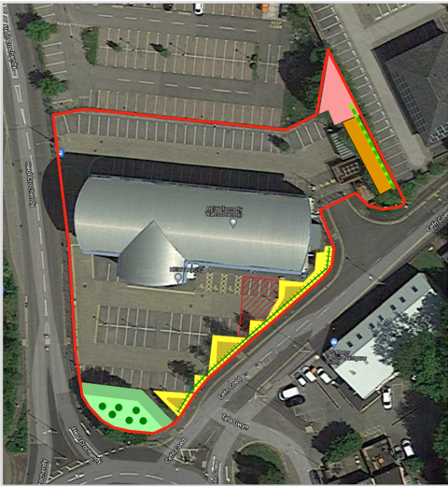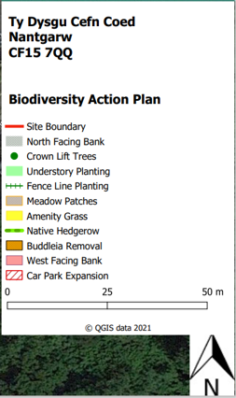

Appendix 2: Climate Smart Education & Training 2024-27
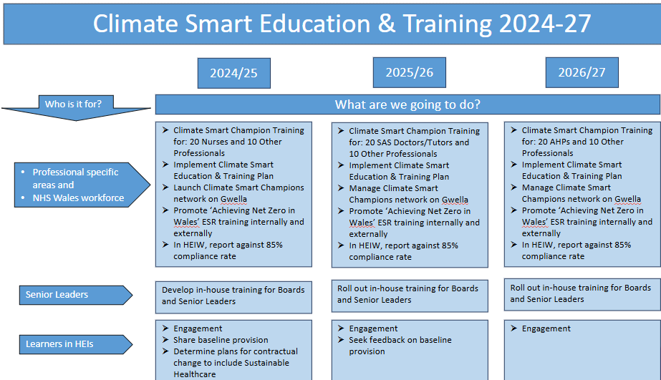
Appendix 3: Embedding Climate Smart Education and Training into Professional Pathways – Plan on a Page
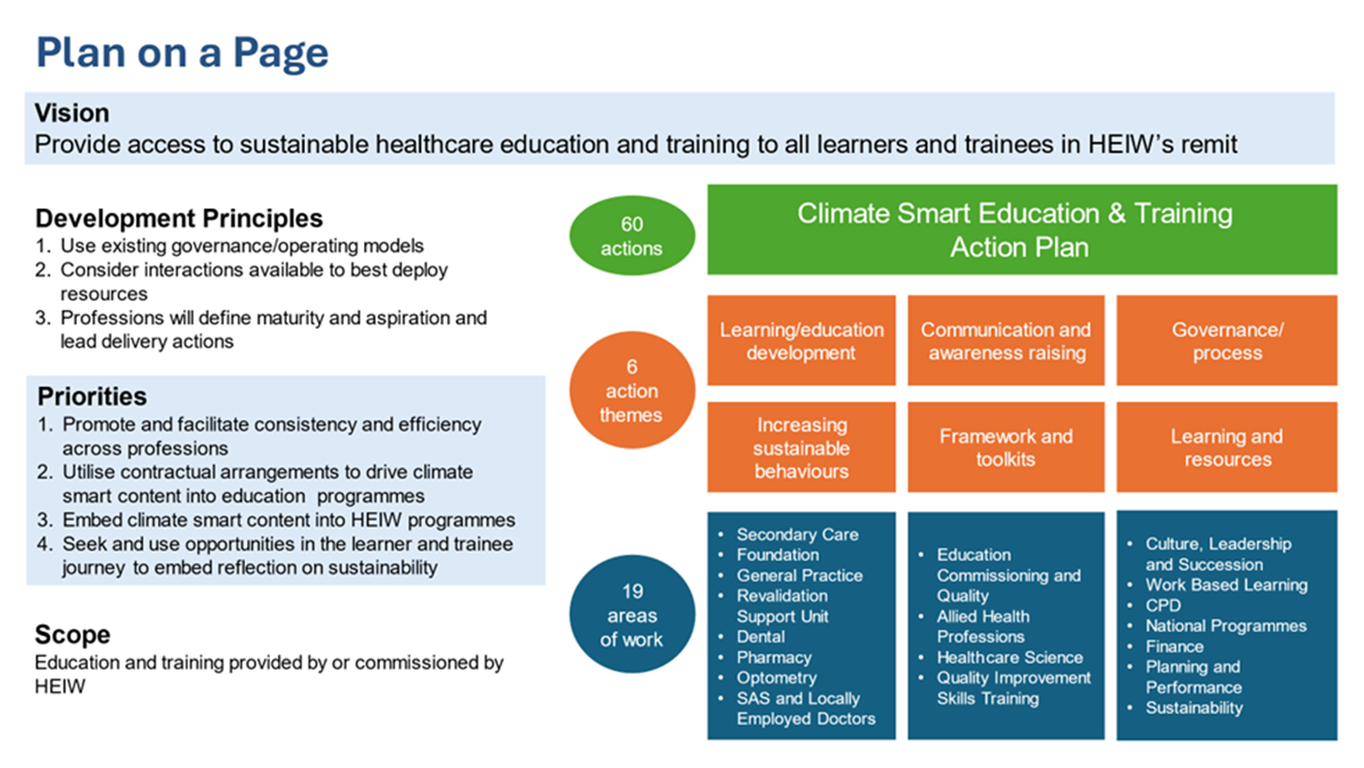

As outlined in Environment (Wales) Act 2016, Part 1, Guidance for Section 6 – The Biodiversity and Resilience of Ecosystems Duty, Reporting Guidance, Welsh Government, 2019
Nature Recovery Action Plan for Wales

