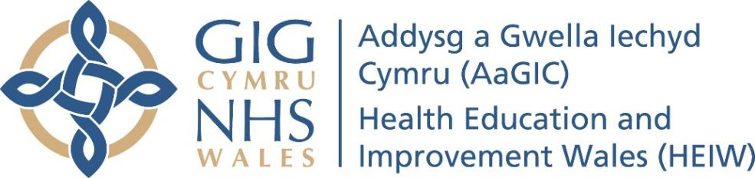
Sept 2023

Educational Development Time for Doctors in Training: Key Principles

This document outlines principles to support local education providers (LEPs) in the planning and delivery of Educational Development Time (EDT) for post graduate medical trainees, including GP trainees who rotate through secondary care placements, to acquire specialty specific experience. It does not apply to General Practice trainees in general practice placements where arrangements supporting EDT are already in place.

What is EDT?
EDT is protected time for trainee development previously referred to as “SPA time” or “half day for audit”. It was renamed EDT to reflect the broader more generic capabilities required for safe effective high-quality care across all departments and specialties that include skills required for consultants working in the future NHS. EDT enables trainees to meet their PDP objectives, facilitating them acting as adult learners and organising their own development. As such, allotted time to support this will increase with seniority.
In the Foundation curriculum EDT is described as Self Development Time (SDT), but the principles are the same and for the purpose of this document will be described as EDT.

EDT allowance:
Following a review of the UKFPO and Royal College training curricula, EDT indicative time allowances are as follows; (the hours set out apply to weeks in training and are based upon a 40-week training year) following the full use of annual leave and study leave.
- Foundation training- F1 doctors should have timetabled 1 hour/week and F2 doctors 3 hours /week and should be named as SDT on their rota. This may be clustered into a morning or afternoon. E.g. an F1 Doctor could have a 4-hour afternoon in a 4-week period to facilitate this.
- Core/early specialty Trainees (CT/ST 1-5) should have an indicative 2 hours/week.
- Higher Trainees (ST6 and above) should be allocated an indicative 4 hours/week.

Guiding Principles:
- There is flexibility in how the time is allocated - it can be clustered into days or spread out over the period of the training placement depending on the operational arrangements of individual departments/ specialties.
- EDT is pro rata for Less than Full Time trainees.
- EDT is NOT accrued during annual leave and study leave.
- EDT is in addition to time allocated for departmental teaching and clinical administrative time.
- EDT should be prospectively agreed by the Educational Supervisor in a personal development plan and the output of EDT clearly defined in the trainee’s e-portfolio.
- EDT should be allocated on the electronic rota
- Wherever possible, the trainee should be present in the hospital to complete EDT activities and the time should be ‘bleep free’. Should departments not be able to accommodate this, trainees could be allowed to work from home or alternative venue with agreement of their ES.

Examples of Activities appropriate for EDT (not exhaustive):
Non-patient facing activities:
- Critical appraisal activity e.g., journal clubs (either as educator or learner).
- Quality improvement and/or audit activity.
- Development of leadership/management portfolio, e.g., handling complaints, serious incident investigation, clinical governance meetings.
- Teaching and development as an educator
- Simulation and/or procedural skills training.
- Research and evaluation activities.
- Local teaching on these activities may be included in EDT as long as it fits with the trainee’s personal development plan.

Patient facing activities:
Where trainers have identified at ARCP a specific learning need for a trainee that requires training in a patient facing environment, EDT could be used to support this. This must be prospectively discussed with and agreed by the Head of School/Training Programme Director and documented in a targeted training plan at ARCP. The details of the targeted training plan will be set out in the ARCP outcome form.

