

RCN Wales Healthcare Connect Programme

Education Provider Handbook
2025



Contents

Welcome 3
Programme Overview 4
Qualification overview 5
Health Education and Improvement Wales (HEIW) 7
About HEIW 8
Programme Delivery 9
Colleges 10
Recruitment 10
Universities 14
Welsh language 15
Equality, diversity and inclusion 15
Key Contacts 16
Further information 17
Points of contact 17
Appendices 18
Appendix 1 – Health Board Recruitment Flow diagram 19
Appendix 2 – Recruitment Journey Passport 20
Appendix 3 – Intention to Progress Form 21
Appendix 4 – Competency Based Assessments 22
Appendix 5 – Notification to withdraw 25
Appendix 6 – Frequently Asked Questions - Colleges 26
Appendix 6 – Frequently Asked Questions - Universities 30

Welcome
As the Health Education and Improvement Wales (HEIW) Work Based Learning (WBL)Team, we would like to welcome you to the Level 3 RCN Wales Healthcare Connect Programme. The course is delivered in Wales through a partnership of colleges, health boards/trusts, universities, RCN Wales and HEIW. We all look forward to working with you over the next 6 months.
This handbook has been designed to provide key information about the RCN Wales Healthcare Connect Programme which includes the Agored Cymru level 3 qualification.
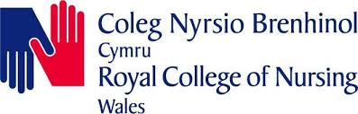












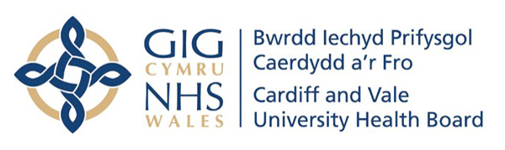
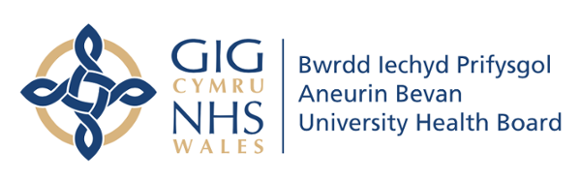
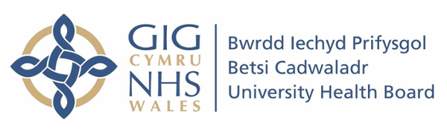
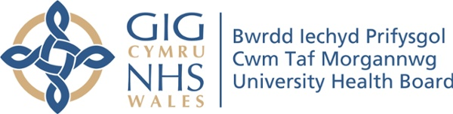

Programme Overview

Qualification overview
The RCN Wales Healthcare Connect Programme is a 6-month work-based learning qualification. It is designed for those who wish to study a degree level programme in nursing or midwifery, who either did not gain the full entry requirements or feel they would benefit from further experience before they enrol on their degree.
The purpose of this vocational qualification is to develop the trainee’s knowledge, understanding and skills of nursing/midwifery whilst working as a Healthcare Support Worker (HCSW). Working alongside registered and experienced professionals in NHS Wales health boards/trusts, the trainee will develop their skills, enabling them to continue their path to becoming a registered nurse / midwife.
The course offers a unique opportunity to:
- earn while you learn – as an employed HCSW in one of the health boards/trusts trainees will work between 12 and 30 hours.
- attend university, one day a month, to develop knowledge of the fields of nursing and the role of a healthcare support worker, practical skills sessions, learn how to write an application statement and university finance.
- attend college one day a week to gain a level 3 qualification which is recognised by the partner universities and helps facilitate access to their full-time nursing/midwifery degree. The qualification is accredited by Agored Cymru.
Course title: Diploma in the Royal College of Nursing Wales Healthcare Connect | Level | Credits
Mental Health & Wellbeing | 2 | 2
Principles of Health Promotion | 2 | 2
Dementia Awareness | 2 | 2
Promote Equality and Inclusion | 3 | 2
Principles for Implementing Duty of Care | 3 | 1
Promote Person Centred Approaches | 3 | 6
Promote and Implement Health and Safety | 3 | 6
Promote Good Practice in Handling Information | 3 | 2
Working within Multidisciplinary, Primary, Secondary and/or Community Teams | 3 | 4
Principles of Safeguarding and Protection in Health and Social Care | 2 | 3
Engage in Personal Development | 3 | 3
Communication Skills for use within Healthcare Settings | 3 | 7
Infection Prevention and Control | 3 | 2
Study Skills for HCSW: Reflective Practice | 3 | 3
Total number of credits for the qualification |  | 45

On successful completion of the qualification, trainees are eligible to apply direct to a partner university for a place on a nursing / midwifery degree. The expected start date for the degree would be April 2026.

Health Education and Improvement Wales (HEIW)

About HEIW
Health Education and Improvement Wales (HEIW) was established on the 1 October 2018. It is a Special Health Authority within NHS Wales. Sitting alongside Health Boards and Trusts, HEIW has a leading role in the education, training, development, and shaping of the healthcare workforce in Wales. Its key functions include education and training, workforce development and modernisation, leadership development, strategic workforce planning, workforce intelligence, careers, and widening access.
HEIW’s purpose is, “as part of the NHS, to work with partners to plan, develop, educate and train the current and future workforce”.
The RCN Wales Healthcare Connect Programme is managed by HEIW. But is run in partnership with RCN Wales, NHS Wales health boards colleges and universities. Whilst undertaking the programme, you will attend weekly face-to-face teaching sessions at college and/or university.


Programme Delivery
Partner education providers to the RCN Wales Healthcare Connect Programme will be either colleges or universities.

Colleges
The colleges of further education (FE) primary role will be the delivery and support of the trainees whilst they are completing the Agored Cymru level 3 Diploma in the Royal College of Nursing Wales Healthcare Connect. This qualification has been agreed by the partner universities as an acceptable qualification to allow progression onto their nursing/midwifery degrees. The qualification is designed for individuals who did not achieve the necessary the level 3 grades for a successful nursing or midwifery application.
The areas of consideration contained in this document are in addition to the ordinary expectation of teaching, delivery, assessment and quality assurance which constitute normal activity for the college.

Recruitment

Pre-programme
- Advertising
The colleges will be responsible for the main advertising of the programme. The programme can be advertised to the current cohort of level 3 learners. Whilst it is expected that the main interest will come from students studying vocational level 3 Health and Social Care or Access to Nursing courses, the course is also open to those following the A level route. It is not necessary for students to be currently studying a health or care related qualification.
In addition to the current cohort of students, the programme is also available to previous students who had a desire and the qualities to become a nurse or midwife but may have not attained sufficient grades to progress onto the degree programme.
The timing and methodology of the advertisement is a decision for the college, but consideration may be given to the timings of health board recruitment (appendix 1). The window for recruitment is set before the release of current academic grades to allow for the initiation and progress of pre-recruitment checks. There are two windows of health board recruitment, with the first being for those who have already attained their level 3 qualifications and the second for those expecting results in August of the current academic year.
Students should be encouraged to apply for the programme if there are concerns about achieving the necessary grades or if the student feels that they would benefit from the opportunity to gain practical experience. The later perhaps being of greater significance for students currently following a non-health/care related pathway.
HEIW are willing to visit partner colleges around Dec/Jan of the current academic year to make an initial ‘pitch’ to students who may have an interest in the course.
Colleges are encouraged to issue and use the Recruitment Journey Passport (appendix 2) to provide guidance and trail for the trainees as they progress through their onboarding to the programme.
Administration
The Agored Cymru L3 Diploma in the Royal College of Nursing Wales Healthcare Connect must be added to the college qualification framework to enable delivery of the qualification.

Selection and on-boarding of trainees
The initial selection of trainees for the RCN Wales Healthcare Connect Programme will be made by the colleges.
Potential trainees must:
- have completed/expected to complete a qualification equivalent to three A levels or 3 A levels
- have achieved a grade C in GCSE Maths and English/Welsh (or equivalent qualification)
- the values and behaviours expected of a professional working in a health/care setting

These entry requirements are to ensure that the student has sufficient qualifications to progress onto the nursing/midwifery degree course at a partner university following completion of this programme.
Where potential trainees have qualifications other than those indicated above, it may be necessary to check with the partner university that they will be accepted, to ensure the progression pathway after the programme is not closed.
Once a trainee has had a successful college interview the college will pass the trainees contact details to the employing health board. The college will also pass a hidden job application to trainees who have successfully met the starting qualification check and college interview, starting the employment application process. This link will have been previously made available to the colleges by the health boards/trusts.
The health boards/trusts will communicate the outcome of the employment interviews with the colleges. Colleges should not register trainees on the Agored Cymru qualification until they have received notification that the trainees have had a successful interview and been employed. It is possible that not all applicants will be offered employment. This could be due to limited vacancies in some health boards/trusts/trusts or unsuccessful employment interview. Where employment is not offered, it is not possible for the applicant trainee to continue with the programme as both the academic and employment elements must be fulfilled.
Once trainees have completed both the college and employment interviews the college needs to notify HEIW of the outcomes (for both trainees intending to continue and those wishing to withdraw). Every trainee who is offered a place, regardless of whether they take up the place should complete an Intention to Progress form (appendix 3). These forms are to be shared with HEIW. The purpose of this is to ensure HEIW are aware of the cohort size and distribution of trainees across NHS Wales. In addition, the information collated on starting qualifications will enable reflection for future cohorts.

Delivery of the programme
The college will create an appropriate delivery and assessment plan for the Agored Cymru L3 Diploma in the Royal College of Nursing Wales Healthcare Connect qualification. The programme would be expected to start delivery at the beginning of the academic year and facilitate successful completion by the end of February.
The completion date has been agreed to allow for progression of successful trainees onto the April intake for the nursing/midwifery degree programmes in the partner universities.
HEIW expect that attendance at the study days will be recorded and the attendance at these days to be shared with both HEIW and the health boards/trusts. This requirement is essential to ensure the trainees receive payment for the 7.5 hours of study leave as part of their monthly salary. As this payment is made from public funds, it would be unacceptable for the trainee to be receiving payment where they had not been attending. The college would follow their normal attendance and registration procedures, payment will be made for any recognised positive attendance or authorised absence.
Assessment of the qualification will involve both theoretical and competency-based assessments. There is an approved workbook which can be used as a resource to centralise a trainee’s responses for assessment. However, it is acknowledged that this may not be an appropriate assessment methodology for all trainees. In these circumstances the college may choose alternative methodologies, provided they produce the required evidence to demonstrate achievement of the assessment criterion and are acceptable to the awarding body.
Partner colleges are expected to work together in the development and sharing of all-Wales resources. This will reduce the burden of work on any one college whilst ensuring the optimum use of time and expertise to ensure that replication and repetition of effort is reduced. HEIW support this approach as it also helps to ensure the reputation of the programme is maintained on an all-Wales basis and helps to ensure standardisation of the programme wherever it is delivered.
The Agored Cymru L3 Diploma in the Royal College of Nursing Wales Healthcare Connect has assessment criteria which cover practical skills. Some of these need to be demonstrated in practice and will be signed off by a registered nurse in the trainee’s workplace, others require a professional discussion to be held with the work-based assessor (appendix 4). The college is best placed to determine a suitable place for the assessments and may determine that some/all of them may be held within the college and not in the workplace.
Where a trainee makes the decision to withdraw from the course, the college is to notify HEIW of this intention via the notification to withdraw form (appendix 4). Whilst withdrawal from the academic element of the programme may be immediate, the trainee will be required to work their notice period as per their employment contract. The trainee will be expected to offer their resignation to the health board in accordance with their policy and procedure. HEIW will not be responsible for this notification. Where the college is unable to obtain the learner signature on the notification to withdraw form, it will be acceptable for a tutor to sign the form.
Internal quality assurance (IQA) will be the responsibility of the college, and this will be monitored by the awarding body following their external quality assurance (EQA) processes and procedures. HEIW will facilitate a cross-college moderation event once per cohort. The purpose of this event is to ensure equity in assessment for all trainees, regardless of the partner college they are studying with. The partner colleges are expected to attend this event.
The colleges will support and guide the trainee in the post course options, these include:
- Entry into undergraduate programme at partner university in April.
- Entry into undergraduate programme at partner university in September (recognising that these programmes are more generally competitive)
- Remain working as a Healthcare Support Worker – this must be supported by the clinical area manager and approved due to the need to change the contract of employment. It is not automatically available to the trainees.
- Remain working as a Healthcare Support Worker and apply for the flexi route into nursing/midwifery. This is very competitive, and the health boards/trusts have their own procedures for this route. It should be recognised that they are recruiting and filling these posts well in advance of the start date. This could mean that in reality, even though the policy says the trainee needs to have worked in the health board for at least 12 months, it could be more like 18 months before there is a vacant application stream.
- Complete the programme and leave the profession. It may be that the trainee decides that a career in nursing/midwifery is not for them. In these situations, the college may provide access to further career guidance or qualifications.
The college will also support the trainees in their direct application to a partner university. The intention of the course is to provide suitable candidates for the April intake of undergraduates onto the nursing/midwifery programmes. To ensure the trainees make a timely application for the spring intake this should be sent to the partner university by their agreed deadline. Where trainees are not intending to enter university in spring following commencement of the programme, the colleges will support and guide the trainee in other options.

Post course
It is anticipated that during the duration of the programme the college carry out course evaluation surveys. HEIW have an expectation that intelligence gathered through these surveys will be shared to ensure continued development and improvement of the programme.
The college will also be invited to any review of the Agored Cymru L3 Diploma in the Royal College of Nursing Wales Healthcare Connect. The qualification end date is currently 31st July 2029.

Universities
The university works in partnership to provide the trainees with valuable experience and to build confidence in the higher education environment. Whilst the university study days are funded by the university, the return is felt through the increase in applications to their undergraduate nursing/midwifery degree.
The university study days will be delivered by university staff. Experience has indicated that the trainees receive a positive experience where this member of staff has practical experience in a healthcare environment and is in a position that has strategic oversight to coordinate the university days. This will enable the study days to be varied and interactive including a variety of activities.
Partner universities provide the progression pathway for successful trainees as well as contributing a programme of delivery which is aimed at providing information and guidance to the trainees; enhancing their skills, knowledge and belief that a place on the undergraduate programme is achievable.
As such they are required to recognise the RCN Wales Healthcare Connect programme as a progression root onto the undergraduate nursing/midwifery degree programmes. On the provision that previous level 3 qualifications are recognised and grade C in GCSE Maths and English has been achieved.
To ensure this pathway, colleges will refer any queries over acceptable qualifications direct to the partner university for the final decision on acceptability for the progression pathway.
Partner universities will offer a programme of study, one day a month for the duration of the programme; the first session will be in September. The content of these sessions is variable, but to ensure consistency of the programme and equality of experience the expected programme would include sessions on:
  - introduction to higher education
  - introduction to the fields of nursing
  - introduction to the role of HCSW
  - HEI finance talk
  - statement writing
  - clinical scenario development /reflection
  - introduction to clinical skills
HEIW expect that attendance at the study days will be recorded and the attendance at these days to be shared with both HEIW and the health boards/trusts. This requirement is essential to ensure the trainees receive payment for the 7.5 hours of study leave as part of their monthly salary. As this payment is made from public funds, it would be unacceptable for the trainee to be receiving payment where they had not been attending. The university would follow their normal attendance and registration procedures, payment will be made for any recognised positive attendance or authorised absence.
Following successful completion of both the academic and employment parts of the programme, successful trainees will be able to make a direct application to the university for a place on their undergraduate programme for nursing/midwifery. The university commits to a guaranteed interview being offered to the trainee, but acceptance is wholly at the discretion of the university, following this interview.
If the university does not accept the trainee onto the nursing/midwifery they may signpost them to other opportunities which exist within their institution

Welsh language
Partner colleges/universities are committed to training through the medium of Welsh. Trainees have the right to be assessed via the medium of Welsh.

Equality, diversity and inclusion
The partnership is committed to supporting, developing and promoting equality, diversity and inclusion in all of its activities. The programme aims to establish an inclusive culture, free from discrimination, based upon the values and behaviours developed by academic and NHS Wales staff.

Key Contacts

Further information
- Agored Cymru Website
Agored Cymru

Level 3 Diploma in the Royal College of Nursing Waleshttps://www.agored.cymru/Qualification-Guide/328 Heathcare Connect

- Health Education and Improvement Wales (HEIW) Internet site
Home - HEIW (nhs.wales)
RCN Heathcare Connect Programme

Points of contact
HEIW – to send key documents and registers: HEIW.HealthcareConnectEnquiries@wales.nhs.uk

Health board contacts to send registers to ensure correct salary paid to trainees
Aneurin Bevan University Health Board: Paige.difranco @wales.nhs.uk or rebecca.scottt2@wales.nhs,uk
Betsi Cadwalader University Health Board: Anne-Marie Mason Anne-Marie.Mason@wales.nhs.uk

Central health board contacts for liaison re trainees
Aneurin Bevan University Health Board: Siân Kinsella sian.kinsella3@wales.nhs.uk
Betsi Cadwalader University Health Board: Ade Evans ade.evans@wales.nhs.uk

Appendices

Appendix 1 – Health Board Recruitment Flow diagram

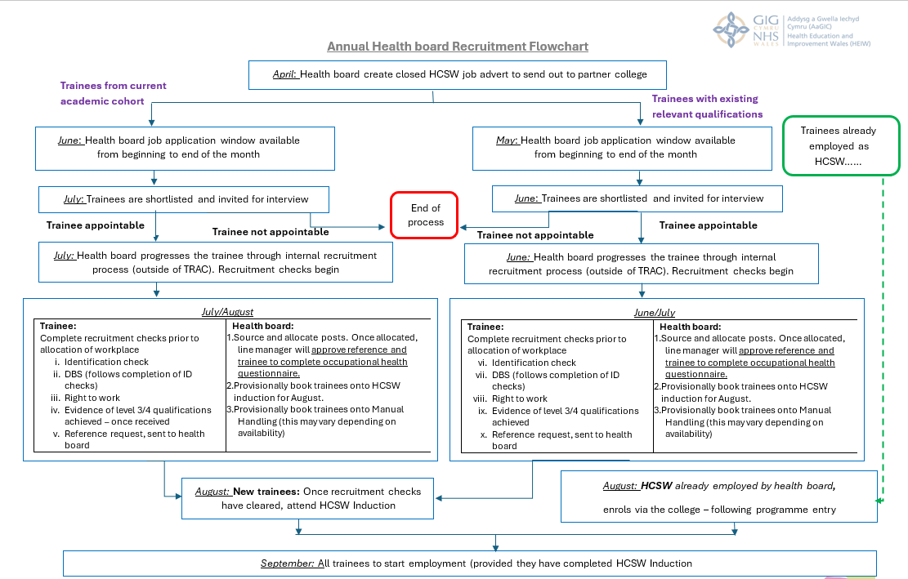

Appendix 2 – Recruitment Journey Passport

Name:
Contact email:
Contact telephone number:
Trainees not currently employed by a health board only please complete SECTION A.
Trainees already employed by a health board please complete SECTION B.
Trainees employed by a 3rd party organisation, who intend to continue this employment to meet the employment element of the programme complete SECTION C.
SECTION A – Recruitment Checks
Following a successful interview, you will be required to complete the recruitment checks for the health board. Please ensure these checks are completed promptly, as any delay may impact your ability to start employment.
Recruitment Check | Date Completed
Identification (1 x photographic ID and 2x proof of address)
DBS (this can only take place once I.D checks have been completed).
Right to work form
Qualifications (If you've already received your qualifications please send proof immediately. If you're still studying, provide it as soon as your results are available).
Reference (This will be requested from the health board. To facilitate a prompt response, please ensure your referee is aware of the upcoming request).
Occupational Health Questionnaire (Please have your immunisation history ready)
Once all your recruitment checks are complete, you will be able to attend the Healthcare Support Worker induction hosted by your chosen health board.

SECTION B – Those already employed by the health board
I confirm that my manager has approved my participation in this programme and is aware of the 7.5 hours study leave each week to enable my attendance at college/university.
Signature
Date

SECTION C – Those employed by an independent provider
I can confirm that my workplace employs registered nurses, with whom I work regularly and who agree to sign off required practical elements of my qualification.
Signature
Date

Appendix 3 – Intention to Progress Form
Name:
Contact email:
Contact telephone number:
Intention to Progress onto RCN Wales Healthcare Connect Programme

Please complete EITHER section A or B.
SECTION A – Decision to withdraw
I confirm that I no longer wish to proceed with my place on the RCN Wales Healthcare Connect Programme. I understand that this means I am no longer eligible for either the academic or employment elements of the programme.
Please provide a brief reason for this decision:

Signature
Date

SECTION B - Decision to proceed
I confirm that I wish to proceed with my place on the RCN Wales Healthcare Connect Programme.
Partner College to be attended
Partner university to be attended
Health board for employment (include location if known) | e.g. Aneurin Beven – Royal Gwent
Qualification(s) gained prior to commencement of RCN Wales Health Care Programme  (at level 3 / 4) | Full title of qualification (e.g. level 3 diploma health & social care)
 | Grade(s) achieved (e.g.PPM)

Signature
Date

Appendix 4 – Competency Based Assessments

Unit Code | Module | Assessment Criteria | Work Based Assessor | Registered Nurse
PT12CY138 | Principles of Safeguarding and Protection in Health and Social Care | 5.1 | 
PT12CY138 |  | 5.2
PT12CY138 |  | 5.3
PT13CY098 | Promote and Implement Health and Safety | 2.1
PT13CY098 | Promote and Implement Health and Safety | 2.2
PT13CY098 | Promote and Implement Health and Safety | 2.3
PT13CY098 | Promote and Implement Health and Safety | 2.4
PT13CY098 | Promote and Implement Health and Safety | 2.5
PT13CY098 | Promote and Implement Health and Safety | 2.6
PT13CY098 | Promote and Implement Health and Safety | 4.1
PT13CY098 | Promote and Implement Health and Safety | 4.2
PT13CY098 | Promote and Implement Health and Safety | 4.3
PT13CY098 | Promote and Implement Health and Safety | 5.1
PT13CY098 | Promote and Implement Health and Safety | 5.2
PT13CY098 | Promote and Implement Health and Safety | 5.3
PT13CY098 | Promote and Implement Health and Safety | 6.1
PT13CY098 | Promote and Implement Health and Safety | 6.2
PT13CY098 | Promote and Implement Health and Safety | 7.1
PT13CY098 | Promote and Implement Health and Safety | 7.2
PT13CY098 | Promote and Implement Health and Safety | 7.3
PT13CY098 | Promote and Implement Health and Safety | 7.4
PT13CY098 | Promote and Implement Health and Safety | 8.1
PT13CY098 | Promote and Implement Health and Safety | 8.2
PT13CY098 | Promote and Implement Health and Safety | 8.3

PH53CY126 | Infection Prevention and Control | 2.1
PH53CY126 | Infection Prevention and Control | 2.2
PH53CY126 | Infection Prevention and Control | 2.3
PH53CY126 | Infection Prevention and Control | 2.4
PH53CY126 | Infection Prevention and Control | 2.5
PH53CY126 | Infection Prevention and Control | 2.6
PH53CY126 | Infection Prevention and Control | 2.7
PH53CY126 | Infection Prevention and Control | 3.1
PH53CY126 | Infection Prevention and Control | 3.2
PH53CY126 | Infection Prevention and Control | 3.3
PH53CY126 | Infection Prevention and Control | 3.4
PT13CY120 | Communication Skills for use within Health and Social Care | 2.1
PT13CY120 | Communication Skills for use within Health and Social Care | 2.2
PT13CY120 | Communication Skills for use within Health and Social Care | 2.3
PT13CY120 | Communication Skills for use within Health and Social Care | 4.1
PT13CY120 | Communication Skills for use within Health and Social Care | 4.2
PT13CY120 | Communication Skills for use within Health and Social Care | 4.3
PT13CY120 | Communication Skills for use within Health and Social Care | 4.4
PT13CY120 | Communication Skills for use within Health and Social Care | 5.1
PT13CY120 | Communication Skills for use within Health and Social Care | 5.2
PT13CY120 | Communication Skills for use within Health and Social Care | 5.3
PT13CY120 | Communication Skills for use within Health and Social Care | 5.4
PT13CY120 | Communication Skills for use within Health and Social Care | 5.5
PT13CY120 | Communication Skills for use within Health and Social Care | 6.1
PT13CY120 | Communication Skills for use within Health and Social Care | 6.2
PT13CY100 | Promote Person Centred Approaches | 2.1
PT13CY100 | Promote Person Centred Approaches | 2.2
PT13CY100 | Promote Person Centred Approaches | 2.3
PT13CY100 | Promote Person Centred Approaches | 3.1
PT13CY100 | Promote Person Centred Approaches | 3.2
PT13CY100 | Promote Person Centred Approaches | 3.3
PT13CY100 | Promote Person Centred Approaches | 4.1
PT13CY100 | Promote Person Centred Approaches | 4.2
PT13CY100 | Promote Person Centred Approaches | 4.3
PT13CY100 | Promote Person Centred Approaches | 4.4
PT13CY100 | Promote Person Centred Approaches | 5.1
PT13CY100 | Promote Person Centred Approaches | 5.2
PT13CY100 | Promote Person Centred Approaches | 5.3
PT13CY100 | Promote Person Centred Approaches | 5.4
PT13CY100 | Promote Person Centred Approaches | 6.1
PT13CY100 | Promote Person Centred Approaches | 6.2
PT13CY100 | Promote Person Centred Approaches | 6.3
PT13CY100 | Promote Person Centred Approaches | 6.4
PT23CY182 | Promote Equality and Inclusion | 2.2
PT23CY182 | Promote Equality and Inclusion | 3.1
PT23CY182 | Promote Equality and Inclusion | 3.2
PT23CY181 | Principles for Implementing Duty of Care | 3.1
PT23CY181 | Principles for Implementing Duty of Care | 3.2
PT13CY099 | Promote Good Practice in Handling Information | 2.2
PT13CY099 | Promote Good Practice in Handling Information | 2.3
PT13CY099 | Promote Good Practice in Handling Information | 3.1
PT13CY099 | Promote Good Practice in Handling Information | 3.2
AF43CY010 | Working within Multidisciplinary, Primary, Secondary and/or Community Teams | 2.1
AF43CY010 |  | 2.2
AF43CY010 |  | 2.3
AF43CY010 |  | 2.4
AF43CY010 |  | 2.5
AF43CY010 |  | 2.6
AF43CY010 |  | 3.1
AF43CY010 |  | 3.2
AF43CY010 |  | 3.3
AF43CY010 |  | 3.4
AF43CY010 |  | 3.5
PT23CY187 | Engage in Personal Development | 3.2
PT23CY187 | Engage in Personal Development | 3.3
PT23CY187 | Engage in Personal Development | 4.1
PT23CY187 | Engage in Personal Development | 4.2
PT23CY187 | Engage in Personal Development | 4.3

Appendix 5 – Notification to withdraw
Name:
Partner college currently attending
Partner university to be attended
Health board for employment

Notification to withdraw from RCN Wales Healthcare Connect Programme

Please note that when you withdraw from the academic element of the programme, you may be eligible to immediately stop attending college and university. However, you are contractually obliged to work your notice period with the health board as your employer. The duration of this notice period will be stated in your contract of employment and in the health boards/trusts policies and procedures.
I confirm that I wish to withdraw from the RCN Wales Healthcare Connect Programme. I understand that this means I am no longer eligible for either the academic or employment elements of the programme.
Please provide a brief reason for this decision:

I confirm that I have notified my employer in writing of my intention to withdraw from the programme.
Signature
Effective withdrawal date
Termination of employment date

Appendix 6 – Frequently Asked Questions - Colleges
Support for Trainees

Q. With the trainee's consent, who should we inform if the trainee has any specific learning needs?
To ensure the trainee has the best learning experience, it would be helpful for the university to be informed. This will enable the university to make any necessary adjustments to the days the trainee will spend with them. Any adjustments required for the employment element of the programme will be identified and discussed as part of the occupational health, pre-employment checks.
Q. Do we provide support to learners applying for nursing or midwifery degree courses?
Yes, for trainees aiming to enrol directly onto a full-time nursing or midwifery course, please guide them to apply directly through the university rather than UCAS.
For those planning to join the April intake for nursing or midwifery, encourage them to submit their application by the end of November to allow sufficient time for the university to conduct interviews.
Q. What options are available to trainees upon completion of the programme?
- Full-Time Nursing/Midwifery Course – April Intake

- Full-Time Nursing/Midwifery Course – September Intake

- Remain in work and apply for the flexible route

- Remain in work as a HCSW

- Complete the programme and leave the profession

Practical Learning Outcomes

Q. Is the college responsible for signing off the trainees' practical learning outcomes?
Yes, the college collaborates with the health board to sign off the trainees' practical learning outcomes. Please refer to appendix 3, which outlines who is responsible for signing off each practical learning outcome.
Q. Are work-based assessors required to visit the clinical area to hold professional conversations for signing off the trainees' practical learning outcomes?
No, not necessarily.

Even if the work-based assessors visited the trainees in their clinical area they need to carry out their professional conversations away from the clinical area. If the work-based assessor feels it is more appropriate, those conversations could take place on the college campus.

Q. Is there a specific timeframe for signing off practical learning outcomes?

If possible, we recommend that the practical learning outcomes for each module be completed alongside the theoretical teaching. Trainees should be encouraged to engage in these conversations with registered nurses in their workplace, where they are required to sign off on the practical learning outcomes.
This approach will help prevent a backlog of practical learning outcomes needing to be signed off towards the end of the programme.
Communication and Notifications

Q. Are we required to notify partner organisations about trainees' attendance?
Yes.
You will be required to send registers to a nominated person in your partner health board on a weekly basis and to HEIW. This will allow health boards/trusts & HEIW to monitor unauthorised absences
Q. Who should we contact if a trainee is struggling with the theoretical aspects of the programme?

In the first instance, the college is responsible for supporting the theoretical aspects of the programme. If the problem continues, then HEIW should be notified (HEIW.healthcareconnectenquiries@wales.nhs.uk). HEIW will then facilitate a tripartite meeting between the college, the health board and HEIW to determine the best approach for the trainee.

Q. Will trainees continue to have protected study hours during weeks when the college is closed?
Yes.
Trainees are expected to fulfil their contracted employment hours over the Christmas period, even though the college is closed. However, the health board will continue to schedule a 7.5-hour paid study day for the trainee each week. The protected study time may not fall on the usual college day, as this will depend on the timing of Christmas Day and New Year’s Day. This arrangement ensures they have dedicated time to complete the required theoretical work.
Q. Who must we notify if a trainee withdraws from the programme?

If a trainee withdraws from the programme, please notify HEIW at HEIW.healthcareconnectenquiries@wales.nhs.uk

Q. Who do we need to notify about trainee outcomes at the end of the programme?
HEIW need to be informed of all trainee outcomes following the completion of the 24-week programme. HEIW will issue certificates to those who have completed both the theoretical and employment elements of the programme.

Please send the trainee outcomes to HEIW at HEIW.healthcareconnectenquiries@wales.nhs.uk

Q. What is the timeframe for notification for completing the programme?
For those trainees who have decided to apply for the full-time nursing or midwifery degree programme for the April intake, the partner university need to be notified by the end of March. Please ensure HEIW are copied into all these communications.
Q. What is the process if a trainee does not meet all the assessment criteria by the end of the programme?
We encourage trainees to remain in college to complete all aspects of the programme. If a trainee has outstanding practical learning outcomes at the end of the programme, they should discuss an extension of their employment contract with their manager. However, the manager is not obligated to grant this extension.
A delay in completing the programme will impact trainees who wish to pursue nursing or midwifery studies in April. It is also important to recognise that once the 24-week programme concludes, funding to support trainees attending college will no longer be available. Health boards/trusts are also under no obligation to continue the trainee’s employment. If a health board chooses to extend a trainee’s contract, they may not be able to support the release of the trainee to attend college days.

Appendix 6 – Frequently Asked Questions - Universities
Q How do we know how many trainees will be attending the university days
HEIW will send trainee’s confirmed desire to proceed forms once they have been received from the colleges following the trainee having a successful employment interview and begun recruitment checks.
Q. Who should I notify about the trainee’s attendance during the programme?
Please send register to HEIW at HEIW.healthcareconnectenquiries@wales.nhs.uk

This register is required to ensure the trainee received the correct pay and so should be sent ASAP following each university day.
Q. Are we obligated to take the trainee onto the nursing / midwifery course at the end of the programme?
No

There is a requirement for the partner university to offer a guaranteed interview to a trainee who has completed the programme, but this does not need to be converted in to place on the degree programme if the university does not feel this is appropriate.
Q. How do we know if the trainee has completed the programme?
The trainee will be issued with a certificate demonstrating successful completion of both the employment and theoretical elements of the course. In addition, as the L3 is an accredited course, Agored Cymru (the awarding body) will issue certification for this qualification.
Q. Will the trainee apply to the university via UCAS upon completion of the programme?
No.
As a partner university in the programme, the trainee will be able to make a direct application to the university.
Q. Can we decide what to deliver in the university days?
To ensure an equitable experience for all trainees whilst on the programme, HEIW request that there are common themes which are delivered during these university days:
  - introduction to higher education
  - introduction to the fields of nursing
  - introduction to the role of HCSW
  - HEI finance talk
  - statement writing
  - clinical scenario development /reflection
  - introduction to clinical skills

You are free to deliver these elements in any manner you prefer.

Version 1 - January 2025

