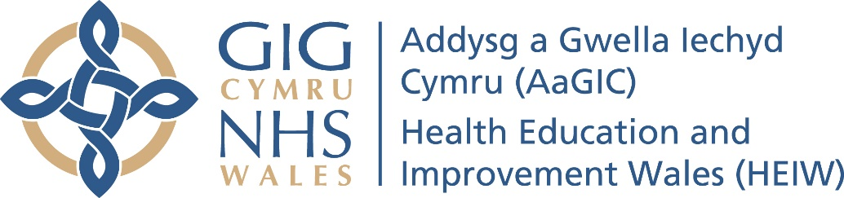

**Glamorgan Vale & Beacons DFT Scheme 2022/23**



