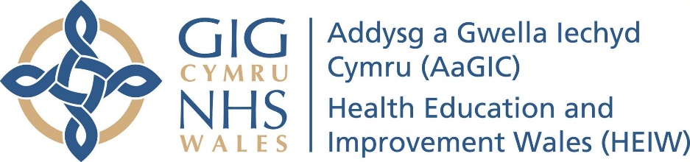

Travel, Expenses and Subsistence Policy for Dental Foundation Training
Introduction
Prior to booking or incurring any expense, all claimants should ensure they have checked and agreed with HEIWs DFT Manager that funding will be provided. Failure to do so may result in the claimant incurring the costs themselves.
During the foundation training year, travel expenses will be funded for travel to and from study days. Mileage will be reimbursed from your practice or place of work to the venue. (Please note you will need Business insurance on your policy to claim back mileage expenses)
It is expected that all claimants will take the necessary steps to ensure that costs incurred, are minimised where possible to ensure value for money. For example, by booking tickets in advance rather than on the same day, and when booking accommodation, the most cost effective and practical option is used.
Claims in excess of the amount indicated may be considered in exceptional circumstances but claimants should contact HEIWs DFT Manager for advice prior to booking any travel or accommodation. Failure to do so could result in non-payment.
Claims should not be submitted before the event but must be submitted within 28 days following the event or activity taking place.

Travel expenses claim criteria.
Reimbursement for travel may include one or more of the following: train, bus, tube, taxi.
Train travel should normally be standard class unless a first class/business class ticket can be purchased at a cheaper rate than the standard ticket. You must provide evidence of the first class/business class ticket being cheaper than a standard class ticket. Split ticketing options may also offer the best value for money.
Taxi fares will only be reimbursed under the following conditions:
- No suitable public transport is available to travel to and from the event location; or
- The taxi is shared by at least two attendees, and doing so provides a cost effective travel option.
The full names of all travellers must be included with the claim.
Reimbursement will only be made for travel from your practice or place of work to the event venue.
All taxi travel must be approved in advance by the DFT Associate Dean. Claims submitted without prior approval will not be reimbursed.
Tube: When travelling in London, underground costs will be reimbursed if using an Oyster Card and the card is registered, and a printout can be provided. Or where contactless payment is used, and a copy of a bank statement can be provided to show the payment.
Mileage will be reimbursed for the Journey” minus “home to base and return at 24p per mile for those using their own vehicle.
Mileage claimed will be checked to ensure that it is correct.
Mileage allowance should reflect shortest practicable route between practice and place visited.
Toll fees will not be reimbursed.
Reimbursement of any penalty imposed under the Road Traffic Act incurred whilst travelling to interview/event will not be paid.
Congestion charge will not be reimbursed.
Parking costs will be reimbursed upon production of a valid receipt or parking ticket.
(Please note to be reimbursed for your mileage you will need to upload a copy of your car insurance document to evidence that using your vehicle for business use is permitted.)

Accommodation expenses claim criteria.
For overnight B&B accommodation, the rate should not exceed £75 per night outside London/Cardiff and £100 within London/Cardiff plus, a meal allowance of £25 per 24-hour period.
Non-commercial accommodation (i.e. friends or relatives) per 24-hour period = £25 including meal allowance (no receipts required; course details needed.)

Any claimant participating in an event over two or more consecutive days will qualify for overnight accommodation OR if travel to the postgraduate centre exceeds two hours travel time from term time home address or practice address. Overnight accommodation may also be available to those foundation dentists that need to leave before 7 am to attend a study day.
Accommodation arrangements must be agreed in advance with the regional administrators /Training Programme Directors. Foundation Dentists will need to arrange and pay for this accommodation initially and claim this back.

If a dentist is claiming for an overnight stay, they must attach a receipt or statement to indicate that the expenses were actual and necessarily incurred. Please see above distances and times relate to place of work not home address.
Subsistence expenses claim criteria.
Meal allowances are payable where the activity requires you to be away from your base for more than five hours on official business.
Where lunch and refreshments are provided at the venue, a separate claim for lunch allowance is not payable.
Evening meal allowances can be claimed where you are away from your base/home for more than 10 hours, and unable to return to your base/home by 7.00pm.
Costs for alcohol cannot be claimed.
Summary of allowances from 1st April 2024
Night Subsistence Allowances from 1st April 2024

Accommodation claims are at the discretion of HEIW and must be agreed with regional administrators /Training Programme Directors in advance and are travel distance dependent.

Category of Accommodation | Rate Payable
Night Allowances: first 30 nights | Actual receipted cost of bed and breakfast up to a maximum of £75 outside London/Cardiff and £100 within London /Cardiff
Meals Allowance | Per 24-hour period: actual receipt cost up to the maximum amount of £25. Receipts are required to support the actual expenditure claimed.
Night allowances in non-commercial accommodation | Per 24-hour period: £25.00 No receipt is required.
Night Allowances: after first 30 nights | Employees who have certain responsibilities e.g. are married/in a civil partnership/living with a partner and/or have dependents residing with them Maximum amount payable: £35.00 Employees without responsibilities and those staying in non-commercial accommodation Maximum amount payable: £25.00

If a dentist is claiming for an overnight stay, they must attach a receipt or statement to indicate that the expenses were actual and necessarily incurred.

Day Subsistence Allowances from 1st April 2024
Period | Rate Payable
Day Meals Subsistence Allowances | Lunch Allowance (more than five hours away from base, including the lunchtime period between 12:00 pm to 2:00 pm) up to a maximum of £5.00. A receipt is required for the actual expenditure claimed, before claims are processed and reimbursement is made.  Evening Meal Allowance (more than ten hours away from base and return after 7:00 pm) up to a maximum of £10.00. A receipt is required for the actual expenditure.
Incidental Expenses Allowance (this allowance is subject to a tax liability) | Per 24-hour period: £4.20
Late Night Duties Allowance (this allowance is subject to a tax liability) | Per 24-hour period: £3.25
Queries
Please contact HEIW DFTenquiries HEIW.DFTenquiries@wales.nhs.uk if you have any queries regarding this policy.

