WDTFT Educational Supervisor Approval Process
Introduction
This guidance is to be read in conjunction with the Dental Educational Supervisor Approval Process platform (DESAP). Please try to answer the questions openly and with reflection to give a full account of yourself.

Access to the system.
To begin, you can access the Dental Educational Supervisor Approval Platform (DESAP) using this link to the https://desap.heiw.wales/
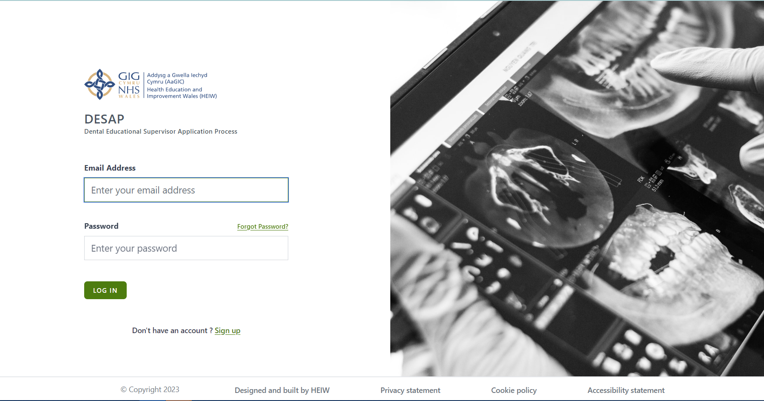
- If you are a new DESAP applicant, you will need to click “sign up” and complete the registration form.
(Please note, the password will need to be 10 characters long, must contain 1 upper case, 1 number and 1 special Character (no brackets))
- If you are an existing applicant, you will need to log in as usual
First Log-in
When you first log into the system you will see this dashboard.
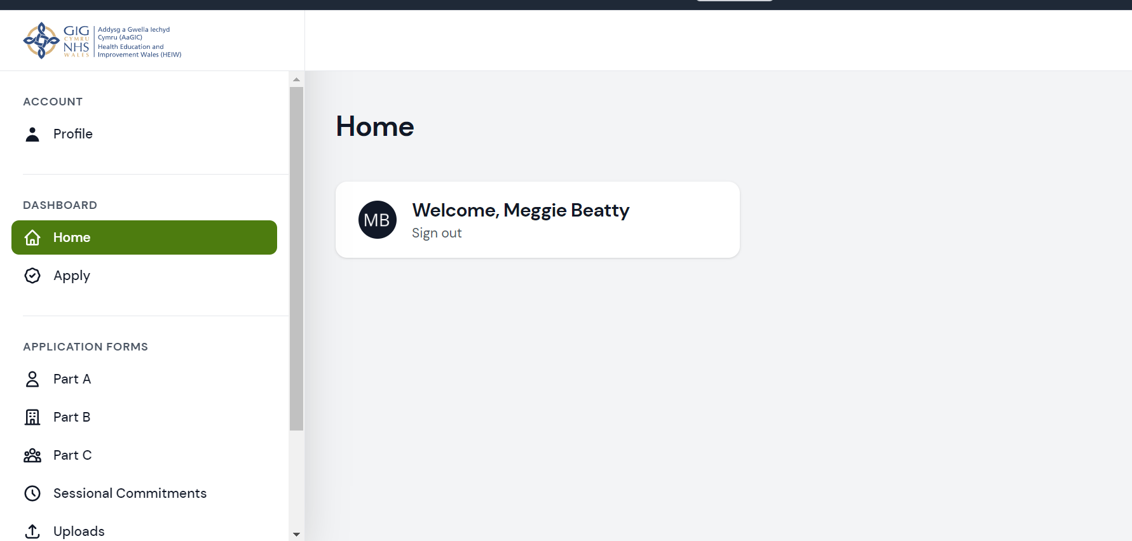

Account Tab
Under this tab you will find your profile. This allows you to make changes to your personal details, you will be able to amend your name, GDC number, contact number and change your password. If you want to make changes to the email address, you will need to contact an administrator.
Dashboard
The Dashboard is your home page and allows you to open and view your application.
WDTFT Application Forms
This is where you are able to find the WDTFT application form. Please be sure that you have ticked the relevant programme to apply to:
WDTFT or DFT – please note, if you are applying to both, you will need to complete two forms.
More information is available on our website. Before you start your application, you should visit our website and familiarise yourself with the roles and responsibilities of an Educational Supervisor and the facilities and equipment that need to be available in a Dental Foundation Training Practice.
You must be able to comply with all the mandatory requirements, in order to proceed with your application.

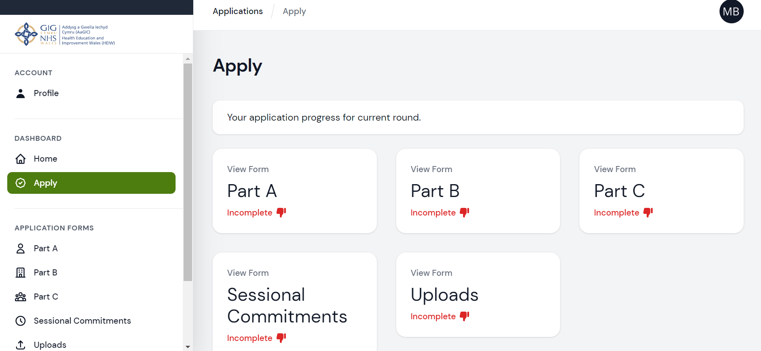
A few things to note:
- Please ensure you click ‘save changes’ before clicking to move onto the next page.
- Sessional Commitments will not apply to WDTFT
- Some elements require activity to be completed within certain time frames etc. If anything is entered outside of what is required, this will be flagged to you and may affect your ability to submit. If this is the case the system will let you know what is outstanding.
- The system will let you put in future dates if necessary.
- The system will not let you submit until all aspects of the approval requirements are met.
- If you add or update any information, there is a slight lag in the system and it doesn’t appear straight away.

Part A
Part A is basically information about the Educational Supervisor.
Once you have clicked Part A, you will see that a form has been created for you. You will need to click on the edit button to open the form.
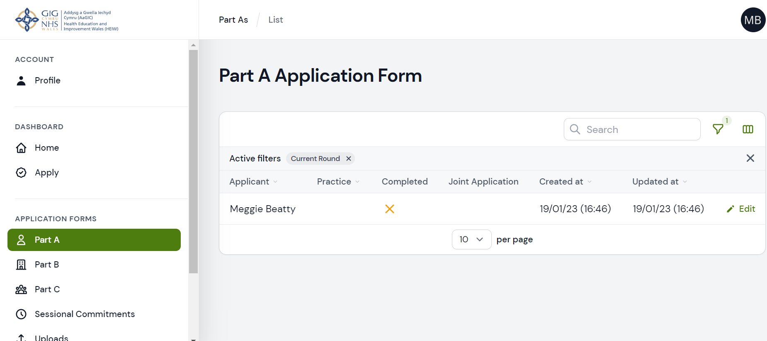
There are 10 tabs to complete; please make your way through each one ensuring you save before moving on to the next page.
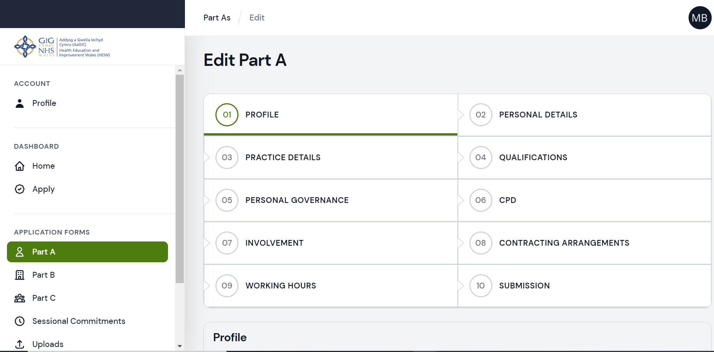

Once you have completed Part A, save and submit. Your Dashboard will be updated to show it is complete. The form will be locked, and you will be unable to edit.
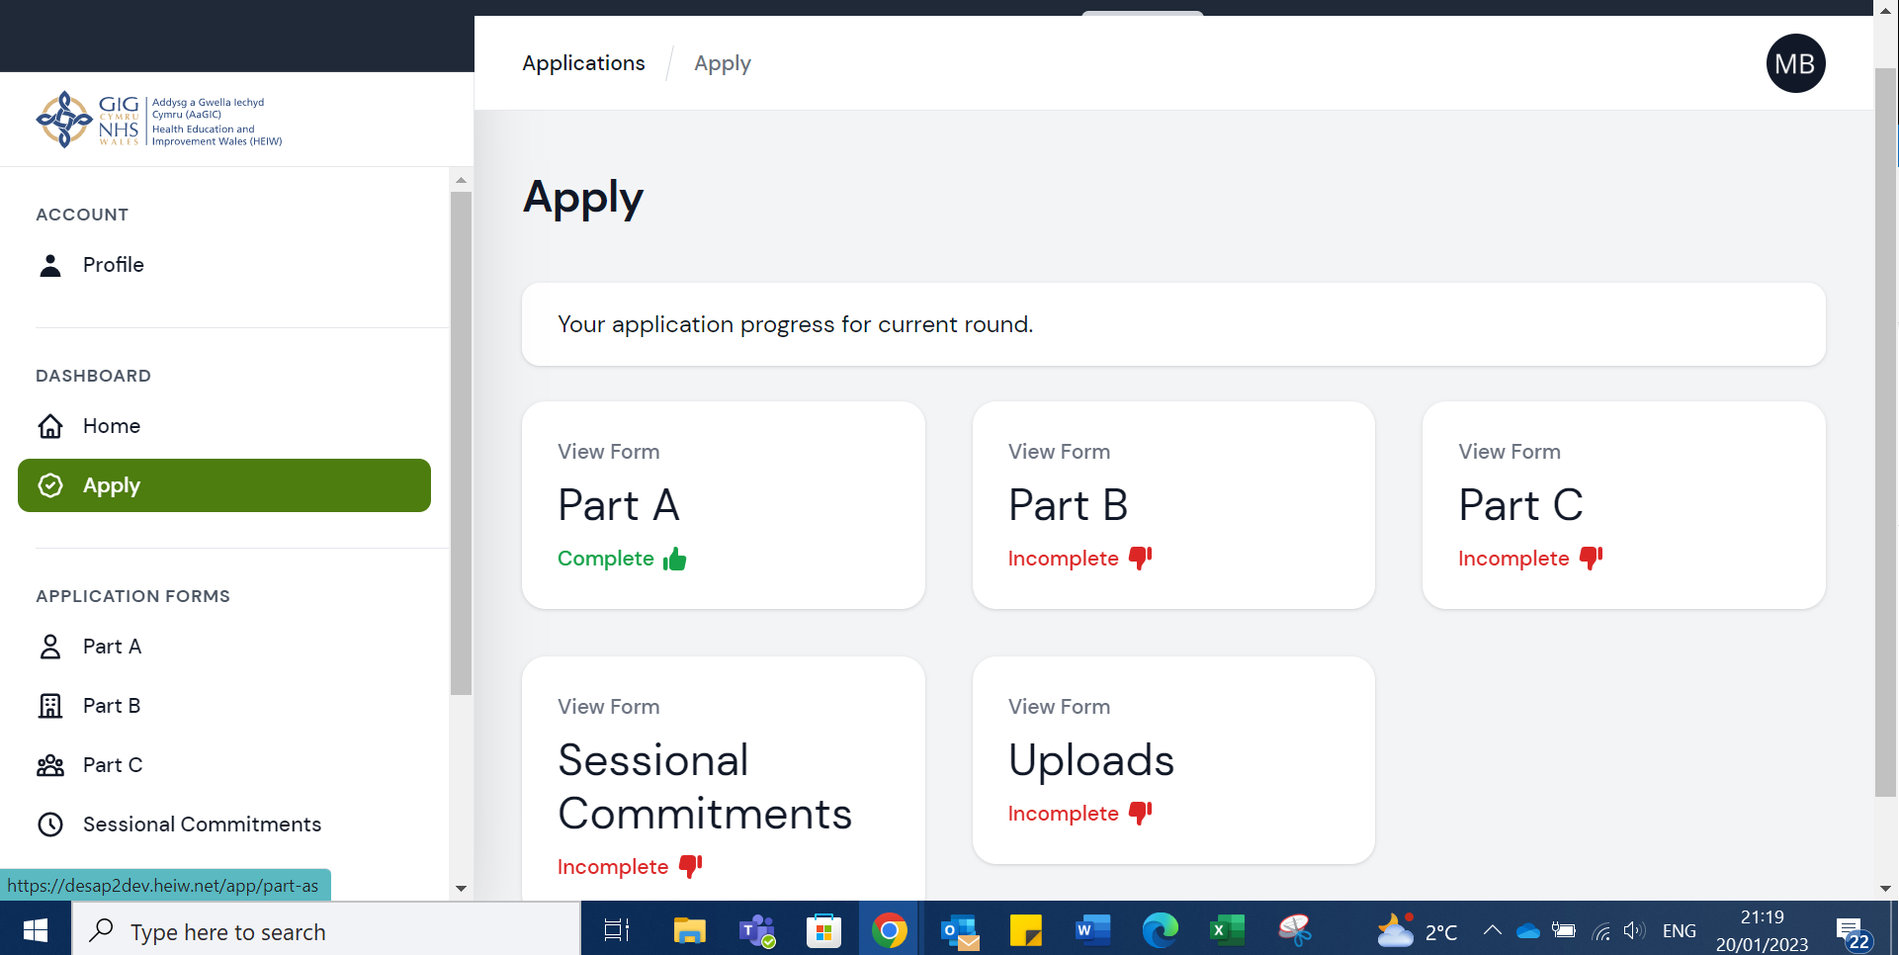

Part B
As with Part A, to access Part B click the apply button and then Part B.
Once you have clicked Part B, you will see that a form has been created for you. You will need to click on the edit button to open the form.
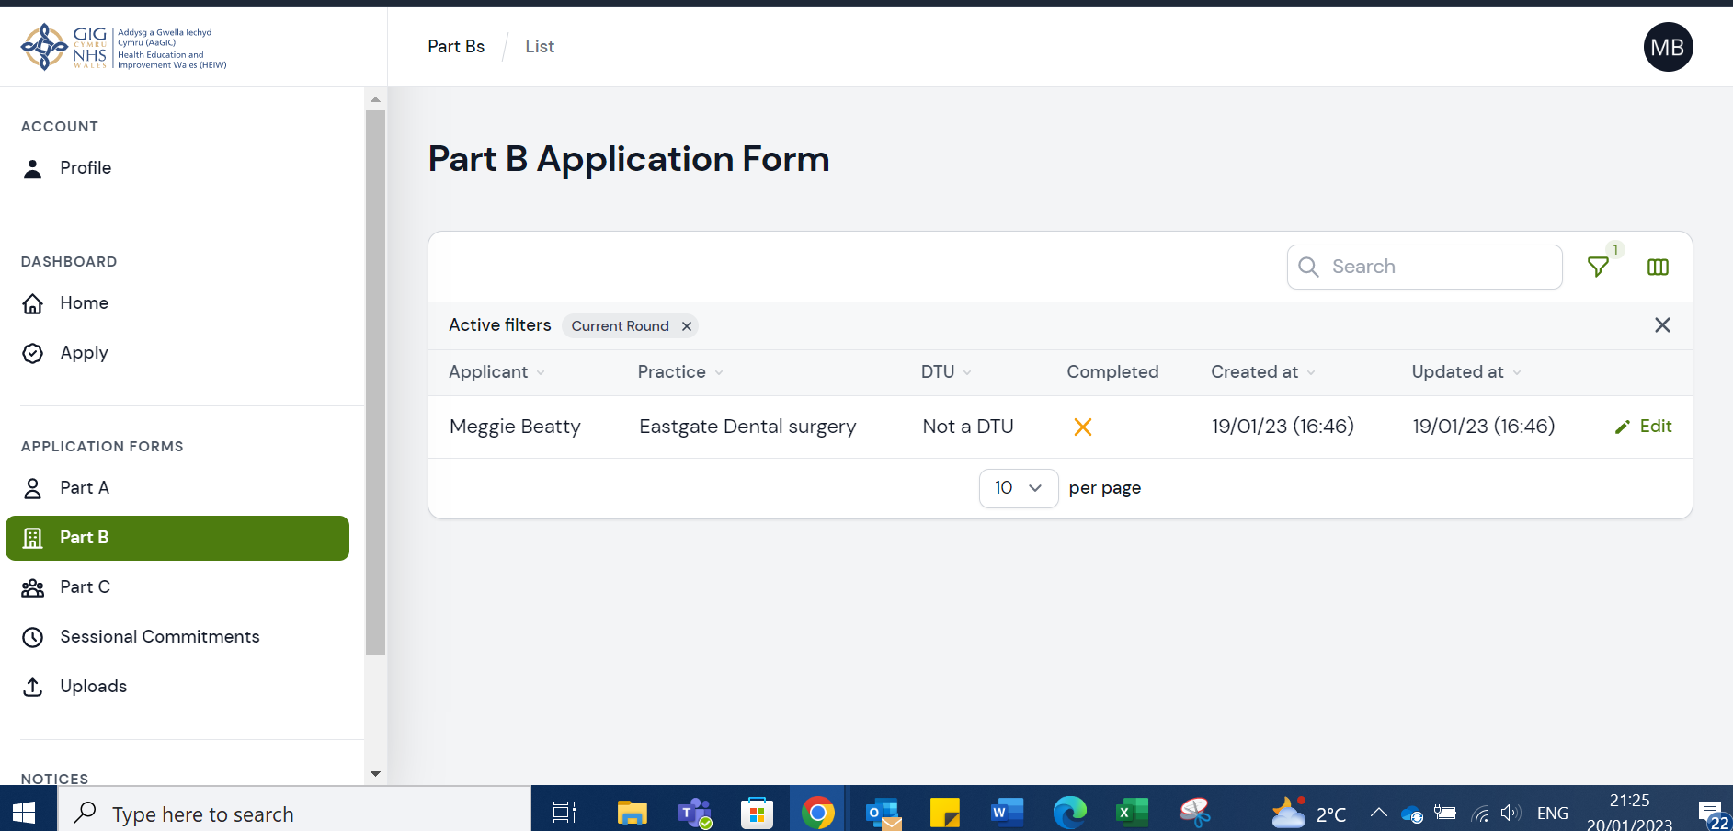

Part B is essentially about the applicant and the practice.
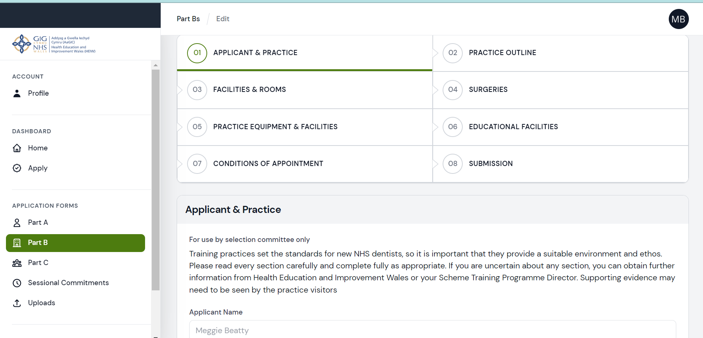
There are 8 tabs to complete; please make your way through each one ensuring you save before moving on to the next page.
Once you have completed Part B, save and submit. Your Dashboard will be updated to show it is complete. The form will be locked, and you will be unable to edit.
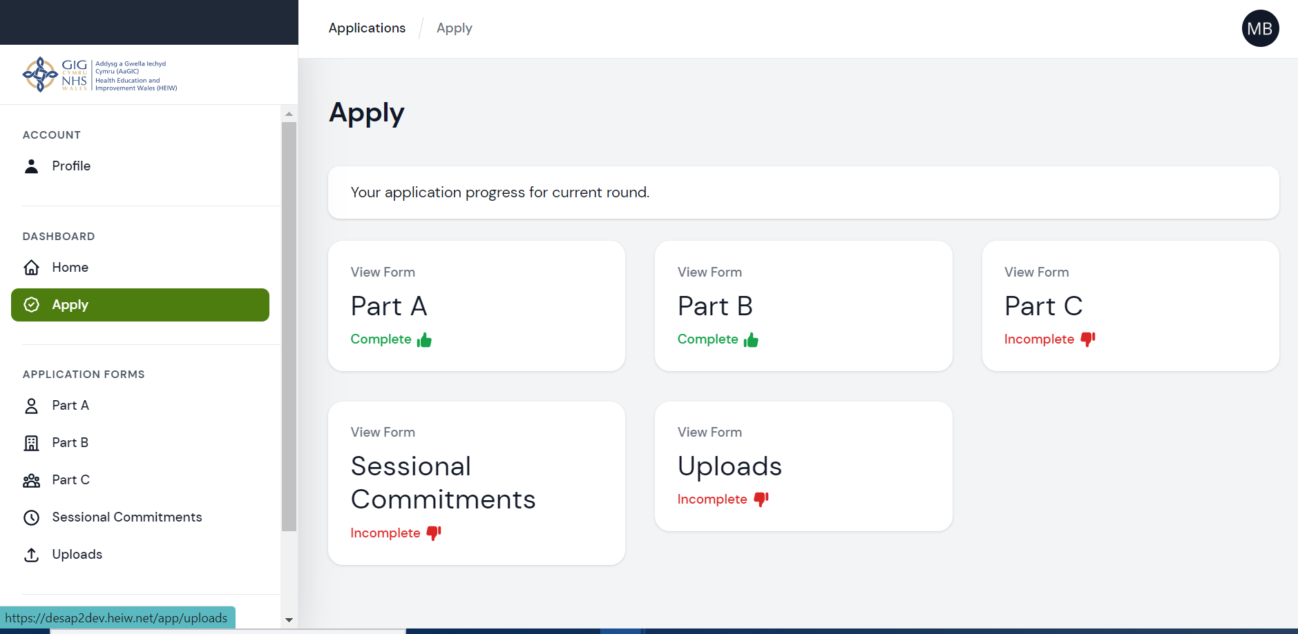

Part C
As with Part B, to access Part C click the apply button and then Part C.
Once you have clicked Part C, you will see that a form has been created for you. You will need to click on the edit button to open the form.
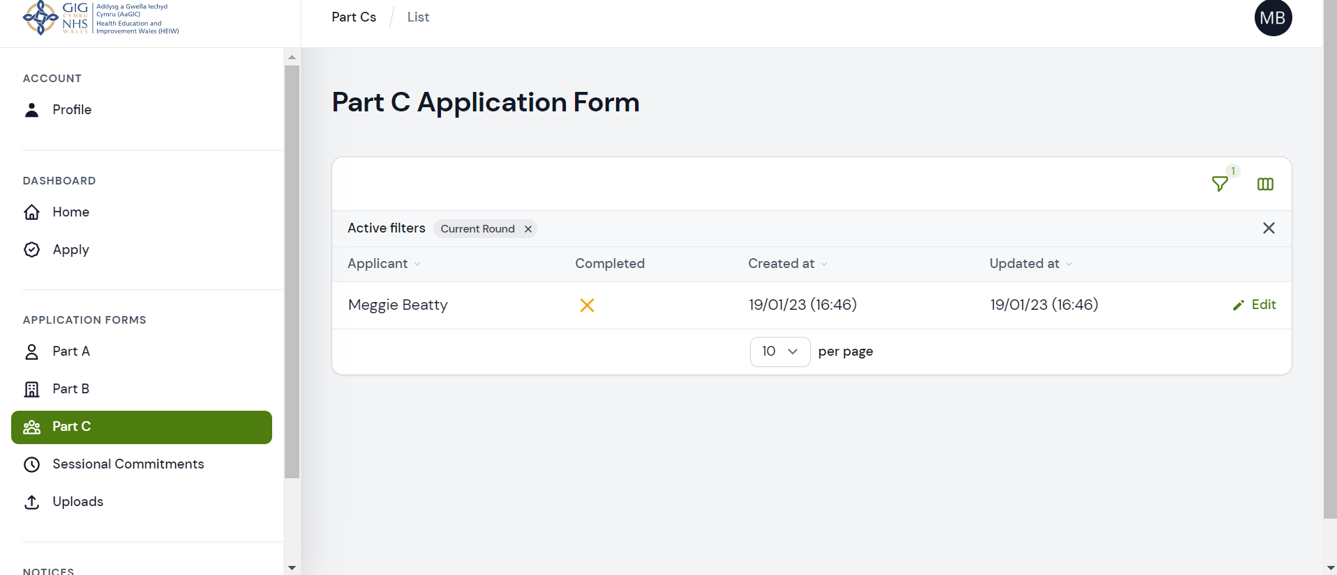
Part C of the application is our Equal Opportunities form.
There are 3 tabs to this form; please make your way through each one ensuring you save before moving on to the next page.
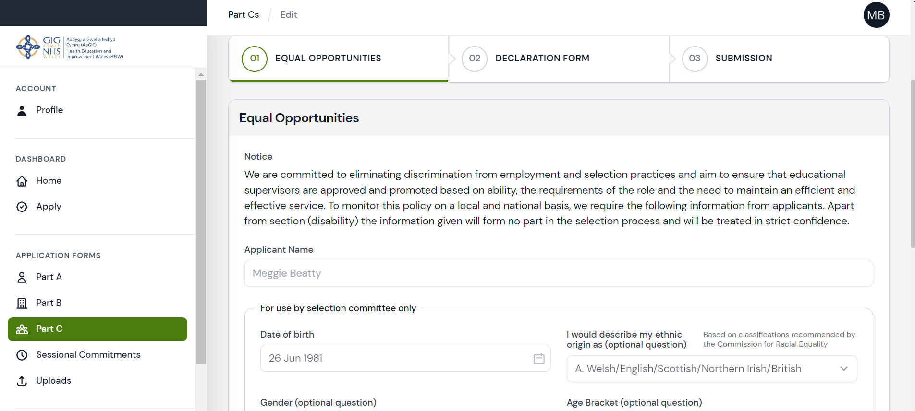
Once you have completed Part C, save and submit. Your Dashboard will be updated to show it is complete. The form will be locked, and you will be unable to edit.

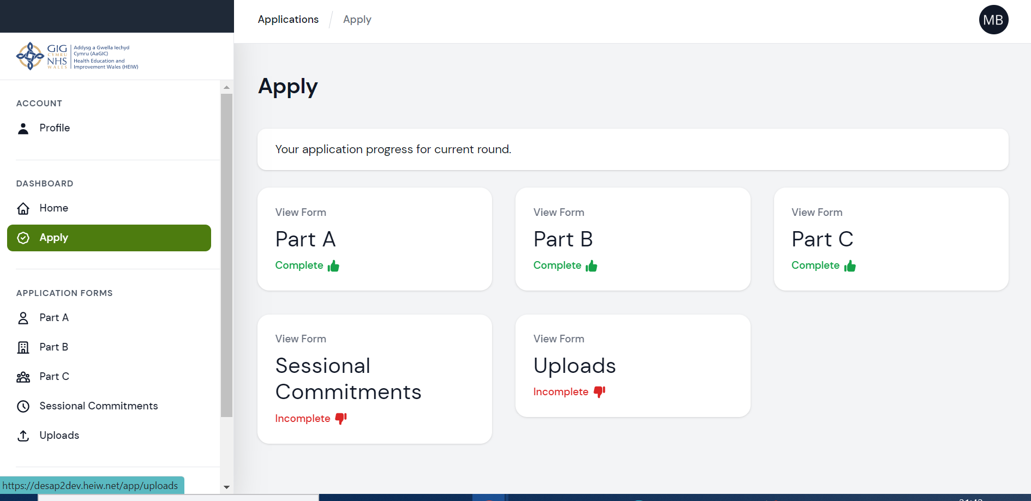

Uploads
Uploads is where you can upload any required evidence to support your application.
Once you have clicked the apply button you will see that a form has been created for you. You will need to click on the edit button to open the form.

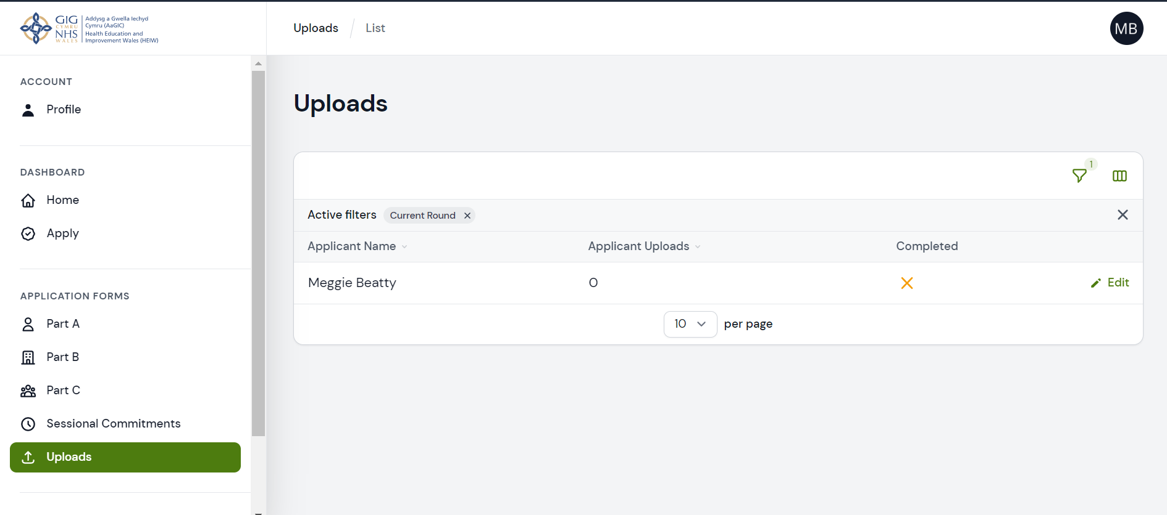
Or you can access this page from the CPD tab of the application form, but you must click save before clicking uploads or the information entered in the CPD tab will be lost.
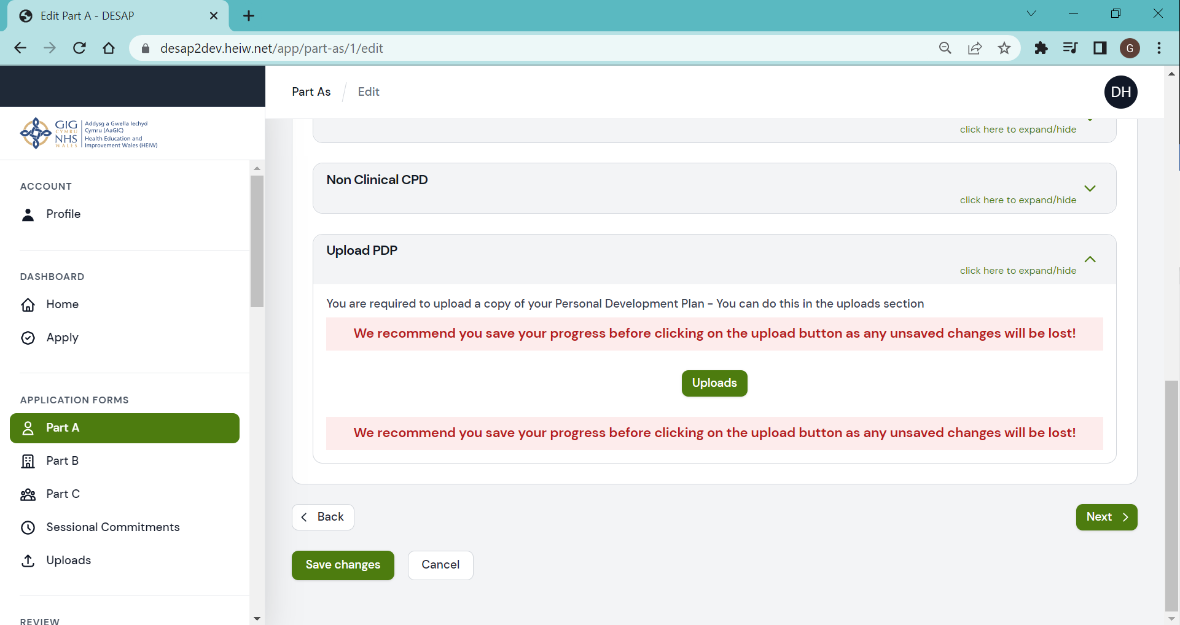
The required documentation to be uploaded is
- a Record of Audit (copy of most recent Audit certificate)
- a Record of CPD (Dental Postgraduate Department record plus any other CPD carried out but not recorded with Dental Postgrad)
- HIW Inspection Report (if applicable)

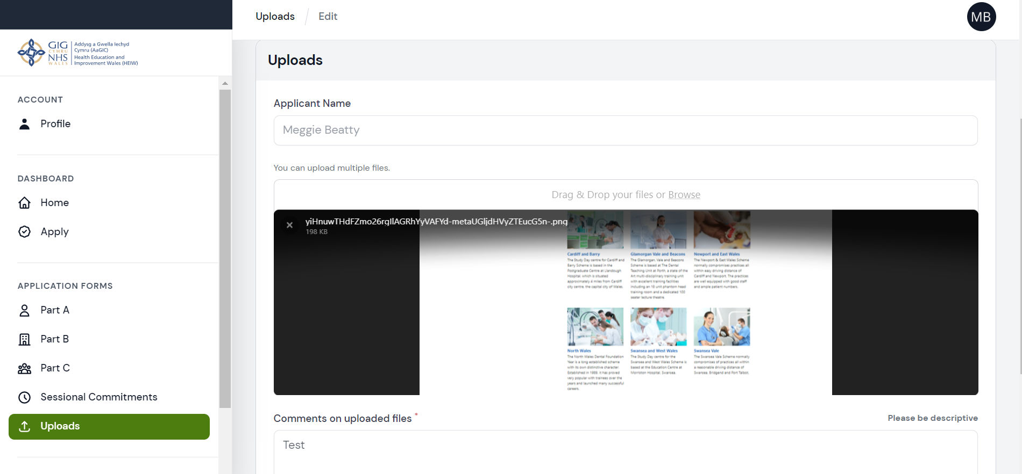
Once you have uploaded the required evidence click save and submit. Your Dashboard will be updated to show it is complete. The form will be locked, and you will be unable to edit.

Quality Assurance Practice Visits
Practice Visits form part of HEIWs quality assurance processes. They are conducted to ensure that your practice and staff provide a suitable environment to accommodate a foundation therapist.
If your application is approved, your Training Programme Director (TPD) will be in touch to arrange a practice visit from April (existing DF Educational Supervisors will not require a formal practice visit, but the TPD may carry out an informal short visit).

What happens after submission?
Your application will be considered by the WDTFT Training Programme Director

Local Health Board’s feedback and further supporting documents are collated.

Practice Inspection Visit to take place (if appropriate)

Applicants notified of outcome by 31st May 2024

