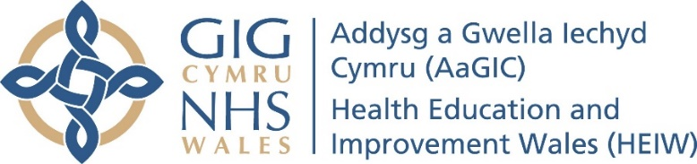
Dental Postgraduate Section
Dentists with Enhanced Skills (DES)
Application Guidance

Introduction
This guidance is designed to be read in conjunction with the speciality specific DES guidance documents, prior to submitting your application. All information and updates will be available via the HEIW DES webpage.

- Your completed DES Application Form will enable the Panel to assess and determine whether you meet the requirements for DES accreditation, so please take care to complete the form fully.

- Candidates should submit a single PDF portfolio of evidence along with a completed DES Application Form. Guidance on the structure of the portfolio is provided by each speciality.

- When creating your portfolio, you can choose to use the templates provided on the HEIW DES webpage or you can use own format, but the information must be clear and specific.

- Copies of Certificates and Qualifications included withing your Portfolio should be in date order.

- Within your DES Application Form ensure you have ticked which documents you will be enclosing in your Portfolio.

- Please try to answer all questions openly and with reflection on your strengths and weaknesses. If the panel identify that you have further learning needs, they will do their best to help you address them.

- When you are ready to submit, you should email your Application Form and Portfolio to HEIW.DES@Wales.nhs.uk.

- The deadlines for each application cycle vary by speciality. For up-to-date information you should consult the HEIW DES webpage.

- If you have any queries which aren’t answered by the guidance documents and the FAQ’s on the HEIW DES webpage, you can contact the All-Wales DES team via HEIW.DES@Wales.nhs.uk. Please state clearly in the subject line which speciality you are enquiring about.

