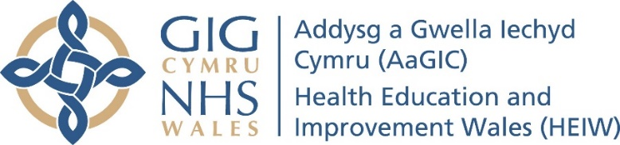
Dental Postgraduate Section
Dentist with Enhanced Skills (DES)
Directly Observed Procedure (DOP)

Date of procedure | Click or tap to enter a date.
Title | Click or tap here to enter text.
Brief anonymous history | Click or tap here to enter text.
Setting e.g. theatre | Click or tap here to enter text.
Procedure | Click or tap here to enter text.
Reflection | Click or tap here to enter text.
Supervisor Feedback | Click or tap here to enter text.
Agreed actions / learning needs | Click or tap here to enter text.

