WELSH APPRENTICESHIP FRAMEWORK FOR DENTAL TECHNOLOGY CONSULTATION EVENT

TECHNICAL CONSULTATION SUMMARY DOCUMENT
May 2025

CONTENTS

INTRODUCTION 2
FEEDBACK SUMMARY 3
ENTRY REQUIREMENTS 3
ESSENTIAL SKILLS WALES PATHWAYS 3
LEVEL 5 QUALIFICATIONS 4
GENERAL QUESTIONS/COMMENTS 4
APPENDIX 1 – DEMOGRAPHIC DATA FROM ONLINE CONSULTATION SURVEY 5

INTRODUCTION
HEIW, as the Development Partner for the Healthcare Apprenticeships, has been leading on a review of the Dental Technology Apprenticeship Pathway. A Steering Group was established to oversee this work with membership from HEIW, NHS Wales, Education and Training Providers, Welsh Government, Qualifications Wales and the Independent Sector.
The proposal in this reviewed framework is to ensure the qualifications within the framework, entry onto the framework and progression from the framework are relevant and up to date for apprentices within this specialist area of work.

FEEDBACK SUMMARY
All comments and feedback received during the consultation period via consultation responses have been considered within the feedback. In addition to asking respondents to respond via multiple choice questions, we have also given respondents the opportunity to give their views via free-text commentary to ensure we are able to gather high-quality and in-depth feedback that will help to shape the final plan. A breakdown of the demographic data can be found in Appendix 1.
It is important to note that the online responses came from individuals giving personal responses in comparison to the written emailed responses which reflect the views on behalf of larger groups, organisations or professional bodies. For the purpose of this paper we have considered them as each representing one respondent as we think all views are equally valid and will be considered in the final version of the units.

ENTRY REQUIREMENTS
100% of respondents agreed that the entry requirements were accurate for entering the apprenticeship framework.
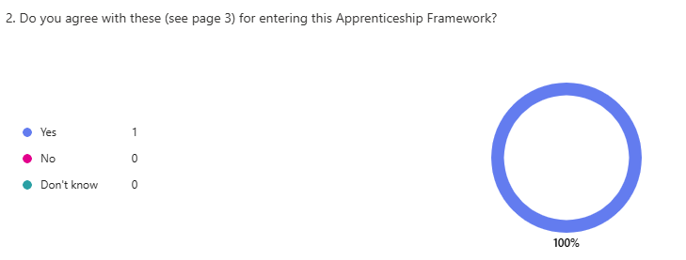

ESSENTIAL SKILLS WALES PATHWAYS

Level 5
100% of respondents agreed that Essential Skills Level 2 is the correct level for this pathway.
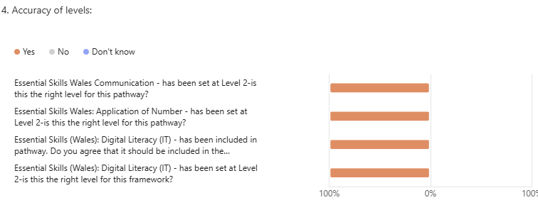

LEVEL 5 QUALIFICATIONS
100% of respondents agreed that the Level 5 qualifications included in the framework (Foundation Degree in Dental Technology) are appropriate qualifications for the pathway.
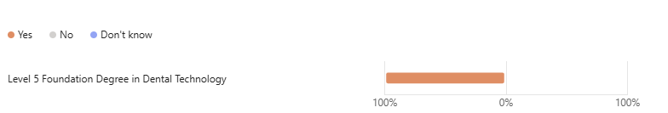

GENERAL QUESTIONS/COMMENTS
Overall, 100% of respondents support the proposed revision of the Welsh Apprenticeship Framework for Dental Technology.
100% of those who responded to the online consultation are currently classed as ‘other’ and 100% of those agreed that the framework is required within Wales. Respondents identified that they are not an employer of Dental Technologists and so no comment was made as to the number of apprentices they would be employing. No further comments were made to the online consultation.

APPENDIX 1 – DEMOGRAPHIC DATA FROM ONLINE CONSULTATION SURVEY

Online responses were received from 1 individuals. The responses were anonymous, but the following demographic information was collected:

