WELSH APPRENTICESHIP FRAMEWORK FOR DENTAL NURSING CONSULTATION EVENT

TECHNICAL CONSULTATION SUMMARY DOCUMENT
August 2025

CONTENTS

INTRODUCTION 3
FEEDBACK SUMMARY 3
ENTRY REQUIREMENTS 3
ESSENTIAL SKILLS WALES PATHWAYS 4
LEVEL 3 QUALIFICATIONS 4
GENERAL QUESTIONS/COMMENTS 4
APPENDIX 1 – DEMOGRAPHIC DATA FROM ONLINE CONSULTATION SURVEY 5

INTRODUCTION
HEIW, as the Development Partner for the Healthcare Apprenticeships, has been leading on a review of the Dental Nursing Apprenticeship Pathway. A Steering Group was established to oversee this work with membership from HEIW, NHS Wales, Education and Training Providers, Welsh Government, Qualifications Wales and the Independent Sector.
The proposal in this reviewed framework is to ensure the qualifications within the framework, entry onto the framework and progression from the framework are relevant and up to date for apprentices within this specialist area of work.

FEEDBACK SUMMARY
All comments and feedback received during the consultation period via consultation responses have been considered within the feedback. In addition to asking respondents to respond via multiple choice questions, we have also given respondents the opportunity to give their views via free-text commentary to ensure we are able to gather high-quality and in-depth feedback that will help to shape the final plan. A breakdown of the demographic data can be found in Appendix 1.
It is important to note that the online responses came from individuals giving personal response. For this paper we have considered them as each representing one respondent as we think all views are equally valid and will be considered in the final version of the units.

ENTRY REQUIREMENTS
67% of respondents agreed that the entry requirements were accurate for entering the apprenticeship framework.
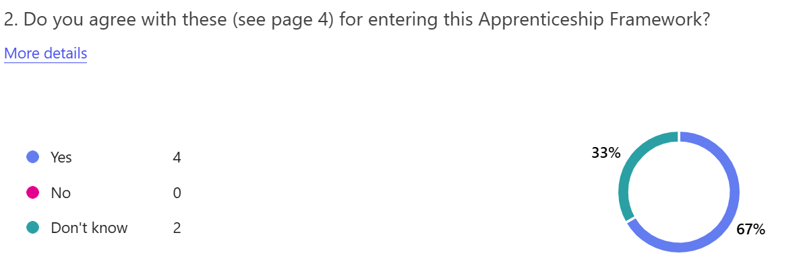

ESSENTIAL SKILLS WALES PATHWAYS
83% of respondents agreed that Essential Skills Level 2 Communication is the correct level for this pathway.
83% of respondents agreed that Essential Skills Level 2 Application of Number is the correct level for this pathway.
83% of respondents agreed that Digital Literacy should be included in the framework.
100% of respondents agreed that Essential Skills Level 2 Digital Literacy is the correct level for this pathway.

LEVEL 3 QUALIFICATIONS
100% of respondents agreed that the City & Guilds Level 3 Diploma in Dental Nursing qualification whilst 83% agreed that the Agored Cymru Level 3 Diploma in Dental Nursing qualification are appropriate qualifications for the pathway.

GENERAL QUESTIONS/COMMENTS
Overall, 100% of respondents felt this framework is required in Wales.
50% of those who responded to the online consultation currently employ dental nurses, of these 67% said they would use the framework within their organisation.
Additional comments included:
- This framework supports the training and development of Dental Nurses in Wales and is vital to the promotion of high-quality provision in the Dental Sector. Importantly, it offers appropriate access to those committed to a career as a Dental Care Practitioner.
- It needs to be organised, with clear end results and fully supportive of apprentice dental nurses.

APPENDIX 1 – DEMOGRAPHIC DATA FROM ONLINE CONSULTATION SURVEY

Online responses were received from 6 individuals. The responses were anonymous, but the following demographic information was collected:
