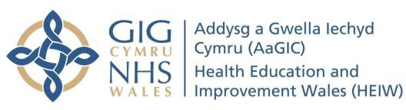

Interprofessional Education (IPE) in
Practice-Based Learning: Case Study Template

Interprofessional education (IPE) can be defined as members or students of two or more professions, engaged in learning with, from and about each other.

Share your IPE example to support and inspire others …
We would like to capture examples of successful, real-world IPE taking place as part of healthcare
students’ practice-based learning. These case studies will be used to inform a national toolkit being developed to support IPE across Wales. Question prompts are provided as a guide, but you are welcome to structure your case study in the way you prefer.
We would like to capture examples from a range of professions, settings and sectors e.g. primary care, mental health, public health, acute care, voluntary sector placements and across the Pillars of
Practice (clinical, leadership, education, research).
Please contact heiw.practiceeducationteam@wales.nhs.uk if you have any questions.

Your name, role and organisation.
Briefly outline the IPE opportunity, the setting and students / professions involved. You may wish to
mention if the IPE was formally allocated and structured or informal.

How did the placement impact on student learning and experience? You might like to include the
student voice here and any feedback, comments or reflections from students if you have them.
How will the IPE benefit care and outcomes for the patient / group / community? Any other
identified benefits? e.g. workforce readiness.
What was the key to success in this example of IPE? e.g. partner arrangements that helped, alignment with practice-based learning competencies, equity and inclusion. Any plans to develop
the IPE further?
What two tips would you share with educators keen to facilitate a similar IPE experience?

To enable us to use your case study to develop the national IPE toolkit, please complete the
consent form - Consent form: Educational and Training Materials. A photograph, image or video can really bring your case study to life. If you have a photograph, image or video as part of your case study, please include it with your template and when completing the consent form.
Thank you for sharing your experience to help inspire innovative IPE across Wales.

Please return the completed template to heiw.practiceeducationteam@wales.nhs.uk

Thank you

