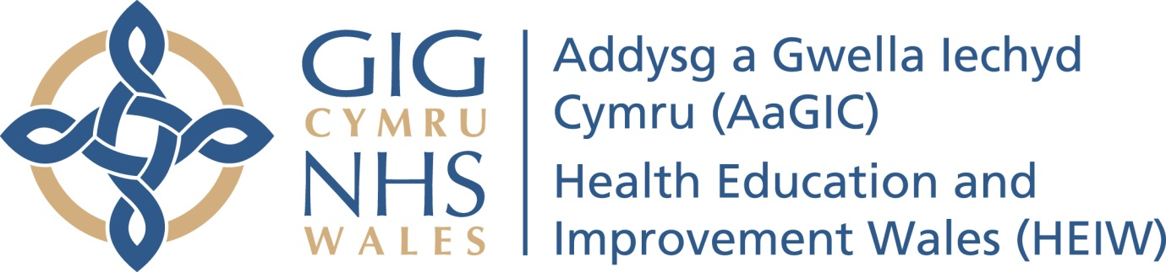

BOARD ASSURANCE FRAMEWORK
2019-20

Health Education Improvement Wales Board Control Framework

Leadership
Staff
Systems and Processes
Finances
Technology
Controls: evidenced within
- Annual Plan
- Commissioning
- Equality Impact Assessment

Assurance: gained via
- Escalation arrangements
- Internal/External Audits, visits
- Executive Director and Senior Leadership Team meetings
- Audit and Assurance Committee
- Proposed Education Commissioning and Quality Committee

Controls:
- Risk management strategy and Policy
- Board Assurance Framework
- Corporate Risk Register
- Divisional Risk Register
- Reports to the Board, Senior Leadership Team and sub committees
- Policies and Procedures
- Scheme of Delegation
Assurance: gained via
- Proposed Education Commissioning and Quality Committee
- Senior Leadership Team
- Annual Report and Annual Governance Statement
- Chairs Reports
- Visits and Inspections
Controls and Assurance Mechanisms
High Quality Education
Performance Management
Risk Management

Assurance: gained via
- Escalation arrangements
- Audits, visits
- Executive Director and Senior Leadership Team meetings
- Audit and Assurance Committee
- Proposed Education Commissioning and Quality Committee
- Internal/External Audits

Controls:
- Objectives and Appraisals
- Performance targets
- Performance Dashboards and monthly reporting
- Regular Performance and Quality reports

- Internal Audit Plan
- Wales Audit Office (Structured Assessment)
- External Audits (eg. Annual Accounts and Annual Report)
- HIW Inspections
- Regulators
- Reviews and Reports by Royal Colleges
- External visits and accreditations
- Independent Reviews
Third Line
Independent

Second Line
Risk and Compliance
Reports to Assurance and Oversight Committees
- Audit and Assurance Committee
- Proposed Education Commissioning and Quality Committee
- Remuneration Committee
- Health and Safety Groups etc

Findings and/or reports from inspections, Annual Reporting through to Committees

First Line
Operational
- Organisational structures – evidence of delegation of responsibility through line Management arrangements
- Compliance with appraisal process
- Compliance with Policies and Procedures
- Incident reporting and thematic reviews
- Compliance with Risk Management processes and systems
- Performance Reports, Complaints and [Trainee Experience Reports], Finance Reports

Levels of Assurance

Second Line of Assurance – Sub Units
Board Assurance Framework Summary as at [insert date]

Strategic Objective 1 - As a new organisation establishing HEIW as a valued and trusted partner, an excellent employer and a reputable and expert brand.

Strategic Objective 2 - Building a sustainable and flexible health and care workforce for the future.

Strategic Objective 3. With Social Care Wales shaping the workforce to deliver care closer to home and to better align service delivery.

Strategic Objective 4. Improving quality and safety by supporting NHS organisations find faster and more sustainable workforce solutions for priority service delivery challenges.

Strategic Objective 5. Improving opportunities for use of technology and digitalisation in the delivery of education and care.

Strategic Objective 6. Reinvigorating leadership development and succession planning across health and social care in partnership with Social Care Wales and Academi Wales.

Strategic Objective 7. Demonstrating value from investment in the workforce and the organisation.

Key | Improvement | Deterioration | No Change

Approach to Risk Assessment - Risk scoring
The risks reported within the Board Assurance Framework is broadly consistent with the Corporate Risk Register and are assessed by using the following assessment approach. However, it is recognised that this needs to be further developed and refined to reflect the development of the Corporate Risk Register. In particular, it will seek to differentiate between high and extreme risks.

Risk Scoring Matrix
LIKELIHOOD | Probable |  | 5 |  | 10 | 15 |  | 20 | 25 |  |  |  | Score Range
LIKELIHOOD | Likely |  | 4 |  | 8 | 12 |  | 16 | 20 |  |  |  | 1 – 6
LIKELIHOOD | Possible |  | 3 |  | 6 | 9 |  | 12 | 15 |  |  |  | 7 – 14
LIKELIHOOD | Unlikely |  | 2 |  | 4 | 6 |  | 8 | 10 |  |  |  | 15 – 25
LIKELIHOOD | Rare |  | 1 |  | 2 | 3 |  | 4 | 5
 |  |  | Negligible |  | Minor | Moderate |  | Major | Critical
 |  |  | IMPACT
Level |  | Colour |  | Score Range
Low |  |  |  | 1 – 6
Moderate |  |  |  | 7 – 14
High |  |  |  | 15 – 25

DRAFT Template
HEIW Board Assurance Framework 2019/20
Corporate Objective :
Principal Risk :
Corporate Risks |  |  |  | Unit/Operational Risks
Executive Lead: |  |  |  | Assuring Committee: [ ]
Key Controls | Effectiveness | Form of Assurance | Adequacy | Gaps in Control | Gaps in Assurance | Actions Agreed for any gaps in control or assurance | Current Risk Rating | Direction of Travel
 |  |  |  |  |  |  | 15

