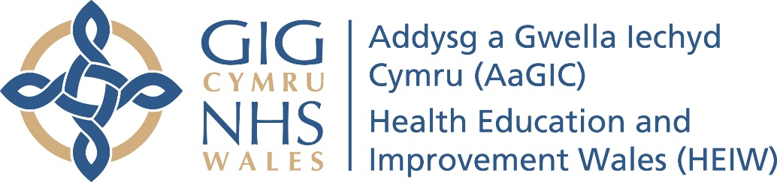
Meeting Date | 28 March, 2019 |  | Agenda Item |  |  | 4.4
Report Title | Review of Standing Orders (Excluding the Standing Financial Instructions)
Report Author | Dafydd Bebb, Board Secretary
Report Sponsor | Dafydd Bebb, Board Secretary
Presented by | Dafydd Bebb, Board Secretary
Freedom of Information | Open
Purpose of the Report | The purpose of the report is to provide an update to the Board following a review of HEIW’s Standing Orders.
Key Issues | Standing Orders (SOs) are usually reviewed on an annual basis.  The SOs were adopted in October and subsequently amended at the November and January Boards in respect of the terms of reference for the Audit and Assurance Committee and RATS Committee.  It is anticipated that the SOs will be amended at March Board to establish the Education, Quality and Commissioning Committee.  It is not otherwise proposed to amend the SOs significantly.
Specific Action Required  (please one only) | Information | Discussion |  | Assurance | Approval
Recommendations | Members are asked to:  approve that the Standing Orders be amended to incorporate the terms of reference for the Education, Quality and Commissioning Committee as approved at March Board;  approve the Responsible Officer section be amended to include the Medical Director’s role as ‘Responsible Officer for medical trainees’ and the minor typographical amendments to the SOs as attached at Appendix 1.

Review of HEIWs Standing Orders

- Introduction

The purpose of this report is to provide an update to the Board following review of the Health Board’s Standing Orders and seek approval for the proposed amendments.

- Background

The SOs were initially adopted at HEIW’s initial Board Meeting in October. They have subsequently been amended at November and January Board to incorporate the recommended amendments proposed by the Audit and Assurance Committee and RATS Committee to their own terms of reference.

To ensure effective governance the SOs are to be reviewed on an annual basis. The Standing Financial Instructions are to be initially reviewed by the Audit and Assurance Committee.

It is proposed that the SOs be amended to incorporate the terms of reference of the proposed Education, Quality and Commissioning Committee. It is also proposed that the SOs be updated to capture the Medical Officers role as the Responsible Officer for medical trainees and to reflect minor typographical corrections.

- Governance and risk issues

The Board is required to review the SOs on an annual basis. The review of SOs is a key element of the corporate governance of HEIW.

- Financial Implication

No financial implication in reviewing and updating the Standing Orders.

- RECOMMENDATION

Members are asked to:
approve that the Standing Orders be amended in accordance with the terms for establishing the Education, Quality and Commissioning Committee;
approve the Responsible Officer section be amended to include the Medical Director’s role as ‘Responsible Officer for medical trainees’ and approve the minor typographical amendments to the SOs captured in Appendix 1.

Governance and Assurance

Link to corporate objectives  (please ) | As a new organisation establishing HEIW as a valued and trusted partner, an excellent employer and a reputable and expert brand |  | Building a sustainable and flexible health and care workforce for the future. | With Social Care Wales shaping the workforce to deliver care closer to home and to better align service delivery. | Improving quality and safety by supporting NHS organisations find faster and more sustainable workforce solutions for priority service delivery challenges.
Link to corporate objectives  (please ) | Improving opportunities for use of technology and digitalisation in the delivery of education and care. |  | Reinvigorating leadership development and succession planning across health and social care in partnership with Social Care Wales and Academi Wales | Demonstrating value from investment in the workforce and the organisation.
Quality, Safety and Patient Experience
The SOs are a key foundation of HEIW’s governance and accountability framework. A robust governance and accountability framework is more likely to impact favourably on the safety and experience of patients and staff.

Financial Implications
There are no financial implications contained within this report.

Legal Implications (including equality and diversity assessment)
The SOs are designed to translate the statutory requirements for HEIW set out in legislation into day to day operating practice.

The SOs are deemed to have a neutral impact on equality and diversity.
Staffing Implications
There are no direct implications on workforce in this report.

Long Term Implications (including the impact of the Well-being of Future Generations (Wales) Act 2015)
There are no implications on the Well Being of Future Generations (Wales) Act 2015.

Report History |  | n/a
Appendices |  | The SOs (excluding the SFIs) are attached at Appendix 1.  (The Terms of Reference for the Education Committee is the subject matter of a separate report at March Board).

