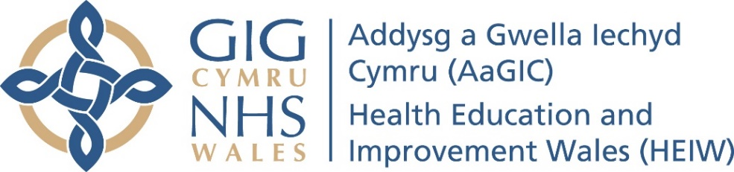

Meeting Date | March 2019 |  | Agenda Item |  |  | 3.3
Report Title | Draft communications and engagement strategy
Report Author | Angharad Price – Head of Communications & Engagement
Report Sponsor | Julie Rogers
Presented by | Julie Rogers
Freedom of Information | Open
Purpose of the Report | To seek the Board’s approval of the draft HEIW communications and engagement strategy.
Key Issues | The draft strategy provides a framework for all communications and engagement activity by staff, and representatives of HEIW, aligned to the achievement of HEIW’s strategic objectives and functions.
Specific Action Required  (please one only) | Information | Discussion |  | Assurance | Approval
Recommendations | Members are asked to:  approve the draft communications and engagement strategy, and its implementation from April 2019.

PURPOSE:
- Attached to this paper is a draft communication and engagement strategy for Health Education and Improvement Wales (HEIW). It replaces the draft communications and engagement strategy put in place in summer 2018 to cover the initial transition period.
BACKGROUND:
- A comprehensive communications and engagement strategy is critical to the organisation’s success and delivery of its objectives and functions. The draft strategy has the organisation’s purpose, objectives and values at its heart and has been shaped by feedback from staff and stakeholder meetings and events during 2018.

- The strategy is intended to be a clear statement of intent on our part and to address our needs in this area over the next 12 months. It will be kept under review as the organisation continues to grow and develop, and as we gain greater insight into our business as well as what is required from us and our partners, We will have arrangements in place to capture feedback from staff and stakeholders on its effectiveness following implementation. It will be replaced in April 2020 by an updated version which will be developed in parallel with our first three year Integrated and Medium Term Plan.

Planned Activity

- As part of the finalisation of the HEIW annual plan for 2019-20, project leads in each business area are assessing the communications and engagement activity required to support the delivery and achievement of the 7 strategic objectives. Once that work is completed we will pull together an overview (action plan) of the communications and engagement activity for 2019-20, which will sit alongside the strategy.

Next steps

- Once agreed, the strategy will be formatted, translated and published to our Intranet and Internet pages. Links to the strategy will be sent to our stakeholders and staff through our normal mechanisms, including stakeholder bulletins. We anticipate these actions being completed by the end of April 2019. We will make it clear that, whilst the strategy has been developed using staff and stakeholder feedback, comments during the course of the next 12 months will be welcomed as the strategy is tested operationally.

- We are intending to use our ‘lunch & learn’ approach for staff to answer questions and embed the messages within the strategy, holding sessions in April and June. We will repeat these as necessary during the year.

GOVERNANCE AND RISK ISSUES

- There are no governance and risk issues arising from this strategy.

FINANCIAL IMPLICATIONS

- The costs associated with leading and implementing this strategy will be accommodated within existing HEIW staffing and budgets. The costs of the activity to support the achievement of the 7 strategic objectives in the 2019-20 plan will be considered as part of the development of individual project plans.

RECOMMENDATIONS
- The Board is recommended to approve the draft communications and engagement plan. Further that it is implemented with effect from April 2019.

HEIW Communications & Engagement Team

