Innovation Fellowships for Healthcare Scientists

Application Form - Associate Scheme NHS Wales

Please read the Programme Information sheet prior to applying

Deadline for submission: 23rd June 2023

Applicant Information
Surname: |  |  |  |  |  | Title:
Forename(s) in full:

Work Contact Details:  Address (to be used for written correspondence)  Preferred telephone number: |  | NHS Email address:
UK Resident:
Yes / No

 |  | Current NHS AfC Band:
Healthcare Science (HCS) Specialism: |  | Date of HCS Qualification:
Job title:  Your de |  | Name of current employing organisation:
Brief outline of HCS qualification/s and other relevant qualifications (Max 50 words): |  | Head of Department Contact Details:  Name:  Job Title:  Email:
Contact in Trust/Health Board Finance Department (name/role/email address):
Name:
Job Title:
Email:

HEALTHCARE SCIENCE INNOVATION FELLOWSHIP – ASSOCIATE NHS WALES
QUESTIONS:
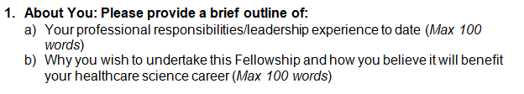
Please type below:

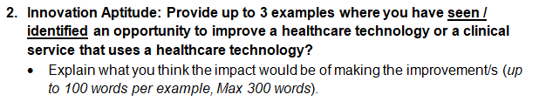
Please type below:

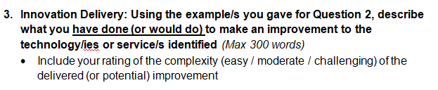Please type below:

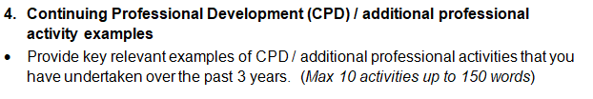
Please type below:

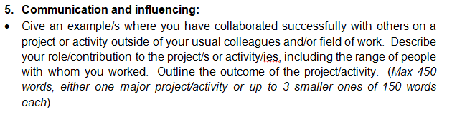
Please type below:

Please type below:

7. Declaration of Applicant:
I confirm that I have read the Background Information document for the Healthcare Science Innovation Fellows Programme and that I meet its eligibility criteria. | Y/N
I have completed the application form in full and all information provided is true to the best of my knowledge | Y/N
Signature:

Date:

Please type below:

9. Declaration of Head of Department:
As per my statement of support above, I confirm that I support the Applicant’s submission to the NHS Wales Associate Innovation Fellow’s programme and the required provision of protected time to undertake the programme. | Y/N
Signature:

Date:

