Additional Evidence
The content of the programme has been mapped to the All Wales induction framework for health and social care (AWIF) where highlighted. The learning that takes place during the joint / community induction should meet these outcomes. However, managers will need to ensure that the worker has achieved the relevant knowledge and understanding and can embed the learning in their practice.
It is the registered manager’s responsibility to sign off the evidence, confirming that the learning outcomes have been achieved and that the worker has completed the AWIF to a satisfactory standard.
Social Care Wales 2024
AWIF / Joint Induction for Acute and Community

Reference AWIF-workbook-1-principles-and-values.docx (live.com)
AWIF-workbook-3-health-well-being-adults.docx (live.com)
AWIF-workbook-5-professional-practice.docx (live.com)
AWIF-workbook-6-safeguarding-individuals.docx (live.com)
AWIF-workbook-7-health-and-safety.docx (live.com)
Health Board Joint Induction for Acute and Community
All Wales Induction Programme for Health and Care Workers supporting Nursing and Allied Health Professionals in acute and community settings

Write the number in the corresponding box to identify the definitions!

- Advance care planning (3-10.3)
- Advocacy (1-2.4)
- Positive Role modelling (5-5.1)
- Diversity (1-4.1)
- Positive approaches (1-9.1)
- Voice and Control (1-3.2)
- Equality (1-4.1)
- Duty of Care (5-1.7

“A situation in which men and women, people of different races, religions, etc. are all treated fairly and have the same opportunities”.

“Inspiring individuals to live meaningful lives, demonstrating how to live with integrity, optimism, hope, determination, and compassion”.

“The practice or quality of including or involving individuals from a range of different social and ethnic backgrounds and of different genders, sexual orientations”.

“Putting the individual and their needs, at the centre of their care, and giving them a voice in, and control to reach the outcomes that help them achieve well-being”.

“Getting support from another individual to help you express your views and wishes, and help you stand up for your rights”.

“Having conversations and making decisions about the care you'd like in future with your health and care team”.

“Based on the principles of person-centred care: getting to know an individual, respecting and valuing their histories and backgrounds, and understanding: their likes and dislikes”.

“The obligations placed on individuals to act towards others in a certain way, in accordance with certain standards”.

- Best Interest Decisions (1-5.5)

- Handling Information (5-4.1)

- Restrictive practices (1-9.1)
- Wellbeing (3-1.1)
- Personal Care (3-3.1)
- Advances directives (3-10.3)
- Inclusion (1-4.1)
- Rights based approach (1-2.1)

“All forms of discrimination in the realisation of rights must be prohibited, prevented and eliminated”.

Are things that limit the rights of an individual, like being able to move around freely if there is a risk to safety right at that time”.

“Legal documents that communicate an individual’s wishes about health care decisions in the event the individual becomes incapable of making health care decisions”.

“The steps to be taken in order to ensure that any confidential information is handled appropriately”.

“Anything done for you that's of a personal nature”.

“How we're doing as individuals, communities and as a nation, and how sustainable that is for the future”.

“The practice of providing equal access to opportunities and resources for individuals who might otherwise be excluded”.

“A decision made by applying the Best Interest principles and support for an individual who lacks capacity”.

- Substance Misuse (3-15.1)
- Discrimination (1-4.1)
- Continued professional development (5-6.1)
- Active Participation (1-3.8)
- Person Centred Care (3-2.1, 3.13.5)
- Secure Systems (5.4.3)
- Co Production and partnership working (1.2.2)
- Protected Characteristics (1.4.2)
“A way of working that supports an individual's right to participate in the activities and relationships of everyday life as independently as possible, this particularly important for individuals with dementia”.

You have a right not to be treated less favourably, or subjected to an unfair disadvantage, by reason of that characteristic.

Data protection legislation protects the rights of individuals using health and social care services by making sure the information about individual is stored securely.

“Learning experiences which help you develop and improve your professional practice”.

“Treating an individual 'less favourably' than someone else”.

“A way of working where service providers and individuals work together to reach a collective outcome”.

“The use of alcohol, illegal drugs, or over the counter or prescription medications in a way that they are not meant to be used and could be harmful to you or others around you”.

Co-production is about developing more equal partnerships between individuals who use care and support workers, and professionals.

Name of legislation/law, convention, national policy, national document, or guidelines. | What rights does it promote?  What does it cover? | How it promotes these rights?  How does this affect/govern your practice?  What must you consider in relation to this and your role?
Equality Act 2010 (1.2.2) | Promotes the right not to be discriminated against down to any of the ….. protected characteristics.
Human Rights Act 1988 (1.2.2) |  | As a HCSW or Social Care Support Worker, I must respect an individual’s human rights. Therefore, I am responsible for protecting those I care for from …… and help them to make ……. for themselves.
Mental Capacity Act 2005 (3.1.13) | 5 key principles of the mental capacity act:  Presume individuals have capacity unless proven otherwise.  Individuals must be given all possible help to make their own decisions.  Individuals …….. be assumed not to have capacity if they make an unwise decision.  When an individual is deemed to lack capacity, anything done for on or their behalf must be in their …….. …………….  When making decisions for a person, the least restrictive option should be chosen.
Welsh Government Strategic Framework for the Welsh Language in Health and Social Care 2013 (1.2.2 & 1.8.2) | This stipulates that individuals have the right to have their care delivered in ….. without having to ask.
The Welsh Language Act 1993; Welsh Language Measure (2011) and Mwy na geriau / More than just words: (1.8.2, 1.8.3) |  | In Wales, the Welsh language should be treated no less favourably than the ………… language and individuals in Wales should be able to live their lives through the medium of ……. if they wish to.  Mwy na geiriau / More than just words has principles to make sure individual’s Welsh language ..….. are met.
Data protection Act 2018 (5.4.2) | This act enforces the ……….. ………. ………… ………………. (GDPR).  Promoting the safe use and storage of any personal information.
Health & Safety at work act (1974) (7.1.1) | Employers must protect the ………….., ……………………..at work of all their employees, as well as others on their premises, including temps, casual workers, the self-employed, clients, ……….and the general …….
Health & Safety at work act (1974) (7.6.7, 7.6.8) | Identify 4 Roles of the employer  Identify 4 Roles of the employee | The Health and Safety at Work Act puts a general duty on ……………to protect ………. health and safety. All workers also have a duty to protect themselves and others by following …………, ………………… and control procedures.
Working Together to Safeguard People (Wales) 2022  Social Services and Wellbeing Act (2014), (6.1.4, 6.1.5,) | Sets out a clear …… framework for how local authorities and other parts of the system should ……. adults at risk of abuse or neglect. | Sets out duties to report and duties to…….. abuse or neglect.
6.1.4 & 6.1.5. Children Act 2004 | Promoting rights such as allow children to be healthy, ………., remain …… and to succeed. | The act reinforces that everyone working with children has a responsibility to ……… help and ………… children.  Therefore, in my role, if I have any concerns about a child I must……………………………………………………

Positive Risk Taking
Watch this video and answer the questions below https://www.youtube.com/watch?v=2qUcIQvnBC0
Question | Answer
1.5.1 a) What does the term ‘positive risk taking’ mean?
b) What is the importance of being able to take positive risks for the well-being of individuals

1.5.2 & 5.3 what Rights does Emily have to make choices and take risks?

1.5.4 what were the considerations for Emily to make her own beverage?

1.6.1 What does the term ‘relationship centred working’ for Emily mean?

Assistive Technology
Watch this video and answer the questions below https://www.youtube.com/watch?v=1zbJUhSoEBo&list=PLEZj8vabV3cuw0fF0oMiVHm2UZ5hrkt8N
Question | Answer
3.11.1 What is meant by the terms ‘assistive technology’ and ‘electronic assistive technology’?
3.11.2 List the types and range of technological aids that can be used to support an individual’s independence and how these can be accessed.
3.11.3 How technological aids can be used to support active participation?

3.11.4 The range of support that is available for the use of assistive technology.

How does each principle of the act relate to safeguarding? How does is support the rights of individuals to be protected from harm, abuse and neglect? Label each description with the correct principle title...
Working well with other partners and agencies (i.e. health, social care, police, schools) to ensure needs are met. | Putting individuals in the middle of anything we do, giving them the chance to speak out about what they want to happen. | Includes, protection from abuse and neglect to ensure they are happy and well in all aspects of their life. | Increasing preventative services so individuals can ask for the help they need in a timely way so that their situation doesn’t reach a crisis point. | Working together with individuals, involving them in the how, what and when their care is delivered. Recognising the important role they play, seeing them as the expert in their situation.

MCQ’s for Workbook 1
Assessment criteria | Question | Possible answers
1.1.1 | Identify the five principles of the Social Services and Well-being (Wales) Act 2014 | - voice and control, prevention and early intervention, well-being, co-production, multi-agency.  - wellbeing, patient centred care, voice and control  - dignity and respect, compassion, responsive care.
1.1.2 | Why are they important and how do they underpin what we do? (select 2 answers) | - sets out how we should provide care.  - so that individuals can access all the services that are available  - ensures that individuals are at the centre and can access advice and support they require.
1.3.11 | What is the importance of personal plans? (select 2 answers) | - to record the care delivered to individuals.  - to document how the individuals behave  - to write about the individuals giving the care  - to document changes in an individual’s condition
1.4.5 | Ways in which discrimination or practice that doesn’t support equality, diversity and inclusion can be challenged. (select 2 answers) | - question the way you are spoken to.  - tell someone that they are being unkind.  - agree and join in with the crowd

MCQ’s for workbook 3
Assessment criteria | Question | Possible answers
3.3.7 | An individual’s beliefs, sexual preference and values may affect their continence management in which of the following ways: (select 2 answers) | - Transgender individuals may struggle to find a suitable toilet and be embarrassed to ask.  - Some cultures have a requirement for cleanliness during prayer.  - Continence isn’t a problem for many so does not affect anyone that much.
3.3.5 | True or False: | Poor oral care can negatively affect a person's wellbeing and dignity, leaving them with poor self-esteem.
3.4.1 | True or False; pressure area care is: | Maintenance of healthy skin to prevent pressure ulcers.
3.4.1 | Pressure damage is: | - Damage to skin and tissues, caused by prolonged pressure.  - Damage to fingernails after nail biting due to work pressure
3.4.1 | A pressure ulcer is: | - A quickly healing wound that can occur anywhere on the body.  - Caused by prolonged pressure, usually occurring at a boney point on the body.
3.5.1 | Match these to the appropriate meaning:  Oral health care  Mouth care | - Is the health of the mouth in general including teeth, gums and may include a visit to the dentist.  - Involves keeping an individual's mouth clean and healthy. It may include moistening lips and cleaning teeth and dentures.
3.5.5 | Identify 3 of these which may be potential impacts of poor oral health and mouth care:  on health, well-being, self-esteem, and dignity | - Gum disease  - Poor self esteem  - High blood pressure  - Communication problems
3.5.6 | True or False:  Poor oral health and mouth care can have an effect on an individual’s ability to eat and therefore their nutrition | - True  - False
3.6.2 | Common conditions that cause problems with feet | - Mobility  - Dementia  - Ingrown toenail  - Stomach pains
3.6.4 | What can be the impact of health conditions / abnormalities on the health of individuals | - Emotional turmoil  - Stress  - Unable to access social activities  - All above
3.6.5 | The range of professionals that may help with foot care (2 correct answers) | - Outpatients’ clinic  - Podiatrists  - Care Workers  - Chiropodists
3.8.1 | Match these to the appropriate definition:  - Nutrition  - Hydration | - The intake of sufficient food to provide energy.  - The intake of disease  - The intake of sufficient water and fluid into the body.
3.8.2 | How many portions of fruit and vegetables should we eat each day? | - five  - three  - seven
3.8.2 | How many glasses of fluid should we be drinking each day? | - four to six  - Six to eight  - eight to 10
3.13.9 | What is Dementia? | - A mental health diagnosis  - An umbrella term for many conditions  - A physical health condition.
3.14.2 | What factors can contribute to mental ill health? (select 3 answers) | - Abuse  - Debt  - Loneliness  - Good physical health
3.14.6 | What positive outcomes are associated with improved mental health and well-being? (select 2 right answers) | - Feeling accepted for who you are  - Low confidence  - Meeting new people and using your own experiences to help others
3.15.2 | What are some of the signs of substance misuse? (select 2 right answers) | - severe mood swings  - losing interest in activities and hobbies  - spending more time with family
3.15.3 | What is the potential impact of substance misuse on the health and well-being of individuals? (select 2 right answers) | - Improved work performance  - neglecting home responsibilities  - reckless behaviour
3.15.4 | What support is available to individuals who misuse substances? (select 3 answers) | - G.P.  - Charities  - N.H.S.  - Schools

Workbook 6:
1.2 Circle the main categories of abuse and neglect: 6.1.2, 6.1.3

Workbook 5
3.1 &3.2
Here is an example of a team structure:

Following the example, consider what structure your own team has. Include your job role in this diagram and populate the boxes with others in your team. You may not be able to fill every box, but fill at least 4, to include your line manager and those who work directly alongside you.

Thinking about how your team works, what are some of the key principles to good team working? For example, respect. Think of 3 more examples:
a.
b.
c.

Fill in the blanks.
Workbook 3
Every, regularly or at least 6 hourly,
3.4.2 NICE guidelines on pressure ulcers: prevention and management (2014), states that individuals who have been assessed as being at risk of developing pressure ulcers, should change their position ________________. Remember, _______ Individual is at risk of developing pressure ulcers.
__________________________________________________________________________________
3.8.4 What is the importance of a balanced diet for the optimum health and well-being of individual.
nutrients, diseases, balanced,
Following a healthy, _______ diet helps make sure that our bodies get all the _______ needed to work well from day to day and can also reduce the risk of _______ like heart disease, stroke, type 2 diabetes, and some types of cancer in the longer term.
__________________________________________________________________________________
3.13.1 What condition is described below?
Huntington’s disease, heart disease, dementia, sepsis,
_______ is an umbrella term for several conditions, such as Alzheimer’s disease. There are more than 100 different types, and you can expect to see changes in a person’s ability to remember, think, reason, and solve problems.
__________________________________________________________________________________

Workbook 5
developing, 6, development
5.6.2 Section _______ of the Code of Professional Practice for Social Care, states that registered social care workers are responsible for maintaining and _______ knowledge and skills through continued professional _______ (CPD). __________________________________________________________________________________
Workbook 6
6.2.9 Which is the right answer 1 or 2 _____________
You’re a foster carer looking after John, who’s eight years old. John has experienced sexual abuse. He’s very unsettled at bedtime and wants you to sit on his bed until he goes to sleep. | - you sit on his bed in the dark until he nods off to comfort him.  - you reassure him and sit outside his door until he drops off, you use a night light to provide him with some comfort.
______________________________________________________________________________
Workbook 7
7.1.2 Fill in the gaps for the roles and responsibilities of the employer, individual and others.
yourself, reasonable, You, others, responsible
- As a health or social care worker _______ are _______ for taking _______ care of _______ and _______ in the workplace.
legal, protected, employer, ensure, everyone’s, individuals
- Your _______ has _______ responsibilities to _______ you and the _______ you work with, and support are_______ from harm. Health and safety is _______ responsibility.

7.2.3 & 7.2.5 What should be completed before approaching any situation? _______
Why is it important? ______________________________
__________________________________________________________________________________
7.6.3 Which of these terms refer to “infections” and which refers to ‘colonisation’.
______ are caused by microbes invading the body. These are also known as ‘germs’ or ‘bugs’.
_______refers to the presence of microbes or germs which can cause infection, but not the infection itself. __________________________________________________________________________________
7.6.4 Label the correct statement ‘systemic infection’ and ‘localised infection’.
_______ infections stay in one part of the body, the infection won’t spread anywhere else.
_______ infections happen when the microbes or germs spread through the body rather than staying in one place.
__________________________________________________________________________________

7.8.1 What is meant by the term ‘hazardous substances’.

cleaning, gases, chemicals, fumes, hazardous

Hazardous substances can include things like _____, ______ and _______. Many of the household _____agents you use every day include chemicals that would be classed as a _______ substance.

Workbook 5 MCQ’s
Assessment criteria | Question | Possible answers
5.1.2 | Why is it important for an organisation to have clear and well-defined roles and responsibilities within a job description and person specification? (select 3 answers) | - So that staff can work within their scope of practice  - To ensure staff maintain professional conduct  - To create ambiguity  - Duty of Candour
5.1.9 | What does the term duty of candour mean?  Why is this important? | - To be open and honest when things go wrong  - To be open and honest when you do something good.  Why is this important? ________________________________
5.1.13 | True or false:  Who should this information be passed on to? | An example of a time when ‘confidential’ information should be passed on, is where there is a serious risk to public health or national security and where it is necessary to protect other people from risk of serious harm or to prevent a serious crime.  - Family  - Neighbours  - Police or relevant organisations such as social services.
5.1.14 | Can you think of a conflict or dilemma when you may need to pass on ‘confidential information’?  (Potential conflicts and dilemmas that can occur between retaining confidentiality and safe practice). | __________________________________________  __________________________________________
5.1.15 | Why it is important to discuss with individuals and/ or carers any ‘confidential’ information that must be passed on? | - To be open and honest about what you are sharing, who with and why  Duty of candour
5.2.1 & 5.2.6 | What are the key principles of working in partnership?  (select 3 answers) | - Shared values  - Agreed goals or outcomes for the individuals you support  - Trust  - Irregular communication.
5.4.8 | Which one of these is the most important when recording information? | - Facts  - Ideas  - Opinions  - Judgements
5.6.4 | Why is continuing professional development important for both you and your employer, and whose responsibility is it? (select 2 answers) | - A chance to think about the knowledge and skills you need to fulfil your role, your learning needs, and what needs to happen to meet them  - Opportunities to develop a career within the sector  - To undertake training that I like.
5.6.8 | Why is feedback from individuals, families, and colleagues both useful and important? (select 2 answers) | - Recognise strengths, build confidence and to feel valued  - Recognise areas for improvement  - To reduce my role satisfaction
5.6.10 | What is the purpose of supervision and appraisal, and why are they important? (select 2 answers) | - A. Receive feedback and set goals for your development  - Discuss progress and concerns  - Chat about colleagues
5.6.11 | How would you describe both you and your employer's role & responsibilities in relation to supervision and appraisal? (select 2 answers) | - Prepare thoroughly  - Fit in if we can  - Follow organisational process & policies
5.6.12 | Why is reflective practice important as part of supervision & appraisal? (select 2 answers) | - To evaluate how well you are doing, including what is working well and what is not working  - Think about any conflicts and dilemmas  - To feel frustrated again following a difficult situation
5.6.13 | What positive impact will good supervision, reflective practice & learning have on your wellbeing? (select 2 answers) | - Recognise and celebrate your successes and achievements, identifying areas for improvement.  - Decrease job satisfaction  - Feel safe in your practice, especially when faced with difficult and challenging situations
5.6.14 | Provide examples of the following  - I will need to use my literacy skills when I am…  - I will need to use my numeracy skills when I am …  - I will need to use my digital skills when I am ... | - Writing notes, completing my induction documentation  - Reading my novel in work time  - Shopping with someone, helping someone to learn to budget  - Completing my online shopping in work time  - Researching new activities online, participating in a Teams meeting  - Browsing my personal social media in work time

Workbook 6 MCQ’s
Assessment criteria | Question | Possible answers
6.1.1 | What is safeguarding?  choose 2 correct answers | - protecting an individual’s health, well-being and human rights  - supporting individuals to make the right choices.  - making sure everyone’s free from harm, abuse or neglect.
6.1.3 | Signs or indicators  select all that apply | - Hitting, slapping  - Indecent exposure, rape  - Changes in behaviour  - Confusion, anxiety  - Dehydration, weight loss
6.1.6 | How do you record and report concerns or incidences? | - Tell your partner at home, see what they think  - Escalate to your line manager and formally report on appropriate system to document what has happened  - Mention it to the neighbour when they pop round  - Make a note on the paper in the service users’ kitchen.

Scenario Paul
Workbook 6 safeguarding
Case study – Paul
Your organisation supports individuals with a range of learning disabilities in a community day centre. Paul lived with his parents and attended the centre regularly, rarely missing a day. He was always smartly dressed and took pride in his appearance.
Paul has recently moved to live with his brother, as he wants to become more independent. Since moving in with his brother his attendance has become poor.
When you ask him about this, Paul tells you he’s been busy with the move.
Over the next few weeks when he comes in, you notice Paul’s appearance is becoming untidy and his clothes are sometimes stained. He’s also missed a routine health check-up at the hospital, and he looks as if he’s lost weight. You share your concerns with your senior colleagues, but they don’t seem worried.
Today, when Paul arrives at the centre, he tells you he won’t be coming back again. He seems very upset, but he tells you it’s his choice.

2.1 List the roles and responsibilities of health and social care workers in relation to safeguarding.

2.2 Describe the role of advocacy in relation to safeguarding.

2.3 Why is it important to establish relationships that support trust and rapport with individuals.

2.4 Describe the importance of person/child centred practice in safeguarding.

2.5 Why is it important to work in ways that uphold the rights of individuals.

2.6 List factors that would support an environment where individuals can express fears, anxieties, feelings and concerns without worry of ridicule, rejection, retribution or not being believed.

1.6 How should concerns and incidents be reported?

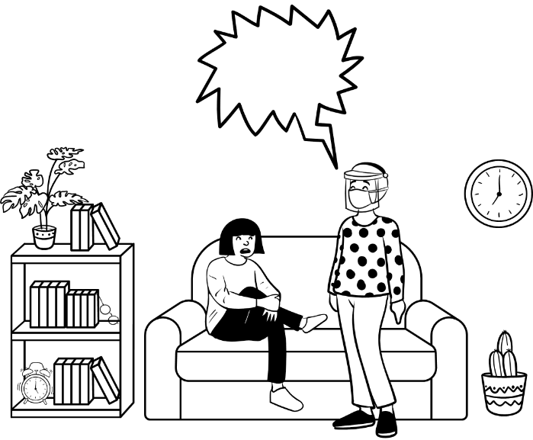
Positive approaches
1.9.2 List three causes that may impact upon behaviour of individuals.
____________________________________________________________________

1.9.3 Identify three positive approaches that can be used to reduce restrictive practices.
____________________________________________________________________
____________________________________________________________________

Label the following situations!
Hazard Accident Emergency Incident
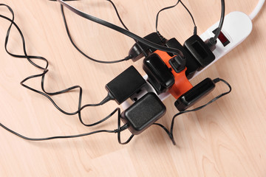
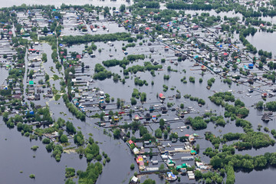

Scenarios / Case studies questions to be completed.
Workbook 1, Case study – Mrs Desai
Towards the end of her life my mum was more or less bed-bound and unable to walk. She had carers who came three times a day (morning, lunchtime and evening). The biggest problem was language, as none of her carers spoke Gujarati, which is the only language my mum spoke. So, there was total lack of communication and she felt completely isolated and started feeling more and more depressed. Luckily, they sent female carers so at least she was spared the humiliation of being tended to by a man. Hindu women (particularly the elderly) are very shy – I had never seen my mum's legs as she always wore a sari and no part of her was ever exposed, even to us as children.
One day I visited her in hospital and the nurse (female) was giving her a bed bath, so I waited outside her room. Then for some reason the nurse was called away and she left the room, leaving the door open and my mum half-dressed and exposed to anyone walking into ward to see. I quickly went in and closed the door. Mum was very, very upset, she was crying and kept saying to me “please take me home”. She found the whole hospital experience very disturbing. She was – the only word I have is traumatised – not only because of the bathing incident but not being able to understand a word the nurses and doctors said to her. She couldn't understand what they were saying and was unable to ask for help or request a bed pan or anything.
Modesty is such a big part of Hindu culture. The home care workers had no idea about dignity and modesty. When I visited mum at home, I often found them giving mum a bed bath and leaving her exposed and talking to someone on their mobile phones. They had no idea how to put a sari on mum – in the end we had to buy kaftans as mum would not wear short nighties. Also, since my father died mum always wore sacred tulsi beads around her neck. The workers didn’t understand the significance of this and removed it without her permission.
Mum had a small shrine in her bedroom where for years she lit a candle and incense each day and prayed. None of us ever wore our shoes in mum's bedroom because although it was her bedroom, it was also her prayer room. The workers had no understanding of this and because they changed so often you would inform one of them and the following week there would be a different worker.
Mum was a pure vegetarian so she wouldn’t even eat eggs. Some workers/nurses had very poor knowledge of what Hindu vegetarians can or can’t eat. Mum wouldn’t even eat something which was cooked with utensils used to cook meat, so she never ate hospital food, and the family would take her food from home.
So, the key thing is high quality cultural awareness training; it is most essential for anyone who works with older Hindu people. I felt really sorry for my mum because this dignified, proud lady who bore eight children and worked really hard to help my dad in his business, made many sacrifices. She educated her children really well and had led an exemplary life, she found her end of life so hard and undignified.
1.3.3 Describe the importance of knowing Mrs Desai’s preferences and background.
____________________________________________________________________
____________________________________________________________________

1.3.10 Explain how person-centred approaches are used to support active participation and inclusion.
____________________________________________________________________
____________________________________________________________________
1.6.2 What is the importance of developing a positive relationship with Mrs Desai, her family and carers?
____________________________________________________________________
____________________________________________________________________
1.11.1 What impact does the attitude and behaviour of the carers have on Mrs Desai and her family?
____________________________________________________________________
____________________________________________________________________
Workbook 3
3.1.3 & 3.1.4 What is the importance of including families, friends and community networks to support Mrs Desai’s well-being?
____________________________________________________________________
____________________________________________________________________

1.6.4
Read this list and tick which would be unacceptable practices.

- Watching an individual undress before bathing even though they don’t need any help with this. They only need help with getting in and out of the bath
- Accepting a birthday card with £20 in it from someone you support
- Accepting a Christmas card from a family member that thanks you for your care for their mother
- Lying on the sofa to have a cwtch with a young adult while watching TV
- Refusing to take an individual to church on Sunday because you don’t believe in God

Case study Bethan workbook 5 maps to workbook 1, 6.3, also workbook 5, 5.4, 5.5,
Jan has Parkinson’s disease and lives with her husband Dafydd. Dafydd has been managing to care for Jan but has had a fall in the garden and badly sprained his ankle. Their son Mark has moved in to support to his parents until his father’s ankle is better.
Bethan is one of the team of social care workers who visit every day to support Jan with her personal care. Bethan and Mark get on well straight away. Mark asks Bethan out for a drink, which she agrees to.
When Bethan is alone with Jan, she asks her about Mark and whether he’s married or has a partner. Jan is uncomfortable talking about her son and has told Bethan this, but she still keeps asking lots of personal questions about him – where does he work, does he earn lots of money, does he own his own house? Jan is afraid to offend Bethan in case she doesn’t want to work with her anymore. The agency providing care has a high turnover of staff and Jan is fed up having different social care workers all the time.
1.6.3 What does the term ‘professional boundaries’ mean and how do you balance these with relationship centred working?
____________________________________________________________________
____________________________________________________________________
__________________________________________________________________________

Workbook 7 MCQ’s
Assessment criteria | Question | Possible answers
7.1.4, 7.2.6 | Why is it important to raise concerns about practices or working conditions that are unsafe or risky. (select 2 answers) | - to protect self and others from harm  - it’s the right thing to do  - to minimise risks and hazards
7.2.1 | True or False | A risk assessment is the process of identifying policies and procedures.
7.2.4 & 7.2.5 | What is your responsibility for carrying out and recording risk assessments? (select 2 answers) | - Filling in a form  - Identifying potential hazards  - Reporting to my manager
7.6.1, 7.6.2 | Influenza is: | - A viral infection  - A bacterial infection
7.6.1, 7.6.2 | Which of the following is a bacterial infection? | - Salmonella  - Rubella
7.6.1, 7.6.2 | Which of the following is a fungal infection? | - Syphilis  - Ringworm
7.6.1, 7.6.2 | Scabies is an infection caused by: | - Fungi  - Parasites
7.6.6, | How is infection spread,  direct contact – | - through shaking hands,  - sneezing,  - mosquitos
7.6.6, | Indirect contact – | - door handles and phones.  - Coughing  - Mites
7.6.6, | Contamination (select 2 answers) | - eating or drinking contaminated food or water.  - sewage gets into the water supply.  - Headlice
7.6.6, | Droplet transmission –  (select 2 answers) | - Coughing or sneezing  - talking  - using a phone
7.6.6, | Airborne  (select 2 answers) | - Coughing  - Sneezing  - Head lice
7.6.6, | Vector borne  (select 2 answers) | - insect bites.  - head lice and mosquitos  - coughing and sneezing
7.6.9 | How can you maintain a clean environment to prevent the spread of infection?  (select 2 answers) | - Use detergent and hot water.  - Use a clinel wipe.  - Use one cloth per room.  - Wash hands regularly
7.6.10 | Why is it important to have good personal hygiene? | - To smell nice  - Prevents the spread of infection.  - To have a shower every day
7.8.2 | What is meant by ‘Control of Hazardous Substances’? (select 2 answers) | - Assess the risk.  - Provide information and equipment required.  - Let someone use substances without guidance
7.8.3 | What types of hazardous substances may be found in the workplace? (select 2 answers) | - Bleach  - Milk  - Savlon  - Cleaning products / chemicals
7.8.4 | Identify what is safe practice for: storing, using, dealing with spillages and disposing of hazardous substances. (select 3 answers) | - Always keep hazardous substances in a locked cupboard  - Use gloves when using hazardous substances.  - Dispose of safely in appropriate bags  - Leave the hey in the cupboard so everyone can get then when they require them
7.9.1 | Identify what are the potential risks to security in the work setting:  (select 3 answers) | - Unsafe entry and exit  - Verbal and physical threats  - Lockable doors and windows  - No risk assessments in place
7.9.2 | Identify what is safe practice to ensure security in the work setting: (select 2 answers) | - Lockable doors and windows  - Angry visitors shouting requiring assistance.  - Safe entry and exit from workplace.
7.10.1 | What are the signs of stress? | - Increased use of alcohol, cigarettes, drugs  - Sleep disturbance  - Feeling Overwhelmed  - All above
7.10.1 | What are the symptoms of stress? | - Relationship difficulties  - Fatigue  - Difficulty in communication

Workbook 1, Case study – Jenny.
Jenny lived in a residential healthcare setting for 45 years. She has learning disabilities and mental health issues. She moved into her own home four years ago. She shares her home with Francis, and they receive 24-hour support. Jenny gets upset and angry when workers move on. Only a few have stayed in contact with her as she can be very demanding and is verbally abusive if she’s distressed. Jenny takes this as a personal rejection and the team are trying to help her build relationships with her family and friends.
Francis goes home for Christmas every year and Jenny stays at the house. Although Jenny is back in contact with her family, relationships are strained, and she doesn’t see them over the Christmas holidays. Jenny gets very distressed at this time of year. The deputy manager, Sian, thinks it would be a good idea for Jenny to spend Christmas day with her and her family. Sian would officially be on duty on Christmas day.
5.1.8 Identify conflicts and dilemmas that may arise between duty of care and Jenny’s rights?
____________________________________________________________________
____________________________________________________________________
____________________________________________________________________

Care Study Ebube – workbook 7, 10.3, 10.4, 10.5,
Ebube is a new worker in a care home setting for children who are looked after. The manager of the setting has had a car accident and is on extended sick leave.
Ebube has only had a brief induction and isn’t able to shadow a more experienced worker as they’re so short staffed. Ebube feels out depth and is exhausted by working long hours. On top of that, one of the young people is constantly verbally abusive towards her. Ebube feels as though she’s failing at her new job. She isn’t sleeping well and is snappy and irritable at home with her own children.
a) What symptoms of stress is Ebube is showing? ____________________________________________________________________
____________________________________________________________________
____________________________________________________________________
b) What actions could Ebube take?
____________________________________________________________________
____________________________________________________________________
____________________________________________________________________
c) What actions should her employers take?

_____________________________________________________________________





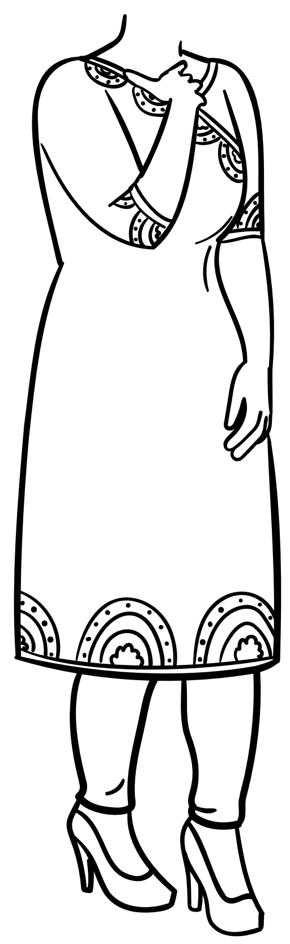

What if everyone can see my incontinence pad?

There’s no way I can go to the gym as usual …what if I leak
I’m so tired from being up all night going to the loo, how am I going to manage in work today

To do list:
Put bedsheets on to wash
Find a dress to wear on Saturday
Events to remember:
Blood test for kidneys on 21st at 1pm
Ball on Saturday
Travel to Rome for work on 22nd –



3.3.6 Ashlee has urinary incontinence. Label the picture with each of these terms to show she is affected as a result
- Health
- Wellbeing (ability to have control)
- Self esteem
- Day to day activities

Link the professional to their area of expertise (3. 3.9, 3.5.7, 3. 6.5)
Signs of foot and toenail abnormalities (3.6.3) label the diagram using the descriptors below some examples include:
District Nurse
Podiatrist
Dentist

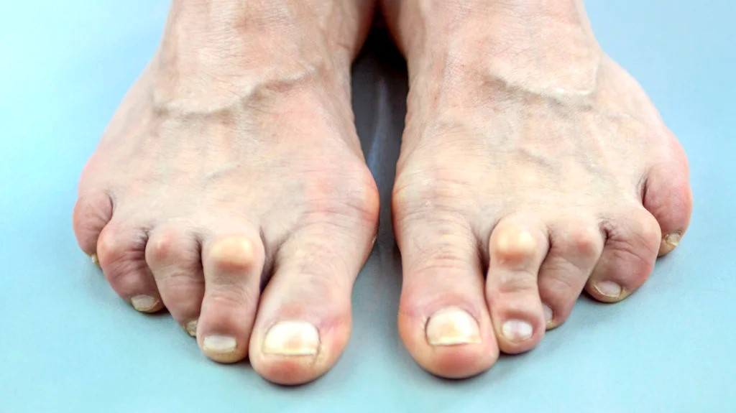

Continence Nurse
Chiropodist
Dental Hygienist

3.
Foot care
2.
Oral care/Mouth Care
1.
Urinary/Faecal incontinence
Itchy white patches
Redness
Bony lumps
Blisters
Hardened toenails

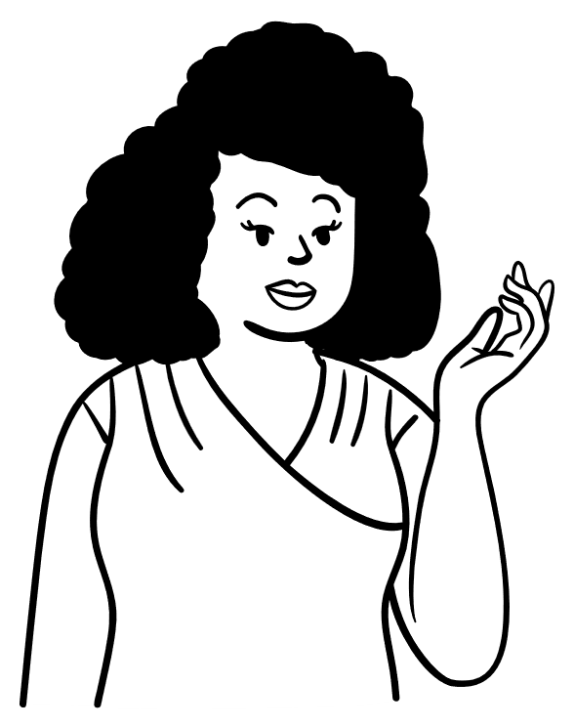



i.e. resentment of others _______________________________________
i.e. fear, pain
________________________________________________
(3.10.4) What support is available in your area when someone is reaching end of life? This might be a local charity or organisation.
______________________________________________________________________________
End of life care (10.1)
In the speech bubbles, identify how death and dying might affect Joan and those around her.
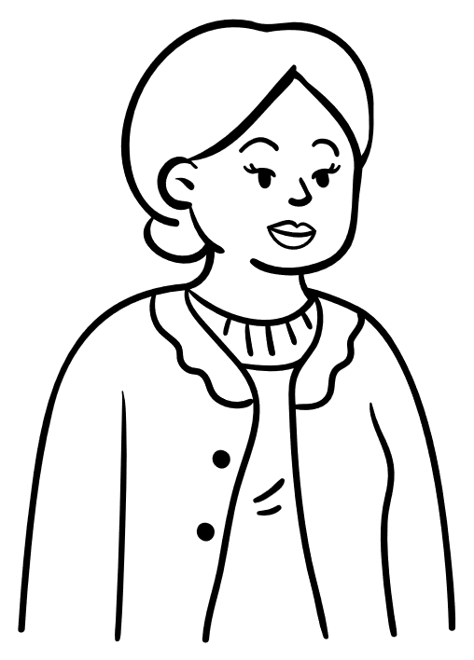
Name: Joan Ridgemont
Age: 78
Past Medical History: High blood pressure, glaucoma, terminal diagnosis of bowel cancer
Support Network: Lives with her husband, has 2 daughters who live away. Her brother lives 2 doors down.

5.2.4 Why is it important to support multi agency working?
___________________________________________________________________________________________________________
_________________________________________________________________________

All Wales induction Framework Mapping to All Wales Agored Cymru accredited health and Care induction
Workbook 1 – Principles and Values
AWIF Assessment Criteria | Mapped to Agored Cymru Assessment Criteria V6 | Mapped to additional resources (this Document) | Developmental requirements (additional booklet)
1.1 Legislations, codes |  | Quiz
1.2 | 1.1 a-k,
1.3 | 1.1 a, b,
1.4 | 1.1 b,
2.1 Rights-based approaches |  | Pictoral Quiz
2.2 |  | Activity / Table
2.3 |  | Pictoral Quiz
2.4 |  | Pictoral Quiz
2.5 | 1.1 d
3.1 Person centred care | 1.1, 2.1, 2.2 | Pictoral Quiz 5-1.7
3.2 |  | Pictoral Quiz
3.3 | 2.3 | Mrs Desai
3.4 | 2.3
3.5 | 1.1
3.6 | 1.1
3.7 | 2.2
3.8 |  | Pictoral Quiz
3.9 | 2.4 | Mrs Desai
3.10 | 2.4 | Mrs Desai
3.11 |  | MCQ
4.1 Equality diversity and inclusion |  | Pictoral Quiz
4.2 |  | Quiz
4.3 | 2.2
4.4 | 2.3
4.5 |  | MCQ
5.1 Positive risk taking | 2.4 | Video
5.2 | 2.4 | Video
5.3 | 2.4 | Video
5.4 | 2.4 | Video
5.5 |  | Pictoral Quiz
6.1 Positive relationships |  | Scenario / Pictoral Quiz
6.2 |  | Scenario
6.3 |  | Scenario
6.4 |  | Table
7.1 Effective communication | 3.2
7.2 | 3.1
7.3 | 4.1
7.4 | 4.1
7.5 | 3.3
8.1 Welsh language and culture | 3.2
8.2 |  | Table
8.3 |  | Quiz
8.4 | 3.2, 4.1,
9.1 Positive approaches |  | Picture quiz, specific picture
9.2 |  | Picture quiz, specific picture
9.3 |  | Picture quiz, specific picture
10.1 Transitions |  |  | Transitions questions AWIF
10.2 |  |  | Transitions questions AWIF
11.1 Own beliefs |  | Mrs Desai

Workbook 3 – Health and Wellbeing
AWIF Assessment Criteria | Mapped to Agored Cymru Assessment Criteria V6 | Mapped to additional resources (this Document) | Developmental requirements (additional booklet)
1.1 Wellbeing |  | Pictoral Quiz
1.2 | 10.1
1.3 |  | Mrs Desai / Gwyneth
1.4 |  | Mrs Desai
2.1 Factors that affect wellbeing |  |  | Questions from AWIF
2.2 |  |  | Questions from AWIF
2.3 |  |  | Questions from AWIF
2.4 |  |  | Questions from AWIF
2.5 |  |  | Questions from AWIF
2.6 |  |  | Questions from AWIF
2.7 |  |  | Questions from AWIF
2.8 |  |  | Questions from AWIF
2.9 |  |  | Questions from AWIF
2.10 |  |  | Questions from AWIF
2.11 |  |  | Questions from AWIF
2.12 |  |  | Questions from AWIF
2.13 |  |  | Questions from AWIF
2.14 | 18.1
2.15 | 19.1
2.16 | 19.2, 17.1, 17.2,
2.17 |  |  | Questions from AWIF
2.18 |  |  | Questions from AWIF
3.1 Personal care and continence |  | Pictoral Quiz
3.2 | 20.1
3.3 | 20.2
3.4 | 9.1
3.5 | 9.2
3.6 |  | Pictroral Quiz
3.7 |  | MCQ
3.8 | 9.3
3.9 |  | MCQ
3.10 | 9.4
4.1 Pressure area care |  | MCQ
4.2 |  | Table
4.3 | 7.3
4.4 | 7.2
4.5 | 7.1
5.1 Oral health |  | MCQ
5.2 | 8.1 | MCQ
5.3 | 11.3, 11.3, 8.4, 8.2
5.4 | 11.1,
5.5 |  | MCQ
5.6 |  | MCQ
5.7 |  | Question / activity MCQ
6.1 Foot care | 12.1
6.2 | 12.2, 12.3, | MCQ
6.3 |  | MCQ, Label the diagram
6.4 | 12.3 | MCQ
6.5 |  | Activity
7.1 Medication |  |  | Development from AWIF
7.2 |  |  | Development from AWIF
7.3 |  |  | Development from AWIF
7.4 |  |  | Development from AWIF
8.1 Nutrition and hydration |  | MCQ
8.2 |  | Quiz
8.3 | 8.1
8.4 |  | Quiz
8.5 | 8.2
9.1 Falls prevention | 6.1
9.2 | 6.2
10.1 End of life care |  | Activity Scenario
10.2 | 21.1
10.3 |  | Pictoral Quiz
10.4 |  | Pictoral Quiz
10.5 | 21.5
11.1 Assistive technology |  | Video Questions
11.2 |  | Video Questions
11.3 |  | Video Questions
11.4 |  | Video Questions
12.1 Sensory loss | 16.1
12.2 | 16.2
12.3 | 16.1, 16.2, 16.3,
12.4 | 16.1, 16.2, 16.3,
12.5 | 16.3
12.6 | 16.3
12.7 | 16.1, 16.2, 16.3,
12.8 | 16.3
13.1 Dementia |  | Pictoral
13.2 | 13.2
13.3 |  |  | Development scenario
13.4 |  |  | Development Scenario
13.5 | 13.3,
13.6 | 13.3
13.7 |  |  | Development scenario
13.8 |  |  | Development scenario
13.9 |  | MCQ
13.10 | 13.3 | MCQ
14.1 MH | 15.1
14.2 |  | MCQ
14.3 | 15.2
14.4 | 15.2
14.5 | 15.3
14.6 |  | MCQ
14.7 | 15.3
15.1 Substance misuse |  | Pictoral Quiz
15.2 |  | Question
15.3 |  | Question
15.4 |  | Question

Workbook 5 – Professional Practice
AWIF Assessment Criteria | Mapped to Agored Cymru Assessment Criteria V6 | Mapped to additional resources (this Document) | Developmental requirements (additional booklet)
1.1 Roles and responsibilities | 1.1 a, b, c,
1.2 |  | MCQ
1.3 | 1.1 a, b, c,
1.4 | 1.1 a, b, c,
1.5 | 1.1 h,
1.6 | 1.1 d,
1.7 |  | Pictoral Quiz
1.8 |  | Mrs Desai / Socrative
1.9 |  | Question
1.10 | 1.1 d,
1.11 | 23.1, 23.2,
1.12 | 1.1 f,
1.13 |  | Question
1.14 |  | Question
1.15 |  | Question
2.1 Partnership working |  | MCQ / Activity
2.2 |  | MCQ / Activity
2.3 cross referenced Workbook 3.6.3, 6.5, 3.9, 5.7, |  | MCQ / Activity
2.4 cross referenced Workbook 3.6.3, 6.5, 3.9, 5.7, |  | MCQ / Activity
2.5 Cross referenced 5.4.8, 5.2.6, 5.2.7 |  | MCQ / Activity
2.6 Cross referenced 5.2.1 |  | MCQ / Activity
2.7 cross referenced Mrs Desai 3.3.3, 3.3.10, |  | Scenario
3.1 Team working |  | Flow chart
3.2 |  | Question
3.3 cross reference to 5.2.4 |  | MCQ / Activity
4.1 Record keeping, handling info |  | Pictoral Quiz
4.2 |  | Table
4.3 |  | MCQ / Activity
4.4 | 1.1 k,
4.5 | 1.1 k,
4.6 | 1.1 k,
4.7 | 1.1 k,
4.8 cross referenced 5.2.5, 5.2.6, 5.2.7, |  | MCQ
4.9 cross referenced 5.2.5, 5.2.6, 5.2.7, |  | MCQ / Activity
5.1 Professionalism, boundaries |  | Pictoral quiz
5.2 | 1.1
5.3 | 1.1
5.4 cross referenced 1.6.1, 1.6.2, 1.6.3, |  | Professional boundaries scenario
5.5 cross referenced 1.6.1, 1.6.2, 1.6.3, |  | Professional boundaries Scenario
6.1 CPD |  | Pictoral quiz
6.2 |  | Table
6.3 | 23.1
6.4 |  | MCQ
6.5 | 1.1 j,
6.6 | 1.1j, 23.1,
6.7 | 23.2
6.8 |  | MCQ
6.9 | 23.1
6.10 |  | Quiz
6.11 |  | Quiz
6.12 |  | Quiz
6.13 |  | Quiz
6.14 |  | Quiz

Workbook 6 – Safeguarding
AWIF Assessment Criteria | Mapped to Agored Cymru Assessment Criteria V6 | Mapped to additional resources (this Document) | Developmental requirements (additional booklet)
1.1 |  | MCQ
1.2 |  | MCQ
1.3 |  | MCQ
1.4 |  | Table
1.5 |  | Table
1.6 |  | Scenario Paul
2.1 |  | Scenario Paul
2.2 |  | Scenario Paul
2.3 |  | Scenario Paul
2.4 |  | Scenario Paul
2.5 |  | Scenario Paul
2.6 |  | Scenario Paul
2.7 |  | MCQ
2.8 |  | MCQ
2.9 |  | Fill in the gaps
3.1 |  |  | Questions from AWIF
3.2 |  |  | Questions from AWIF
3.3 |  |  | Questions from AWIF
3.4 |  |  | Questions from AWIF
3.5 |  |  | Questions from AWIF
4.1 |  |  | Questions from AWIF
4.2 |  |  | Questions from AWIF
4.3 |  |  | Questions from AWIF
4.4 |  |  | Questions from AWIF
4.5 |  |  | Questions from AWIF
4.6 |  |  | Questions from AWIF
4.7 |  |  | Questions from AWIF
4.8 |  |  | Questions from AWIF
4.9 |  |  | Questions from AWIF
4.10 |  |  | Questions from AWIF
4.11 |  |  | Questions from AWIF

Workbook 7 – Health and Safety
AWIF Assessment Criteria | Mapped to Agored Cymru Assessment Criteria V6 | Mapped to additional resources (this Document) | Developmental requirements (additional booklet)
1.1 Health and safety in the workplace |  | Table
1.2 |  | Fill in the gaps
1.3 | 1.1 c
1.4 |  | MCQ
2.1 Risk assessments for health and safety |  | MCQ
2.2 |  | Picture quiz
2.3 and 7.2.5 |  | MCQ
2.4 and 7.2.5 |  | MCQ
2.5 see 7.2.3, 7.2.4 |  | MCQ
2.6 see 7.1.4 |  | MCQ
3.1 Fire Safety |  |  | Questions from AWIF
3.2 |  |  | Questions from AWIF
3.3 |  |  | Questions from AWIF
3.4 |  |  | Questions from AWIF
3.5 |  |  | Questions from AWIF
4.1 Moving and handling and moving and positioning | Moving and handling passport
4.2 | Moving and handling passport
4.3 | Moving and handling passport
4.4 | Moving and handling passport
5.0 Emergency First Aid |  |  | Additional Course in Workplace
6.1 Infection Prevention and Control |  | MCQ
6.2 | 5.1
6.3 |  | Fill in the blanks
6.4 |  | Fill in the blanks
6.5 | 5.3, 5.2, 5.1,
6.6 |  | Question
6.7 |  | Table
6.8 |  | Table
6.9 | 5.2, 5.3, | MCQ
6.10 |  | Question
6.11 | 5.4,
6.12 | 5.5,
7.1 Food safety |  |  | Questions from AWIF
7.2 |  |  | Questions from AWIF
7.3 |  |  | Questions from AWIF
7.4 |  |  | Questions from AWIF
7.5 |  |  | Questions from AWIF
7.6 |  |  | Questions from AWIF
7.7 |  |  | Questions from AWIF
7.8 |  |  | Questions from AWIF
8.1 Hazardous substances |  | Fill in the gaps
8.2 |  | MCQ
8.3 |  | MCQ
8.4 |  | MCQ
9.1 Security in the work setting |  | MCQ
9.2 |  | MCQ
10.1 Managing stress | 10.1 | MCQ
10.2 | 10.1 | MCQ
10.3 |  | Scenario
10.4 |  | Scenario
10.5 |  | Scenario

I have seen the evidence that meets the criteria from the mapping document. Managers Signature and date

Feedback
Date |  | Signature
I confirm that the new worker has achieved all the requirements of the workbook with the evidence submitted (All Wales workbook plus this workbook which meets the requirements of the AWIF).

Managers Comments

 | Assessors Comments
I confirm that the evidence listed for the workbook is authentic and a true representation of my own work.

Learners Comments

