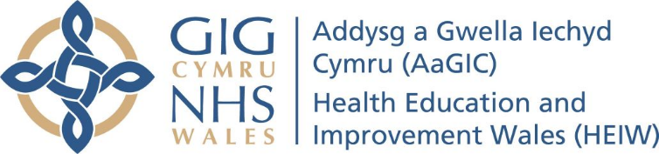

Faculty Lead (Royal Glamorgan): Cwm Taf Morgannwg University Health Board

Post Reference: FL(RG)-CTM-0222

Employer: Secondment to Health Education and Improvement Wales (appointment will be via an external secondment agreement)
Department: Quality Unit
Location: Based within Cwm Taf Morgannwg University Health Board
Pay Scale: Consultant / SAS Doctor / GP Educator
Hours: 1 session per week (the successful candidate will need to ensure that the sessional commitment can be accommodated within their job plan, and written confirmation of this from their Clinical Director is required)
Start Date: Post available from 9th May 2022
Tenure: 3 years from date of appointment
Closing date for applications: Friday 21 July 2023 at 23:59
Interview date: TBC

-----------------------------------------------------------------------------------------------------------------------------------------------
About Health Education and Improvement Wales (HEIW)
Health Education and Improvement Wales (HEIW) is a special health authority which has a leading role in the education, training, development and shaping of the healthcare workforce in Wales. It has a range of functions including strategic workforce planning, workforce modernisation, commissioning and delivery of training, quality management, quality improvement, careers, leadership development and succession planning.
----------------------------------------------------------------------------------------------------------------------------------------

HEIW is seeking an outstanding, ambitious and enthusiastic individual to work as part of the Faculty Team within Cwm Taf Morgannwg University Health Board to support, deliver and manage medical education and training in Wales.

The Faculty Lead (Royal Glamorgan) will have three specific areas of responsibility at Royal Glamorgan Hospital:

- Quality: Ensuring systems of quality control, educational governance and implementation of GMC standards within the LEP and providing a link between directorates, HEIW and Specialty (including GP) and Foundation Training Schools. In addition the role includes providing advice and information on the maintenance of quality standards and monitoring of training in undertaking changes in service delivery;

- Trainers: Supporting and developing trainers in the delivery of their role, professionalising the trainer role, and striving to continuously improve the quality of training;

- Trainees: Ensuring the provision of appropriate systems of support for trainees and promoting the ‘trainee voice’ and trainee engagement with quality improvement initiatives.

The Faculty Lead (Royal Glamorgan) will represent HEIW within the Health Board, with joint accountability to both the Postgraduate Dean within HEIW and the Medical Director within Cwm Taf Morgannwg University Health Board. The post holder will be expected to work closely with the Assistant Medical Director (Education and Training). The role will be geographically based within the Health Board.

This crucial role will provide the opportunity to shape and enhance standards within the Health Board along with opportunities for personal and professional development in management, leadership and specialised areas.

The ability to speak Welsh is desirable for this post; Welsh and/or English speakers are equally welcome to apply.

To apply please complete the application form (which must include evidence to support the required behaviours set out in the person specification) and submit this with a statement of support from your Clinical Director to confirm that the Faculty Lead role can be accommodated within your job plan. The application form, job description and person specification can be found online at http://bitly.ws/8IHX or are available on request from HEIW’s Quality Unit at heiw.pges@wales.nhs.uk. We are unable to accept CVs in place of an application form.

Applicants should check their email account regularly. Successful applicants will receive all recruitment related correspondence via the email account registered on the application form.

The organisation reserves the right to close a vacancy early or withdraw an advertisement at any stage of the process.

Posts may be subject to a Disclosure and Barring Service (DBS) Check and Professional Registration Check

For further details contact:
- Shakir Mustafa, Assistant Medical Director (Education and Training), Cwm Taf Morgannwg UHB (email: shakir.mustafa@wales.nhs.uk)
- Leanne Holborn, Clinical Education Manager, Cwm Taf Morgannwg UHB (email: leanne.holborn@wales.nhs.uk)
- Jane Gwilliam, Associate Dean (Postgraduate Education Support and Improvement), HEIW (email: heiw.pges@wales.nhs.uk)
- Kaye Walters, Postgraduate Education Support and Development Manager and Recruiting Manager (email: heiw.pges@wales.nhs.uk)

